**Assignment # 2(A)**

**Submitted by Muzammil Mehmood & Ali Umair**

**Problem Statement**

Write a dataclass describing a mountain (containing fields for name and elevation) and:- Construct an instance of the dataclass- Convert it to string

**Solution**

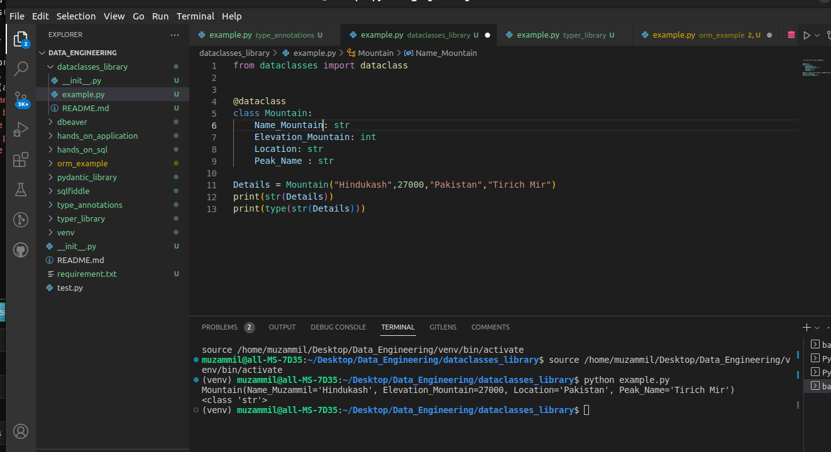

from dataclasses import dataclass

@dataclass

class Mountain:

Name_Mountain: str

Elevation_Mountain: int

Location: str

Peak_Name : str

Details = Mountain("Hindukash",27000,"Pakistan","Tirich Mir")

print(str(Details))

print(type(str(Details)))