**Assignment # 2(B)**

**Problem Statement**

Create a new SQLFiddle and then add the database from db.sql (provided in tasks/1_introduction/day_2_basic_tooling/hands_on_sql) to be able to perform queries.

Your task then is to do two things:  
1. Insert two articles written by Joe (id 3) into articles table (choosing the titles is up to you).  
2. Write a query that will return you a list of articles written by authors who are at least 25 years old.

**Solution**

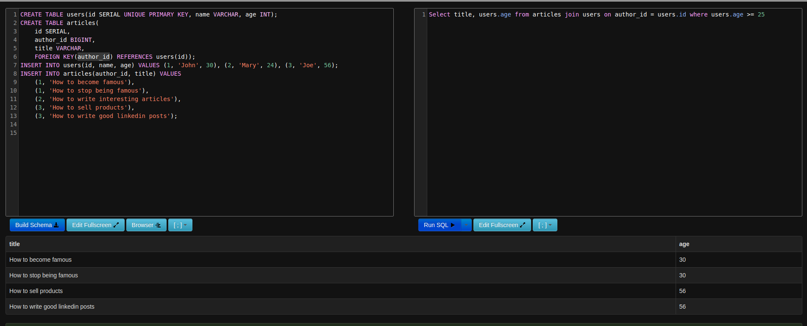

**Query for writing table**

CREATE TABLE users(id SERIAL UNIQUE PRIMARY KEY, name VARCHAR, age INT);

CREATE TABLE articles(

id SERIAL,

author_id BIGINT,

title VARCHAR,

FOREIGN KEY(author_id) REFERENCES users(id));

INSERT INTO users(id, name, age) VALUES (1, 'John', 30), (2, 'Mary', 24), (3, 'Joe', 56);

INSERT INTO articles(author_id, title) VALUES

(1, 'How to become famous'),

(1, 'How to stop being famous'),

(2, 'How to write interesting articles'),

(3, 'How to sell products'),

(3, 'How to write good linkedin posts');

Query for SQL input

Select title, users.age from articles join users on author_id = users.id where users.age >= 25

1,3,5,7 – ye aik line mai agaya

2,4,6,8 – ye doosri line mai likhdete?