Report

The site we have scrapped is Amazon

1- We have used these libraries to scrape the data and to import it in excel file:

import requests

from bs4 import BeautifulSoup

import pandas as pd

import os

import time

from bs4 import BeautifulSoup

2-we have scrapped all the product names,product page,company name,price, and the source of the images of the all products in the electronics pages by looping on all urls of the electronics pages and each page we loop in all the div classes In each product and get all its data.

scraped_data = []

for url in URL_list:

    response = requests.get(url)

    soup = BeautifulSoup(response.content, 'html.parser')

    products = soup.find_all('div', class_='sg-col-inner')

    for product in products:

        product_data = {}

        if product_link:

            product_data['Product Page'] = "https://www.amazon.eg" + product_link['href']

        else:

            product_data['Product Page'] = 'N/A'

        product_name = product.find('span', class_='a-size-base-plus a-color-base a-text-normal')

        if product_name:

            product_data['Product Name'] = product_name.text.strip()

        else:

            product_data['Product Name'] = 'N/A'

        price = product.find('span', class_='a-offscreen')

        if price:

            product_data['Price'] = price.text.strip()

        else:

            product_data['Price'] = 'N/A'

        ratings = product.find('span', class_='a-icon-alt')

        if ratings:

            product_data['Ratings'] = ratings.text.strip()

        else:

            product_data['Ratings'] = 'N/A'

        company_name = product.find('span', class_='a-size-base a-color-secondary')

        if company_name:

            product_data['Company Name'] = company_name.text.strip()

        else:

            product_data['Company Name'] = 'N/A'

        image = product.find('img', class_='s-image')

        if image:

            product_data['Product Image'] = image['src']

        else:

            product_data['Product Image'] = 'N/A'

        scraped_data.append(product_data)

for data in scraped_data:

    print("Product Name:", data['Product Name'])

    print("Price:", data['Price'])

    print("Ratings:", data['Ratings'])

    print("Company Name:", data['Company Name'])

    print("Product Page:", data['Product Page'])

    print("Product Image:", data['Product Image'])

    print("------------------------")

3-OUTPUT:

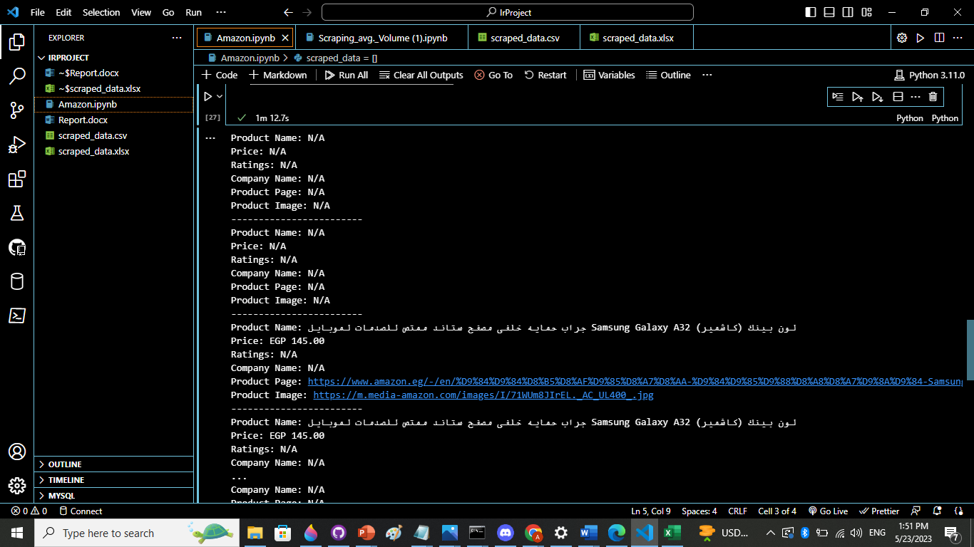

Importing the data in excel file

