21K-4653

Q1:

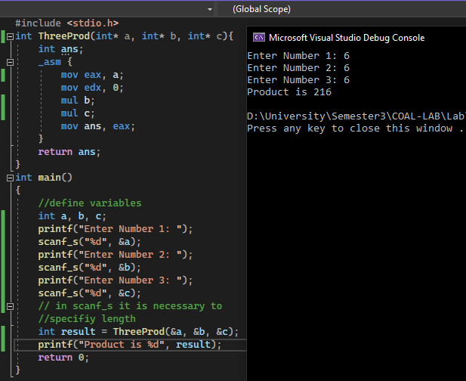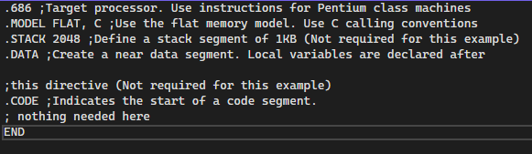

Q2:



