Ali Zain 21K-4653

Task #1

setting up samba.

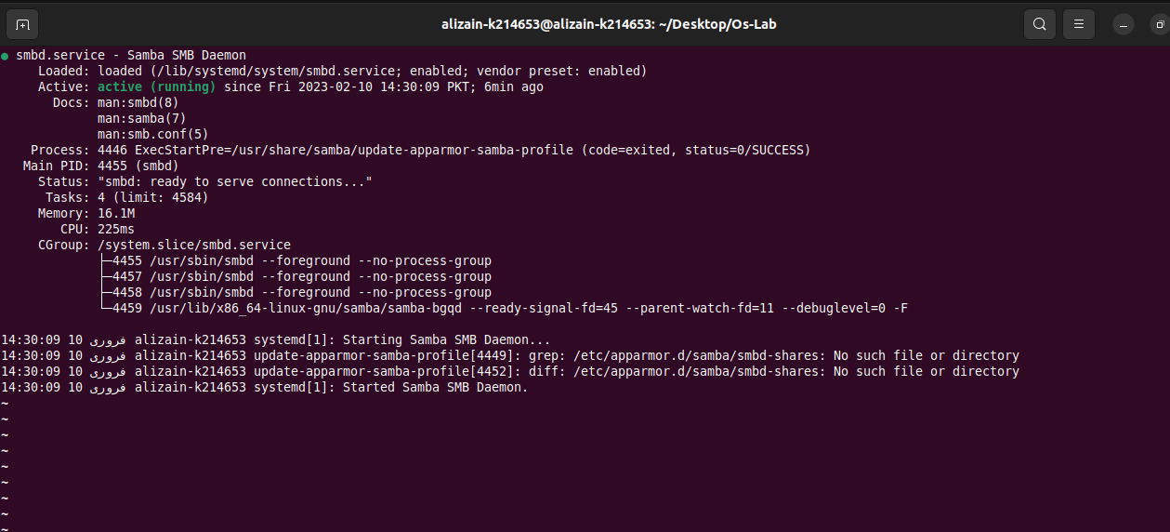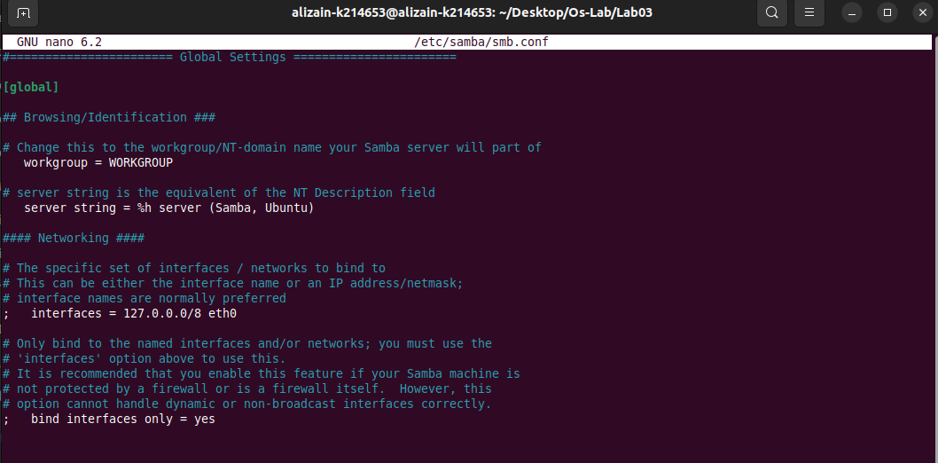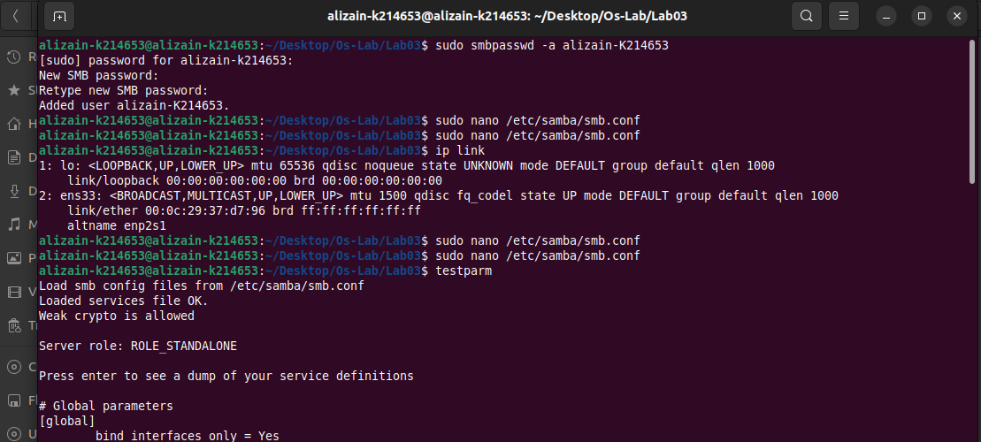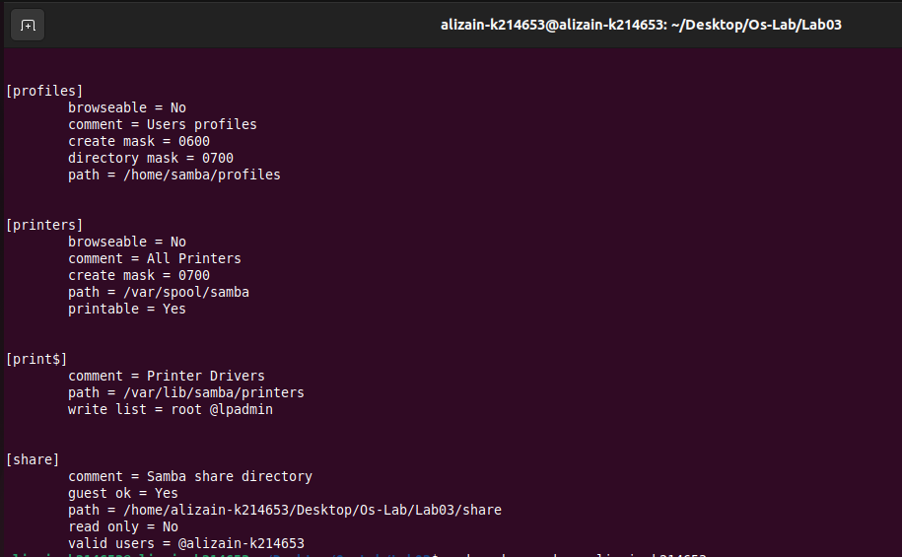

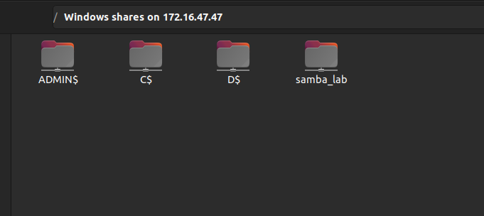

Task #2:

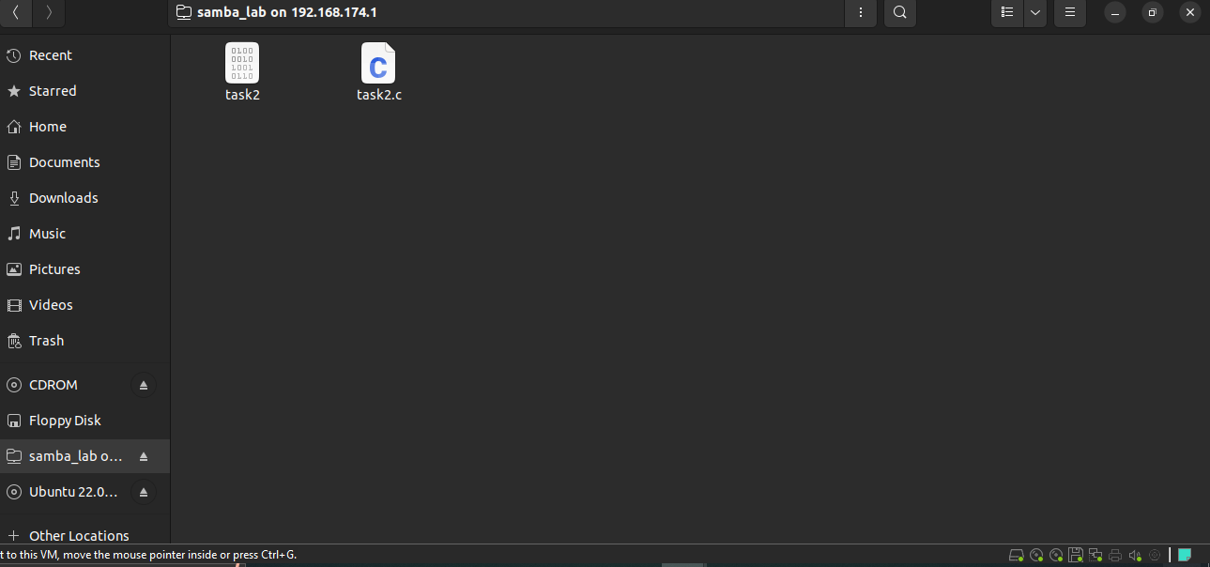

Task #3:

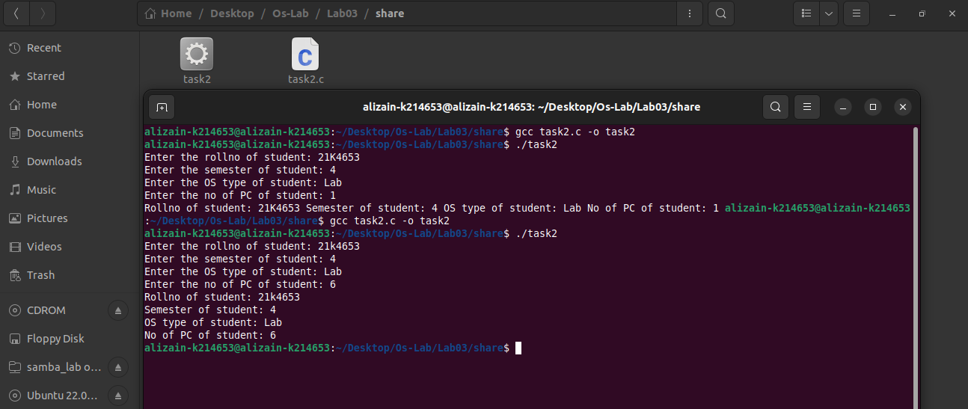

Task #4:

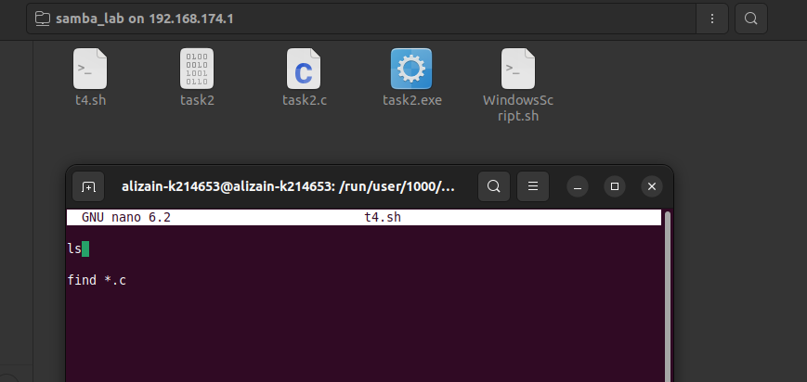

Task #5:

* t5.sh inside window shared folder.
* WindowsScript inside ubuntu share folder.

