# Ali Zain K214653

Task #1:

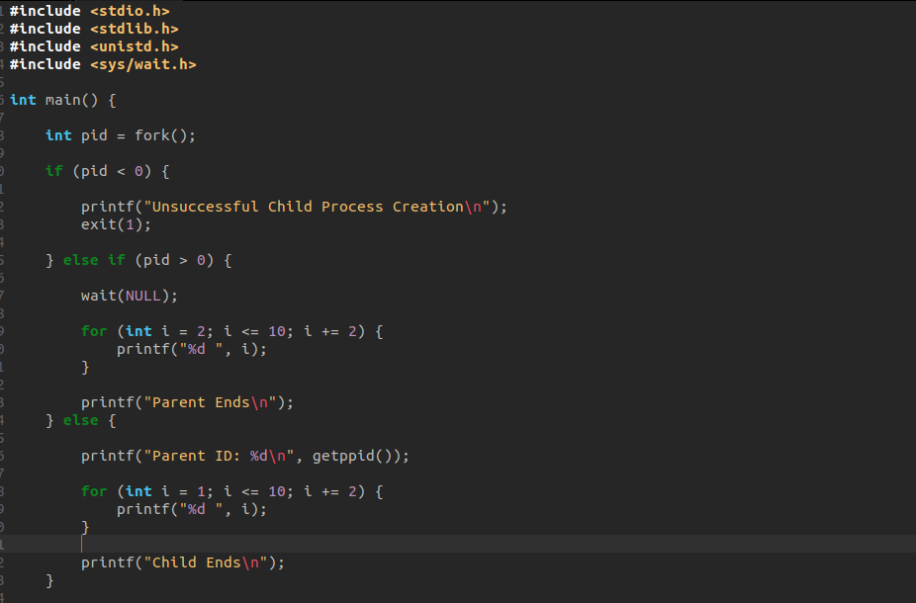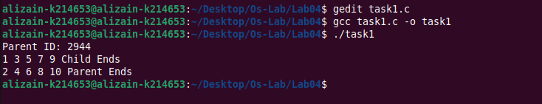

Task #2:

Task #3:

Task #4:

Task #5:

Pointer Function for Creating Child in every Tree

Tree 1:

Tree 2:

Tree 3:

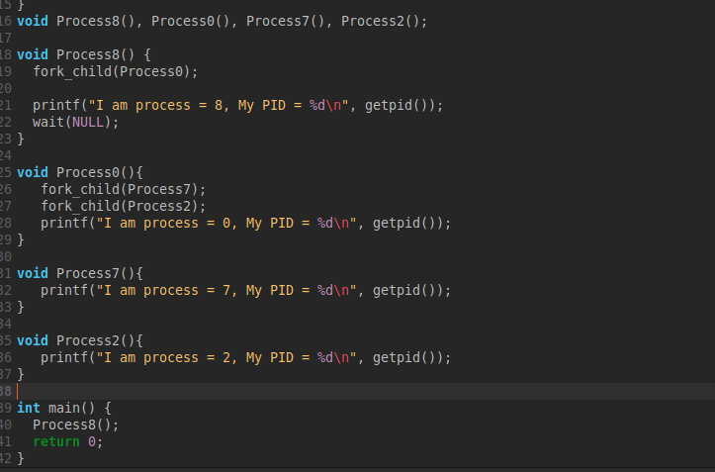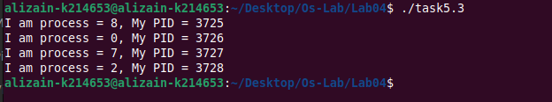

Tree 4:

Tree 5:

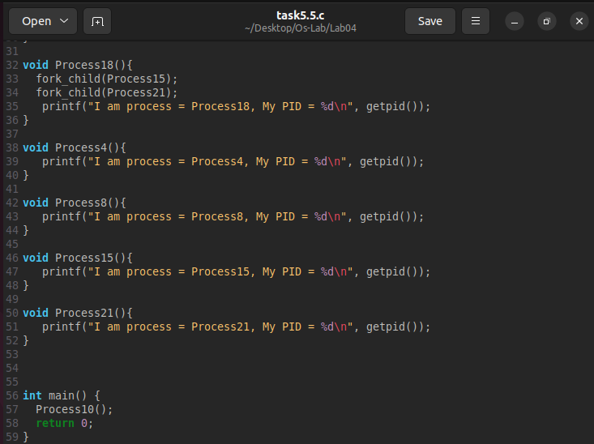

Tree 6:

Tree 7:

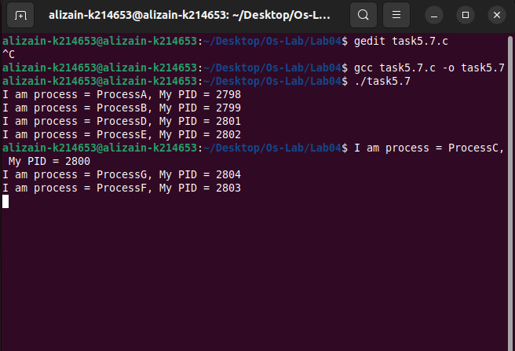

Tree 8:

Tree 9:

