# Lab Activity

1. Reverse the example in ‘unnamed_pipe.c’ so that child would send message to parent and parent would print the message on screen.

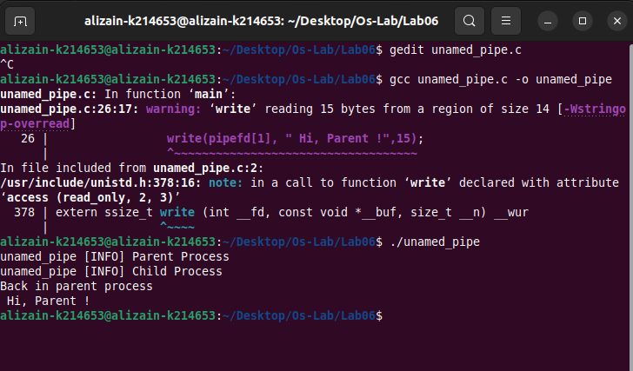

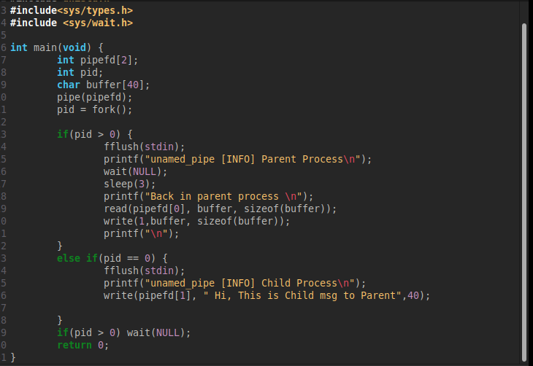

1. Run the FIFO example with three read processes and one write process.

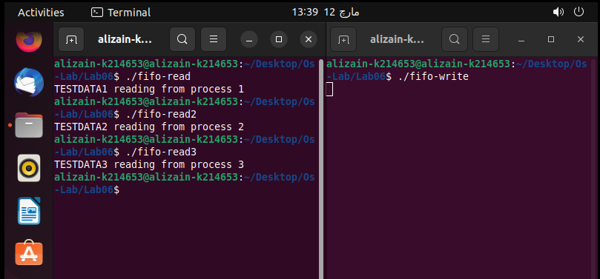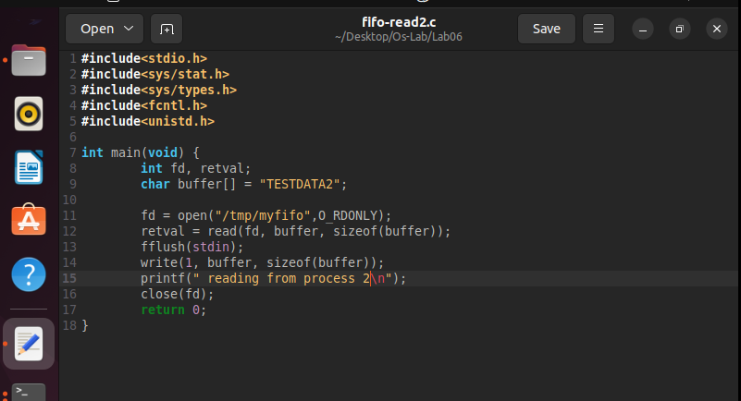

1. Write two programs that would implement the concept of shared memory, the requirements are as follow:
   1. The first program would create a shared memory and put a number in it.
   2. The second program would store the number (which would come as string) in an integer variable and then writes in the memory “ready”.
   3. The term “ready” is then picked up by the first program, it prints this value onto the screen and puts ‘*’ in the memory.
   4. The second program when read ‘*’ will put the table of the number which it stored in part b from 1 – 10. Such that
      1. Assume num is the variable it stored the number came from program 1.
      2. It will initiate an iterator say int i and assign 1 in it.
      3. Whenever it sees ‘*’ in the shared memory it will put the value calculated from the equation: i*n in the shared memory. Which then picked up by the first program and again it will read the value, print it on the screen and put ‘*’ again.
      4. This cycle continues till i > 10

1. In mathematics, the Fibonacci numbers are the numbers in the following integer sequence, called the Fibonacci sequence, and characterized by the fact that every number after the first two is the sum of the two preceding ones:   
     
    0 ,1 ,1 ,2 ,3 ,5 ,8 ,13 ,21 ,34 ,55 ,89 ,144,….

Write three programs two writers (say A, B) and one reader (say C). Initially A and B will have a shared memory (A = 0 and B = 1) and C would attach these shared memories and would generate Fibonacci series. Given below is a general algorithm

* C: Read memory of A
* C: Read memory of B
* C: Add A+B
* C: Assign memory of B to memory of A
* C: Assign value of A+B to memory of B
* The above iteration is done n times (where n can be any value from one – hundred)

