# Ali Zain K214653

Make sure if you have installed gcc and g++ for compiling cpp files. For compiling “g++ T1.cpp -o T1”

Task #1:

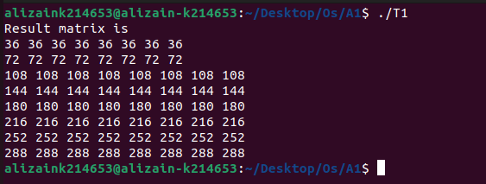

Task #2:

