# Ali Zain K214653

Ubuntu version : 16.04

Linux Kernel Version : 4.19.235

Task #1:

Installing Few dependencies

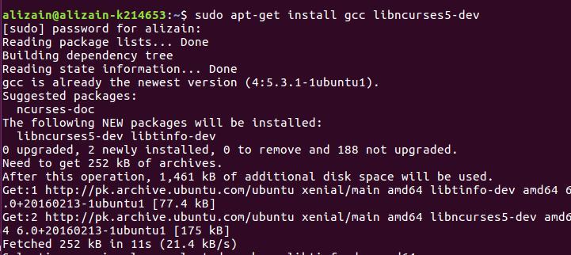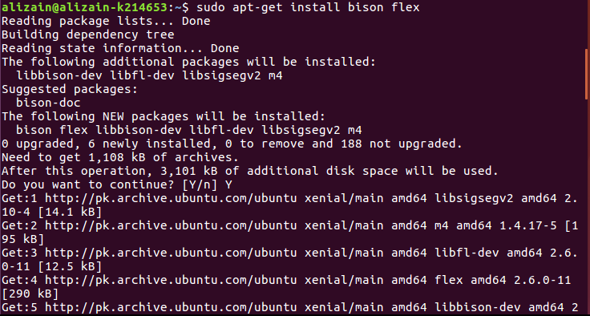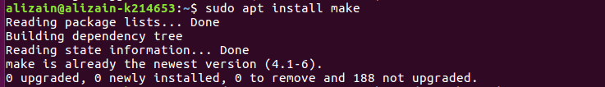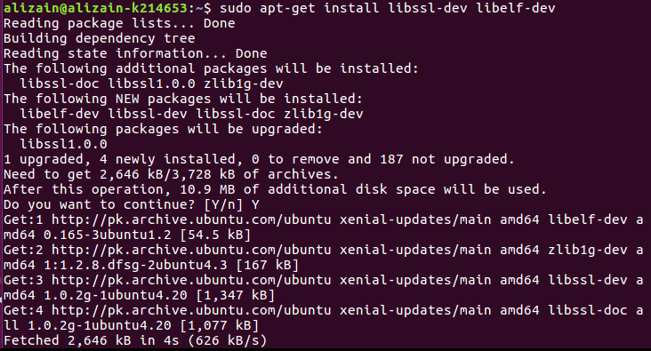

Step #2:

* Creating hello folder
* Creating hello.c and Makefile inside hello folder

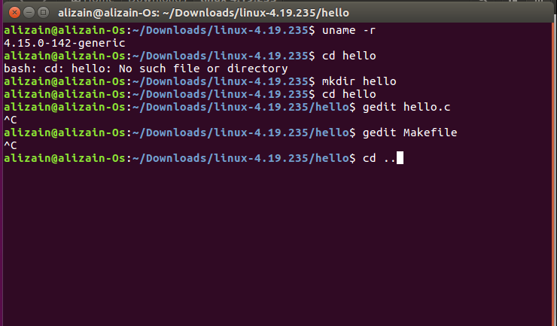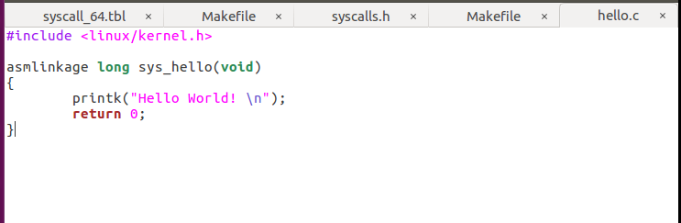

Step #3:

* Adding sys_hello in syscall_64.tbl at line 335
* Function prototype in syscalls.h
* Adding hello folder in core-y

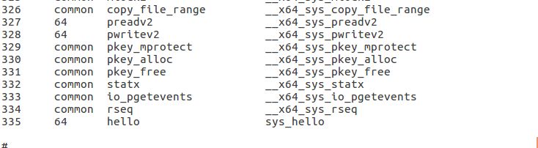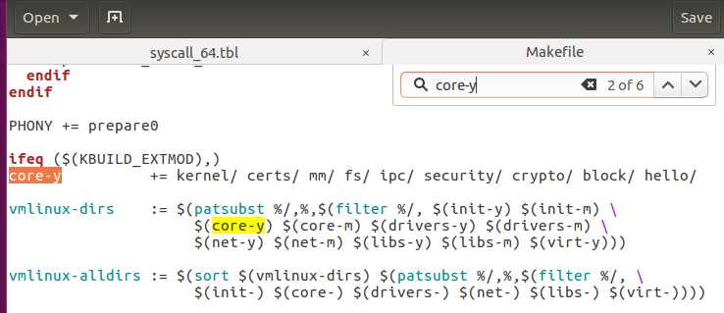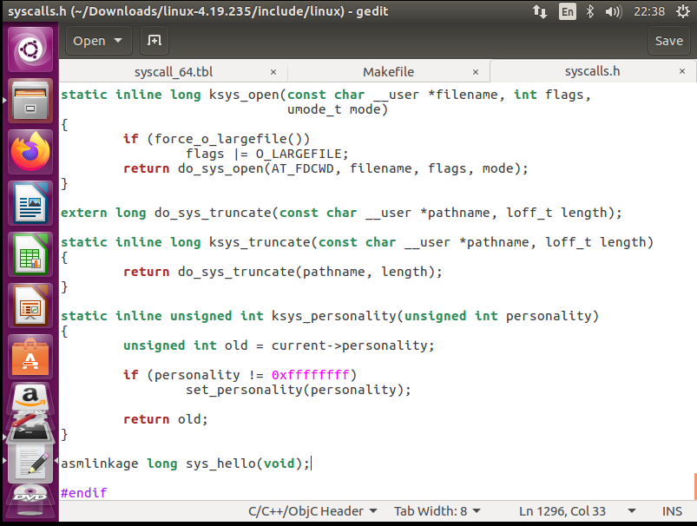

Step #4:

* Creating Config file
* Cleaning the Kernel
* Compiling the kernel
* Installing modules

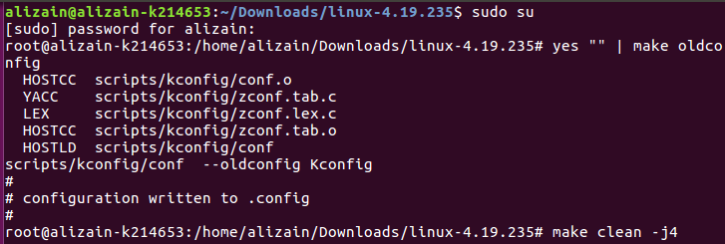

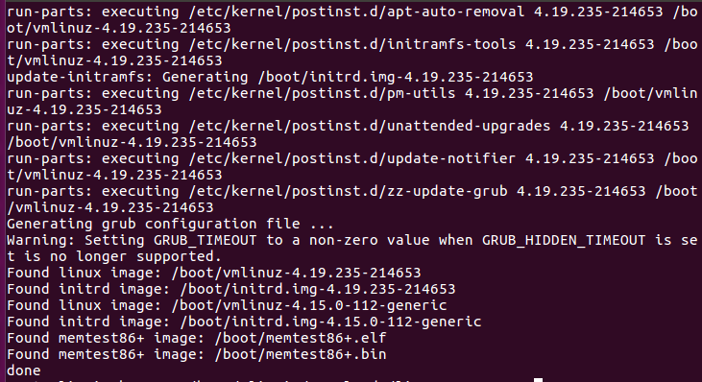

Step #5:

New Kernel Check

