**Case Study: Monitoring via EVM**

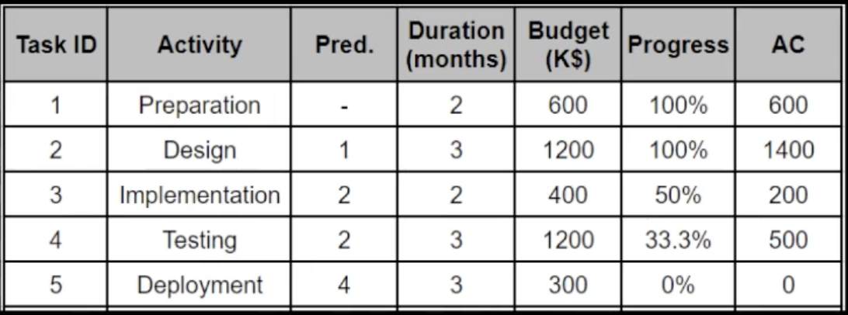

By how much is it over/under budget ?

it is over budget by 300.4

By how many days is it ahead/behind the schedule ?

behind by 3 months

By the end of the project how much will it be over/under budget ?

(planned value)3700-(EAC)4447.74= -747.74

(BAC)3949.6-(EAC)4447.74= -498.14

Calculate:

EV(Earned value): Progress % X Budget => (600)+(1200)+(400x0.5)+(1200x0.333)=2399.6

BAC(budget at completion) => (600) + (1400) + (400) + (500/0.667)+(500) + 300 = 3949.6

CV(cost variance): EV - AC => 2399.6 - 2700 = -300.4 => over budget -ve

SV(schedule variance): EV - PV(planned value) => 2399.6 - 3700 = -1300.4 => behind schedule -ve

CPI: EV/AC => 2399.6 / 2700 = 0.888

SPI:EV/PV= 2399.6/3700= 0.648

EAC(Estimated at completion):BAC/CPI= 3949.6/0.888 = 4447.74 AED