Assignment 2 — Technical Analysis Using R, Preliminary Stage
Student: Alia GhahremaniTabrizi
Course: BDA400 — Data Science Tools and Techniques
Institution: CDI College
Submission: Assignment 02 (A02)
GitHub: https://github.com/AliaTabrizi-lab/TechnicalAnalysis/tree/main/Assignment02

1. Objective and project overview
This preliminary stage established a technical-analysis workspace in RStudio, organized a five-stock portfolio, retrieved market data, calculated descriptive statistics, generated 20-day simple moving average (SMA) charts, and published the project files in GitHub. The portfolio contains AAPL, MSFT, GOOGL, AMZN, and NVDA.

2. GitHub repository setup
The public TechnicalAnalysis repository was created under AliaTabrizi-lab. The Assignment02 subfolder holds the assignment README, two R scripts, portfolio.txt, Stock_Statistics.csv, and five stock-chart PNG files. The screenshot below verifies the uploaded file listing and the assignment README.
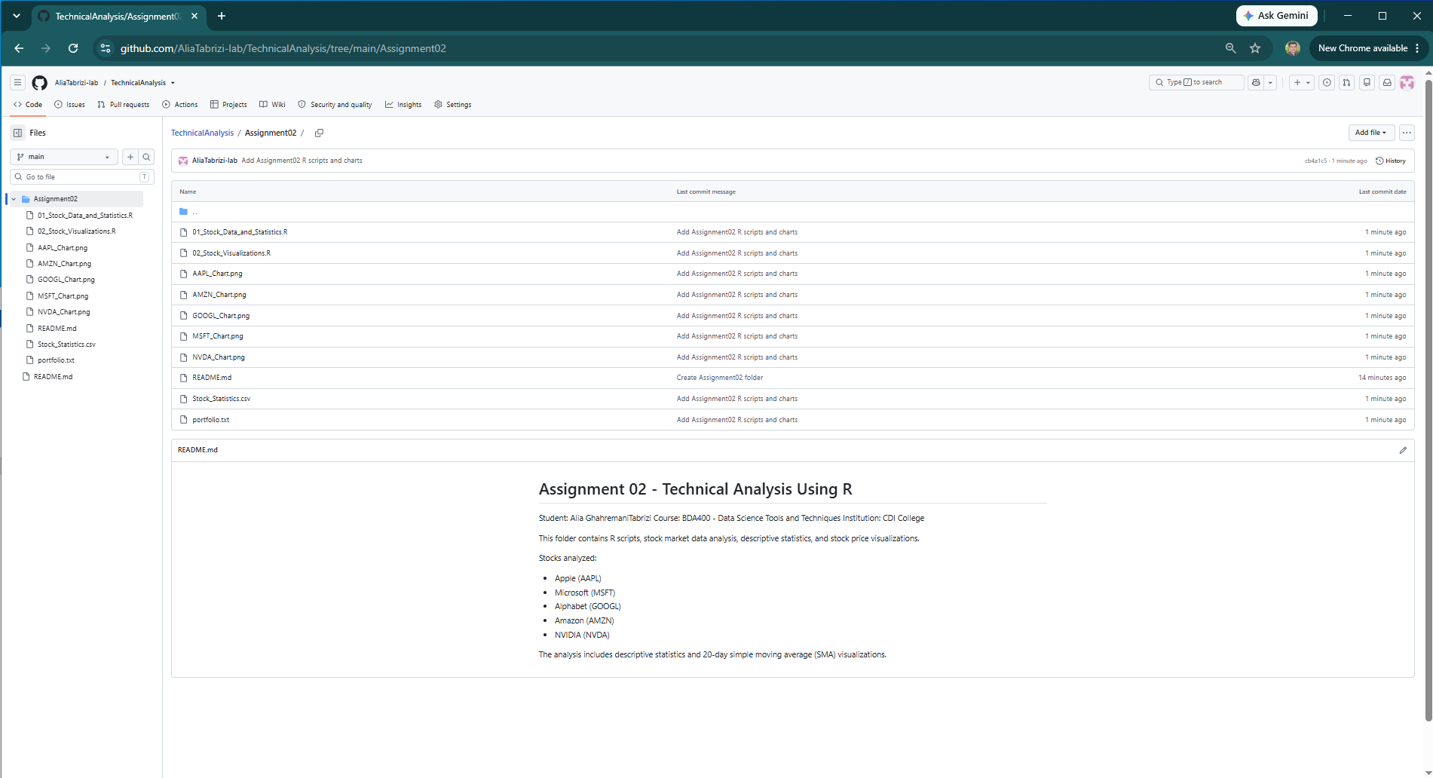
Figure 1. GitHub Assignment02 folder with all 10 files and README.

3. R and RStudio environment
RStudio was used on Windows with R 4.6.1, as visible in the Console. The screenshots demonstrate an operating R installation and an active RStudio environment. Original installer-wizard screenshots were not captured in the evidence provided; therefore, the installation sequence itself cannot be independently documented step by step.
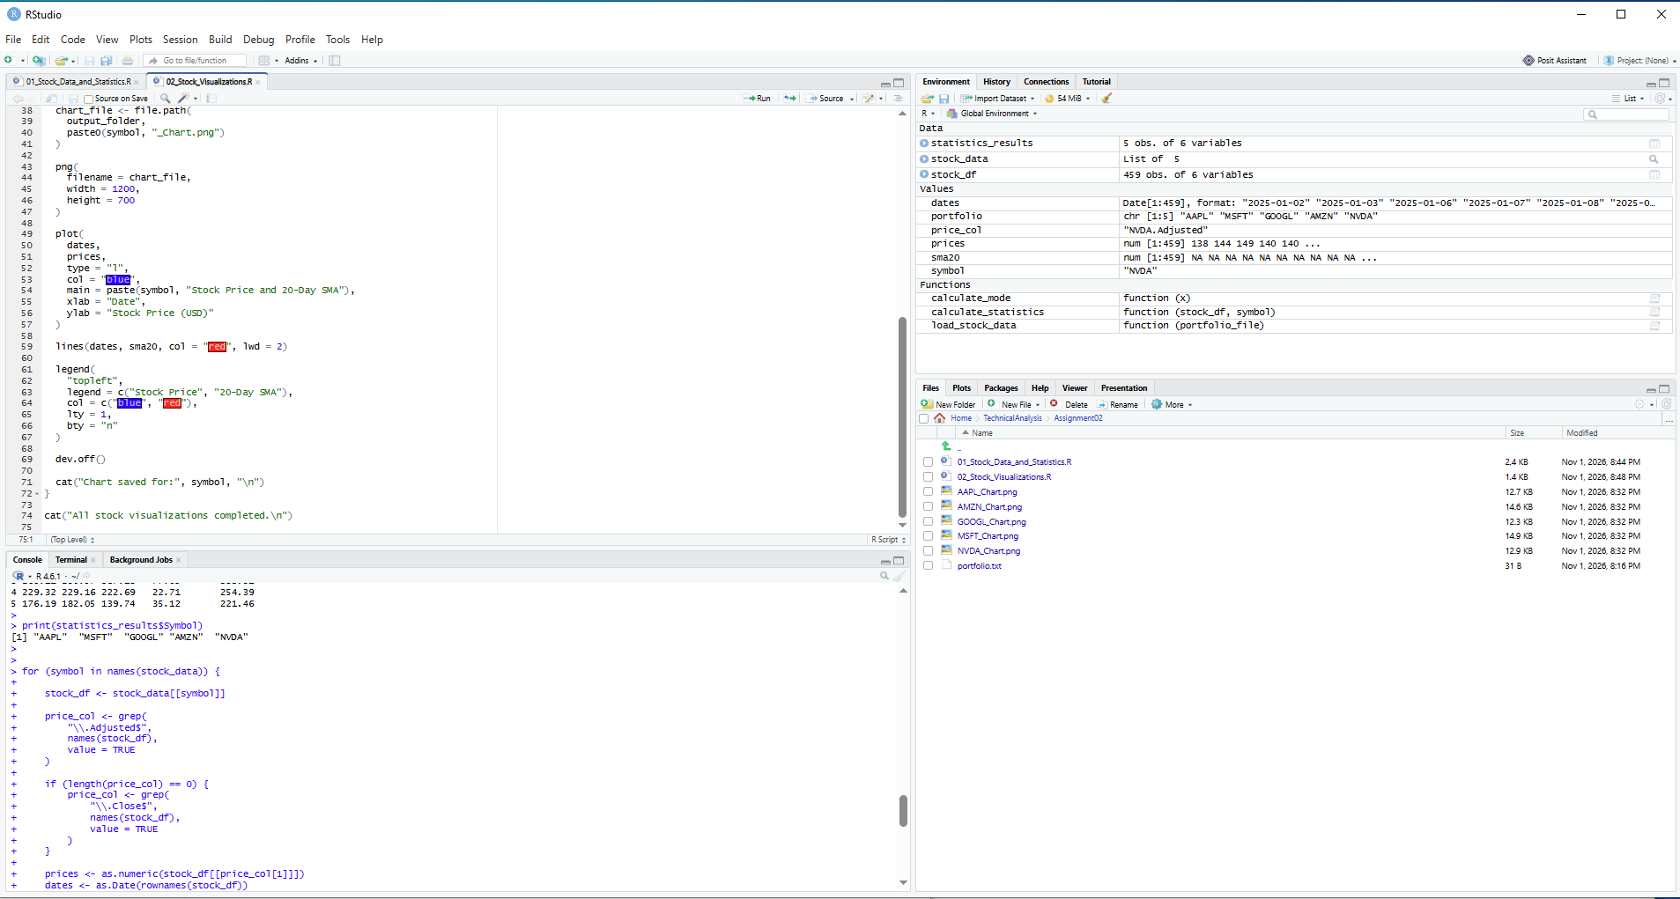
Figure 2. RStudio environment and saved project scripts.

4. R packages and configuration
The R code uses quantmod to obtain stock prices from Yahoo Finance and TTR to compute a 20-day simple moving average. Execution and chart generation indicate the necessary package functionality was available. A separate screenshot of install.packages() installation output was not provided.
The portfolio.txt file lists five symbols: AAPL, MSFT, GOOGL, AMZN, NVDA. The script reads the file, loops through each symbol, retrieves price history and stores each stock in a separate data frame within a named list.
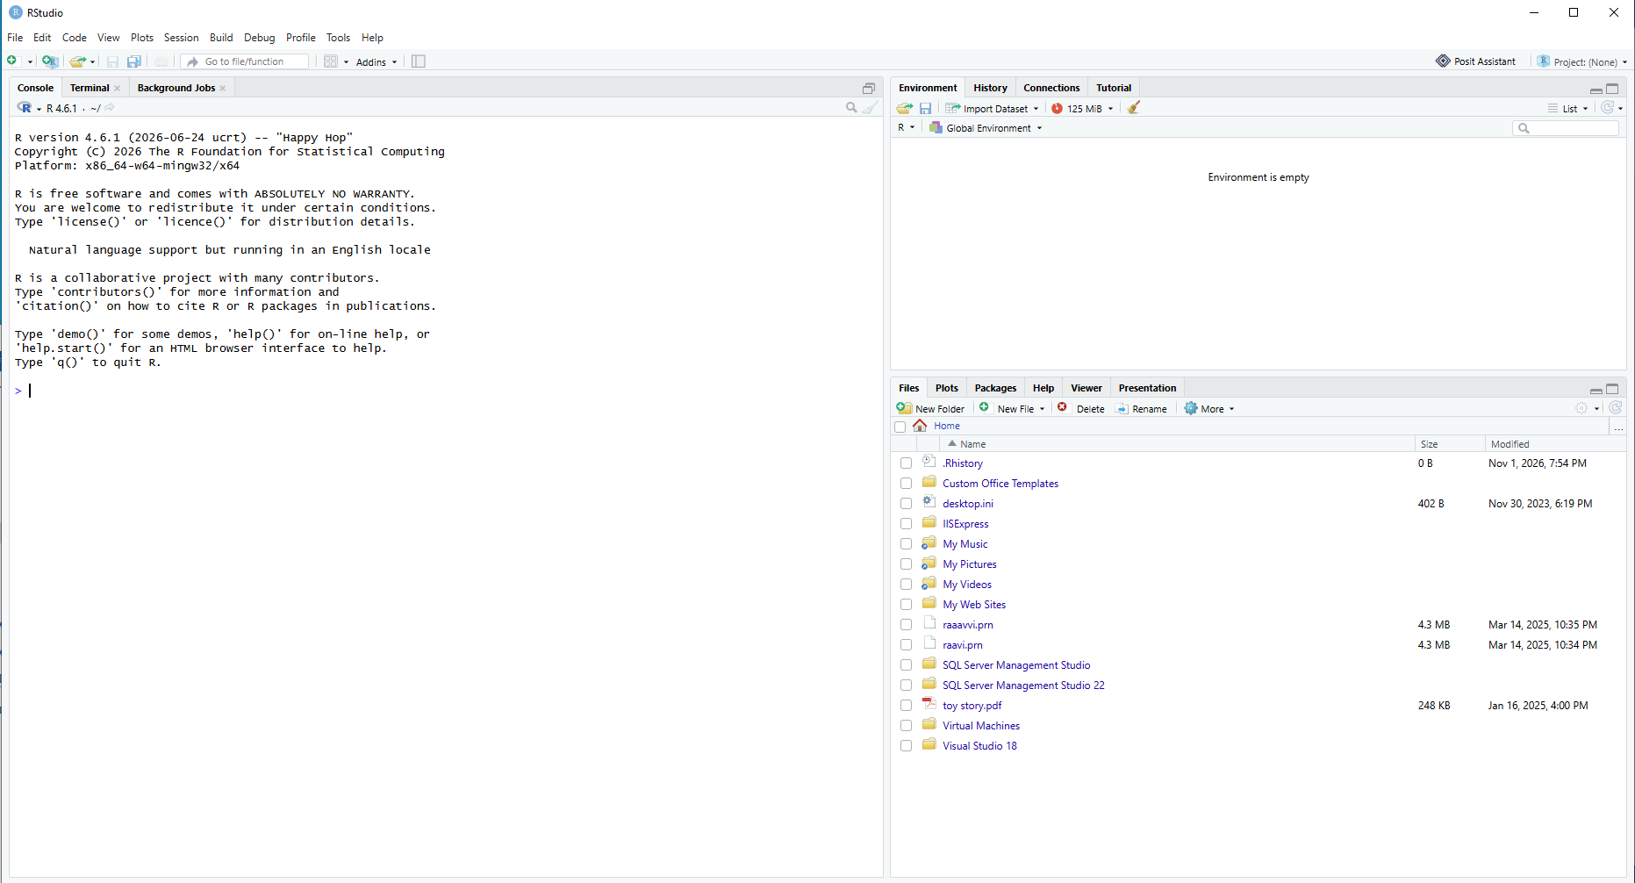
Figure 3. Portfolio file and successful import of five stock datasets (459 rows each).

5. Stock-data import and descriptive statistics
The calculate_statistics function identifies an Adjusted price column (or Close as fallback), converts prices to numeric, removes missing observations, and calculates mean, median, mode, standard deviation and the latest 20-day SMA. The mode is defined as the most frequent observed numeric price; for continuously valued prices it may not be economically meaningful.
Stock | Mean | Median | Mode | Std. dev. | Latest SMA20
AAPL | 260.12 | 258.34 | 200.03 | 42.88 | 342.08
MSFT | 450.10 | 455.85 | 480.42 | 53.10 | 530.98
GOOGL | 269.11 | 290.57 | 387.18 | 77.05 | 333.91
AMZN | 229.32 | 229.16 | 222.69 | 22.71 | 254.39
NVDA | 176.19 | 182.05 | 139.74 | 35.12 | 221.46
Values above are rounded from the RStudio Console screenshot; they are not independent recalculations. The full-precision values are in Stock_Statistics.csv on GitHub.
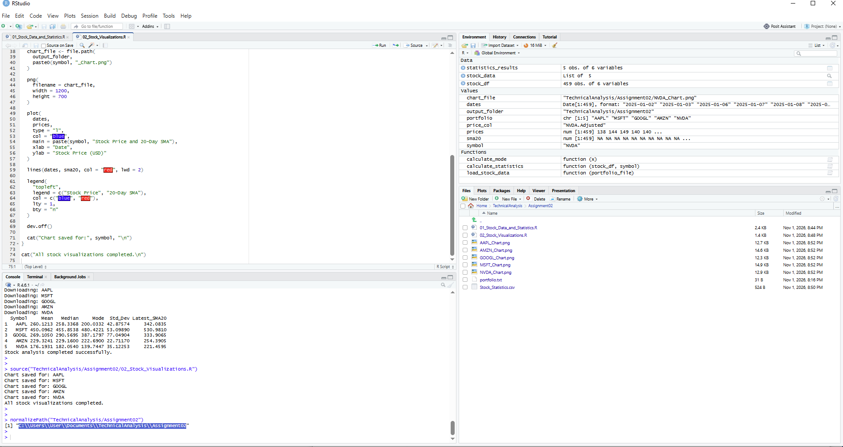
Figure 4. Successful source() execution, five-stock statistics output and completion message.

6. Visualization of stock prices and moving averages
The second R script creates a chart for each portfolio symbol. The blue series represents the stock price, and the red series shows the 20-day SMA. Each chart is saved as a PNG file in Assignment02. The console confirms all five chart files were saved successfully.
Figure 5. Console confirmation that five stock charts were saved.
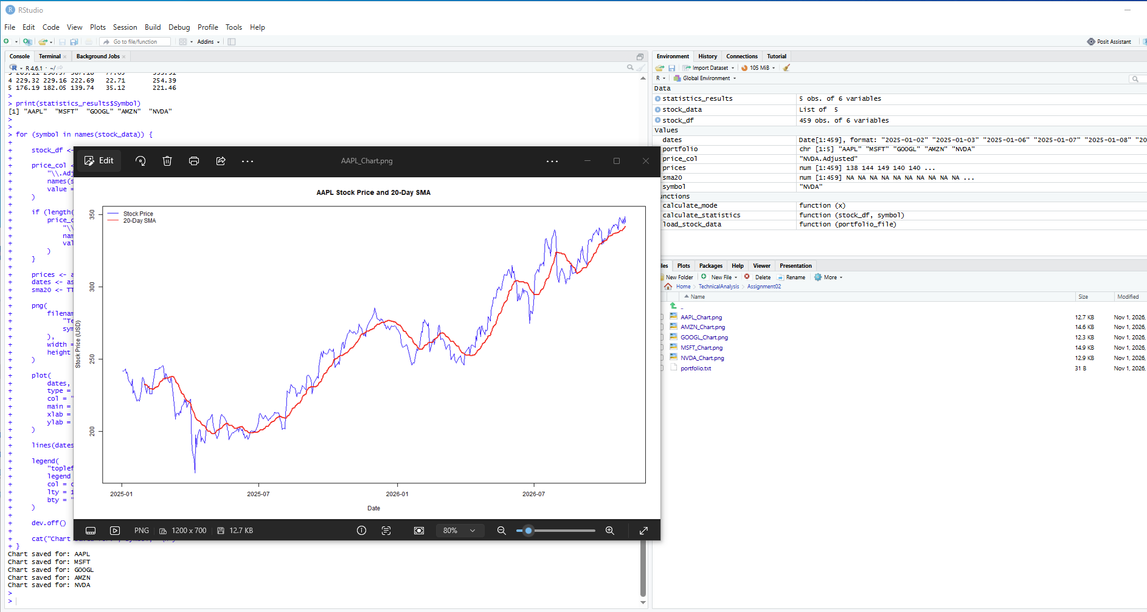
Figure 6. Example output: AAPL stock price and 20-day SMA.

7. Output files and reproducibility
The repository contains 01_Stock_Data_and_Statistics.R, 02_Stock_Visualizations.R, portfolio.txt, Stock_Statistics.csv, README.md and the five PNG charts. The source scripts use a relative TechnicalAnalysis/Assignment02 path; they should be run from the parent working directory in which that relative folder exists. Yahoo Finance data can change over time, so a fresh run may produce different statistics.

8. Reflection
This assignment helped me connect the basic steps of a data-analysis workflow: organizing the project, importing data, applying reusable functions, checking numerical output, and presenting trends in charts. The most useful lesson was that a script is easier to verify when its outputs are saved as separate files and the repository clearly explains their purpose. I also learned that a moving average smooths short-term price movements, but does not predict future stock performance.

Repository URL:
https://github.com/AliaTabrizi-lab/TechnicalAnalysis/tree/main/Assignment02

