Name: Aliaa Emad Ahmed Abd-El-Mtaleb Bata

الاسم:علياء عماد أحمد عبدالمطلب باطة

B.N:532

Topic: Programming languages

**Application Brief:**

In these days, computer becomes the first controller in the all world. Therefore, we should ask ourselves why is programming important in this age? Billions of people are actually using internet as a part of their daily life. Wherever you are, you need to be connected to the internet. In school, in working sites, and even in streets, you need an incoming to the internet to be able to compete in the global economy. Because of the internet, global communication became possible. Global business is also targeting its success due to internet. Hence, we must know the answer to an important question, which is what is the importance of programming language? Programming language is significant because it defines the relationship, semantics and grammar which allow the programmers to effectively communicate with the machines that they program. Without the programs that the programmers create, telling computers and other technological devices what to do, they would exactly be doing nothing and none of us would be able to enjoy any of the prosperities of technology. We can find programs in everything, starting from video games to phone apps, and the products of that field grow. Moreover, we are moving towards a more technologically progressed world which means that the need for programmers will become bigger every year. Computer programs are basically group of written languages that computers understand. Those languages are combinations of regular English and mathematics. With a fairly high starting salary and in a field that is expanding at an exponential rate, learning how to program and work as a programmer seems to be a skill that will last for a very long time. Thus, we all should know the importance of programming in our life as it has helped us a lot under the corona pandemic and it proves its importance in these days.

**Screen shots:**

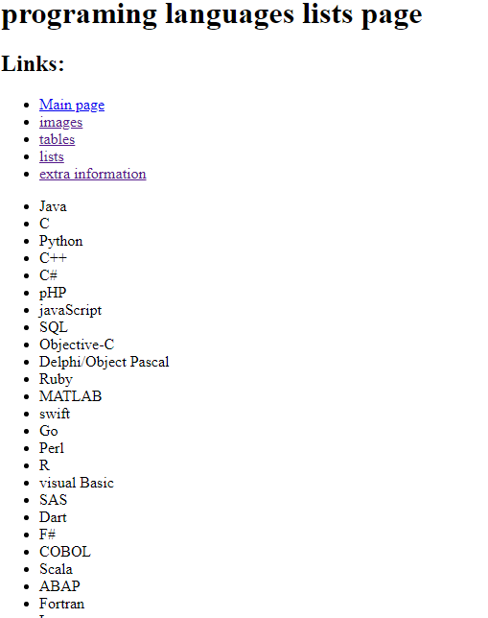

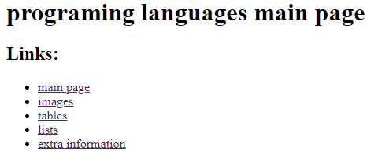

**Source code:**

