Database Design Document

# Introduction

This document is going to expand the attributes and components of the ThinkCube busines model. The business model consists of the management of product orders and shipping for customers.

# Assumption and Constraints

A staff member can handle many invoices

1. An invoice is handled by only one staff member
2. A shipment can have many invoices
3. An invoice can be shipped once
4. The customer can have multiple invoices
5. An invoice only has one customer
6. An invoice can have many products listed
7. A product can belong to many invoices
8. A customer can purchase many products
9. A product can be sold to many customers according to its inventory
10. A staff member can ship many products
11. A product can be shipped by only one staff member
12. An invoice can only ship once
13. A shipment can have many invoices
14. A customer and both send and receive invoices
15. A staff member can handle many invoices
16. A customer can be a sender or receiver

# Identified Issues

The relationship between the staff and products could be eliminated and presented through the invoice table.

Payment terms is ambiguous, could represent the time needed to pay the invoice or the salesperson.

# Personnel

Identify who is working on the project, responsibilities, etc. Example jobs below. It is possible to be more than one of these.

* Analyst: Aliab/ Ajith/ Ayham
* Architect: Ajith
* Quality Assurance: Aliab/ Ajith/ Ayham
* Documentation Specialist: Aliab/ Ajith

# Entities

Database Name: ThinkCube Revision: Ajith / Aliab/ Ayham

Date: 8/1/2020

Author: Aliab

|  |  |  |
| --- | --- | --- |
| Entity Name | Entity Type | Relates to |
| customer | Table | invoice |
| shipment | Table | invoice |
| staff | Table | invoice |
| invoice | Table |  |
| product | Table | staff |
| order | Table | invoice |
|  |  |  |
|  |  |  |
|  |  |  |

Notes:

The relationship shown is centred around the invoice table. The assumption made is that the invoice table is the focal point for all service happening to the ThinkCube database.

# Entity Details

## Fields form – < Customer >

Database Name: ThinkCube Revision: Ajith / Aliab/ Ayham

Entity Name: customer Date: 8/1/2020

Author: Aliab

|  |  |  |  |
| --- | --- | --- | --- |
| Field Name | Data type | Field Properties | Relates to |
| id | CHAR (10) | PRIMARY KEY, NOT NULL |  |
| name | VARCHAR (20) | NOT NULL | id |
| address | VARCHAR (60) | NOT NULL | id |
| phone | VARCHAR (60) | NOT NULL | id |
| work | VARCHAR (10) | NOT NULL | id |
| type | VARCHAR (10) | NOT NULL | id |
|  |  |  |  |
|  |  |  |  |
|  |  |  |  |
|  |  |  |  |
|  |  |  |  |
|  |  |  |  |

Notes: 

-Work: Receiver/ sender’s business.

-Type: type of customer, a sender or a receiver.

-Address: involves the street name & number, postal code, city, provincial code.

## Fields form – < Shipment >

Database Name: ThinkCube Revision: Ajith / Aliab/ Ayham

Entity Name: shipment Date: 8/1/2020

Author: Ajith

|  |  |  |  |
| --- | --- | --- | --- |
| Field Name | Data type | Field Properties | Relates to |
| method | VARCHAR (40) | NOT NULL | id |
| term | CHAR (6) | NOT NULL | id |
| id | CHAR (10) | PRIMARY KEY, NOT NULL |  |
|  |  |  |  |
|  |  |  |  |
|  |  |  |  |
|  |  |  |  |
|  |  |  |  |
|  |  |  |  |
|  |  |  |  |
|  |  |  |  |
|  |  |  |  |

Notes:

-Method: Shipping method used, Fed Ex, etc…

-Term: Shipping terms.

## Fields form – < Staff >

Database Name: ThinkCube Revision: Ajit / Aliab/ Ayham

Entity Name: staff Date: 8/1/2020

Author: Ayham

|  |  |  |  |
| --- | --- | --- | --- |
| Field Name | Data type | Field Properties | Relates to |
| id | CHAR (6) | PRIMARY KEY, NOT NULL | invoice |
| name | VARCHAR (20) | NOT NULL | id |
| job | VARCHAR (20) | CAN BE NULL | id |
|  |  |  |  |
|  |  |  |  |
|  |  |  |  |
|  |  |  |  |
|  |  |  |  |
|  |  |  |  |
|  |  |  |  |
|  |  |  |  |
|  |  |  |  |

Notes:

## Fields form – < Invoice >

Database Name: ThinkCube Revision: Ajit / Aliab/ Ayham

Entity Name: invoice Date: 8/1/2020

Author: Ajith

|  |  |  |  |
| --- | --- | --- | --- |
| Field Name | Data type | Field Properties | Relates to |
| invoice_date | DATE | NOT NULL |  |
| id | CHAR (10) | PRIMARY KEY, NOT NULL |  |
| company | VARCHAR (20) | NOT NULL |  |
| address | VARCHAR (60) | NOT NULL |  |
| phone | VARCHAR (16) | NOT NULL |  |
| fax | VARCHAR (16) | NOT NULL |  |
| email | VARCHAR (20) | NOT NULL |  |
| cust_c_id | CHAR (10) | FOREIGN KEY, NOT NULL | customer |
| staff_id | CHAR (6) | FOREIGN KEY, NOT NULL | staff |
| ship_id | CHAR (10) | FOREIGN KEY, NOT NULL | shipment |
|  |  |  |  |
|  |  |  |  |

Notes:

-Invoice_date: Date the invoice was created

## Fields form – < product >

Database Name: ThinkCube Revision: Ajit / Aliab/ Ayham

Entity Name: product Date: 8/1/2020

Author: Ajith

|  |  |  |  |
| --- | --- | --- | --- |
| Field Name | Data type | Field Properties | Relates to |
| id | CHAR (6) | PRIMARY KEY, NOT NULL |  |
| staff_id | CHAR (6) | FOREIGN KEY, NOT NULL | staff |
| description | VARCHAR (20) | NOT NULL | id |
| unit_price | DECIMAL (10,2) | NOT NULL | id |
| discount | CHAR (10) | NOT NULL | id |
|  |  |  |  |
|  |  |  |  |
|  |  |  |  |
|  |  |  |  |
|  |  |  |  |
|  |  |  |  |
|  |  |  |  |

Notes:

-Discount: if there is no discount, set to 0.

## Fields form – < Order >

Database Name: ThinkCube Revision: Ajith / Aliab

Entity Name: order Date: 8/1/2020

Author: Ajith

|  |  |  |  |
| --- | --- | --- | --- |
| Field Name | Data type | Field Properties | Relates to |
| id | CHAR (10) | PRIMARY KEY, NOT NULL |  |
| invoice_id | CHAR (10) | FOREIGN KEY, NOT NULL | invoice |
| del_date | DATE | NOT NULL | id |
| payment_term | VARCHAR (20) | NOT NULL | id |
| due_date | DATE | NOT NULL | id |
|  |  |  |  |
|  |  |  |  |
|  |  |  |  |
|  |  |  |  |
|  |  |  |  |
|  |  |  |  |
|  |  |  |  |

Notes:

-Del_date: Delivery date

-Due_date: Deadline for order fees.

# Basic ERD

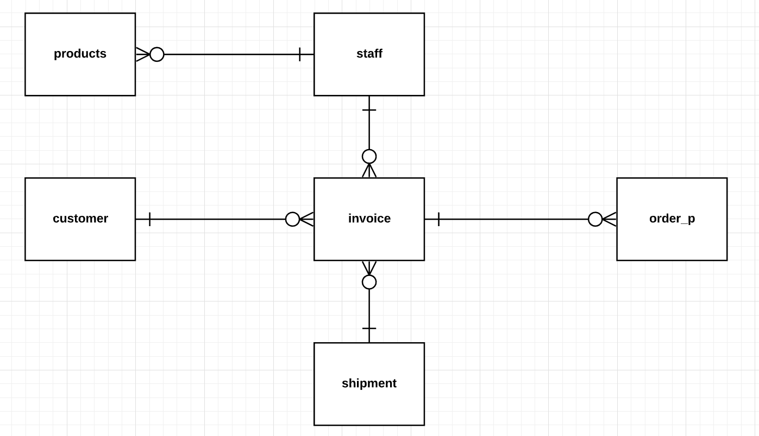

Table 1. Logical ERD of ThinkCube Database

# Physical ERD

Table 2: Physical ERD of ThinkCube Database