

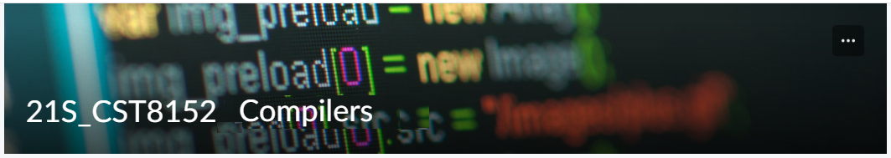

MODEL TASK FOR ASSIGNMENT 2.1 – ApouC Compiler

Team: Aliab Eman- Id: 041000420
/ Matt Vecchio- Id: 041004137

- Note: This task is part of the Assignment 2 from Compilers Course. Any problem, contact your lab professor.

PART 1: RE – Regular Expression (1.5 mark)

Lexeme Classes: Define the classes to be used in your regular expression:

Answer:
- L = [A-Za-Z] (Letters)
- D = [0-9] (Digits)
- SQ = ‘ (Single-Line Delimitator- single quotes)
- Q = “ (Single Line Delimitator -double quotes)
- LC = /* (Multi-Line comment left brace)
- RC = */ (Multi-line comment right brace)
- SLC = # (Single line comment) **
- P = . (Period for Floating Point Numbers)
- E = e (Exponential for Scientific Notation) ***
- S = +|- (Sign for Scientific Notation) ***
- U = _ (Underscore)
- OP = ( (Open Parenthesis for MNID)
- CP = ) (Close Parenthesis for MNID)
- O = [^LDSQQLCRCSLCPESUOPCP] (Other chars)

Define the RE to be used for: variables, literals and keywords:

Answer:

* Variables:
Int
Float
String
Char
* Literals:
Integer Literal (IL):
IL = DD*
Floating Point Literal (FL):
FL = DD*PD* | ((D*|D*PD*)E(S)D*)
String Literal (SL):
SL = Q(^Q)*Q
Character Literal (CL):
CL = SQ(^SQLCRC)¹SQ
Multi-Line Comment (MLC):
MLC= LC(^RC)RC
Single-Line Comment (SLC):
SLC = SC(^EOL)

* Keywords:
def, global, if, elif, else, int, char, string, float, return, break

PART 2: TD – Transition Diagram (1.5 marks)

Activity: Starting from the previous lexeme classes and obeying the RE, it is possible to define the automata for your language:

Answer (draw / copy image of the automata):

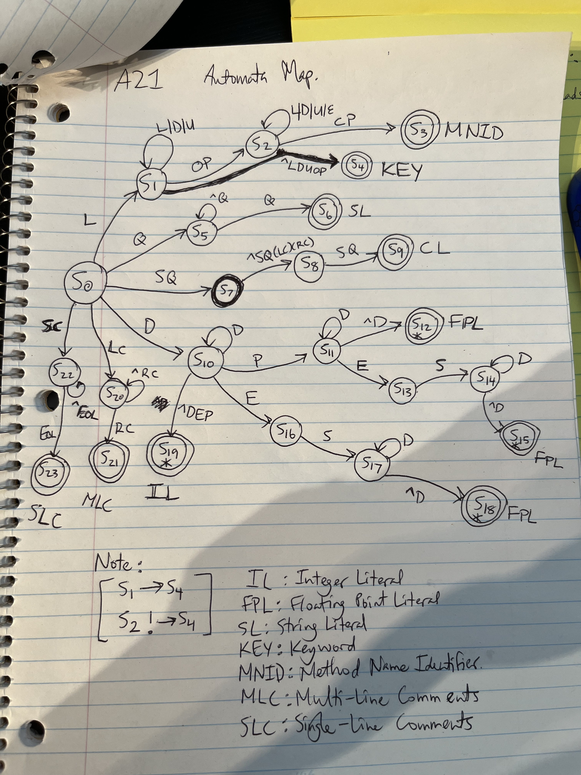

PART 3: TT – Transition Table (2 marks)

Activity: Now, it is possible to define the TT for these lexemes:

Answer (Transition Table):
Attached in an Excel Sheet

Update: Oct 2nd 2022.

Adapted from resources developed by Prof. Svillen Ranev (Algonquin College, 2019)

