*Aliab Eman*

*Algonquin College | Computer Engineering Technology –Computing Science*

*A11- Assignment 11*

*CST8221-302*

*Presented to: Professor Paulo Sousa*

**Explanation**

Assignment 11 will serve as the template necessary for me to begin to brainstorm how to approach the creation of my own style of the game “NumPuz”. My understanding of the game is that we need to be able to arrange our numbered elements from the smallest to largest element based on the dimensions of the game we allow the user to play.

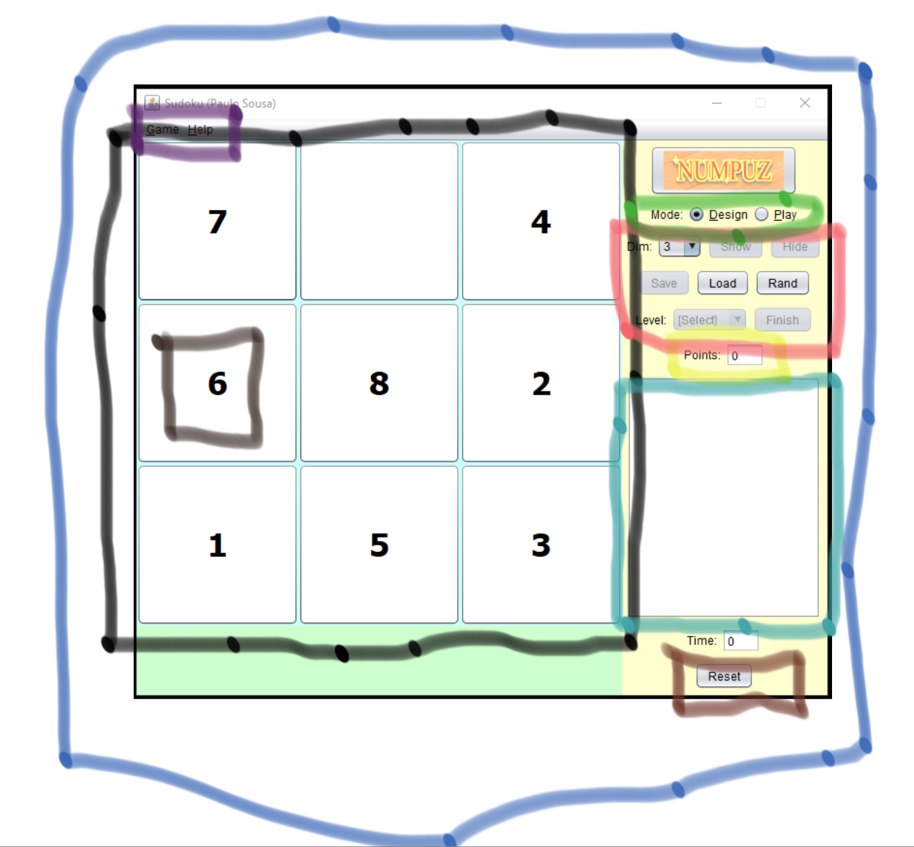

**Figure 1. Dissecting Professor’s NumPuz Design into potential components**

**My Hypothesis on the Highlighted Areas**

Blue Component:

Purple Component:

Black Component:

Green Components:

Pink Components:

Yellow Component:

Teal Component:

Brown Component:

Dimensions:

I would like for my game to have

-Panel to contain the entire game

-components

-methods to invoke

-list of sequence of steps

-How will we allow for an arrangement of elements within a resizable grid.

-How do I want to move elements within my grid

-Options:

Move-By -Click:

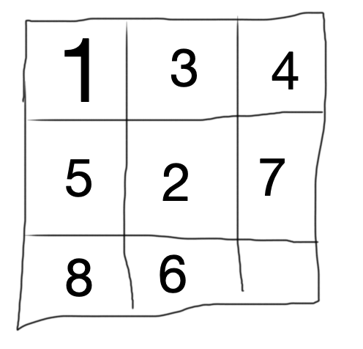

1. Click to select the element you wish to reposition to the empty square
2. Constraints to account for:
   1. Let position (x, y) be the location of the blank square
   2. Position changes must be within the grid that contains the numbered elements and the blank element
   3. Two numbered elements cannot switch positions
   4. In order to switch positions with the blank square, the element you select must either be at position

(x+1, y),(x-1, y),(x, y+1) or (x, y-1)

-Second-click is relative to the available “guide” that appears after the element is selected from its first click.

-When the second click is activated as an event, you can then switch the selected element with an element in the position it exists.

Drag and Drop:



-Click and hold onto the element you wish to move

-The element is allowed to be dragged in the 2D (x,y) plane by one position

References:

1. JavaFX Layout Panes. <https://www.tutorialspoint.com/javafx/javafx_layout_panes.htm>