*Team: Aliab Eman / 041-000-420*

*Algonquin College | Computer Engineering Technology –Computing Science*

*A11 Game interface*

*CST8221-302*

*Presented to: Professor Paulo Sousa*

**Explanation**

Assignment 11 will serve as the template necessary for me to brainstorm how to approach the creation of my own style of the game “NumPuz”. My understanding of the game is that we need to be able to arrange a disordered set of consecutive numbered elements from the smallest to largest number based on the dimensions of the game we allow the user to play.

**1.1. Defining the Components**

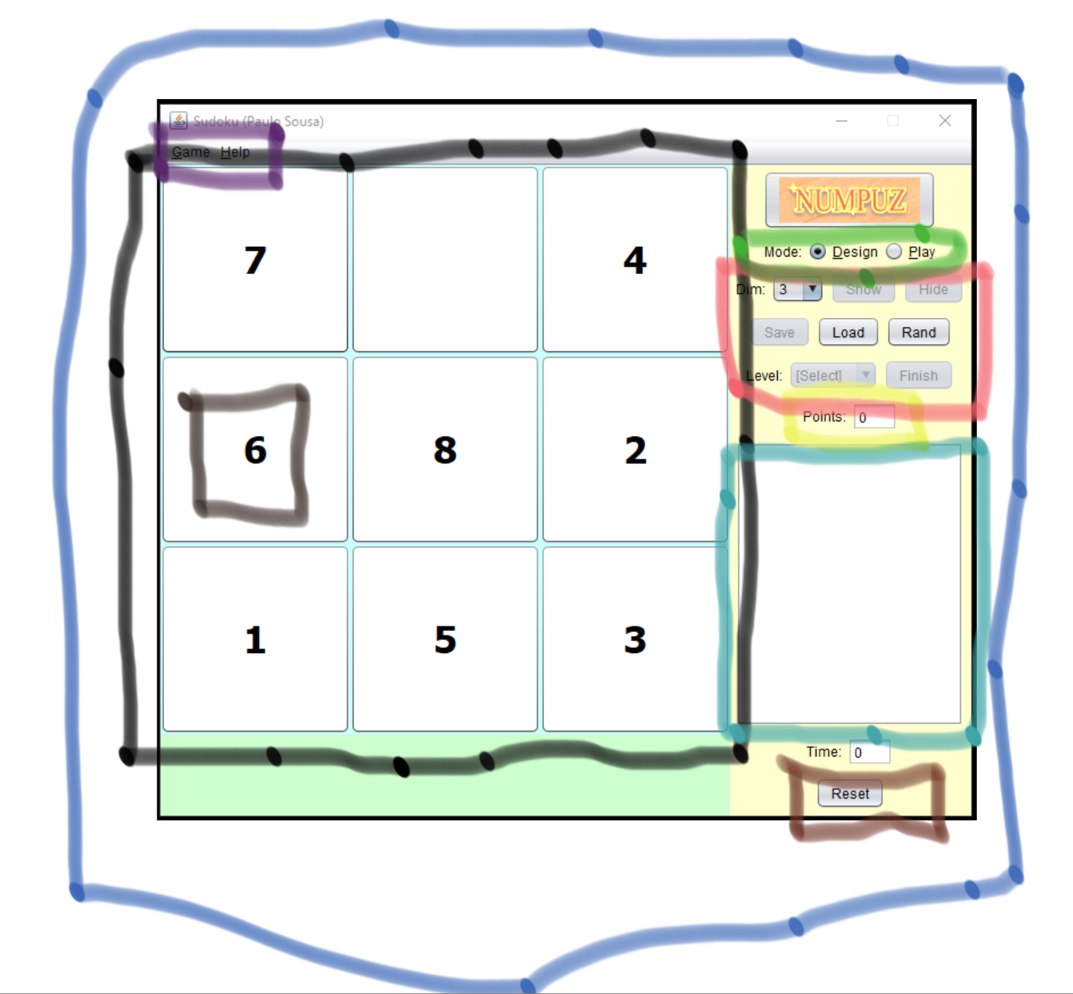

**Figure 1. Dissecting Professor’s NumPuz Design into potential components**

List of Components

JFrame:

-needs to hold a temporary start-up screen where the menu

JLabel:

JPanel:

JScrollPane:

JTextArea:

JTextField:

JCheckBox:

JButton:

Functionalities and Behaviors

**My Hypothesis on the Highlighted Regions**

Blue:

Purple:

Black:

Green:

Pink:

Yellow:

Teal:

Brown:

Dimensions:

I would like for my game to have

-Panel to contain the entire game

-components

-methods to invoke

-list of sequence of steps

**1.2. User Manual**

-How will we allow for an arrangement of elements within a resizable grid.

-How do I want to move elements within my grid

-Options:

Move-By -Click:

1. Click to select the element you wish to reposition to the empty square
2. Constraints to account for:
   1. Let position (x, y) be the location of the blank square
   2. Position changes must be within the grid that contains the numbered elements and the blank element
   3. Two numbered elements cannot switch positions
   4. In order to switch positions with the blank square, the element you select must either be at position

(x+1, y),(x-1, y),(x, y+1) or (x, y-1)

-Second-click is relative to the available “guide” that appears after the element is selected from its first click.

-When the second click is activated as an event, you can then switch the selected element with an element in the position it exists.

References:

1. JavaFX Layout Panes. <https://www.tutorialspoint.com/javafx/javafx_layout_panes.htm>