«jmf_ClientName»

Insurance Declaration

### «jmf_DateCreated»

<<+DISTCHOICE+ Distinctive.Choice.>>

Table of Contents

Header~Start|NoProfile|<<jmf_PolicyClass>>|Header~End

CONTENTS READ and APPROVED (Client Use Only):

Name:

Position:

Signed: Dated:

<<+DECINTRO+ Introduction - Declaration>>

<<+RECOVRE+ Recovre Preferred Provider Form>>

<<+CLIENTPROF+ Client Profile Description>>

<<+SANCT+ Sanctions>>

<<+DECLARINFO+ Fire & Security Protection Questionnaire>>

<<+STAMPDUTY+ NSW Stamp Duty Exemption Declaration>>

Start|PolicyGroup

# Header~Start|NoProfile|<<jmf_PolicyClass>>|Header~End

**Header~Start|NoProfile|Our Ref: <<jmf_PolicyNo>>|Header~End**

Header~Start|NoProfile|Insured: <<jmf_PolicyInsured>>|Header~End

Header~Start|NoProfile|Location: <<jmf_PolicySituation>>|Header~End

Header~Start|NoProfile|Underwriter: <<jmf_PolicyUwName>>|Header~End

Header~Start|NoProfile|UW Policy Number: <<jmf_PolicyUwRef>>|Header~End

Header~Start|NoProfile|Policy Inception: <<jmf_PolicyFrom>>|Header~End

Header~Start|NoProfile|Policy Expiry: <<jmf_PolicyExpiry>>|Header~End

<<+POLPRFNAME+ Policy Profile Description>>

<<+DECINTROCO+ Declaration Questionnaire Introduction>>

## Carefully check the information below, which currently applies, particularly limits, sub-limits and declared values. If any changes are required for the next insured period please indicate these by amending the Schedule.

## Schedule

**NOTE:** Where a coverage heading incorporates provision for an amount to be inserted (e.g. Sub-Limit) but no amount is recorded, no cover is provided under this policy.

<<+COVERSCOPE+ Scope of Cover>>

<<+SCHEDULE+ Schedule>>

<<+WORDCOND+ Policy Wording and Conditions>>

<<+ASSSCEINTR+ Asset Schedule Declaration Introduction>>

<<+ASSETSCH+ Asset Schedule>>

<<+WAGEROLL+ Wageroll>>

<<+QUESTIONS+ Questionnaire>>

**UNREPORTED CLAIMS** After reasonable enquiry by you are there any claims or incidents/circumstances which could give rise to a claim which have not been reported to us or any insurer?

Yes / No

If yes, please provide details.

End|PolicyGroup

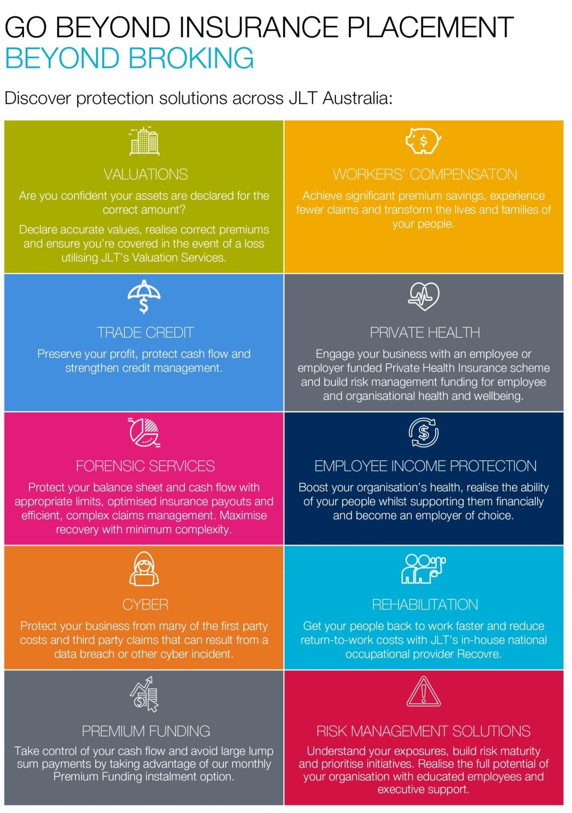

<<+UNINSRISK+ Uninsured Risks>>

<<+JLTCONTACT+ JLT Contacts>>

<<+PRIVACY+ Privacy Act>>

<<+IMPORTINFO+ Important Information>>

<<+COPYRIGHT+ Copyright>>

**CONTACTS**

«jmf_Broker1Name»

«jmf_Broker1Title»

Tel «jmf_Broker1DirDial»

Mob «jmf_Broker1Mobile»

«jmf_Broker1Email»

«jmf_Broker2Name»

«jmf_Broker2Title»

Tel «jmf_Broker2DirDial»

Mob «jmf_Broker2Mobile»

«jmf_Broker2Email»



**«jmf_BranchTeamLetterHeadName1»**

«jmf_BranchTeamLetterHeadPrep1»

**«jmf_BranchTeamLetterHeadName2»**

«jmf_BranchTeamLetterHeadABN»

«jmf_BranchTeamLetterHeadPrep2»

**«jmf_BranchTeamLetterHeadName3»**

«jmf_BranchTeamLetterHeadParentABNACN»

«jmf_BranchTeamLetterHeadBlock»

«jmf_BranchTeamLetterHeadBlock2»

«jmf_BranchTeamLetterHeadBlock3»

A member of the Jardine Lloyd Thompson Group.