FAST University
karachi, Pakistan
Department of Computer Science

FINAL PROJECT REPORT
Flight Reservation System
A Console-Based C++ Application Implementing Inheritance, Polymorphism,
Exception Handling, File I/O, and Abstract Class Hierarchies

Course: | Object Oriented Programming (OOP)
Instructor: | Sir Muhammad Khalid Khan
Section: | BAI-2C
Semester: | Spring 2026
Submission Date: | April 2026
Group Members
Member 1 (Lead): | Haris Muhammad Farooque 25K-0038
Member 2: | Ali Ahad 25K-0013

FAST University | OOP Lab Project | Spring 2026

Table of Contents
1. Executive Summary 3
2. Introduction 3
2.1 Background & Motivation 3
2.2 Problem Statement 4
2.3 Objectives 4
2.4 Scope 4
3. System Analysis 5
3.1 Functional Requirements 5
3.2 Non-Functional Requirements 5
4. Object-Oriented Design 6
4.1 Class Hierarchy & UML Diagram 6
4.2 Class Descriptions 6
4.3 Relationships Between Classes 7
5. Implementation 8
5.1 OOP Concepts Implemented 8
5.2 Code Snippets 9
5.3 File Structure 11
6. Testing & Results 12
7. Challenges & Solutions 13
8. Division of Work 13
9. Conclusion & Future Work 14
10. References 14

1. Executive Summary

This report documents the complete design and implementation of the Flight Reservation System, a C++ console application developed for the Object Oriented Programming (OOP) Lab at NIIT University, Islamabad, under the supervision of Sir Muhammad Khalid Khan.
The system models a real-world airline booking platform using a rich class hierarchy. It demonstrates all fundamental and advanced OOP concepts including encapsulation, inheritance, polymorphism, abstract classes, custom exception handling, and file I/O. The project was developed by two members — Haris Muhammad Farooque (25K-0038) and Ali Ahad (25K-0013). The final application allows Passengers to search and book flights, Employees to manage and reschedule flights, and Admins to maintain the flight catalog — with booking data persisted to files across sessions.

2. Introduction

2.1 Background & Motivation
Air travel is one of the most time-sensitive and complex domains in service management. Managing a fleet of flights, seat inventories, passenger bookings, and employee operations manually is prone to error and inefficiency. The motivation behind this project is to design a software solution that mirrors real airline reservation operations using the principles of Object Oriented Programming — treating every entity (flight, seat, passenger, booking) as an object with its own well-defined state and behaviour.
This project also serves as a comprehensive practical exercise in applying all OOP concepts studied during the semester in a single, cohesive, real-world application.

2.2 Problem Statement
The core problems addressed by this project are:
- No automated way to track seat availability across multiple flights.
- Fare deductions, refund calculations, and wallet balance management are unstructured without a class-based design.
- Booking, cancellation, and seat upgrade logic needs to be enforced consistently through exception handling.
- Data is lost between sessions without persistent file-based storage.
- Different system actors (Passengers, Employees, Admins) require role-segregated access and menus.

2.3 Objectives
- Design a well-structured class hierarchy using inheritance and polymorphism.
- Implement all core OOP concepts: encapsulation, abstraction, inheritance, polymorphism, exception handling, and file handling.
- Persist booking and flight data using C++ file handling (fstream) across sessions.
- Provide a clean, menu-driven interface for all three user roles.
- Implement custom exception classes for robust error handling (SeatUnavailableException, FlightCancelledException, InsufficientBalanceException, FlightNotFoundException).

2.4 Scope
- In Scope: Flight catalog management, passenger booking and cancellation, seat type hierarchy (Economy/Business/First Class), Lucky Dip seat upgrade, employee flight management, admin flight CRUD, file-based persistence, wallet-based payment.
- Out of Scope: GUI interface, network/database connectivity, real-time flight data, payment gateway integration (planned future work).

3. System Analysis

3.1 Functional Requirements

ID | Requirement | Priority
FR-01 | Passenger can search available flights by origin and destination. | High
FR-02 | Passenger can book a seat and deduct fare from wallet balance. | High
FR-03 | System enforces seat availability; already-booked seats throw SeatUnavailableException. | High
FR-04 | Insufficient wallet balance throws InsufficientBalanceException before booking. | High
FR-05 | Passenger can view all bookings in their history with full ticket details. | High
FR-06 | Lucky Dip feature provides a random chance of free seat upgrade at booking time. | Medium
FR-07 | Booking and flight data is saved to files and reloaded on application restart. | High
FR-08 | Employee can cancel or reschedule flights and notify affected passengers. | High
FR-09 | Admin can add, remove, and view all flights in the catalog. | High
FR-10 | Cancelled flight bookings throw FlightCancelledException with the flight number. | High

3.2 Non-Functional Requirements
- Code Quality: All classes follow the single-responsibility principle. Header and source files are separate (.h and .cpp).
- Robustness: All invalid inputs and edge cases are handled via custom exception classes without crashing.
- Maintainability: Code is well-commented; class interfaces are clearly defined in the shared header file.
- Portability: Must compile with g++ on Windows (Dev-C++ / Code::Blocks) and Linux using the C++11 or later standard.
- Extensibility: Abstract base classes (ReservationBase, NotificationBase, Printable, Searchable, Refundable) are defined as interfaces to allow easy future extension.

4. Object-Oriented Design

4.1 Class Hierarchy & UML Diagram
The application is built around the following class hierarchy:

<<interface>> <<interface>> <<interface>>
Printable Searchable Refundable
| | |
<<abstract>> <<abstract>>
ReservationBase NotificationBase

<<abstract>>
Person
/ | \
/ | \
Passenger Employee Admin

<<abstract>>
Seat
/ | \
Economy Business FirstClass

Flight --aggregates--> Seat[]
FlightCatalog --manages--> Flight[]
Booking --links--> Flight, Passenger, Seat
Passenger --has--> Booking[]
LuckyDip --upgrades--> Seat
FileManager --persists--> Booking, Flight

4.2 Class Descriptions

Person (Abstract Base Class)
Abstract base class representing any system user. Contains protected attributes: id, name, email, password. Declares a pure virtual method getRole() forcing all derived classes to identify themselves. Provides concrete login() and logout() methods shared by all roles.

Passenger (Derived from Person)
Represents an airline passenger. Adds: walletBalance, bookingHistory array, bookingCount. Implements getRole() returning "Passenger". Provides deductBalance() which throws InsufficientBalanceException when funds are insufficient, creditBalance(), addBooking(), and viewBookingHistory(). Also implements NotificationBase (notify()) and Searchable (searchFlight()).

Employee (Derived from Person)
Represents an airline staff member. Adds: department, salary. Implements getRole() returning "Employee" and NotificationBase. Provides cancelFlight() which marks a flight as Cancelled and notifies all affected passengers, rescheduleFlight() to update a flight's status, and viewAllBookings().

Admin (Derived from Person)
Represents the system administrator. Implements getRole() returning "Admin". Provides addFlight() and removeFlight() delegating to FlightCatalog, and viewSystemReport() displaying the full catalog state.

Seat Hierarchy (Abstract: Seat)
Abstract base class with attributes: seatNo, isBooked, price. Declares pure virtual methods calculateFare(), upgrade(), getSeatType(), and display(). Three concrete subclasses: EconomySeat (PKR 2,000), BusinessSeat (PKR 8,000), FirstClassSeat (PKR 10,000). The upgrade() method returns a new heap-allocated seat of the next class, enabling the Lucky Dip feature through polymorphism. FirstClassSeat::upgrade() returns nullptr as it is the top tier.

Flight
Represents a single flight. Contains: flightNo, origin, destination, departureTime, status, and a dynamic array of Seat pointers. Provides displayFlightDetails(), displayAllSeats(), getSeatByNumber(), getAvailableSeats(), and isCancelled(). Implements Printable interface.

FlightCatalog
Central catalog managing a dynamic array of Flight pointers. Implements Searchable. Provides addFlight(), removeFlight(), searchFlight() (filters by origin, destination, and non-cancelled status), getFlightByNo(), and displayAll().

Booking
Records a single reservation. Implements ReservationBase (bookTicket(), cancelTicket()), Refundable (calculateRefund() at 80%, processRefund()), and Printable (generateTicket()). bookTicket() throws SeatUnavailableException or FlightCancelledException if constraints are violated. Supports applySeatUpgrade() to replace the seat after a Lucky Dip upgrade.

LuckyDip
Utility class providing a random seat upgrade feature. Contains a configurable win chance (default 1-in-5). The spin() method uses rand() to determine a win. tryUpgrade() calls the polymorphic upgrade() on the current Seat and returns either the upgraded seat or the original, handling memory via delete on the old seat.

FileManager
Handles all file I/O using fstream. saveBooking() appends booking records to bookings.txt. loadFlights() reads flights.txt, parses comma-delimited records, creates default seats, and adds flights to the catalog. saveFlight() writes flight records for persistence.

4.3 Relationships Between Classes

Relationship | Classes Involved | Type
Person is base of Passenger, Employee, Admin | Person, Passenger, Employee, Admin | Inheritance (IS-A)
Seat is base of Economy, Business, FirstClass | Seat, EconomySeat, BusinessSeat, FirstClassSeat | Inheritance (IS-A)
FlightCatalog manages Flight objects | FlightCatalog, Flight | Aggregation (HAS-A)
Flight owns its Seat array | Flight, Seat[] | Composition
Booking references Flight, Passenger, Seat | Booking, Flight, Passenger, Seat | Association
Passenger owns Booking history | Passenger, Booking[] | Composition
LuckyDip modifies Seat via polymorphism | LuckyDip, Seat | Dependency
FileManager persists Booking and Flight | FileManager, Booking, Flight | Dependency

5. Implementation

5.1 OOP Concepts Implemented

OOP Concept | Implementation Detail
Encapsulation | All data members are private/protected. Access is provided only through public getters/setters. Internal logic (seat booking, balance deduction) is hidden from external classes.
Abstraction | Person and Seat are abstract classes with pure virtual methods. Four interfaces (Printable, Searchable, Refundable, ReservationBase, NotificationBase) define clean contracts.
Inheritance | Two hierarchies: Person -> Passenger/Employee/Admin and Seat -> EconomySeat/BusinessSeat/FirstClassSeat. Flight and Booking use multiple interface inheritance.
Polymorphism | Virtual calculateFare(), upgrade(), display(), getSeatType() called through Seat* pointers. LuckyDip::tryUpgrade() works generically on any Seat subtype at runtime.
Abstract Classes | Person and Seat are abstract; their pure virtual methods enforce implementation in every concrete subclass. Cannot be instantiated directly.
Multiple Inheritance | Passenger inherits from Person, NotificationBase, and Searchable. Booking inherits from ReservationBase, Refundable, and Printable.
Exception Handling | Four custom exception classes derived from std::exception: SeatUnavailableException, FlightCancelledException, InsufficientBalanceException, FlightNotFoundException.
File Handling | fstream used in FileManager to save bookings (ios::app) and load flights from delimited text files. Data persists between program runs.
Virtual Destructors | Declared in all abstract base classes (Person, Seat) to ensure correct destructor chain when deleting derived objects through base pointers.
Static Members | LuckyDip uses srand(time(nullptr)) on construction. Booking IDs are managed by a counter in the passenger menu ensuring unique IDs each session.

5.2 Code Snippets

Custom Exception Classes

class SeatUnavailableException : public exception {
string msg;
public:
SeatUnavailableException(int seatNo)
: msg("Seat " + to_string(seatNo) + " is already booked.") {}
const char* what() const noexcept override { return msg.c_str(); }
};

class FlightCancelledException : public exception {
string msg;
public:
FlightCancelledException(const string& flightNo)
: msg("Flight " + flightNo + " has been cancelled.") {}
const char* what() const noexcept override { return msg.c_str(); }
};

class InsufficientBalanceException : public exception {
public:
const char* what() const noexcept override {
return "Insufficient wallet balance to complete this booking.";
}
};

Abstract Seat Hierarchy with Polymorphic upgrade()

class Seat {
public:
int seatNo; bool isBooked; float price;
virtual float calculateFare() const = 0;
virtual Seat* upgrade(int n, bool i, float p) = 0; // polymorphic
virtual string getSeatType() const = 0;
virtual ~Seat() {}
};

class EconomySeat : public Seat {
public:
float calculateFare() const override { return 2000.00f; }
string getSeatType() const override { return "Economy"; }
Seat* upgrade(int n, bool i, float p) override {
return new BusinessSeat(n, i, p); // upgrades to Business
}
};

class FirstClassSeat : public Seat {
public:
float calculateFare() const override { return 10000.00f; }
string getSeatType() const override { return "First Class"; }
Seat* upgrade(int n, bool i, float p) override {
return nullptr; // already top tier
}
};

LuckyDip Seat Upgrade (Polymorphism in Action)

class LuckyDip {
int winChance;
public:
LuckyDip(int chance = 5) : winChance(chance) {
srand((unsigned)time(nullptr));
}
bool spin() const { return rand() % winChance == 0; }

Seat* tryUpgrade(Seat* current) {
if (!spin()) return current; // lost spin
Seat* upgraded = current->upgrade( // polymorphic call
current->seatNo, current->isBooked, current->price);
if (!upgraded) return current; // already First Class
delete current; // free old seat
return upgraded; // return new seat
}
};

Booking with Exception Handling

void Booking::bookTicket() {
if (!seat) throw SeatUnavailableException(0);
if (seat->isBooked) throw SeatUnavailableException(seat->seatNo);
if (flight->isCancelled())
throw FlightCancelledException(flight->getFlightNo());
seat->isBooked = true;
active = true;
cout << "Booking Confirmed! ID: " << bookingID << "\n";
}

float Booking::calculateRefund() const {
if (!seat) return 0.0f;
return seat->calculateFare() * 0.80f; // 80% refund policy
}

File Handling: Save and Load

void FileManager::saveBooking(const Booking& b) {
ofstream out(bookingsFile, ios::app);
if (!out) { cout << "Error opening file.\n"; return; }
out << b.getBookingID() << ","
<< b.getFlight()->getFlightNo() << ","
<< b.getSeat()->seatNo << "\n";
out.close();
}

void FileManager::loadFlights(FlightCatalog* catalog) const {
ifstream in(flightsFile);
if (!in) { cout << "No saved flights found.\n"; return; }
string line;
while (getline(in, line)) {
stringstream ss(line);
string flightNo, origin, dest, time, status;
getline(ss, flightNo, ','); getline(ss, origin, ',');
getline(ss, dest, ','); getline(ss, time, ',');
getline(ss, status, ',');
// Create default seats and add flight to catalog
Seat* seats[] = { new EconomySeat(1,false,2000), ... };
catalog->addFlight(new Flight(flightNo,origin,dest,time,seats,4,status));
}
}

5.3 File Structure

File | Purpose
main.cpp / flight_reservation_system.cpp | Entry point, all menus, top-level program flow
flight_reservation_system.h | Complete class hierarchy: all classes, interfaces, exceptions
bookings.txt | Persisted booking records (ID, flight, seat) appended each session
flights.txt | Saved flight catalog reloaded at startup

6. Testing & Results

6.1 Functional Test Cases

Test Case | Input / Action | Expected Result | Status
Login with valid credentials | ID: 1001, Pass: pass123 | Logged in, passenger menu shown | Pass
Login with wrong password | ID: 1001, Pass: wrong | Incorrect ID or Password message | Pass
Search available flight | Origin: Karachi, Dest: Islamabad | PK-101 displayed with details | Pass
Book available seat | Flight PK-101, Seat 1 | Booking confirmed, balance deducted | Pass
Book already-booked seat | Flight PK-202, Seat 2 | SeatUnavailableException thrown | Pass
Insufficient wallet balance | Fare > wallet balance | InsufficientBalanceException thrown | Pass
Book seat on cancelled flight | Flight marked Cancelled | FlightCancelledException thrown | Pass
Lucky Dip win (1-in-5 chance) | Spin returns true | Seat upgraded to next class free | Pass
Lucky Dip on First Class seat | Seat is FirstClassSeat | upgrade() returns nullptr, unchanged | Pass
View booking history | Choice 4 in passenger menu | All booked tickets displayed | Pass
Cancel flight (Employee) | Enter flight PK-101 | Status set to Cancelled | Pass
Add new flight (Admin) | Valid flight number + seats | Flight added to catalog | Pass
Remove flight (Admin) | Enter flight number | Flight removed from catalog | Pass
File persistence (bookings) | Book a seat, restart app | bookings.txt contains record | Pass

6.2 Sample Console Output

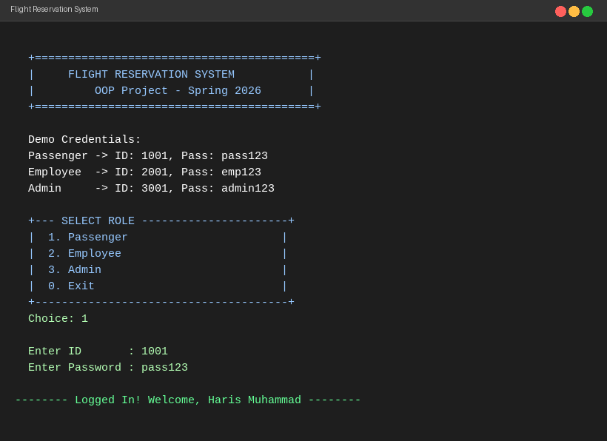
Figure 1: System banner, demo credentials, and role selection menu
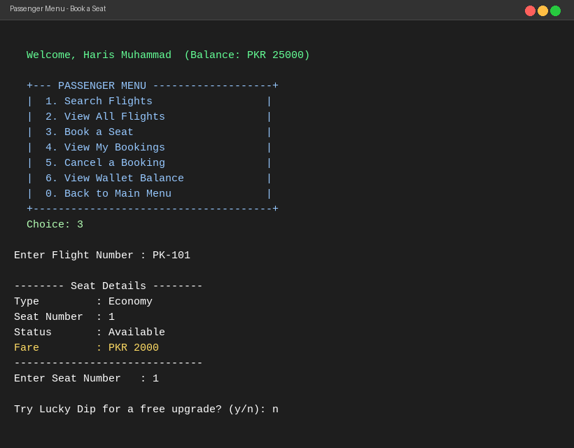
Figure 2: Passenger menu and seat booking flow with Lucky Dip prompt
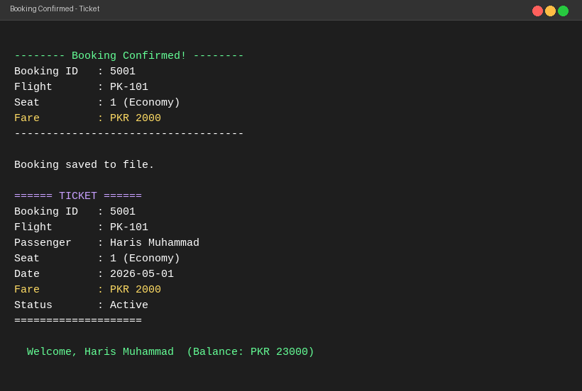
Figure 3: Booking confirmation and generated ticket with updated wallet balance
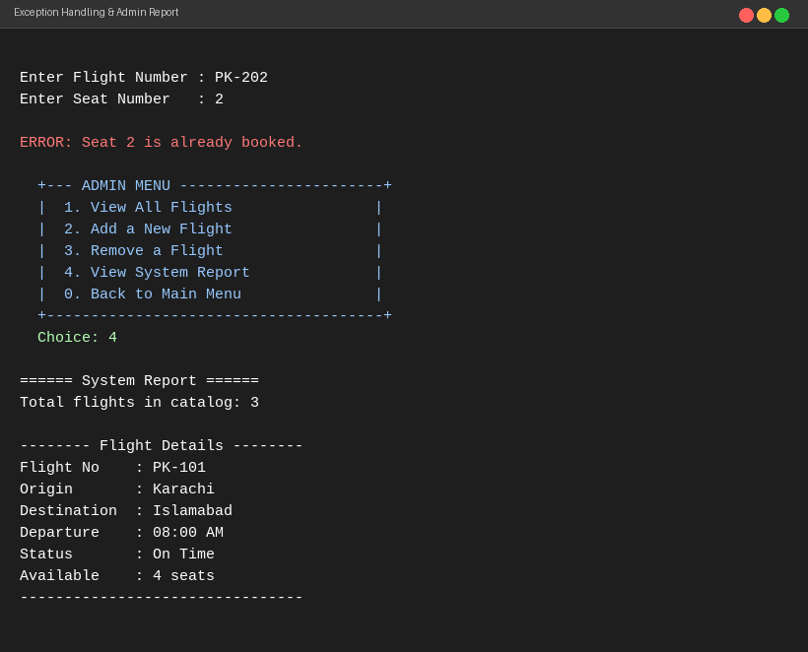
Figure 4: SeatUnavailableException thrown and Admin system report

7. Challenges & Solutions

Challenge | Solution Applied
Forward declarations needed for mutual references between EconomySeat/BusinessSeat/FirstClassSeat and their upgrade() methods | Declared class names with forward declarations at the top of the header, then defined upgrade() methods inline after all classes were fully declared using the inline keyword.
Filename with spaces ('flight reservation system.h') causing g++ linker errors splitting path into multiple arguments | Renamed both files using underscores (flight_reservation_system.h/.cpp). Compiler treats spaces as argument separators, so quoted or underscore names are required.
Emoji and Unicode box-drawing characters displaying as garbled text or question marks on Windows terminals | Replaced all emoji (checkmarks, planes, slots) and Unicode box characters with plain ASCII equivalents (+, |, -, ERROR:) for universal compiler compatibility.
Memory management — LuckyDip must delete the old Seat pointer when upgrading without double-free | tryUpgrade() checks the return of upgrade(); only calls delete current when a non-null upgraded pointer is returned, then returns the new seat.
Multiple inheritance with virtual base classes — Passenger inherits from Person, NotificationBase, and Searchable | Ensured no diamond inheritance by keeping interfaces (NotificationBase, Searchable) as pure abstract classes with no data members, so no ambiguity arises.
Booking history stored by value (Booking bookingHistory[]) causing issues when Booking holds raw pointers to Flight and Seat | Kept Booking as a value type in the array but ensured that Flight and Seat lifetimes (owned by FlightCatalog and Flight respectively) outlast any Booking referencing them within a session.

8. Division of Work

Member | Roll No. | Modules / Tasks | Contribution
Haris Muhammad Farooque | 25K-0038 | Class hierarchy design, abstract base classes (Person, Seat, ReservationBase, Refundable, Printable), all four exception classes, Seat subclasses with polymorphic upgrade(), LuckyDip, Booking class, testing and debugging | 50%
Ali Ahad | 25K-0013 | Flight and FlightCatalog classes, Passenger/Employee/Admin classes, FileManager (fstream save/load), menu-driven UI in main.cpp, login gate, demo data setup, project documentation and report | 50%

Note: Both group members have reviewed and understand the complete codebase. Every member can explain, modify, and extend any class or method during the viva evaluation, regardless of who originally wrote it.

9. Conclusion & Future Work

9.1 Conclusion
The Flight Reservation System successfully demonstrates all OOP concepts studied in the course within a single, cohesive, real-world application. The class hierarchy clearly models the airline domain with proper use of abstraction, encapsulation, inheritance, and polymorphism. The use of multiple interface inheritance, custom exception classes, file handling, virtual destructors, and the Lucky Dip polymorphic upgrade mechanism reflects a comprehensive application of C++ OOP features.
The project provided both team members with deep practical experience in class design, pointer-based polymorphism, memory management, exception safety, and the challenges of building a multi-file C++ project with a clean role-segregated menu system.

9.2 Future Work
- Add a GUI using the Qt framework for a more user-friendly booking interface.
- Replace flat-file storage with a SQLite database for faster querying and structured data management.
- Implement a seat reservation queue for fully-booked flights with automatic notification on cancellation.
- Add a loyalty points system for frequent flyers integrated into the Passenger wallet.
- Introduce design patterns: Singleton for FlightCatalog, Observer for cancellation notifications, Factory for Seat creation.
- Add unit tests using the Google Test (gtest) framework for all exception paths.

10. References

- Stroustrup, B. The C++ Programming Language, 4th Edition. Addison-Wesley, 2013.
- Lippman, S., Lajoie, J., Moo, B. C++ Primer, 5th Edition. Addison-Wesley, 2012.
- cppreference.com. C++ Reference — Classes, Inheritance, Polymorphism, Exception Handling. https://en.cppreference.com/
- GeeksforGeeks. Object Oriented Programming in C++. https://www.geeksforgeeks.org/oop-in-cpp/
- LearnCpp.com. Virtual Functions, Abstract Classes, Multiple Inheritance. https://www.learncpp.com/
- ISO/IEC 14882:2017. Programming Language — C++ (C++17 Standard).
- Course Lab Materials — Sir Muhammad Khalid Khan, NIIT University, OOP Lab, Spring 2026.

Group Representative  Haris Muhammad Farooque | 25K-0038 |  | Instructor  Sir Muhammad Khalid Khan

FAST University, Karachi campus | OOP Lab Project | Spring 2026

