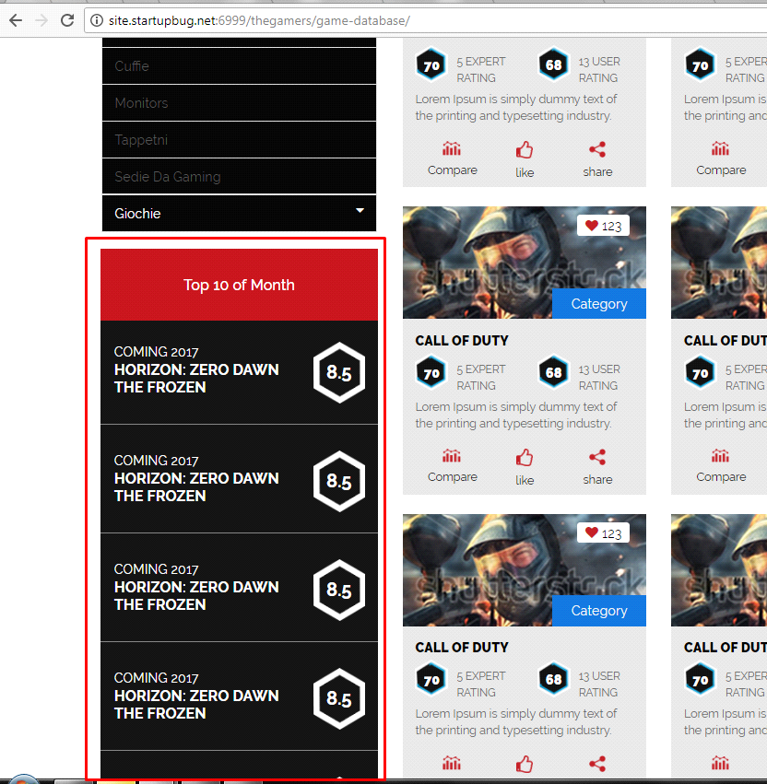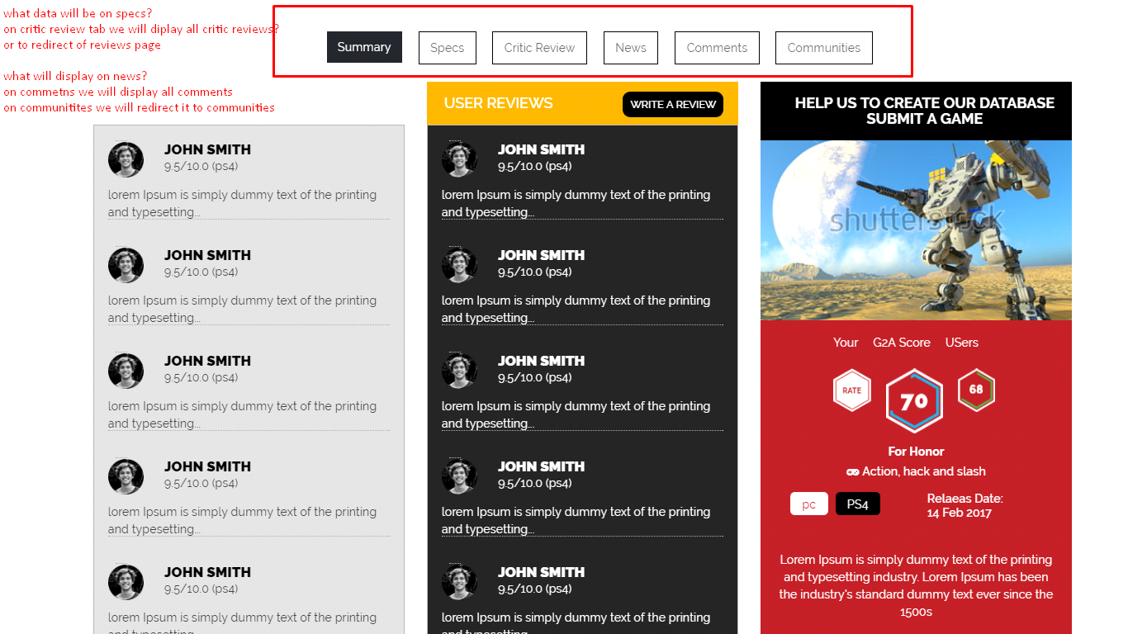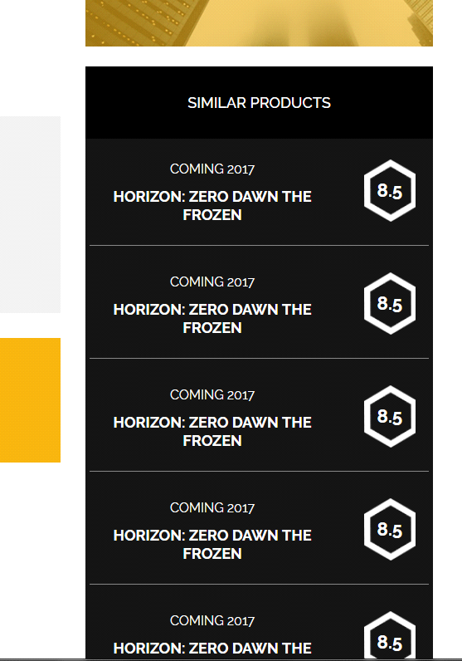Can you please respond to the following queries so that we can proceed ahead accordingly?

* How to select top 10 of the month?
* Top 10 of the month will be the games who got the best ratings this month.  
  

2. This is single game page, please have a look at the screenshot



* In the upper part of the page we have some specifications, but we have more specifications to show, expecially for tech products like monitor, mouses etc. Here we will show all the specifications of the product or game.
* Get rid of critic review tabs, we already have a page for reviews and links to it.
* On news we wil ldisplay related article. For example a news about the videogame.
* Get rid of comments, we already display the comments at the page bottom.
* Communities tab will display all the community connected to the game, in summary we show 4 here we show all the community connected to the game.

3. How to find which are the similar products of this game on single game page

Example: we have a car game. Similar games will be other car games, who share some characteristic. It's like related post but made with the same custom post category who share tags or whatever make them similar

