# Digital Systems 1 Final Project - Vending Machine

This project is the final assignment for the Digital Systems 1 course. It involves the design and simulation of a vending machine capable of selling two types of chocolates (20¢ and 45¢). The system accepts coins of 5¢, 10¢, and 25¢, calculates the total amount entered, dispenses the selected chocolate, and returns the remaining change. The total inserted amount is displayed using two seven-segment displays.

## Features

- Two chocolate products: Chocolate A (20¢) and Chocolate B (45¢)  
- Accepts coins of 5¢, 10¢, and 25¢  
- Implements a Mealy finite state machine (FSM)  
- Displays total inserted amount on a dual seven-segment display  
- Returns change after product dispensing  
- Simulated in Proteus software

## State Diagram

The following state diagram illustrates the Mealy FSM for the vending machine:

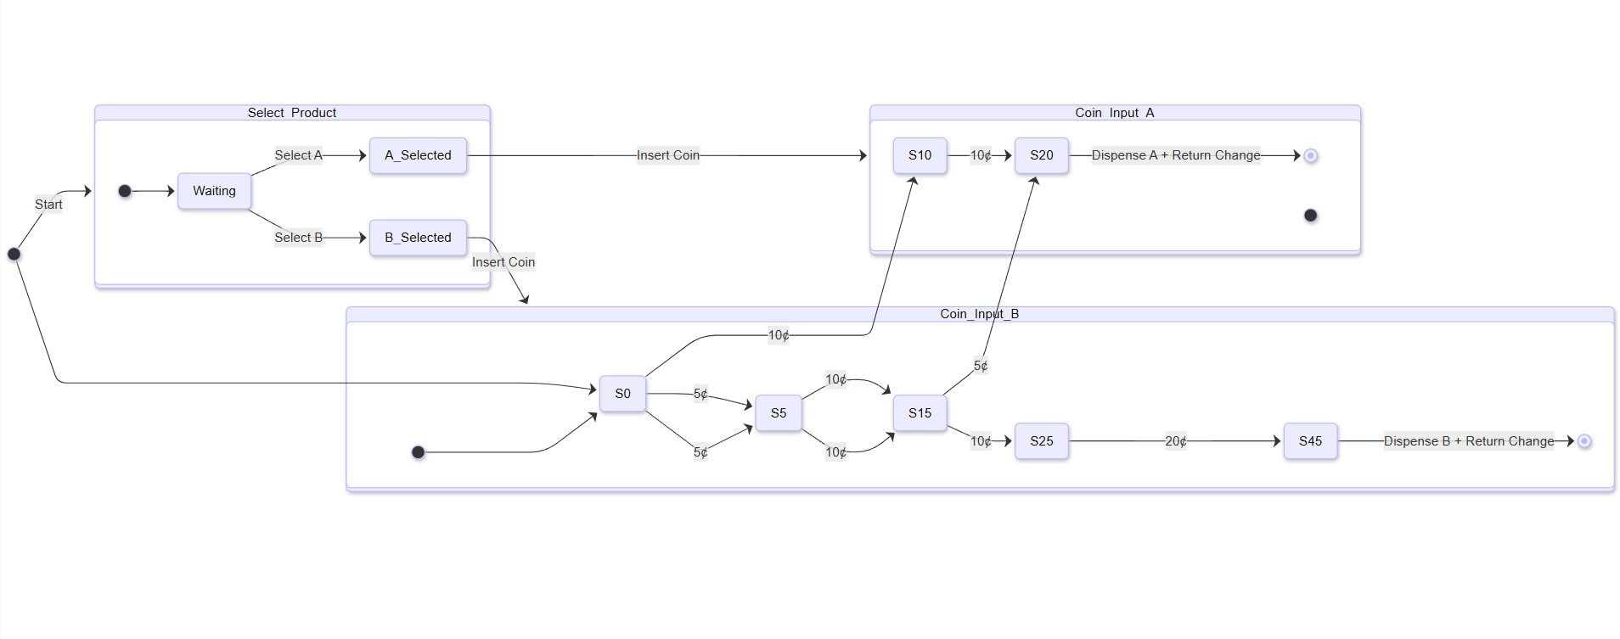

## Simulation Scenarios

Three different test scenarios were implemented in Proteus to validate the machine's functionality:

### Scenario 1

Selecting Chocolate A (20¢) with one 5¢ coin and two 10¢ coins.

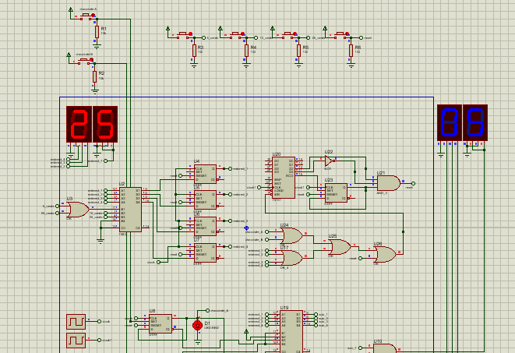

### Scenario 2

Selecting Chocolate A (20¢) with three 5¢ coins and one 25¢ coin.

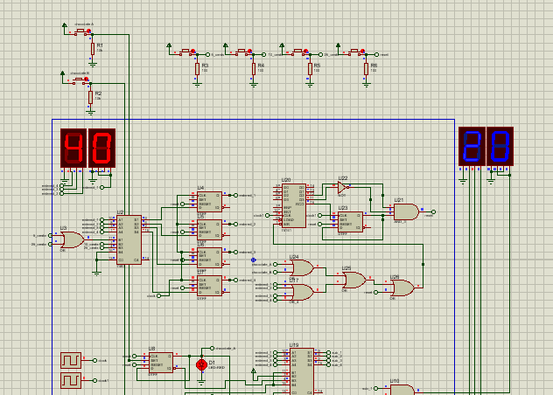

### Scenario 3

Selecting Chocolate B (45¢) with two 25¢ coins.

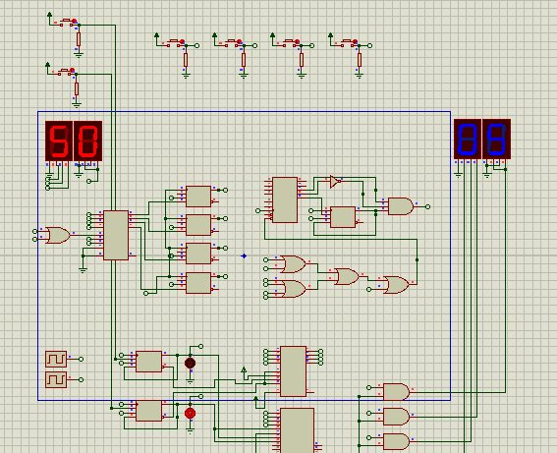

## Components Used in Proteus

The project uses the following components:  
- 7SEG-BCD (Seven Segment Display, Red & Blue): Displays the inserted amount.  
- Logic Gates (AND, OR, XOR, NOT): Implements combinational logic.  
- 74HC74: D-type flip-flops for state storage.  
- 7485: Comparator for value checking.  
- 74161: 4-bit binary counter for tracking input.  
- LEDs (Red, Green, Blue): Indicate machine states and product dispense.  
- Buttons: Simulate coin insertion.  
- CLOCK: Provides clock pulses to drive the FSM.

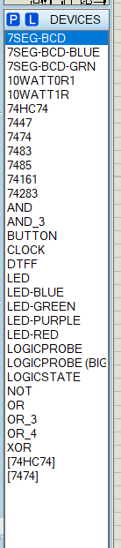

## Full Circuit View

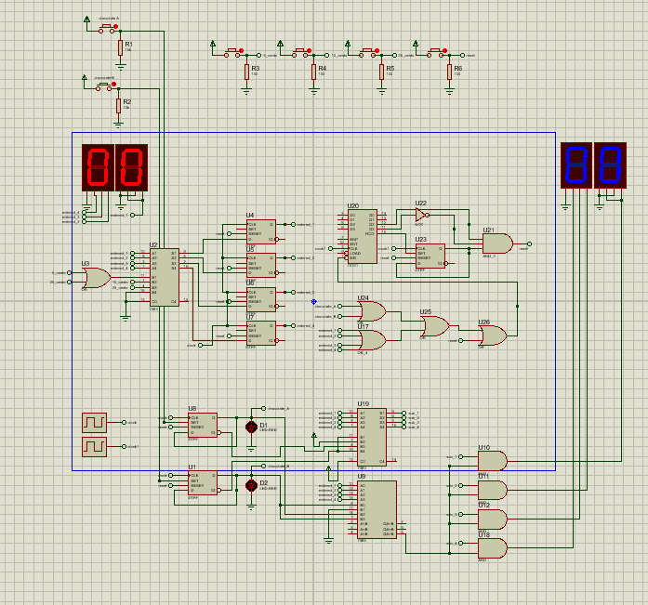

## State Table

The state table for the vending machine is as follows:  
  
Chocolate A (20¢):  
Present State | Input (¢) | Next State | Output  
--------------|-----------|------------|---------------------------  
S0 | 5 | S5 | -  
S5 | 10 | S15 | -  
S15 | 5 | S20 | Dispense A + Return Change  
S0 | 10 | S10 | -  
S10 | 10 | S20 | Dispense A + Return Change  
  
Chocolate B (45¢):  
Present State | Input (¢) | Next State | Output  
--------------|-----------|------------|---------------------------  
S0 | 5 | S5 | -  
S5 | 10 | S15 | -  
S15 | 10 | S25 | -  
S25 | 20 | S45 | Dispense B + Return Change