1. Jenkins has been installed as service and configured (JDK, Maven, Ant, Gradle)

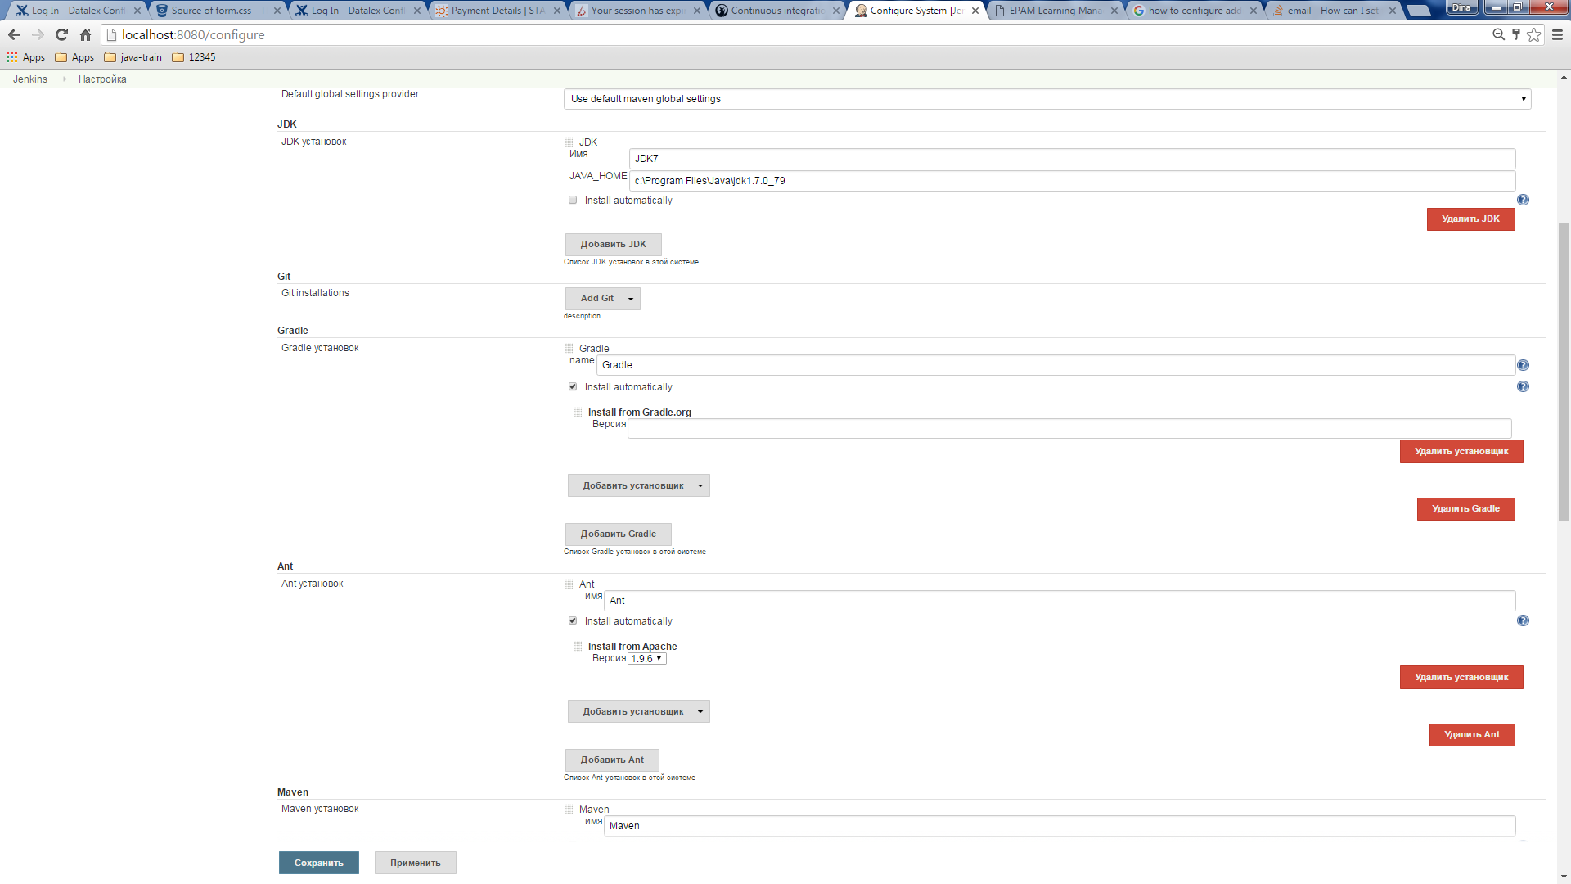

1. Plugins have been installed (Git Plugin, Github plugin, Role-Based Authorization Strategy and others)

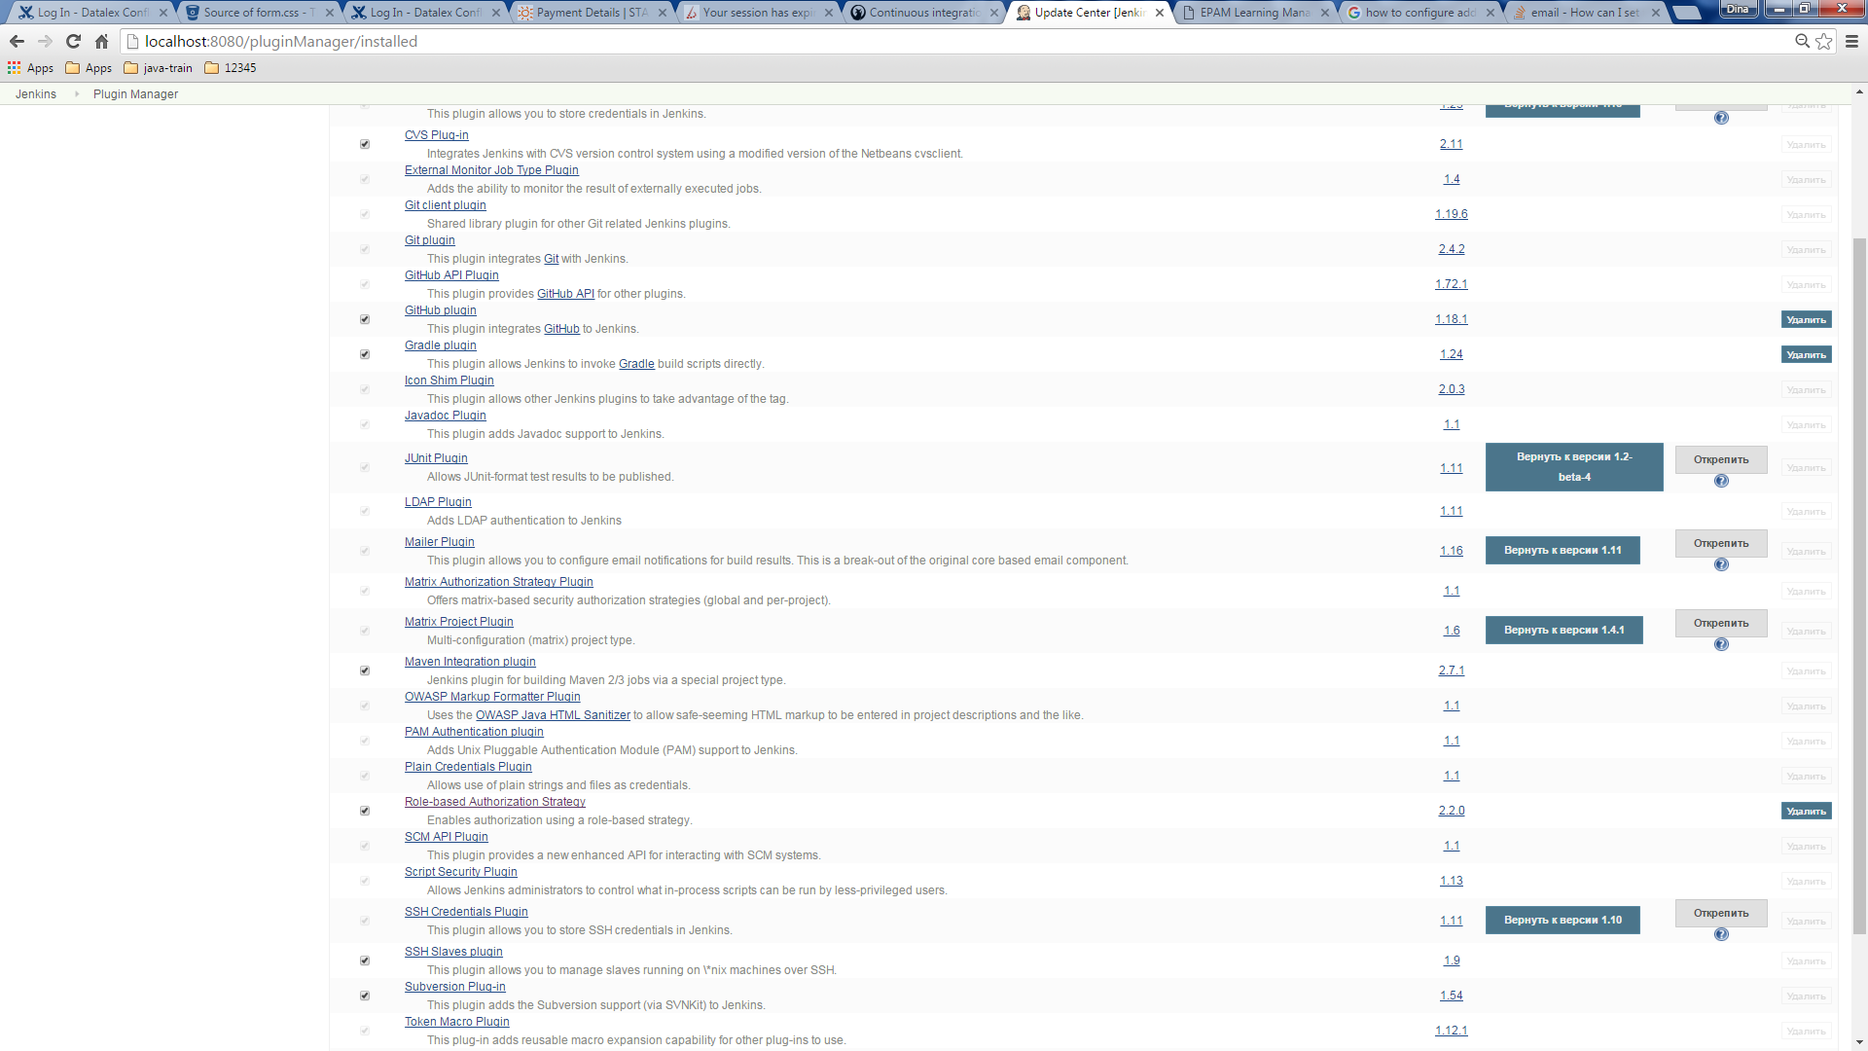

1. Jenkins security has been configured for the following users: admin (all permissions), developer (read, build, cancel permissions)

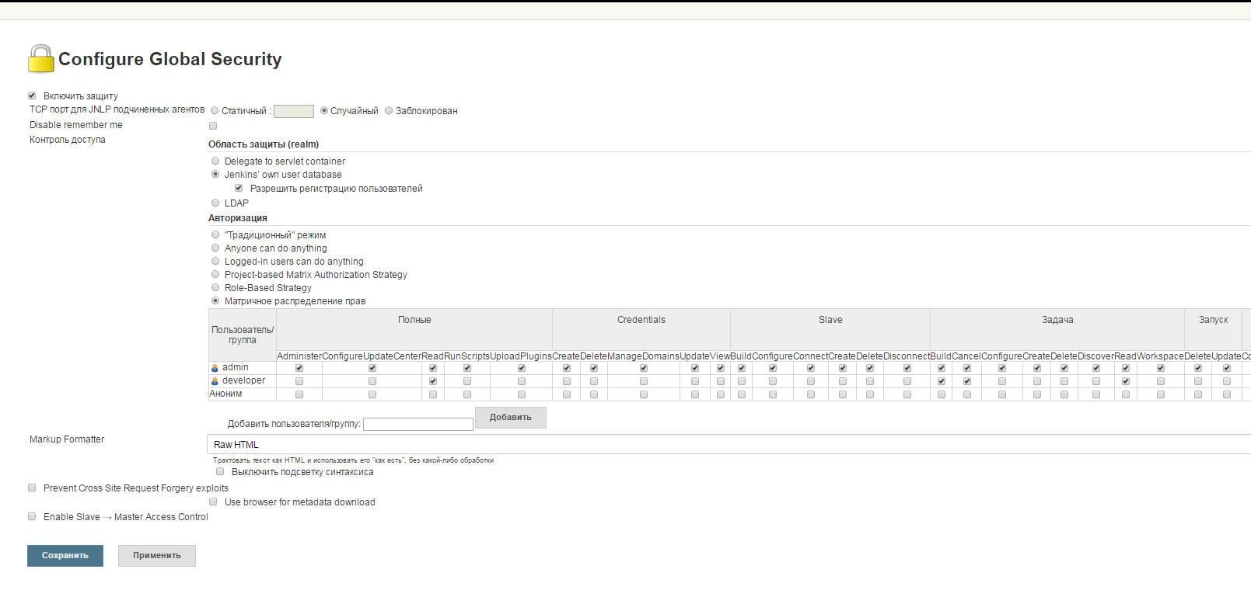

1. Simple-free job has been created

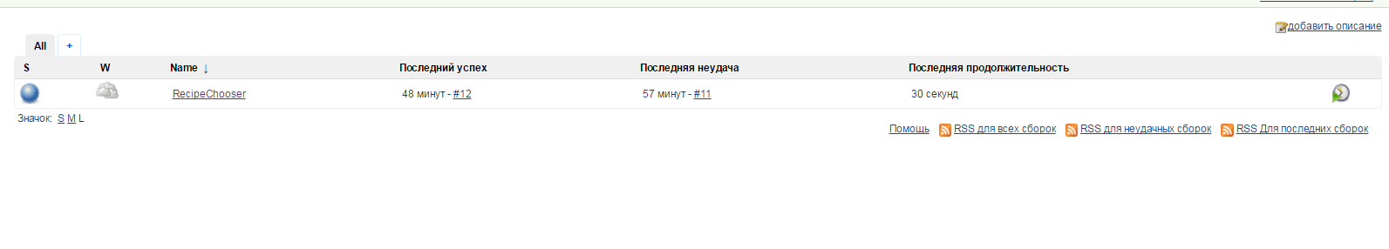

With the following settings

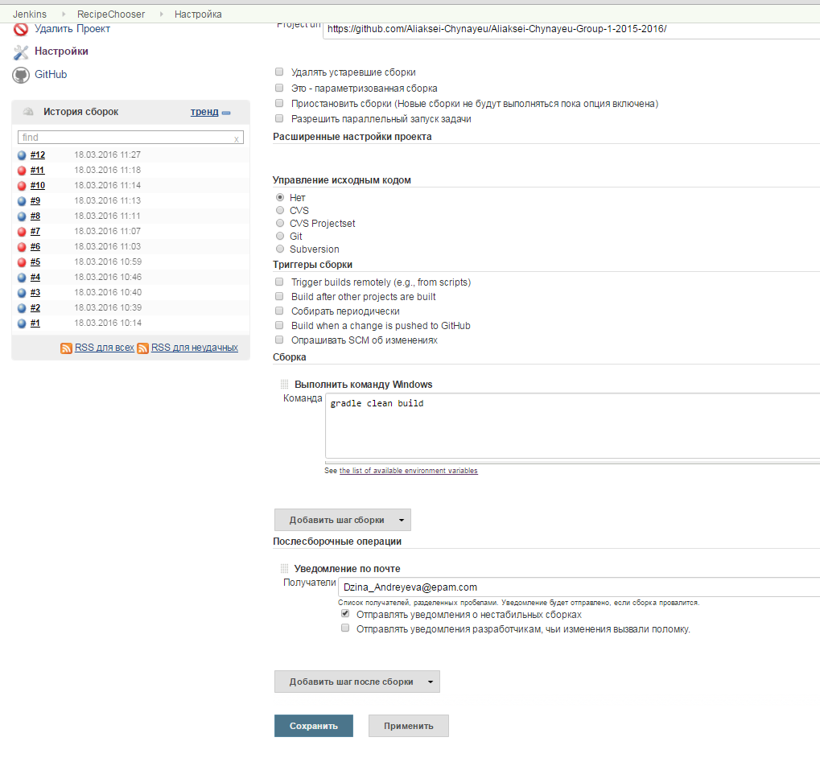

1. Project has been built succefully

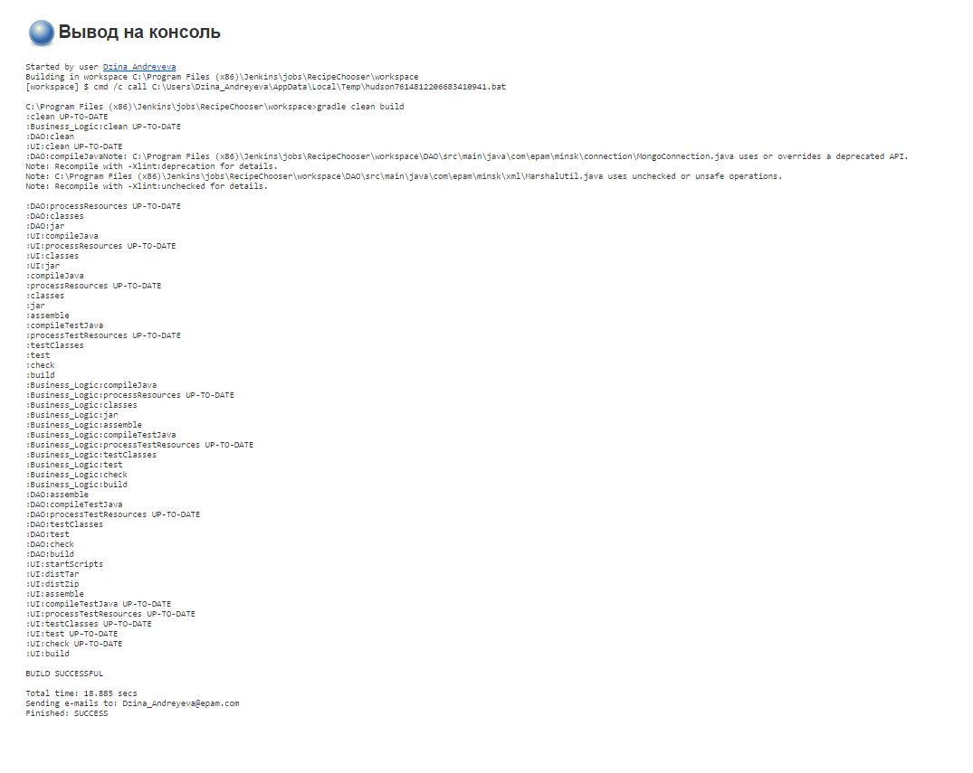

1. After finishing users from the list receive email with build results

Build fail:

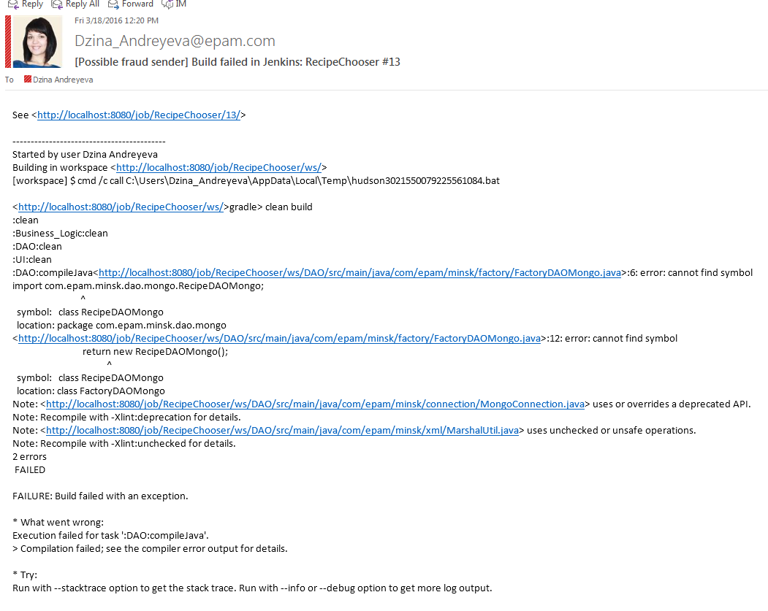

Build success:

