Description:
Task 1.
Without indexes, the DBMS uses the Sequential Scan method, reading all rows in the table. This results in high costs and long execution times (Execution Time 619.385 ms). ORDER BY num sorting is performed as a separate in-memory Sort step, which adds additional load to the system.
Command differences:
EXPLAIN:
Just a plan.
EXPLAIN ANALYZE:
Shows the execution plan.
Shows the actual execution time.
Shows the number of rows processed.
Does not show memory page statistics.
EXPLAIN (ANALYZE, BUFFERS):
Does the same as regular ANALYZE.
Additionally displays the Buffers: block.
Shared Hit: Blocks found in shared_buffers (RAM).
Shared Read: Blocks read from disk.
Shared Dirtied/Written: Blocks modified or written to disk.

The plan of the select does not change during re-checking (used EXPLAIN).

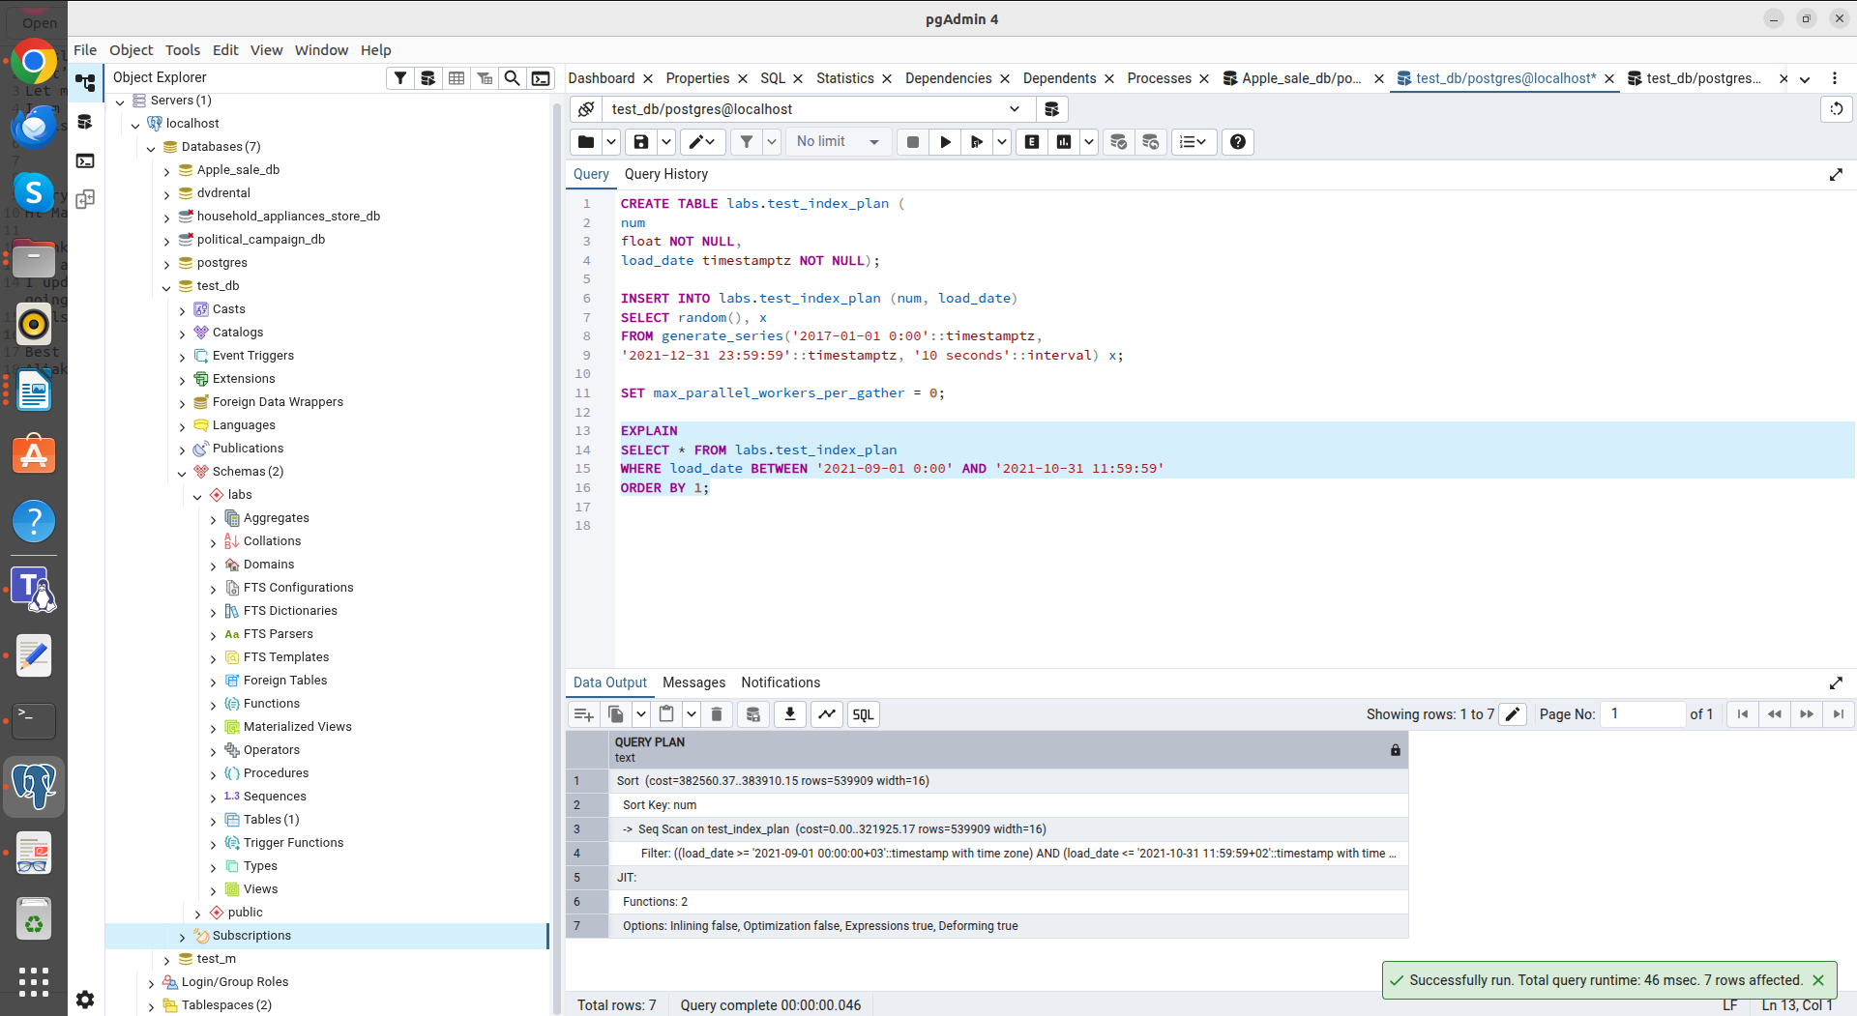
EXPLAIN

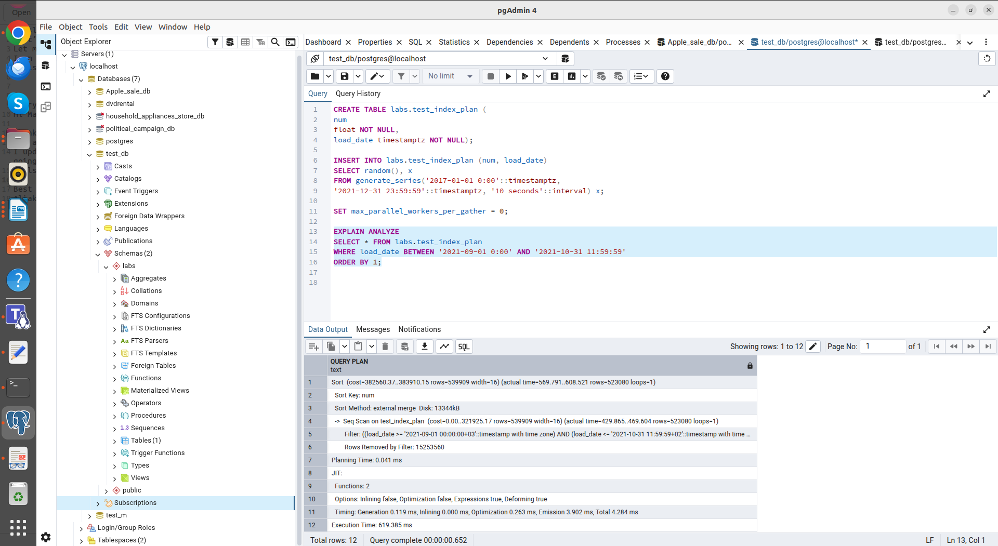
EXPLAIN ANALYZE

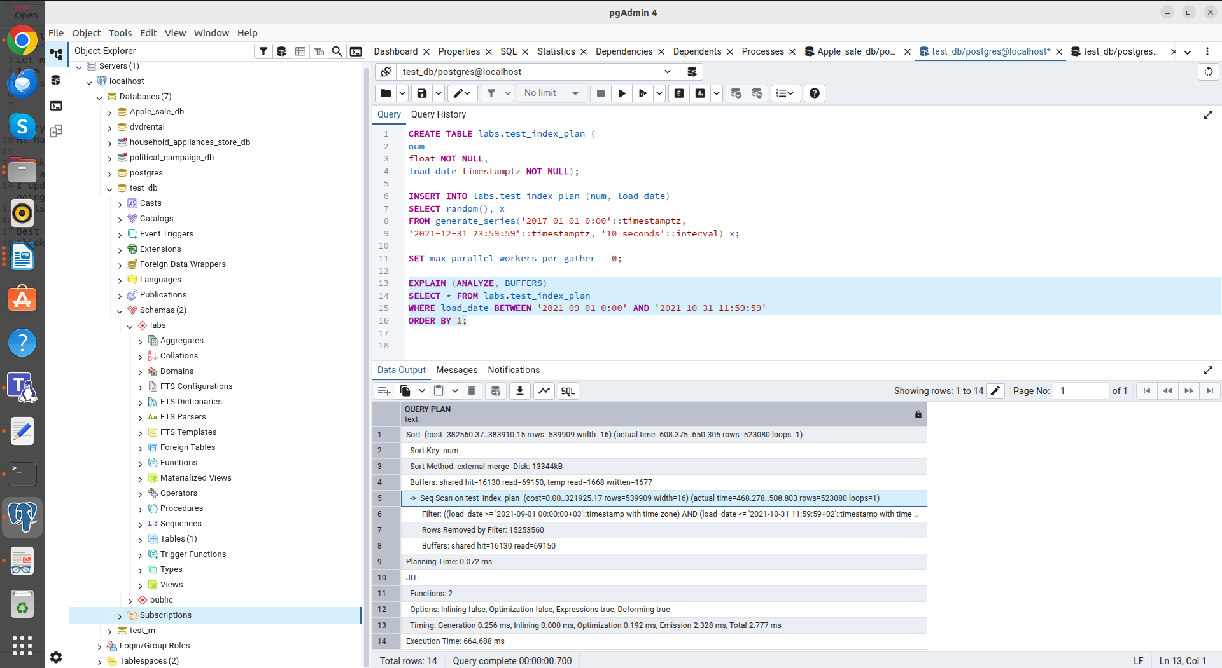
EXPLAIN (ANALYZE, BUFFERS)

Task 2.
Using the index reduced the search time (Execution Time 178.880 ms) by tens of times, as the database switched from a full scan to selective reading of pages through the index.
To activate the Index Only Scan method, you need to create an index that includes all query columns (in this case, load_date and num). This prevents the DBMS from accessing the main table (CREATE INDEX idx_test_cover ON labs.test_index_plan(load_date, num).
The plan of the select does not change during re-checking (used EXPLAIN).

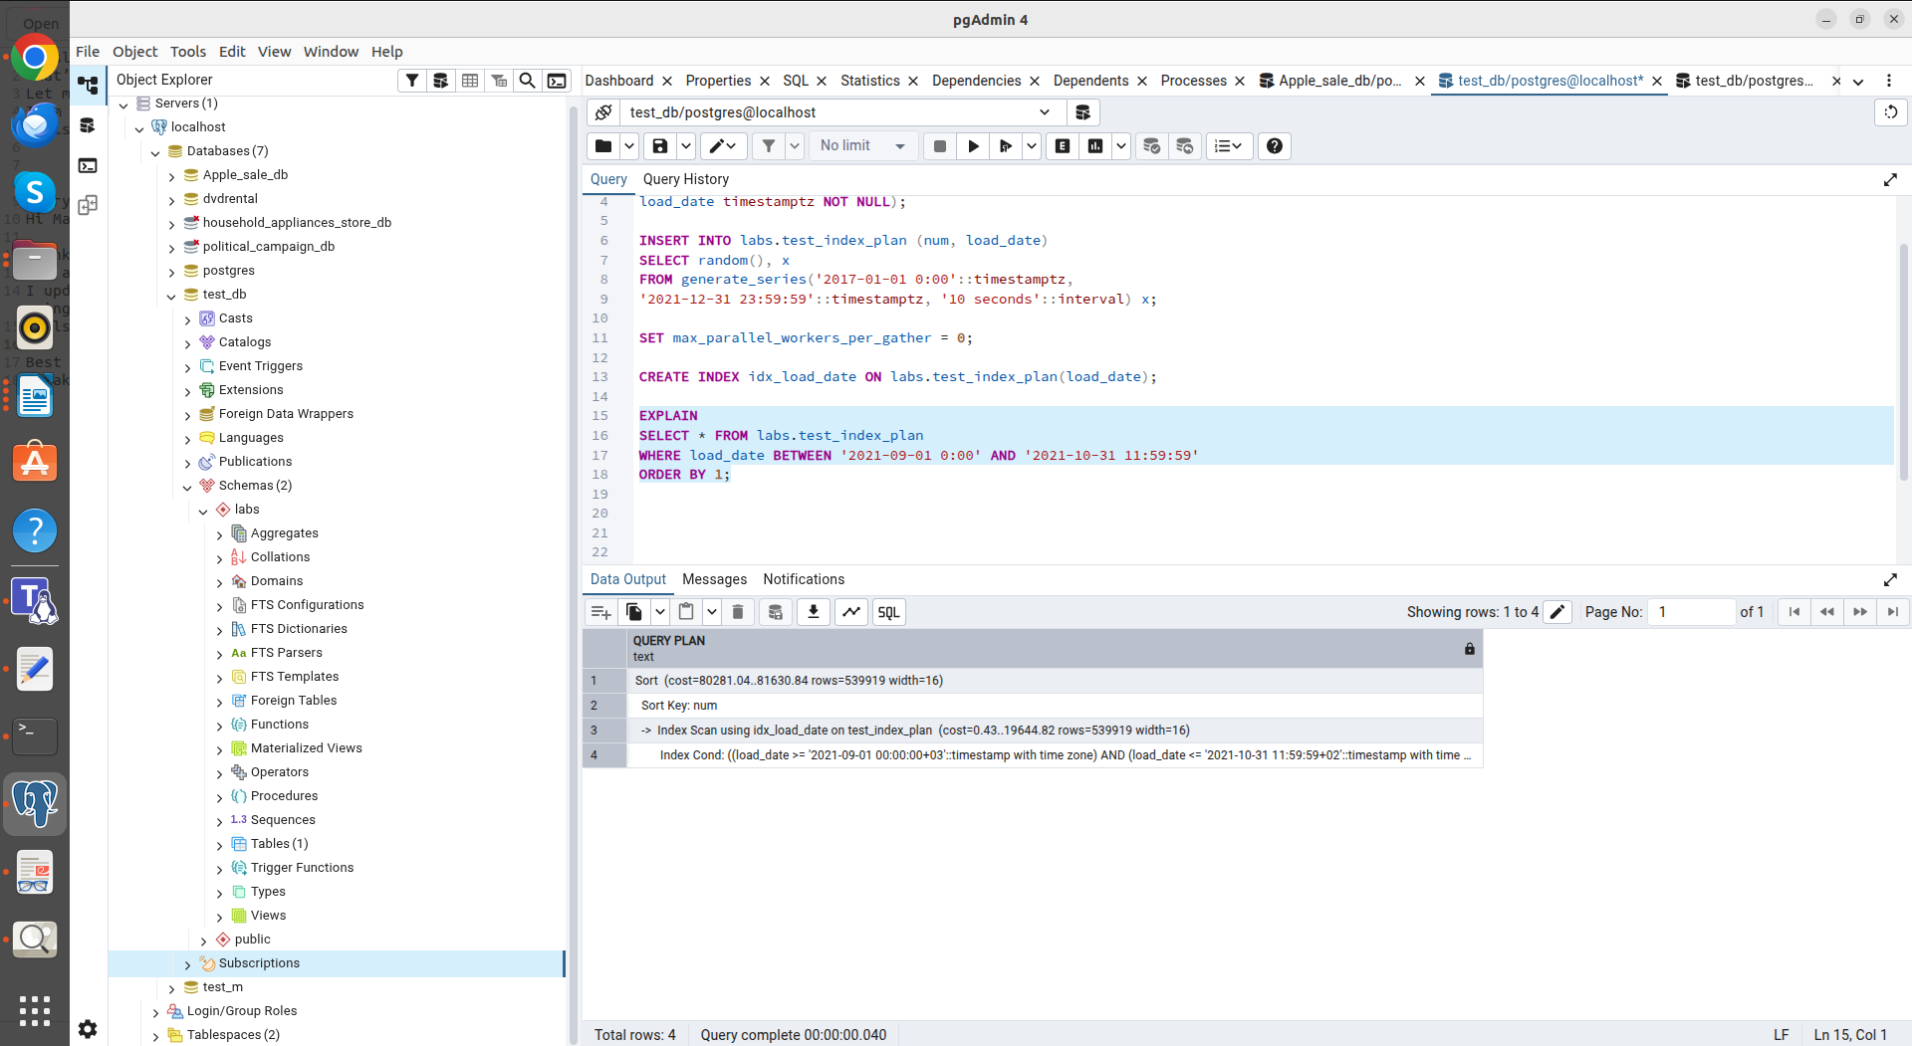
B-Tree EXPLAIN

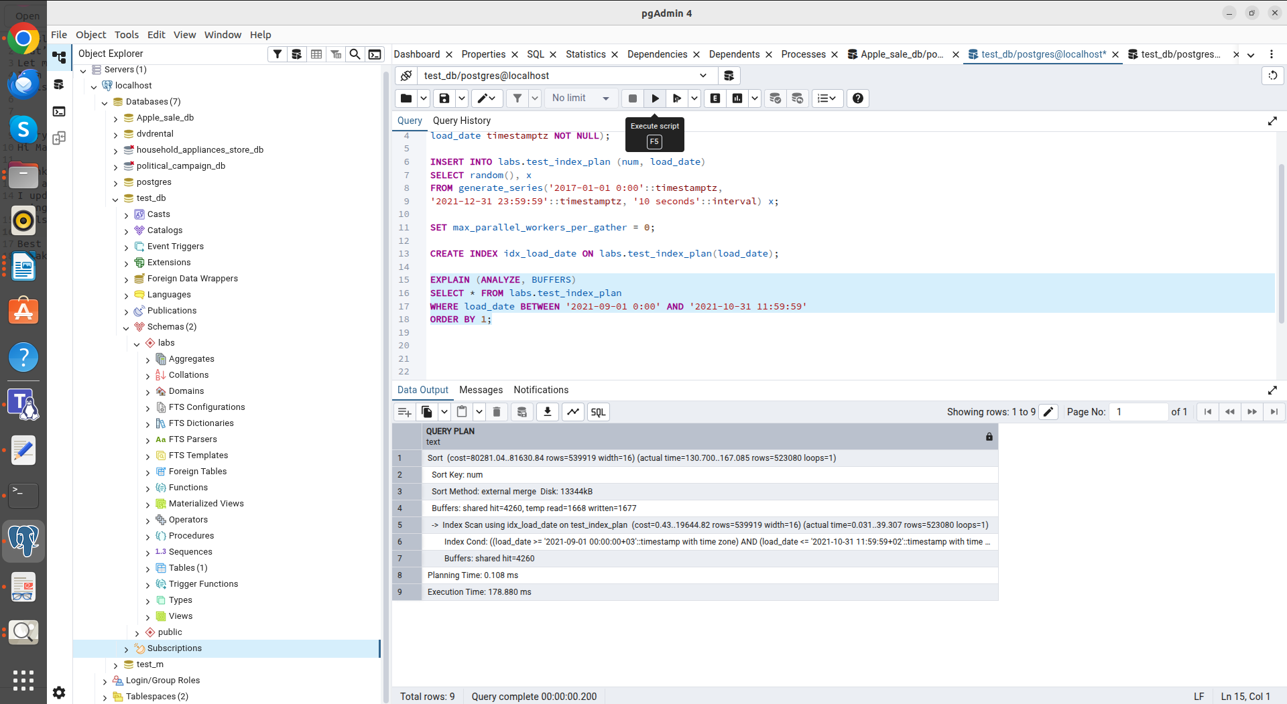
B-Tree EXPLAIN (ANALYZE, BUFFERS)

The BRIN index showed high efficiency (similar time to B-Tree) (Execution Time 181.687 ms)
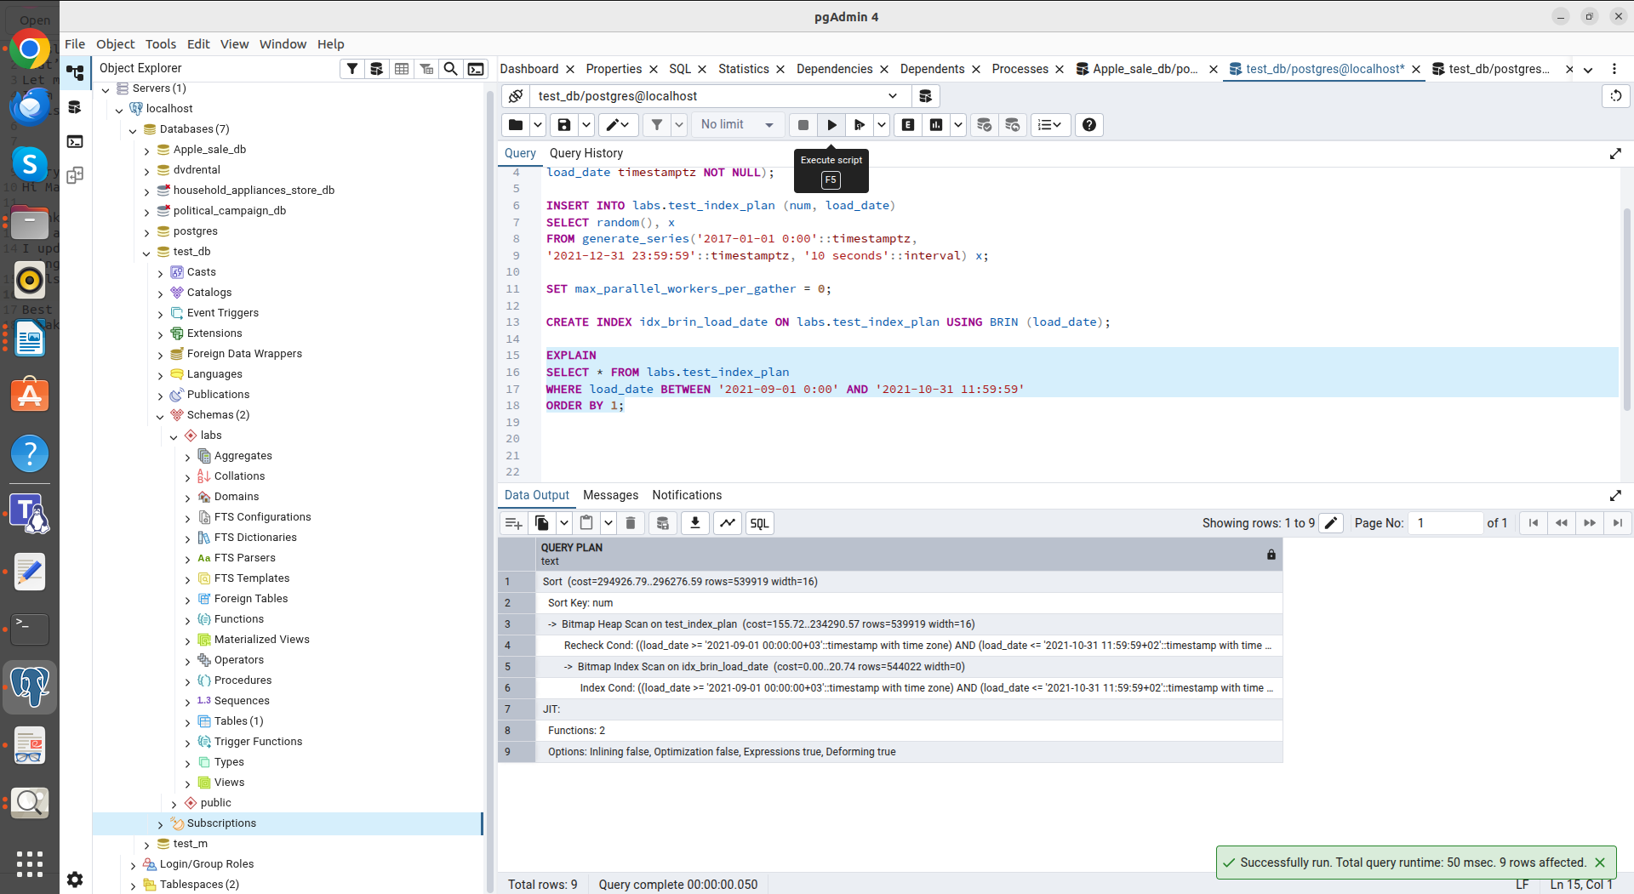
BRIN EXPLAIN

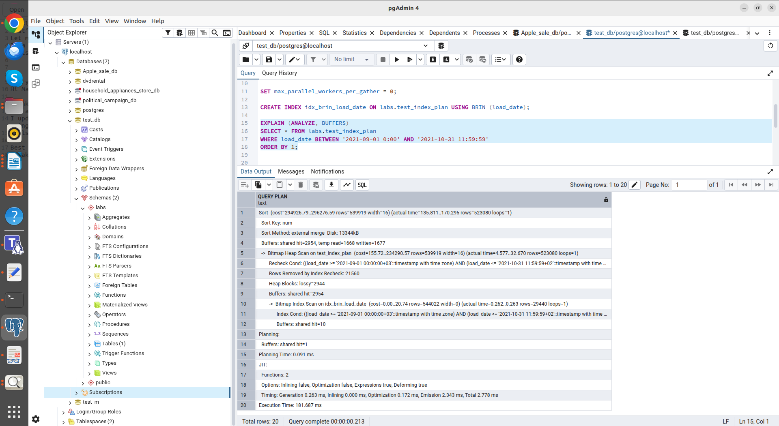
BRAIN EXPLAIN (ANALYZE, BUFFERS)

Task 3.
Using INSERT INTO ... SELECT... FROM labs.test_index_plan is effective for moving data within a database, but indexes slow down the process.

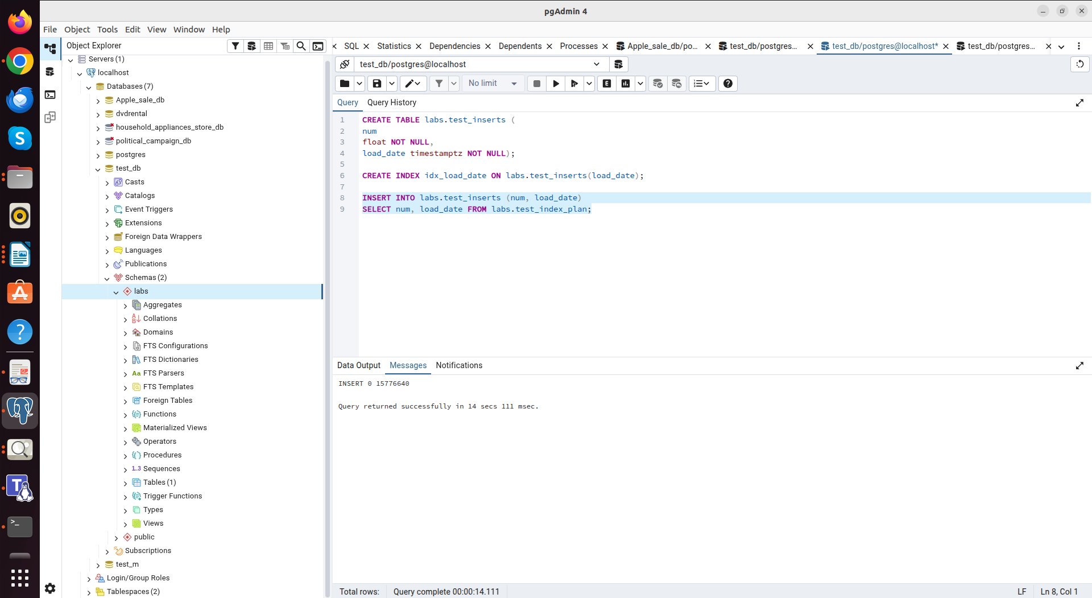
Inserting rows into a table with an index (Execution Time 14 secs 111 ms).

Multi-row INSERT reduces the number of transactions and speeds up inserting small batches of data.

Rewrited INSERT statements from Task 3.5
Improvements:
Load reduction: Instead of 14 separate transactions, one is executed.
Explicit column specification: It is recommended to always specify target columns to prevent code breakage when changing the table structure.
ISO date format: Using the YYYY-MM-DD format ensures correct date recognition regardless of local server settings (unlike the DD-MON-YY format).

INSERT INTO emp (empno, ename, job, mgr, hiredate) VALUES
(1,'SMITH','CLERK',13,'1980-12-17'),
(2,'ALLEN','SALESMAN',6,'1981-02-20'),
(3,'WARD','SALESMAN',6,'1981-02-22'),
(4,'JONES','MANAGER',9,'1981-04-02'),
(5,'MARTIN','SALESMAN',6,'1981-09-28'),
(6,'BLAKE','MANAGER',9,'1981-05-01'),
(7,'CLARK','MANAGER',9,'1981-06-09'),
(8,'SCOTT','ANALYST',4,'1987-04-19'),
(9,'KING','PRESIDENT',NULL,'1981-11-17'),
(10,'TURNER','SALESMAN',6,'1981-09-08'),
(11,'ADAMS','CLERK',8,'1987-05-23'),
(12,'JAMES','CLERK',6,'1981-12-03'),
(13,'FORD','ANALYST',4,'1981-12-03'),
(14,'MILLER','CLERK',7,'1982-01-23');

Task 4.
Command to export column load_date from test_index_plan with quotes and num column without quotes. The FORCE_QUOTE parameter puts the date in quotation marks, but leaves the number without them.

COPY labs.test_index_plan TO '/tmp/test_index_plan.csv'
WITH (FORMAT CSV, HEADER, DELIMITER ',', FORCE_QUOTE (load_date));

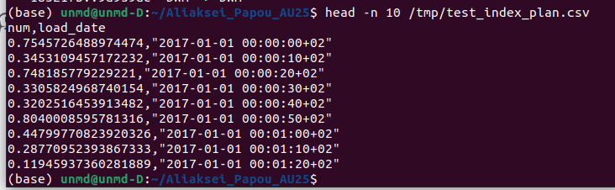
num without quotes, load_date with quotes

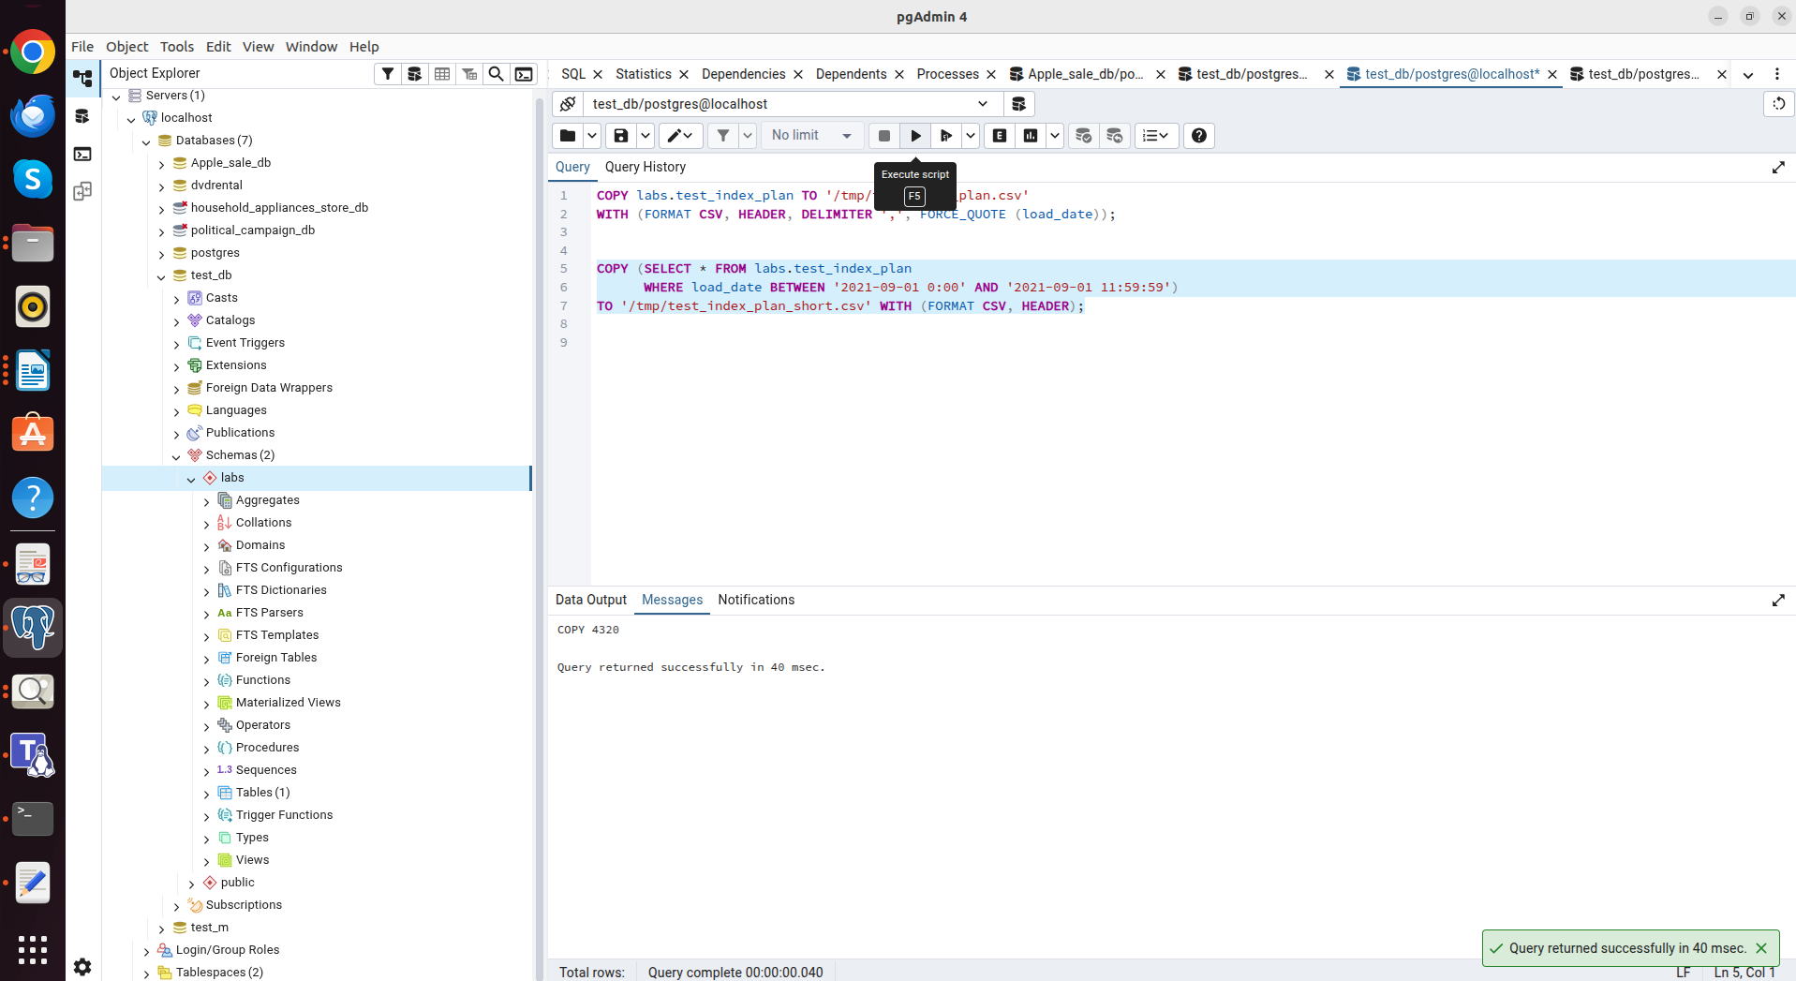
Use COPY to export data from test_index_plan table into csv file ‘test_index_plan_short.csv’

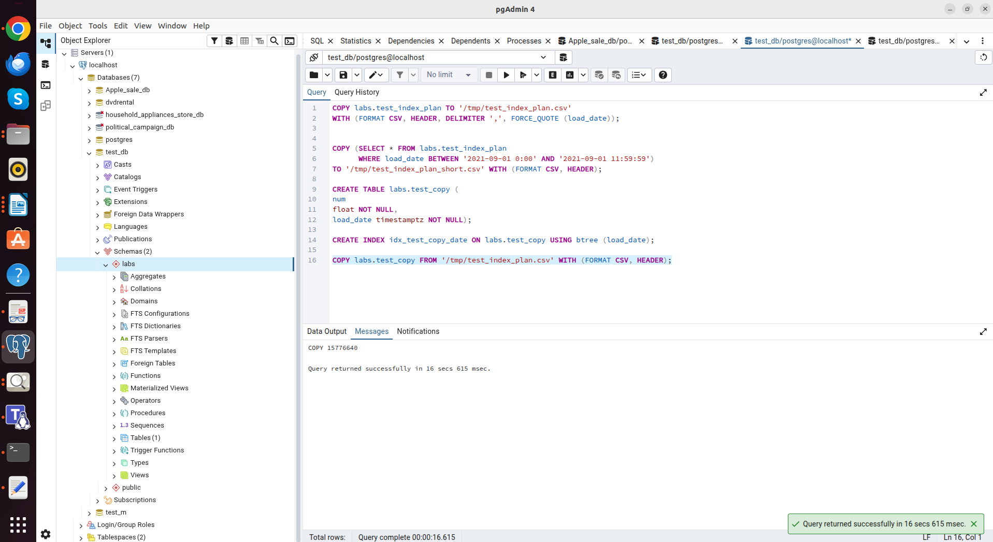
COPY into test_copy by using test_index_plan.csv file.

Task 5.
ON CONFLICT allows you to combine "insert or update" logic into a single atomic query, eliminating duplicate key errors.

INSERT INTO emp (empno, ename, job, mgr, hiredate) VALUES
(1, 'SMITH', 'MANAGER', 13, '2021-12-01'),
(14, 'KELLY', 'CLERK', 1, '2021-12-01'),
(15, 'HANNAH', 'CLERK', 1, '2021-12-01'),
(11, 'ADAMS', 'SALESMAN', 8, '2021-12-01'),
(4, 'JONES', 'ANALYST', 9, '2021-12-01')
ON CONFLICT (empno)
DO UPDATE SET
ename = EXCLUDED.ename,
job = EXCLUDED.job,
mgr = EXCLUDED.mgr,
hiredate = EXCLUDED.hiredate;

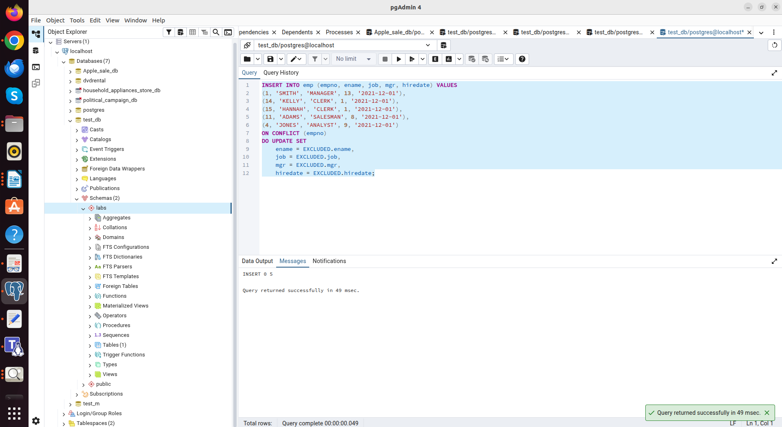

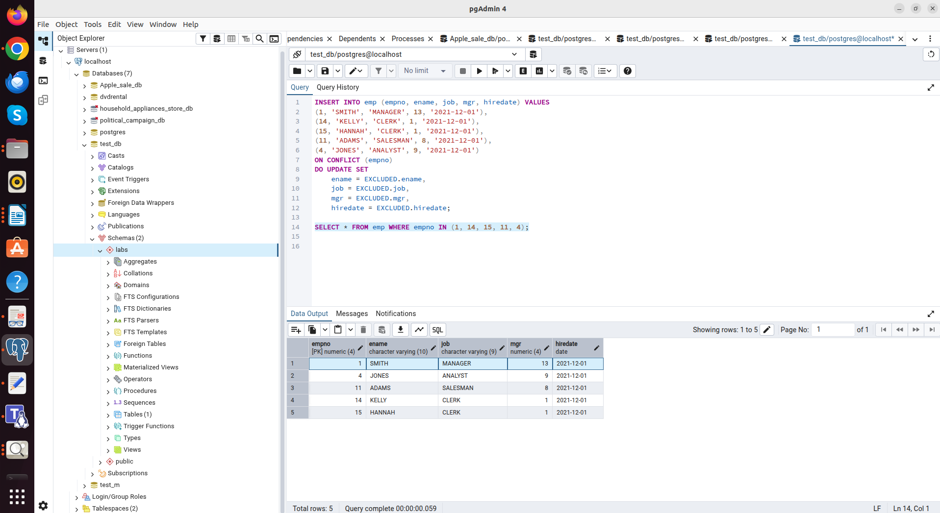
Query result: old entries (e.g. SMITH) have been updated and new ones (KELLY, HANNAH) have been added.

