Description:
In Task 1-4, I used the standard isolation level. Using the xmin and xmax fields, we can see that each row is tied to a transaction ID. Until the transaction is committed (COMMIT), other system participants don't see the changes, ensuring integrity.

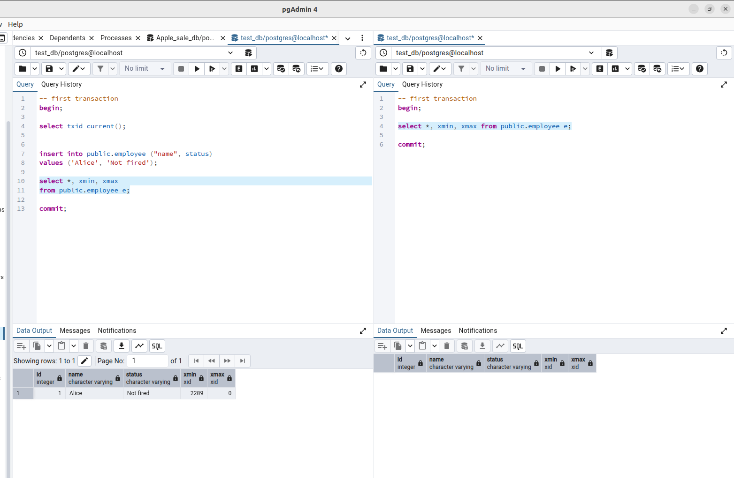

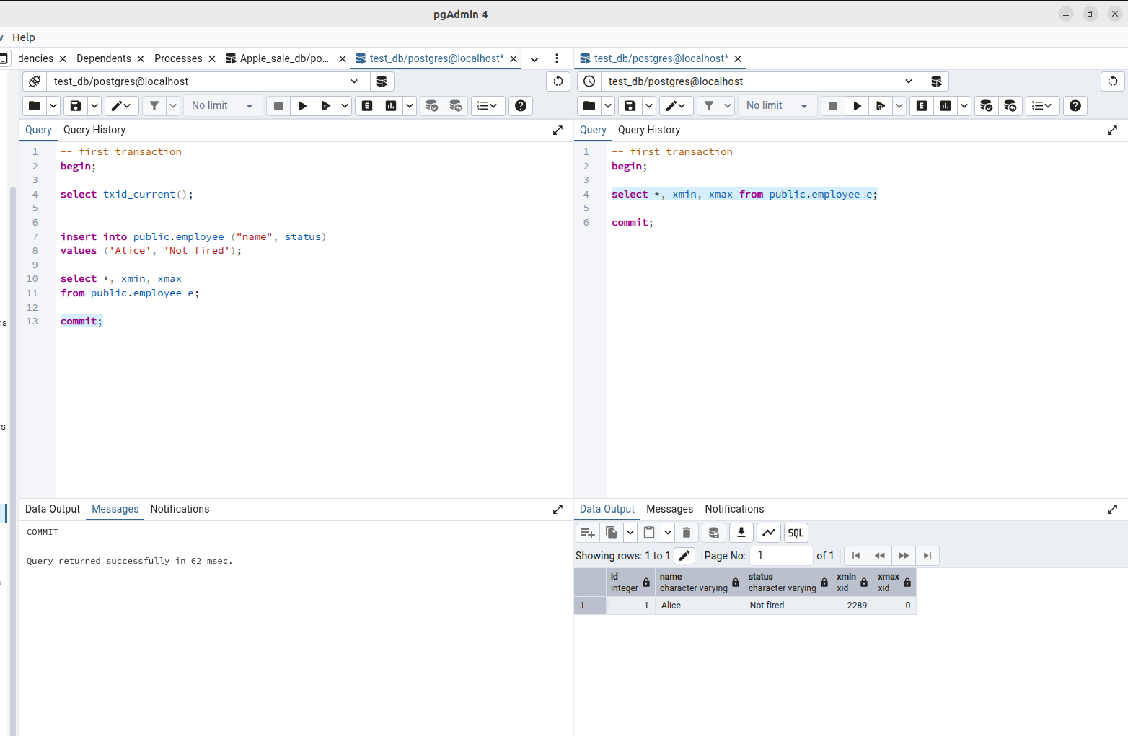

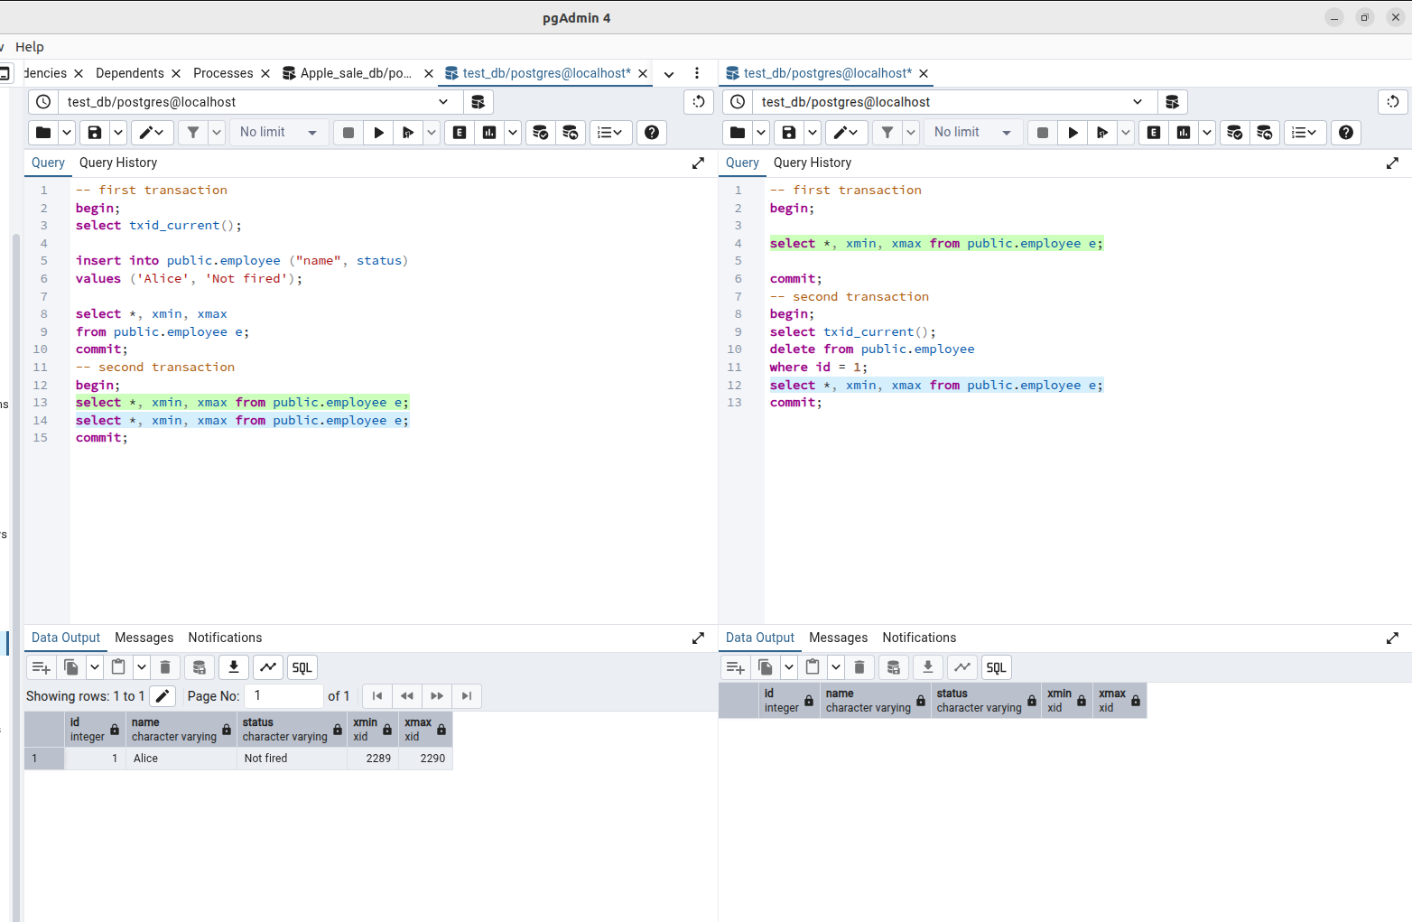

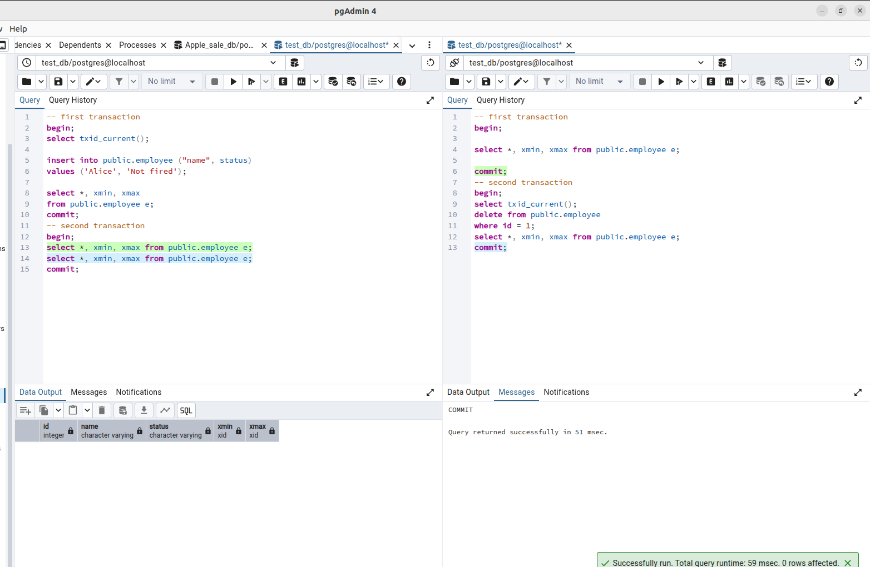

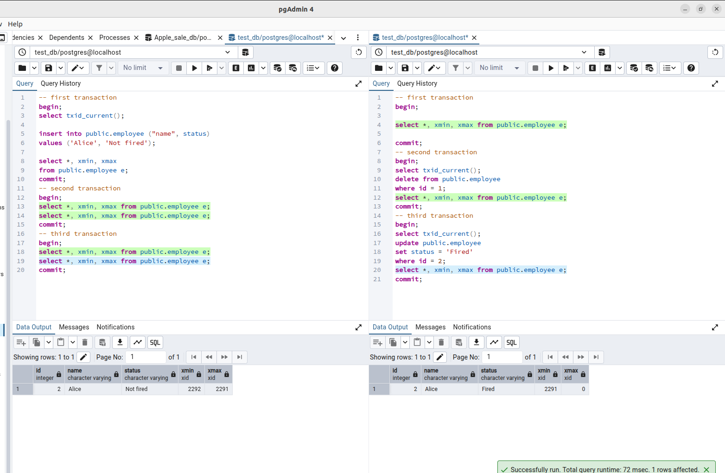

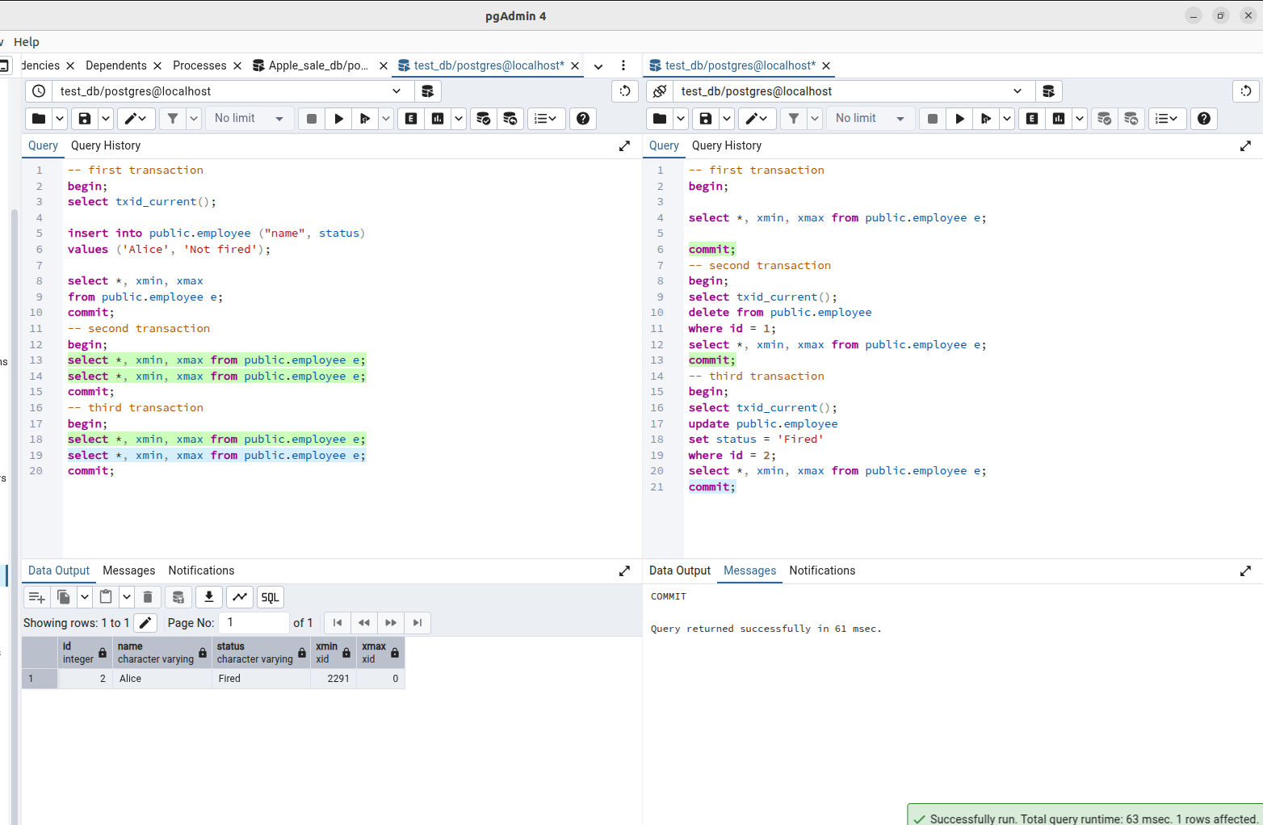

To ensure stronger data consistency, I moved the session to the REPEATABLE READ level.
At this level, a transaction "freezes" a snapshot of the data at the moment it began. Even if I change and commit the data, as long as my transaction is open, I'll still see the old version (snapshot).

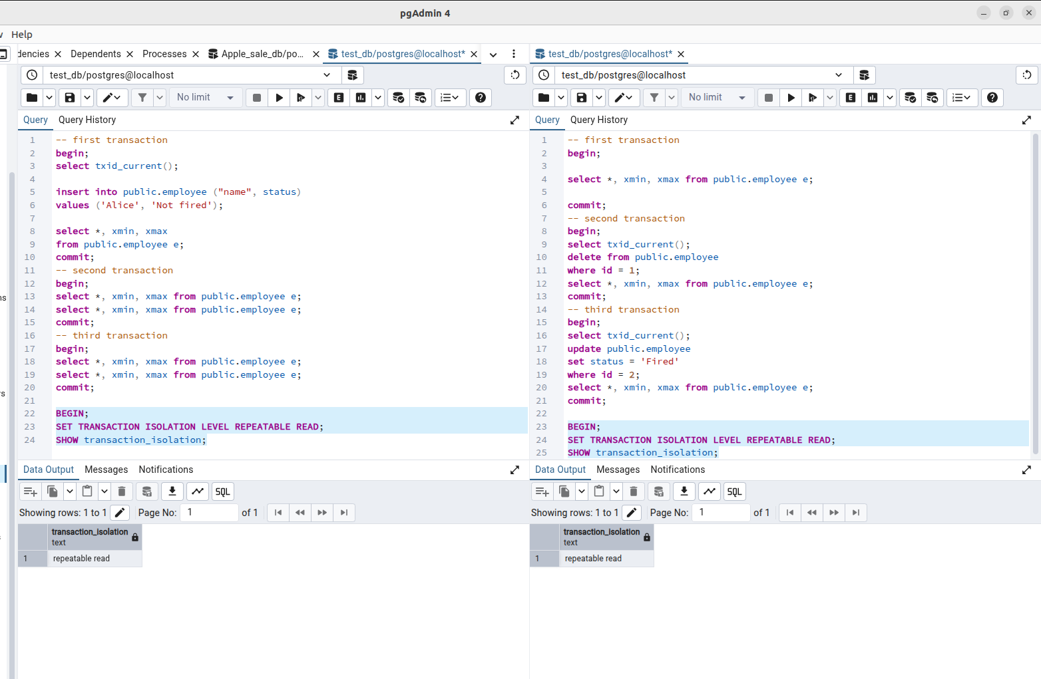

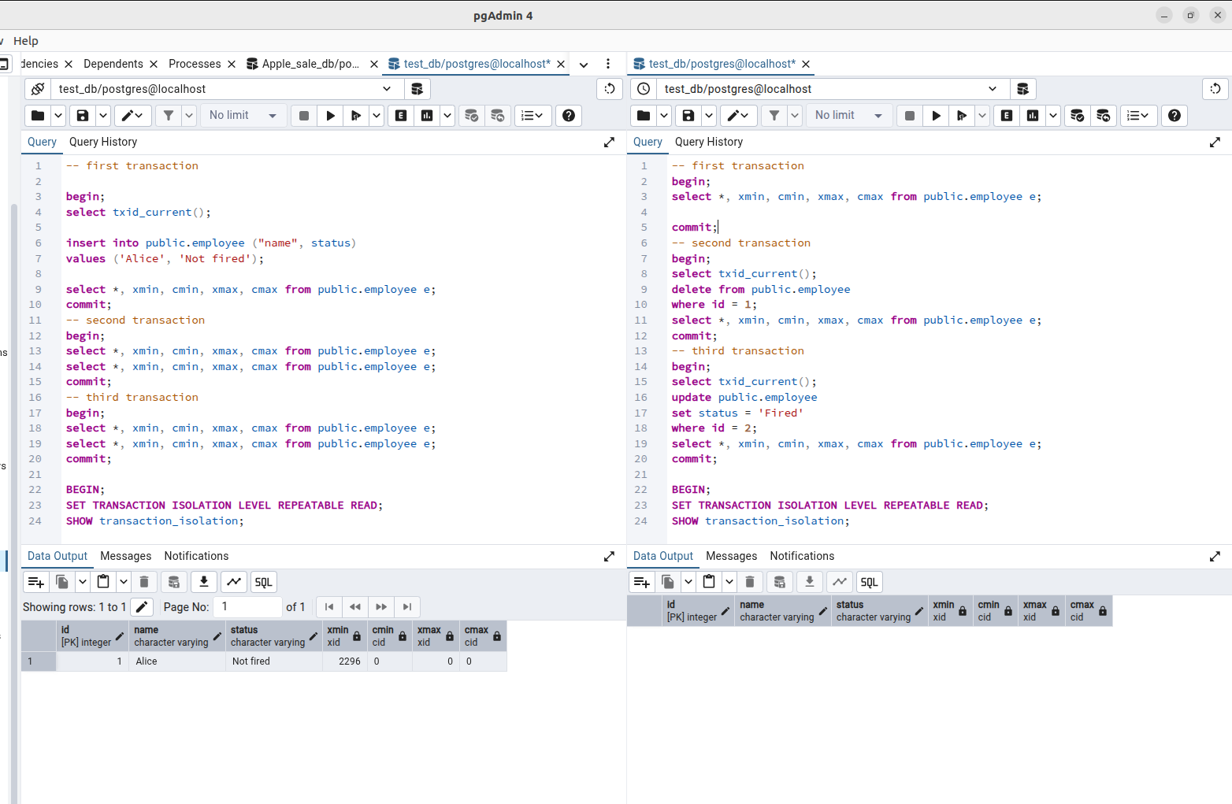

In Task 5, I added the cmin and cmax fields. This allowed me to see the internal order of commands within a single transaction. This is necessary so that the transaction "sees" its own changes made a couple of lines earlier in the same code block.

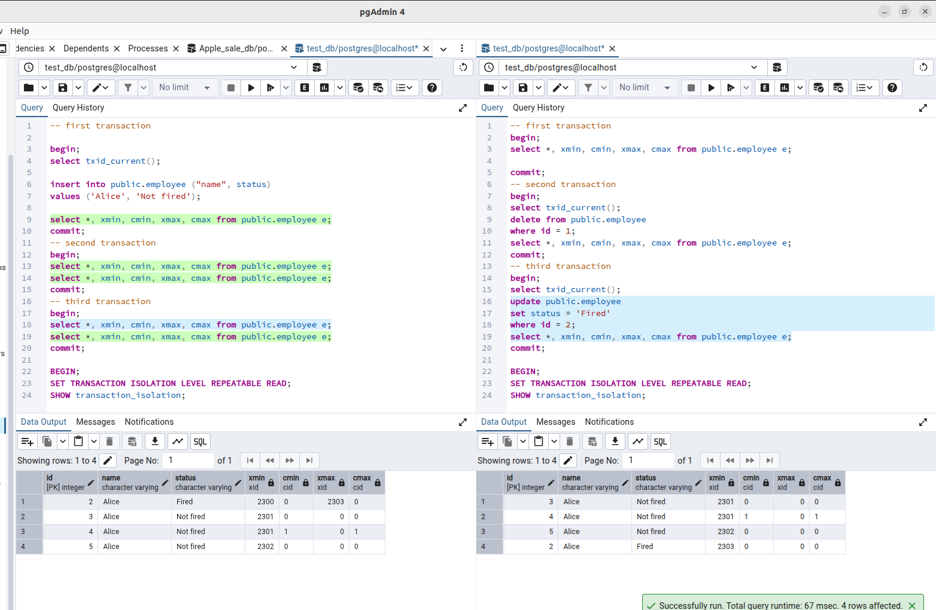

In Task 6, when using the SERIALIZABLE level, I received a serialization error ("could not serialize access"). This proves that Postgres tracks read/write dependencies and prevents committing a result that violates the logical sequence of operations. This ensures that the result will be the same as if the transactions had executed strictly in sequence.

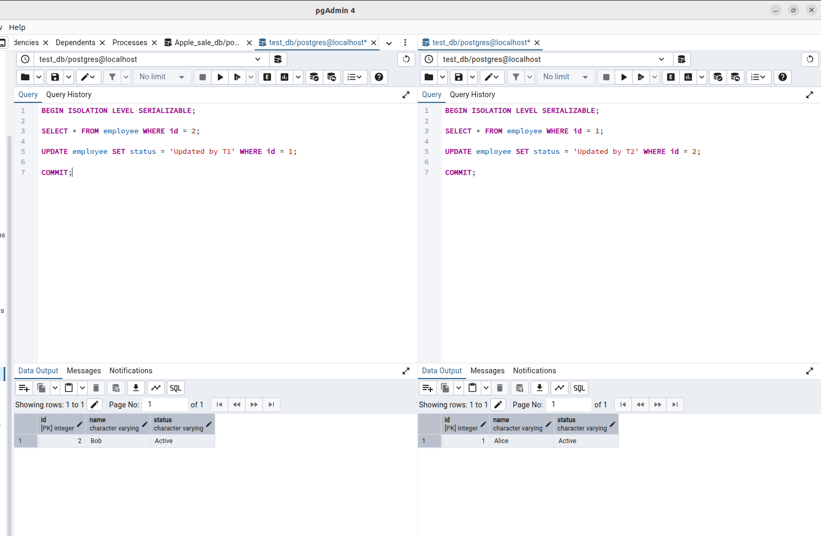

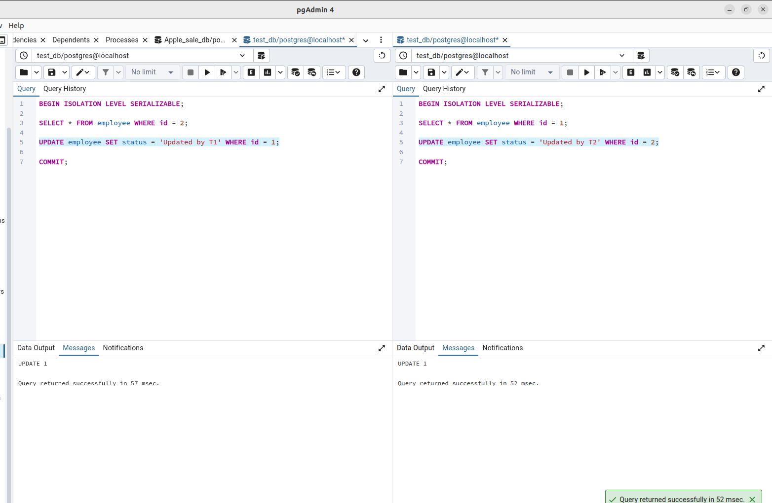

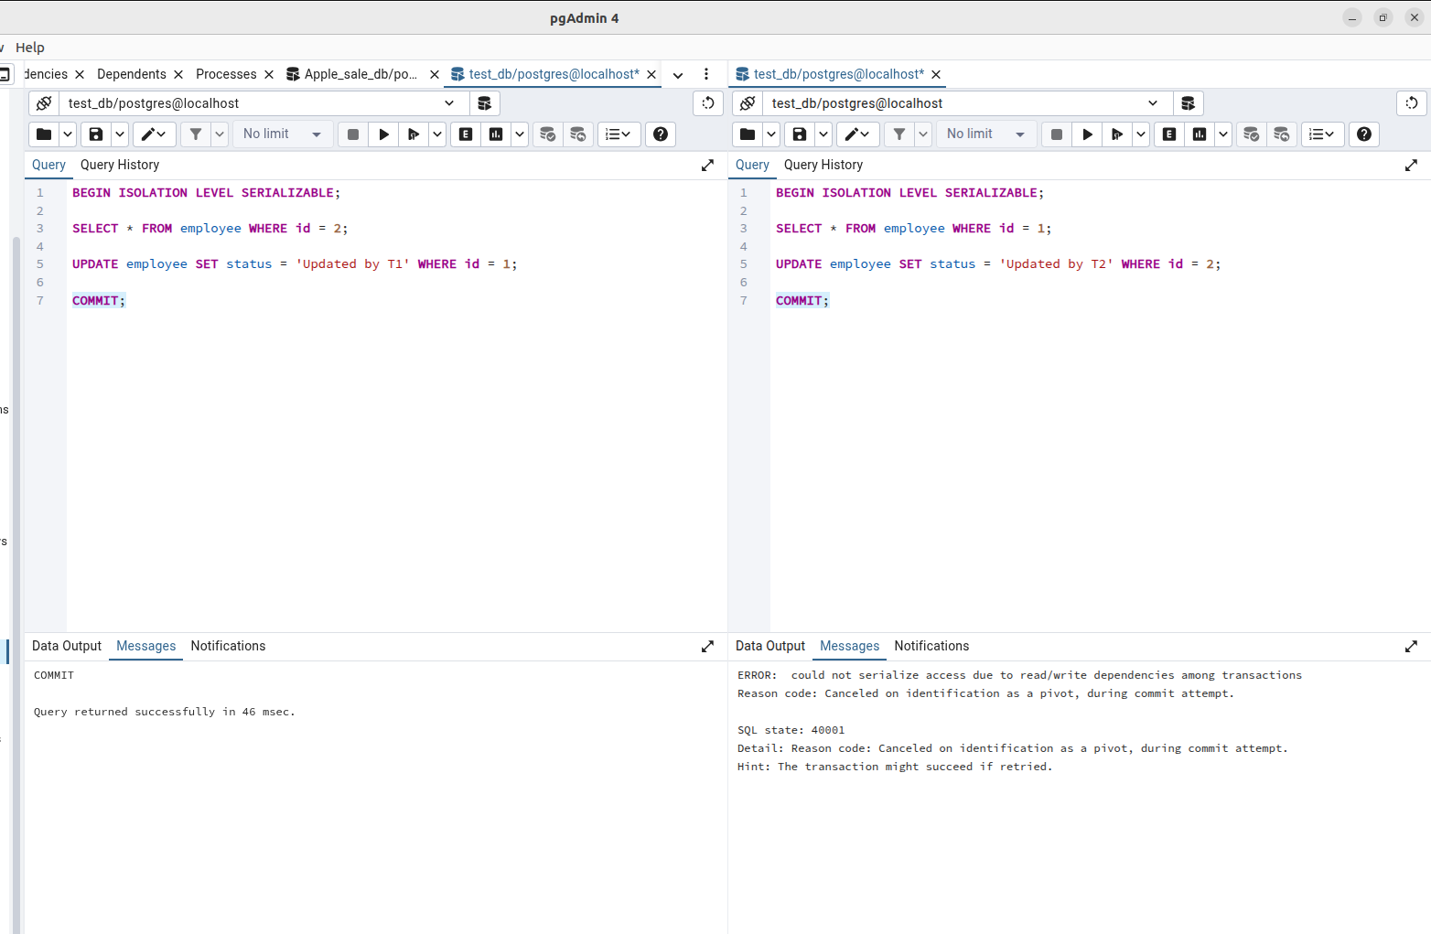

In Task 7, at the READ COMMITTED level, I reproduced the Lost Update anomaly. The second transaction was blocked until the first committed. However, immediately afterward, the second transaction applied its change, completely erasing the work of the first. Postgres prevents physical data loss by locking the row, but at the Read Committed level, a logical problem arises: Session 2 doesn't know that the data has already changed while it was waiting. It simply overwrites Session 1's changes. The main downside is that the system doesn't warn the user about the overwrite. The second transaction performs calculations based on the old row state, which is no longer current at the commit time.

