Description:
In the first task, I created the test_db database. Using a query against pg_database, I verified that the database was assigned a unique OID and was located in the system namespace by default.

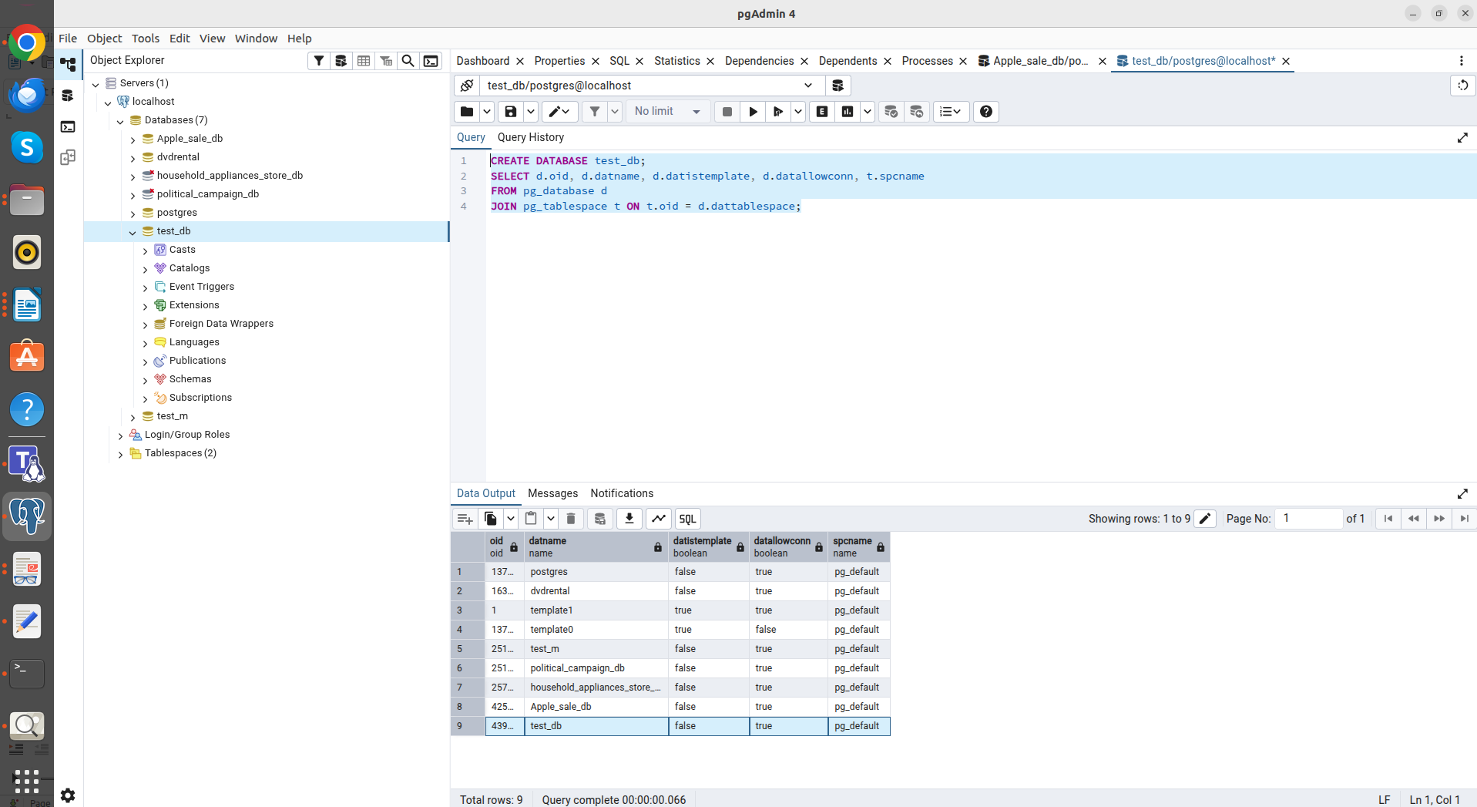
select d.oid, d.datname, d.datistemplate, d.datallowconn, t.spcname
from pg_database d
join pg_tablespace t on t.oid = d.dattablespace

In the second task, I created a user tablespace, mytablespace. This allows you to store data for a specific database on a separate drive or in a different folder. Using the ALTER DATABASE command, I moved the database to the new location and confirmed this by checking the file system.

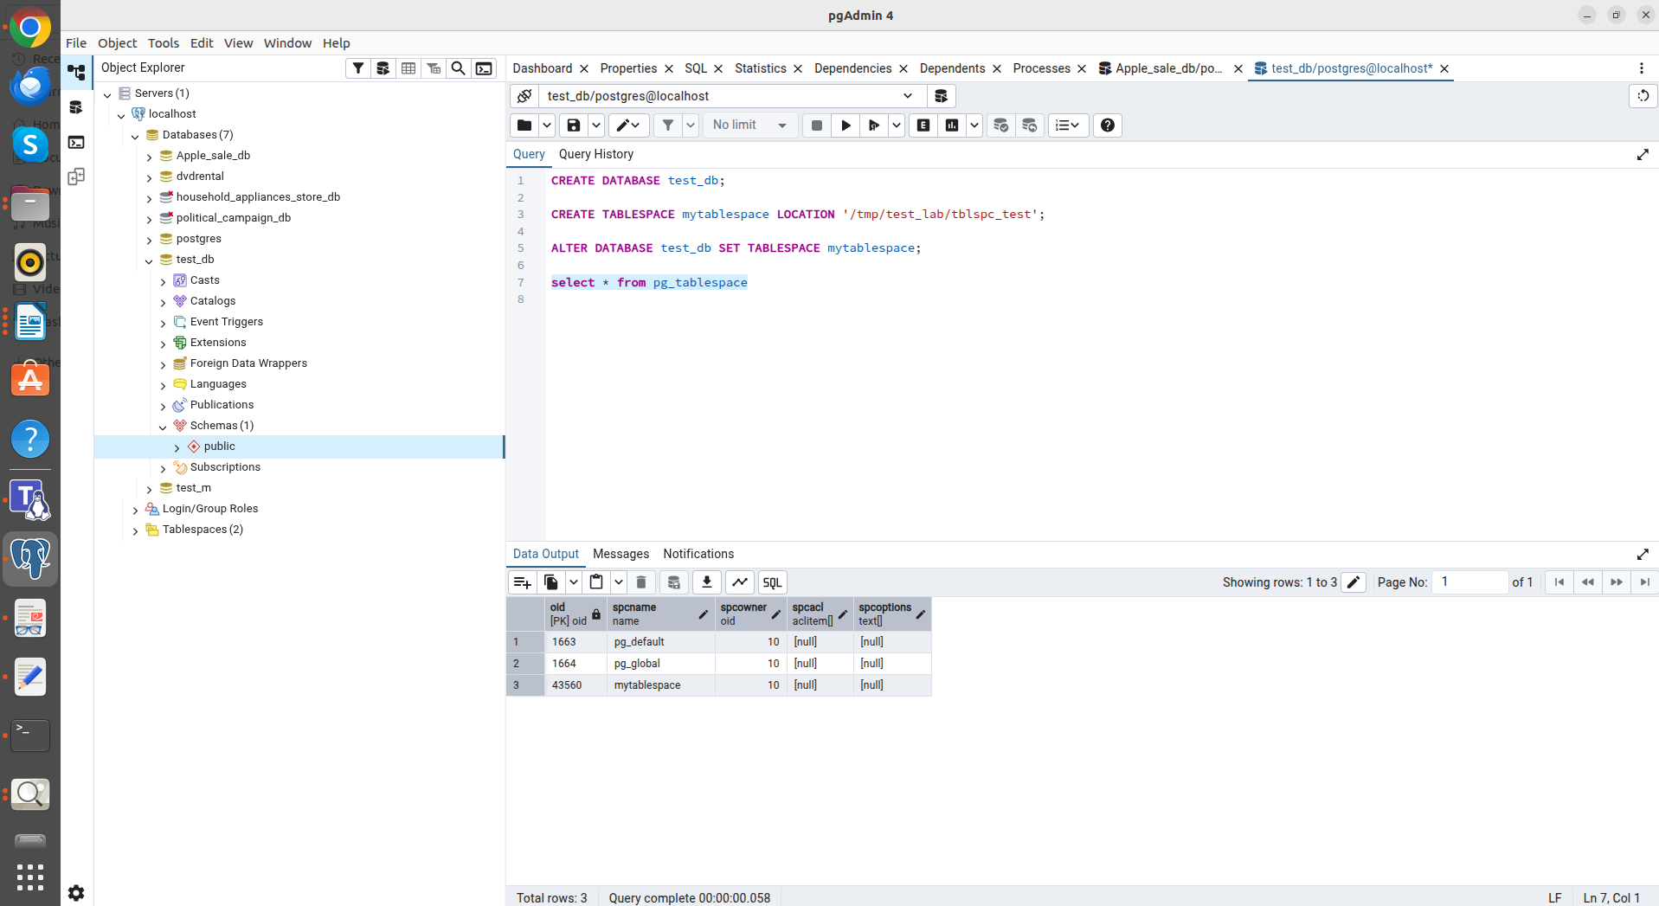
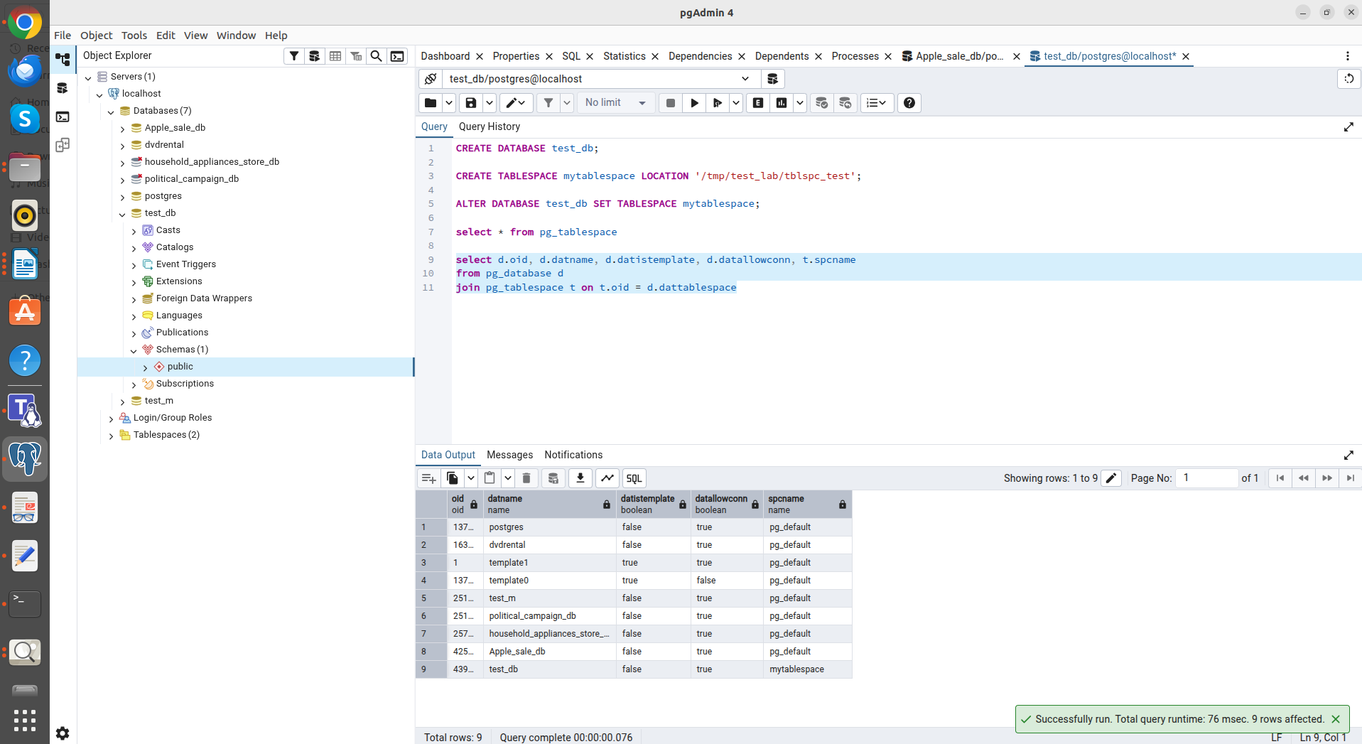
select * from pg_tablespace

select d.oid, d.datname, d.datistemplate, d.datallowconn, t.spcname
from pg_database d
join pg_tablespace t on t.oid = d.dattablespace

In the third task, I worked with the logical structure. I created the labs schema. I used the search_path parameter: after adding the schema to the search path, I could work with the person table without using prefixes, simplifying SQL queries.

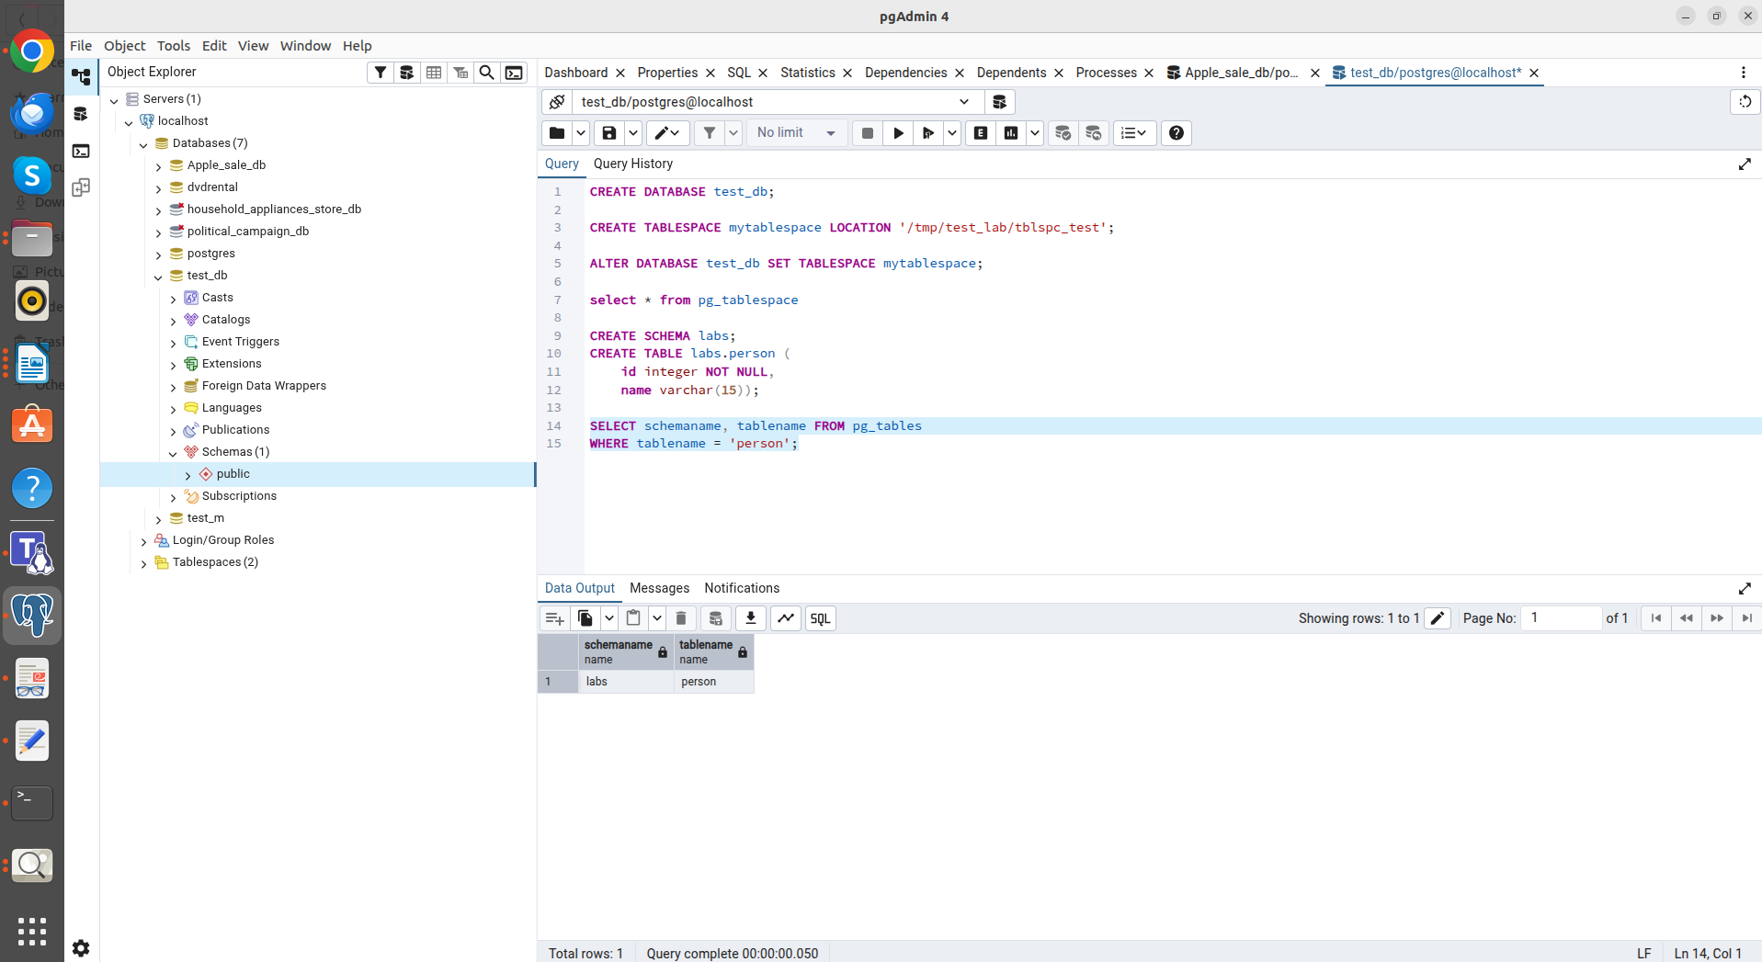
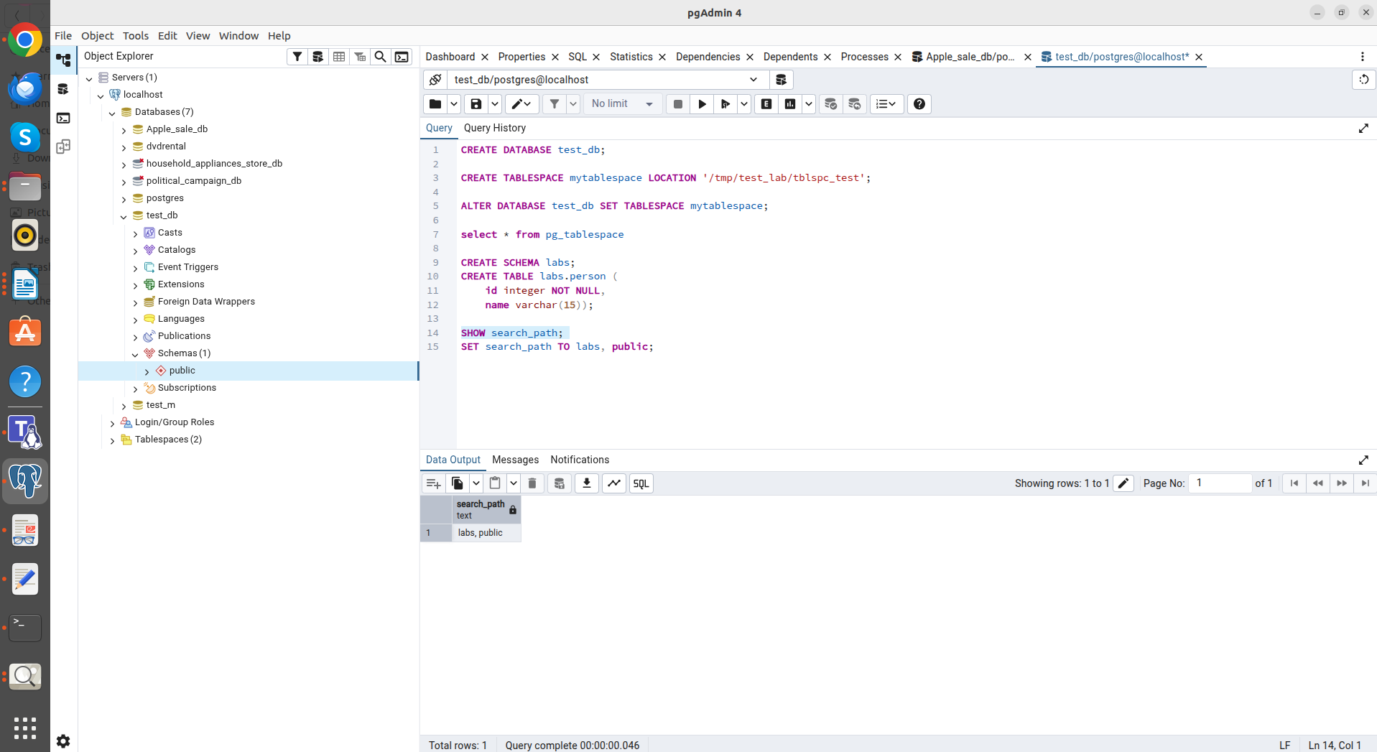
select schemaname, tablename from pg_tables
where tablename = 'person';

During Task 4, I explored multiversion concurrency. When performing an UPDATE, I noticed that PostgreSQL doesn't overwrite the data in a row, but instead creates a copy with a new value. The old version of the row is saved on disk, marked as deleted (the xmax field is populated). This allows other transactions to continue to see the old data until the update is complete.
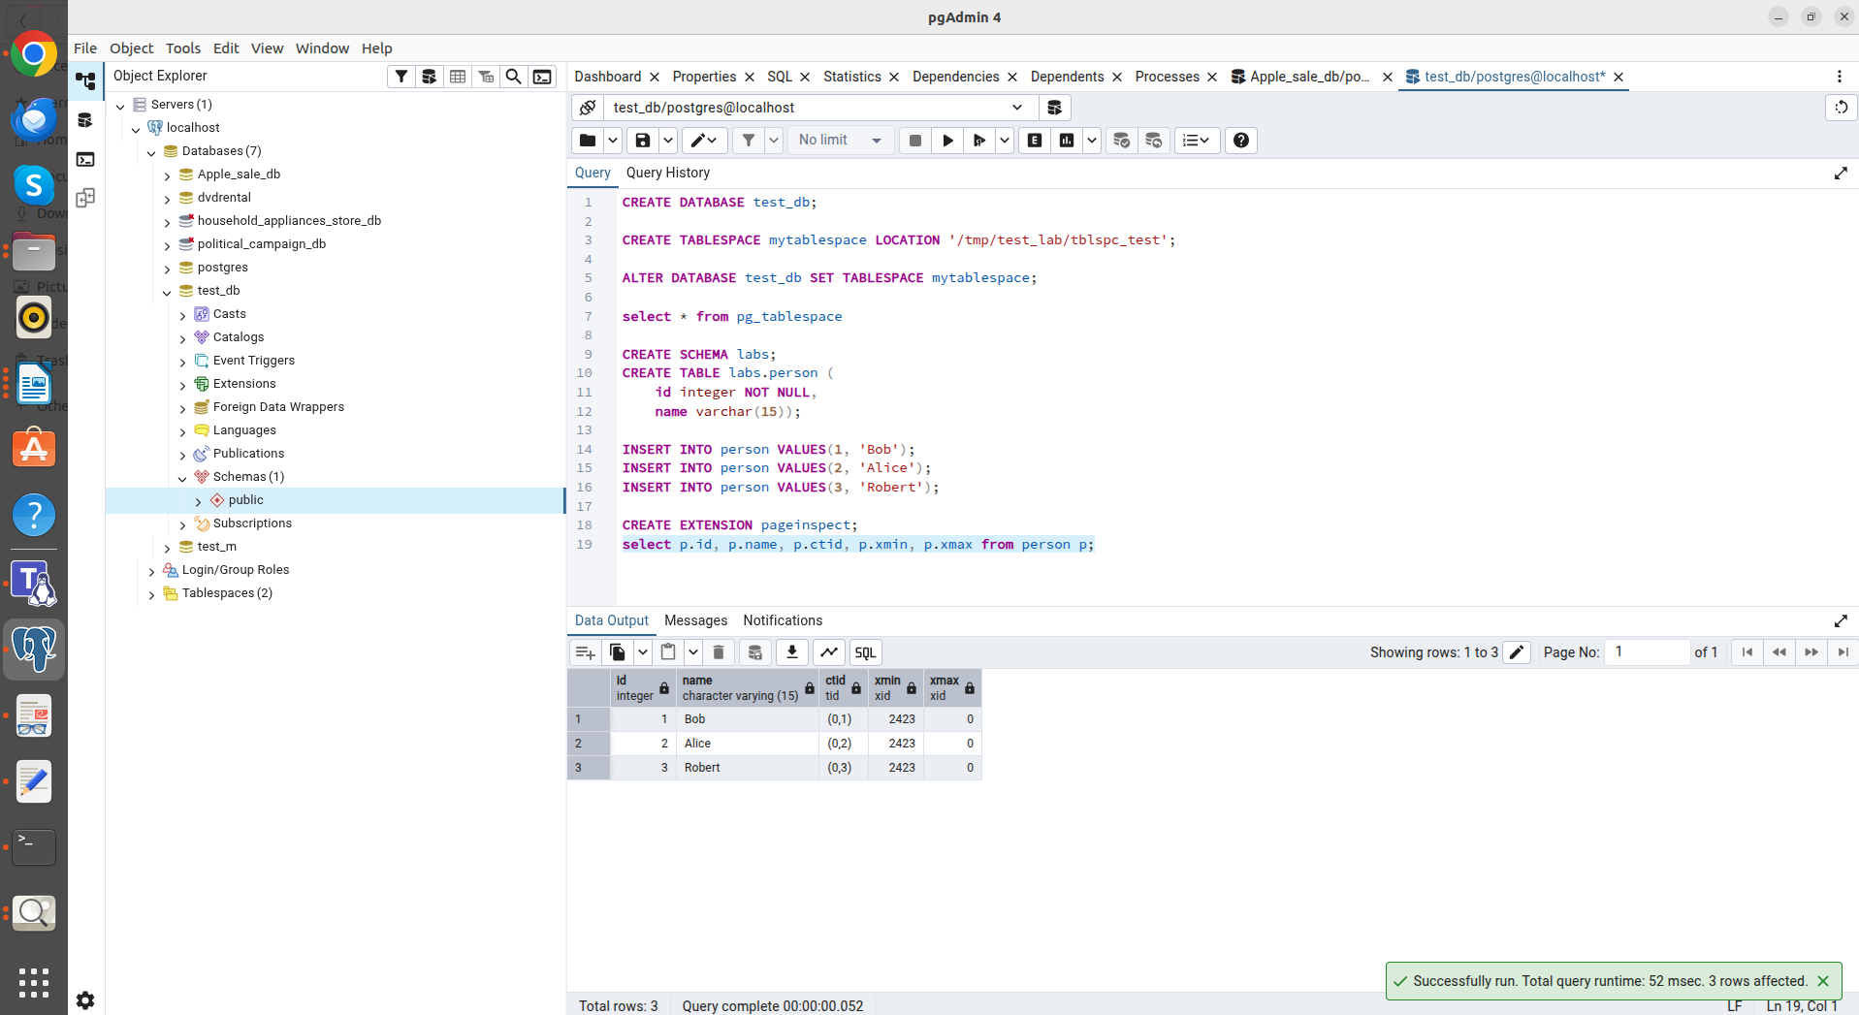
select p.id, p.name, p.ctid, p.xmin, p.xmax from person p; -->Q1
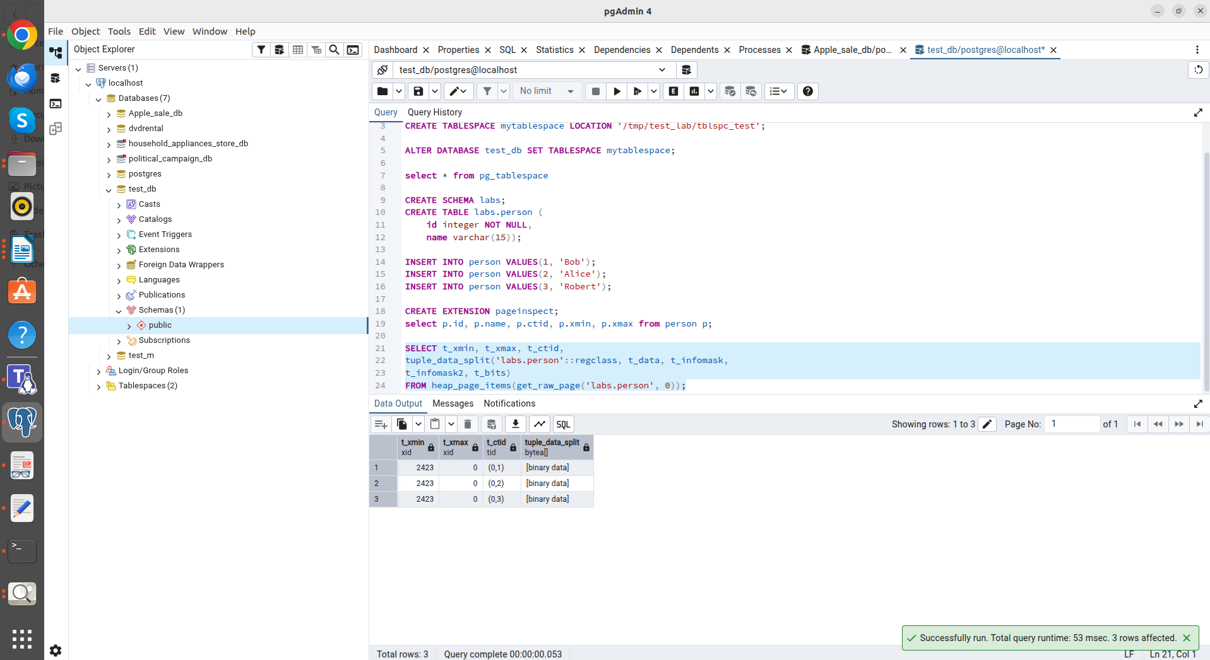
select t_xmin, t_xmax, t_ctid,
tuple_data_split('labs.person'::regclass, t_data, t_infomask,
t_infomask2, t_bits)
from heap_page_items(get_raw_page('labs.person', 0)); -->Q2

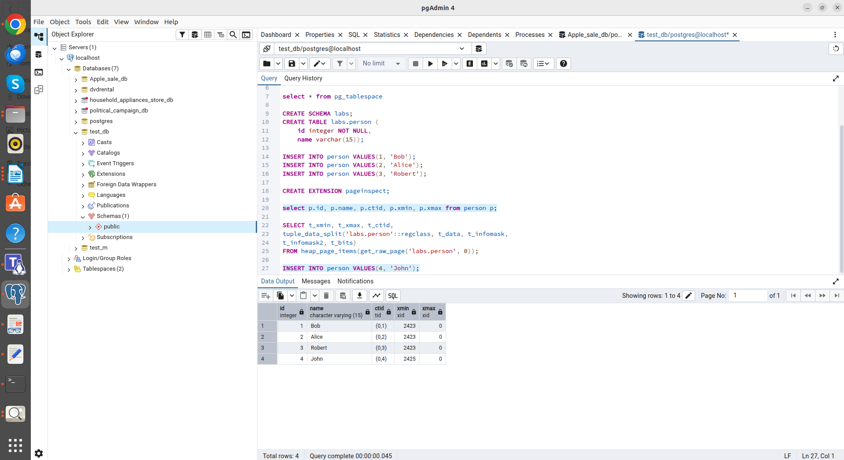
After INSERT INTO person VALUES(4, 'John');
Q1;
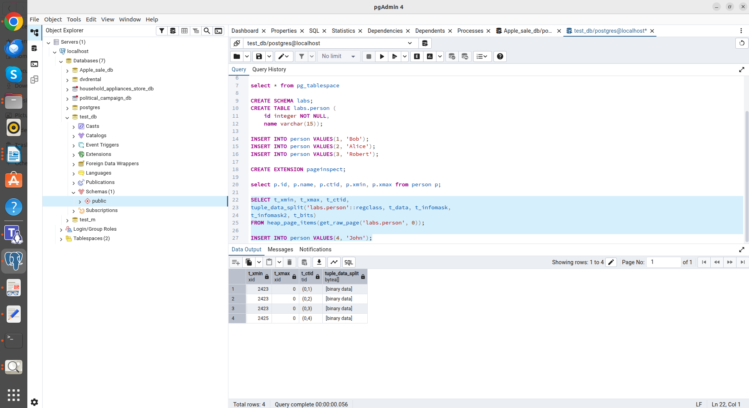
After INSERT INTO person VALUES(4, 'John');
Q2;

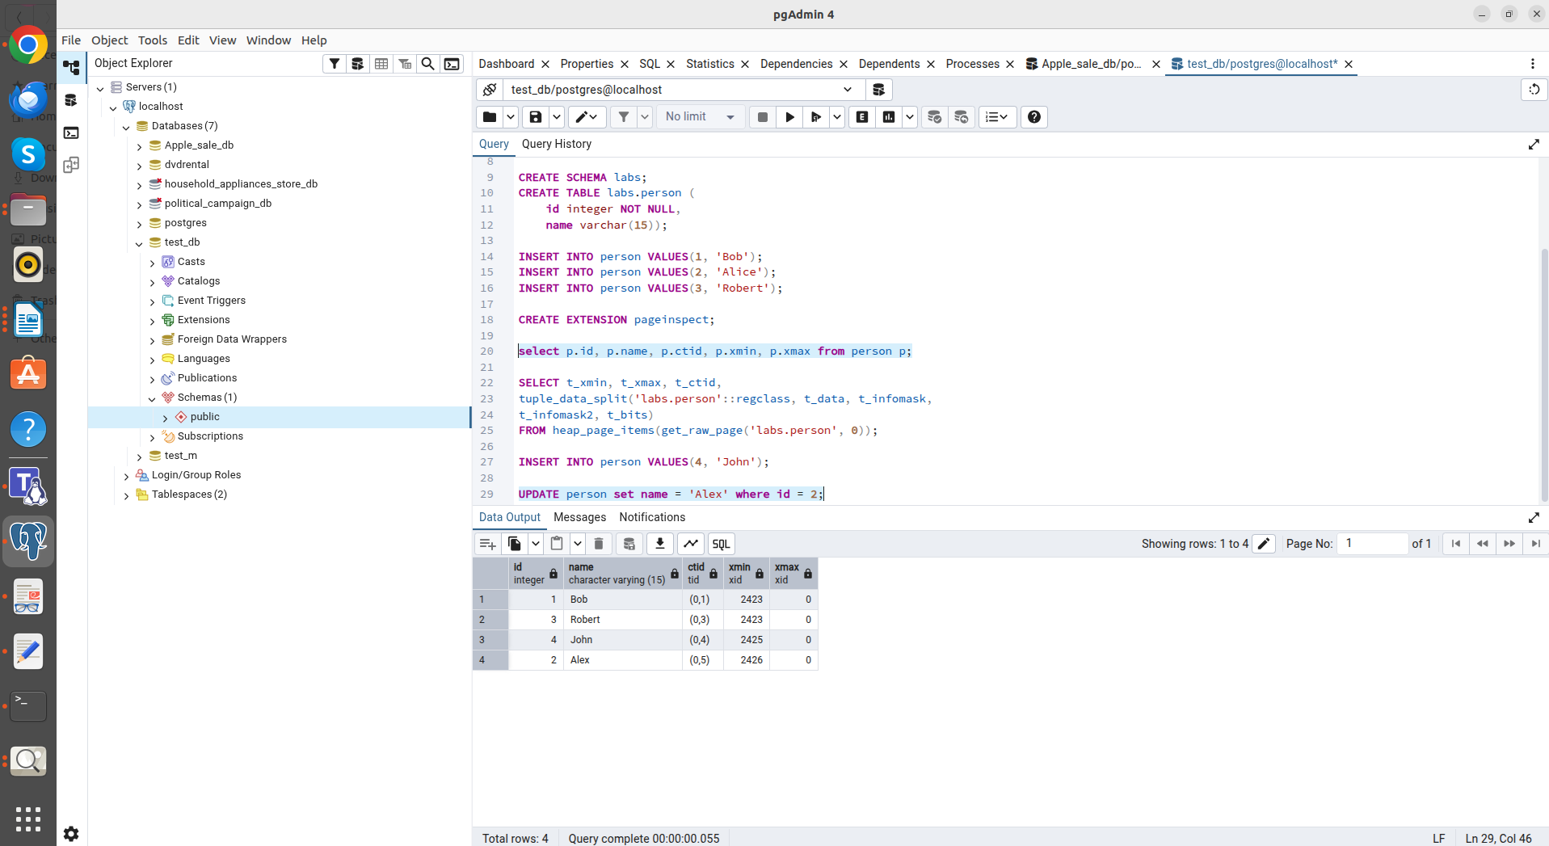
After UPDATE person set name = 'Alex' where id = 2;
Q1;
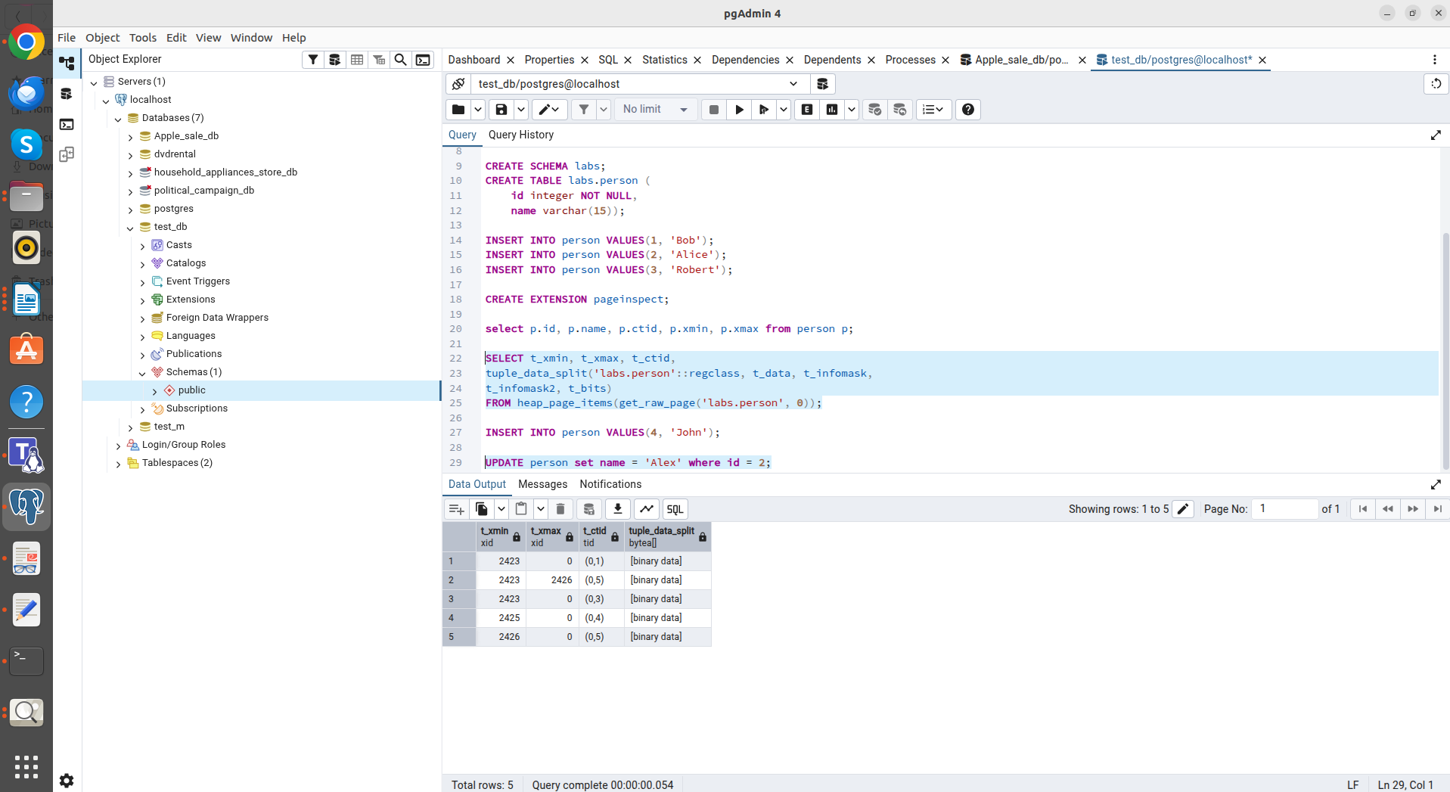
After UPDATE person set name = 'Alex' where id = 2;
Q2;

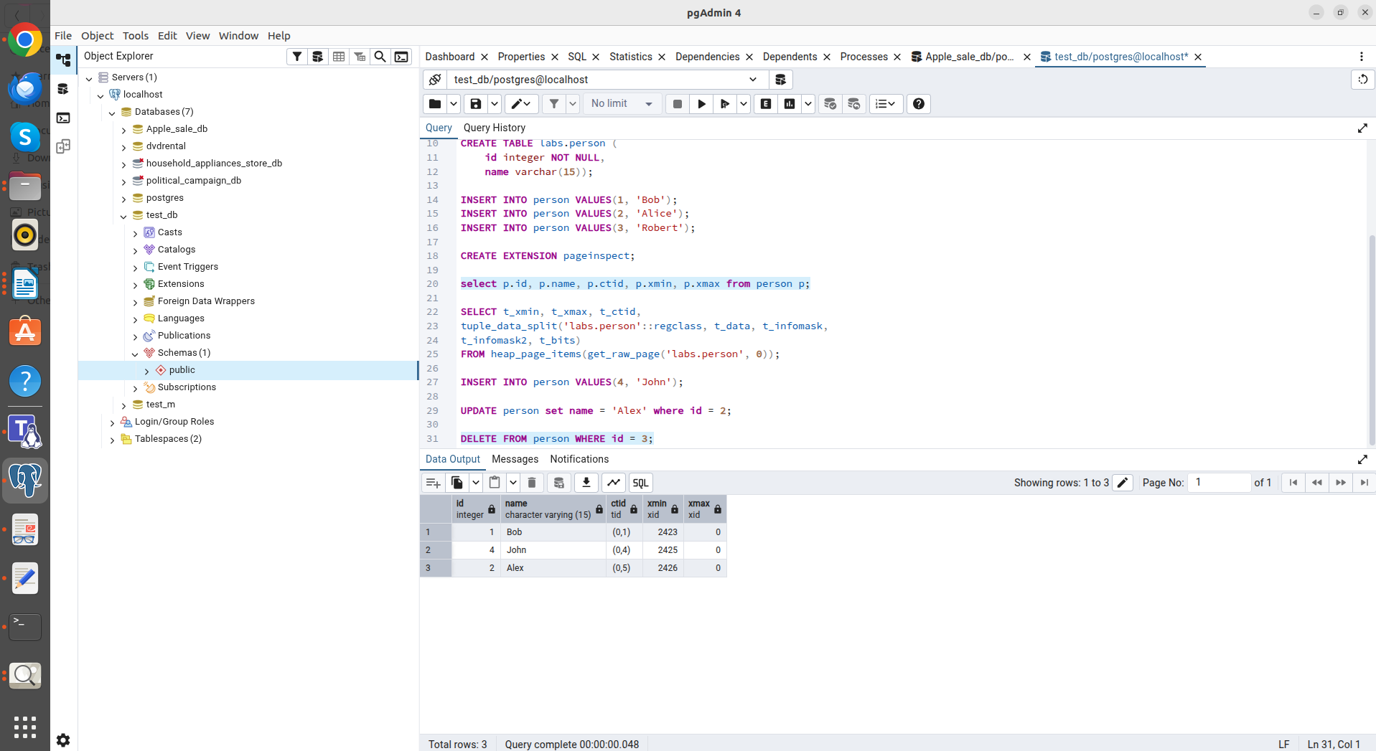
After DELETE FROM person WHERE id = 3;
Q1;
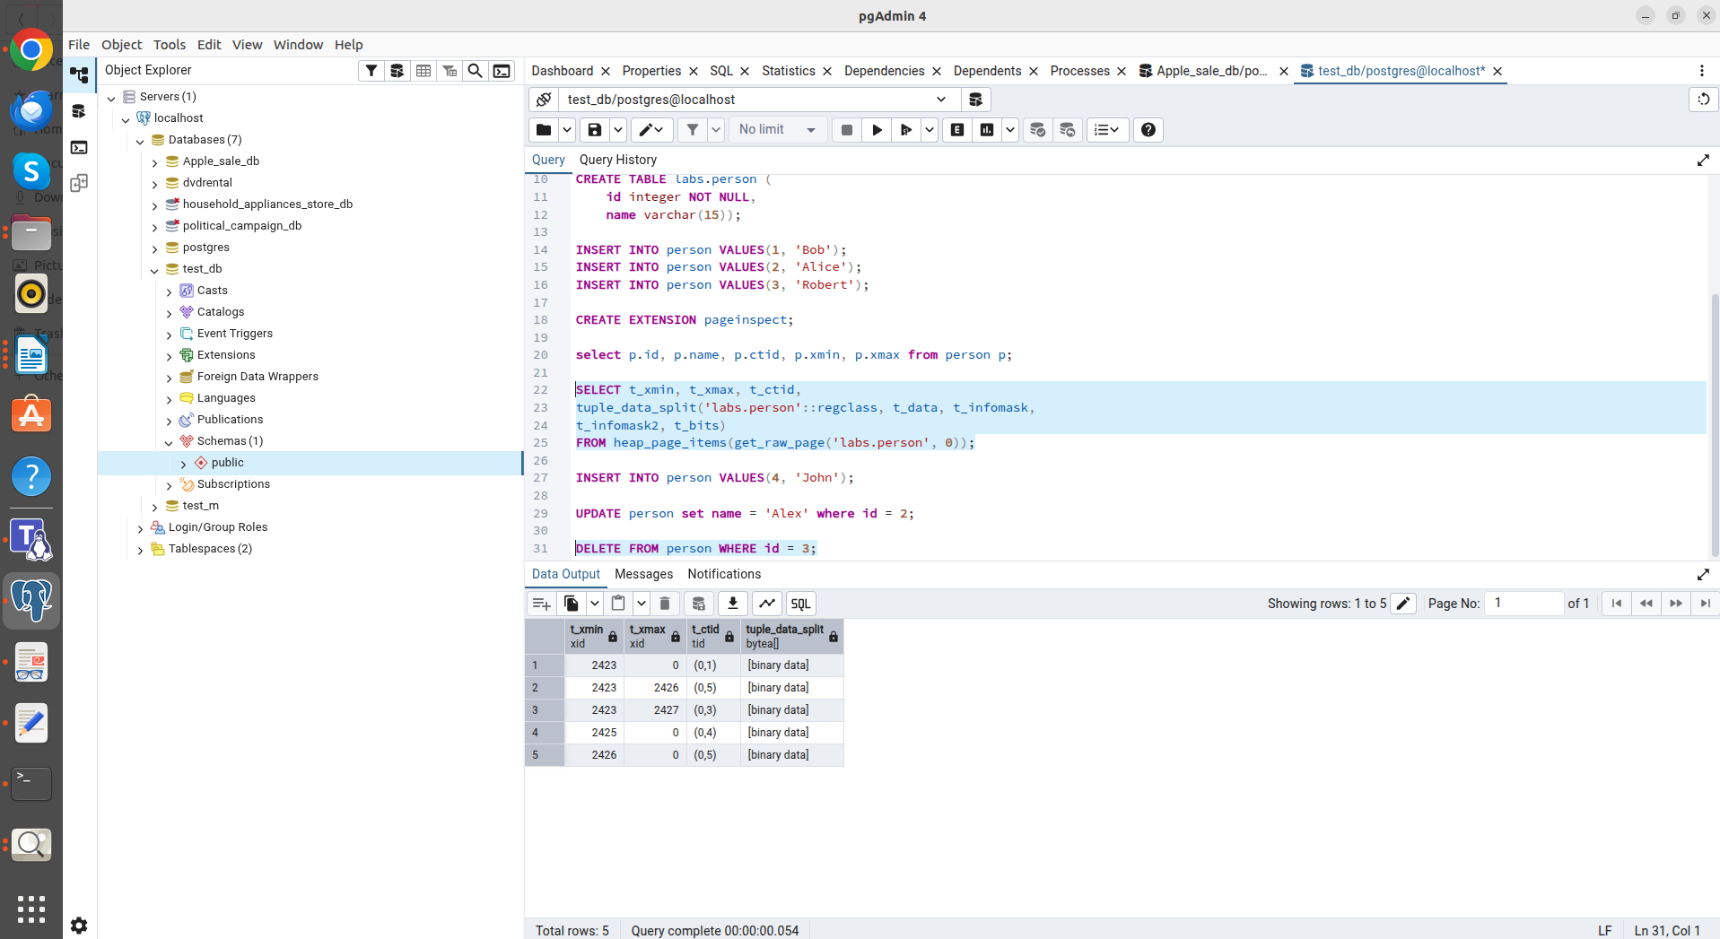
After DELETE FROM person WHERE id = 3;
Q2;

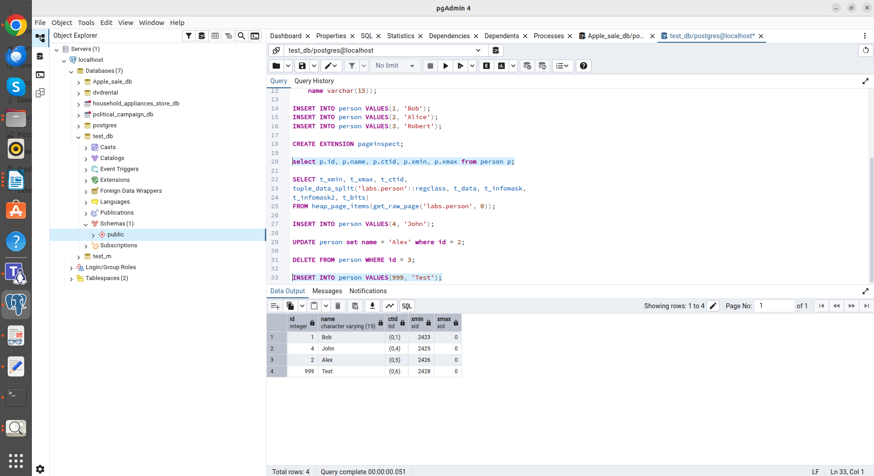
After INSERT INTO person VALUES(999, 'Test');
Q1;
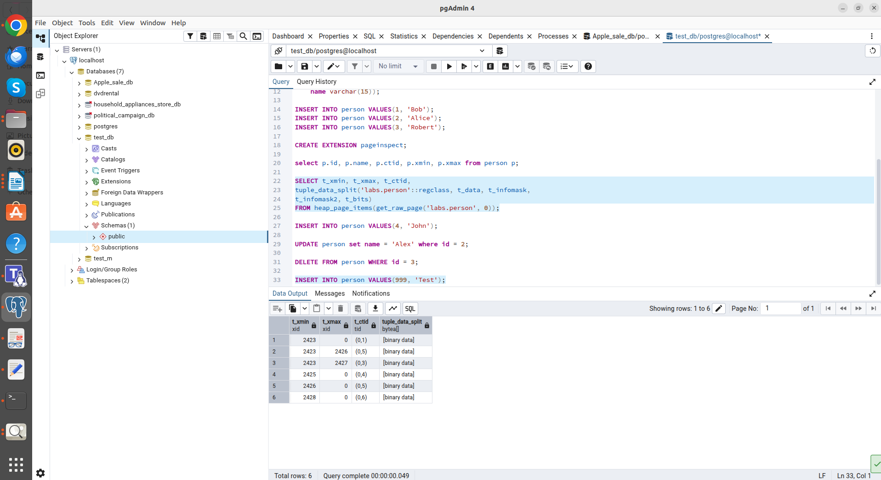
After INSERT INTO person VALUES(999, 'Test');
Q2;

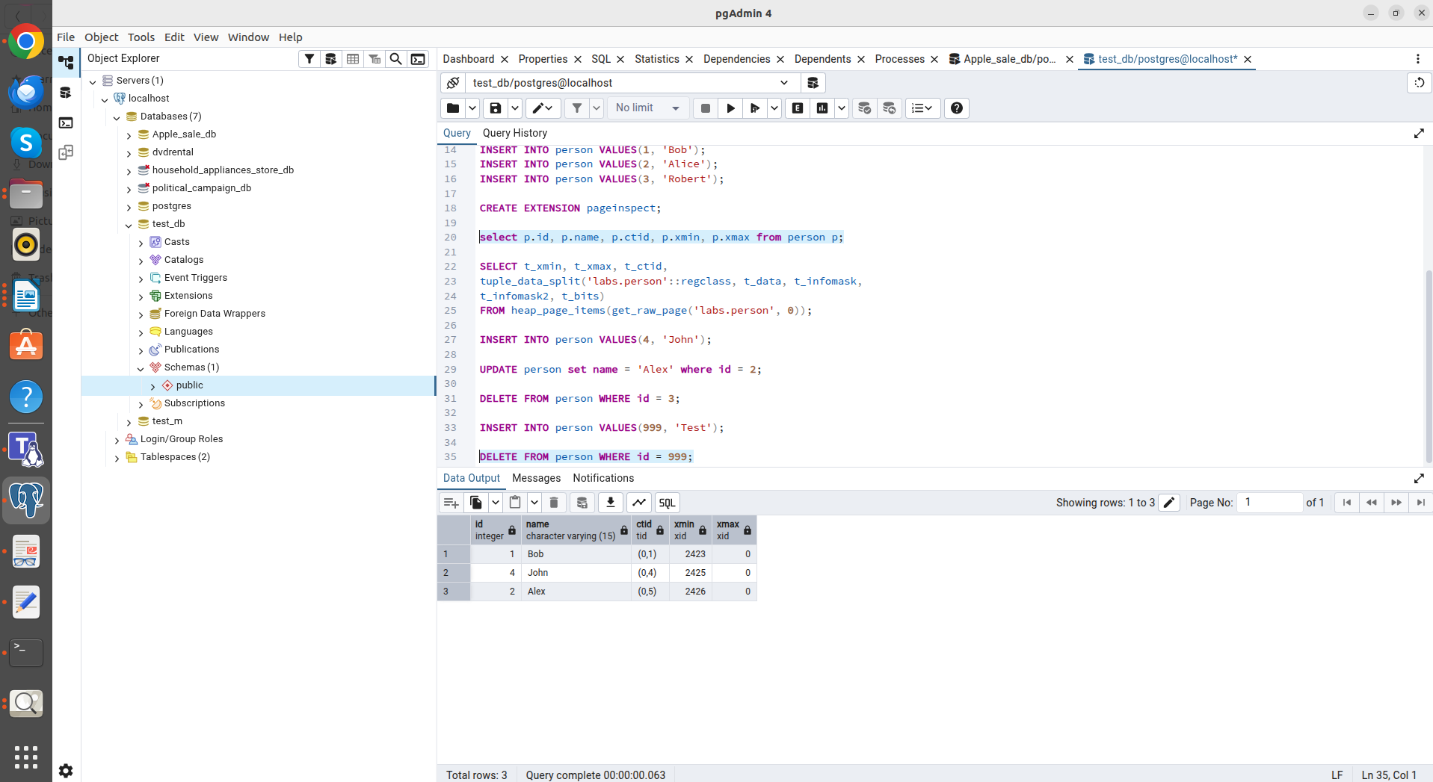
After DELETE FROM person WHERE id = 999;
Q1;
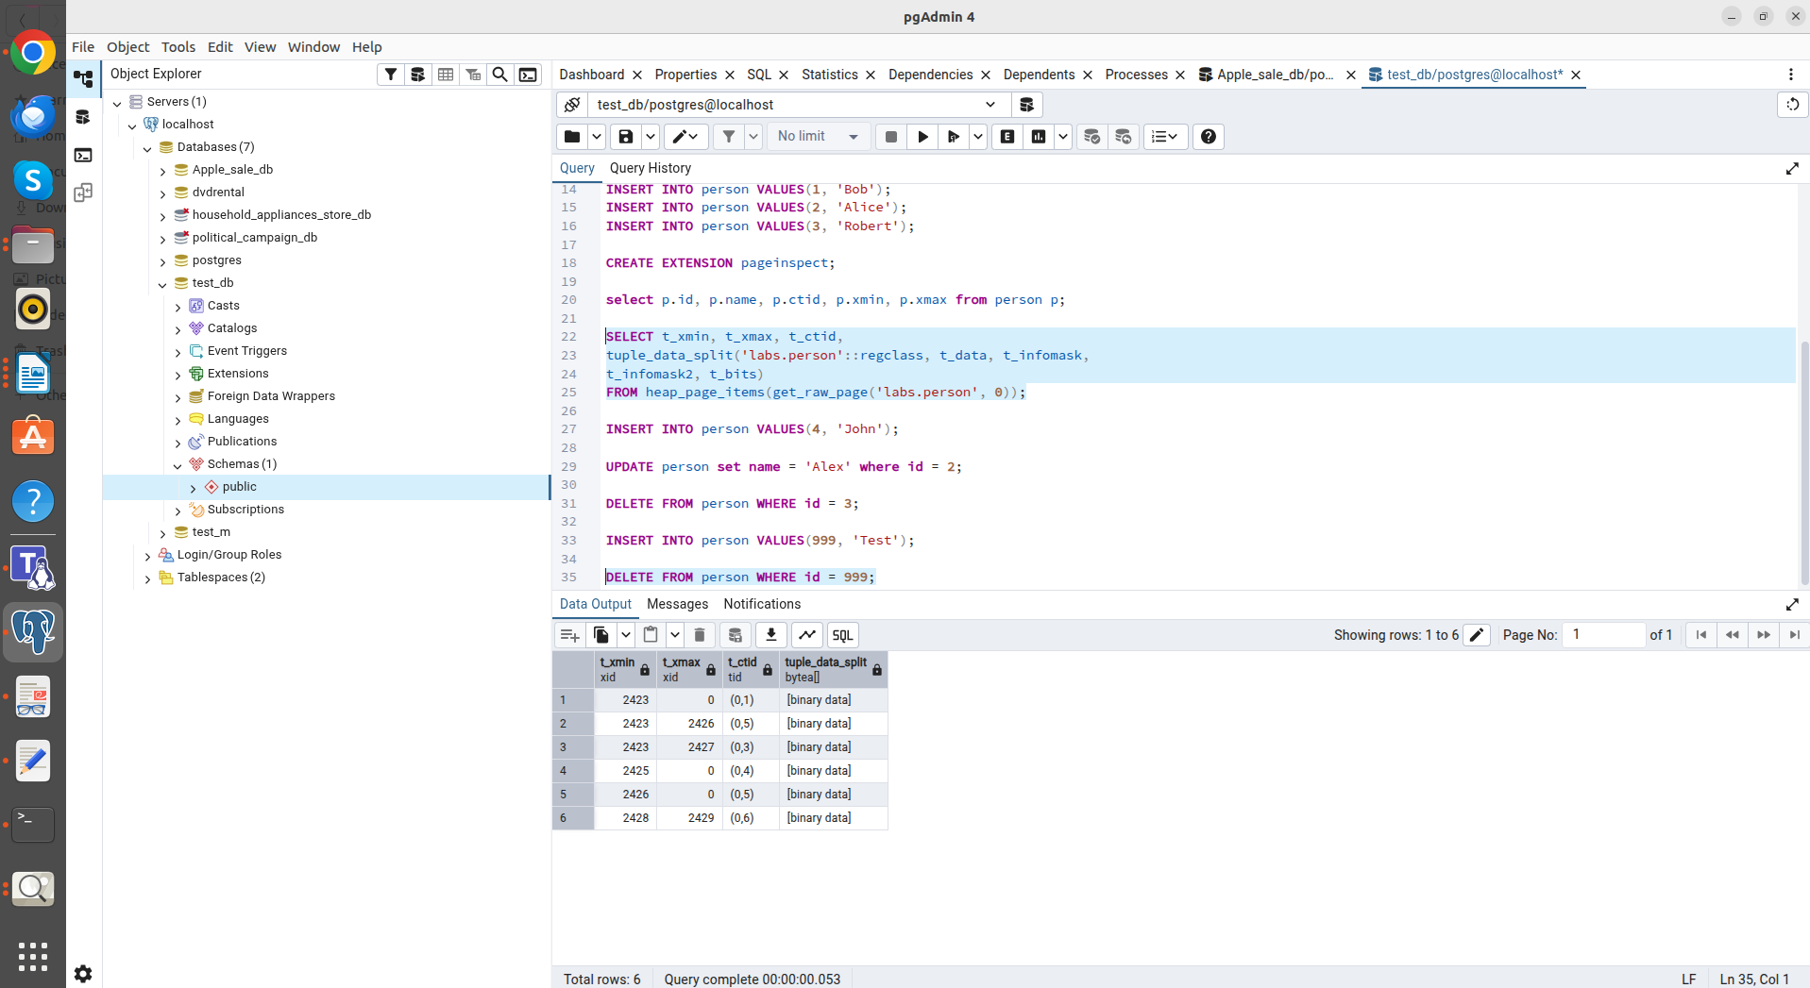
After DELETE FROM person WHERE id = 999;
Q2;

In Task 5, I examined the vacuum process. A regular VACUUM freed up space within the data page, making it available for new inserts (which I confirmed by inserting the record 'Sarah', which replaced the deleted row).

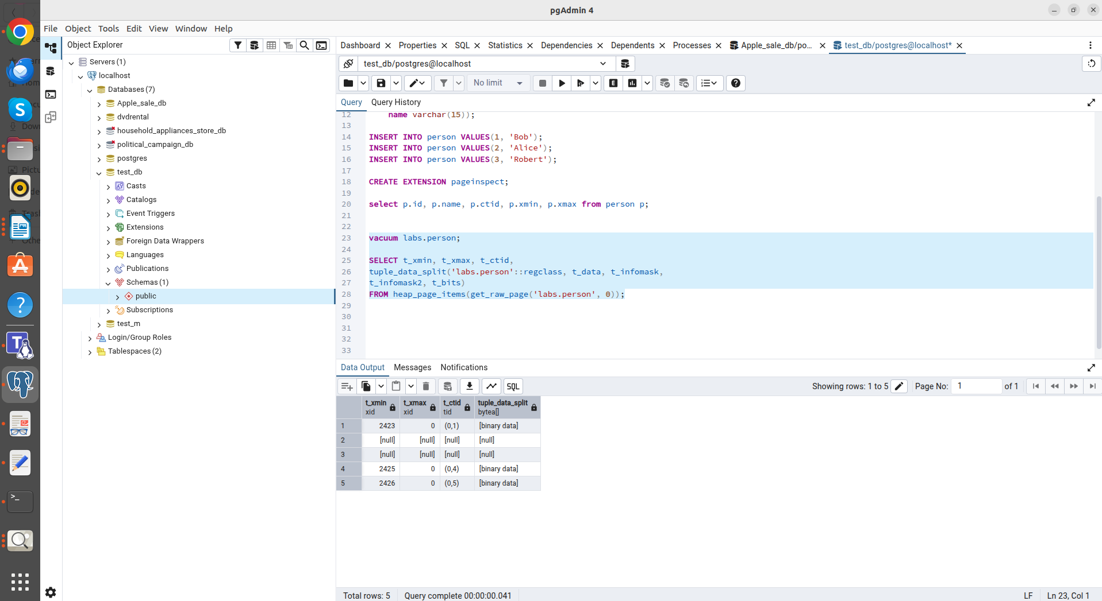
After vacuum labs.person;
Q2;
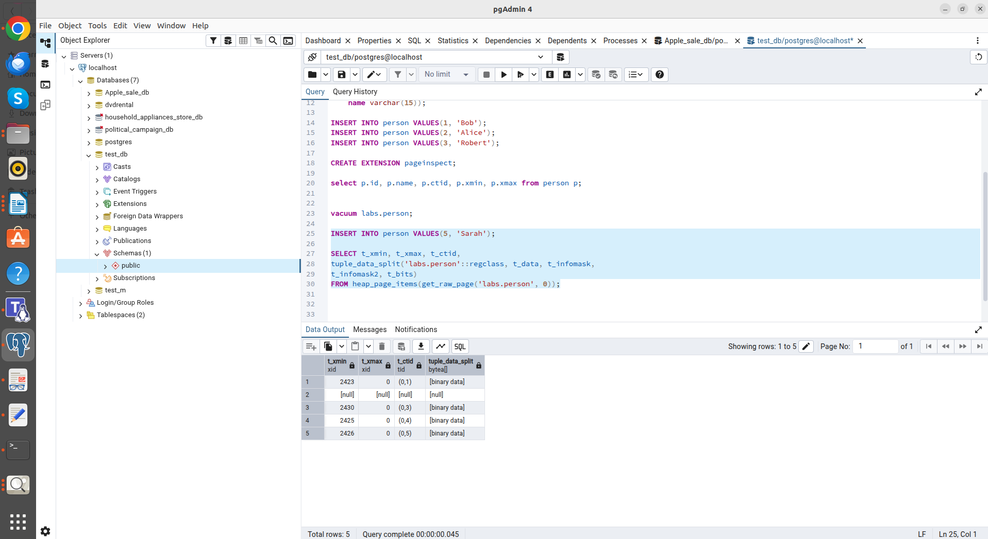
After INSERT INTO person VALUES(5, 'Sarah');
Q2;

The final step was executing a VACUUM FULL. Unlike a regular vacuum, this process completely rebuilt the table, physically removing dead row versions and reducing the size of the data file on disk, which was reflected in a change in the physical addresses of the ctid rows.

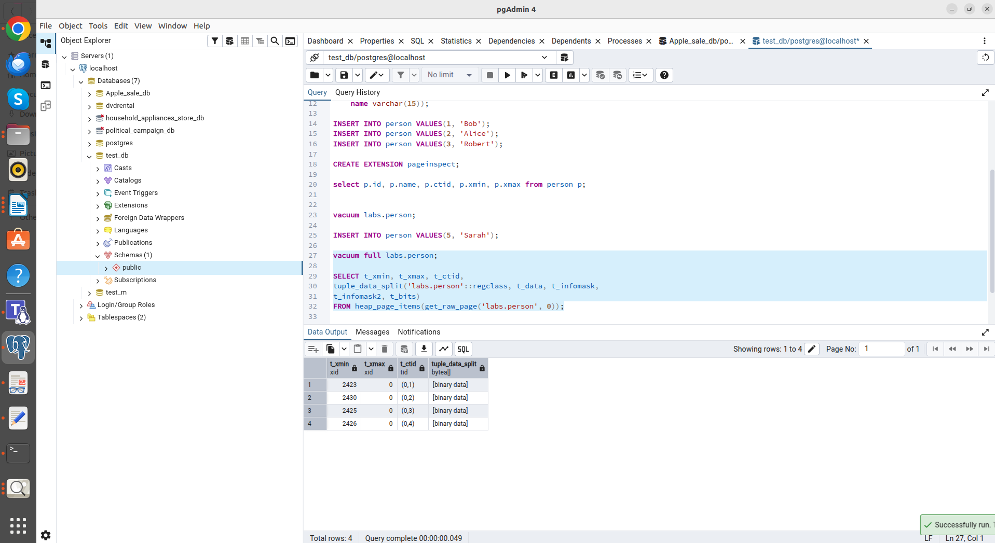
After vacuum full labs.person;
Q2;

