Description of homework
1.1 WORKING WITH POWER BI MODEL
Description:
I examined the relationships automatically detected by Power BI. I specifically looked at:
Cardinality: Verified the "Many-to-One" (*:1) relationship between the fact table and dimensions.
Cross Filter Direction: Ensured the direction is set to "Single" (from Dimension to Fact table).

In the previous home task I already did optimization date relationship:
The FactInternetSales table originally had multiple relationships with DimDate (based on OrderDate, DueDate, and ShipDate).
To ensure the analysis focuses strictly on the transaction date, I removed the relationships linked to DueDateKey and ShipDateKey.
I then set the relationship between OrderDateKey (FactInternetSales) and DateKey (DimDate) to Active, which is indicated by the solid line.

1.2 WORKING WITH POWER BI REPORT
1. Building Visualizations
Description:
I switched to the Report View to begin designing the dashboard. Using the Visualizations pane, I can now select different chart types to represent the data loaded in the previous steps.
2. Adding and Configuring a Slicer
Description:
I added a Slicer to the report page to allow users to filter data by customer.
Field: I dragged the Full Name column (from DimCustomer) into the slicer.
Formatting: I tested two layouts: List and Dropdown.
Search Feature: I enabled the Search option by clicking the ellipsis (...) on the visual and selecting "Search".
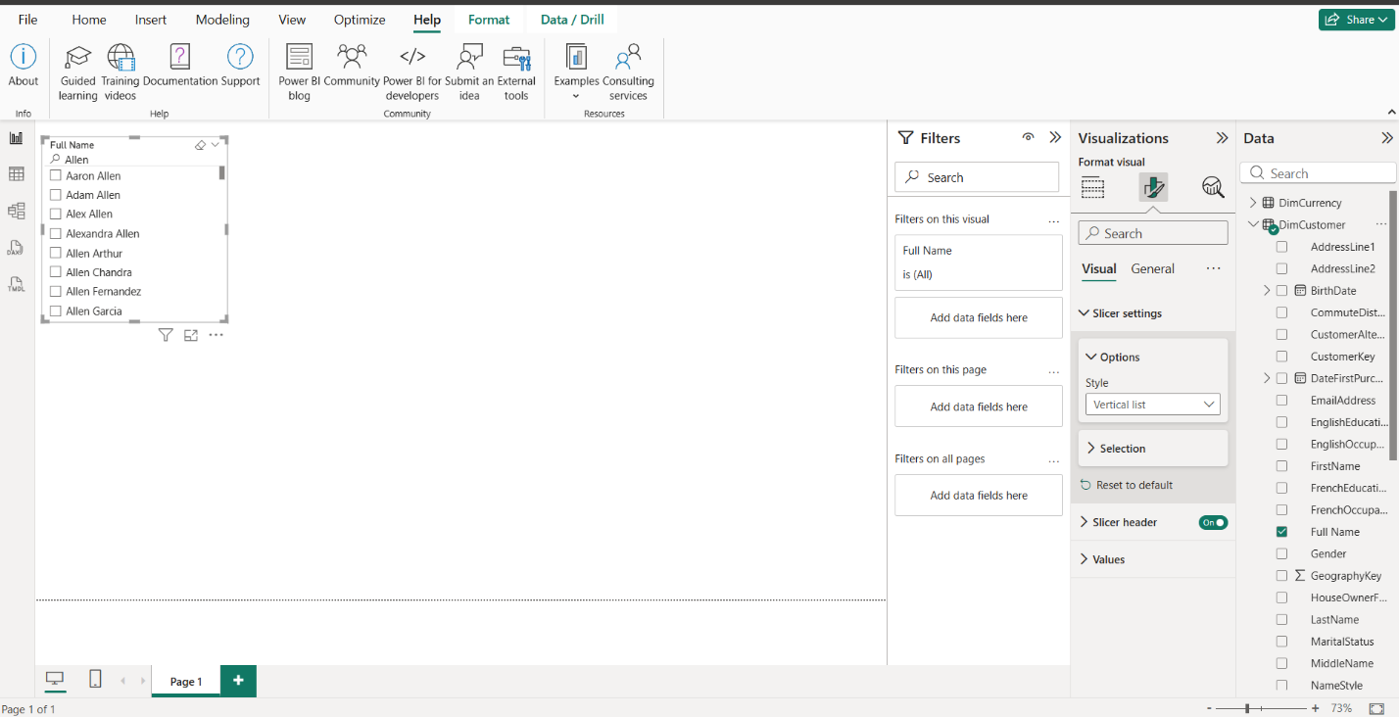

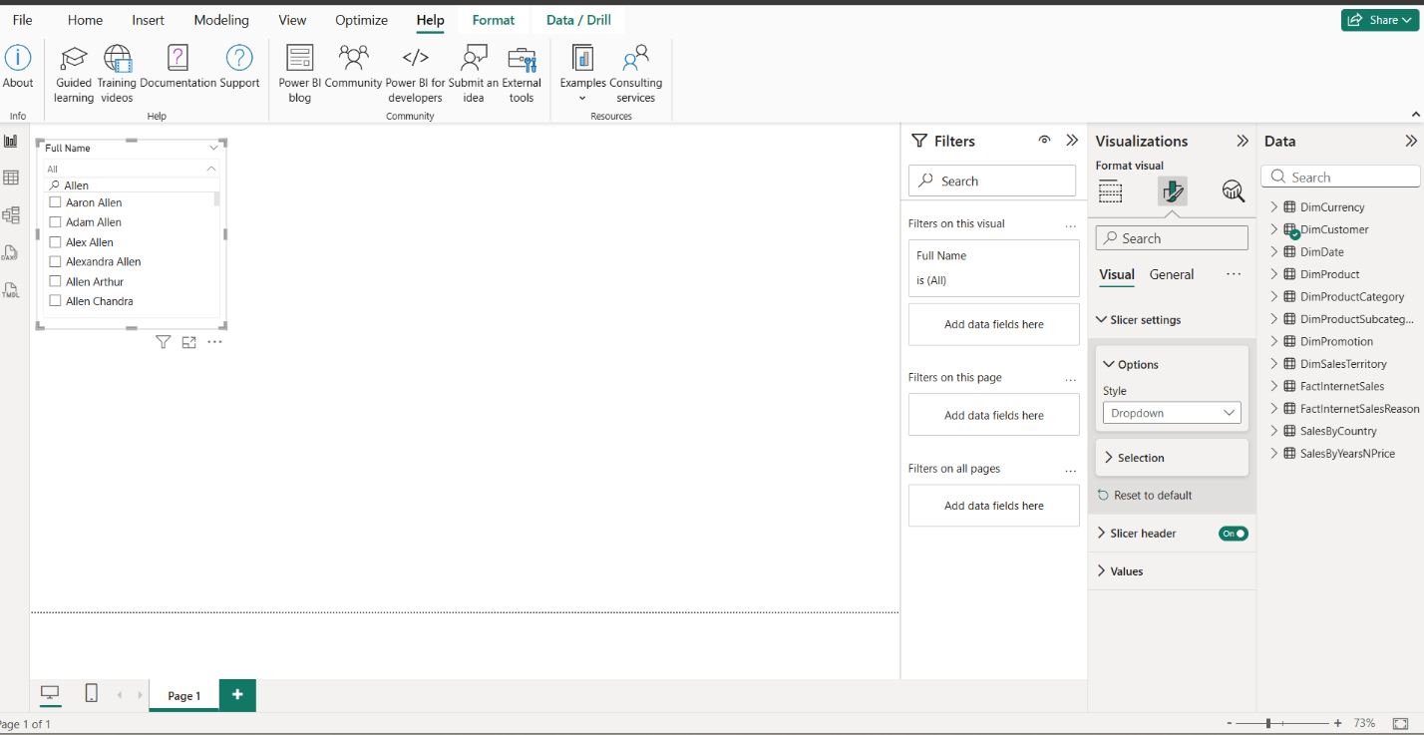

3. Importing a Custom Visual from AppSource
Description:
To enhance the analytical capabilities of the report beyond the standard set of charts, I accessed the Power BI Visuals Marketplace (AppSource).
Selection: I browsed the Marketplace and selected a custom visual Word Cloud. This visual is now available in my local Visualizations pane for use in the report.
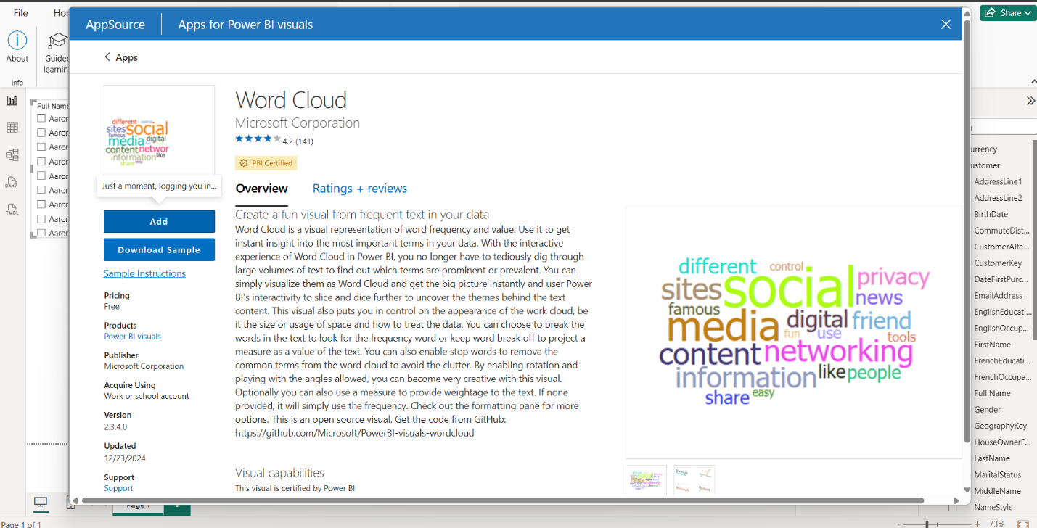
4.2 CREATE LAB REPORT
1. Report Design and Branding
Description:
I tried to create a report design consistent with the corporate style. I also chose a logo that I thought was appropriate.
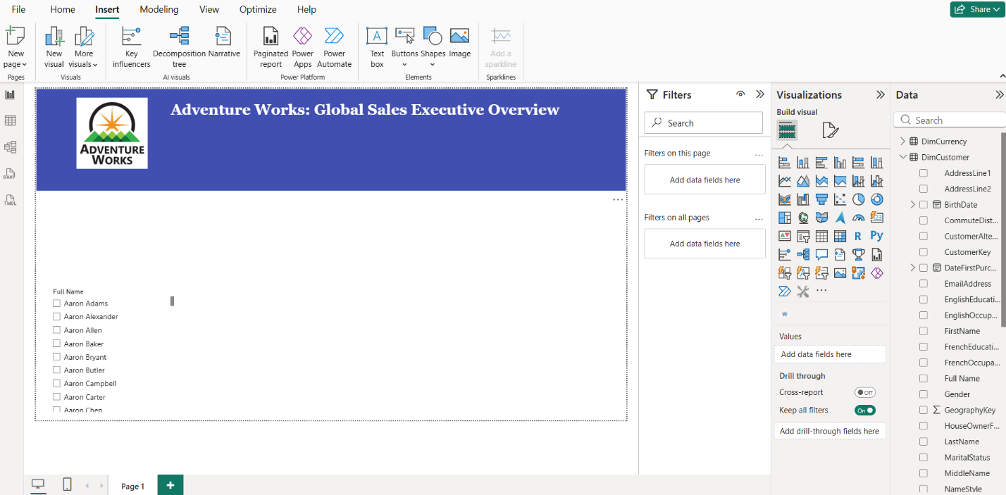

2. Slicers and Interactivity
Description:
To provide flexible data exploration, I implemented three types of slicers:
Date Filter: A "Between" style slider using DimDate[FullDateAlternateKey].
Dropdown Slicer: For SalesTerritoryRegion, allowing compact region selection.
List Box with Search: A product category slicer.
Interaction Control:
I disabled interactions between the Product Category Chiclet Slicer and the Total Sales Trend Line Chart (Sales by year). This allows users to see specific category details in other visuals while maintaining a global performance view on the trend chart for comparison.
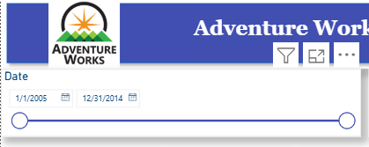

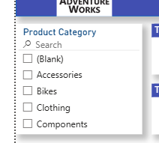 | 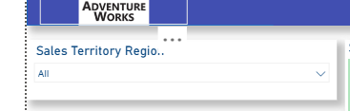
3-5. Data Visualizations
Description:
The report features 5 standard visuals and 2 custom visuals across two pages:
Standard: Cards (Total Sales, Total Orders, Total Profit etc.), Line Chart (Time trends), Bar Chart (Top 10 Products Top 10 Customers), Donut Chart (Gender demographics).
Custom - Word Cloud: Chosen to identify popular product models dynamically. Reason: Provides instant visual cues on product popularity without scrolling through tables. And it seems to me that it matches the name and style of the company.
Custom - Chiclet Slicer: Used for category filtering. Reason: Enhances UI/UX by providing button-style navigation that fits the brand's aesthetic.
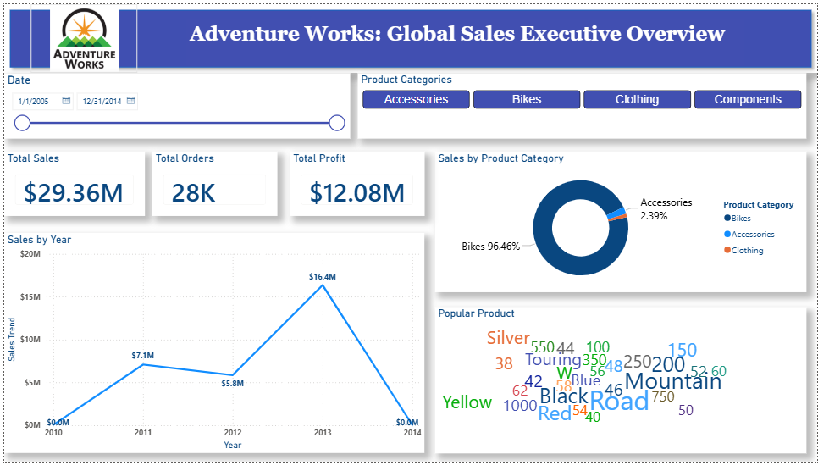
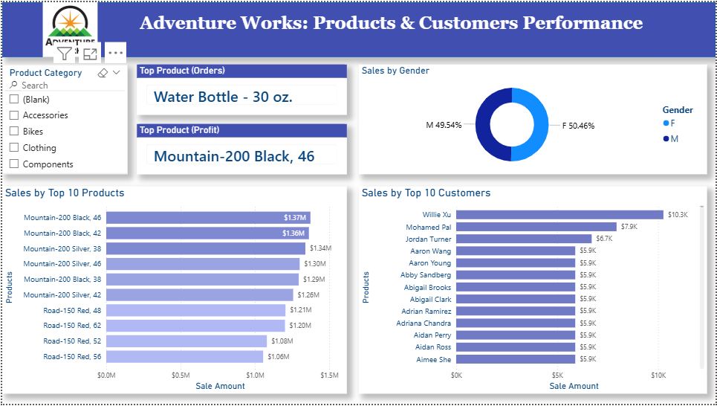
6. Geographic Analysis
Description:
A Map Visual was configured using DimGeography[StateProvinceName] as the location and SalesAmount as the bubble size. This visualizes the global footprint of sales and identifies high-revenue territories.
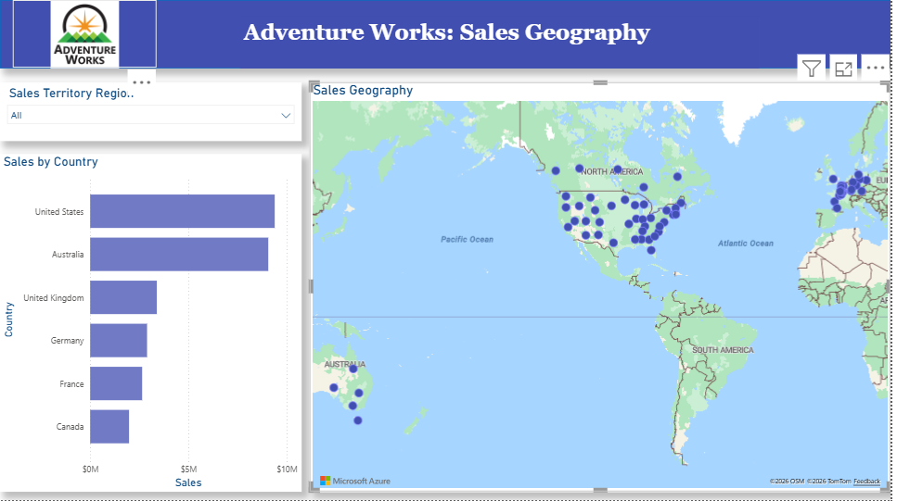

7-9. Mobile Layout & Publishing
Description:
Mobile Layout: Configured a vertical view optimized for smartphones.
Publishing: The report was published to Power BI Service (My Workspace).
Data Refresh: A Personal Gateway was configured. Scheduled Refresh is set to daily at 10:00 AM to ensure the Adventure Works data remains up-to-date.
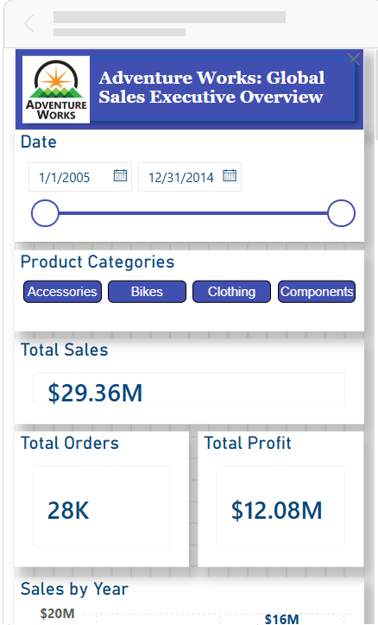 | 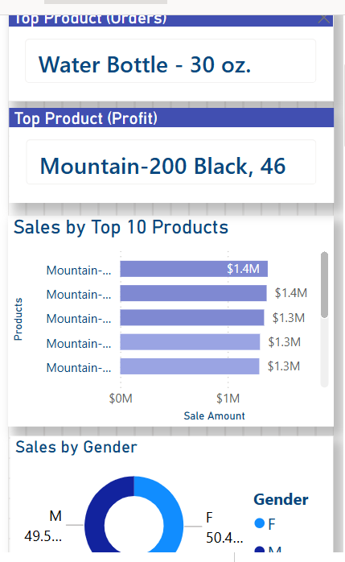

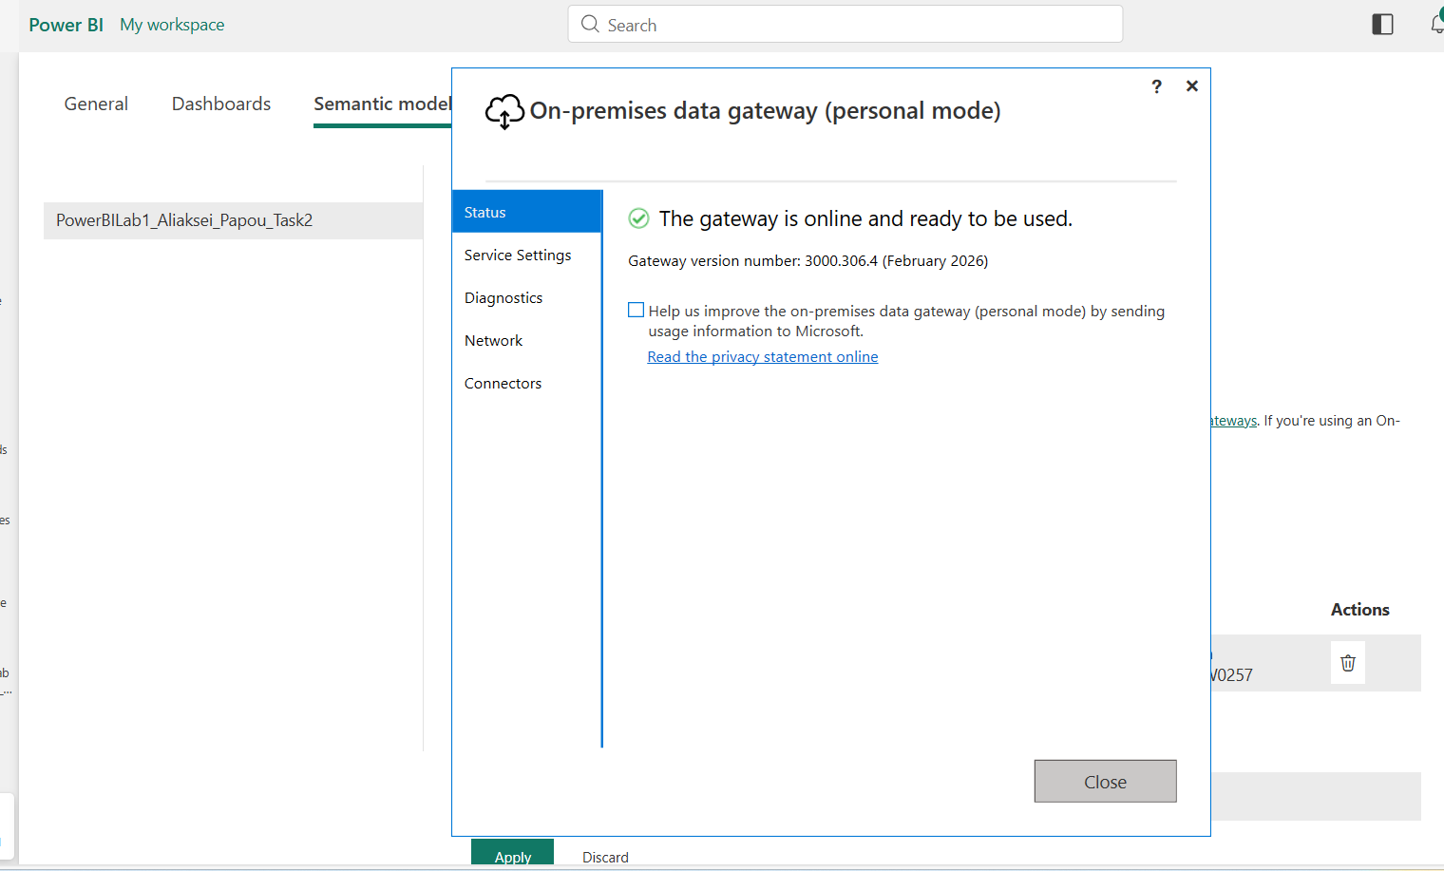

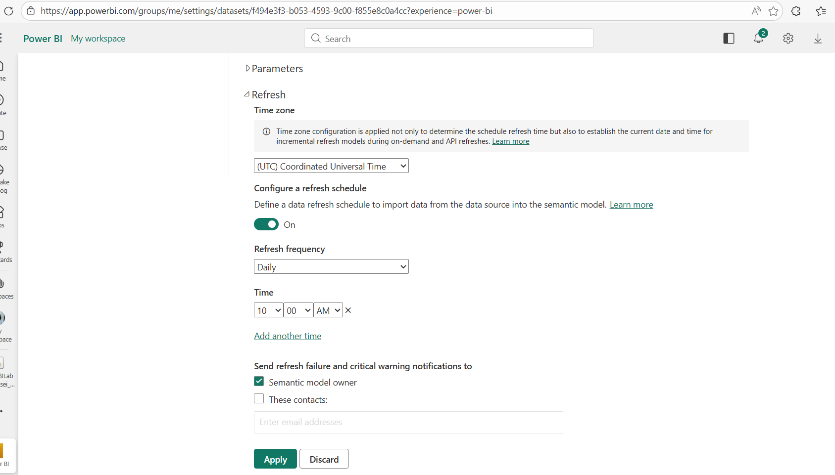

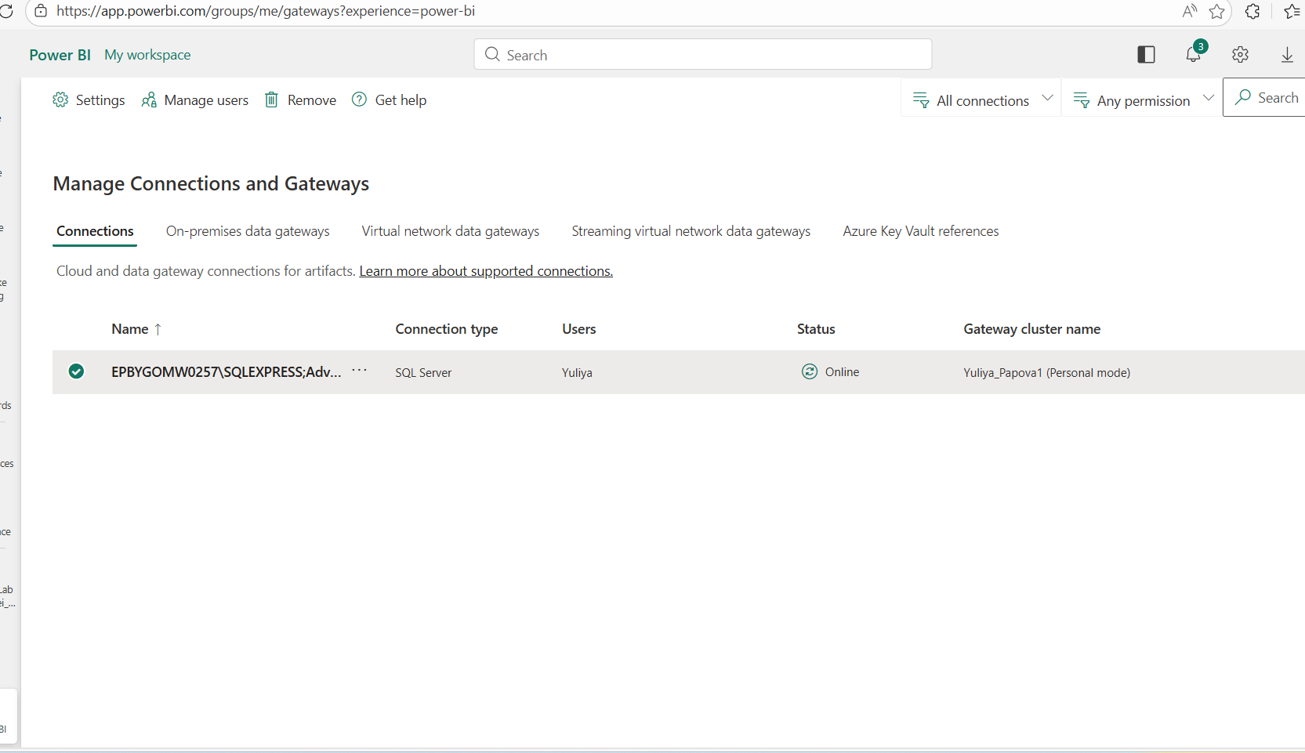

9. Share the report
Description:

I shared the report with my mentor and sent an email notification.
10. URL Filtering
Description:
I created URL links that contain a built-in filter:
by country (France)
Global Sales Overview - PowerBILab1_Aliaksei_Papou_Task2 - Power BI
by category (Bikes)
Global Sales Overview - PowerBILab1_Aliaksei_Papou_Task2 - Power BI

