Description of tasks:
1. Since I don't have access to the database, I created my own MySQL database. I checked the security group for MySQL/Aurora in the Inbound rules.

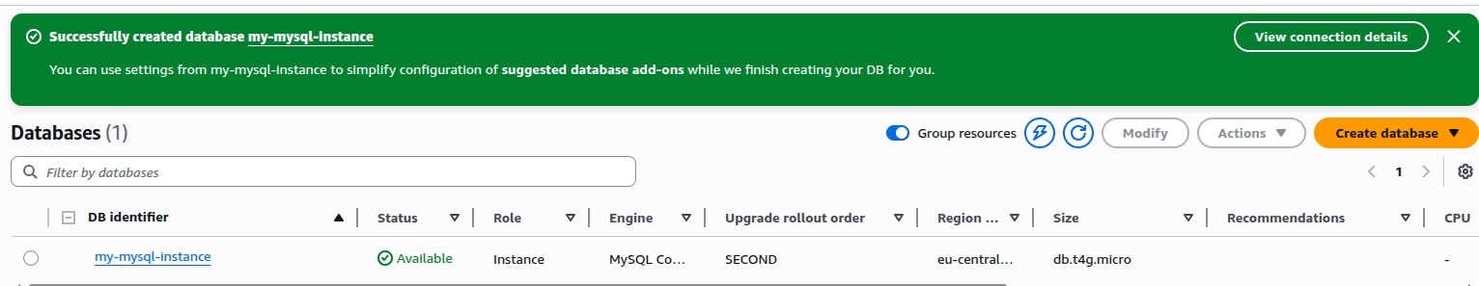

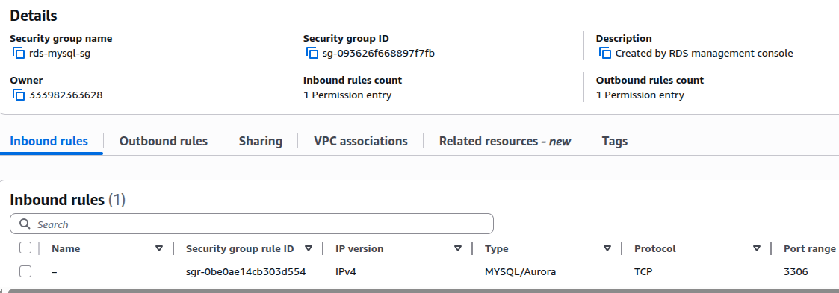

Then I installed the MySQL client on my Ubuntu.

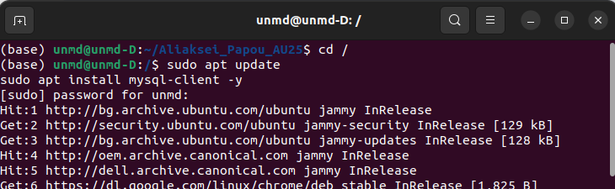

Then I successfully connected to the MySQL instance.

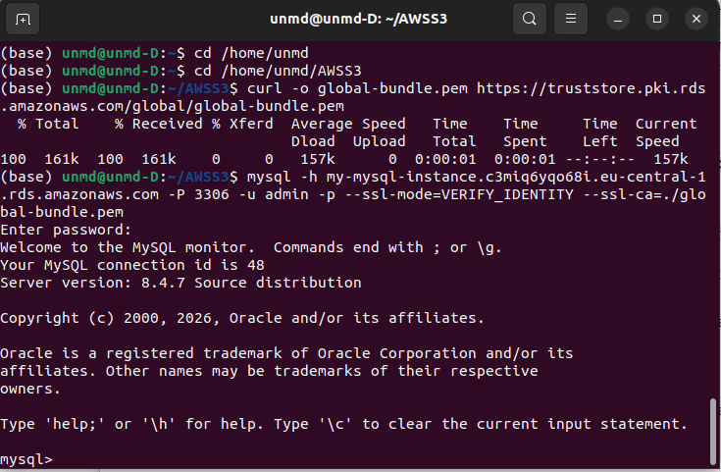

Next, I created a user: aliaksei_student, and database: aliaksei_db, and granted to user aliaksei_student all privileges to the database.

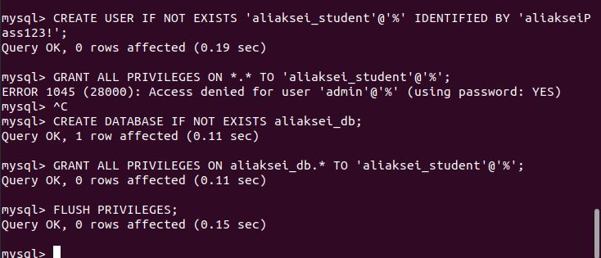

Then I connected to MySQL as user: aliaksei_student and connected to the schema.

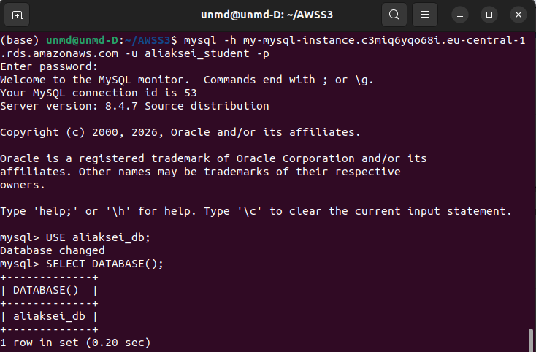

To test this, I added data to the table, ran the procedure, and verified that the changes were reflected in the table.
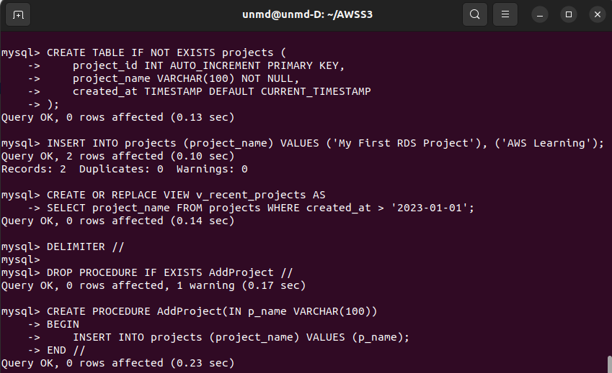

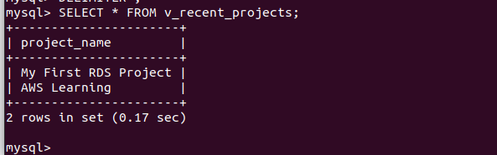 | 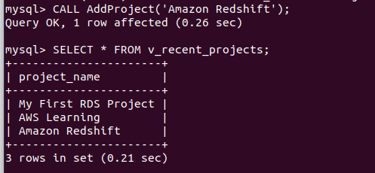

Connecting as the user: aliaksei_student
mysql -h my-mysql-instance.c3miq6yqo68i.eu-central-1.rds.amazonaws.com -u aliaksei_student -p

Initial script:
CREATE SCHEMA IF NOT EXISTS aliaksei_db;

USE aliaksei_db;

CREATE TABLE IF NOT EXISTS projects (
project_id INT AUTO_INCREMENT PRIMARY KEY,
project_name VARCHAR(100) NOT NULL,
created_at TIMESTAMP DEFAULT CURRENT_TIMESTAMP);

INSERT IGNORE INTO projects (project_id, project_name)
VALUES (1, 'My First RDS Project'), (2, 'AWS Learning');

CREATE OR REPLACE VIEW v_recent_projects AS
SELECT project_name FROM projects WHERE created_at > '2023-01-01';

DROP PROCEDURE IF EXISTS AddProject;

DELIMITER //
CREATE PROCEDURE AddProject(IN p_name VARCHAR(100))
BEGIN
INSERT INTO projects (project_name) VALUES (p_name);
END //
DELIMITER ;

2. My Amazon trial account only allowed me to create Aurora (PostgreSQL-compatible).

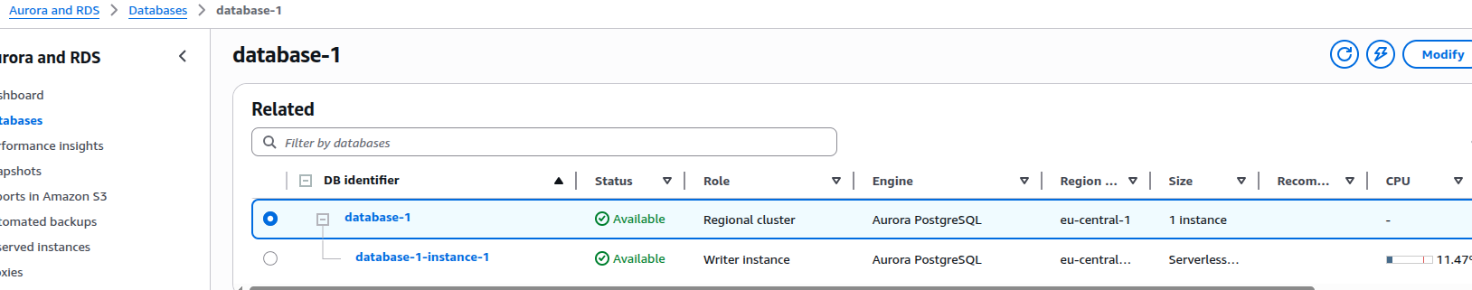

For the same reason, I couldn't use the Query Editor or AWS Cloud09.
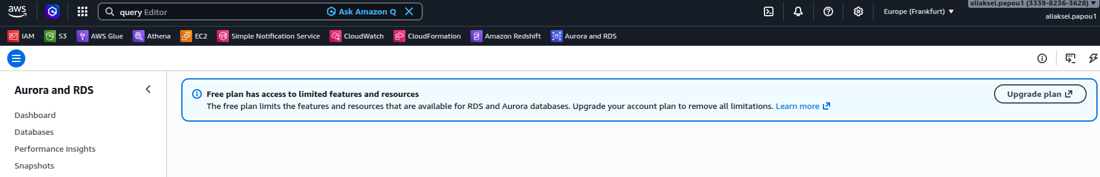

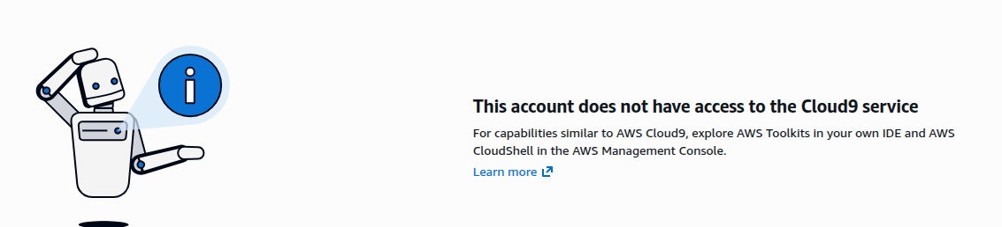

I decided to perform all database operations through my EC2 instance as a bastion server. Local port 5433 is forwarded to port 5432 of the Aurora instance via bastion server.
ssh -i "ubuntu-server.pem" -L 5433:database-1.cluster-c3miq6yqo68i.eu-central-1.rds.amazonaws.com:5432 ubuntu@3.79.156.152
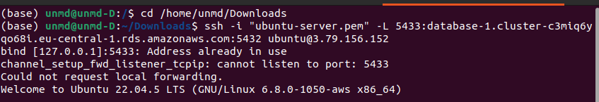

I successfully connected to the database. Then, using the console, I created a schema and table, inserted data, and ran a test query on the table.
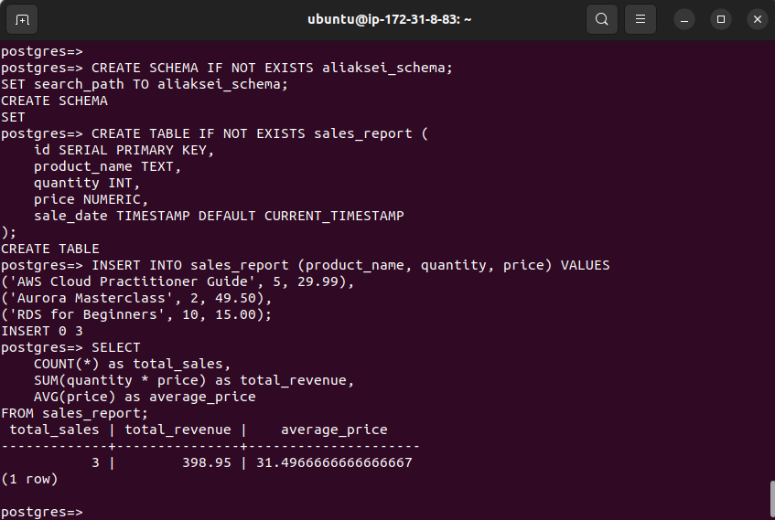
Connecting directly to Aurora from a local PC is impossible because Aurora is located in a private VPC subnet and does not have a public IP address. The database's Security Group only allows incoming connections from the internal AWS network (for example, from my EC2). Therefore, to access from a local PC, you must use SSH Tunneling through the Bastion Server (EC2), which acts as a trusted intermediary.

3. Using the AWS Console, I created a table: temptable. I selected ID as the partition key. I also added data with various attributes. Then, I deleted the table.

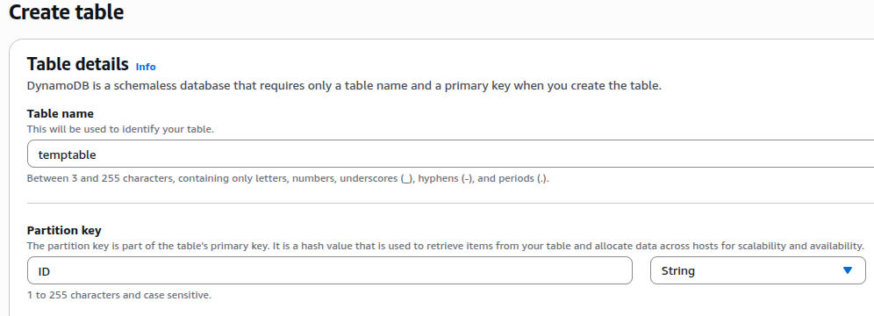
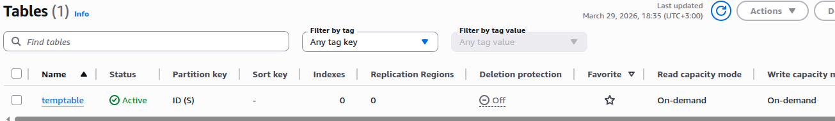

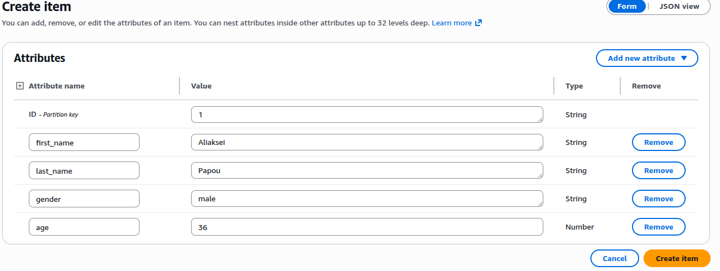

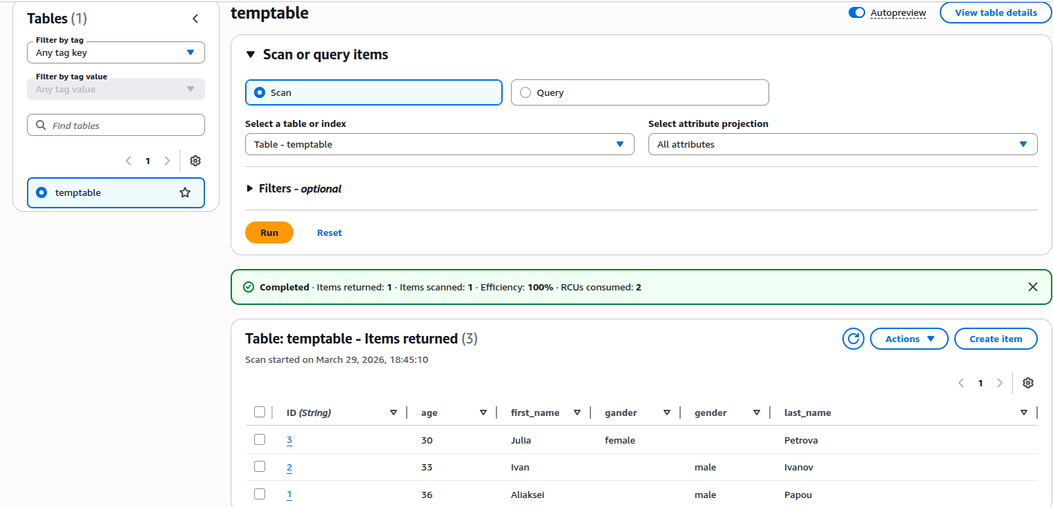

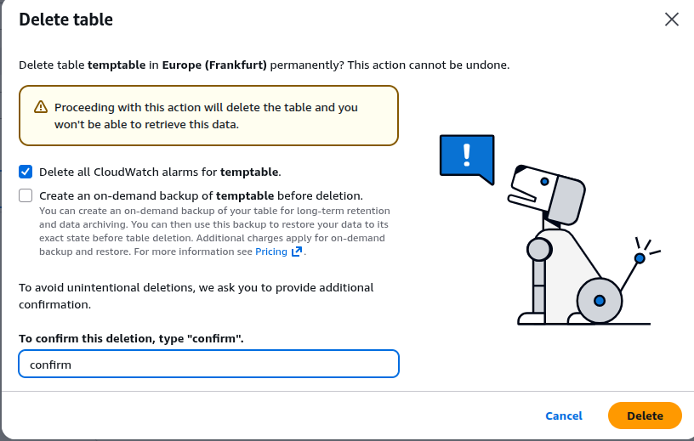

Then I completed all the assignments through the AWS CLI. I created a table: StudentsTable. I chosen StudentId as the Partition Key.

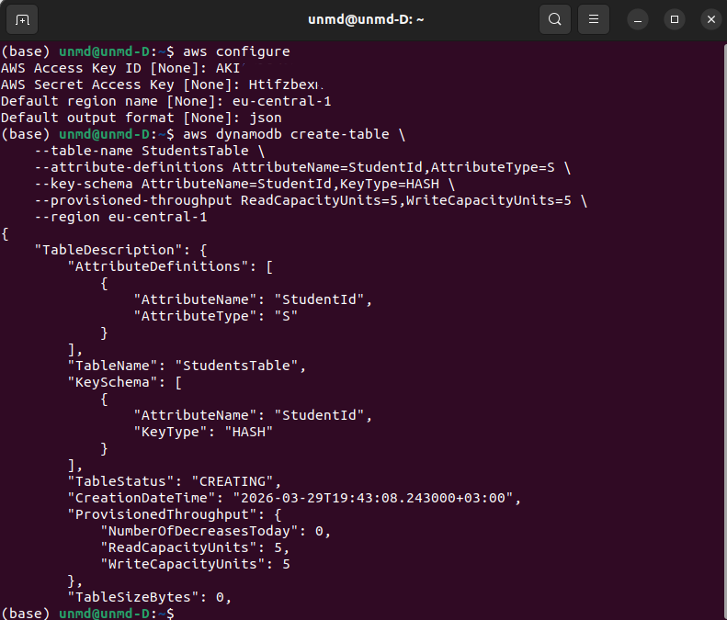

Primary Key Justification: StudentId was chosen as the Partition Key. According to AWS Best Practices, using a unique identifier with high cardinality ensures uniform data distribution across physical partitions. This provides consistent performance as the database scales.

I read that using a JSON file for bulk inserts is best practice. I created a JSON file containing over 20 records. I used the following attributes: StudentId (String), Name (String), and Grade (Number, range 1-5).
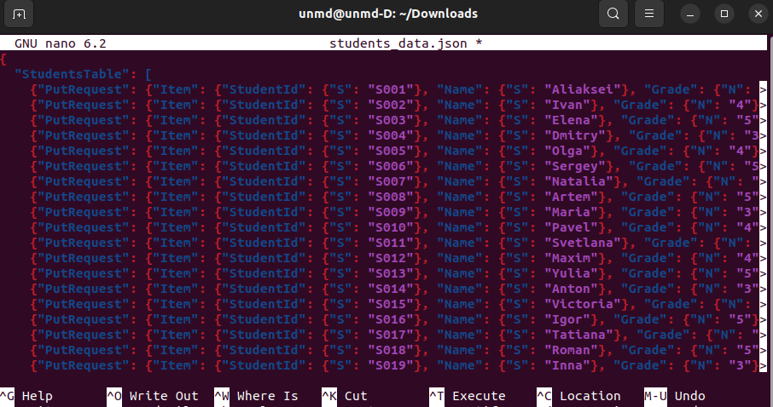

I used data retrieval by ID. I also tried using a JSON file.
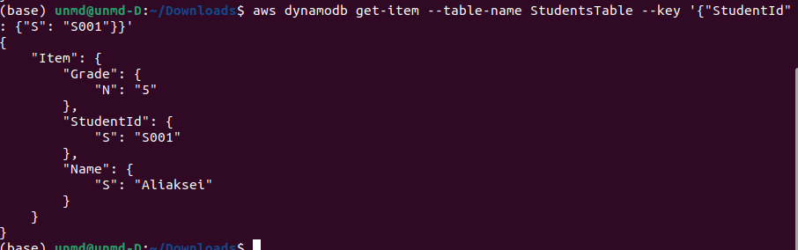
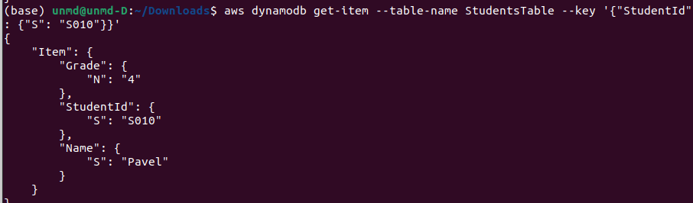
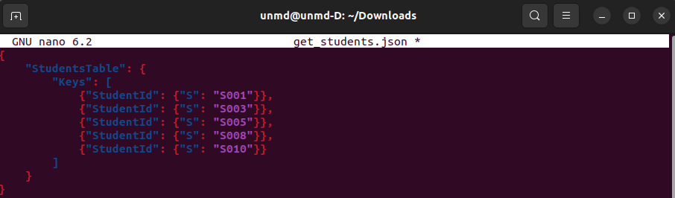
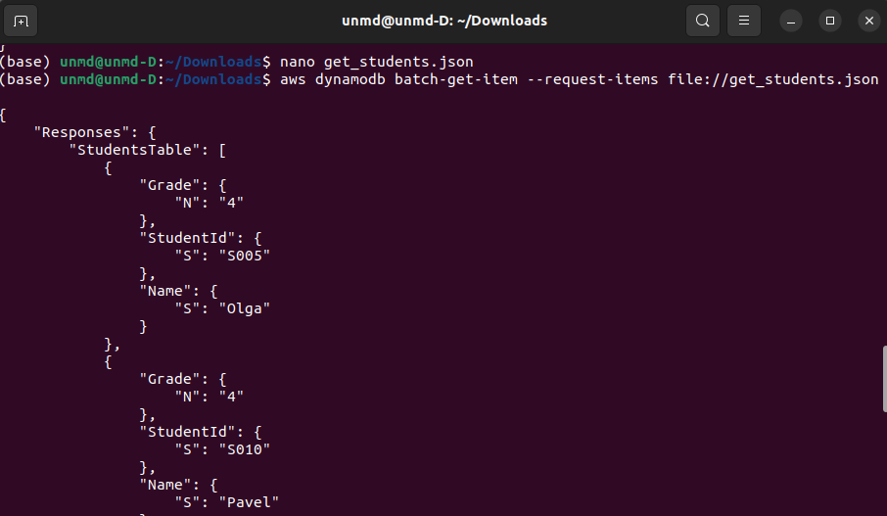

Executed a scan operation with a FilterExpression to find all students with a specific Grade (Grade = 5).

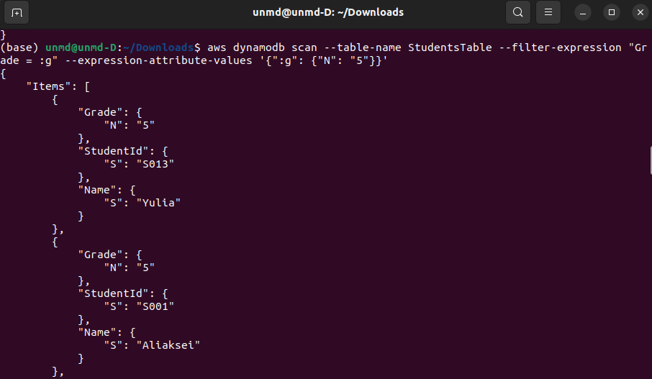

Executed a query to return only specific attributes (Name, Grade). I used #n for Name because I got an error the first time, as "Name" is a reserved word in DynamoDB.
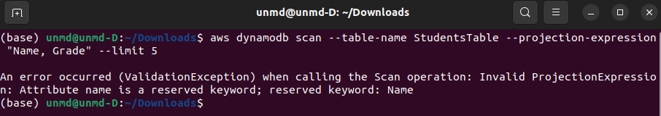

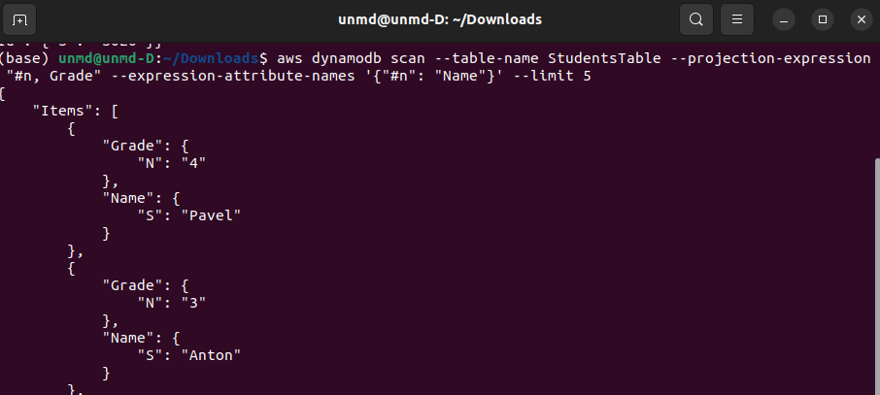

Then, using delete-item, I deleted two specific records (S019 and S020) from the table.

