Description:
Task 1.1
During the task, the execution plans of two queries were analyzed using the EXPLAIN command.

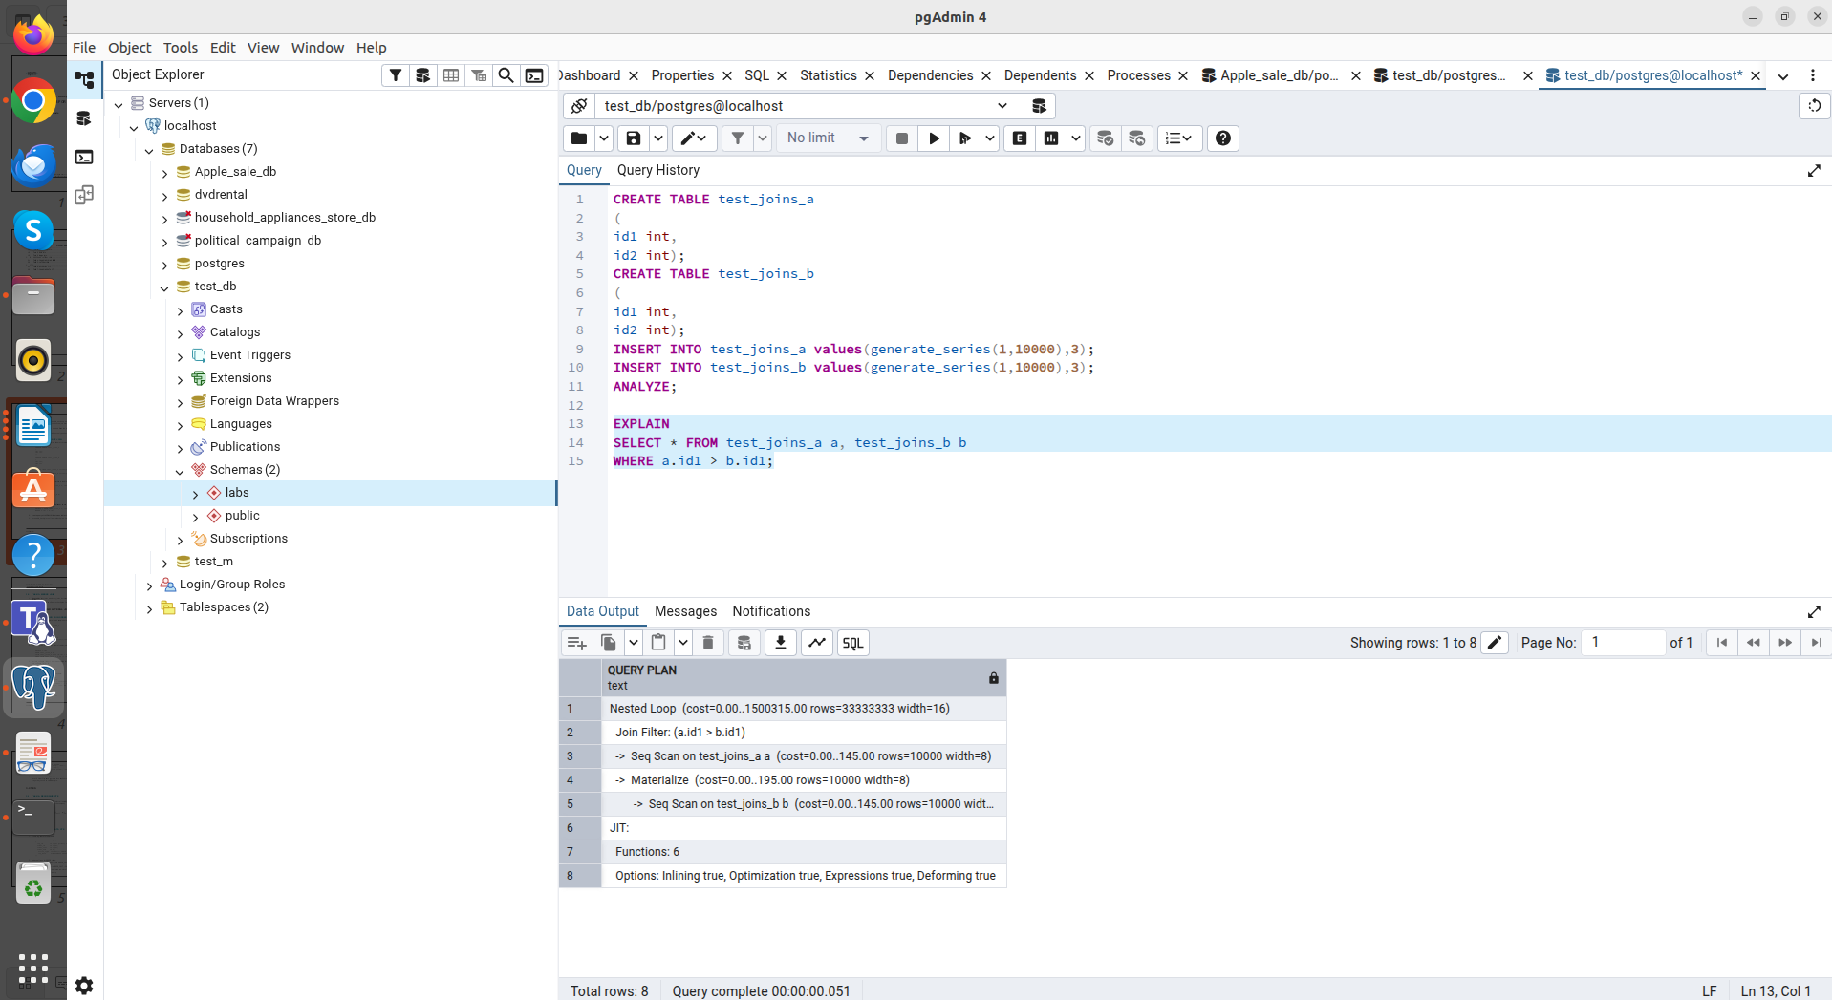
Analysis of a query with an inequality condition
EXPLAIN
SELECT * FROM test_joins_a a, test_joins_b b
WHERE a.id1 > b.id1;

Method: Nested Loop.
Why chosen: The condition a.id1 > b.id1 is an inequality operator. The Hash Join and Merge Join algorithms only work with equality operators. The only available way to match rows by such a condition is to iterate through them in a nested loop.
The Join Filter node is visible. First, a Seq Scan is performed on table a, and for each row, the condition is checked against the rows in table b.
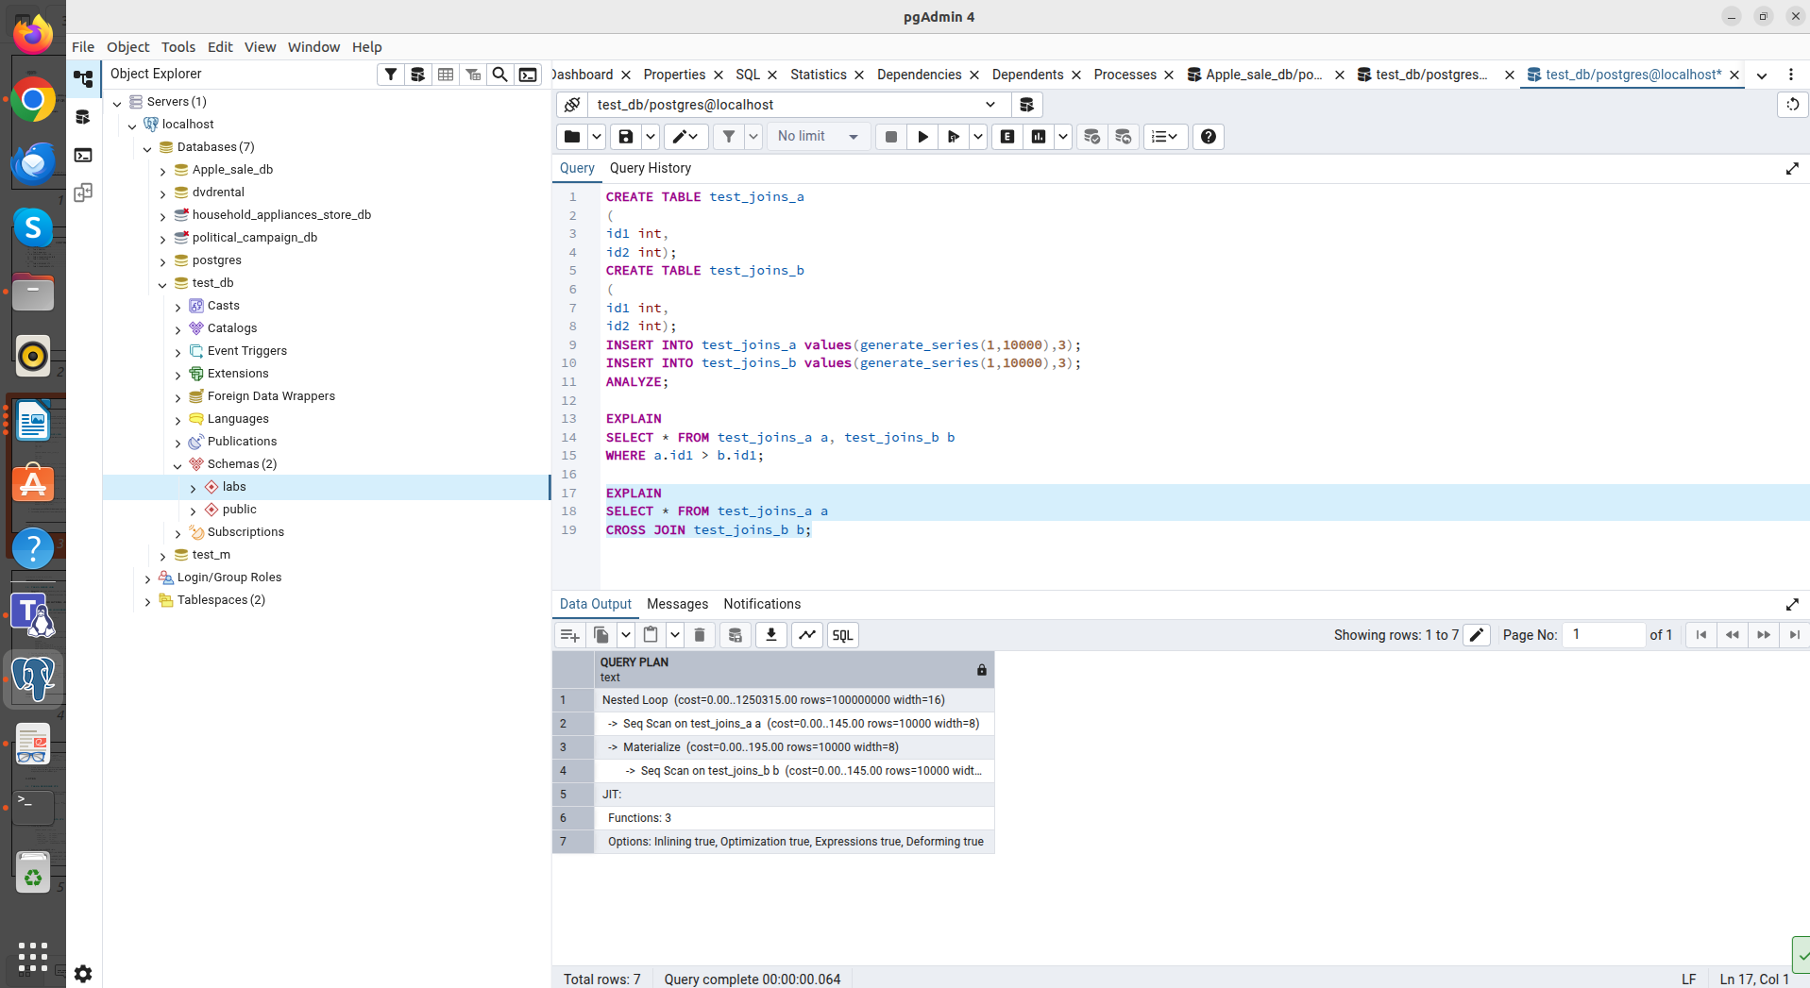
Analysis of a CROSS JOIN query
EXPLAIN
SELECT * FROM test_joins_a a
CROSS JOIN test_joins_b b;

Method: Nested Loop.
Why chosen: CROSS JOIN is a Cartesian product where each row of the first table must be joined to each row of the second table without any conditions.
Unlike the first case, there is no Join Filter here, as filtering is not required. The planner predicts rows=100,000,000 (10,000 * 10,000), confirming a full match of all rows.

The Nested Loop method is universal, but the most computationally intensive. The PostgreSQL planner selects it in cases where:
- There is no join condition (Cartesian product).
- The join condition is based on inequality (>, <, <>), making it impossible to build a hash table or efficiently merge sorted lists.

Task 1.2
1. Query rewriting:
Hash join only works on equijoins (=). To force the planner to use Hash Join, change the condition to equality.

EXPLAIN
SELECT * FROM test_joins_a a
JOIN test_joins_b b ON a.id1 = b.id1;

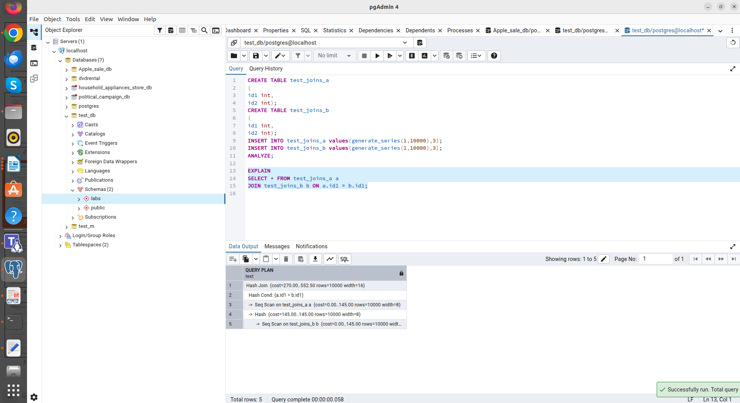

The planner detects the equality condition. This allows it to build an in-memory hash table for one of the tables (a Hash node), ensuring fast matching when scanning the second table.

2.Query with SEMI JOIN:
A semi join occurs when using EXISTS or IN.

EXPLAIN
SELECT * FROM test_joins_a a
WHERE EXISTS (SELECT 1 FROM test_joins_b b WHERE a.id1 = b.id1);

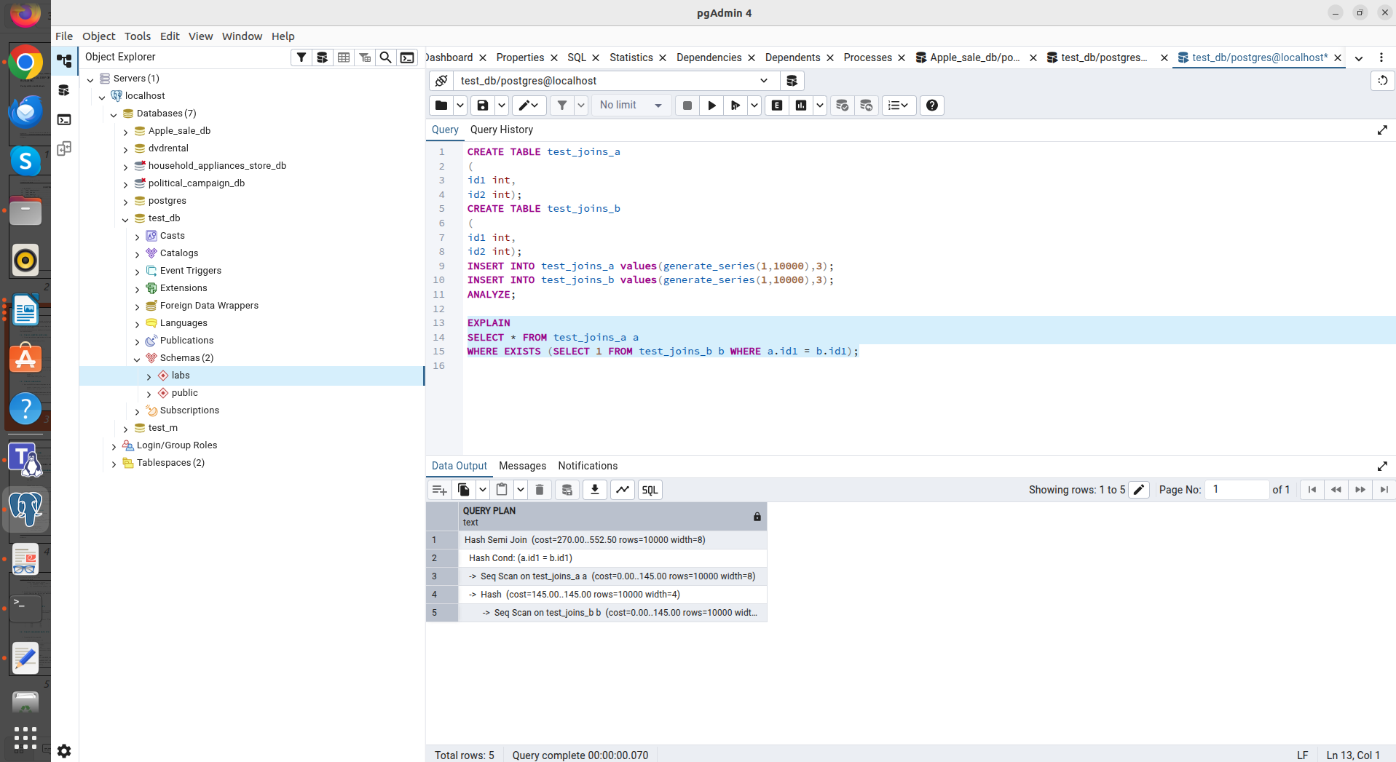
Using EXISTS tells the database to only confirm that at least one matching row exists, rather than returning all duplicates from the right table.

3. Disabling Hash Join:
The enable_hashjoin scheduler parameter was manipulated to observe the change in the plan selection strategy.

SET enable_hashjoin = off;
EXPLAIN
SELECT * FROM test_joins_a a JOIN test_joins_b b ON a.id1 = b.id1;

SET enable_hashjoin = on;

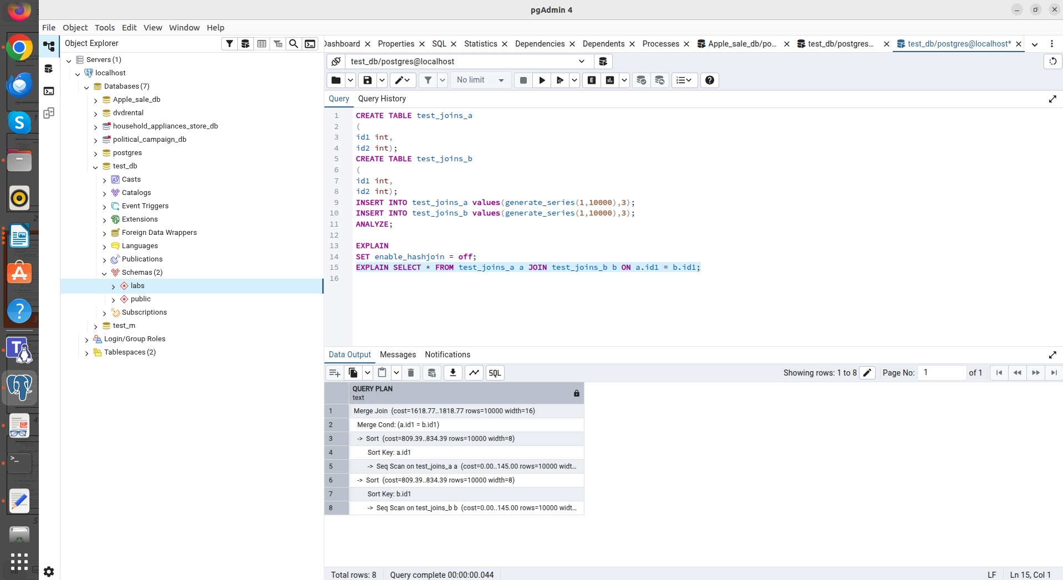
After explicitly disallowing the use of hash tables, the planner switched to the next most efficient method, merge join.
Hash Join is an efficient method for equality in large datasets. It creates an in-memory hash table based on one of the tables. When disabled, the DBMS is forced to use more expensive methods.

Task 1.3
Merge Join requires the input data to be sorted. It is typically chosen for equality conditions, if there are indexes on the columns, or if the planner determines that sorting is worth the cost.
To guarantee Merge Join without indexes, Hash Join must be disabled.
SET enable_hashjoin = off;
EXPLAIN
SELECT * FROM test_joins_a a JOIN test_joins_b b ON a.id1 = b.id1;

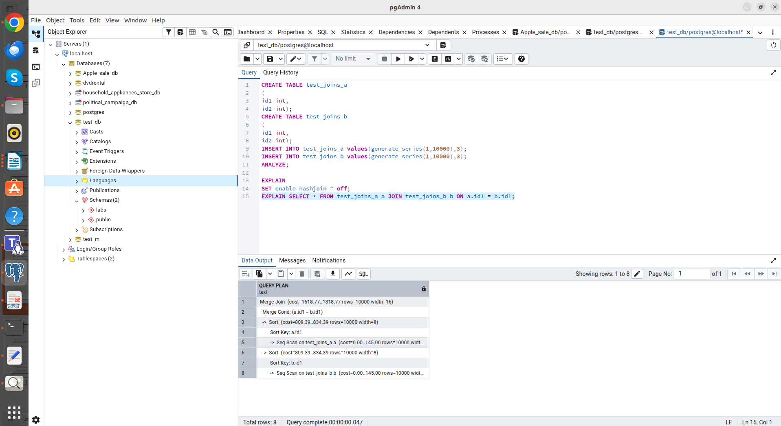
In the absence of indexes and with Hash Join disabled, the planner selects this method. It is efficient for large data sets, but requires both tables to be sorted by the join key.
The plan shows two Sort nodes (one for each table). The total cost (cost=1818.77) is higher than that of a hash join, as sorting 10,000 rows in memory is a resource-intensive operation.

Disabling Merge Join:
Switching to Hash Join when Merge Join is disabled
The command SET enable_mergejoin = off; SET enable_hashjoin = on; and EXPLAIN again were executed.
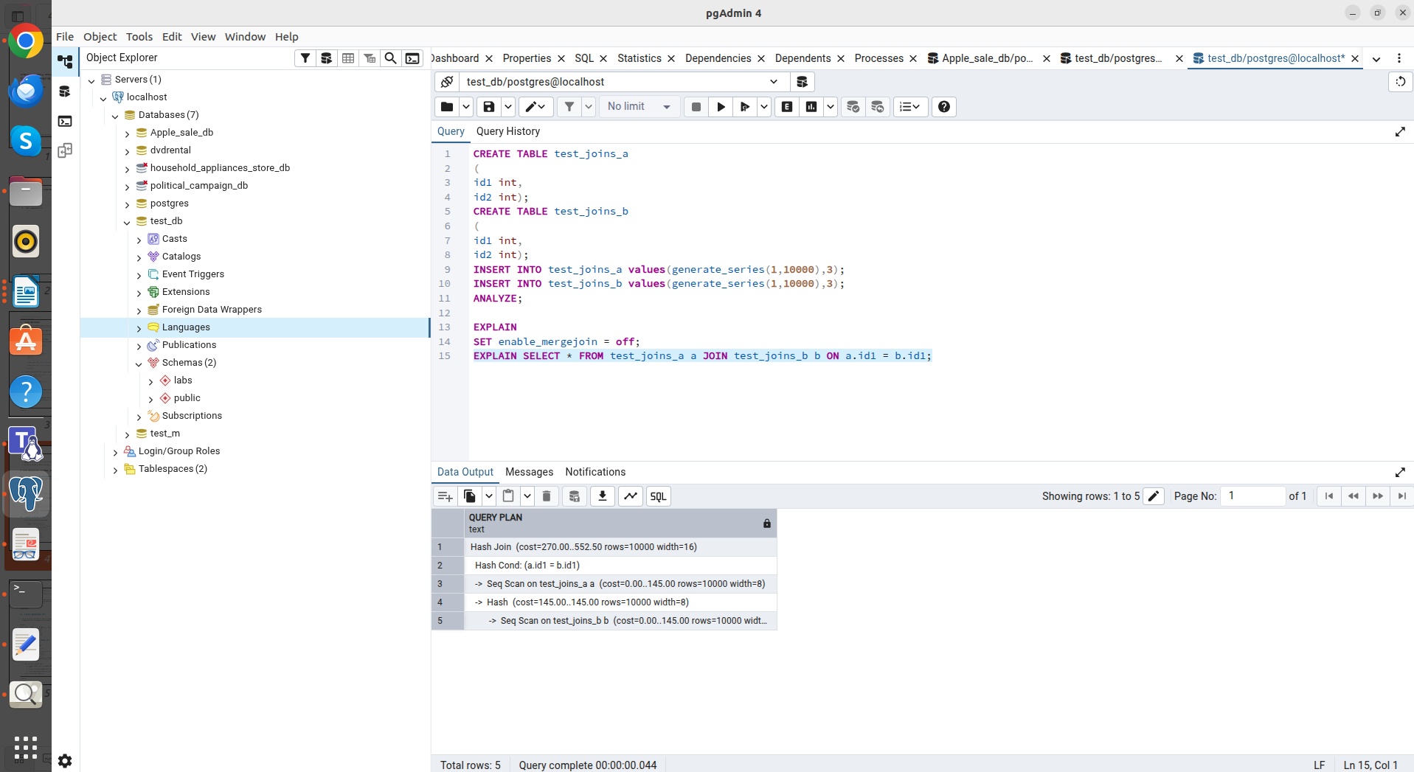
Manipulating the enable_mergejoin parameter to test how the planner adapts to constraints and chooses alternative methods (Hash Join).

Task 2.1
The default scheduler plan is analyzed, which has the right to reorder connections for optimization.

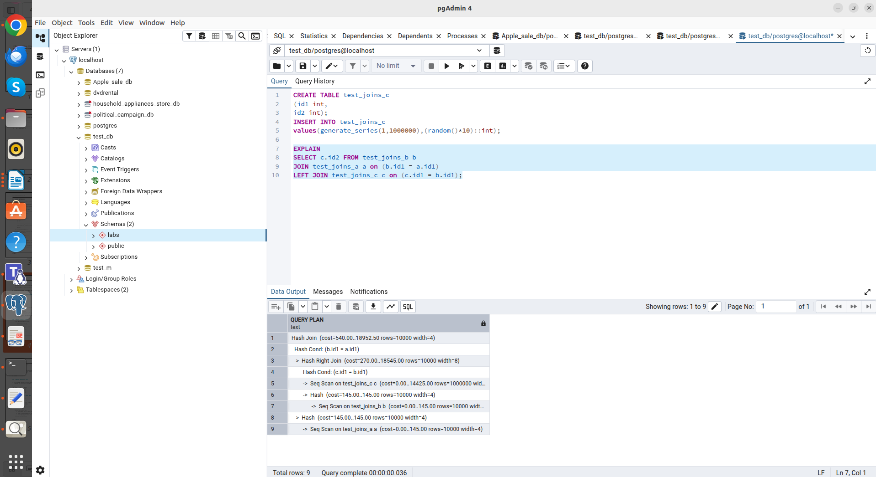
Plan: Hash Join -> Hash Right Join (c + b) -> a.
Table order: In the first step, PostgreSQL decided to join the huge table c (1 million rows) with table b (Hash Right Join), and then merge the result of this join with table a.
With the default value of join_collapse_limit = 8, the planner iterates through possible combinations to find the lowest-cost path based on data distribution statistics.

Setting order constraint (join_collapse_limit = 1).
SET join_collapse_limit = 1;
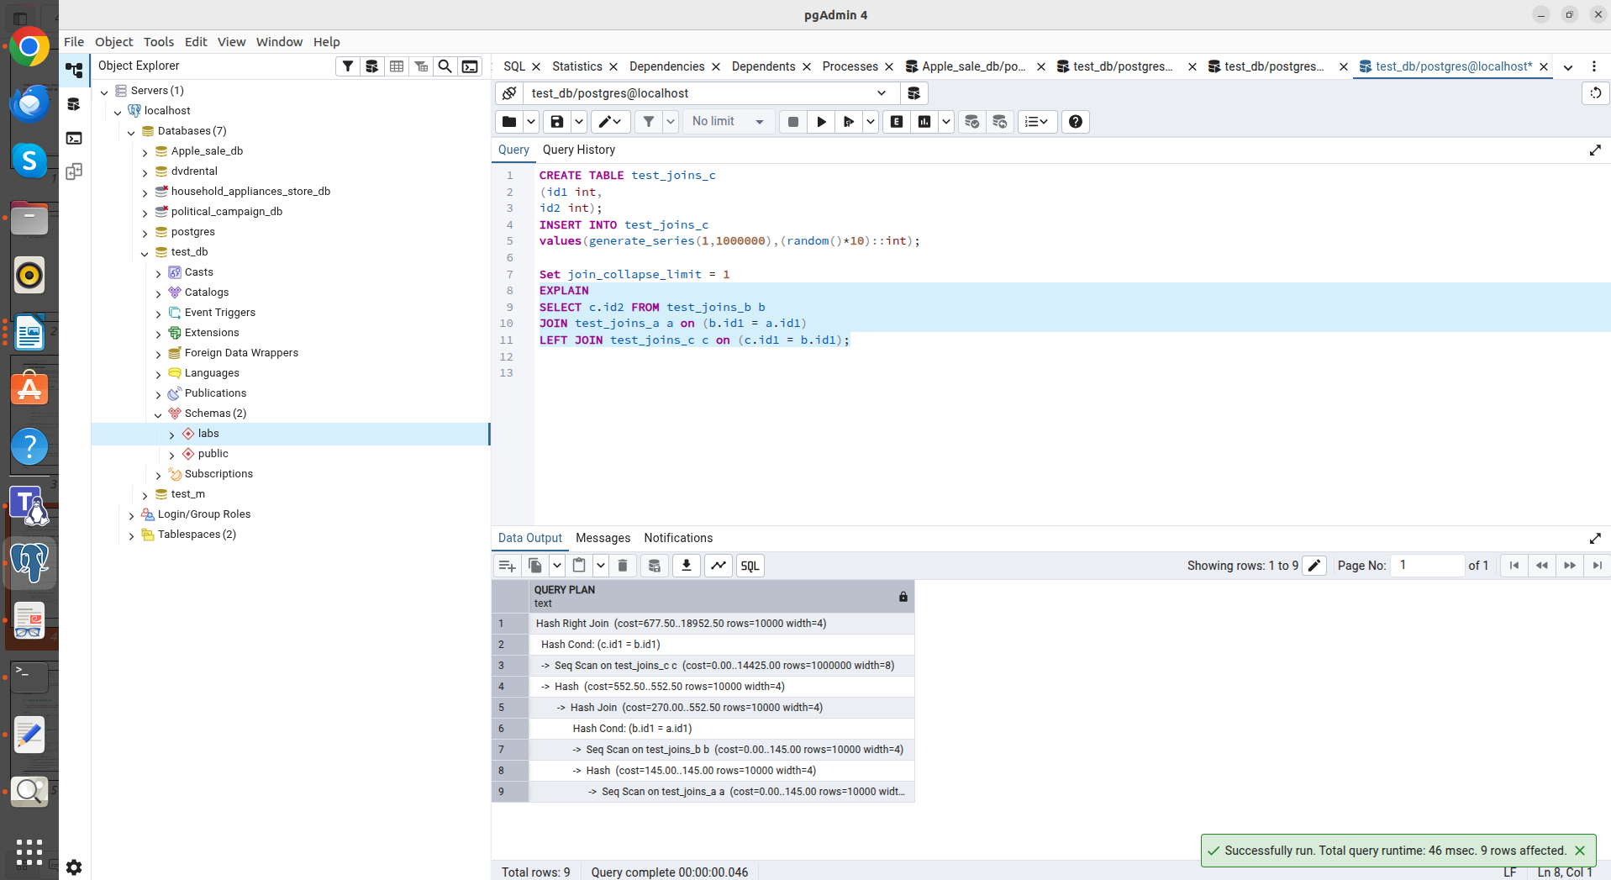
Plan: Hash Right Join (c + (b + a)).

Table order: After SET join_collapse_limit = 1; , the plan structure has changed. Now the planner first performs a Hash Join between a and b (as specified in the first lines of the query), and only then joins the result of this join with table c.
The planner no longer attempts to optimize the sequence, but follows the query syntax. This is evident in the nesting: Hash Join (b + a) has become an internal node for the resulting Hash Right Join with table c.
Changing this setting allows you to manually control the order in which joins are performed in complex queries when the automatic optimizer makes a mistake in choosing the leading table.

Task 2.2
Creating a query using LATERAL join.

SELECT s.store_name, o.order_id, o.order_cost
FROM stores s
CROSS JOIN LATERAL (
SELECT order_id, order_cost
FROM orders
WHERE order_cost < s.max_order_cost
ORDER BY order_cost DESC
LIMIT 10
) AS o;

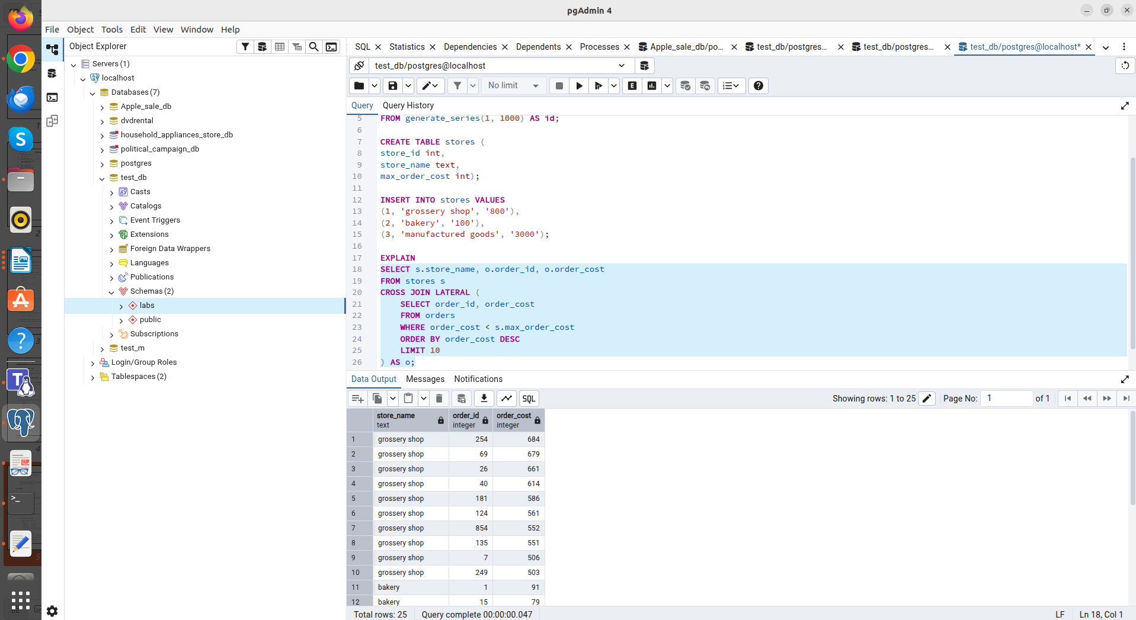

For each store (3 iterations total), a nested query is executed that filters orders by that store's specific price, sorts them, and filters out the top 10. Without LATERAL, such a query would have to be written using complex window functions.
Lateral Join is suitable for correlated subqueries where you need to pass the context of the current row to the nested selection (for example, to get a limited top of records for each category).

Task 3.1
To build the employee hierarchy, we use a recursive generalized table expression.

WITH RECURSIVE employee_hierarchy AS (
SELECT empno, ename, mgr, 1 AS level
FROM emp
WHERE mgr IS NULL
UNION ALL
SELECT e.empno, e.ename, e.mgr, eh.level + 1
FROM emp e
JOIN employee_hierarchy eh ON e.mgr = eh.empno
)
SELECT
eh.ename AS employee,
m.ename AS manager,
eh.level
FROM employee_hierarchy eh
LEFT JOIN emp m ON eh.mgr = m.empno
ORDER BY eh.level, eh.ename;

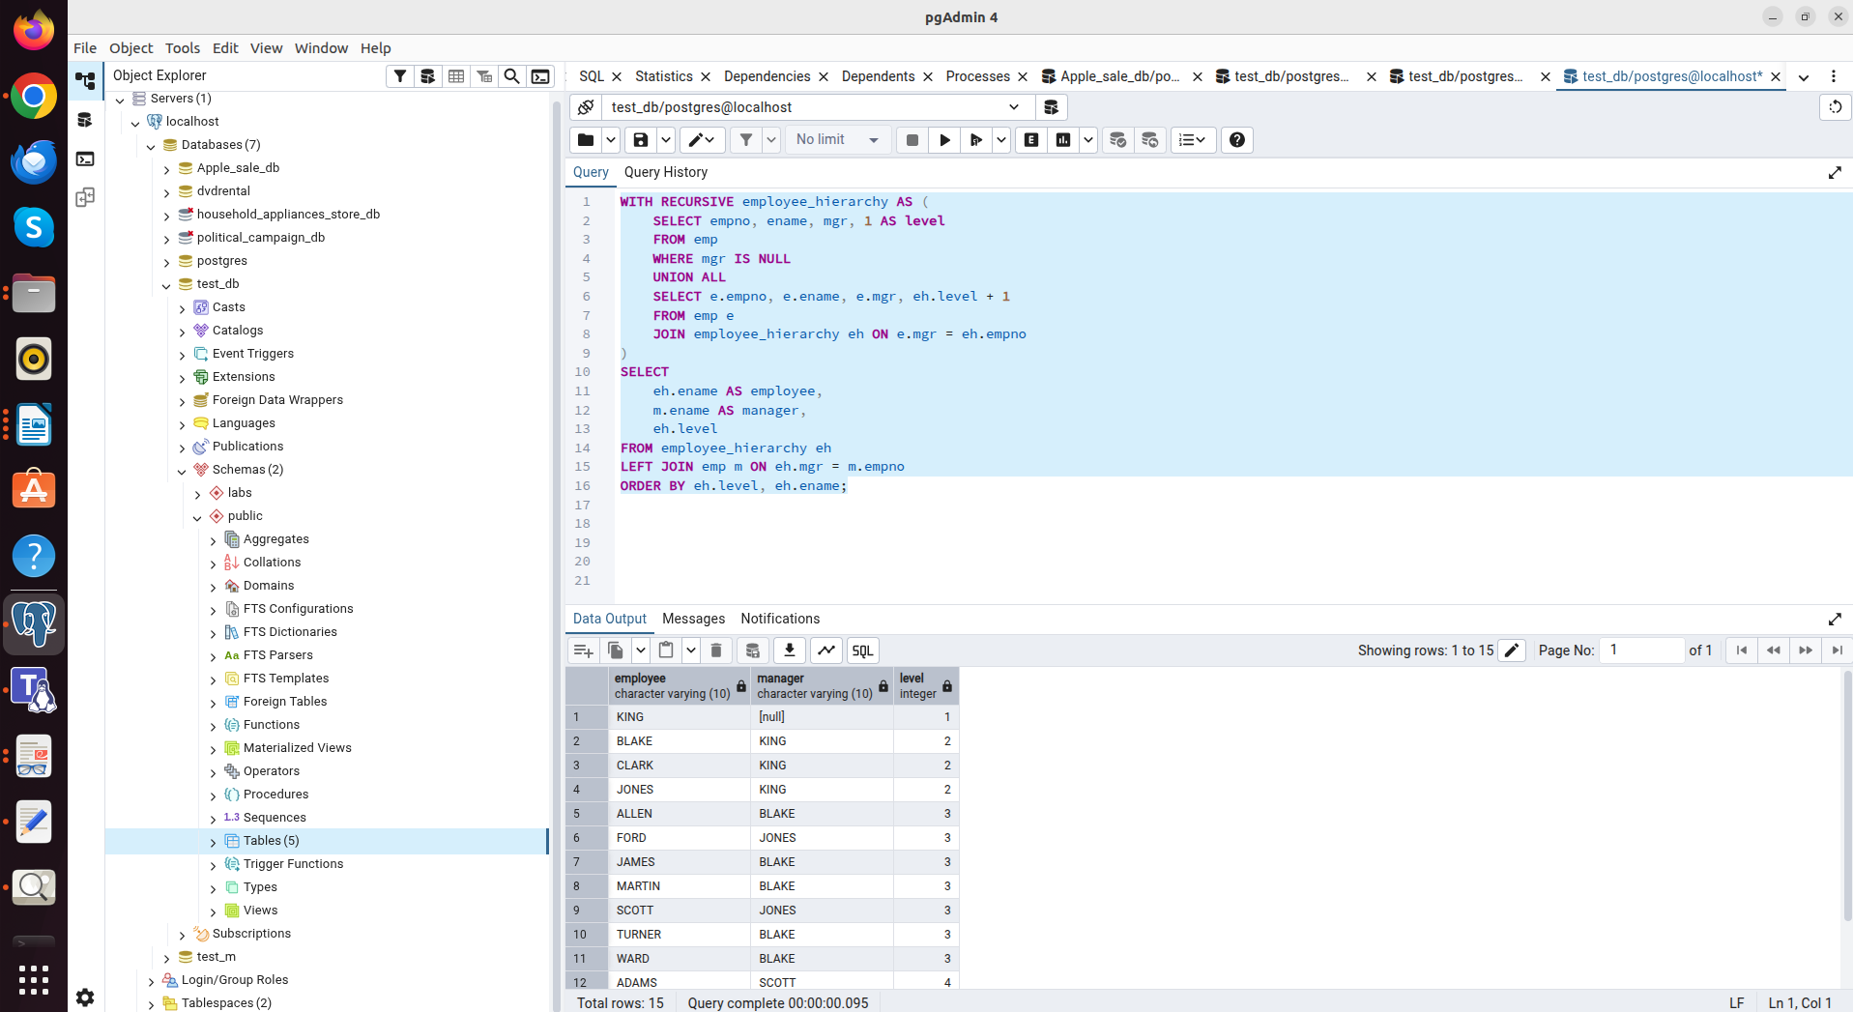

The query generates a control tree. At level 1 is KING (President). At each subsequent step, the database finds employees whose mgr field matches the empno of employees at the level already found.

Task 3.2
PostgreSQL allows UPDATE and DELETE commands to be used within CTEs using the RETURNING clause. This allows you to modify data and immediately use the modified rows for insertion into the log table within a single atomic query.

WITH
updated_rows AS (
UPDATE orders
SET order_cost = order_cost / 2
WHERE order_cost BETWEEN 100 AND 1000
RETURNING order_id, order_cost, order_num, 'U'::varchar(1) as act
),
deleted_rows AS (
DELETE FROM orders
WHERE order_cost < 50
RETURNING order_id, order_cost, order_num, 'D'::varchar(1) as act
)
INSERT INTO order_log (order_id, order_cost, order_num, action_type)
SELECT order_id, order_cost, order_num, act FROM updated_rows
UNION ALL
SELECT order_id, order_cost, order_num, act FROM deleted_rows;

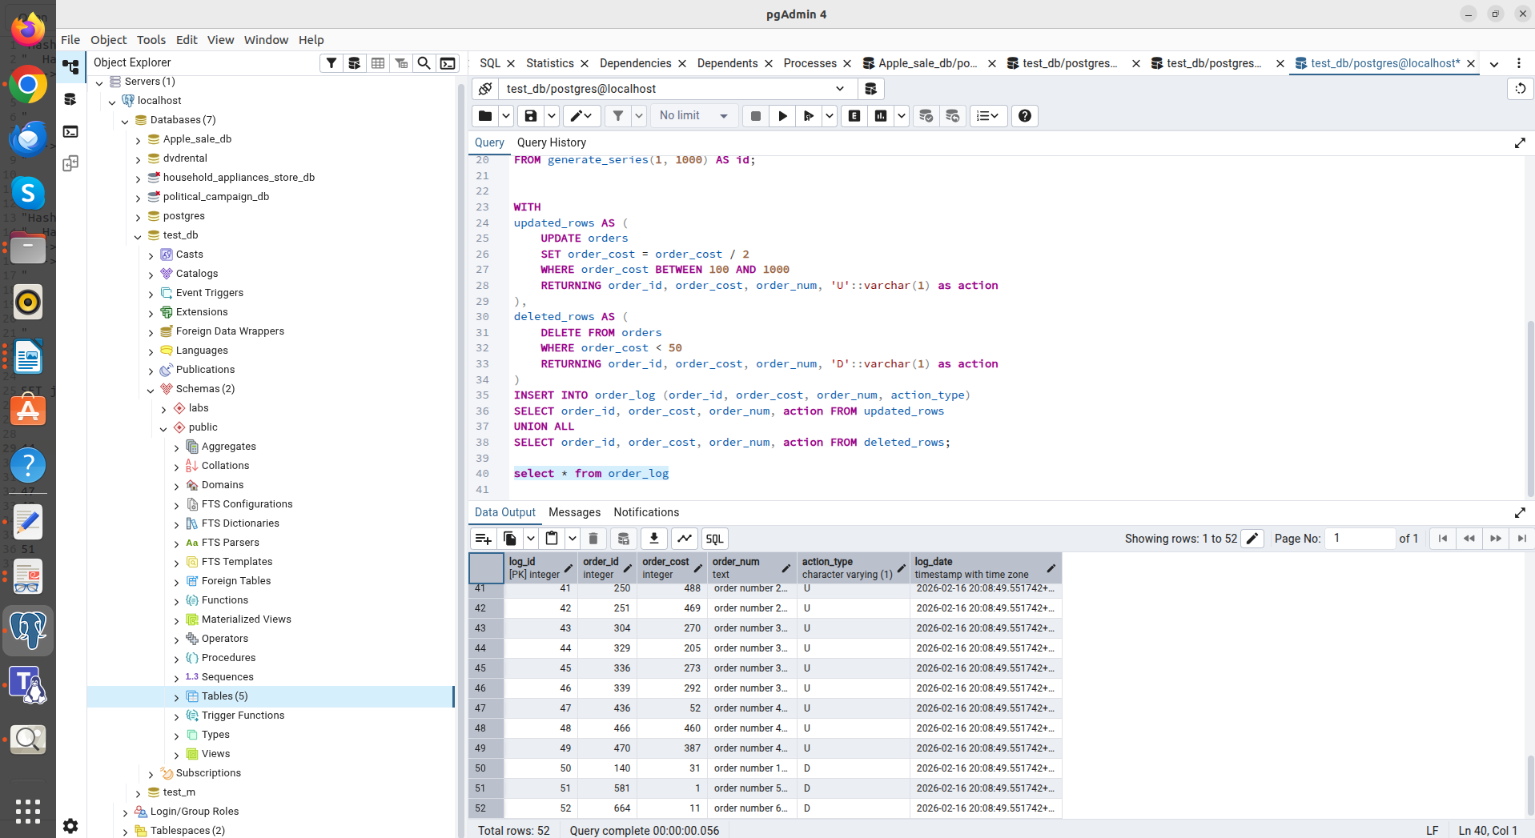

The updated_rows block: Finds orders with a price between 100 and 1000 and divides it in half. For example, there was an order for 62, but it didn't meet this condition.
The deleted_rows block: Finds orders with an initial price < 50. It finds those orders (for example, 31 or 1), deletes them, and returns them to the log with a status of 'D'.
During query execution, it is clear that the log contains rows with the status 'U' and a cost greater than 50, and there are also rows with the status 'D' and a cost less than 50 (for example, order_cost = 31).
I assume that both CTE blocks (UPDATE and DELETE) operate on the same "snapshot" of data taken at the start of the query. The DELETE block doesn't see the results of the UPDATE block. Therefore, it will only delete rows that were initially less than 50. If order_cost was 80 and became 40 after the update, it won't be deleted in the same query, since it still costs 80 for the DELETE block. I think if sequential processing is required (first update, then delete what has become eligible for deletion), queries should be separated.

