
Apple TS Retail Store Business Model


Business Description

Business background
Overview of the Company
Company Name: Apple Tech Solutions.
Field of Activity: Omnichannel retail of premium consumer electronics, software, and digital services.
Apple TS operates as a primary retail engine for Apple products, managing a complex network of physical Apple Stores within the United States (POS) and a sophisticated Global Online Platform serving the rest of the world. With a product portfolio ranging from iPhones and Macs to specialized services, the company sits at the intersection of high-tech hardware and global logistics.

Business Process for Analysis
The report focuses on the "End-to-End Sales & Operational Performance" process.
The analysis includes:
Key Performance Indicator (KPI) Visualization: Cards with key figures (revenue, profit, number of orders).
Dynamics and Trends: Line and area charts showing changes in indicators over time (by day, month, year).
Comparative Analysis: Histograms and pie charts comparing the performance of products and regions.
Structural Analysis (Drill-down): The ability to drill down from general data (for example, company sales) to details (sales of a specific product).
Interactive Filters and Slicers: Allow the user to independently change the data slice (period, category) and filter the entire report with a single click.

Purpose of the Report
Provide senior management and regional directors with a tool to monitor margins, promotional campaign effectiveness, and compare the performance of physical stores (US) with the global online channel.

End Users
Chief Revenue Officer (CRO), Chief Sales Officer (CSO): To monitor global targets.
Regional Retail Managers (USA): To evaluate store-level KPIs and employee performance.
Global Supply Chain Analysts: To align inventory levels with real-time demand trends across online and offline channels.

Business Questions and Problems Resolved
The report is designed to solve the following critical issues:
Channel Performance Disparity: Problem: Previously, online and offline data were stored in different formats. Resolution: The report answers: "What is the exact ratio of online to offline sales per product category, and where is the growth faster?"
Promotion ROI: Problem: Ineffective marketing spend due to lack of promotion tracking. Resolution: Analysis of DimPromotions reveals which campaigns drive "Titanium" iPhone sales vs. which ones merely decrease the average check.
Customer Loyalty & Payment Preferences.

The report implements all requirements set in the assignment.
The report has been published.
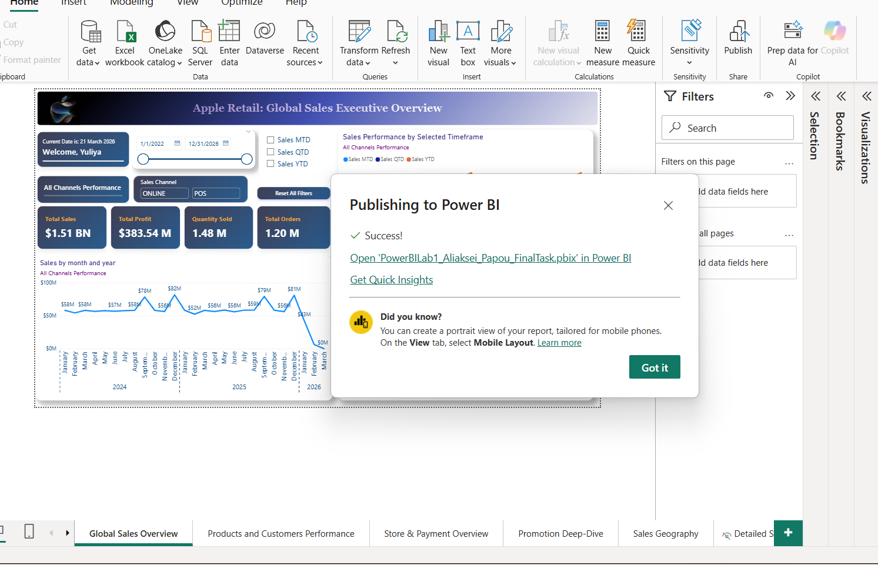

Description of report creation:
While creating the report using Power Query, tables were renamed (without specifying the schema name), calculated columns were added (GrossRevenue, TotalCost, DiscountAmount), columns were merged to create a full name column (first_name and last_name to full_name ), and the data type was changed to percentage (discount_value).
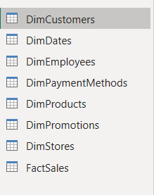 | 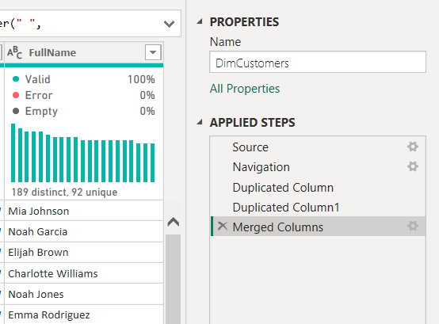

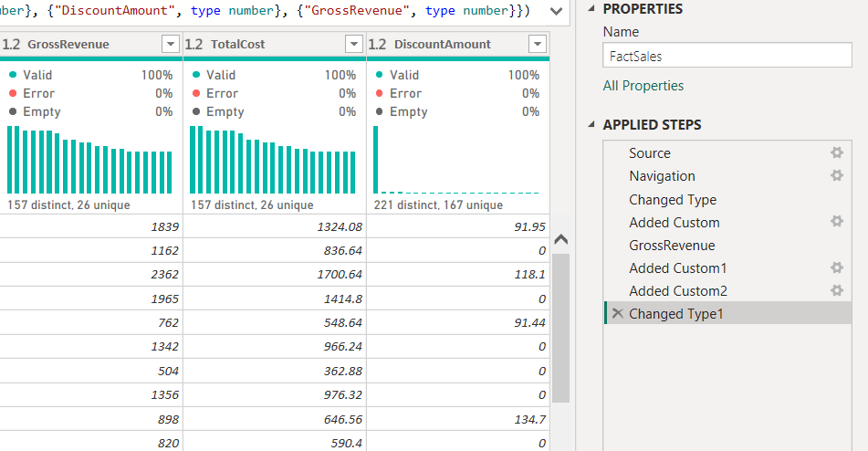

Added a support table for saving visualization of measures for HTML content.
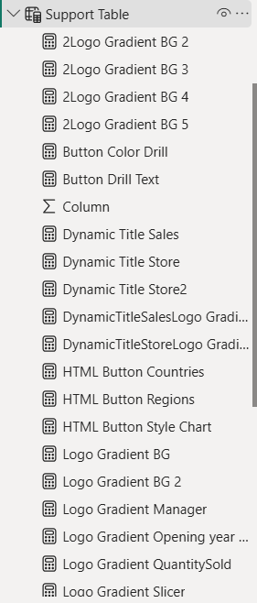

The DimDates table is used as a date table.
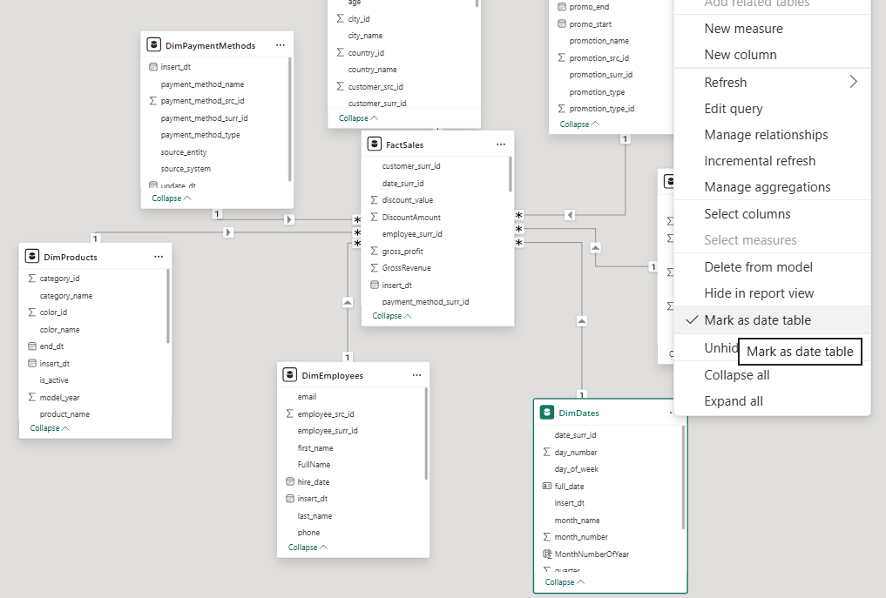

The title and logo were selected and created using a custom visualization based on HTML content. The report includes the following pages: Global Sales Overview, Products and Customers Performance, Store & Payment Overview, Promotion Deep-dive, Sales Geography.

I implemented a dynamic header using DAX measures and Card visuals. I used the USERPRINCIPALNAME() function to create a "Welcome" greeting and the FORMAT(TODAY()) function to display the current date. This ensures the report feels personalized.

Using DAX, I created measures such as: Sales YTD, Sales MTD, Sales QTD, Top 10 products and customers, Top Country, Total quantity and others.
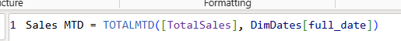
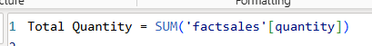

I implemented a dynamic period toggle using Field Parameters. This allows users to seamlessly switch between Month-to-Date (MTD), Quarter-to-Date (QTD), and Year-to-Date (YTD) views. This logic was chosen for its performance and native support for dynamic axis labeling.
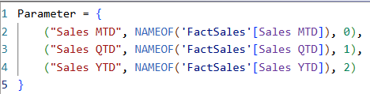

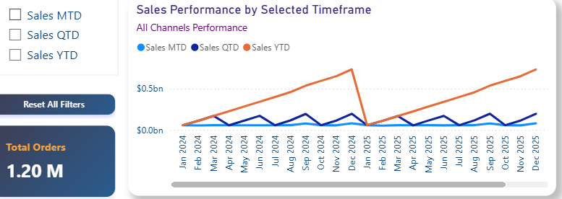

Visualization titles have been created that dynamically change depending on one of the filters (sales channel, stores).
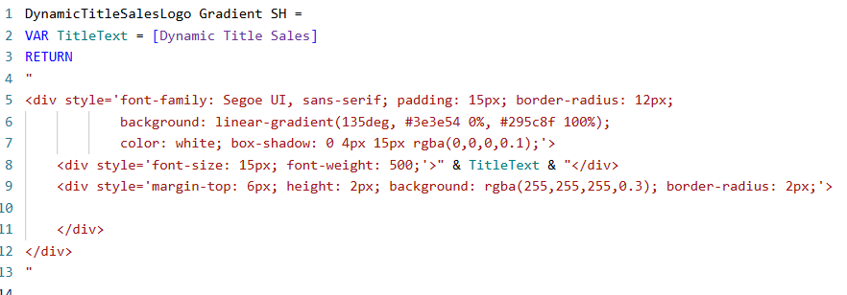




To optimize report real estate, I implemented Bookmarks and Buttons to allow
users to switch between a Bar Chart Countries and a Bar Chart Regions. By utilizing the Selection Pane to manage visual visibility and linking states to buttons via the Action property, I created a cleaner, more interactive user experience.
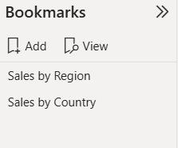

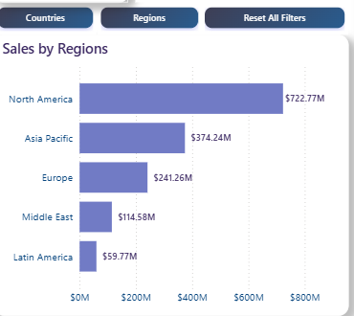 | 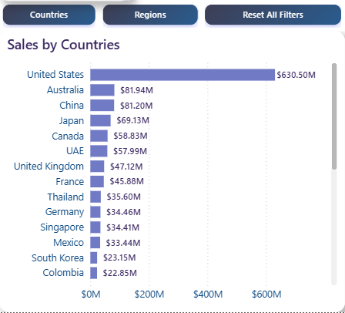

A drill-down option has been enabled to allow users to navigate from the table visualization to a detailed store view. For user convenience, the detailed view also includes a back button.

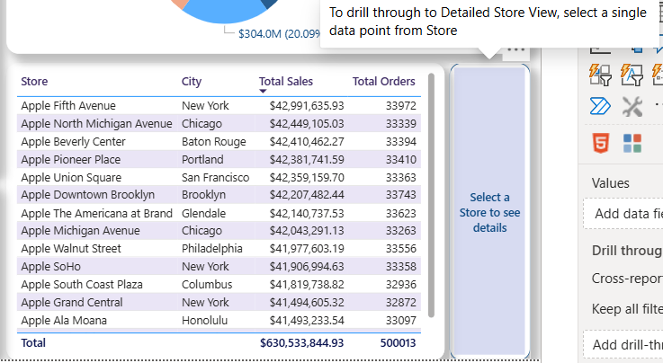

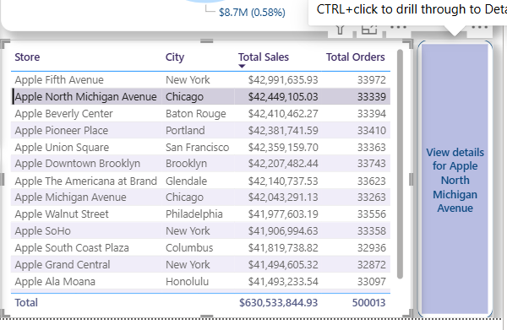

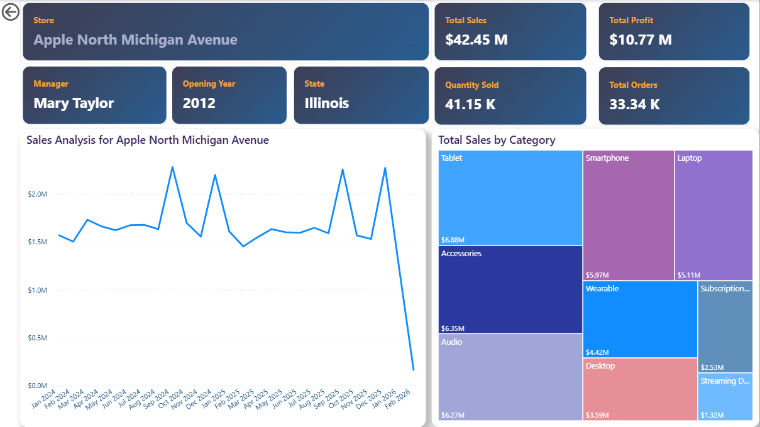

Conditional formatting is applied to a visualization to highlight specific data points based on predefined rules or thresholds. Sales totals >= 100,000,000, and sales totals >= 50,000,000 and less are displayed in different colors on the chart.
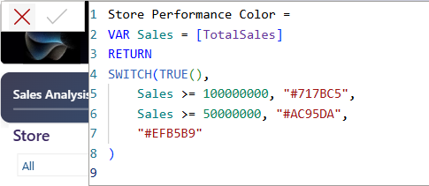

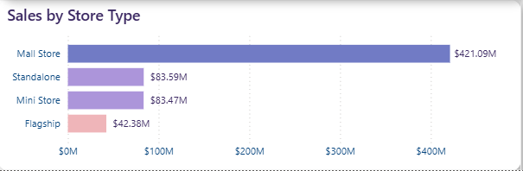

I integrated a Decomposition Tree visual to allow for ad-hoc breakdown of Promo Sales by Promotion Type, Promotion, and Product. This enables users to perform an "Explain By" analysis to find underlying trends.
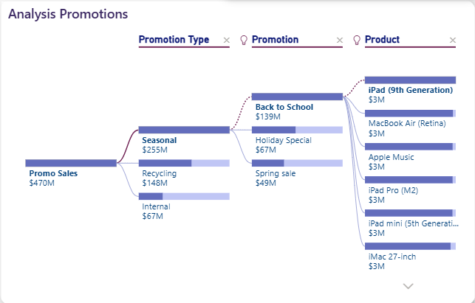

Additionally, I created a Custom Tooltip page that provides secondary insights (Cities) when hovering over map visuals, reducing the need for drill-through actions.
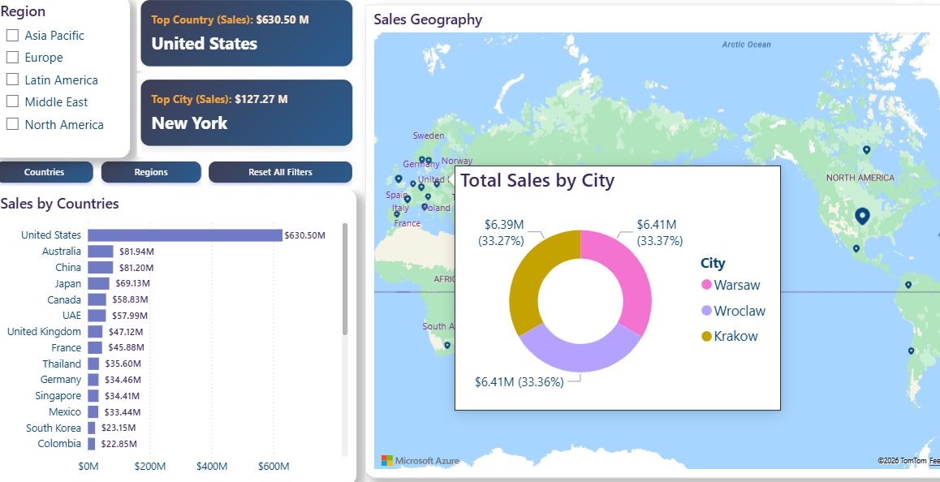

The report also includes a number of different types of slicers (list, drop-down, date) and other visualizations, such as graphs, pie charts, cards, etc.

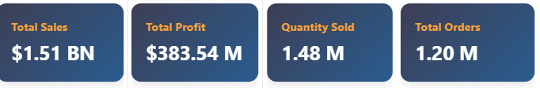
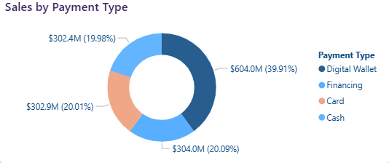
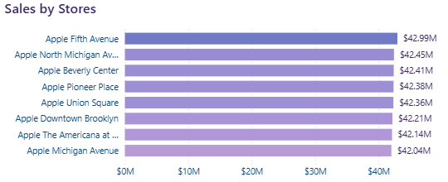

Hint and detail view pages are hidden.


