Description of tasks:
1. After creating an AWS account, I logged in using the root account. Then, using IAM, I created a new user – student-admin, and added the AdministratorAccess policies. I also created an Access key.

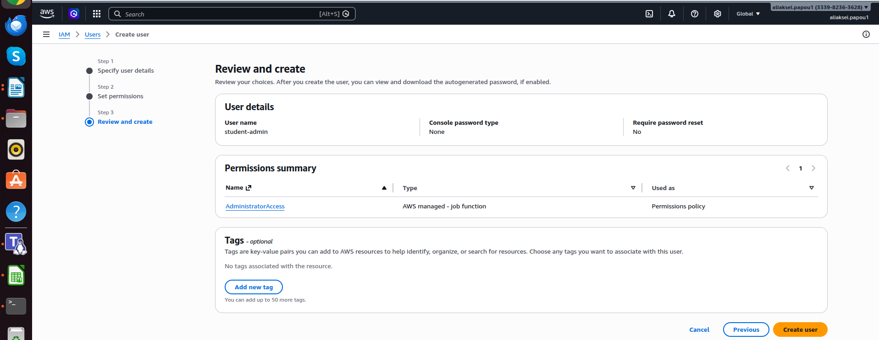

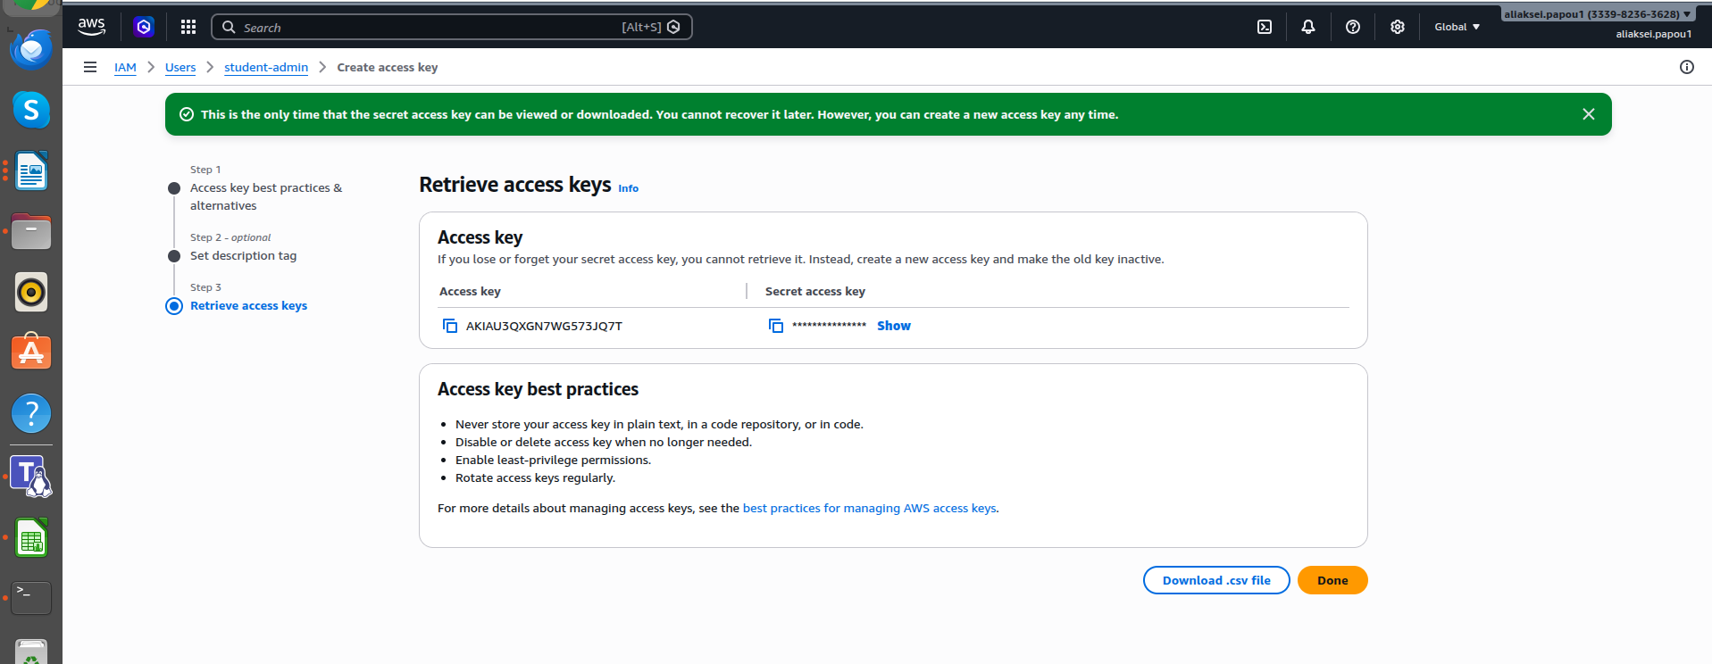

Then I installed AWS CLI 2.0.30 for Linux Ubuntu.

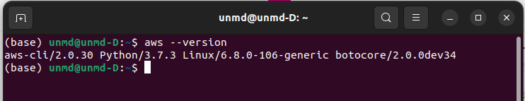

To meet the requirements of the task, I configured the user-role-260586643565 profile using the Frankfurt region: - eu-central-1. Next, I created the role: students-role and assumed it (I configured config file using ~/.aws/config and ARN of the student role).

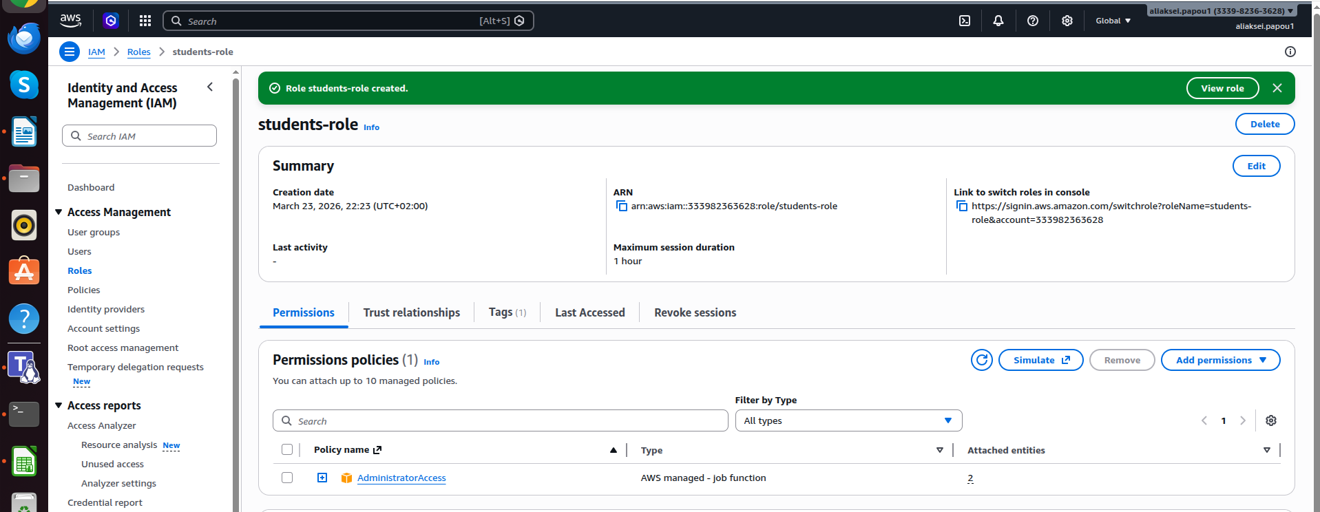

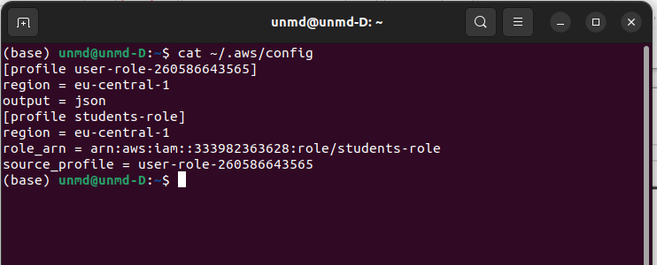

After running: aws sts get-caller-identity --profile students-role
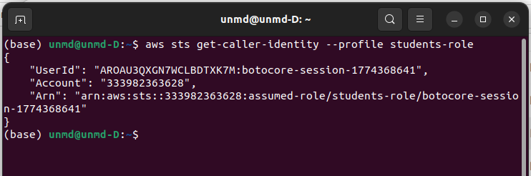

2. Using the AWS CLI, I created a bucket: aliaksei.papou.bucket, and added the tag: owner=student.

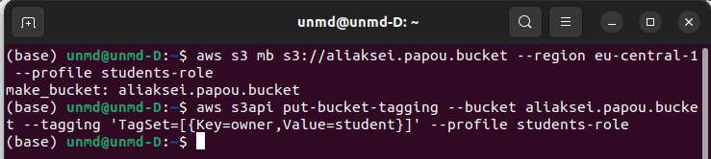

I also used the CLI to upload CSV files to the bucket, creating a separate directory for each table.

aws s3 cp dim_customers.csv s3://aliaksei.papou.bucket/di_dwh_database/bl_dm/dim_customers/dim_customers.csv --profile students-role
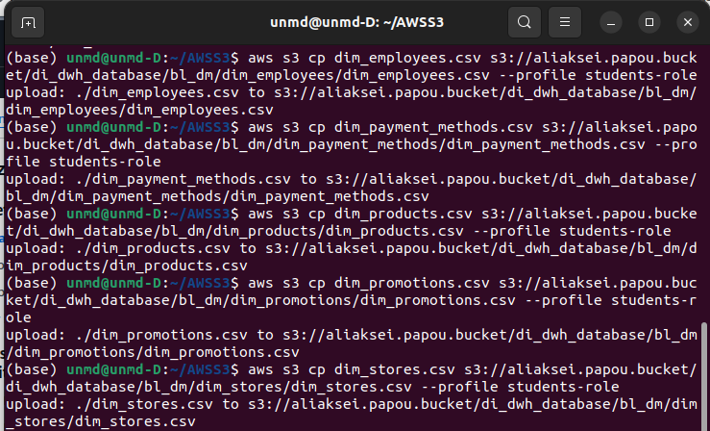

This loaded all the tables from my bl_dm schema.

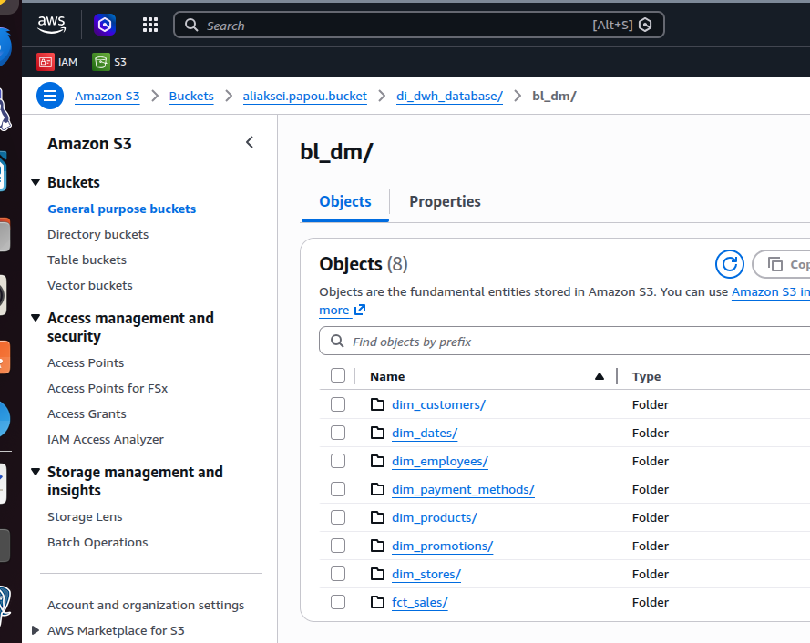

Next, I moved to AWS Glue, where I created a database: db_dwh
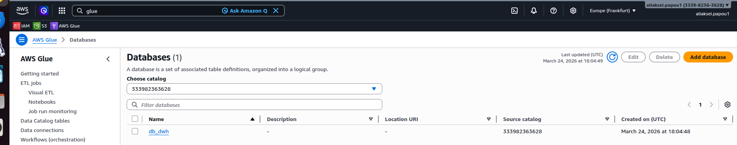

After that, I created a crawler: aliaksei.papou.crawler. My - aliaksei.papou.bucket was selected as the data source. The crawler ran successfully.
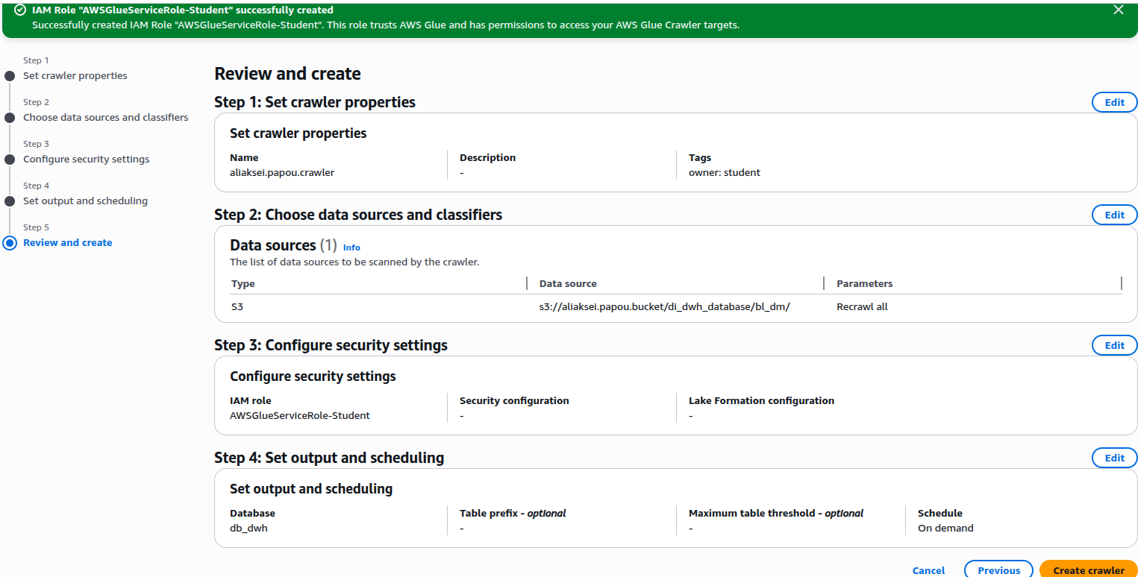



In AWS Athena, I ran one simple query and one with join. I used the row limit because I'm using a trial account.

SELECT * FROM "dim_customers" LIMIT 10;
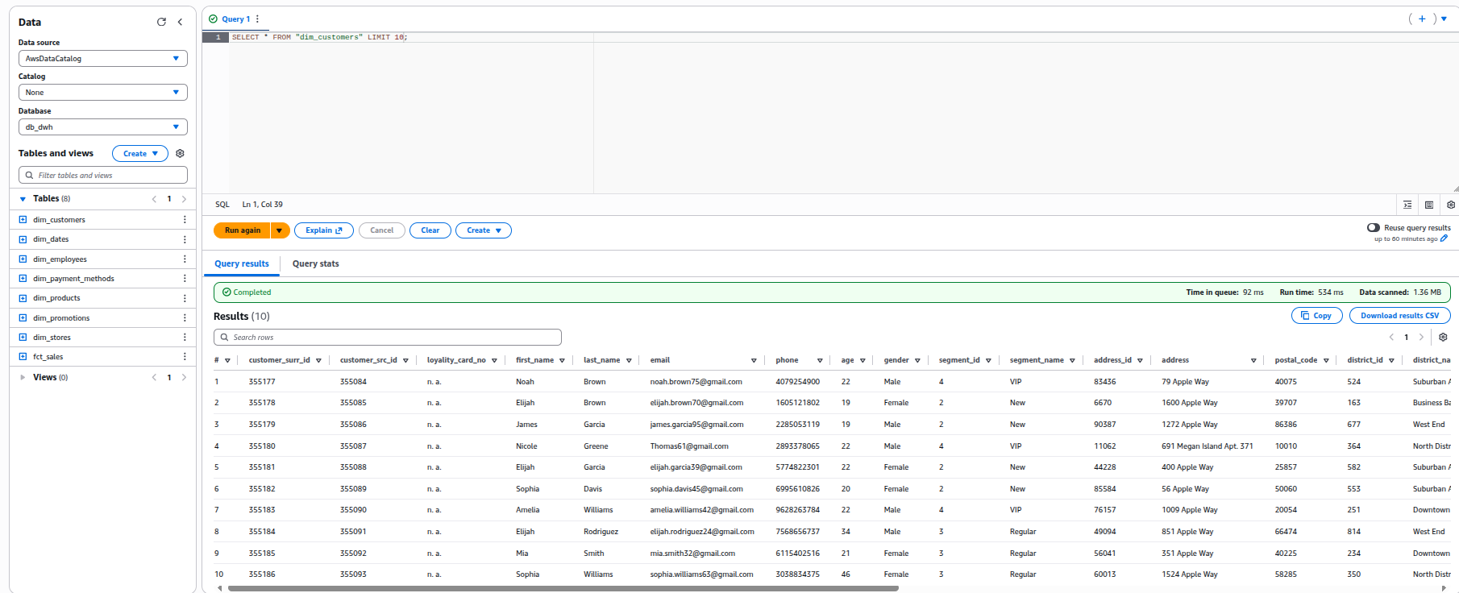

SELECT city_name, COUNT(*) as total_sales
FROM "dim_customers" c
JOIN "fct_sales" f ON c.customer_surr_id = f.customer_surr_id
GROUP BY city_name
ORDER BY total_sales DESC
LIMIT 30;
