My reports and task completion are a bit unusual because I don't have an EPAM account yet. Hanna told me to use a personal account and the Amazon trial account. I'm trying to create the best conditions for completing the task as stated in the requirements. Please let me know if you need more detailed explanations or information. I would be very grateful for your recommendations and advice. Thank you in advance.

1. AWS Lambda service

To meet the requirements of the task, I created the role: dilab-lambda-sf-role.
All Lambda functions were assigned the dilab-lambda-sf-role execution role. This role was configured with the following permission policies:
- AmazonS3FullAccess: To read SQL scripts and write Athena results.
- AmazonAthenaFullAccess: To execute queries and manage workgroups.
- CloudWatchLogsFullAccess: To maintain execution logs for reporting.

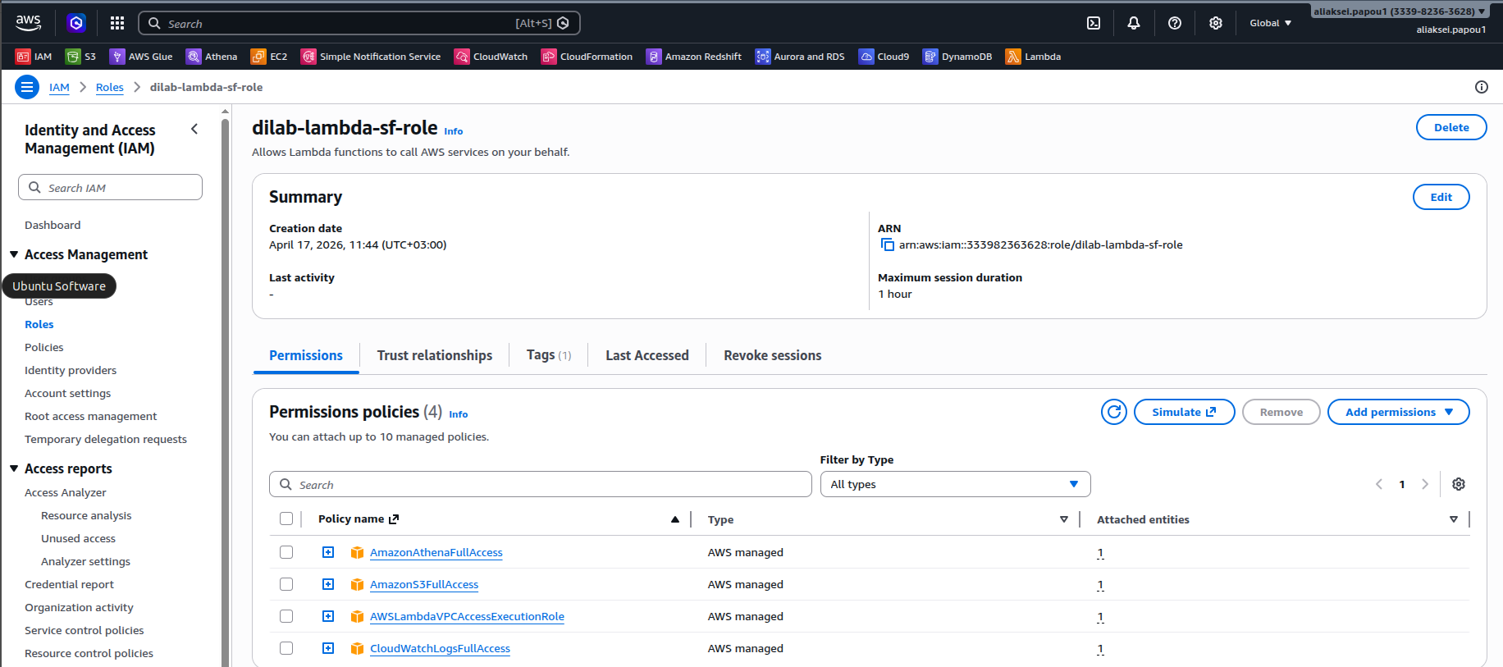

Then I created a Lambda function named Aliaksei_Papou_test_lambda using Python 3.14.
The function iterates through the incoming event dictionary (JSON) and logs each key-value pair to CloudWatch.
Implemented a loop to extract data dynamically, ensuring the output follows the required format: Value for the key <key> is - <value>.

import json

def lambda_handler(event, context):
for key, value in event.items():
print(f"Value for the key {key} is - {value}")

return event

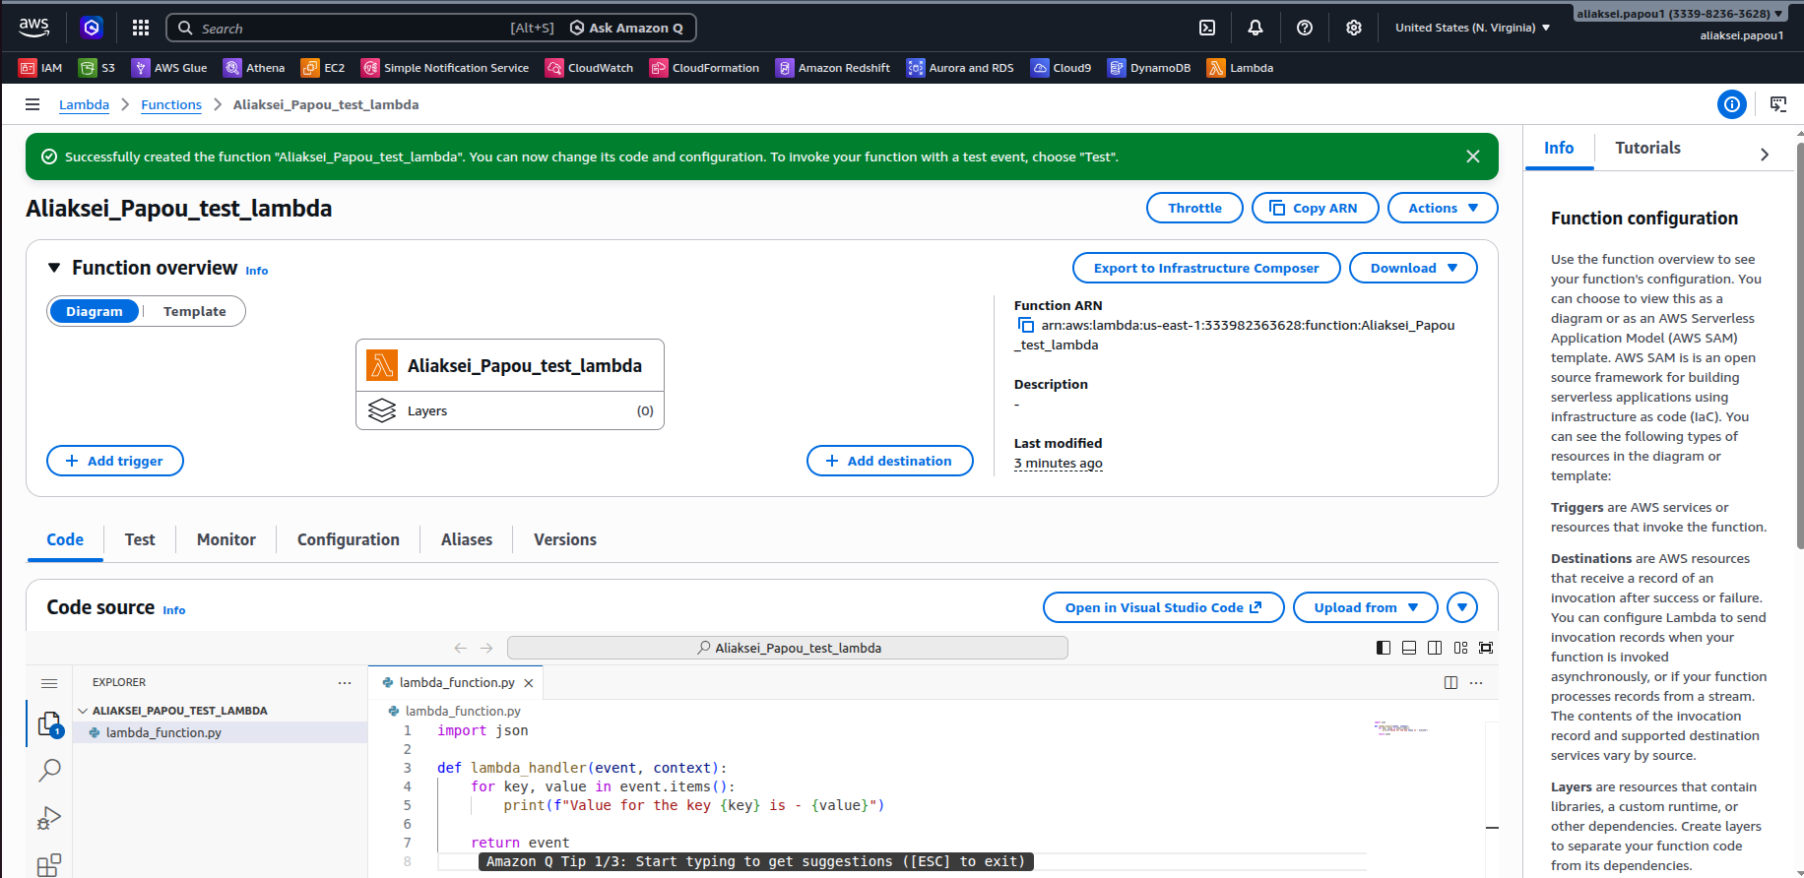

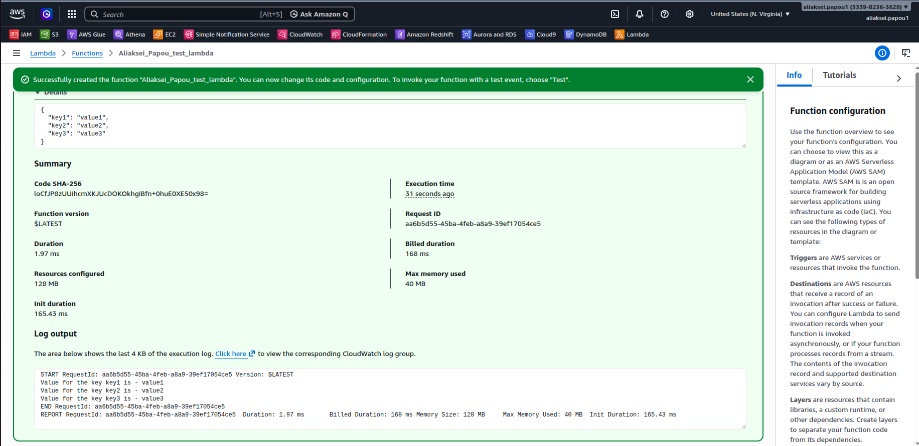

I also checked the logs in CloudWatchLogs:
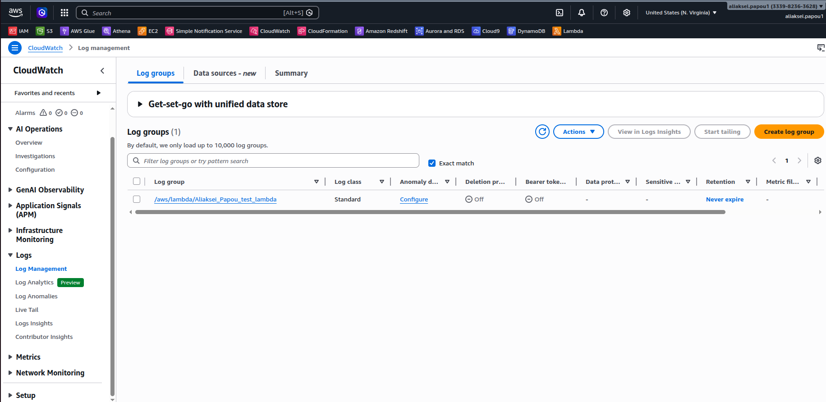

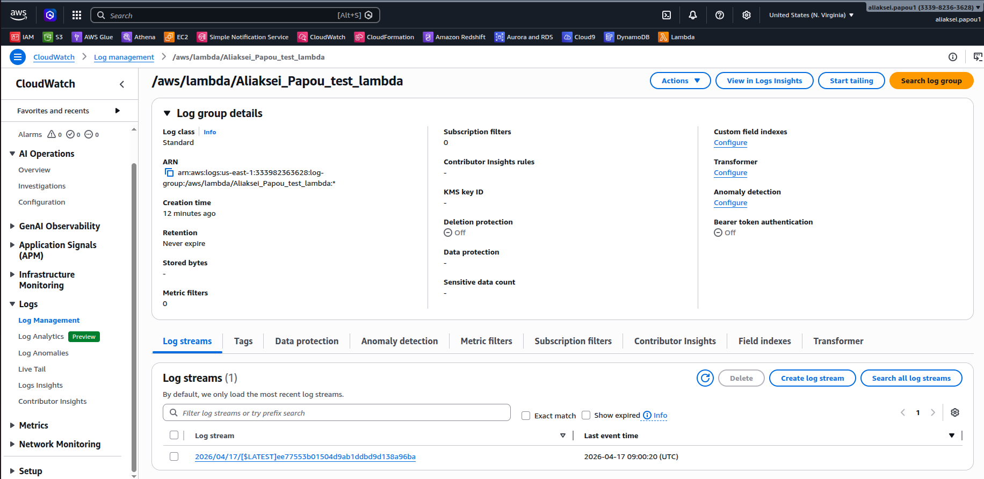

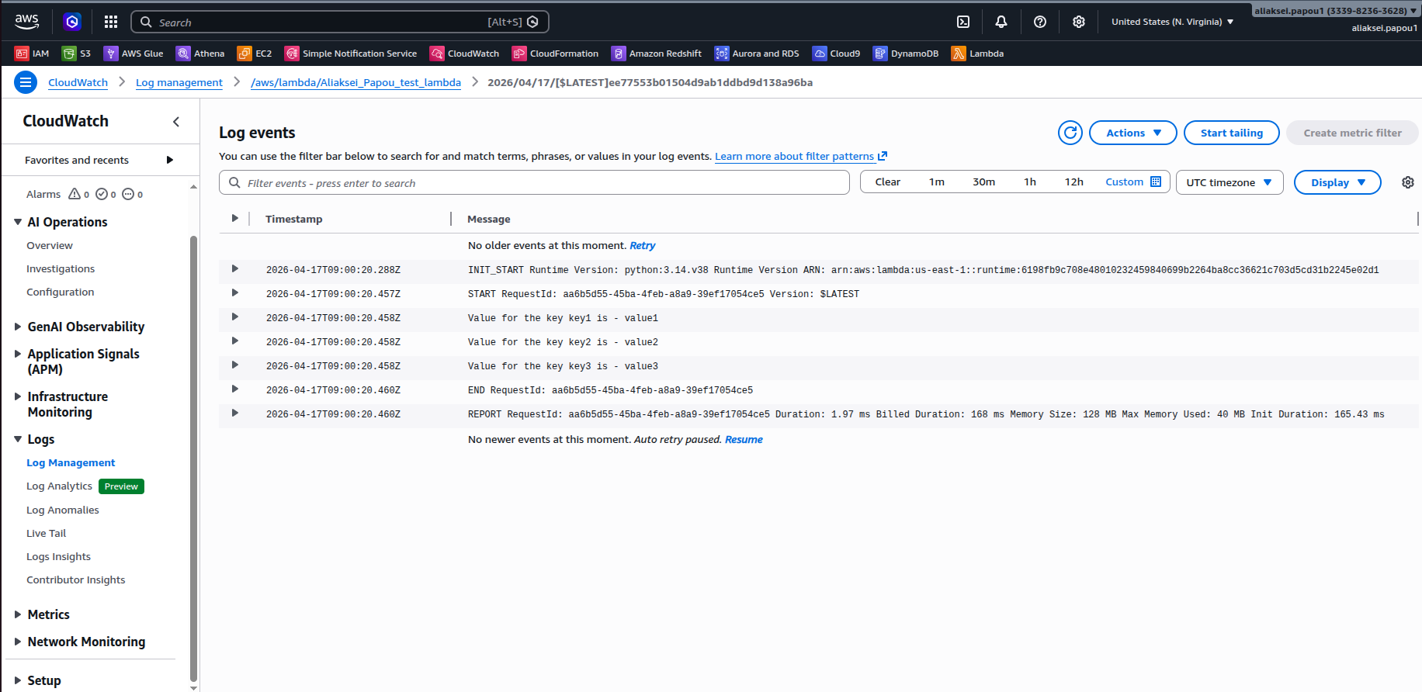

Then in accordance with task 1 b) I сonfigured Amazon Athena to interact with an S3 and perform operations using the Iceberg table format.
I created an S3 bucket: athena-results-aliaksei-papou to act as the output location for Athena query results.
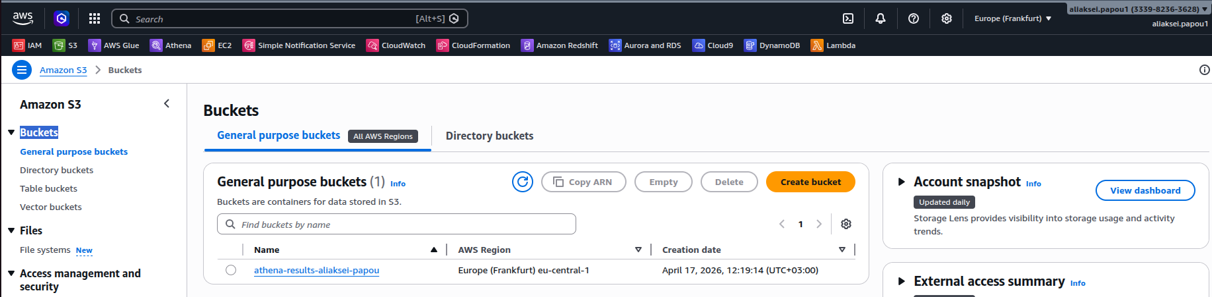

Using Athena query editor, I created a database and an Apache Iceberg table. Iceberg was specifically chosen to enable the UPDATE operation, which is not supported by default Athena tables.
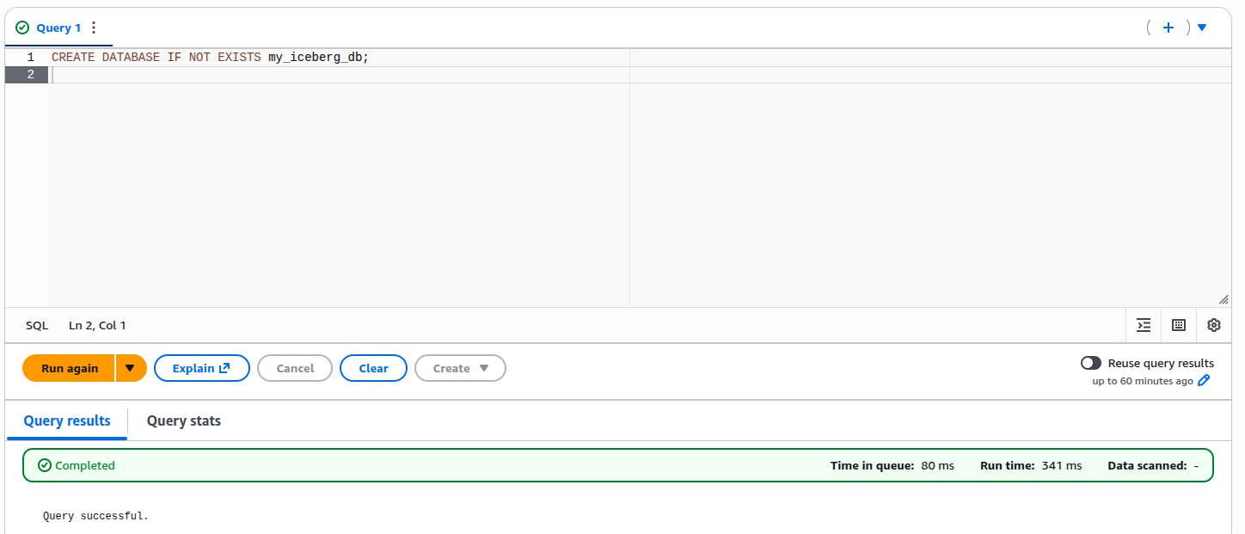

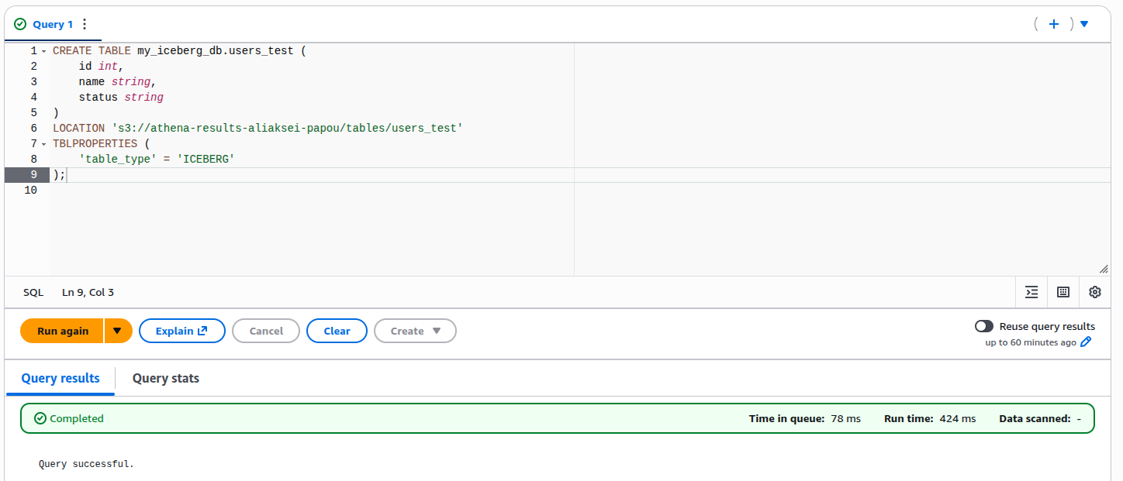
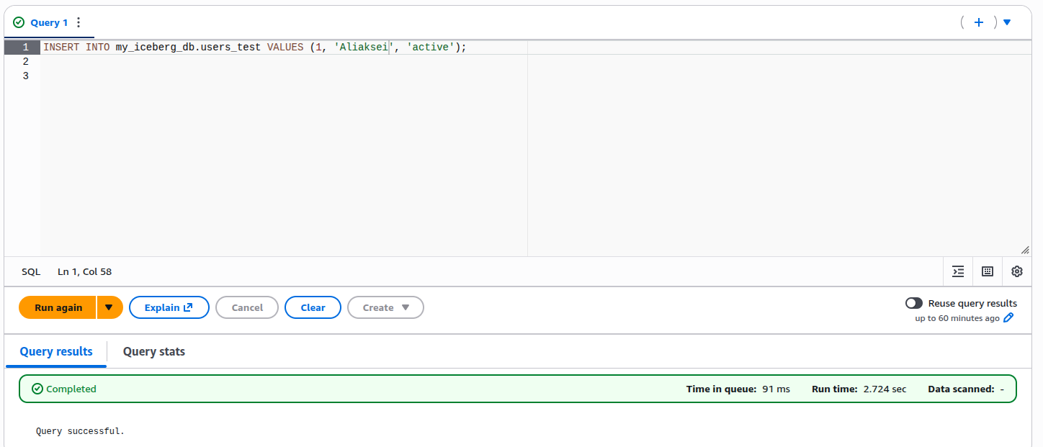

Then I created the Lambda function: Aliaksei_Papou_athena_lambda that utilizes the boto3 library to trigger asynchronous queries via start_query_execution.
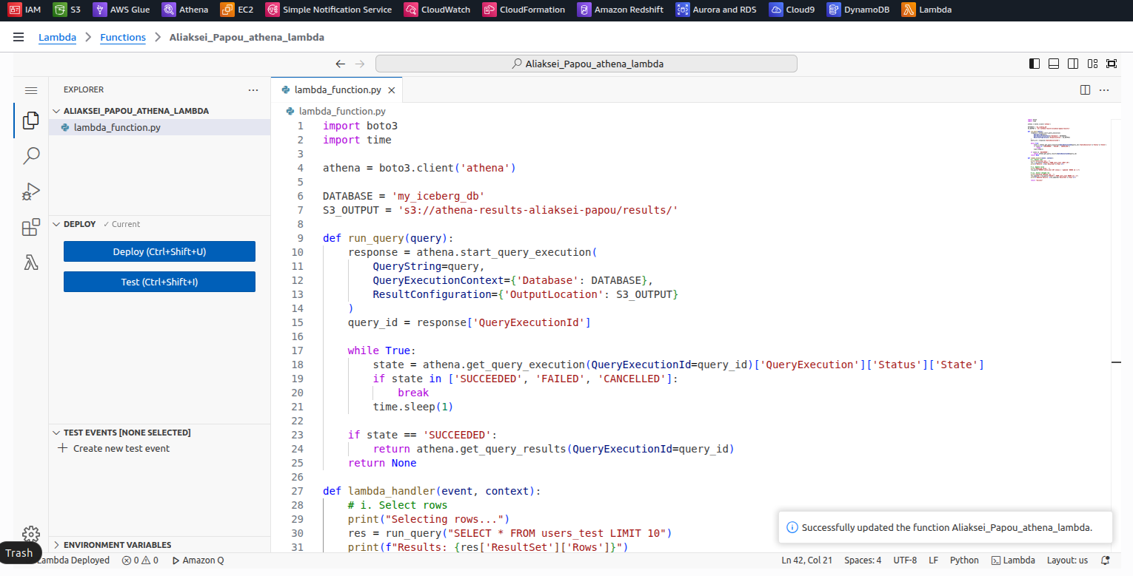

import boto3
import time
athena = boto3.client('athena')

DATABASE = 'my_iceberg_db'
S3_OUTPUT = 's3://athena-results-aliaksei-papou/results/'

def run_query(query):
response = athena.start_query_execution(
QueryString=query,
QueryExecutionContext={'Database': DATABASE},
ResultConfiguration={'OutputLocation': S3_OUTPUT})
query_id = response['QueryExecutionId']

while True:
state = athena.get_query_execution(QueryExecutionId=query_id)['QueryExecution']['Status']['State']
if state in ['SUCCEEDED', 'FAILED', 'CANCELLED']:
break
time.sleep(1)

if state == 'SUCCEEDED':
return athena.get_query_results(QueryExecutionId=query_id)
return None

def lambda_handler(event, context):
# i. Select rows
print("Selecting rows...")
res = run_query("SELECT * FROM users_test LIMIT 10")
print(f"Results: {res['ResultSet']['Rows']}")

# ii. Update value
print("Updating value...")
run_query("UPDATE users_test SET status = 'updated' WHERE id = 1")

# iii. Select changed row
print("Checking updated row...")
res_updated = run_query("SELECT * FROM users_test WHERE id = 1")
print(f"Updated Results: {res_updated['ResultSet']['Rows']}")

return "Success"

I also checked the logs:
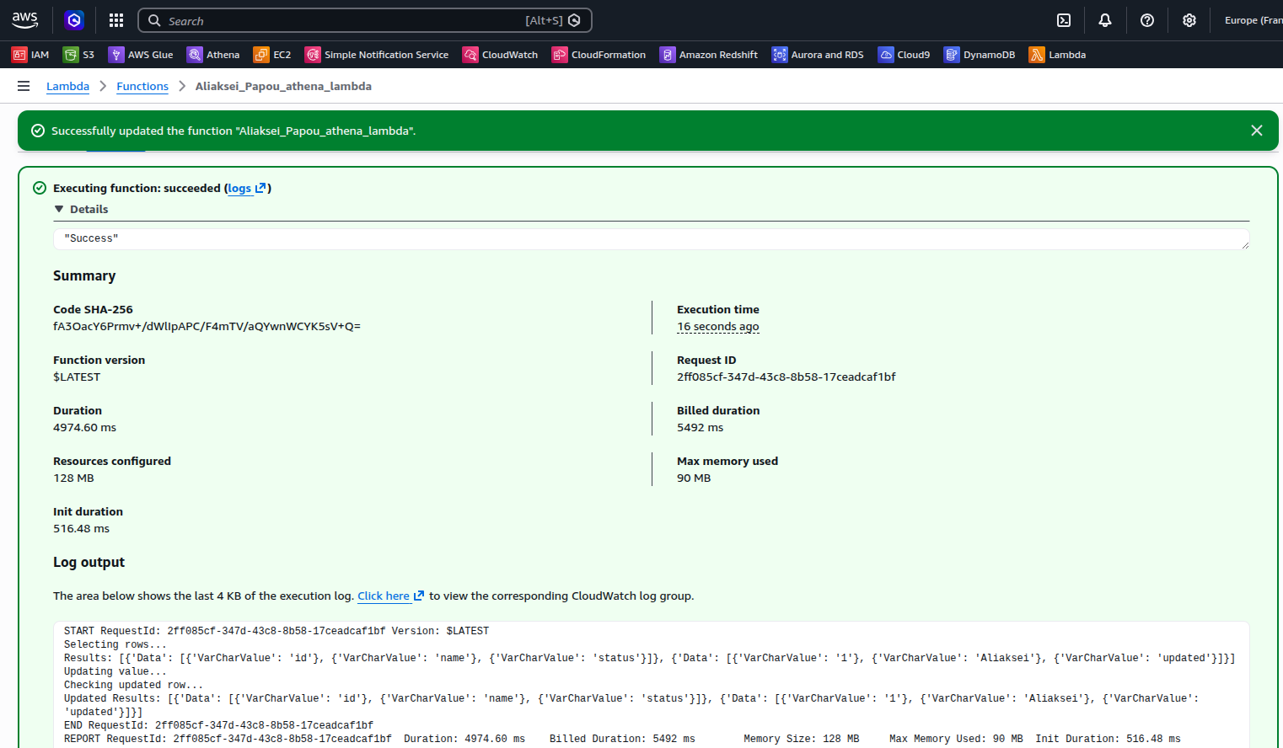
In accordance with task 1 c) I created a Lambda function: Aliaksei_Papou_s3_athena_lambda to fetch SQL query from an external file stored in S3.
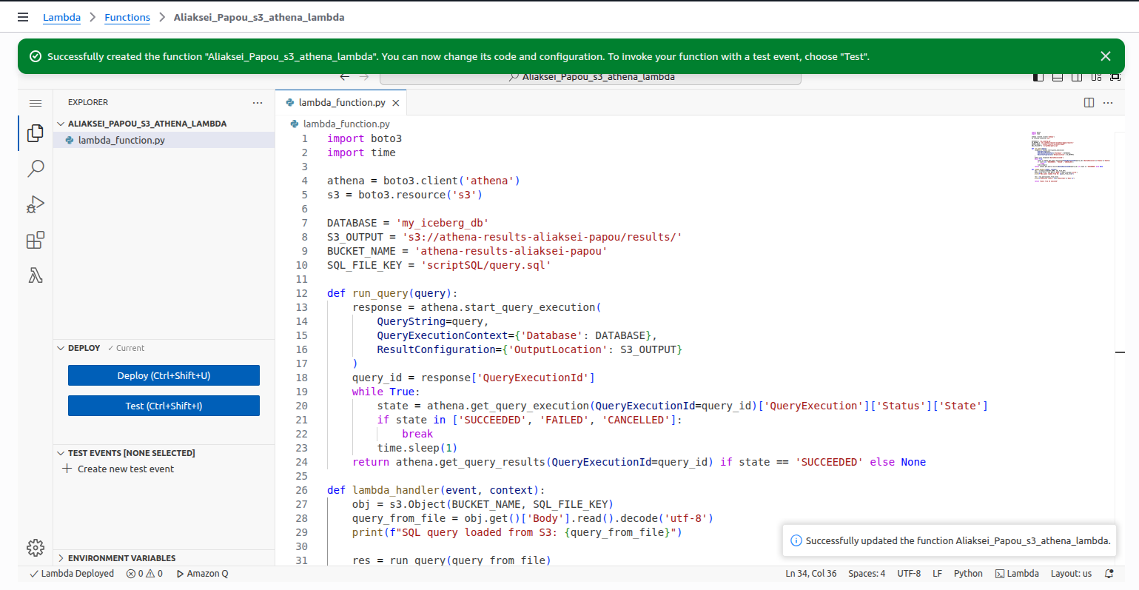

Lambda uses the s3.Object.get() method to read the file content, decodes it from bytes to a UTF-8 string, and passes it as a parameter to the Athena execution engine.
import boto3
import time

athena = boto3.client('athena')
s3 = boto3.resource('s3')

DATABASE = 'my_iceberg_db'
S3_OUTPUT = 's3://athena-results-aliaksei-papou/results/'
BUCKET_NAME = 'athena-results-aliaksei-papou'
SQL_FILE_KEY = 'scriptSQL/query.sql'

def run_query(query):
response = athena.start_query_execution(
QueryString=query,
QueryExecutionContext={'Database': DATABASE},
ResultConfiguration={'OutputLocation': S3_OUTPUT}
)
query_id = response['QueryExecutionId']
while True:
state = athena.get_query_execution(QueryExecutionId=query_id)['QueryExecution']['Status']['State']
if state in ['SUCCEEDED', 'FAILED', 'CANCELLED']:
break
time.sleep(1)
return athena.get_query_results(QueryExecutionId=query_id) if state == 'SUCCEEDED' else None

def lambda_handler(event, context):
obj = s3.Object(BUCKET_NAME, SQL_FILE_KEY)
query_from_file = obj.get()['Body'].read().decode('utf-8')
print(f"SQL query loaded from S3: {query_from_file}")

res = run_query(query_from_file)
print(f"Execution result: {res['ResultSet']['Rows']}")

return "Query from S3 executed"

I uploaded a query.sql file to my S3 backet:
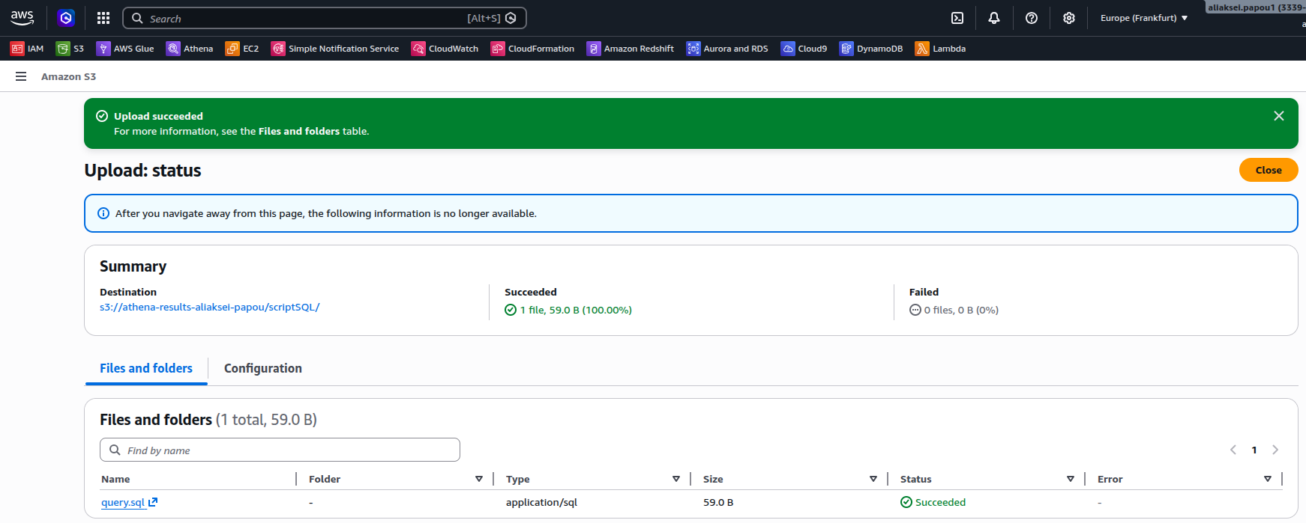

After the test, I checked the log and made sure it was successful.
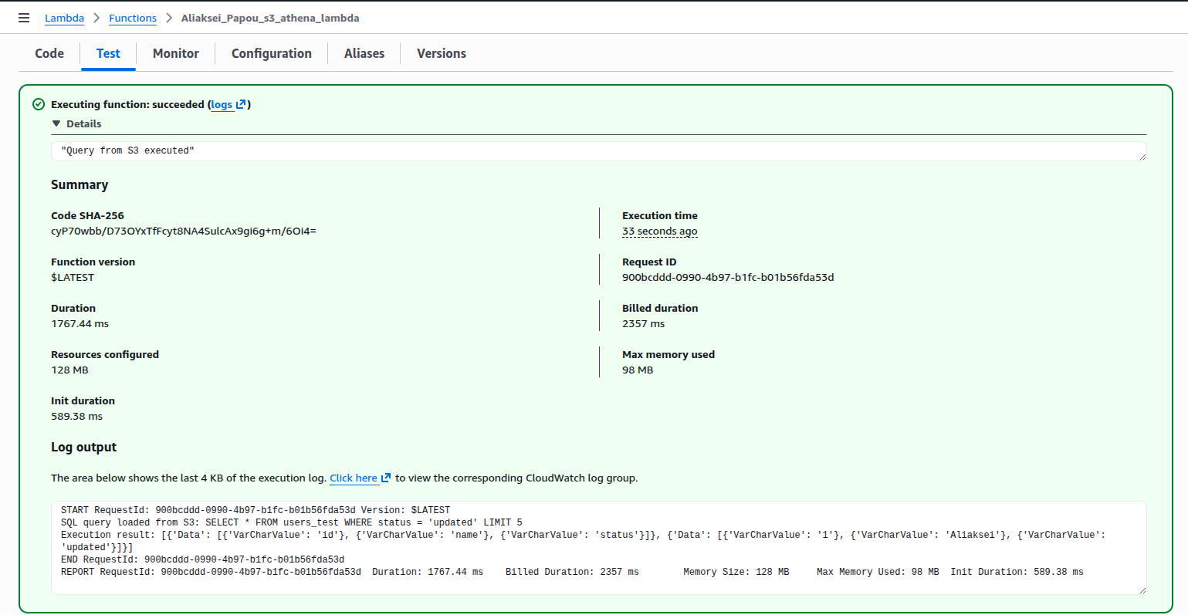

2. AWS Step Function service

As I used a trial account AWS without access to the specific EPAM Redshift cluster, the workflow was implemented using Lambda functions that simulate the Redshift interaction logic within a managed environment.

To support the Step Function workflow, I created Lambda function named: Aliaksei_Papou_step_function_lambda.
This function acts as a multi-purpose handler. It accepts a step_action parameter from the State Machine to simulate different stages of a database operations lifecycle (Testing vs. Updating). It returns structured JSON responses (e.g., {"test_result": "passed"}) that the Step Function uses for conditional branching.
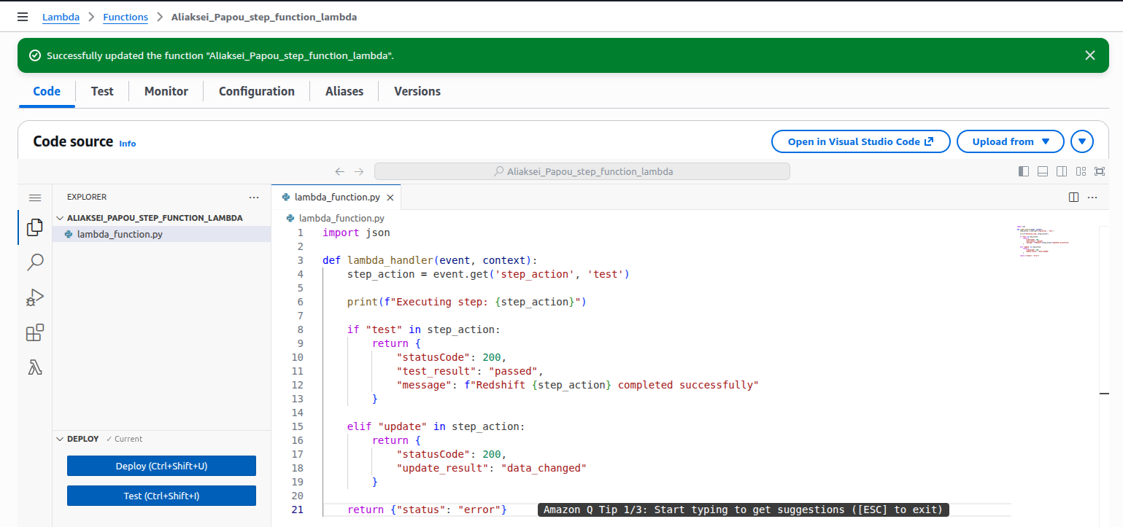

import json

def lambda_handler(event, context):
step_action = event.get('step_action', 'test')
print(f"Executing step: {step_action}")

if "test" in step_action:
return {
"statusCode": 200,
"test_result": "passed",
"message": f"Redshift {step_action} completed successfully"
}
elif "update" in step_action:
return {
"statusCode": 200,
"update_result": "data_changed"
}
return {"status": "error"}

Then I created a State Machine named: Aliaksei_Papou_redshift_flow to orchestrate the sequence of operations required by the assignment.
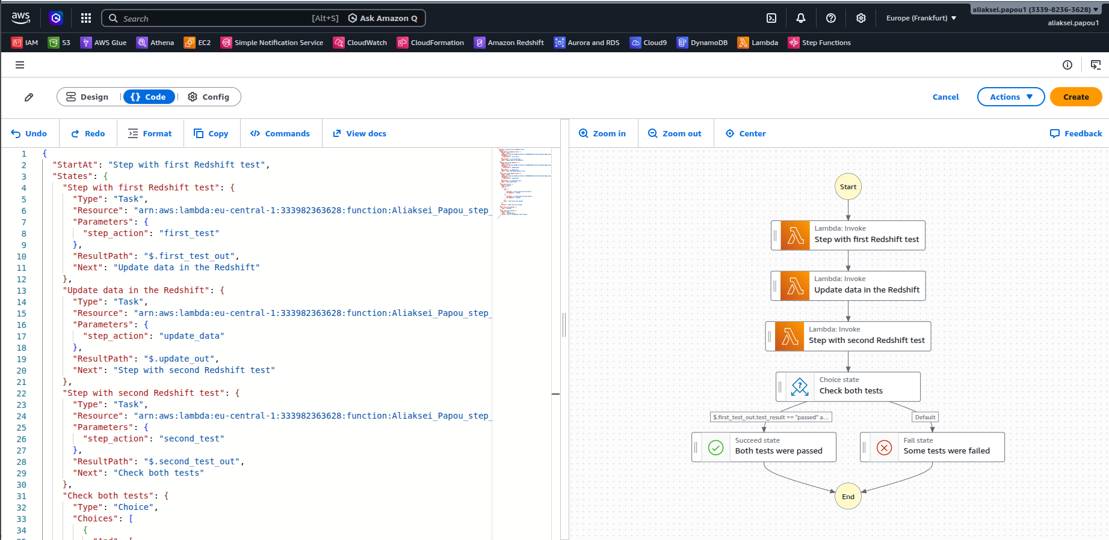

{
"StartAt": "Step with first Redshift test",
"States": {
"Step with first Redshift test": {
"Type": "Task",
"Resource": "arn:aws:lambda:eu-central-1:333982363628:function:Aliaksei_Papou_step_function_lambda",
"Parameters": {
"step_action": "first_test"
},
"ResultPath": "$.first_test_out",
"Next": "Update data in the Redshift"
},
"Update data in the Redshift": {
"Type": "Task",
"Resource": "arn:aws:lambda:eu-central-1:333982363628:function:Aliaksei_Papou_step_function_lambda",
"Parameters": {
"step_action": "update_data"
},
"ResultPath": "$.update_out",
"Next": "Step with second Redshift test"
},
"Step with second Redshift test": {
"Type": "Task",
"Resource": "arn:aws:lambda:eu-central-1:333982363628:function:Aliaksei_Papou_step_function_lambda",
"Parameters": {
"step_action": "second_test"
},
"ResultPath": "$.second_test_out",
"Next": "Check both tests"
},
"Check both tests": {
"Type": "Choice",
"Choices": [
{
"And": [
{
"Variable": "$.first_test_out.test_result",
"StringEquals": "passed"
},
{
"Variable": "$.second_test_out.test_result",
"StringEquals": "passed"
}
],
"Next": "Both tests were passed"
}
],
"Default": "Some tests were failed"
},
"Both tests were passed": {
"Type": "Succeed"
},
"Some tests were failed": {
"Type": "Fail",
"Error": "TestFailure",
"Cause": "One of the Redshift tests failed."}
}
}

Workflow steps:
- Step with first Redshift test: Invokes the Lambda to verify initial data integrity.
- Update data in the Redshift: Invokes the Lambda to simulate data modification.
- Step with second Redshift test: Performs a post-update validation.
- Check both tests (Choice State): Evaluates the outputs of both test steps.
Used ResultPath to preserve data between steps, allowing the final Choice state to access results from multiple previous tasks.
Result: As shown in the screenshot below, the workflow successfully validated both test steps and transitioned to the Both tests were passed (Succeed) state.
