Description of tasks:
1. Since I didn't have the AWS_EC2_full_access_S3 role, the first thing I did was create this role with AmazonS3FullAccess policies.

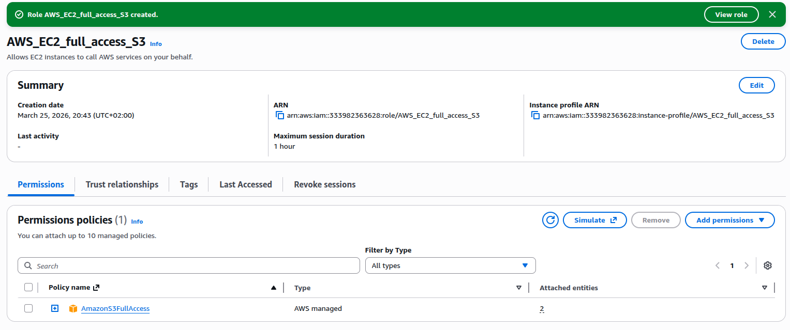

Then in EC2 AWS I created an instance, choosing Linux Ubuntu as operating system, type t3.micro, root volume - 8 GB and EBS - 10 GB. I added the AWS_EC2_full_access_S3 role. created key-pair and I also checked that the Metadata V2 parameter was enabled and that the Metadata version was V2 only. After that my instance: aliaksei.db.server was runned successfully .

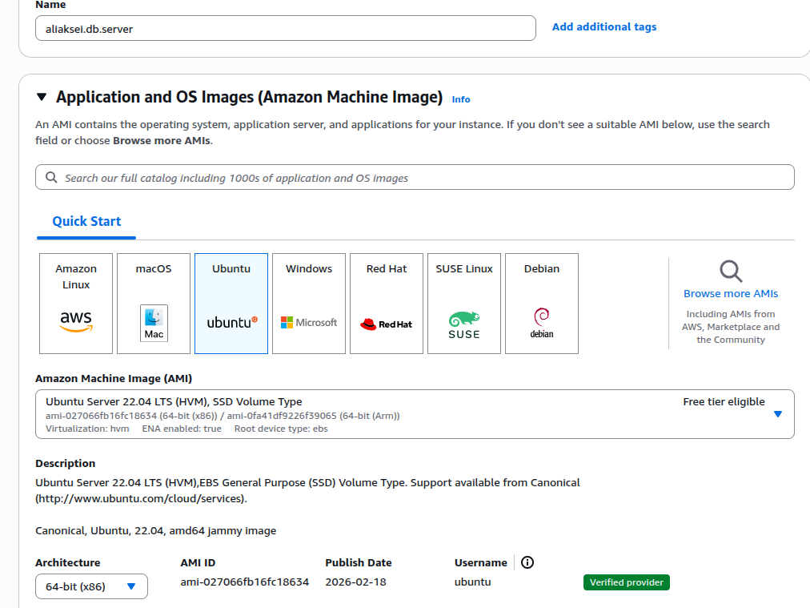

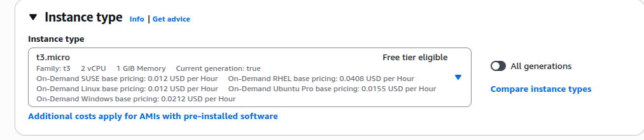

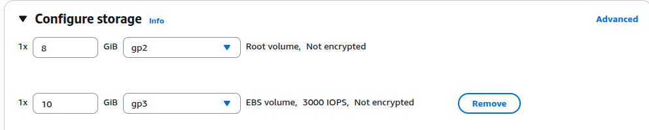

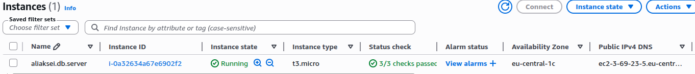

Then I connected to the server using the command line of my Linux Ubuntu and the previously created key pair.

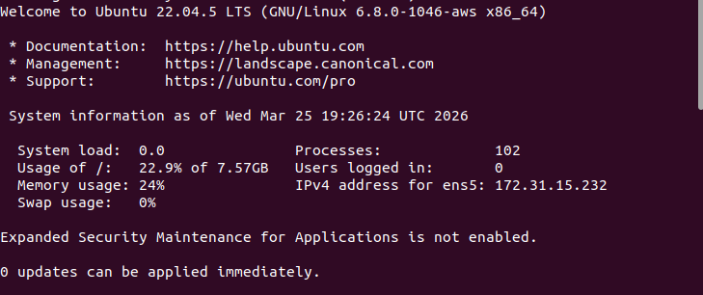

Then I installed PostgreSQL, configured external connections in the conf (set listen_addresses = '*') and set the user password.
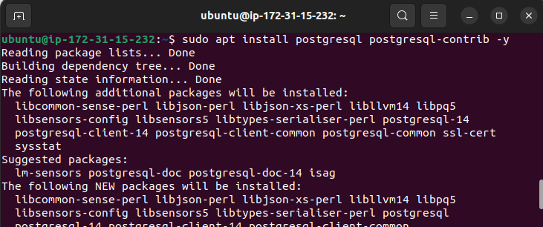

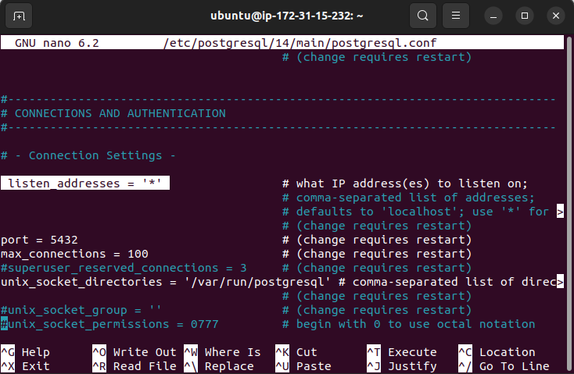

Next, I connected to PostgreSQL using pgAdmin, configuring the connection (host, user, password). I used the public schema and created a table, view, and procedure according to the task requirements.

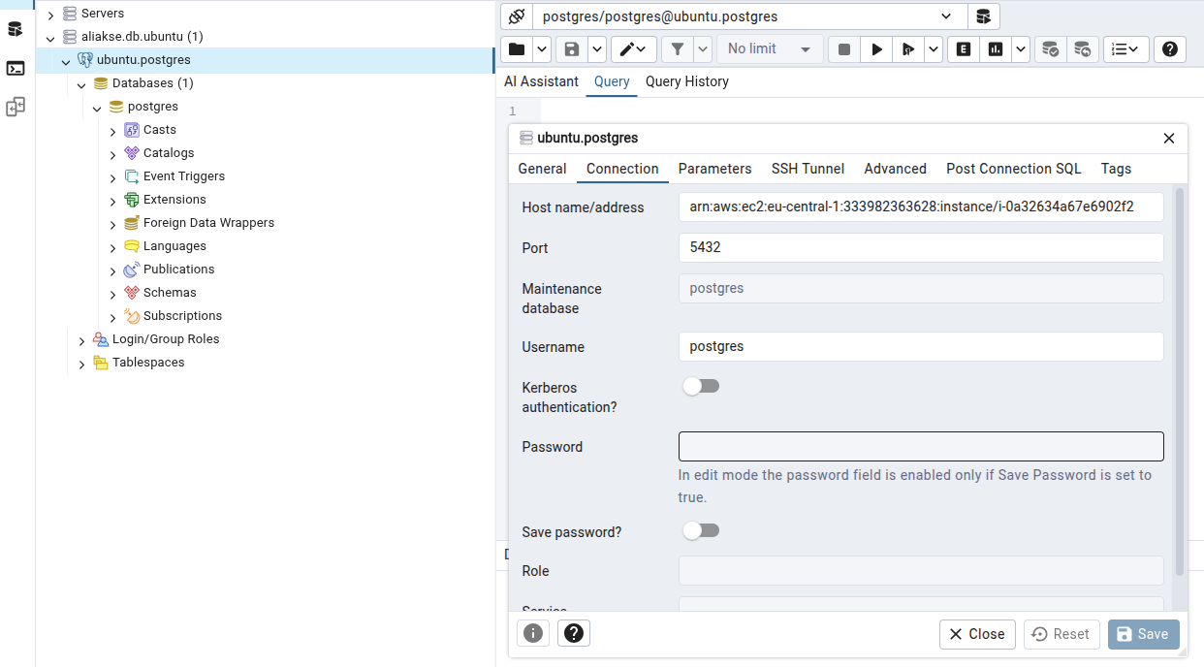

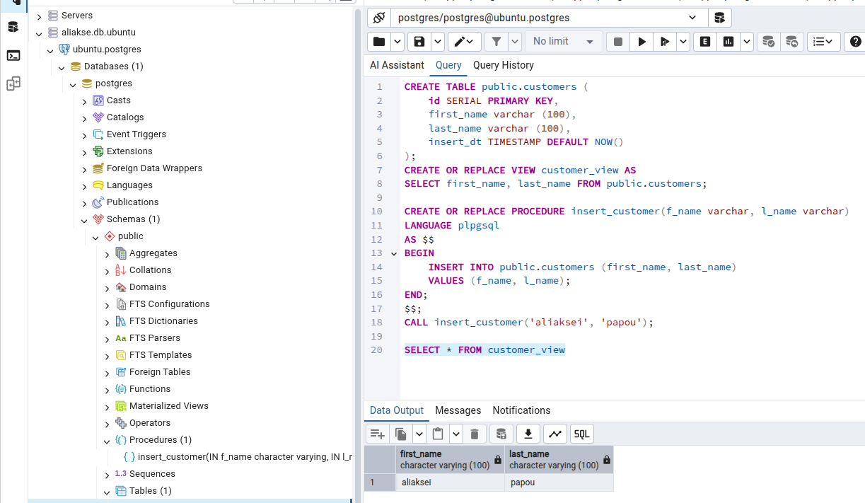

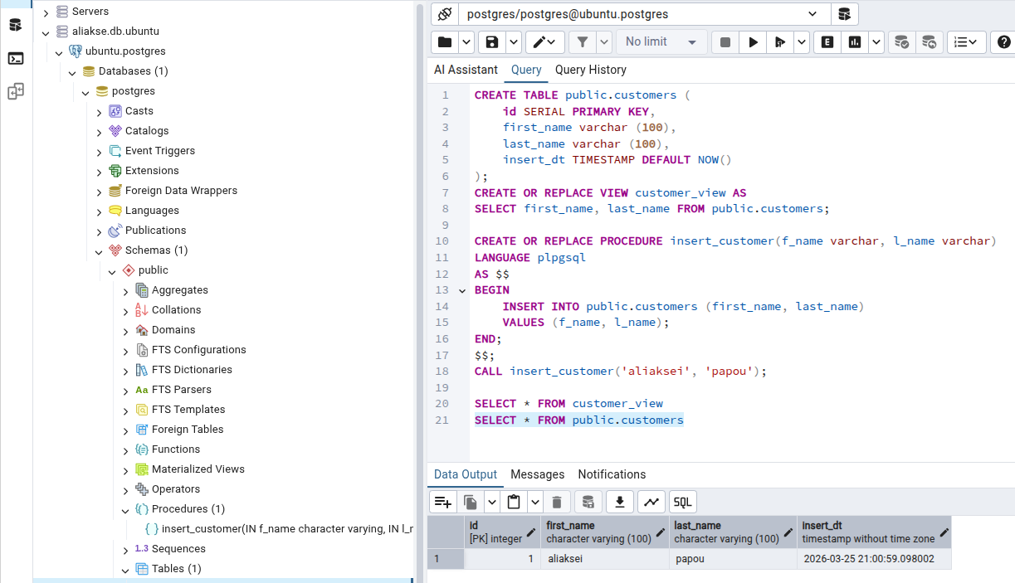
Since I had already added a role to my instance, I copied the dim_promotions.csv file from my S3 bucket to the EC2.
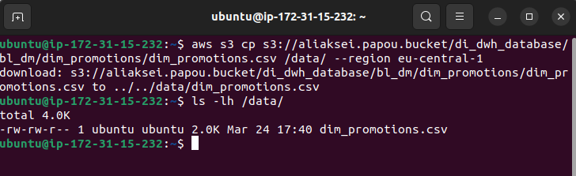
Next, I created a volume snapshot and an AMI image of my aliaksei.db.server EC2.
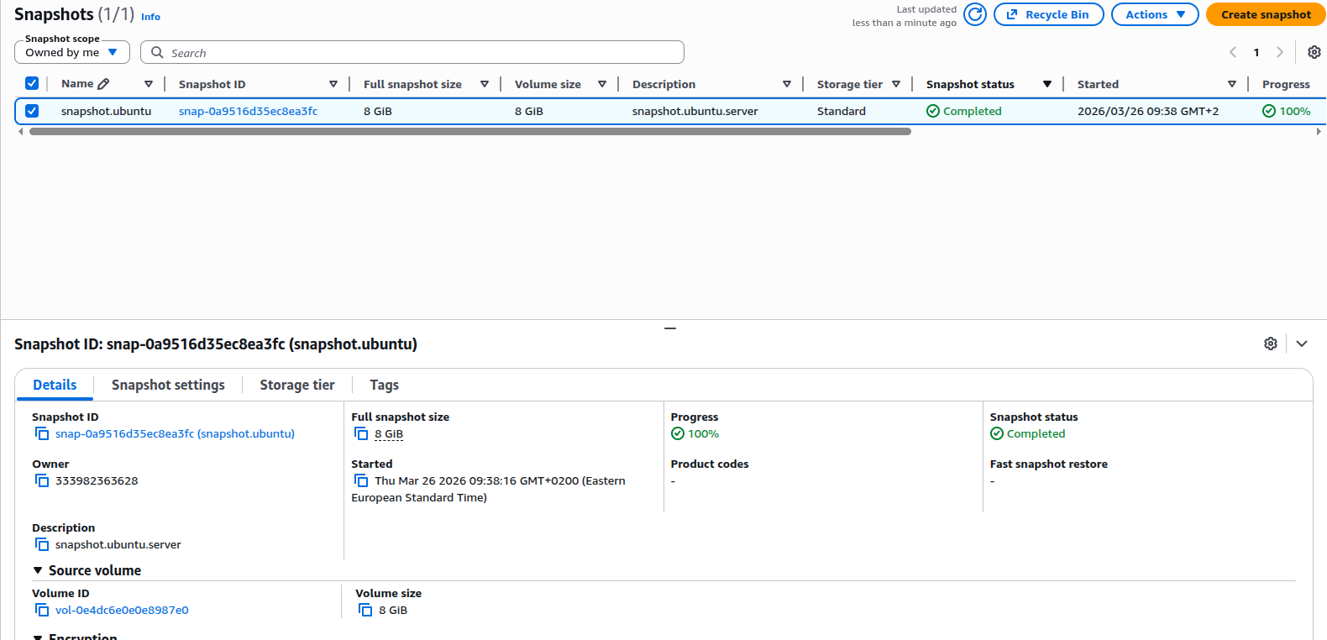

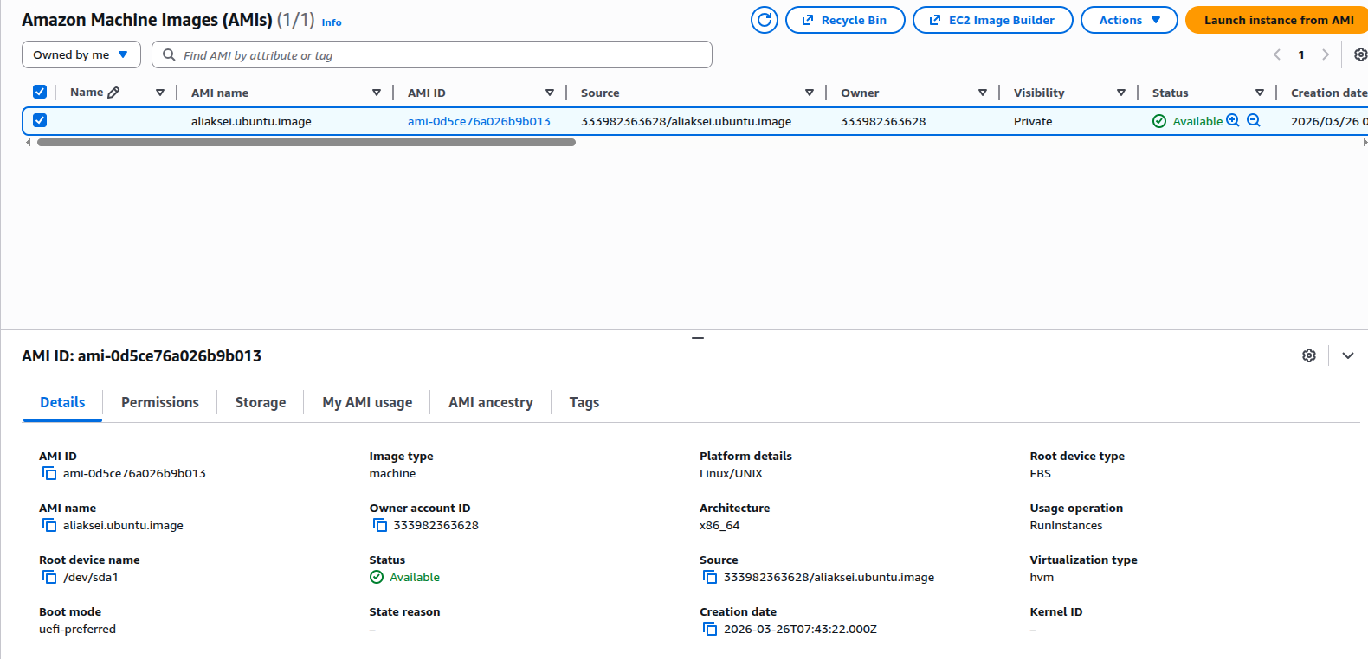

Then, using AMI image, I created a second instance: aliaksei.db.server.2. When creating it, I used the previously created role, key pair, and security group. I also checked that the Metadata V2 parameter was enabled and that the Metadata version was V2 only.
I connected to the new instance from the command line and checked for the presence of the dim_promotions.csv file.

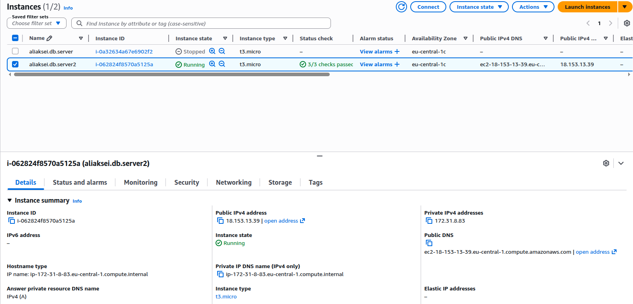

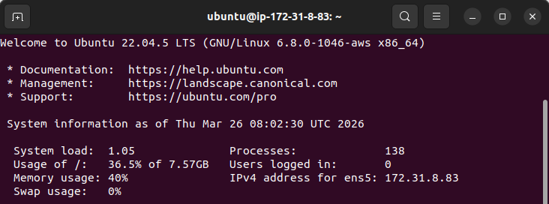

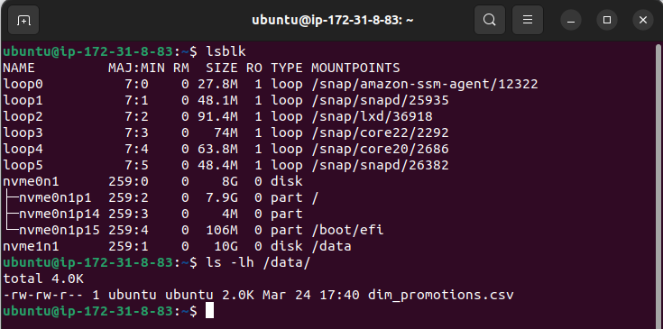

I installed Apache and uploaded the HTML to the standard directory /var/www/html (Since I didn't have access to the general folder, I used my own simple HTML). Earlier, when creating a network security group, I added HTTP with port 80.

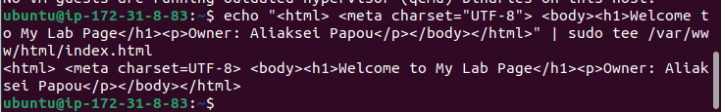

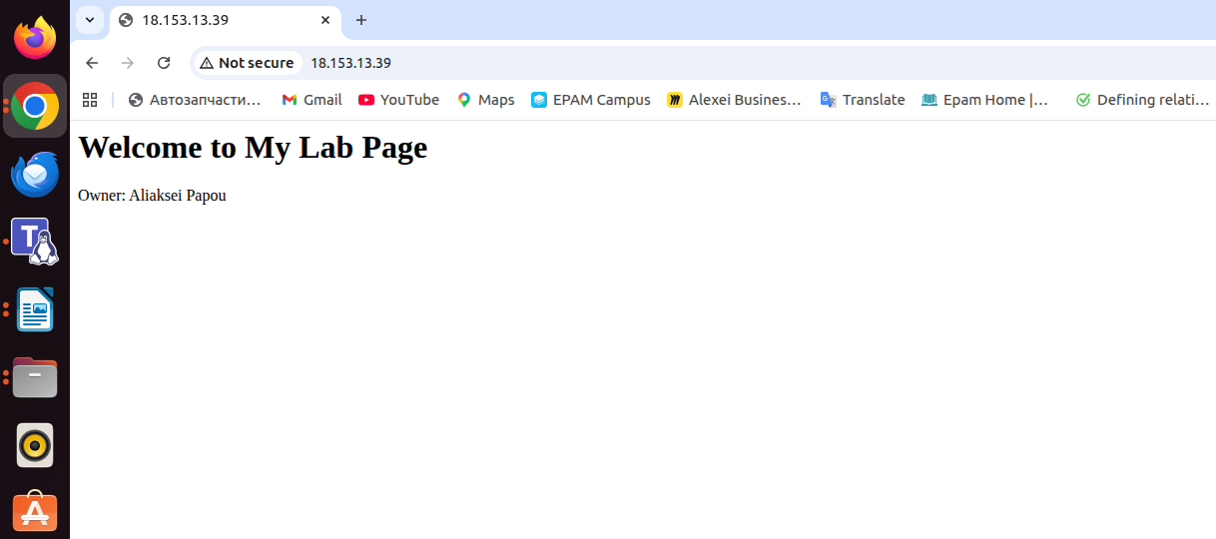
http://18.153.13.39/

Next, I went to SNS, where I created a topic and subscription, specifying my email address in the protocol. Then I confirmed the subscription that I received from AWS using my email address.

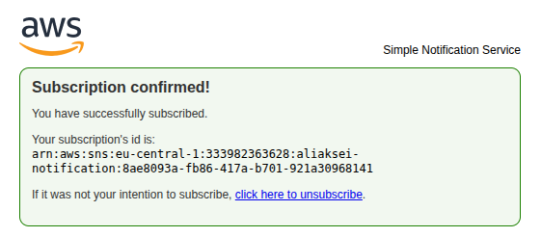

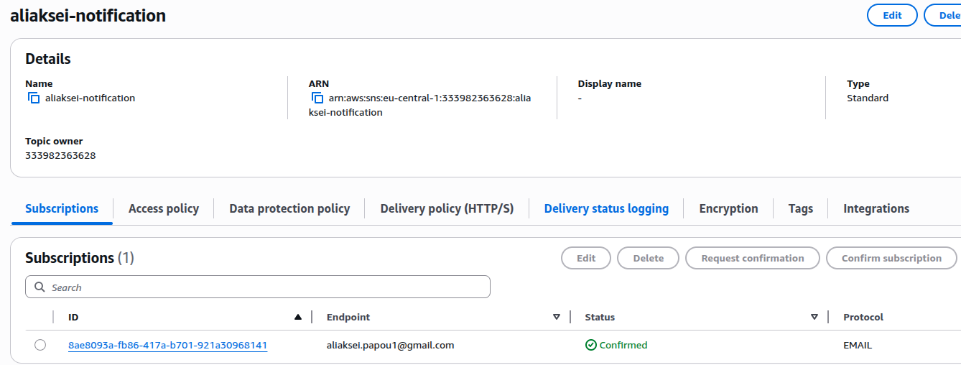

In CloudWatch, I created an alarm, selecting instance 2, and set the CPUUtilization metric threshold to Greater than 80. In the Notification section, I selected the SNS that I had created earlier.

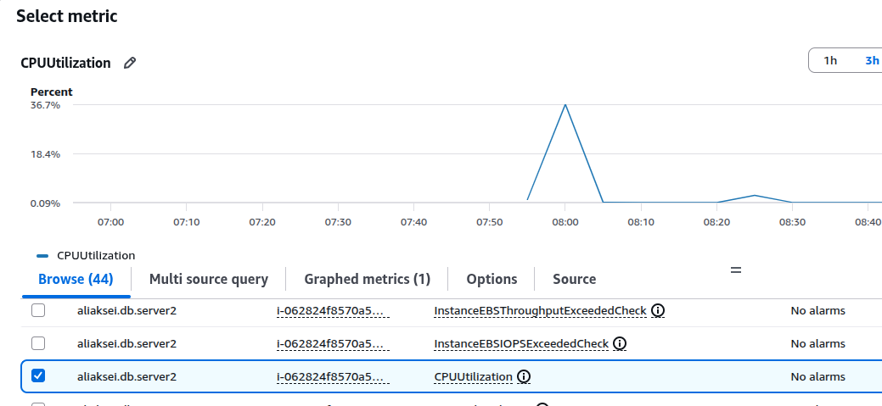

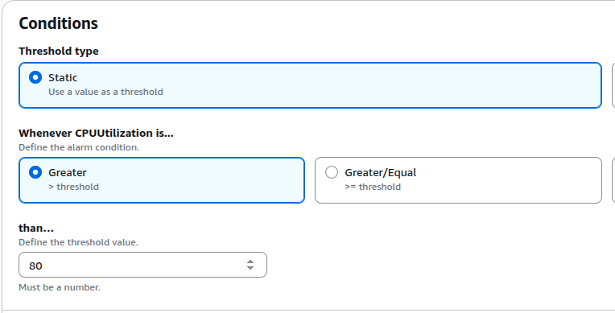

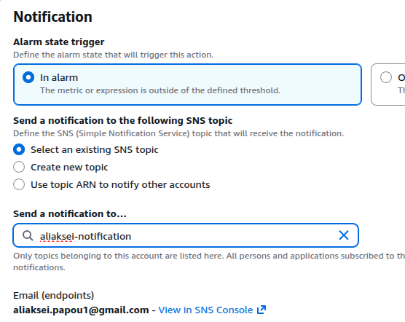

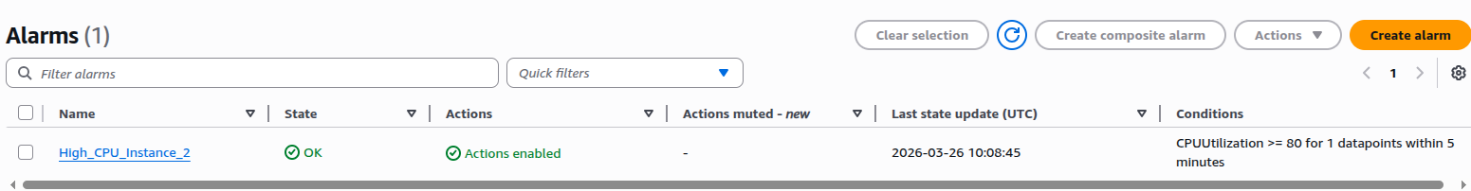

I created aliaksei_ec2.yaml script and uploaded it to my bucket. Then, in CloudFormation, I created a stack using my script as the template file. The new instance was successfully created.
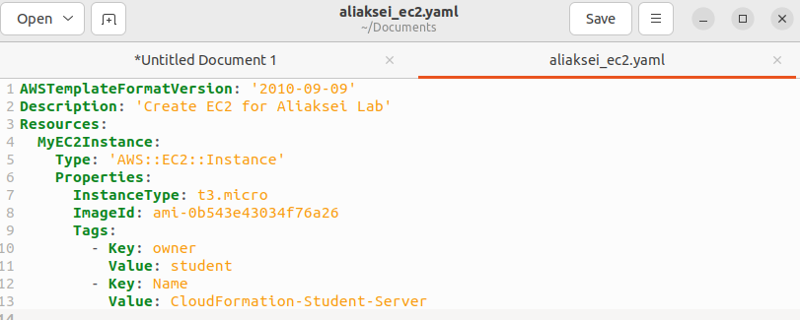

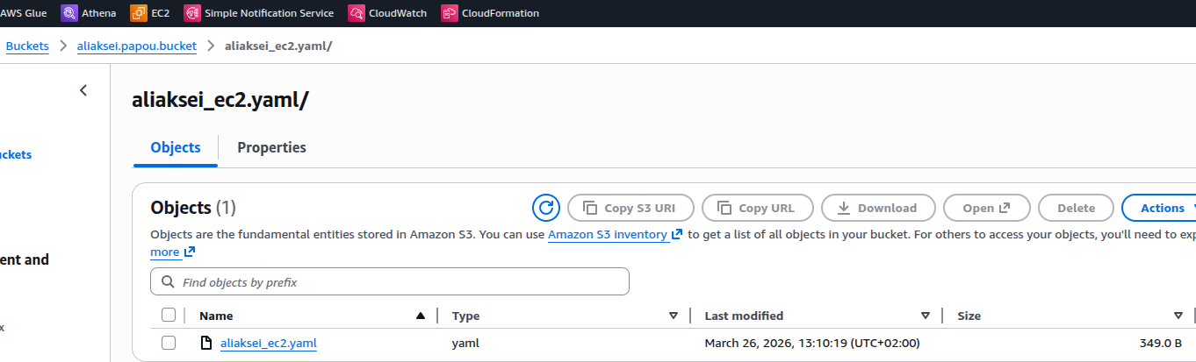

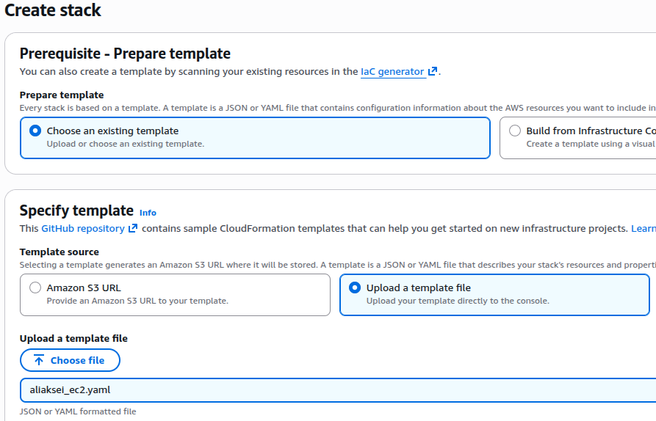

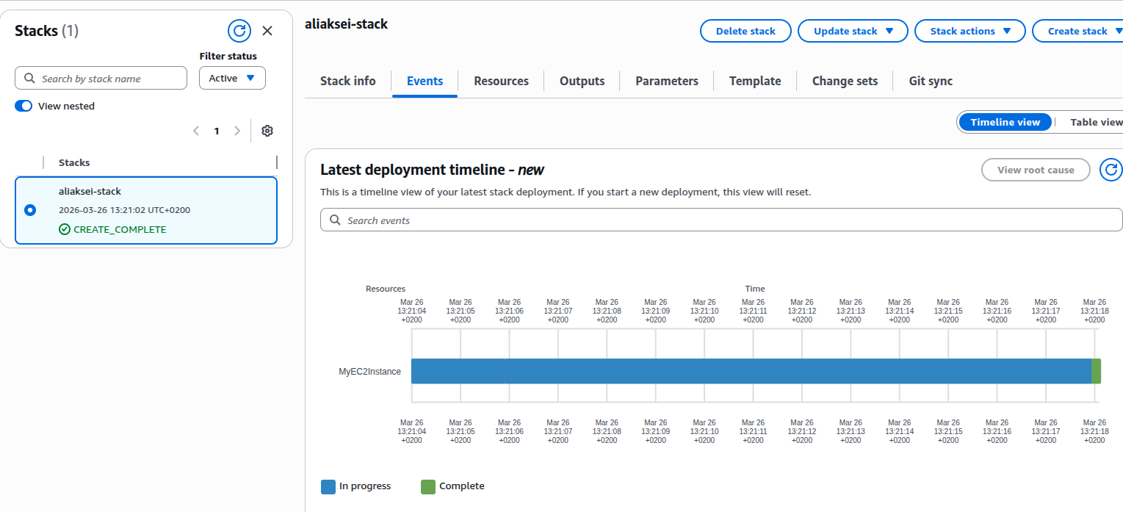

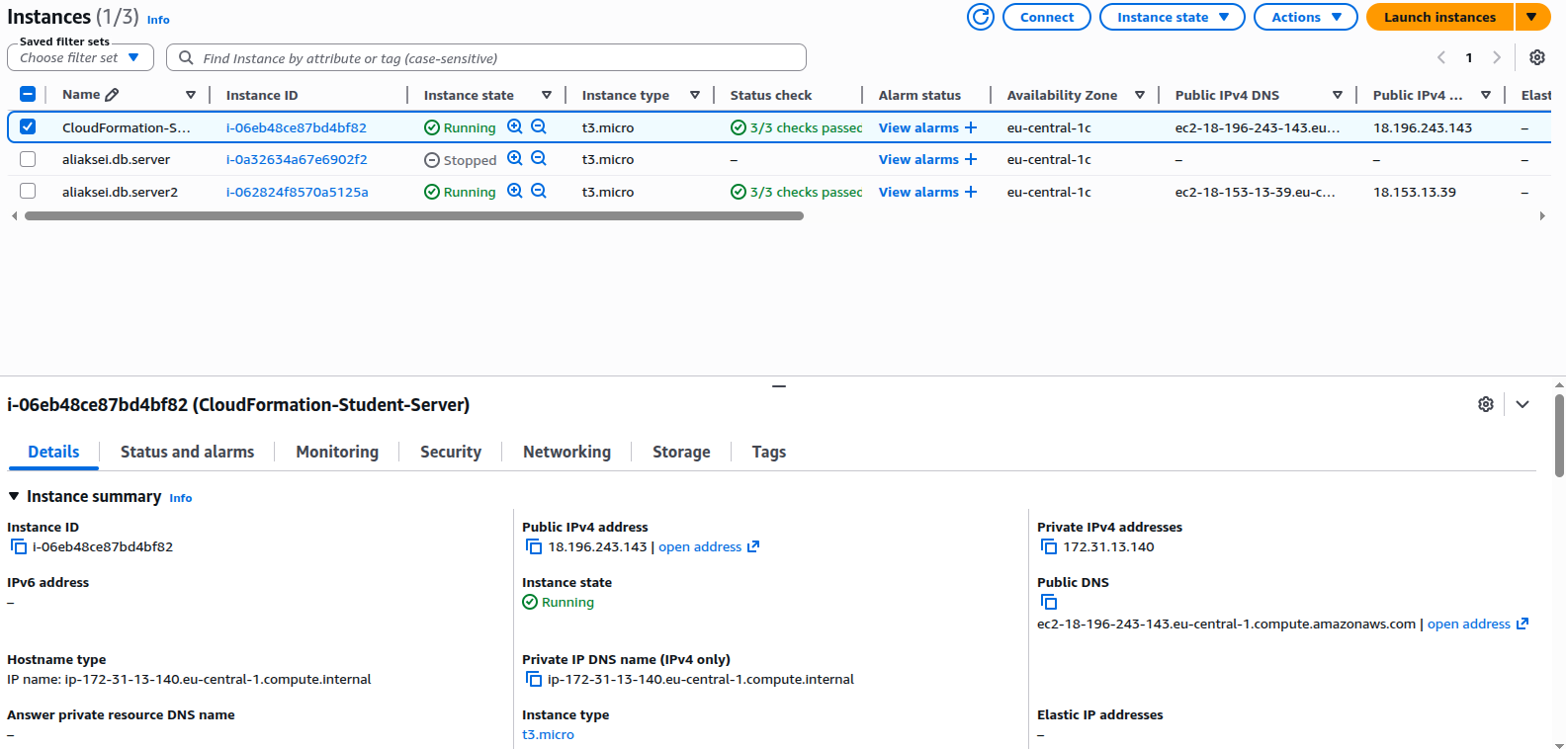

I installed Docker and PostgreSQL. Since I already had PostgreSQL installed locally and it uses the standard port 5432, I changed the port for Docker to 5433. Then I added another port, 5433, to the Security group. After that, I was able to successfully connect to the database.

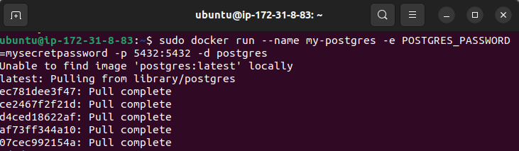
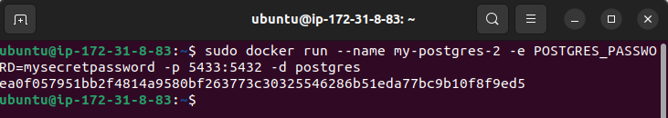

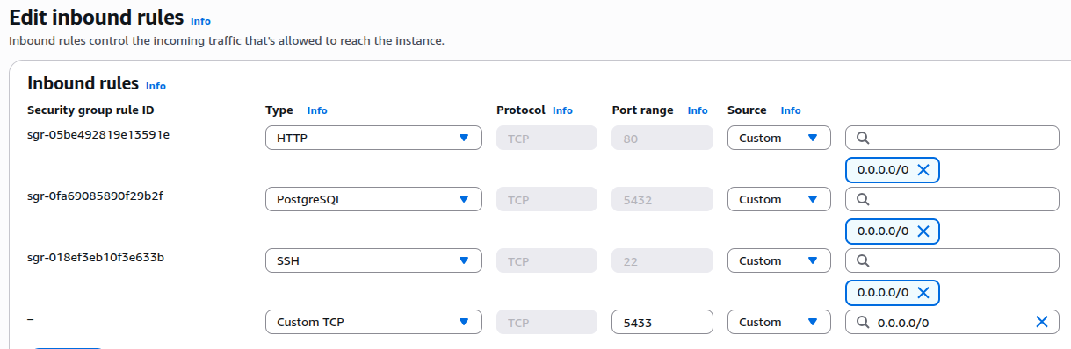

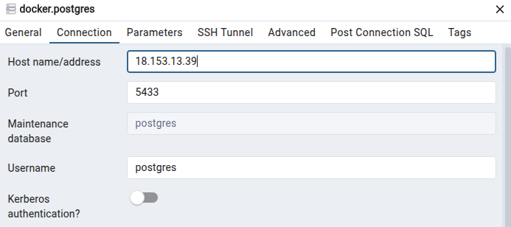

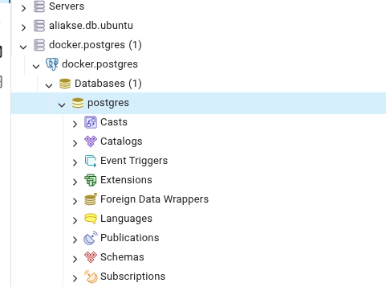

I created a script file that specifies the creation of the cron_table in PostgreSQL and a log.txt file. Next, I made the script executable. In the cron scheduler, I added the path to my script. A few minutes later, I checked in pgAdmin that the cron_table table had been created. I also opened log.txt, which contains information about the table creation, as well as subsequent skips, since the table had already been created.

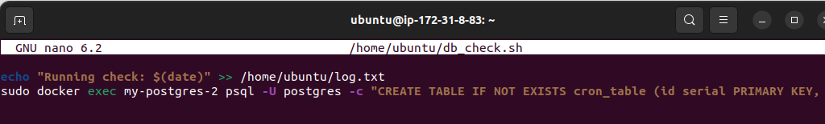

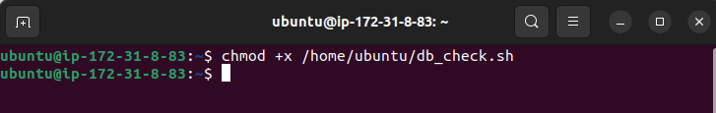

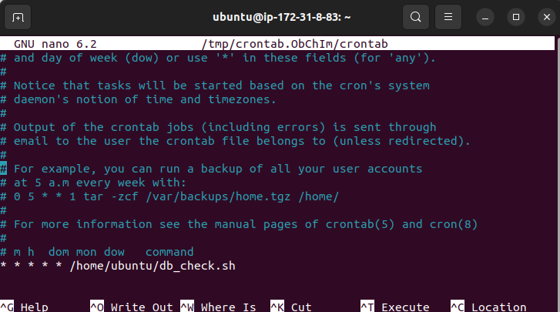

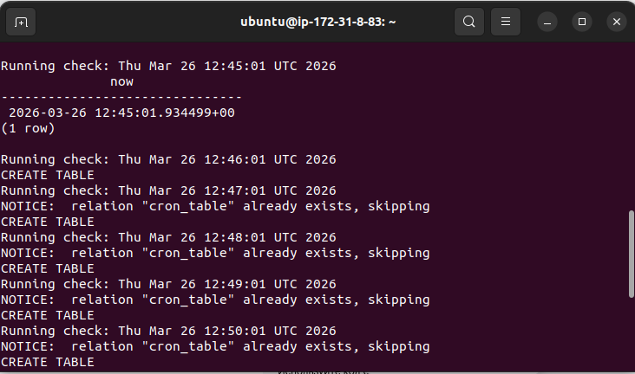

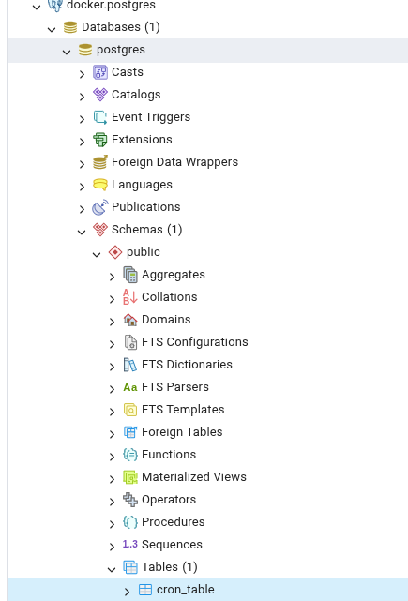

During the all tasks, I used the tag “owner=student”.

