Data Reconciliation Report: SQL Solution
SRC to LND Layer Reconciliation
Environment: PostgreSQL (Target: dwh_hw_db, Source: dwh_src_hw_db)
The primary goal of this task is to verify the data integrity between the Source System and the Landing (LND) layer of the Data Warehouse. We aim to ensure that all records are fully migrated without transformations and identify any mismatches, missing records, or data corruption.
To perform the reconciliation, the following approach was used:
- Connectivity: Established a connection to the external source database using the dblink extension.
- Comparison Logic: Used a FULL OUTER JOIN between source and target tables to identify:
-Records present only in the Source system.
-Records present only in the Target (Landing) layer.
-Attribute mismatches (data discrepancies) for existing records.
All discrepancies were filtered and inserted into a dedicated audit table: lnd.reconciliation_results.

I created a centralized table to store all identified issues for further analysis and bug reporting.
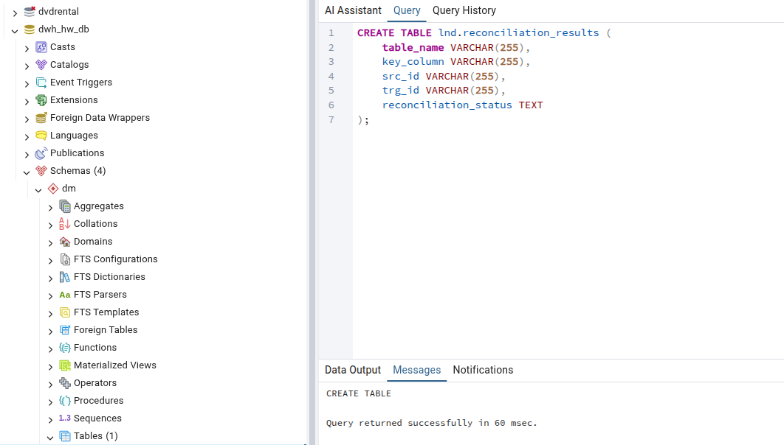

CREATE TABLE lnd.reconciliation_results (
table_name VARCHAR(255),
key_column VARCHAR(255),
src_id VARCHAR(255),
trg_id VARCHAR(255),
reconciliation_status TEXT,
);

Executed Reconciliation Scripts
The following tables were verified:
- S1 System: s1_channels, s1_clients, s1_products, s1_sales.
- S2 System: s2_channels, s2_clients, s2_locations, s2_client_sales.
For fact tables (s1_sales, s2_client_sales), a Composite Key (concatenation of IDs and dates) was implemented to ensure unique row identification.

s1_channels:
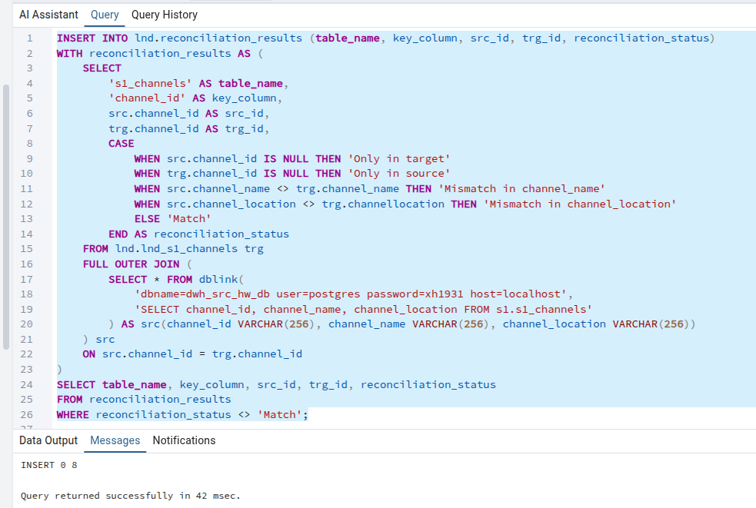

INSERT INTO lnd.reconciliation_results (table_name, key_column, src_id, trg_id, reconciliation_status)
WITH reconciliation_results AS (
SELECT
's1_channels' AS table_name,
'channel_id' AS key_column,
src.channel_id AS src_id,
trg.channel_id AS trg_id,
CASE
WHEN src.channel_id IS NULL THEN 'Only in target'
WHEN trg.channel_id IS NULL THEN 'Only in source'
WHEN src.channel_name <> trg.channel_name THEN 'Mismatch in channel_name'
WHEN src.channel_location <> trg.channellocation THEN 'Mismatch in channel_location'
ELSE 'Match'
END AS reconciliation_status
FROM lnd.lnd_s1_channels trg
FULL OUTER JOIN (
SELECT * FROM dblink(
'dbname=dwh_src_hw_db user=postgres password=xh1931 host=localhost',
'SELECT channel_id, channel_name, channel_location FROM s1.s1_channels'
) AS src(channel_id VARCHAR(256), channel_name VARCHAR(256), channel_location VARCHAR(256))
) src
ON src.channel_id = trg.channel_id
)
SELECT table_name, key_column, src_id, trg_id, reconciliation_status
FROM reconciliation_results
WHERE reconciliation_status <> 'Match';

s1_clients:
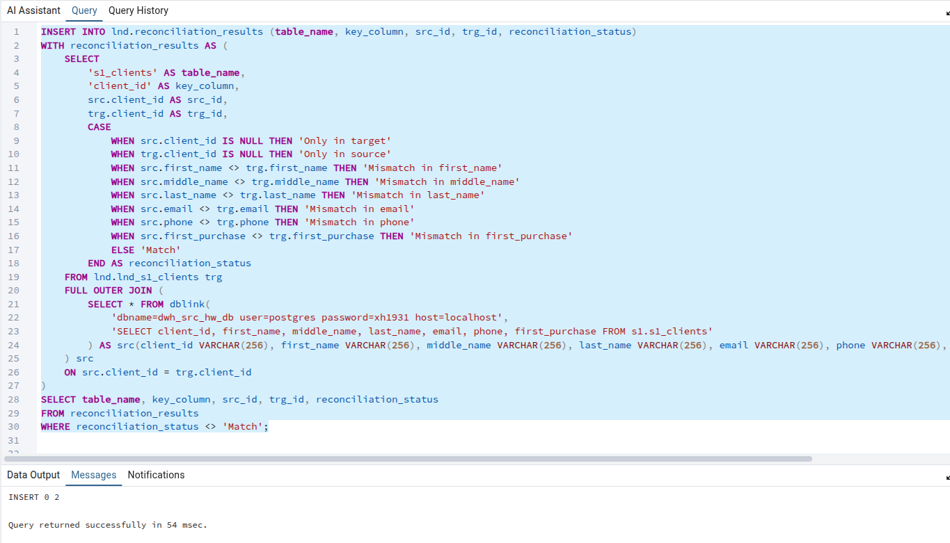

INSERT INTO lnd.reconciliation_results (table_name, key_column, src_id, trg_id, reconciliation_status)
WITH reconciliation_results AS (
SELECT
's1_clients' AS table_name,
'client_id' AS key_column,
src.client_id AS src_id,
trg.client_id AS trg_id,
CASE
WHEN src.client_id IS NULL THEN 'Only in target'
WHEN trg.client_id IS NULL THEN 'Only in source'
WHEN src.first_name <> trg.first_name THEN 'Mismatch in first_name'
WHEN src.middle_name <> trg.middle_name THEN 'Mismatch in middle_name'
WHEN src.last_name <> trg.last_name THEN 'Mismatch in last_name'
WHEN src.email <> trg.email THEN 'Mismatch in email'
WHEN src.phone <> trg.phone THEN 'Mismatch in phone'
WHEN src.first_purchase <> trg.first_purchase THEN 'Mismatch in first_purchase'
ELSE 'Match'
END AS reconciliation_status
FROM lnd.lnd_s1_clients trg
FULL OUTER JOIN (
SELECT * FROM dblink(
'dbname=dwh_src_hw_db user=postgres password=xh1931 host=localhost',
'SELECT client_id, first_name, middle_name, last_name, email, phone, first_purchase FROM s1.s1_clients'
) AS src(client_id VARCHAR(256), first_name VARCHAR(256), middle_name VARCHAR(256), last_name VARCHAR(256), email VARCHAR(256), phone VARCHAR(256), first_purchase VARCHAR(256))
) src
ON src.client_id = trg.client_id
)
SELECT table_name, key_column, src_id, trg_id, reconciliation_status
FROM reconciliation_results
WHERE reconciliation_status <> 'Match';

s1_products:
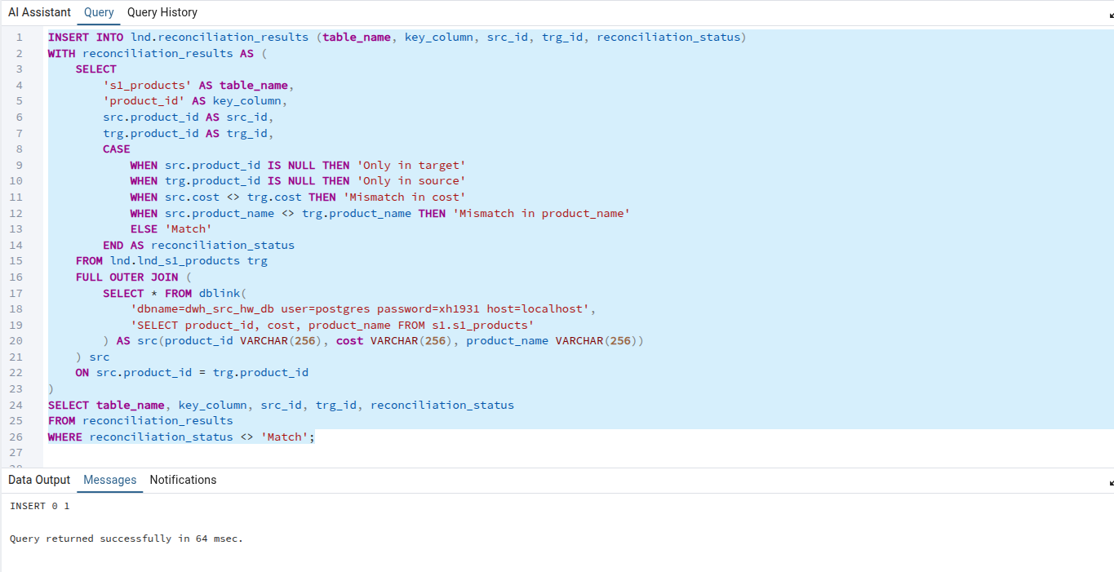

INSERT INTO lnd.reconciliation_results (table_name, key_column, src_id, trg_id, reconciliation_status)
WITH reconciliation_results AS (
SELECT
's1_products' AS table_name,
'product_id' AS key_column,
src.product_id AS src_id,
trg.product_id AS trg_id,
CASE
WHEN src.product_id IS NULL THEN 'Only in target'
WHEN trg.product_id IS NULL THEN 'Only in source'
WHEN src.cost <> trg.cost THEN 'Mismatch in cost'
WHEN src.product_name <> trg.product_name THEN 'Mismatch in product_name'
ELSE 'Match'
END AS reconciliation_status
FROM lnd.lnd_s1_products trg
FULL OUTER JOIN (
SELECT * FROM dblink(
'dbname=dwh_src_hw_db user=postgres password=xh1931 host=localhost',
'SELECT product_id, cost, product_name FROM s1.s1_products'
) AS src(product_id VARCHAR(256), cost VARCHAR(256), product_name VARCHAR(256))
) src
ON src.product_id = trg.product_id
)
SELECT table_name, key_column, src_id, trg_id, reconciliation_status
FROM reconciliation_results
WHERE reconciliation_status <> 'Match';

s1_sales:
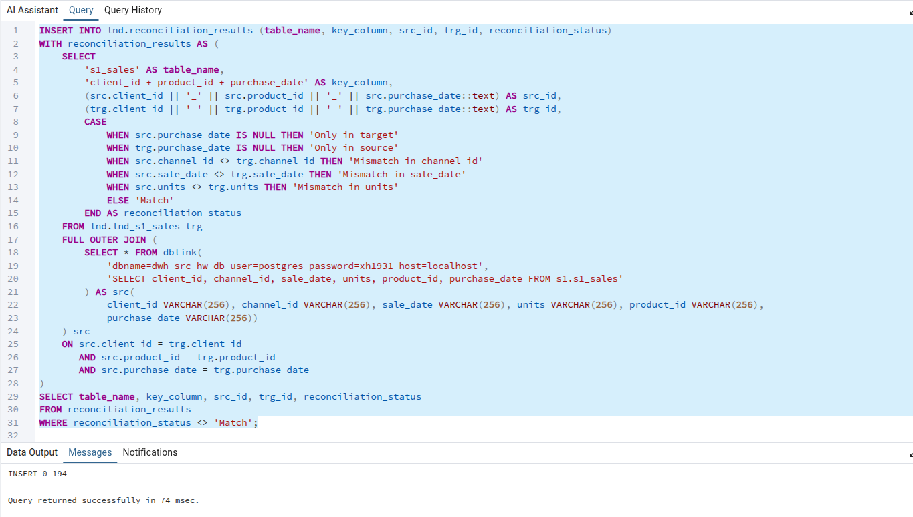

INSERT INTO lnd.reconciliation_results (table_name, key_column, src_id, trg_id, reconciliation_status)
WITH reconciliation_results AS (
SELECT
's1_sales' AS table_name,
'client_id + product_id + purchase_date' AS key_column,
(src.client_id || '_' || src.product_id || '_' || src.purchase_date::text) AS src_id,
(trg.client_id || '_' || trg.product_id || '_' || trg.purchase_date::text) AS trg_id,
CASE
WHEN src.purchase_date IS NULL THEN 'Only in target'
WHEN trg.purchase_date IS NULL THEN 'Only in source'
WHEN src.channel_id <> trg.channel_id THEN 'Mismatch in channel_id'
WHEN src.sale_date <> trg.sale_date THEN 'Mismatch in sale_date'
WHEN src.units <> trg.units THEN 'Mismatch in units'
ELSE 'Match'
END AS reconciliation_status
FROM lnd.lnd_s1_sales trg
FULL OUTER JOIN (
SELECT * FROM dblink(
'dbname=dwh_src_hw_db user=postgres password=xh1931 host=localhost',
'SELECT client_id, channel_id, sale_date, units, product_id, purchase_date FROM s1.s1_sales'
) AS src(
client_id VARCHAR(256), channel_id VARCHAR(256), sale_date VARCHAR(256), units VARCHAR(256), product_id VARCHAR(256),
purchase_date VARCHAR(256))
) src
ON src.client_id = trg.client_id
AND src.product_id = trg.product_id
AND src.purchase_date = trg.purchase_date
)
SELECT table_name, key_column, src_id, trg_id, reconciliation_status
FROM reconciliation_results
WHERE reconciliation_status <> 'Match';

s2_channels:
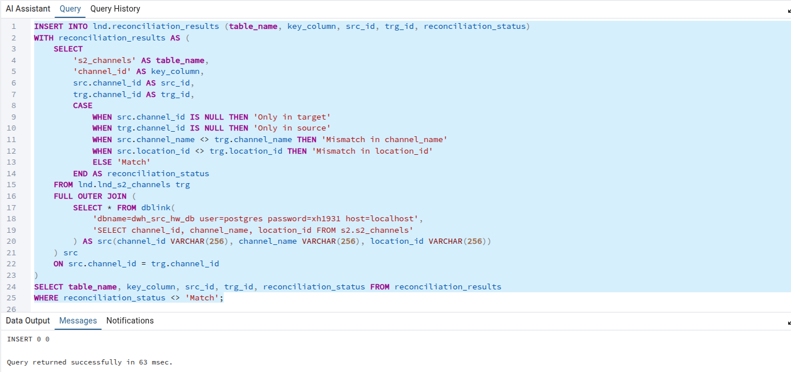

INSERT INTO lnd.reconciliation_results (table_name, key_column, src_id, trg_id, reconciliation_status)
WITH reconciliation_results AS (
SELECT
's2_channels' AS table_name,
'channel_id' AS key_column,
src.channel_id AS src_id,
trg.channel_id AS trg_id,
CASE
WHEN src.channel_id IS NULL THEN 'Only in target'
WHEN trg.channel_id IS NULL THEN 'Only in source'
WHEN src.channel_name <> trg.channel_name THEN 'Mismatch in channel_name'
WHEN src.location_id <> trg.location_id THEN 'Mismatch in location_id'
ELSE 'Match'
END AS reconciliation_status
FROM lnd.lnd_s2_channels trg
FULL OUTER JOIN (
SELECT * FROM dblink(
'dbname=dwh_src_hw_db user=postgres password=xh1931 host=localhost',
'SELECT channel_id, channel_name, location_id FROM s2.s2_channels'
) AS src(channel_id VARCHAR(256), channel_name VARCHAR(256), location_id VARCHAR(256))
) src
ON src.channel_id = trg.channel_id
)
SELECT table_name, key_column, src_id, trg_id, reconciliation_status FROM reconciliation_results
WHERE reconciliation_status <> 'Match';

s2_clients:
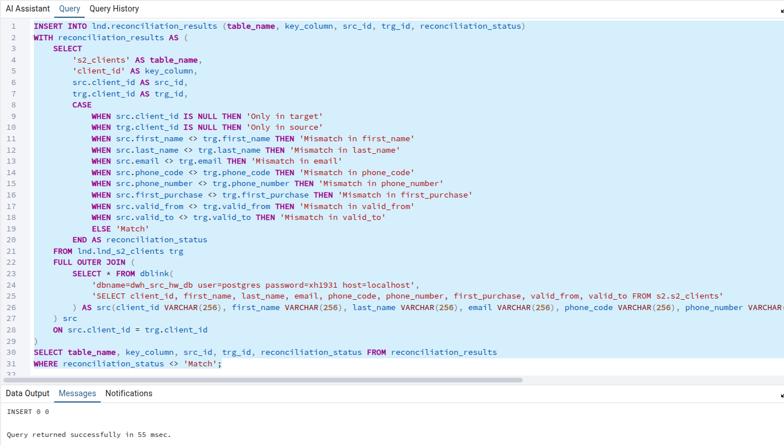

INSERT INTO lnd.reconciliation_results (table_name, key_column, src_id, trg_id, reconciliation_status)
WITH reconciliation_results AS (
SELECT
's2_clients' AS table_name,
'client_id' AS key_column,
src.client_id AS src_id,
trg.client_id AS trg_id,
CASE
WHEN src.client_id IS NULL THEN 'Only in target'
WHEN trg.client_id IS NULL THEN 'Only in source'
WHEN src.first_name <> trg.first_name THEN 'Mismatch in first_name'
WHEN src.last_name <> trg.last_name THEN 'Mismatch in last_name'
WHEN src.email <> trg.email THEN 'Mismatch in email'
WHEN src.phone_code <> trg.phone_code THEN 'Mismatch in phone_code'
WHEN src.phone_number <> trg.phone_number THEN 'Mismatch in phone_number'
WHEN src.first_purchase <> trg.first_purchase THEN 'Mismatch in first_purchase'
WHEN src.valid_from <> trg.valid_from THEN 'Mismatch in valid_from'
WHEN src.valid_to <> trg.valid_to THEN 'Mismatch in valid_to'
ELSE 'Match'
END AS reconciliation_status
FROM lnd.lnd_s2_clients trg
FULL OUTER JOIN (
SELECT * FROM dblink(
'dbname=dwh_src_hw_db user=postgres password=xh1931 host=localhost',
'SELECT client_id, first_name, last_name, email, phone_code, phone_number, first_purchase, valid_from, valid_to FROM s2.s2_clients'
) AS src(client_id VARCHAR(256), first_name VARCHAR(256), last_name VARCHAR(256), email VARCHAR(256), phone_code VARCHAR(256), phone_number VARCHAR(256), first_purchase VARCHAR(256), valid_from VARCHAR(256), valid_to VARCHAR(256))
) src
ON src.client_id = trg.client_id
)
SELECT table_name, key_column, src_id, trg_id, reconciliation_status FROM reconciliation_results
WHERE reconciliation_status <> 'Match';

s2_locations:
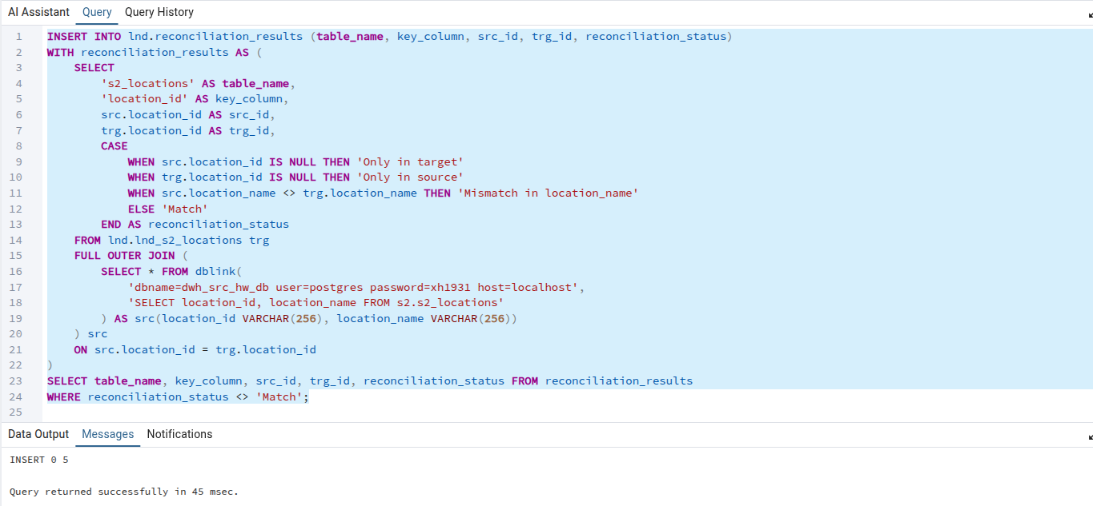

INSERT INTO lnd.reconciliation_results (table_name, key_column, src_id, trg_id, reconciliation_status)
WITH reconciliation_results AS (
SELECT
's2_locations' AS table_name,
'location_id' AS key_column,
src.location_id AS src_id,
trg.location_id AS trg_id,
CASE
WHEN src.location_id IS NULL THEN 'Only in target'
WHEN trg.location_id IS NULL THEN 'Only in source'
WHEN src.location_name <> trg.location_name THEN 'Mismatch in location_name'
ELSE 'Match'
END AS reconciliation_status
FROM lnd.lnd_s2_locations trg
FULL OUTER JOIN (
SELECT * FROM dblink(
'dbname=dwh_src_hw_db user=postgres password=xh1931 host=localhost',
'SELECT location_id, location_name FROM s2.s2_locations'
) AS src(location_id VARCHAR(256), location_name VARCHAR(256))
) src
ON src.location_id = trg.location_id
)
SELECT table_name, key_column, src_id, trg_id, reconciliation_status FROM reconciliation_results
WHERE reconciliation_status <> 'Match';

s2_client_sales:
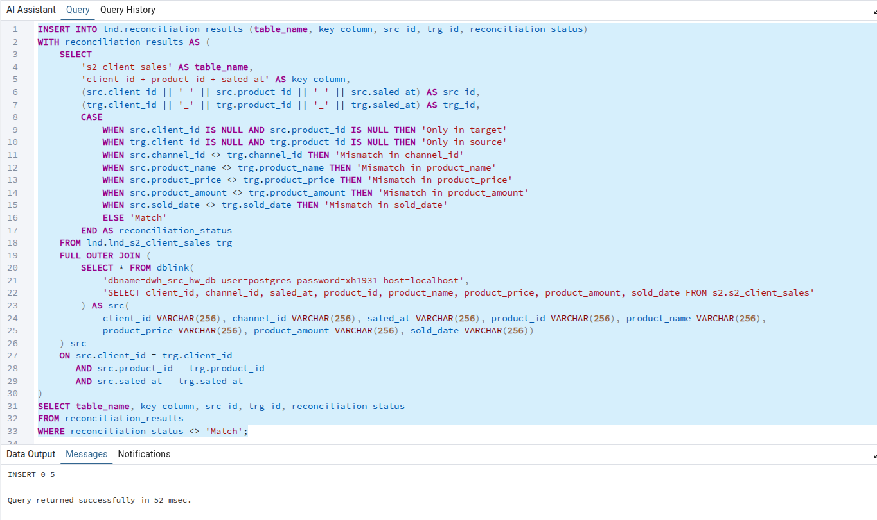

INSERT INTO lnd.reconciliation_results (table_name, key_column, src_id, trg_id, reconciliation_status)
WITH reconciliation_results AS (
SELECT
's2_client_sales' AS table_name,
'client_id + product_id + saled_at' AS key_column,
(src.client_id || '_' || src.product_id || '_' || src.saled_at) AS src_id,
(trg.client_id || '_' || trg.product_id || '_' || trg.saled_at) AS trg_id,
CASE
WHEN src.client_id IS NULL AND src.product_id IS NULL THEN 'Only in target'
WHEN trg.client_id IS NULL AND trg.product_id IS NULL THEN 'Only in source'
WHEN src.channel_id <> trg.channel_id THEN 'Mismatch in channel_id'
WHEN src.product_name <> trg.product_name THEN 'Mismatch in product_name'
WHEN src.product_price <> trg.product_price THEN 'Mismatch in product_price'
WHEN src.product_amount <> trg.product_amount THEN 'Mismatch in product_amount'
WHEN src.sold_date <> trg.sold_date THEN 'Mismatch in sold_date'
ELSE 'Match'
END AS reconciliation_status
FROM lnd.lnd_s2_client_sales trg
FULL OUTER JOIN (
SELECT * FROM dblink(
'dbname=dwh_src_hw_db user=postgres password=xh1931 host=localhost',
'SELECT client_id, channel_id, saled_at, product_id, product_name, product_price, product_amount, sold_date FROM s2.s2_client_sales'
) AS src(
client_id VARCHAR(256), channel_id VARCHAR(256), saled_at VARCHAR(256), product_id VARCHAR(256), product_name VARCHAR(256),
product_price VARCHAR(256), product_amount VARCHAR(256), sold_date VARCHAR(256))
) src
ON src.client_id = trg.client_id
AND src.product_id = trg.product_id
AND src.saled_at = trg.saled_at
)
SELECT table_name, key_column, src_id, trg_id, reconciliation_status
FROM reconciliation_results
WHERE reconciliation_status <> 'Match';

Below is a sample of the records captured in lnd.reconciliation_results.
select * from lnd.reconciliation_results

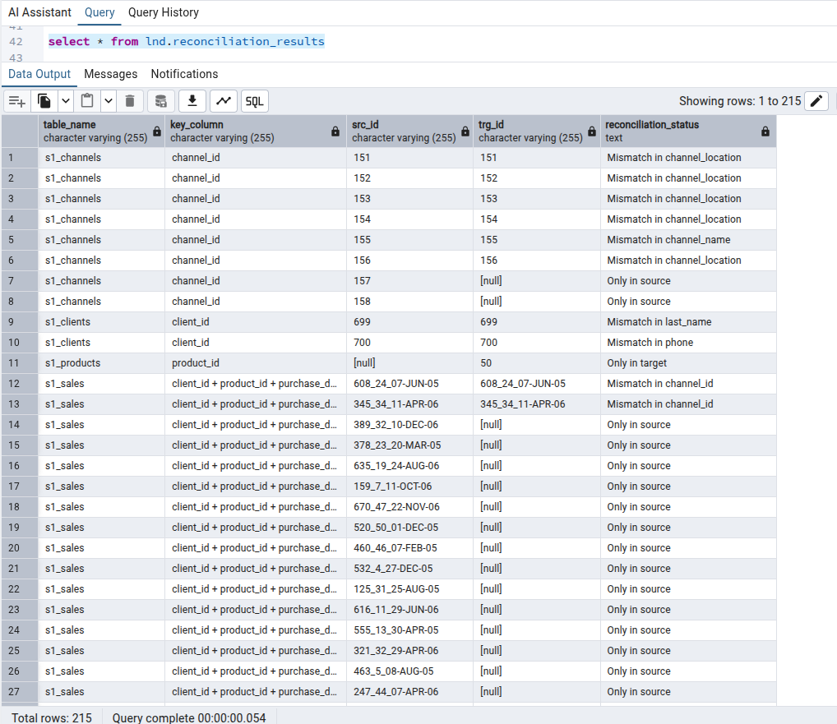

Anomalies Summary
The following query was executed to summarize the findings:

SELECT
table_name,
reconciliation_status,
COUNT(*) AS anomaly_count
FROM lnd.reconciliation_results
GROUP BY table_name, reconciliation_status
ORDER BY table_name, anomaly_count DESC;

