Description:
1.1
TASK 1: USE INHERITANCE

Creating a master table and child tables:
First, we create the main table and its descendants. Each child table will store data for a specific year.

CREATE TABLE SALES_INFO (
id INTEGER,
category VARCHAR(1),
ischeck BOOLEAN,
eventdate DATE);

CREATE TABLE sales_info_2021 (CHECK (eventdate >= '2021-01-01' AND eventdate < '2022-01-01')) INHERITS (SALES_INFO);
CREATE TABLE sales_info_2022 (CHECK (eventdate >= '2022-01-01' AND eventdate < '2023-01-01')) INHERITS (SALES_INFO);
CREATE TABLE sales_info_2023 (CHECK (eventdate >= '2023-01-01' AND eventdate < '2024-01-01')) INHERITS (SALES_INFO);
CREATE TABLE sales_info_2024 (CHECK (eventdate >= '2024-01-01' AND eventdate < '2025-01-01')) INHERITS (SALES_INFO);
CREATE TABLE sales_info_2025 (CHECK (eventdate >= '2025-01-01' AND eventdate < '2026-01-01')) INHERITS (SALES_INFO);
CREATE TABLE sales_info_2026 (CHECK (eventdate >= '2026-01-01' AND eventdate < '2027-01-01')) INHERITS (SALES_INFO);

The INHERITS parameter copies the field structure. The CHECK constraint is important, it allows the optimizer (Constraint Exclusion) to know which table to search for data in.

Creating partition function and trigger:
Inheritance does not automatically distribute data to child tables; a trigger must be defined on the SALES_INFO table to perform this operation.

CREATE OR REPLACE FUNCTION partition_sales_info() RETURNS trigger AS $$
BEGIN
IF (new.eventdate >= '2021-01-01' AND new.eventdate < '2022-01-01') THEN INSERT INTO sales_info_2021 VALUES (new.*);
ELSIF (new.eventdate >= '2022-01-01' AND new.eventdate < '2023-01-01') THEN INSERT INTO sales_info_2022 VALUES (new.*);
ELSIF (new.eventdate >= '2023-01-01' AND new.eventdate < '2024-01-01') THEN INSERT INTO sales_info_2023 VALUES (new.*);
ELSIF (new.eventdate >= '2024-01-01' AND new.eventdate < '2025-01-01') THEN INSERT INTO sales_info_2024 VALUES (new.*);
ELSIF (new.eventdate >= '2025-01-01' AND new.eventdate < '2026-01-01') THEN INSERT INTO sales_info_2025 VALUES (new.*);
ELSIF (new.eventdate >= '2026-01-01' AND new.eventdate < '2027-01-01') THEN INSERT INTO sales_info_2026 VALUES (new.*);
ELSE RAISE EXCEPTION 'Date % out of range!', new.eventdate;
END IF;
RETURN NULL;
END;
$$ LANGUAGE plpgsql;

CREATE TRIGGER partition_sales_info_trigger
BEFORE INSERT ON SALES_INFO
FOR EACH ROW EXECUTE PROCEDURE partition_sales_info();

Generating test data and insert in SALES_INFO table:
EXPLAIN ANALYZE
INSERT INTO SALES_INFO(id,category, ischeck, EventDate)
SELECT id
,('{"A","B","C","D","E","F","J","H","I","J","K"}'::text[])[(
(RANDOM())*10)::INTEGER] category
,((1*(RANDOM())::INTEGER)<1) ischeck
,(NOW() - '10 day'::INTERVAL * (RANDOM()::int * 100))::
DATE EventDate
FROM generate_series(1,10000000) id;

The result of executing the INSERT command with the execution time.
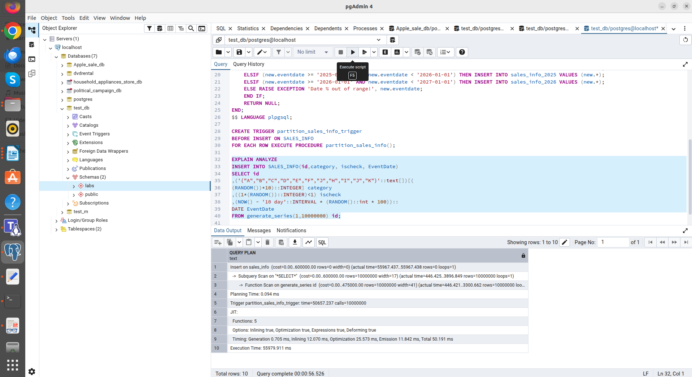
Execution Time: 55979.911 ms

Updating some rows in SALES_INFO and set another eventdate:
Try to move data from one year to another.
UPDATE SALES_INFO SET eventdate = '2024-06-01' WHERE id = 100;
We get an ERROR:
new row for relation "sales_info_2026" violates check constraint "sales_info_2026_eventdate_check"
Failing row contains (100, E, f, 2024-06-01).
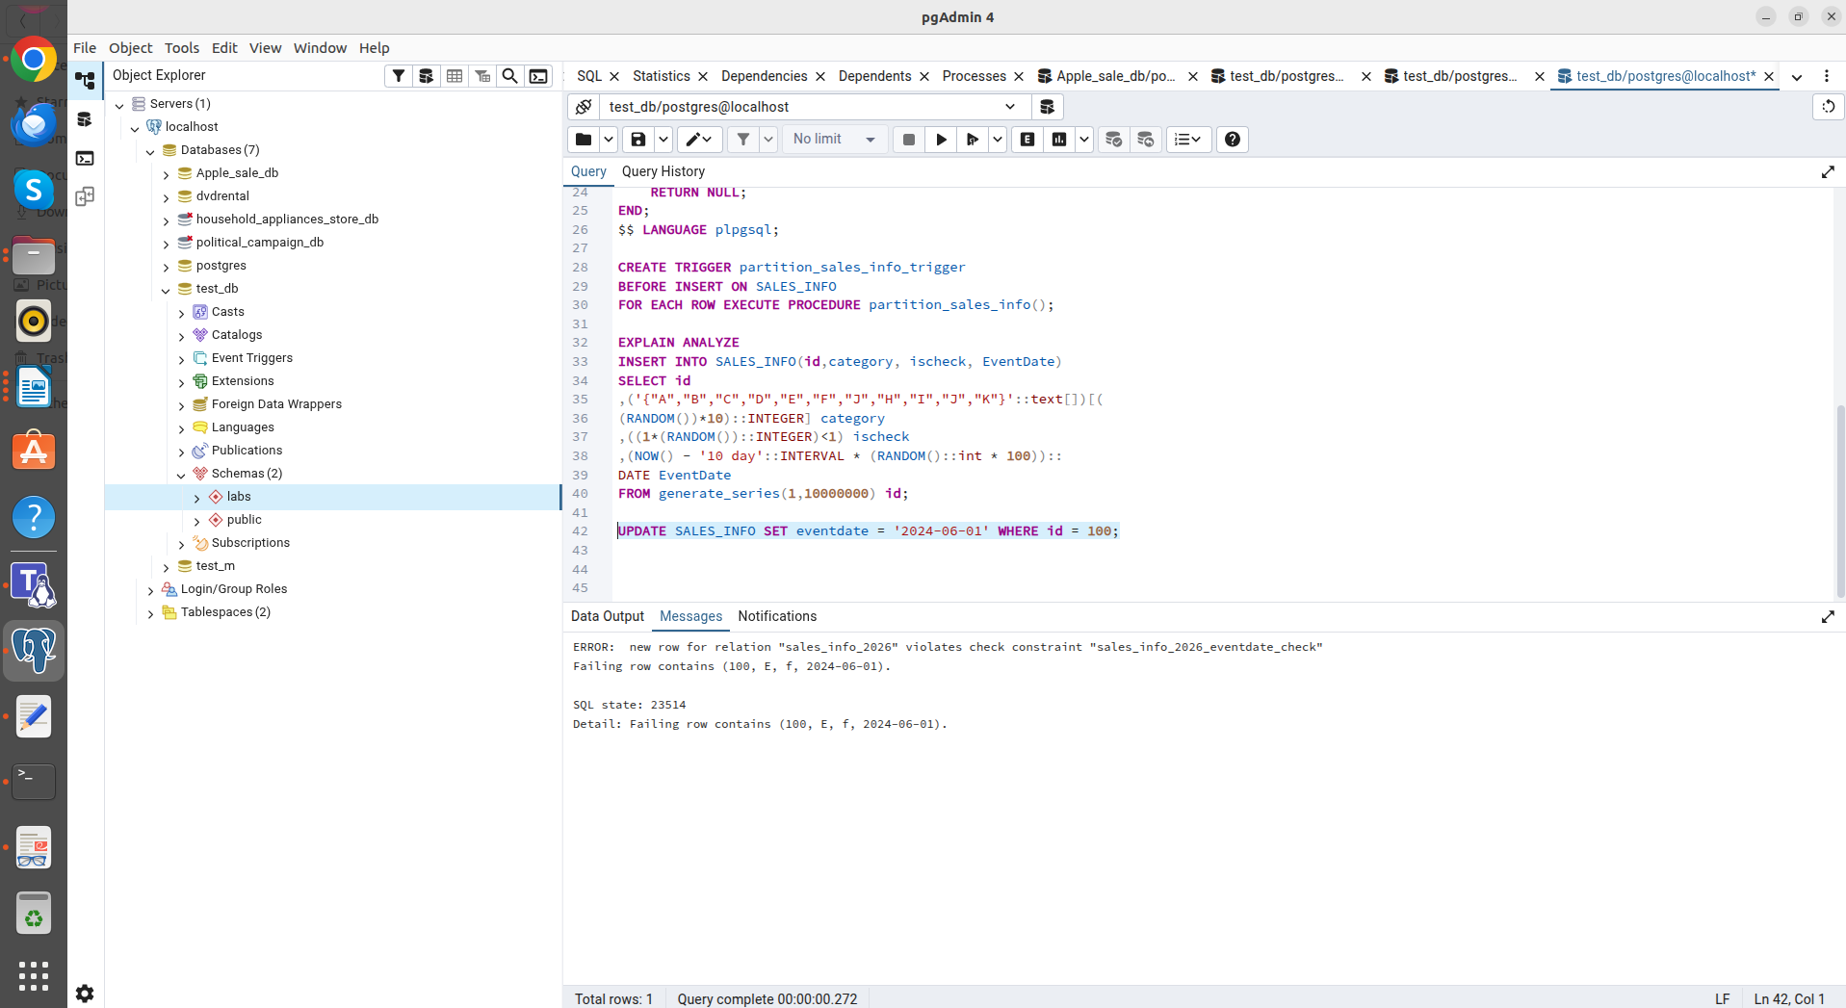

With inheritance, an UPDATE that changes a partition key can cause a CHECK constant violation error, which can be described as a limitation of the inheritance mechanism when updating a partition key.
Error when moving between partitions: Attempting to update a date so that the row moves to a different partition (for example, from 2026 to 2024) causes a CHECK CONSTRAINT error. This occurs because the update is performed in the context of the current child table, and its constraints prevent storing data for a different period.
Successful update:
UPDATE SALES_INFO SET eventdate = '2026-06-01' WHERE id = 100;

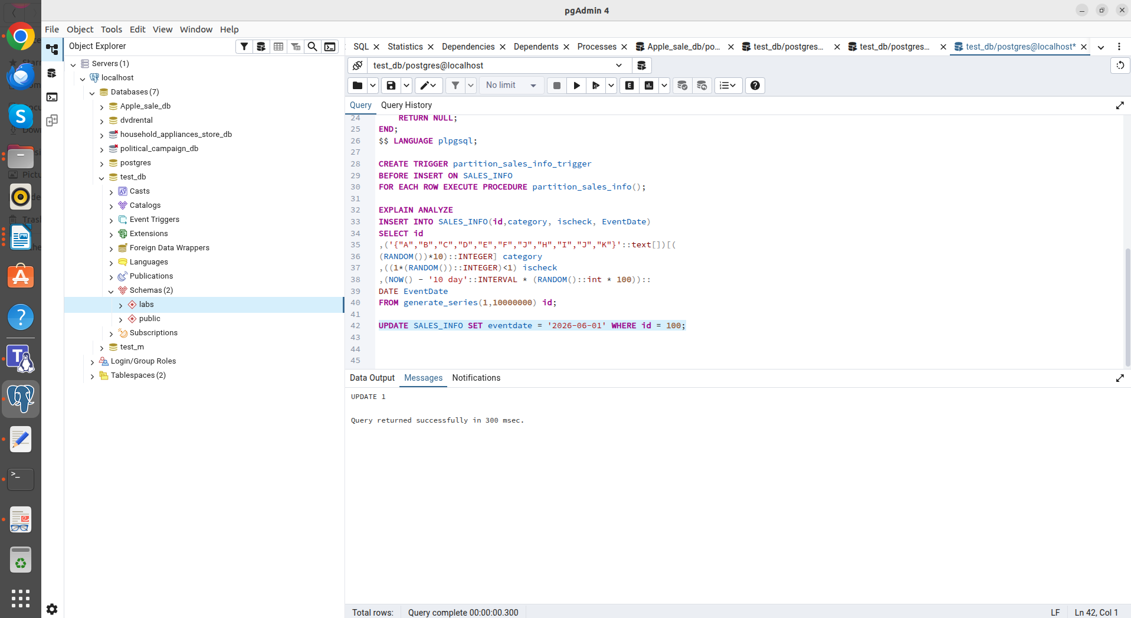
If the new date remains within the current partition's range, the query succeeds.
The inheritance mechanism does not support automatic "movement" of rows between tables during UPDATE. Changing a date outside the current section requires deleting and reinserting the row, or implementing additional logic.
Creating a table SALES_INFO_SIMPLE with the same structure as SALES_INFO but without partitioning.

CREATE TABLE SALES_INFO_SIMPLE AS SELECT * FROM SALES_INFO;

Comparing plans of different queries for tables SALES_INFO and SALES_INFO_SIMPLE:
-Select all
EXPLAIN ANALYZE SELECT * FROM SALES_INFO_SIMPLE;

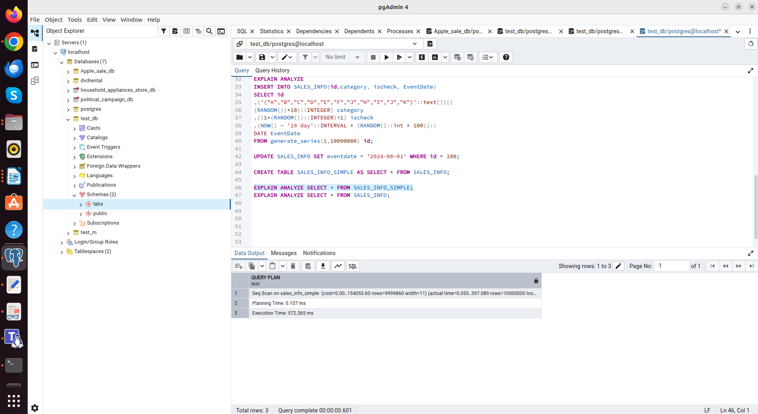
"Execution Time: 572.265 ms"

EXPLAIN ANALYZE SELECT * FROM SALES_INFO;

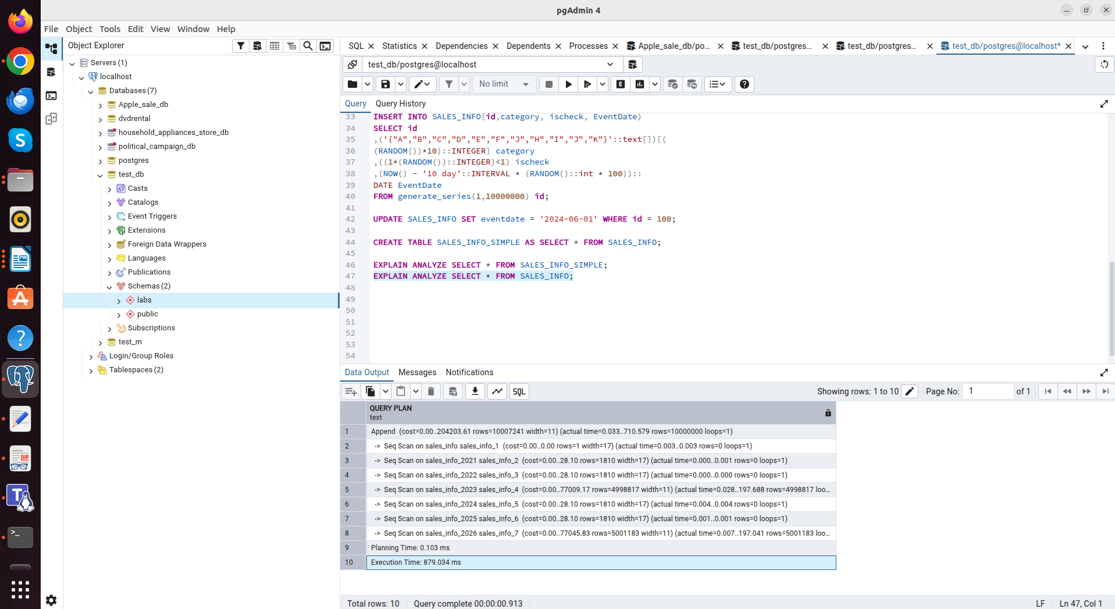
"Execution Time: 879.034 ms"

A simple table is faster. A partitioned table must query the master table and all child partitions separately, which creates overhead for planning and result assembly.

-Select with range of dates
EXPLAIN ANALYZE SELECT * FROM SALES_INFO_SIMPLE WHERE eventdate BETWEEN '2024-01-01' AND '2024-12-31';

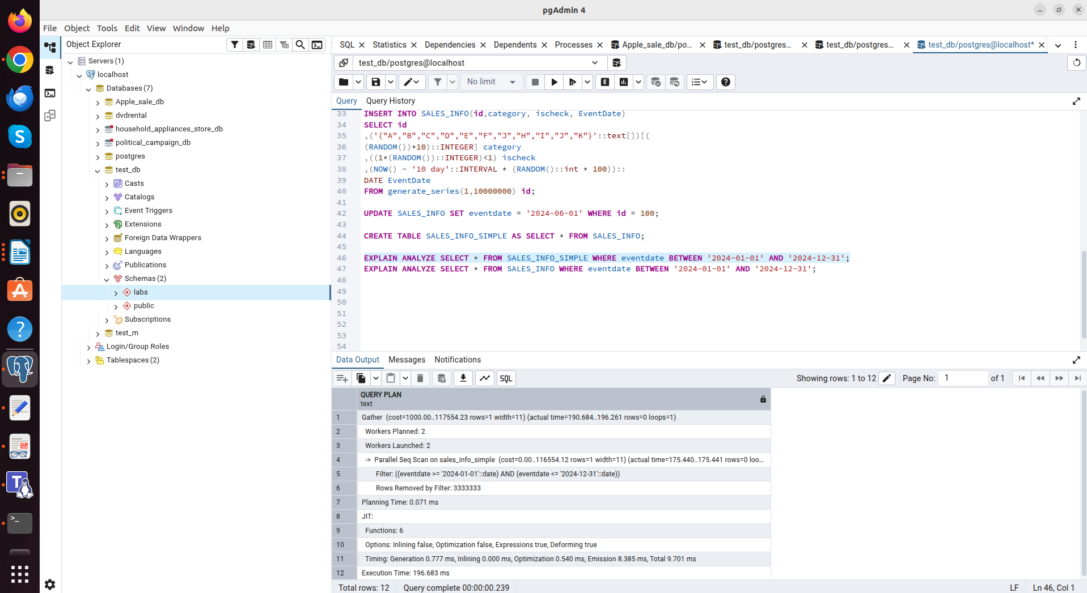
"Execution Time: 196.683 ms"

EXPLAIN ANALYZE SELECT * FROM SALES_INFO WHERE eventdate BETWEEN '2024-01-01' AND '2024-12-31';

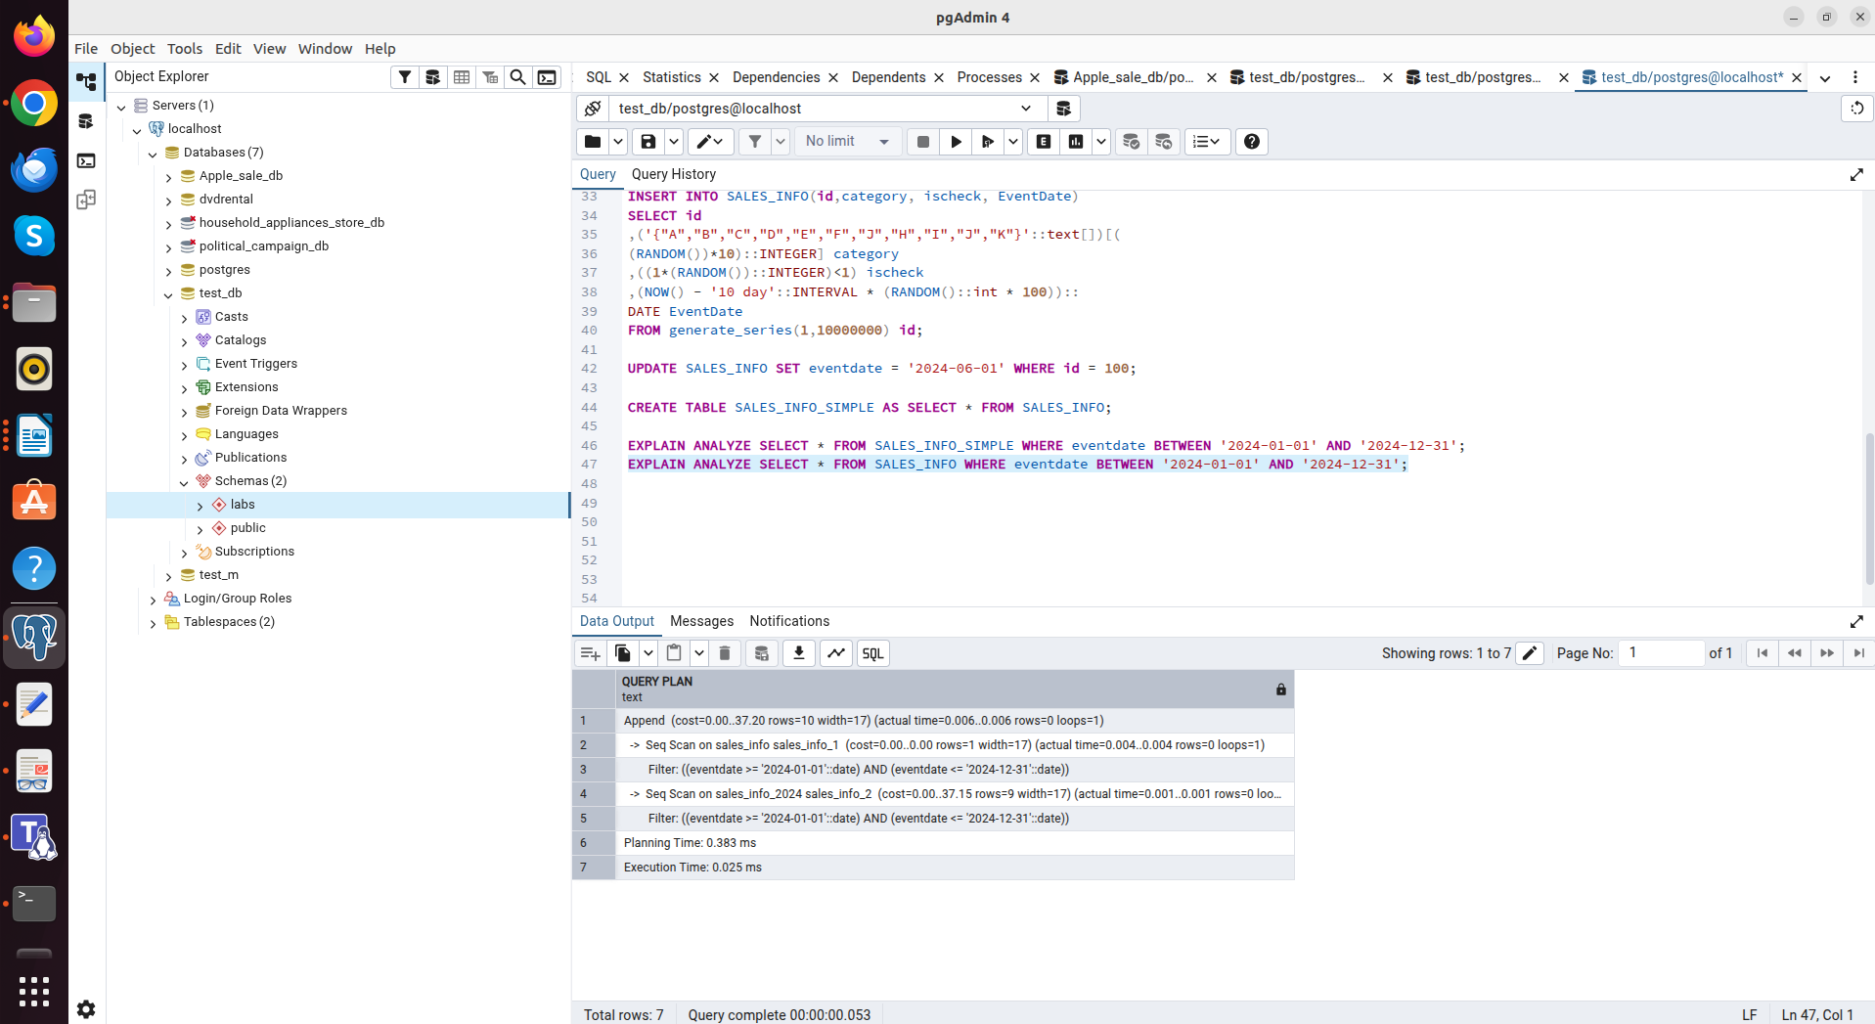
"Execution Time: 0.025 ms"

A huge performance boost on a partitioned table. The planner instantly pruned unnecessary tables and accessed only the partition containing data from 2024.

-Select exact date
EXPLAIN ANALYZE SELECT * FROM SALES_INFO_SIMPLE WHERE eventdate = '2026-06-01';

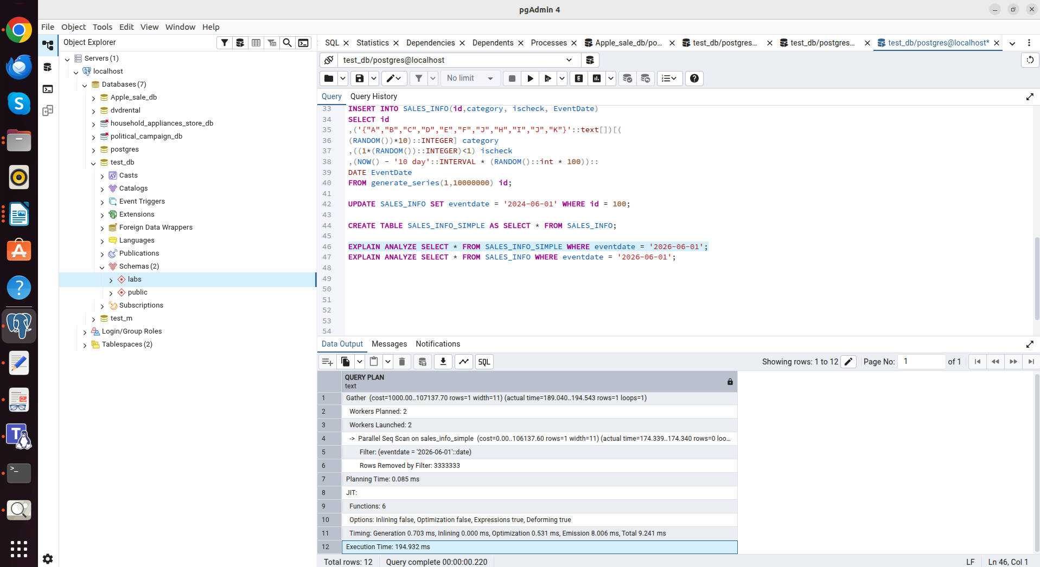
"Execution Time: 194.932 ms"

EXPLAIN ANALYZE SELECT * FROM SALES_INFO WHERE eventdate = '2026-06-01';

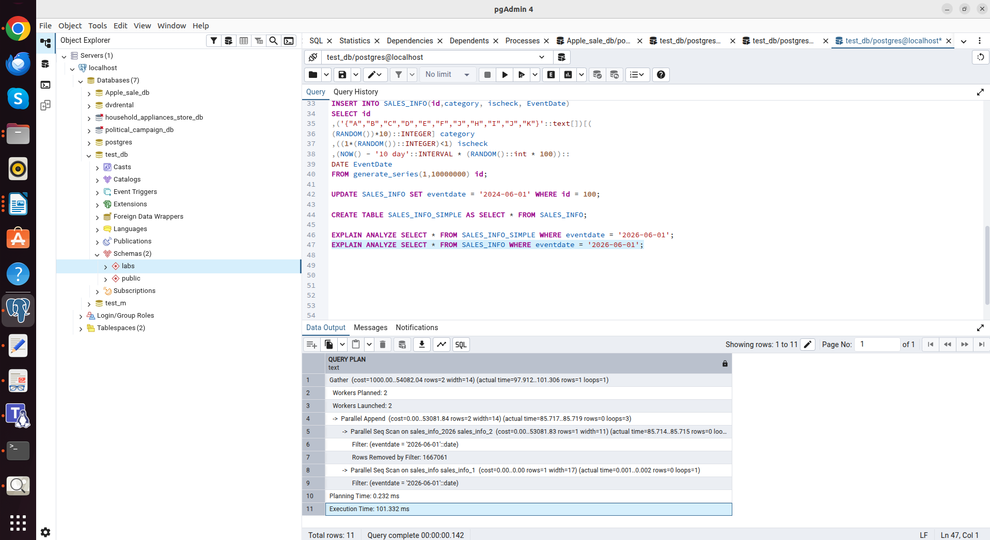
"Execution Time: 101.332 ms"

Partitioning shows a consistent advantage because the amount of data scanned is reduced to the size of specific partitions, while a SIMPLE table is forced to read the entire data array (Sequential Scan).

-Count of all rows
EXPLAIN ANALYZE SELECT COUNT(*) FROM SALES_INFO_SIMPLE;

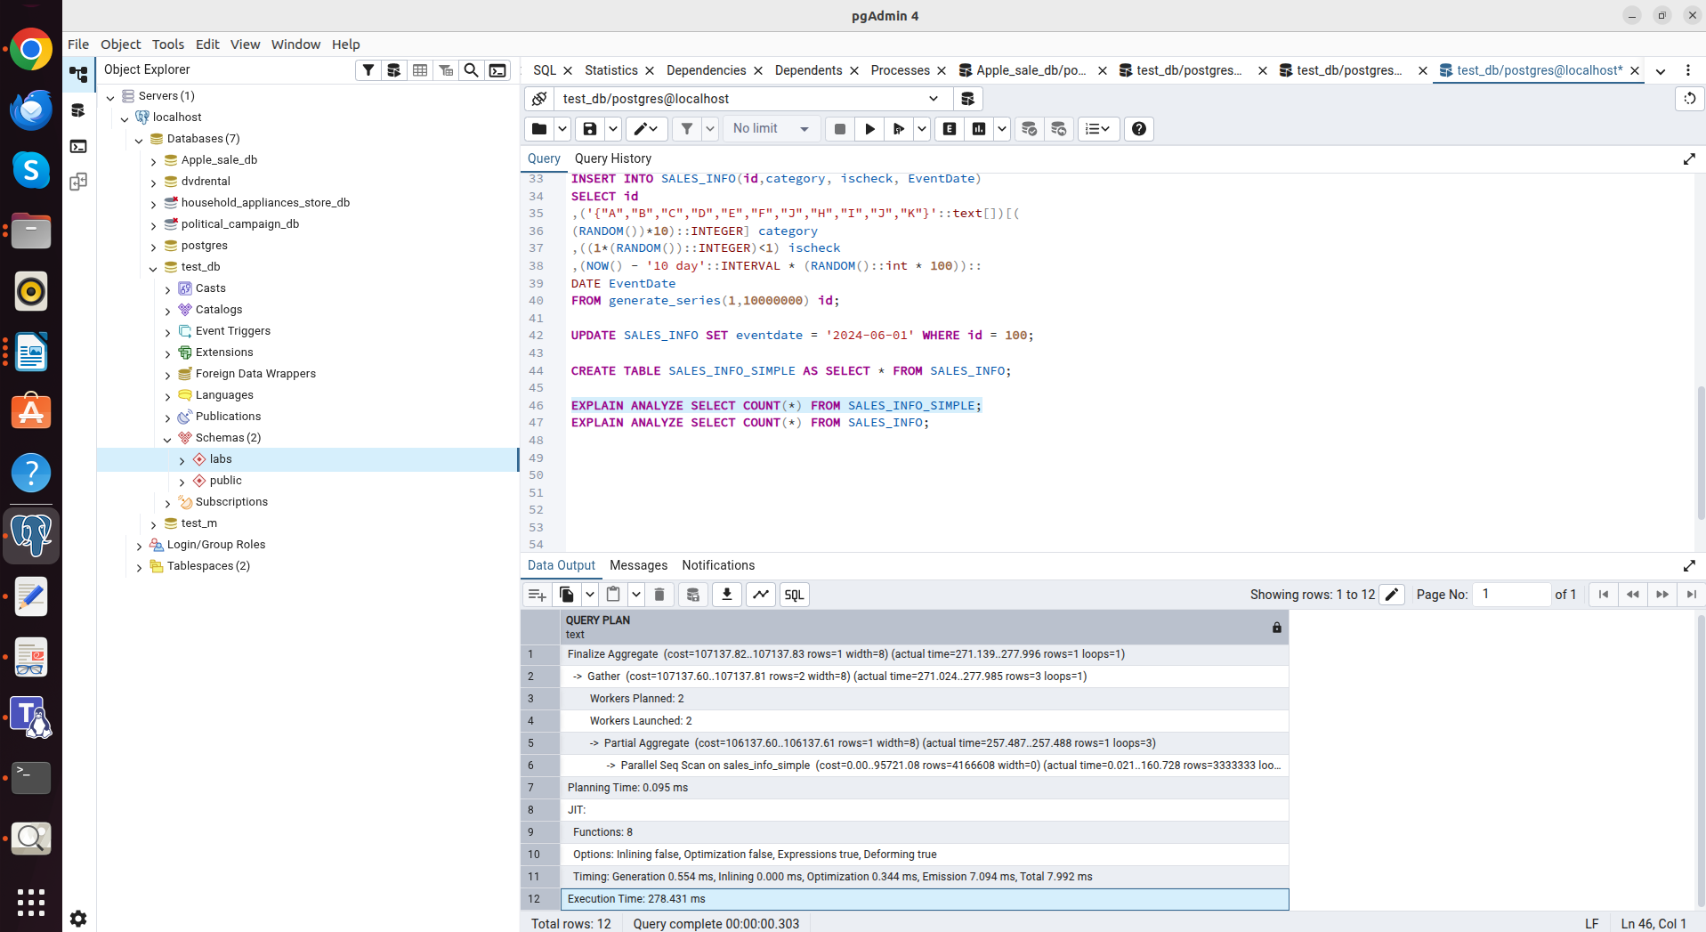
"Execution Time: 278.431 ms"

EXPLAIN ANALYZE SELECT COUNT(*) FROM SALES_INFO;

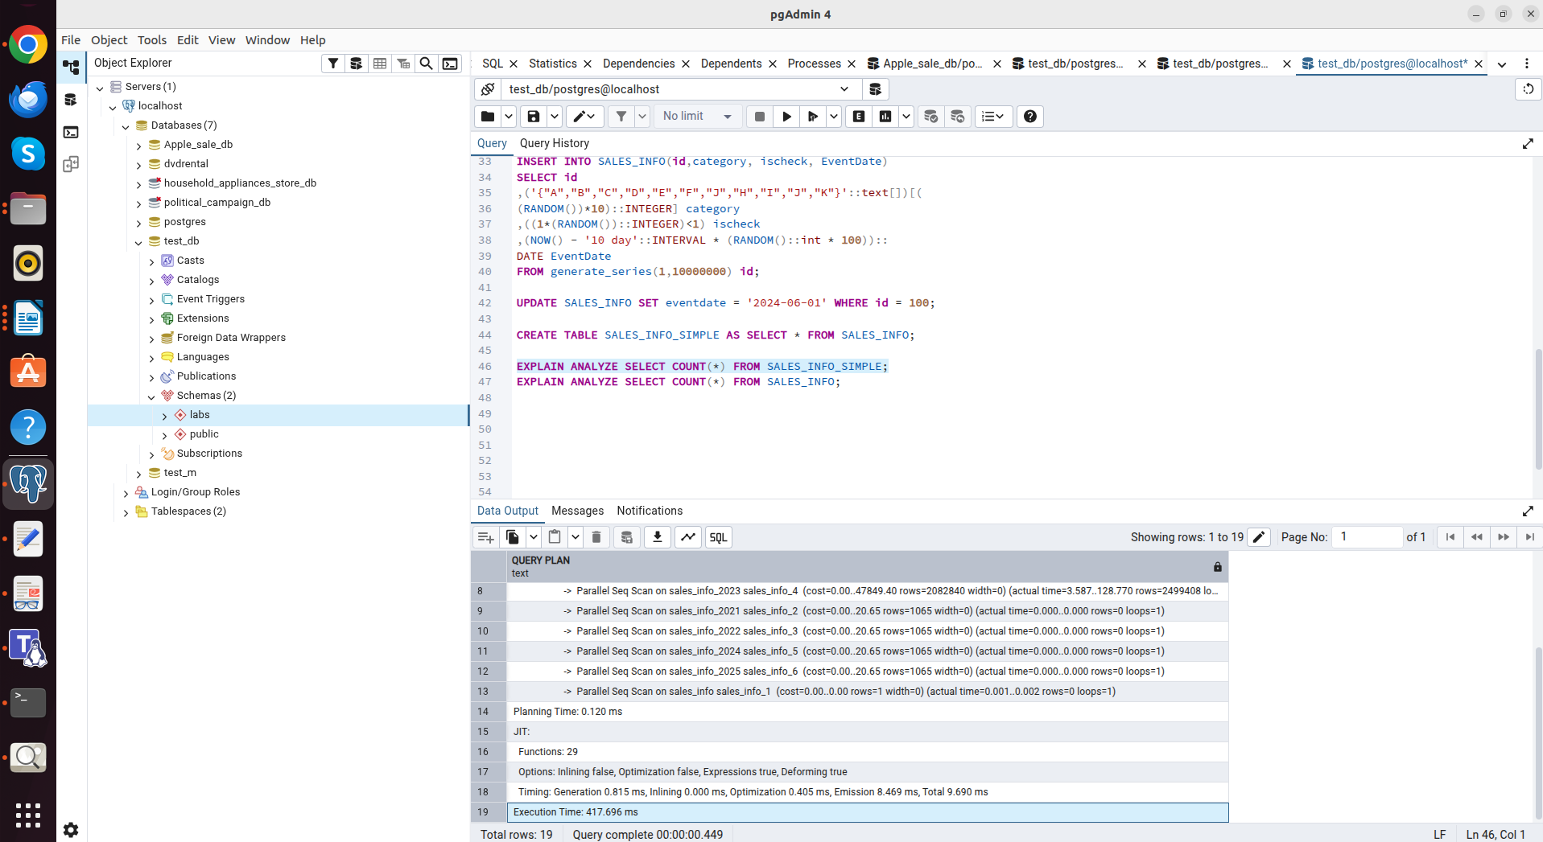
"Execution Time: 417.696 ms"

A simple table is faster. A partitioned table must query the master table and all child partitions separately, which creates overhead for planning and result assembly.

-Count of rows with range of dates
EXPLAIN ANALYZE SELECT COUNT(*) FROM SALES_INFO_SIMPLE WHERE eventdate >= '2025-01-01';

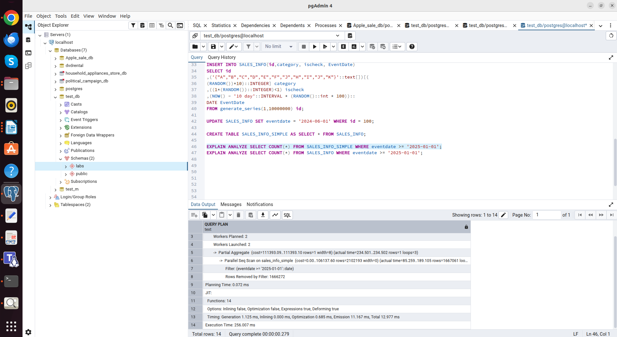
"Execution Time: 256.007 ms"

EXPLAIN ANALYZE SELECT COUNT(*) FROM SALES_INFO WHERE eventdate >= '2025-01-01';

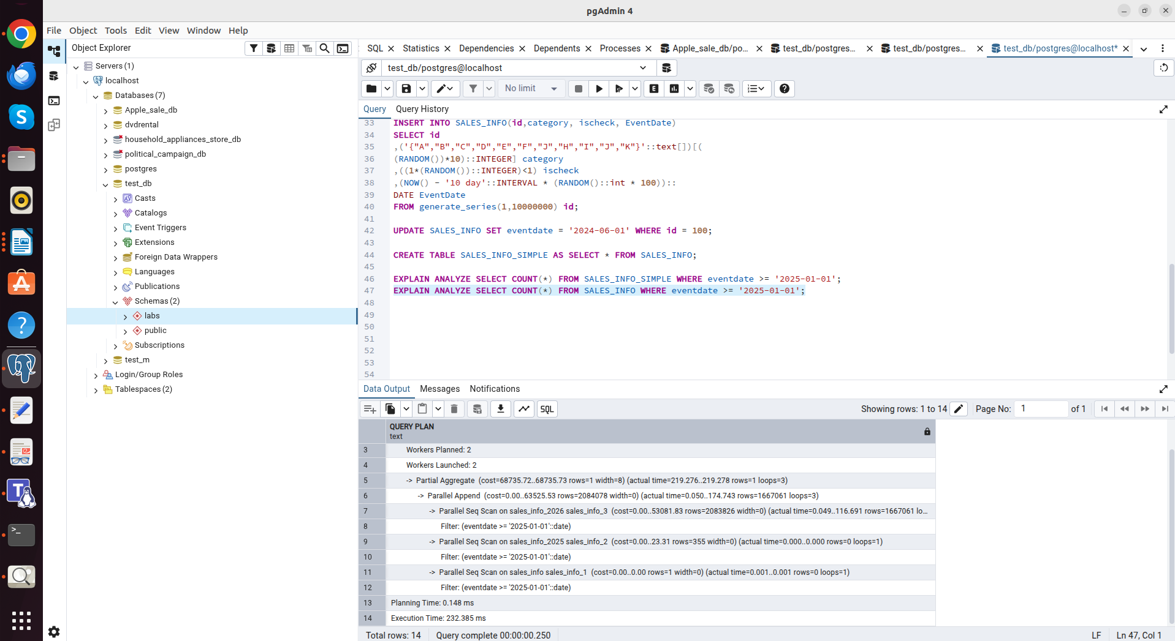
"Execution Time: 232.385 ms"

Partitioning shows a consistent advantage because the amount of data scanned is reduced to the size of specific partitions, while a SIMPLE table is forced to read the entire data array (Sequential Scan).

Partitioning demonstrates its advantage in queries filtered by the partitioning key (eventdate). Execution time is reduced significantly.
For operations that affect all data (COUNT of all rows or SELECT *), partitioning is slower due to the need to scan many individual objects in the database.

Deleting one of partition (the oldest one):

DROP TABLE sales_info_2021;

Creating some general table like sales_info_3000 with the same structure as sales_info and add it as new partition:

CREATE TABLE sales_info_3000 (
CHECK (eventdate >= '3000-01-01' AND eventdate < '3001-01-01')
) INHERITS (SALES_INFO);

I think that deleting data (for example, old ones) via DROP TABLE happens instantly and does not load the system (unlike DELETE, which generates a lot of logs and requires VACUUM).

1.2
TASK2: USE DECLARATIVE PARTITIONING

1-2. Creating SALES_INFO_DP table with composite partitioning by range and list:

Creating a master table with the RANGE type
CREATE TABLE SALES_INFO_DP (
id INTEGER,
category VARCHAR(1),
ischeck BOOLEAN,
eventdate DATE
) PARTITION BY RANGE (eventdate);

Creating sections by year.
Each of them is a master for sectioning by LIST.
CREATE TABLE sales_info_2022 PARTITION OF SALES_INFO_DP
FOR VALUES FROM ('2022-01-01') TO ('2023-01-01')
PARTITION BY LIST (category);

CREATE TABLE sales_info_2023 PARTITION OF SALES_INFO_DP
FOR VALUES FROM ('2023-01-01') TO ('2024-01-01')
PARTITION BY LIST (category);

CREATE TABLE sales_info_2022_ABC PARTITION OF sales_info_2022
FOR VALUES IN ('A', 'B', 'C');
CREATE TABLE sales_info_2022_DEF PARTITION OF sales_info_2022
FOR VALUES IN ('D', 'E', 'F');
CREATE TABLE sales_info_2022_DEFAULT PARTITION OF sales_info_2022
DEFAULT;
CREATE TABLE sales_info_2023_ABC PARTITION OF sales_info_2023
FOR VALUES IN ('A', 'B', 'C');
CREATE TABLE sales_info_2023_DEF PARTITION OF sales_info_2023
FOR VALUES IN ('D', 'E', 'F');
CREATE TABLE sales_info_2023_DEFAULT PARTITION OF sales_info_2023
DEFAULT;

3. Adding date to partitioned table:
INSERT INTO SALES_INFO_DP(id, category, ischeck, eventdate)
SELECT id,
('{"A","B","C","D","E","F","G","H","I","J","K"}'::text[])[(random()*10)::integer + 1],
(random() > 0.5),
(DATE '2022-01-01' + (random() * 700)::integer * INTERVAL '1 day')::DATE
FROM generate_series(1, 10000000) id;

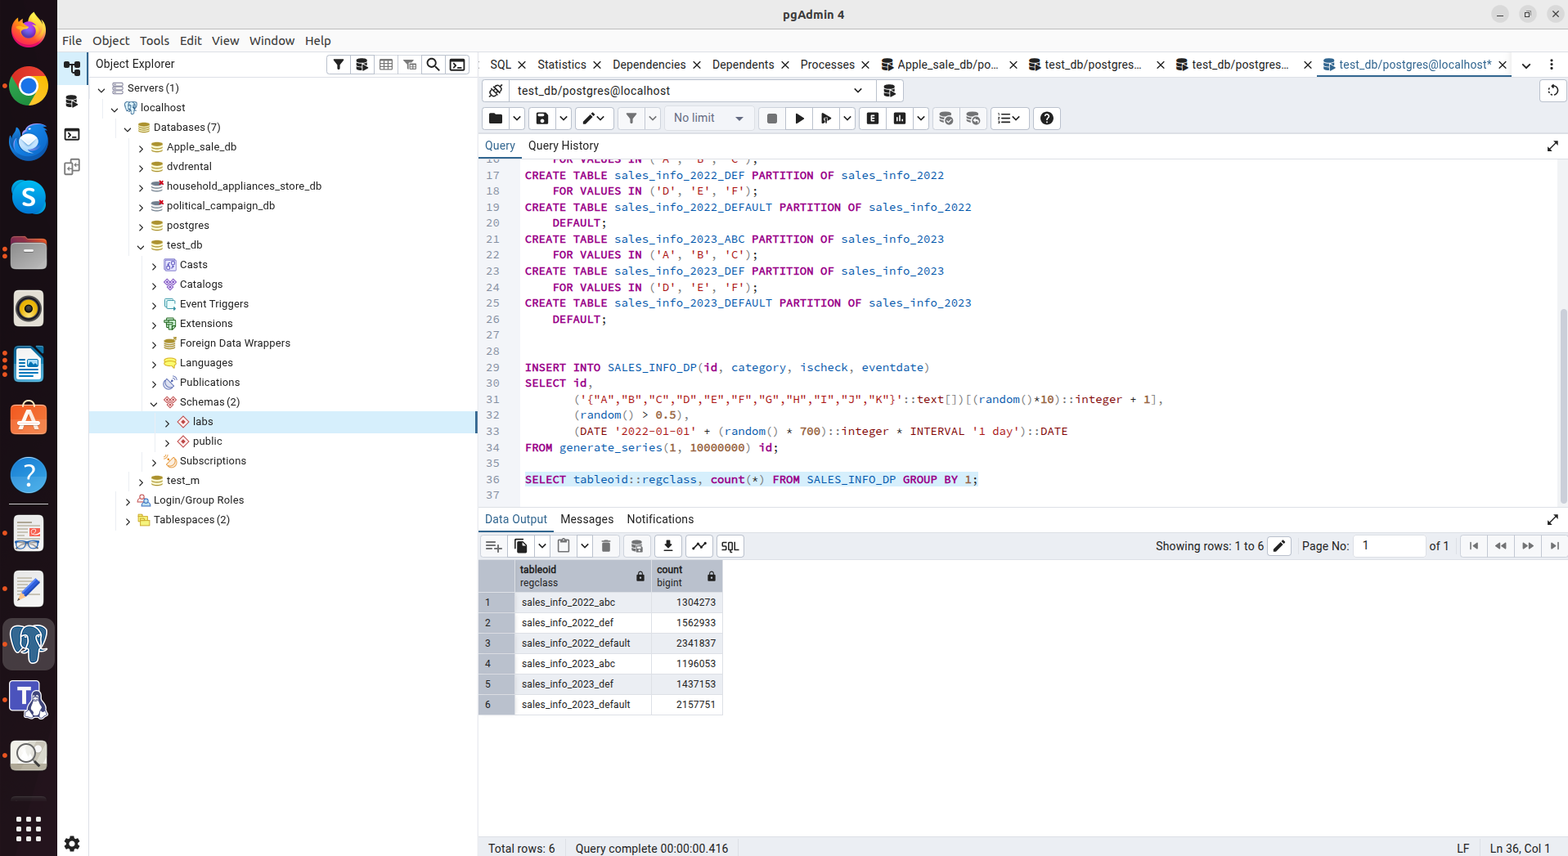
Distribution of data into partitions

4. Category updating:

check category before update
SELECT * FROM SALES_INFO_DP WHERE id = 500;

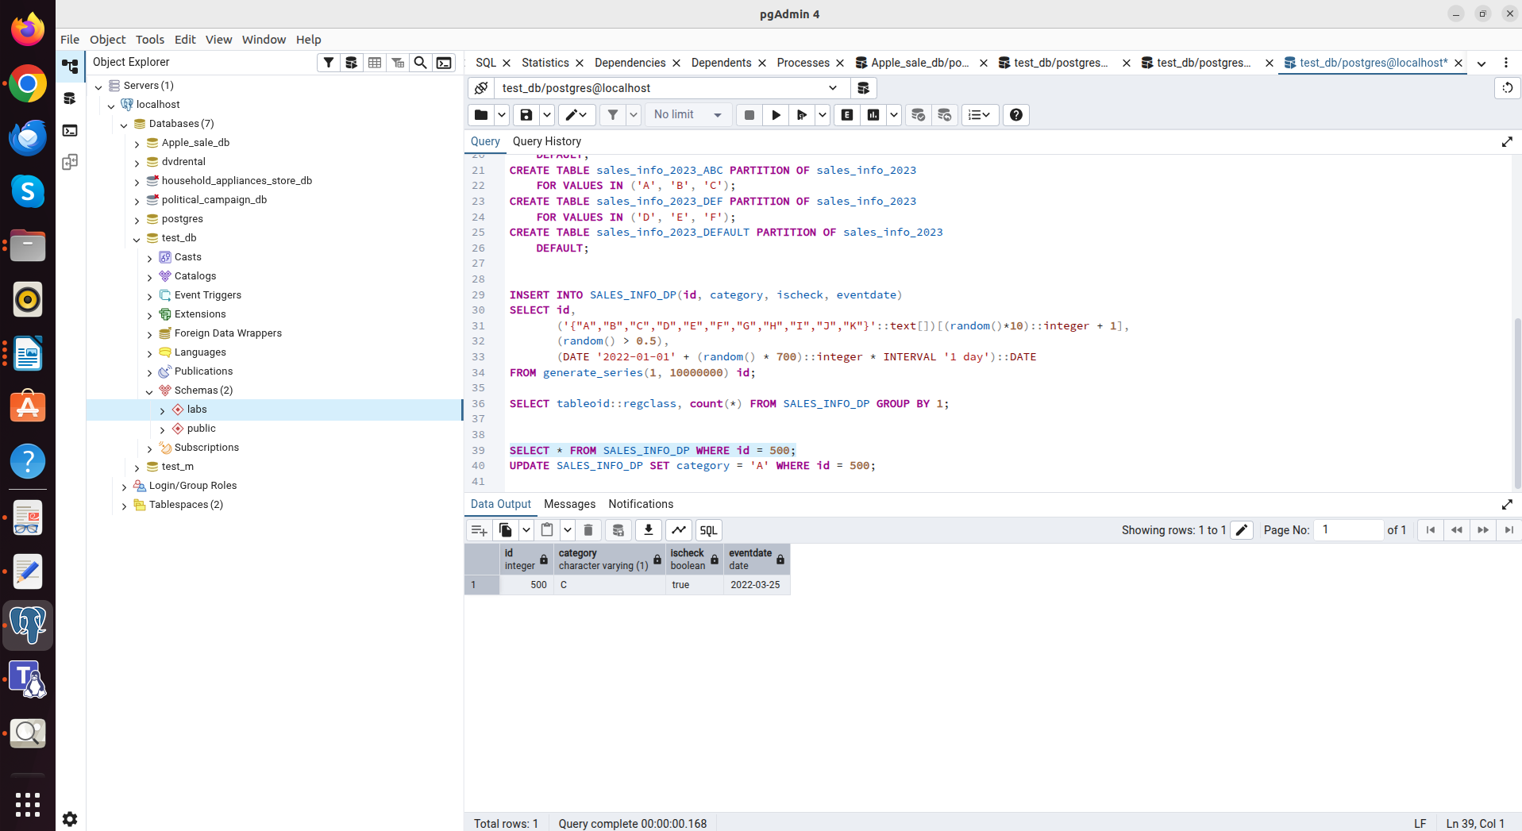

Updating category
UPDATE SALES_INFO_DP SET category = 'A' WHERE id = 500;

Successfully
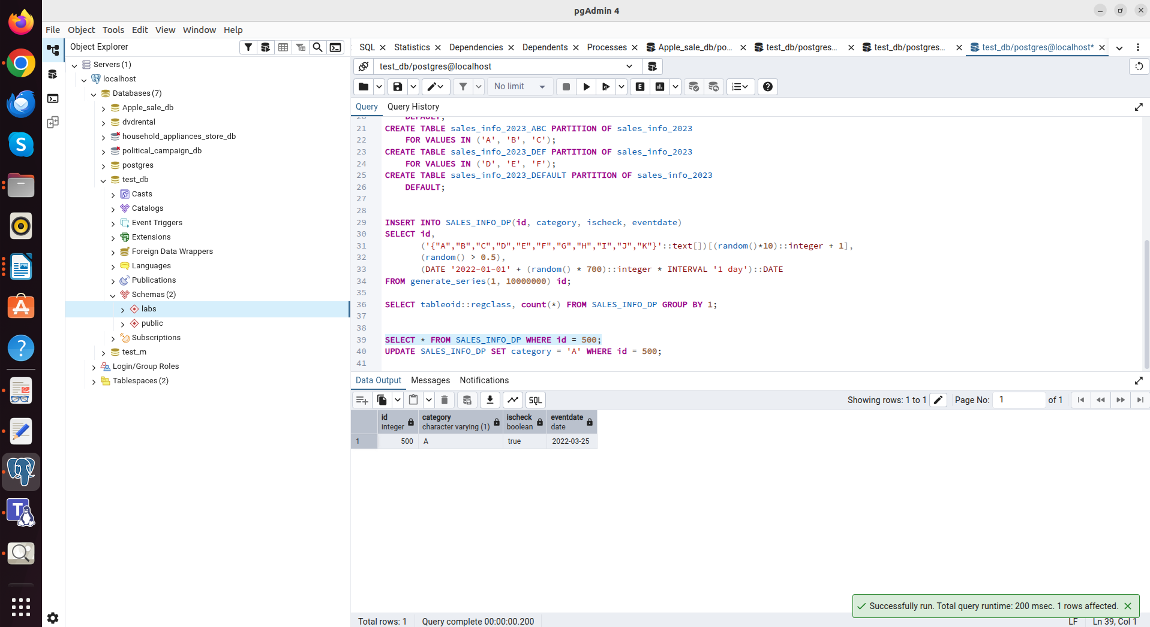

Unlike inheritance, declarative partitioning can move a row from one partition to another when the key changes.

5. Comparing plans of different queries for tables SALES_INFO_DP and SALES_INFO_SIMPLE:
--Select all
EXPLAIN ANALYZE SELECT * FROM SALES_INFO_SIMPLE;

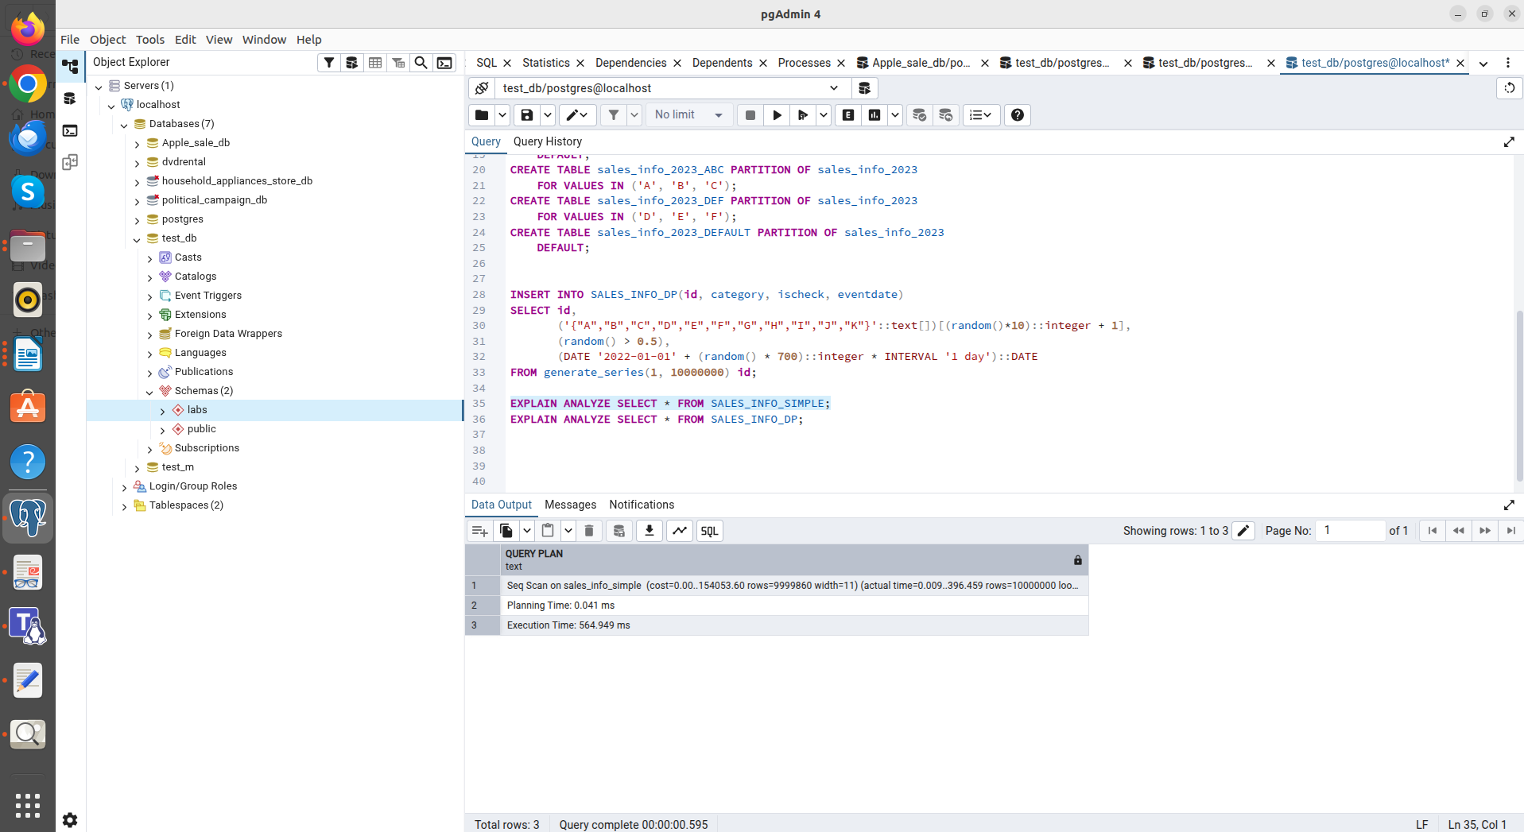
"Execution Time: 564.949 ms"

EXPLAIN ANALYZE SELECT * FROM SALES_INFO_DP;

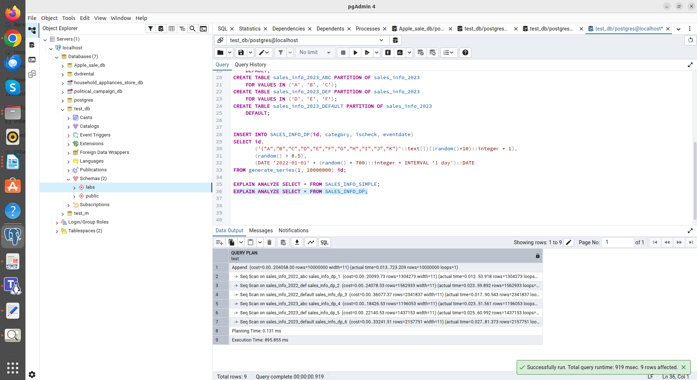
"Execution Time: 895.855 ms"

--Count of all rows
EXPLAIN ANALYZE SELECT COUNT(*) FROM SALES_INFO_SIMPLE;

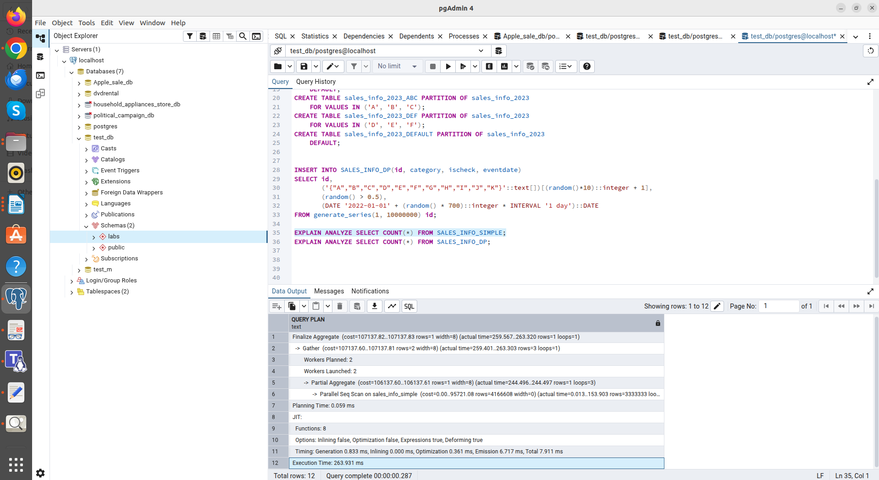
"Execution Time: 263.931 ms"

EXPLAIN ANALYZE SELECT COUNT(*) FROM SALES_INFO_DP;

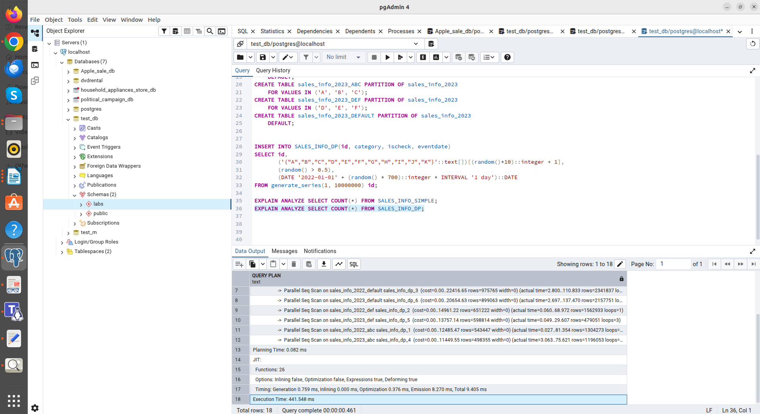
"Execution Time: 441.548 ms"

--Select with range of dates
EXPLAIN ANALYZE SELECT * FROM SALES_INFO_SIMPLE WHERE eventdate BETWEEN '2022-01-01' AND '2022-12-31';

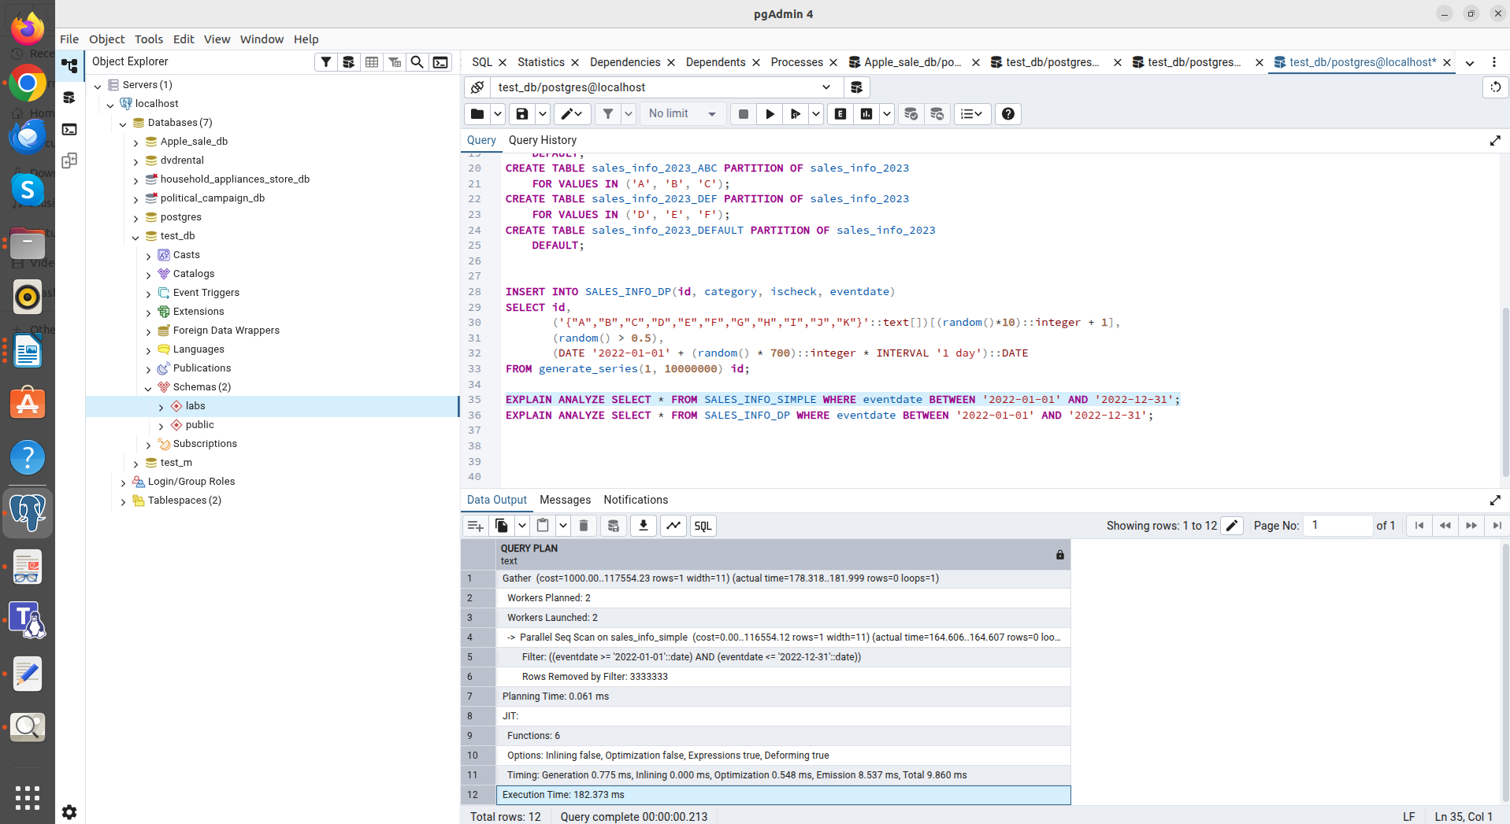
"Execution Time: 182.373 ms"

EXPLAIN ANALYZE SELECT * FROM SALES_INFO_DP WHERE eventdate BETWEEN '2022-01-01' AND '2022-12-31';

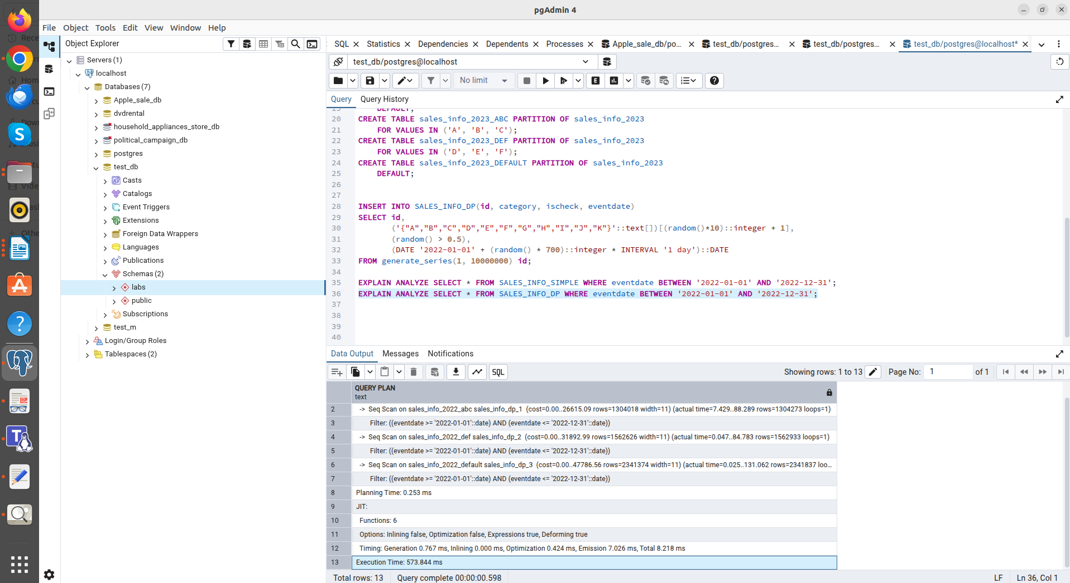
"Execution Time: 573.844 ms"

Operations (1, 2, 3):
In these tests, SIMPLE performs best. This is due to the depth of nesting of the DP. For a SELECT * for an entire year, the planner must open and scan numerous small sub-tables (ABC, DEF, DEFAULT for each period), which creates significant overhead for data collection.

--Select exact date
EXPLAIN ANALYZE SELECT * FROM SALES_INFO_SIMPLE WHERE eventdate = '2023-05-15';

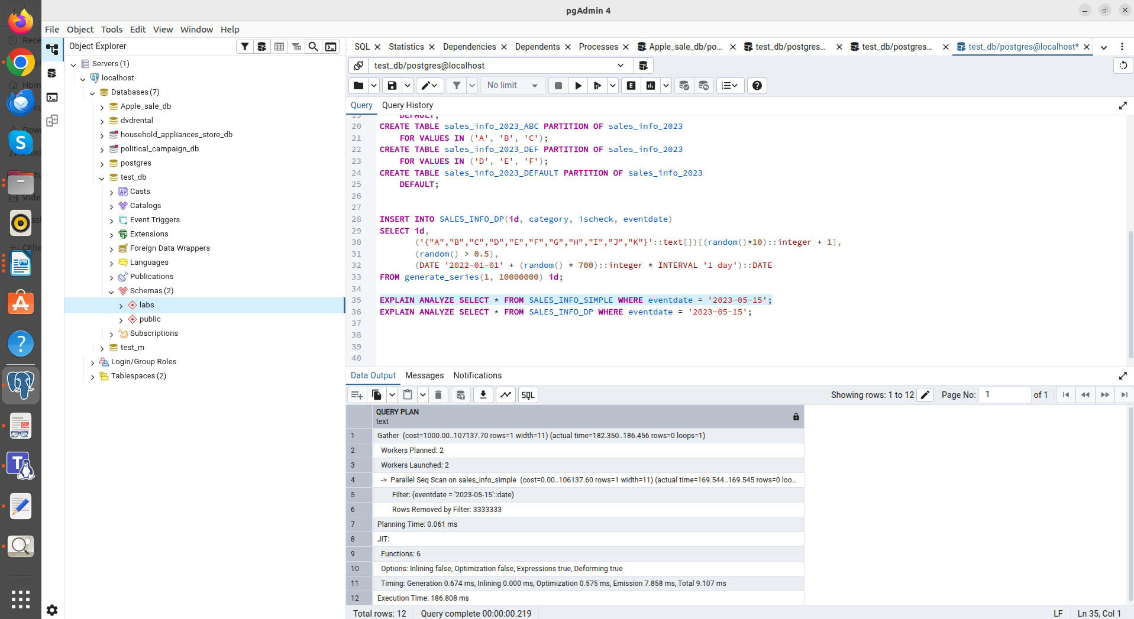
"Execution Time: 186.808 ms"

EXPLAIN ANALYZE SELECT * FROM SALES_INFO_DP WHERE eventdate = '2023-05-15';

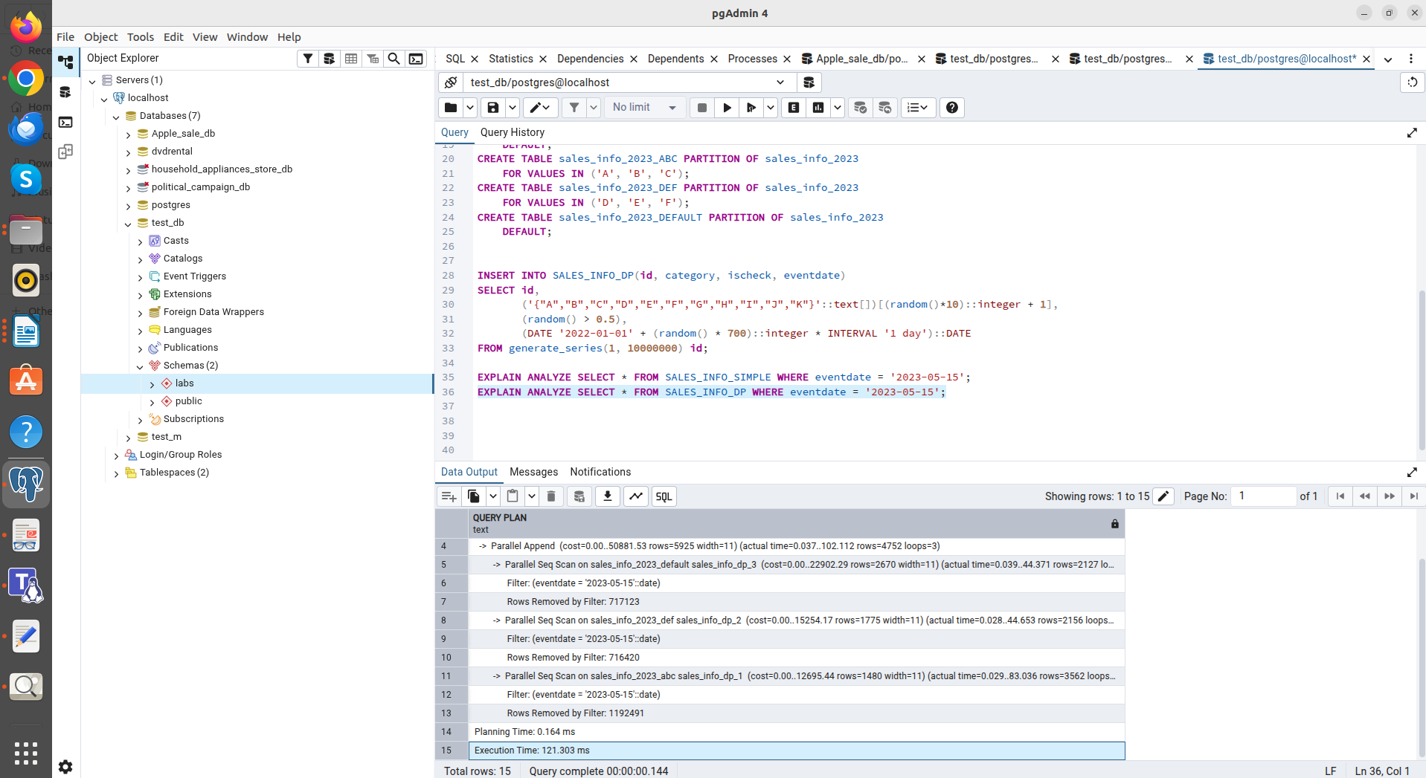
"Execution Time: 121.303 ms"

--Count of rows with range of dates
EXPLAIN ANALYZE SELECT COUNT(*) FROM SALES_INFO_SIMPLE WHERE eventdate >= '2023-01-01';

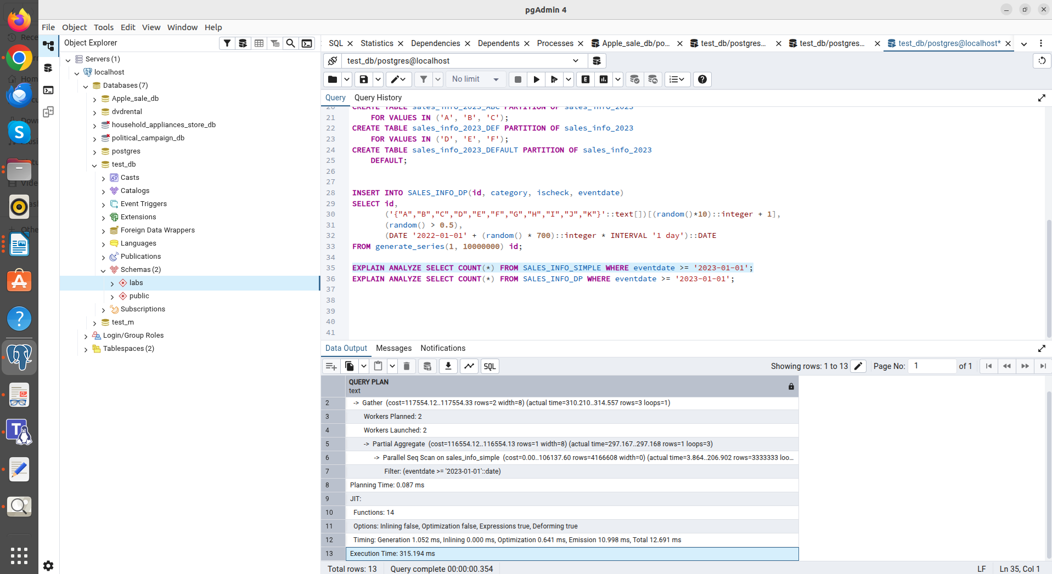
"Execution Time: 315.194 ms"

EXPLAIN ANALYZE SELECT COUNT(*) FROM SALES_INFO_DP WHERE eventdate >= '2023-01-01';

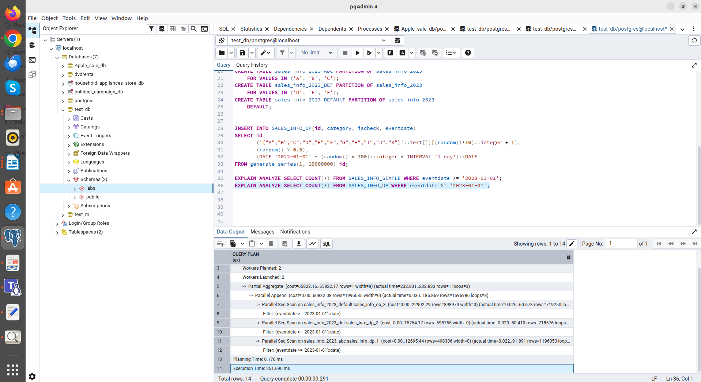
"Execution Time: 251.690 ms"

Operations (4, 5):
Once the search is narrowed to a specific date, DP begins to win, as it ignores the vast amounts of data in other year sections.

--Select exact category
EXPLAIN ANALYZE SELECT * FROM SALES_INFO_SIMPLE WHERE category = 'A';

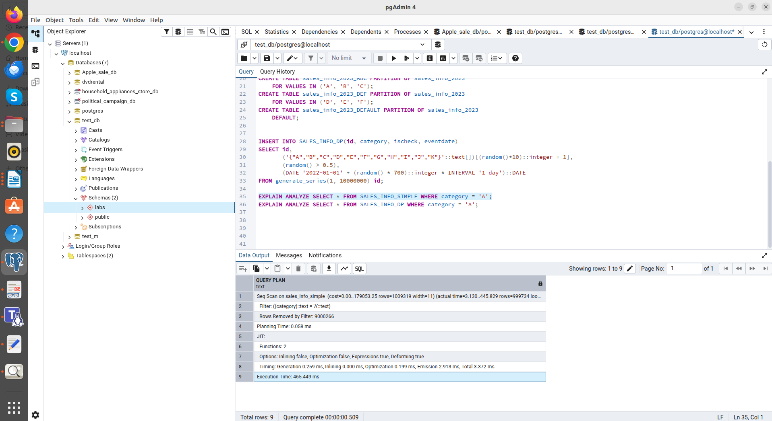
"Execution Time: 465.449 ms"

EXPLAIN ANALYZE SELECT * FROM SALES_INFO_DP WHERE category = 'A';

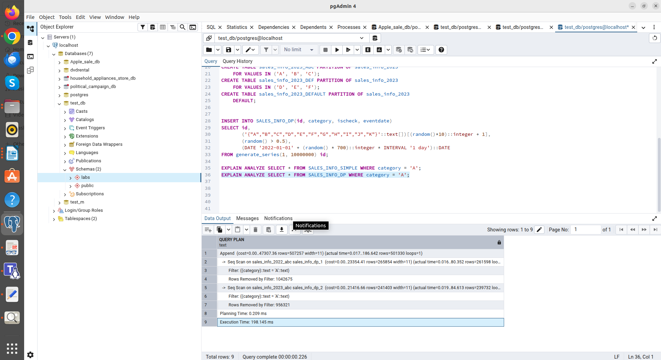
"Execution Time: 198.145 ms"

--Select a list of categories
EXPLAIN ANALYZE SELECT * FROM SALES_INFO_SIMPLE WHERE category IN ('B', 'E');

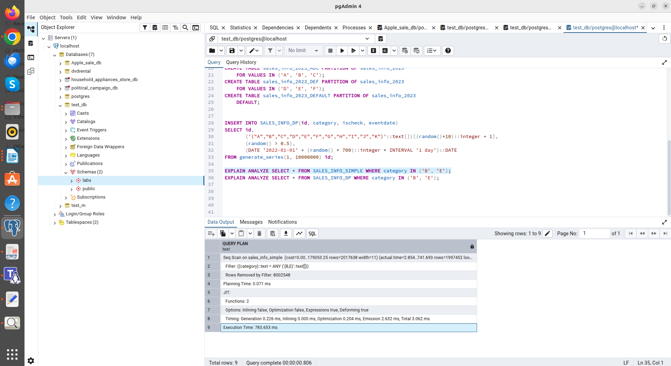
"Execution Time: 783.653 ms"

EXPLAIN ANALYZE SELECT * FROM SALES_INFO_DP WHERE category IN ('B', 'E');

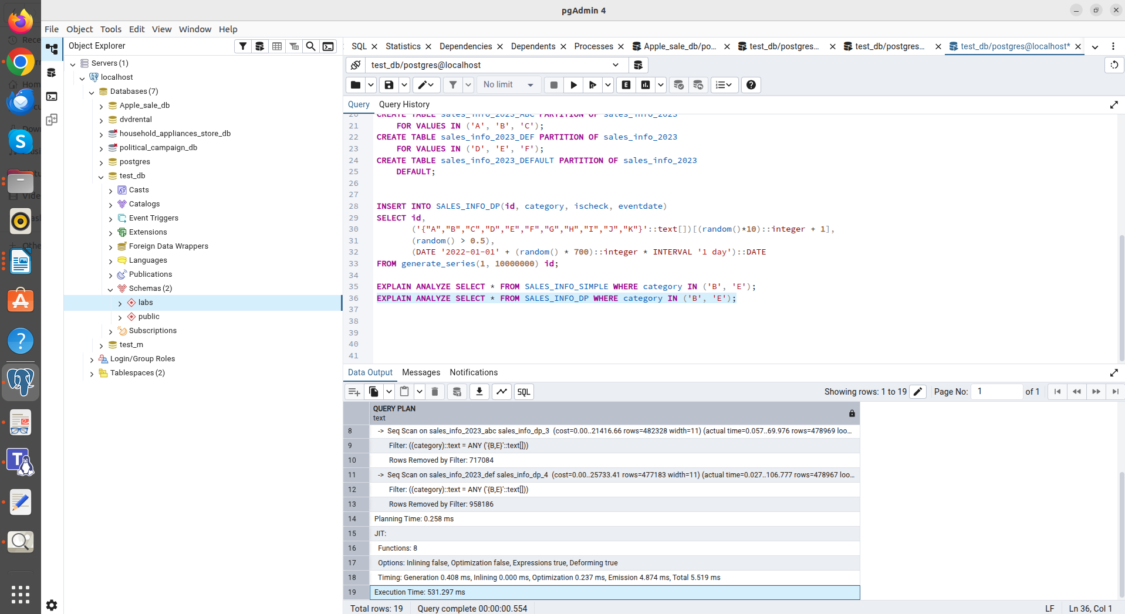
"Execution Time: 531.297 ms"

Operations (6, 7):
Declarative partitioning (by category) works effectively even without specifying a date. The system scans only those sections that match the letters, skipping the rest.

--Select a list of categories in exact date
EXPLAIN ANALYZE SELECT * FROM SALES_INFO_SIMPLE WHERE eventdate = '2022-06-01' AND category IN ('A', 'C');

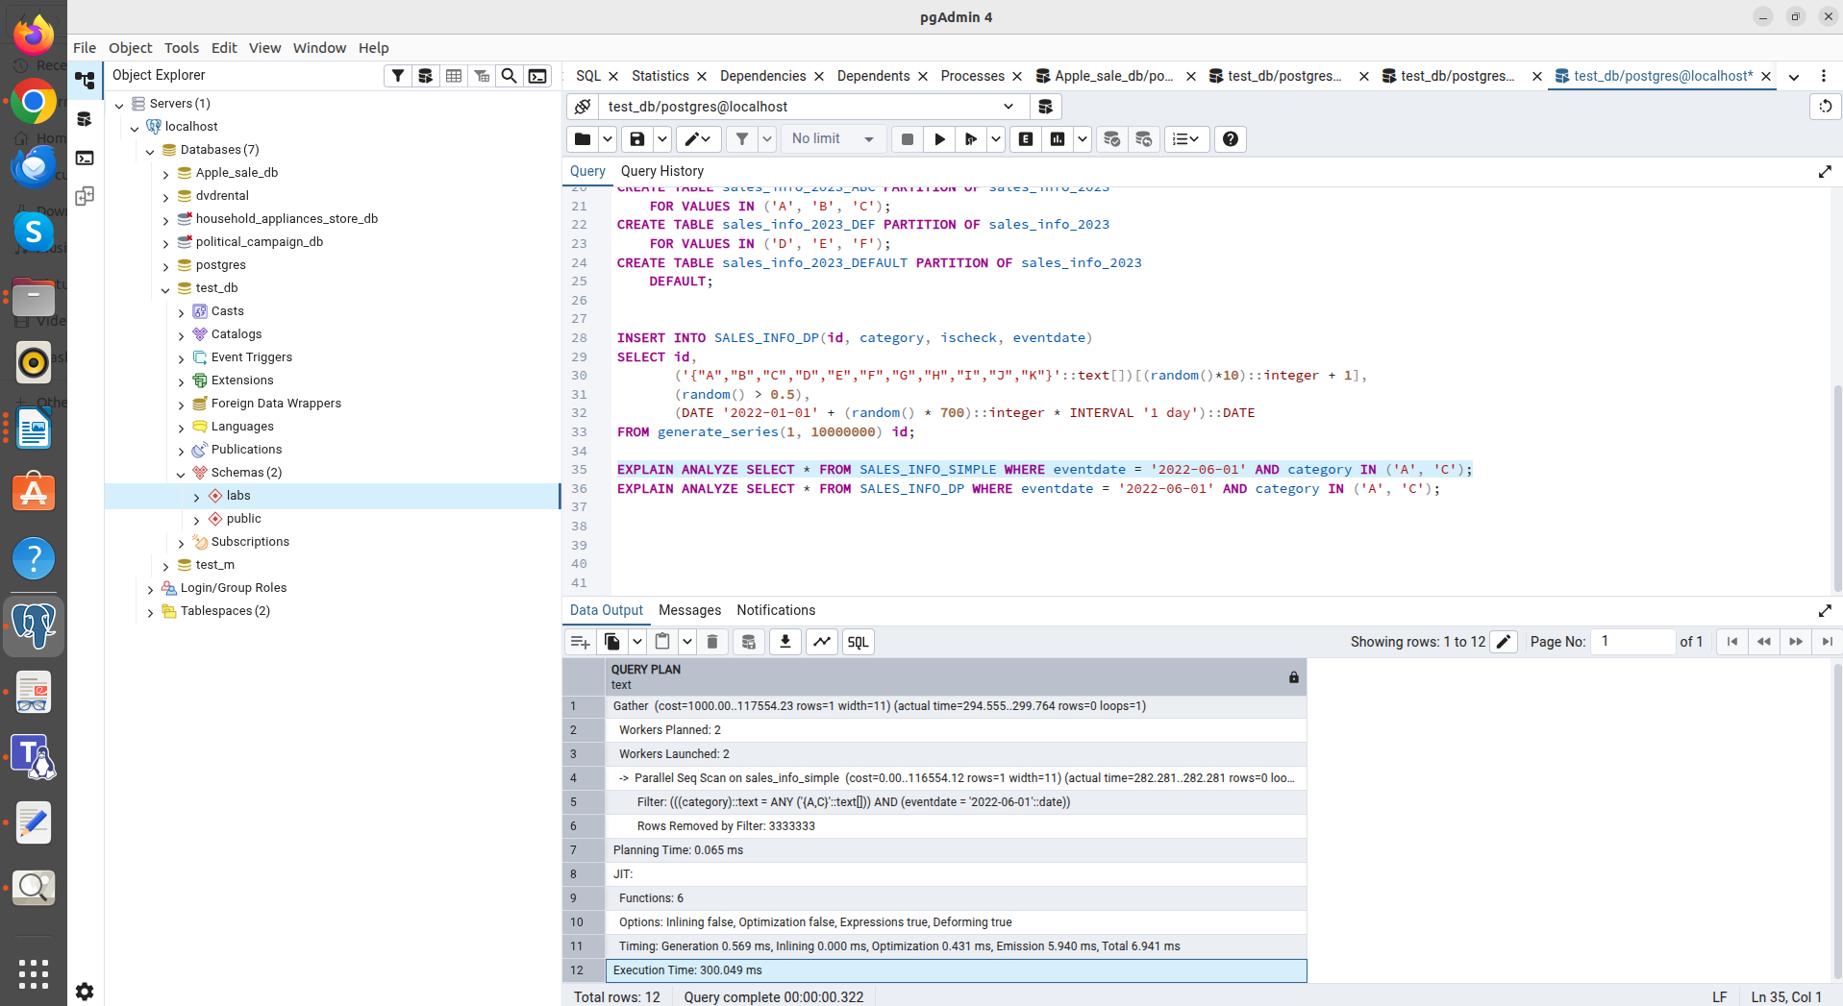
"Execution Time: 300.049 ms"

EXPLAIN ANALYZE SELECT * FROM SALES_INFO_DP WHERE eventdate = '2022-06-01' AND category IN ('A', 'C');

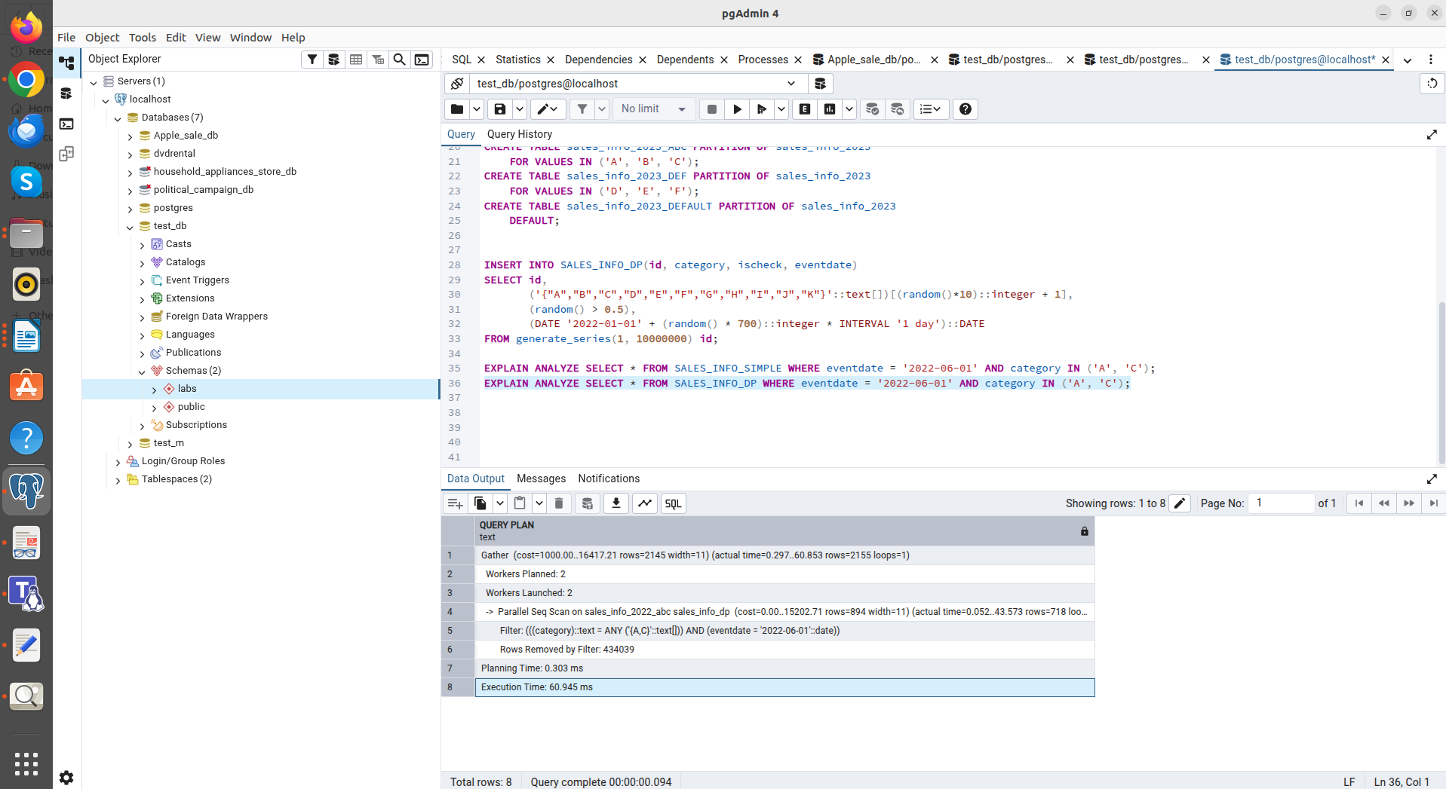
"Execution Time: 60.945 ms"

Operation (8):
The most efficient scenario for DP. It uses two-level partition pruning: first by date, then by category. As a result, the database accesses one or two tiny tables instead of scanning millions of rows.

Summary:
Advantage of sub-partitions: Using SUBPARTITION (date + category) gives maximum results in highly specialized queries. A 5x speedup on query 8 confirms the validity of the architecture for point searches.
Complexity cost: Two-level partitioning is an expensive tool. The scheduler overhead (Execution Time in tests 1 and 3) is higher than with classic inheritance due to the need to traverse the sub-partition tree.

6. Splitting the common section:
Detaching a section from a parent table
ALTER TABLE sales_info_2023 DETACH PARTITION sales_info_2023_ABC;

Creating two new sections with narrower ranges (A, B and C separately)
CREATE TABLE sales_info_2023_AB PARTITION OF sales_info_2023 FOR VALUES IN ('A', 'B');
CREATE TABLE sales_info_2023_C PARTITION OF sales_info_2023 FOR VALUES IN ('C');

Transferring data from the old detached table to the new one and deleting the old table
INSERT INTO sales_info_2023 SELECT * FROM sales_info_2023_ABC;
DROP TABLE sales_info_2023_ABC;

Returning everything to its original state
ALTER TABLE sales_info_2023 DETACH PARTITION sales_info_2023_AB;
ALTER TABLE sales_info_2023 DETACH PARTITION sales_info_2023_C;
DROP TABLE sales_info_2023_AB, sales_info_2023_C;
CREATE TABLE sales_info_2023_ABC PARTITION OF sales_info_2023
FOR VALUES IN ('A', 'B', 'C');

Splitting an existing partition requires DETACH, data spilling, and attach, emphasizing the importance of proper structure planning in advance.
DETACH logic: The DETACH PARTITION command doesn't delete the data, but rather converts the partition into a regular table. This is necessary because we can't create a new partition (for example, for 'A' and 'B') if these values are already "occupied" by the existing partition 'ABC'.

2.1
TASK 3: USE PARALLEL QUERING

1. Add parallel workers:
set max_parallel_workers_per_gather=4;

2. Analyze plans for tables SALES_INFO, SALES_INFO_DP and SALES_INFO_SIMPLE by querying:
--Select all from tables
EXPLAIN ANALYZE SELECT * FROM SALES_INFO_SIMPLE;
"Gather (cost=0.00..79054.65 rows=9999860 width=11) (actual time=0.795..514.514 rows=10000000 loops=1)"
" Workers Planned: 4"
" Workers Launched: 4"
" -> Parallel Seq Scan on sales_info_simple (cost=0.00..79054.65 rows=2499965 width=11) (actual time=0.040..109.922 rows=2000000 loops=5)"
"Planning Time: 0.042 ms"
"Execution Time: 732.438 ms"

EXPLAIN ANALYZE SELECT * FROM SALES_INFO;
"Gather (cost=0.00..91642.22 rows=10007427 width=11) (actual time=0.196..463.720 rows=10002163 loops=1)"
" Workers Planned: 4"
" Workers Launched: 4"
" -> Parallel Append (cost=0.00..91642.22 rows=2501858 width=11) (actual time=0.047..225.788 rows=2000433 loops=5)"
" -> Parallel Seq Scan on sales_info_2026 sales_info_4 (cost=0.00..79070.99 rows=2500499 width=11) (actual time=0.046..127.352 rows=2000433 loops=5)"
" -> Parallel Seq Scan on sales_info_2024 sales_info_2 (cost=0.00..20.65 rows=1065 width=17) (actual time=0.000..0.000 rows=0 loops=1)"
" -> Parallel Seq Scan on sales_info_2025 sales_info_3 (cost=0.00..20.65 rows=1065 width=17) (actual time=0.000..0.000 rows=0 loops=1)"
" -> Parallel Seq Scan on sales_info_3000 sales_info_5 (cost=0.00..20.65 rows=1065 width=17) (actual time=0.000..0.000 rows=0 loops=1)"
" -> Parallel Seq Scan on sales_info sales_info_1 (cost=0.00..0.00 rows=1 width=17) (actual time=0.002..0.002 rows=0 loops=1)"
"Planning Time: 0.079 ms"
"Execution Time: 644.230 ms"

EXPLAIN ANALYZE SELECT * FROM SALES_INFO_DP;
"Gather (cost=0.00..99677.12 rows=9829479 width=11) (actual time=0.240..465.099 rows=8700000 loops=1)"
" Workers Planned: 3"
" Workers Launched: 3"
" -> Parallel Append (cost=0.00..99677.12 rows=3170800 width=11) (actual time=0.022..247.867 rows=2175000 loops=4)"
" -> Parallel Seq Scan on sales_info_2022_default sales_info_dp_3 (cost=0.00..18464.68 rows=743568 width=11) (actual time=0.020..160.774 rows=2040320 loops=1)"
" -> Parallel Seq Scan on sales_info_2023_default sales_info_dp_6 (cost=0.00..16988.04 rows=684104 width=11) (actual time=0.020..130.086 rows=1877033 loops=1)"
" -> Parallel Seq Scan on sales_info_2022_def sales_info_dp_2 (cost=0.00..13750.62 rows=640062 width=11) (actual time=0.029..106.467 rows=1359572 loops=1)"
" -> Parallel Seq Scan on sales_info_2023_def sales_info_dp_5 (cost=0.00..12641.22 rows=588422 width=11) (actual time=0.049..86.675 rows=1249880 loops=1)"
" -> Parallel Seq Scan on sales_info_2022_abc sales_info_dp_1 (cost=0.00..11451.37 rows=533037 width=11) (actual time=0.021..28.246 rows=566162 loops=2)"
" -> Parallel Seq Scan on sales_info_2023_abc sales_info_dp_4 (cost=0.00..10527.18 rows=490018 width=11) (actual time=0.019..20.087 rows=260218 loops=4)"
"Planning Time: 0.172 ms"
"Execution Time: 690.893 ms"

Performance Leader — SALES_INFO (Legacy):
The inheritance method demonstrated the best results. The Parallel Append node efficiently distributed all workers to read a single table, minimizing the overhead of switching between objects.
Parallel Append Efficiency (Partitioning):
Unlike SIMPLE tables, which use Parallel Seq Scan on a single file, partitioned tables use Parallel Append. The SALES_INFO_DP plan clearly shows how workers are distributed across different sub-partitions (sales_info_2022_default, sales_info_2023_def, etc.), working on them simultaneously.
Impact of Nesting Depth (Overhead):
SALES_INFO_DP shows higher execution time for a full scan. The scheduler requires more resources to coordinate six different sub-partitions and distribute workers among them. This confirms the rule: the more small partitions, the higher the overhead for SELECT * queries.
Gather:
In all three cases, the majority of the time (about 60-70% of the total) is spent not on reading data from disk by workers, but on the process of transferring and assembling these strings in the main thread (Gather).

--Add order by eventadate
EXPLAIN ANALYZE SELECT * FROM SALES_INFO_SIMPLE ORDER BY eventdate;
"Gather Merge (cost=430168.44..577512.79 rows=9999860 width=11) (actual time=453.372..2315.647 rows=10000000 loops=1)"
" Workers Planned: 4"
" Workers Launched: 4"
" -> Sort (cost=430168.39..436418.30 rows=2499965 width=11) (actual time=409.799..554.563 rows=2000000 loops=5)"
" Sort Key: eventdate"
" Sort Method: external merge Disk: 37544kB"
" Worker 0: Sort Method: external merge Disk: 39712kB"
" Worker 1: Sort Method: external merge Disk: 34784kB"
" Worker 2: Sort Method: external merge Disk: 47672kB"
" Worker 3: Sort Method: external merge Disk: 55800kB"
" -> Parallel Seq Scan on sales_info_simple (cost=0.00..79054.65 rows=2499965 width=11) (actual time=0.015..112.247 rows=2000000 loops=5)"
"Planning Time: 0.155 ms"
"Execution Time: 2527.068 ms"

EXPLAIN ANALYZE SELECT * FROM SALES_INFO ORDER BY eventdate;
"Gather Merge (cost=443045.08..590502.85 rows=10007558 width=11) (actual time=528.431..2273.550 rows=10002163 loops=1)"
" Workers Planned: 4"
" Workers Launched: 4"
" -> Sort (cost=443045.02..449299.75 rows=2501891 width=11) (actual time=493.826..642.021 rows=2000433 loops=5)"
" Sort Key: sales_info.eventdate"
" Sort Method: external merge Disk: 38744kB"
" Worker 0: Sort Method: external merge Disk: 40752kB"
" Worker 1: Sort Method: external merge Disk: 54776kB"
" Worker 2: Sort Method: external merge Disk: 36208kB"
" Worker 3: Sort Method: external merge Disk: 45088kB"
" -> Parallel Append (cost=0.00..91642.71 rows=2501891 width=11) (actual time=0.018..194.305 rows=2000433 loops=5)"
" -> Parallel Seq Scan on sales_info_2026 sales_info_4 (cost=0.00..79071.32 rows=2500532 width=11) (actual time=0.016..110.683 rows=2000433 loops=5)"
" -> Parallel Seq Scan on sales_info_2024 sales_info_2 (cost=0.00..20.65 rows=1065 width=17) (actual time=0.000..0.000 rows=0 loops=1)"
" -> Parallel Seq Scan on sales_info_2025 sales_info_3 (cost=0.00..20.65 rows=1065 width=17) (actual time=0.000..0.000 rows=0 loops=1)"
" -> Parallel Seq Scan on sales_info_3000 sales_info_5 (cost=0.00..20.65 rows=1065 width=17) (actual time=0.000..0.000 rows=0 loops=1)"
" -> Parallel Seq Scan on sales_info sales_info_1 (cost=0.00..0.00 rows=1 width=17) (actual time=0.001..0.001 rows=0 loops=1)"
"Planning Time: 0.106 ms"
"Execution Time: 2500.417 ms"

EXPLAIN ANALYZE SELECT * FROM SALES_INFO_DP ORDER BY eventdate;
"Gather Merge (cost=490131.06..602389.14 rows=8419356 width=11) (actual time=734.492..2175.076 rows=8700000 loops=1)"
" Workers Planned: 3"
" Workers Launched: 3"
" -> Sort (cost=490131.02..497147.15 rows=2806452 width=11) (actual time=695.204..882.068 rows=2175000 loops=4)"
" Sort Key: sales_info_dp.eventdate"
" Sort Method: external merge Disk: 41016kB"
" Worker 0: Sort Method: external merge Disk: 62400kB"
" Worker 1: Sort Method: external merge Disk: 39728kB"
" Worker 2: Sort Method: external merge Disk: 44352kB"
" -> Parallel Append (cost=0.00..93627.58 rows=2806452 width=11) (actual time=0.029..205.646 rows=2175000 loops=4)"
" -> Parallel Seq Scan on sales_info_2022_default sales_info_dp_3 (cost=0.00..17610.68 rows=658168 width=11) (actual time=0.023..88.116 rows=2040320 loops=1)"
" -> Parallel Seq Scan on sales_info_2023_default sales_info_dp_6 (cost=0.00..16201.95 rows=605495 width=11) (actual time=0.034..102.036 rows=1877033 loops=1)"
" -> Parallel Seq Scan on sales_info_2022_def sales_info_dp_2 (cost=0.00..13014.88 rows=566488 width=11) (actual time=0.032..83.291 rows=1359572 loops=1)"
" -> Parallel Seq Scan on sales_info_2023_def sales_info_dp_5 (cost=0.00..11964.83 rows=520783 width=11) (actual time=0.062..15.243 rows=312470 loops=4)"
" -> Parallel Seq Scan on sales_info_2022_abc sales_info_dp_1 (cost=0.00..10839.02 rows=471802 width=11) (actual time=0.031..32.818 rows=566162 loops=2)"
" -> Parallel Seq Scan on sales_info_2023_abc sales_info_dp_4 (cost=0.00..9963.96 rows=433696 width=11) (actual time=0.026..59.930 rows=1040871 loops=1)"
"Planning Time: 0.398 ms"
"Execution Time: 2358.437 ms"

Gather Merge instead of Gather:
Unlike a simple SELECT *, this uses the Gather Merge node. It doesn't just collect data from workers, but merges streams already sorted by them, preserving the overall order.
Parallel Sort:
The plans show that each worker sorted its portion of the data independently. Because the data was large (10 million rows), the workers couldn't fit it all in RAM (work_mem) and used external merge disk sorting.
Impact of partitioning on sorting:
SALES_INFO_DP showed better performance. Despite having three workers, the total execution time (2.3 seconds) was shorter. This suggests that declarative partitioning better prepares data for parallel processing.

--Select count of all rows
EXPLAIN ANALYZE SELECT COUNT(*) FROM SALES_INFO_SIMPLE;
"Finalize Aggregate (cost=85304.58..85304.59 rows=1 width=8) (actual time=183.655..187.755 rows=1 loops=1)"
" -> Gather (cost=85304.56..85304.57 rows=4 width=8) (actual time=183.463..187.744 rows=5 loops=1)"
" Workers Planned: 4"
" Workers Launched: 4"
" -> Partial Aggregate (cost=85304.56..85304.57 rows=1 width=8) (actual time=165.404..165.405 rows=1 loops=5)"
" -> Parallel Seq Scan on sales_info_simple (cost=0.00..79054.65 rows=2499965 width=0) (actual time=0.016..103.159 rows=2000000 loops=5)"
"Planning Time: 0.076 ms"
"Execution Time: 187.786 ms"

EXPLAIN ANALYZE SELECT COUNT(*) FROM SALES_INFO;
"Finalize Aggregate (cost=97897.46..97897.47 rows=1 width=8) (actual time=273.484..277.336 rows=1 loops=1)"
" -> Gather (cost=97897.44..97897.45 rows=4 width=8) (actual time=273.309..277.327 rows=5 loops=1)"
" Workers Planned: 4"
" Workers Launched: 4"
" -> Partial Aggregate (cost=97897.44..97897.45 rows=1 width=8) (actual time=256.009..256.011 rows=1 loops=5)"
" -> Parallel Append (cost=0.00..91642.71 rows=2501891 width=0) (actual time=0.025..196.365 rows=2000433 loops=5)"
" -> Parallel Seq Scan on sales_info_2026 sales_info_4 (cost=0.00..79071.32 rows=2500532 width=0) (actual time=0.023..113.498 rows=2000433 loops=5)"
" -> Parallel Seq Scan on sales_info_2024 sales_info_2 (cost=0.00..20.65 rows=1065 width=0) (actual time=0.000..0.000 rows=0 loops=1)"
" -> Parallel Seq Scan on sales_info_2025 sales_info_3 (cost=0.00..20.65 rows=1065 width=0) (actual time=0.000..0.000 rows=0 loops=1)"
" -> Parallel Seq Scan on sales_info_3000 sales_info_5 (cost=0.00..20.65 rows=1065 width=0) (actual time=0.000..0.000 rows=0 loops=1)"
" -> Parallel Seq Scan on sales_info sales_info_1 (cost=0.00..0.00 rows=1 width=0) (actual time=0.002..0.002 rows=0 loops=1)"
"Planning Time: 0.135 ms"
"Execution Time: 277.378 ms"

EXPLAIN ANALYZE SELECT COUNT(*) FROM SALES_INFO_DP;
"Finalize Aggregate (cost=100643.73..100643.74 rows=1 width=8) (actual time=310.147..314.919 rows=1 loops=1)"
" -> Gather (cost=100643.71..100643.72 rows=3 width=8) (actual time=306.701..314.869 rows=4 loops=1)"
" Workers Planned: 3"
" Workers Launched: 3"
" -> Partial Aggregate (cost=100643.71..100643.72 rows=1 width=8) (actual time=291.211..291.214 rows=1 loops=4)"
" -> Parallel Append (cost=0.00..93627.58 rows=2806452 width=0) (actual time=3.355..225.176 rows=2175000 loops=4)"
" -> Parallel Seq Scan on sales_info_2022_default sales_info_dp_3 (cost=0.00..17610.68 rows=658168 width=0) (actual time=1.891..102.769 rows=2040320 loops=1)"
" -> Parallel Seq Scan on sales_info_2023_default sales_info_dp_6 (cost=0.00..16201.95 rows=605495 width=0) (actual time=3.106..111.818 rows=1877033 loops=1)"
" -> Parallel Seq Scan on sales_info_2022_def sales_info_dp_2 (cost=0.00..13014.88 rows=566488 width=0) (actual time=3.105..92.362 rows=1359572 loops=1)"
" -> Parallel Seq Scan on sales_info_2023_def sales_info_dp_5 (cost=0.00..11964.83 rows=520783 width=0) (actual time=0.063..19.568 rows=312470 loops=4)"
" -> Parallel Seq Scan on sales_info_2022_abc sales_info_dp_1 (cost=0.00..10839.02 rows=471802 width=0) (actual time=0.063..35.231 rows=566162 loops=2)"
" -> Parallel Seq Scan on sales_info_2023_abc sales_info_dp_4 (cost=0.00..9963.96 rows=433696 width=0) (actual time=5.313..68.097 rows=1040871 loops=1)"
"Planning Time: 0.140 ms"
"JIT:"
" Functions: 34"
" Options: Inlining false, Optimization false, Expressions true, Deforming true"
" Timing: Generation 1.309 ms, Inlining 0.000 ms, Optimization 0.562 ms, Emission 12.907 ms, Total 14.777 ms"
"Execution Time: 315.724 ms"

Two-stage aggregation (Partial/Finalize):
We envision a division of labor. Each worker calculates the number of rows in its data segment (Partial Aggregate). The Gather node then passes these subtotals to the master, which adds them together into a final result (Finalize Aggregate). This minimizes the amount of data transferred between processes.
SIMPLE Efficiency:
A regular table is the clear winner here. It's easiest for the scheduler to split a single large file into four equal chunks. In partitioned tables (Append), workers spend time switching between the metadata of different partitions, which becomes a significant overhead for a fast operation like COUNT.
Impact of JIT (Just-In-Time Compilation):
The SALES_INFO_DP plan now has a JIT block. PostgreSQL compiled expressions on the fly to speed up calculations. Despite this, execution time is higher. This confirms that with a large number of small partitions (6 in the DP), the overhead of worker management outweighs the benefit of code compilation.

--Add range of dates
EXPLAIN ANALYZE SELECT * FROM SALES_INFO_SIMPLE WHERE eventdate BETWEEN '2022-01-01' AND '2023-12-31';
"Gather (cost=0.00..91554.48 rows=4954597 width=11) (actual time=0.424..329.800 rows=4998817 loops=1)"
" Workers Planned: 4"
" Workers Launched: 4"
" -> Parallel Seq Scan on sales_info_simple (cost=0.00..91554.48 rows=1238649 width=11) (actual time=0.022..176.568 rows=999763 loops=5)"
" Filter: ((eventdate >= '2022-01-01'::date) AND (eventdate <= '2023-12-31'::date))"
" Rows Removed by Filter: 1000237"
"Planning Time: 0.074 ms"
"Execution Time: 438.083 ms"

EXPLAIN ANALYZE SELECT * FROM SALES_INFO WHERE eventdate BETWEEN '2022-01-01' AND '2023-12-31';
"Seq Scan on sales_info (cost=0.00..0.00 rows=1 width=17) (actual time=0.004..0.005 rows=0 loops=1)"
" Filter: ((eventdate >= '2022-01-01'::date) AND (eventdate <= '2023-12-31'::date))"
"Planning Time: 0.337 ms"
"Execution Time: 0.019 ms"

EXPLAIN ANALYZE SELECT * FROM SALES_INFO_DP WHERE eventdate BETWEEN '2022-01-01' AND '2023-12-31';
"Gather (cost=0.00..109906.98 rows=8698296 width=11) (actual time=10.948..585.699 rows=8700000 loops=1)"
" Workers Planned: 3"
" Workers Launched: 3"
" -> Parallel Append (cost=0.00..109906.98 rows=2805901 width=11) (actual time=8.584..280.593 rows=2175000 loops=4)"
" -> Parallel Seq Scan on sales_info_2022_default sales_info_dp_3 (cost=0.00..20901.52 rows=658039 width=11) (actual time=5.601..168.378 rows=2040320 loops=1)"
" Filter: ((eventdate >= '2022-01-01'::date) AND (eventdate <= '2023-12-31'::date))"
" -> Parallel Seq Scan on sales_info_2023_default sales_info_dp_6 (cost=0.00..19229.42 rows=605375 width=11) (actual time=9.172..158.468 rows=1877033 loops=1)"
" Filter: ((eventdate >= '2022-01-01'::date) AND (eventdate <= '2023-12-31'::date))"
" -> Parallel Seq Scan on sales_info_2022_def sales_info_dp_2 (cost=0.00..15847.32 rows=566378 width=11) (actual time=9.125..122.937 rows=1359572 loops=1)"
" Filter: ((eventdate >= '2022-01-01'::date) AND (eventdate <= '2023-12-31'::date))"
" -> Parallel Seq Scan on sales_info_2023_def sales_info_dp_5 (cost=0.00..14568.75 rows=520682 width=11) (actual time=0.073..102.193 rows=1249880 loops=1)"
" Filter: ((eventdate >= '2022-01-01'::date) AND (eventdate <= '2023-12-31'::date))"
" -> Parallel Seq Scan on sales_info_2022_abc sales_info_dp_1 (cost=0.00..13198.03 rows=471709 width=11) (actual time=0.057..40.207 rows=566162 loops=2)"
" Filter: ((eventdate >= '2022-01-01'::date) AND (eventdate <= '2023-12-31'::date))"
" -> Parallel Seq Scan on sales_info_2023_abc sales_info_dp_4 (cost=0.00..12132.44 rows=433610 width=11) (actual time=2.640..23.879 rows=260218 loops=4)"
" Filter: ((eventdate >= '2022-01-01'::date) AND (eventdate <= '2023-12-31'::date))"
"Planning Time: 0.366 ms"
"JIT:"
" Functions: 48"
" Options: Inlining false, Optimization false, Expressions true, Deforming true"
" Timing: Generation 3.295 ms, Inlining 0.000 ms, Optimization 1.720 ms, Emission 32.598 ms, Total 37.614 ms"
"Execution Time: 760.271 ms"

SALES_INFO (Legacy) Winner:
The 0.019 ms result is due to the Constraint Exclusion mechanism. During the parsing phase, the planner compared your date range with the CHECK conditions of the child tables. Since all the data in this table is in partition 2026, and the query searches for 2022-2023, Postgres didn't access the disk at all. It simply truncated all the tables and returned an empty result immediately.
SIMPLE:
The table honestly launched 4 workers, which read 10 million rows and filtered half of them (Rows Removed by Filter: 1,000,237 per cycle).
SALES_INFO_DP — Full Scan:
The 760 ms time is due to the fact that this table contains data for both 2022 and 2023. The planner had to scan all 6 sub-partitions. Parallel Append helped distribute the load here.

--Add grouping by category
EXPLAIN ANALYZE SELECT category, COUNT(*) FROM SALES_INFO_SIMPLE GROUP BY category;
"Finalize GroupAggregate (cost=91554.77..91555.57 rows=9 width=10) (actual time=331.624..336.308 rows=10 loops=1)"
" Group Key: category"
" -> Gather Merge (cost=91554.77..91555.30 rows=36 width=10) (actual time=331.611..336.291 rows=50 loops=1)"
" Workers Planned: 4"
" Workers Launched: 4"
" -> Sort (cost=91554.71..91554.73 rows=9 width=10) (actual time=314.668..314.669 rows=10 loops=5)"
" Sort Key: category"
" Sort Method: quicksort Memory: 25kB"
" Worker 0: Sort Method: quicksort Memory: 25kB"
" Worker 1: Sort Method: quicksort Memory: 25kB"
" Worker 2: Sort Method: quicksort Memory: 25kB"
" Worker 3: Sort Method: quicksort Memory: 25kB"
" -> Partial HashAggregate (cost=91554.48..91554.57 rows=9 width=10) (actual time=314.601..314.603 rows=10 loops=5)"
" Group Key: category"
" Batches: 1 Memory Usage: 24kB"
" Worker 0: Batches: 1 Memory Usage: 24kB"
" Worker 1: Batches: 1 Memory Usage: 24kB"
" Worker 2: Batches: 1 Memory Usage: 24kB"
" Worker 3: Batches: 1 Memory Usage: 24kB"
" -> Parallel Seq Scan on sales_info_simple (cost=0.00..79054.65 rows=2499965 width=2) (actual time=0.022..101.278 rows=2000000 loops=5)"
"Planning Time: 0.071 ms"
"Execution Time: 336.349 ms"

EXPLAIN ANALYZE SELECT category, COUNT(*) FROM SALES_INFO GROUP BY category;
"Finalize GroupAggregate (cost=104161.87..104179.66 rows=200 width=10) (actual time=455.739..459.690 rows=10 loops=1)"
" Group Key: sales_info.category"
" -> Gather Merge (cost=104161.87..104173.66 rows=800 width=10) (actual time=455.688..459.638 rows=50 loops=1)"
" Workers Planned: 4"
" Workers Launched: 4"
" -> Sort (cost=104161.81..104162.31 rows=200 width=10) (actual time=431.646..431.650 rows=10 loops=5)"
" Sort Key: sales_info.category"
" Sort Method: quicksort Memory: 25kB"
" Worker 0: Sort Method: quicksort Memory: 25kB"
" Worker 1: Sort Method: quicksort Memory: 25kB"
" Worker 2: Sort Method: quicksort Memory: 25kB"
" Worker 3: Sort Method: quicksort Memory: 25kB"
" -> Partial HashAggregate (cost=104152.17..104154.17 rows=200 width=10) (actual time=431.574..431.580 rows=10 loops=5)"
" Group Key: sales_info.category"
" Batches: 1 Memory Usage: 40kB"
" Worker 0: Batches: 1 Memory Usage: 40kB"
" Worker 1: Batches: 1 Memory Usage: 40kB"
" Worker 2: Batches: 1 Memory Usage: 40kB"
" Worker 3: Batches: 1 Memory Usage: 40kB"
" -> Parallel Append (cost=0.00..91642.71 rows=2501891 width=2) (actual time=13.155..242.166 rows=2000433 loops=5)"
" -> Parallel Seq Scan on sales_info_2026 sales_info_4 (cost=0.00..79071.32 rows=2500532 width=2) (actual time=13.153..153.111 rows=2000433 loops=5)"
" -> Parallel Seq Scan on sales_info_2024 sales_info_2 (cost=0.00..20.65 rows=1065 width=8) (actual time=0.000..0.001 rows=0 loops=1)"
" -> Parallel Seq Scan on sales_info_2025 sales_info_3 (cost=0.00..20.65 rows=1065 width=8) (actual time=0.000..0.000 rows=0 loops=1)"
" -> Parallel Seq Scan on sales_info_3000 sales_info_5 (cost=0.00..20.65 rows=1065 width=8) (actual time=0.000..0.001 rows=0 loops=1)"
" -> Parallel Seq Scan on sales_info sales_info_1 (cost=0.00..0.00 rows=1 width=8) (actual time=0.002..0.002 rows=0 loops=1)"
"Planning Time: 0.180 ms"
"JIT:"
" Functions: 73"
" Options: Inlining false, Optimization false, Expressions true, Deforming true"
" Timing: Generation 5.461 ms, Inlining 0.000 ms, Optimization 2.825 ms, Emission 62.950 ms, Total 71.237 ms"
"Execution Time: 460.983 ms"

EXPLAIN ANALYZE SELECT category, COUNT(*) FROM SALES_INFO_DP GROUP BY category;
"Finalize GroupAggregate (cost=107669.52..107682.52 rows=200 width=10) (actual time=440.996..447.587 rows=11 loops=1)"
" Group Key: sales_info_dp.category"
" -> Gather Merge (cost=107669.52..107677.52 rows=600 width=10) (actual time=440.980..447.567 rows=28 loops=1)"
" Workers Planned: 3"
" Workers Launched: 3"
" -> Sort (cost=107669.48..107669.98 rows=200 width=10) (actual time=418.846..418.849 rows=7 loops=4)"
" Sort Key: sales_info_dp.category"
" Sort Method: quicksort Memory: 25kB"
" Worker 0: Sort Method: quicksort Memory: 25kB"
" Worker 1: Sort Method: quicksort Memory: 25kB"
" Worker 2: Sort Method: quicksort Memory: 25kB"
" -> Partial HashAggregate (cost=107659.84..107661.84 rows=200 width=10) (actual time=418.809..418.813 rows=7 loops=4)"
" Group Key: sales_info_dp.category"
" Batches: 1 Memory Usage: 40kB"
" Worker 0: Batches: 1 Memory Usage: 40kB"
" Worker 1: Batches: 1 Memory Usage: 40kB"
" Worker 2: Batches: 1 Memory Usage: 40kB"
" -> Parallel Append (cost=0.00..93627.58 rows=2806452 width=2) (actual time=10.861..237.211 rows=2175000 loops=4)"
" -> Parallel Seq Scan on sales_info_2022_default sales_info_dp_3 (cost=0.00..17610.68 rows=658168 width=2) (actual time=6.347..132.360 rows=2040320 loops=1)"
" -> Parallel Seq Scan on sales_info_2023_default sales_info_dp_6 (cost=0.00..16201.95 rows=605495 width=2) (actual time=8.872..132.815 rows=1877033 loops=1)"
" -> Parallel Seq Scan on sales_info_2022_def sales_info_dp_2 (cost=0.00..13014.88 rows=566488 width=2) (actual time=8.873..101.612 rows=1359572 loops=1)"
" -> Parallel Seq Scan on sales_info_2023_def sales_info_dp_5 (cost=0.00..11964.83 rows=520783 width=2) (actual time=0.041..16.442 rows=312470 loops=4)"
" -> Parallel Seq Scan on sales_info_2022_abc sales_info_dp_1 (cost=0.00..10839.02 rows=471802 width=2) (actual time=0.028..39.276 rows=566162 loops=2)"
" -> Parallel Seq Scan on sales_info_2023_abc sales_info_dp_4 (cost=0.00..9963.96 rows=433696 width=2) (actual time=19.348..84.859 rows=1040871 loops=1)"
"Planning Time: 0.218 ms"
"JIT:"
" Functions: 67"
" Options: Inlining false, Optimization false, Expressions true, Deforming true"
" Timing: Generation 2.972 ms, Inlining 0.000 ms, Optimization 1.702 ms, Emission 41.770 ms, Total 46.444 ms"
"Execution Time: 448.877 ms"

Partial HashAggregate:
PostgreSQL uses an optimal strategy: each worker first creates a small hash table in its memory and counts the rows for each category (Partial HashAggregate). Since there are only about 10 categories, these tables are tiny (24–40 KB) and fit entirely in RAM.
Gather Merge + Finalize GroupAggregate:
Instead of simple data collection (Gather), the scheduler uses Gather Merge. Workers provide intermediate results already sorted by category, and the master process finalizes the merge. This avoids one large sorting operation at the end.
Using hash aggregation (HashAggregate) makes grouping fast, since it does not require writing intermediate data to disk (unlike a test with ORDER BY).

--Join SALES_INFO and SALES_INFO_DP on id and count rows on exact date.
EXPLAIN ANALYZE
SELECT COUNT(*)
FROM SALES_INFO s
JOIN SALES_INFO_DP dp ON s.id = dp.id
WHERE s.eventdate = '2023-05-24' AND dp.eventdate = '2023-05-24';
"Finalize Aggregate (cost=556507348.14..556507348.15 rows=1 width=8) (actual time=1203.704..1257.533 rows=1 loops=1)"
" -> Gather (cost=556507348.12..556507348.13 rows=3 width=8) (actual time=1203.389..1257.512 rows=4 loops=1)"
" Workers Planned: 3"
" Workers Launched: 3"
" -> Partial Aggregate (cost=556507348.12..556507348.13 rows=1 width=8) (actual time=1185.194..1185.203 rows=1 loops=4)"
" -> Parallel Hash Join (cost=121097.41..455656052.93 rows=40340518079 width=0) (actual time=815.799..1166.667 rows=626874 loops=4)"
" Hash Cond: (s.id = dp.id)"
" -> Parallel Append (cost=0.00..55230.21 rows=1612241 width=4) (actual time=0.107..142.563 rows=1249486 loops=4)"
" -> Parallel Seq Scan on sales_info1_2023 s_2 (cost=0.00..47169.00 rows=1612240 width=4) (actual time=0.105..88.890 rows=1249486 loops=4)"
" Filter: (eventdate = '2023-05-24'::date)"
" -> Parallel Seq Scan on sales_info s_1 (cost=0.00..0.00 rows=1 width=4) (actual time=0.002..0.002 rows=0 loops=1)"
" Filter: (eventdate = '2023-05-24'::date)"
" -> Parallel Hash (cost=94612.86..94612.86 rows=1614284 width=4) (actual time=520.599..520.601 rows=1253592 loops=4)"
" Buckets: 131072 Batches: 128 Memory Usage: 2624kB"
" -> Parallel Append (cost=0.00..94612.86 rows=1614284 width=4) (actual time=197.565..380.693 rows=1253592 loops=4)"
" -> Parallel Seq Scan on sales_info_2023_default dp_3 (cost=0.00..36609.04 rows=645120 width=4) (actual time=61.704..114.536 rows=501889 loops=4)"
" Filter: (eventdate = '2023-05-24'::date)"
" Rows Removed by Filter: 467855"
" -> Parallel Seq Scan on sales_info_2023_def dp_2 (cost=0.00..25946.69 rows=483395 width=4) (actual time=123.339..206.497 rows=751585 loops=2)"
" Filter: (eventdate = '2023-05-24'::date)"
" Rows Removed by Filter: 623040"
" -> Parallel Seq Scan on sales_info_2023_abc dp_1 (cost=0.00..23985.71 rows=485769 width=4) (actual time=148.470..221.292 rows=751820 loops=2)"
" Filter: (eventdate = '2023-05-24'::date)"
" Rows Removed by Filter: 518896"
"Planning Time: 0.256 ms"
"JIT:"
" Functions: 110"
" Options: Inlining true, Optimization true, Expressions true, Deforming true"
" Timing: Generation 4.571 ms, Inlining 167.254 ms, Optimization 368.839 ms, Emission 254.186 ms, Total 794.849 ms"
"Execution Time: 1258.606 ms"

The planner only accessed data for 2023:
In SALES_INFO (Legacy), only one section, sales_info1_2023, was selected.
In SALES_INFO_DP (Declarative), three subsections (default, def, abc) for 2023 were selected.
The remaining millions of rows for other years were completely ignored.
Parallel Hash Join:
The database applied the fastest algorithm for large data sets. Workers created a shared in-memory hash table (Parallel Hash).
Load balancing:
SALES_INFO_DP was read slower due to its structure: three subsections required more filtering (Rows Removed by Filter), while the Legacy section was read faster.

3. Add index
CREATE INDEX idx_dp_eventdate ON SALES_INFO_DP(eventdate);

Index performance testing
EXPLAIN ANALYZE
SELECT * FROM SALES_INFO_DP
WHERE eventdate = '2023-05-15';
"Append (cost=36.23..28789.80 rows=12374 width=11) (actual time=1.012..34.707 rows=12442 loops=1)"
" -> Bitmap Heap Scan on sales_info_2023_abc sales_info_dp_1 (cost=36.23..7409.29 rows=3071 width=11) (actual time=1.012..8.460 rows=3155 loops=1)"
" Recheck Cond: (eventdate = '2023-05-15'::date)"
" Heap Blocks: exact=2382"
" -> Bitmap Index Scan on sales_info_2023_abc_eventdate_idx (cost=0.00..35.46 rows=3071 width=0) (actual time=0.454..0.454 rows=3155 loops=1)"
" Index Cond: (eventdate = '2023-05-15'::date)"
" -> Bitmap Heap Scan on sales_info_2023_def sales_info_dp_2 (cost=45.37..8660.64 rows=3734 width=11) (actual time=0.441..10.534 rows=3710 loops=1)"
" Recheck Cond: (eventdate = '2023-05-15'::date)"
" Heap Blocks: exact=2858"
" -> Bitmap Index Scan on sales_info_2023_def_eventdate_idx (cost=0.00..44.43 rows=3734 width=0) (actual time=0.199..0.200 rows=3710 loops=1)"
" Index Cond: (eventdate = '2023-05-15'::date)"
" -> Bitmap Heap Scan on sales_info_2023_default sales_info_dp_3 (cost=63.59..12658.00 rows=5569 width=11) (actual time=0.694..15.061 rows=5577 loops=1)"
" Recheck Cond: (eventdate = '2023-05-15'::date)"
" Heap Blocks: exact=4330"
" -> Bitmap Index Scan on sales_info_2023_default_eventdate_idx (cost=0.00..62.20 rows=5569 width=0) (actual time=0.305..0.305 rows=5577 loops=1)"
" Index Cond: (eventdate = '2023-05-15'::date)"
"Planning Time: 0.224 ms"
"Execution Time: 35.088 ms"

EXPLAIN ANALYZE
SELECT * FROM SALES_INFO_DP
WHERE eventdate BETWEEN '2022-06-01' AND '2022-06-05';
"Gather (cost=250.34..25913.84 rows=67200 width=11) (actual time=4.220..63.759 rows=62579 loops=1)"
" Workers Planned: 3"
" Workers Launched: 3"
" -> Parallel Append (cost=250.34..25913.84 rows=21677 width=11) (actual time=2.259..40.360 rows=15645 loops=4)"
" -> Parallel Bitmap Heap Scan on sales_info_2022_default sales_info_dp_3 (cost=395.47..11563.76 rows=9285 width=11) (actual time=0.783..19.246 rows=6976 loops=4)"
" Recheck Cond: ((eventdate >= '2022-06-01'::date) AND (eventdate <= '2022-06-05'::date))"
" Heap Blocks: exact=534"
" -> Bitmap Index Scan on sales_info_2022_default_eventdate_idx (cost=0.00..388.28 rows=28785 width=0) (actual time=1.861..1.861 rows=27904 loops=1)"
" Index Cond: ((eventdate >= '2022-06-01'::date) AND (eventdate <= '2022-06-05'::date))"
" -> Parallel Bitmap Heap Scan on sales_info_2022_def sales_info_dp_2 (cost=280.27..7757.00 rows=8449 width=11) (actual time=1.120..24.848 rows=9416 loops=2)"
" Recheck Cond: ((eventdate >= '2022-06-01'::date) AND (eventdate <= '2022-06-05'::date))"
" Heap Blocks: exact=3406"
" -> Bitmap Index Scan on sales_info_2022_def_eventdate_idx (cost=0.00..275.20 rows=20277 width=0) (actual time=1.336..1.336 rows=18833 loops=1)"
" Index Cond: ((eventdate >= '2022-06-01'::date) AND (eventdate <= '2022-06-05'::date))"
" -> Parallel Bitmap Heap Scan on sales_info_2022_abc sales_info_dp_1 (cost=250.34..6484.70 rows=7558 width=11) (actual time=1.952..15.755 rows=7921 loops=2)"
" Recheck Cond: ((eventdate >= '2022-06-01'::date) AND (eventdate <= '2022-06-05'::date))"
" Heap Blocks: exact=4733"
" -> Bitmap Index Scan on sales_info_2022_abc_eventdate_idx (cost=0.00..245.81 rows=18138 width=0) (actual time=2.335..2.335 rows=15842 loops=1)"
" Index Cond: ((eventdate >= '2022-06-01'::date) AND (eventdate <= '2022-06-05'::date))"
"Planning Time: 0.645 ms"
"Execution Time: 65.609 ms"

EXPLAIN ANALYZE
SELECT * FROM SALES_INFO_DP
WHERE eventdate BETWEEN '2023-01-01' AND '2023-01-31'
ORDER BY eventdate;
"Gather Merge (cost=69770.32..74695.92 rows=369420 width=11) (actual time=105.483..178.289 rows=385970 loops=1)"
" Workers Planned: 3"
" Workers Launched: 3"
" -> Sort (cost=69770.28..70078.13 rows=123140 width=11) (actual time=85.972..94.359 rows=96492 loops=4)"
" Sort Key: sales_info_dp.eventdate"
" Sort Method: external merge Disk: 2832kB"
" Worker 0: Sort Method: external merge Disk: 1664kB"
" Worker 1: Sort Method: external merge Disk: 2000kB"
" Worker 2: Sort Method: external merge Disk: 1840kB"
" -> Parallel Append (cost=1307.53..57251.83 rows=123140 width=11) (actual time=6.198..63.860 rows=96492 loops=4)"
" -> Parallel Bitmap Heap Scan on sales_info_2023_default sales_info_dp_3 (cost=2317.56..24105.60 rows=54670 width=11) (actual time=1.762..27.156 rows=43464 loops=4)"
" Recheck Cond: ((eventdate >= '2023-01-01'::date) AND (eventdate <= '2023-01-31'::date))"
" Heap Blocks: exact=1020"
" -> Bitmap Index Scan on sales_info_2023_default_eventdate_idx (cost=0.00..2275.19 rows=169476 width=0) (actual time=5.876..5.876 rows=173856 loops=1)"
" Index Cond: ((eventdate >= '2023-01-01'::date) AND (eventdate <= '2023-01-31'::date))"
" -> Parallel Bitmap Heap Scan on sales_info_2023_def sales_info_dp_2 (cost=1596.95..17022.80 rows=37656 width=11) (actual time=4.795..33.009 rows=57798 loops=2)"
" Recheck Cond: ((eventdate >= '2023-01-01'::date) AND (eventdate <= '2023-01-31'::date))"
" Heap Blocks: exact=2765"
" -> Bitmap Index Scan on sales_info_2023_def_eventdate_idx (cost=0.00..1567.77 rows=116734 width=0) (actual time=7.723..7.723 rows=115596 loops=1)"
" Index Cond: ((eventdate >= '2023-01-01'::date) AND (eventdate <= '2023-01-31'::date))"
" -> Parallel Bitmap Heap Scan on sales_info_2023_abc sales_info_dp_1 (cost=1307.53..15507.73 rows=30814 width=11) (actual time=4.163..29.806 rows=48259 loops=2)"
" Recheck Cond: ((eventdate >= '2023-01-01'::date) AND (eventdate <= '2023-01-31'::date))"
" Heap Blocks: exact=3885"
" -> Bitmap Index Scan on sales_info_2023_abc_eventdate_idx (cost=0.00..1283.65 rows=95522 width=0) (actual time=7.529..7.529 rows=96518 loops=1)"
" Index Cond: ((eventdate >= '2023-01-01'::date) AND (eventdate <= '2023-01-31'::date))"
"Planning Time: 0.502 ms"
"Execution Time: 188.646 ms"

Strategy Change (Seq Scan -> Bitmap Index Scan):
Instead of a full scan of all rows in partitions, the planner switched to using Bitmap Index Scan. First, the database finds the required row addresses in the index, creates a "bitmap," and only then accesses the disk for data. This eliminates the need to read unnecessary data blocks.
Range Performance:
The date range query has accelerated more than 11 times. This demonstrates the synergy between partitioning and indexing: first, Partition Pruning prunes out unnecessary years, and then Index Scan selects only the required days within the remaining partitions.
Sorting and Memory:
In the third query (with ORDER BY), the amount of data to be sorted was reduced so much that the Sort Method switched from a heavy external merge disk (tens of megabytes) to a lightweight external merge disk (only 1.5–2.8 MB per worker). Execution time dropped from 2.3 seconds to 188 milliseconds.

