Description of homework
- Configure Row-Level Security (RLS)
Description:
To ensure data privacy, I configured Row-Level Security (RLS) using a geographic security pattern. In Power BI Desktop, I defined role (North America Manager) within the DimSalesTerritory table, using DAX filters ([SalesTerritoryGroup] = "North America") to restrict data access. I then mapped these roles to specific user in the Power BI Service Security settings to ensure regional manager only access data relevant to their jurisdiction.
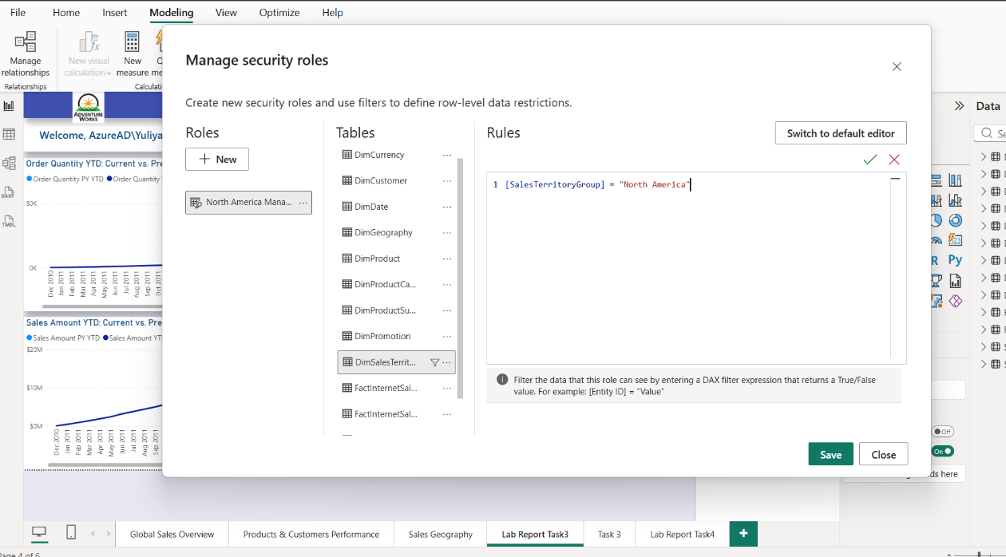

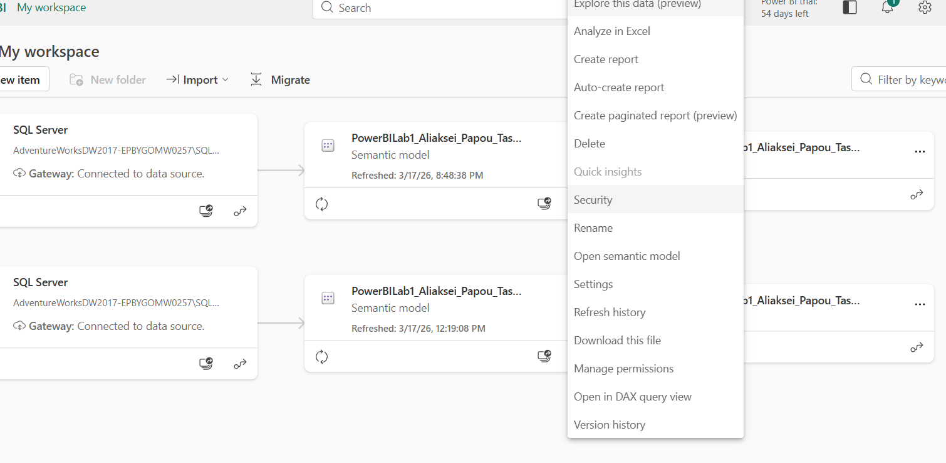

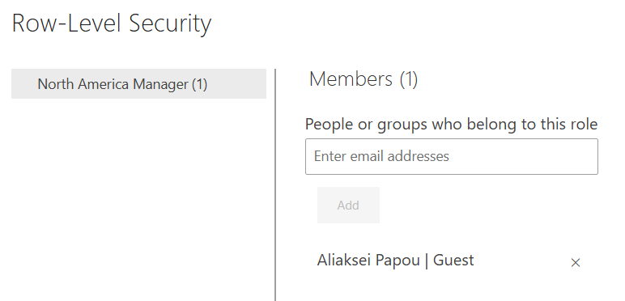

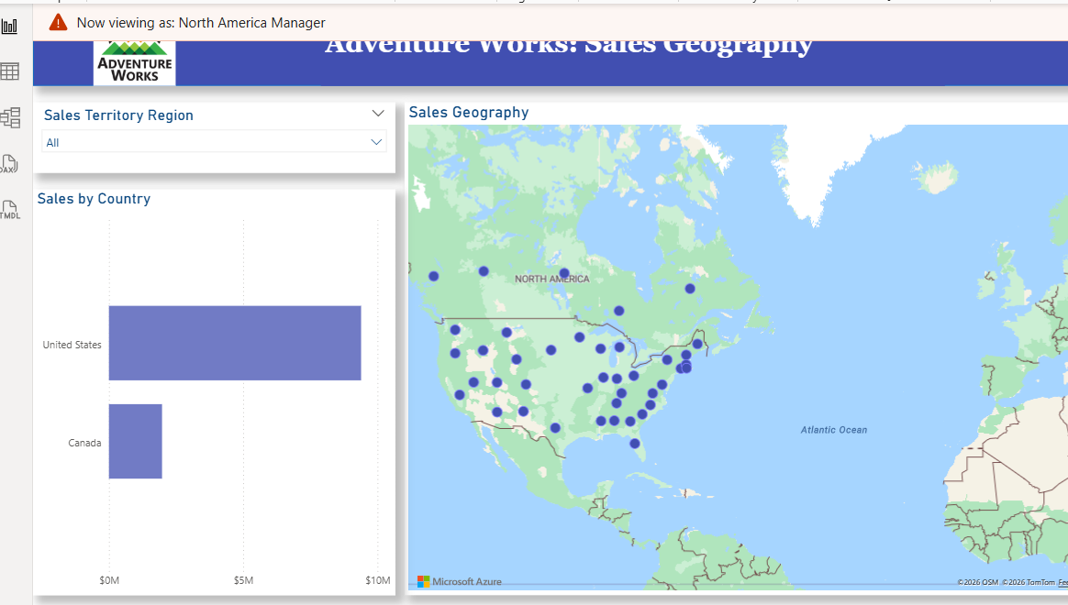
View as: North America Manager
I know that for a real project, it's better to use dynamic RLS (via USERPRINCIPALNAME()) instead of creating ten or more static roles. This simplifies scalability and support, especially if the business has many regions, departments, and managers. It also helps prevent errors and improves security.

- SWITCHING BETWEEN BAR CHART AND MAP (BOOKMARKS & BUTTONS)
Description:
To optimize report real estate, I implemented Bookmarks and Buttons to allow users to switch between a Bar Chart and a Map Visual in the same area. By utilizing the Selection Pane to manage visual visibility and linking states to buttons via the Action property, I created a cleaner, more interactive user experience.
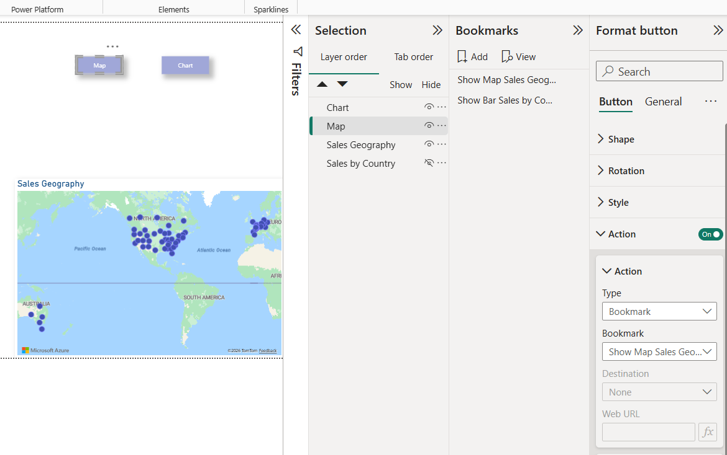

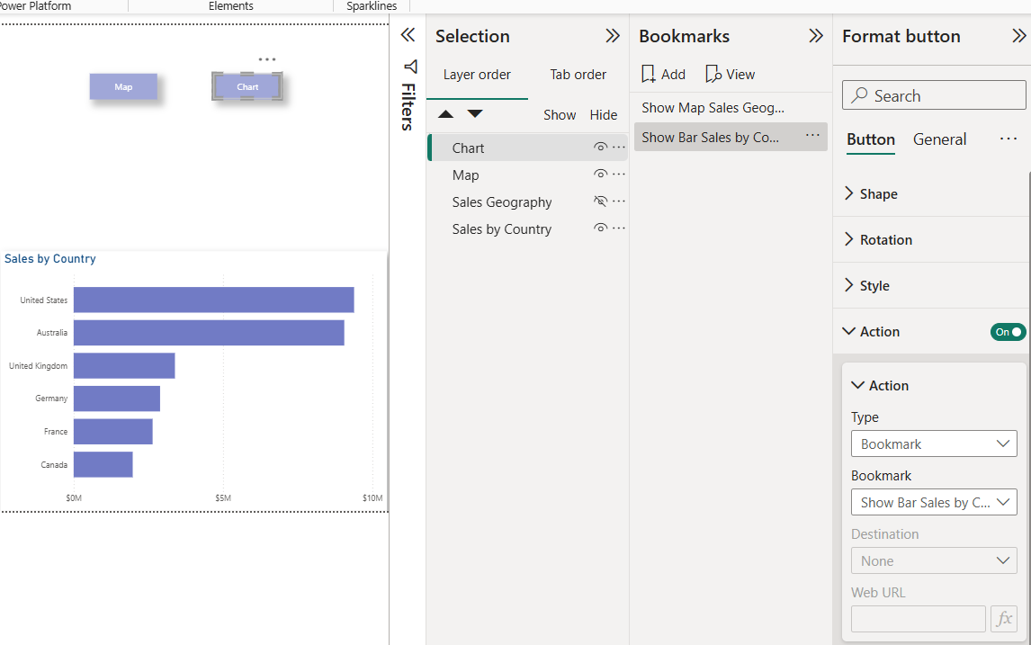

3. DYNAMIC TIME INTELLIGENCE SWITCHER (MTD/QTD/YTD)
Description:
I implemented a dynamic period toggle using Field Parameters. This allows users to seamlessly switch between Month-to-Date (MTD), Quarter-to-Date (QTD), and Year-to-Date (YTD) views. This logic was chosen for its performance and native support for dynamic axis labeling.

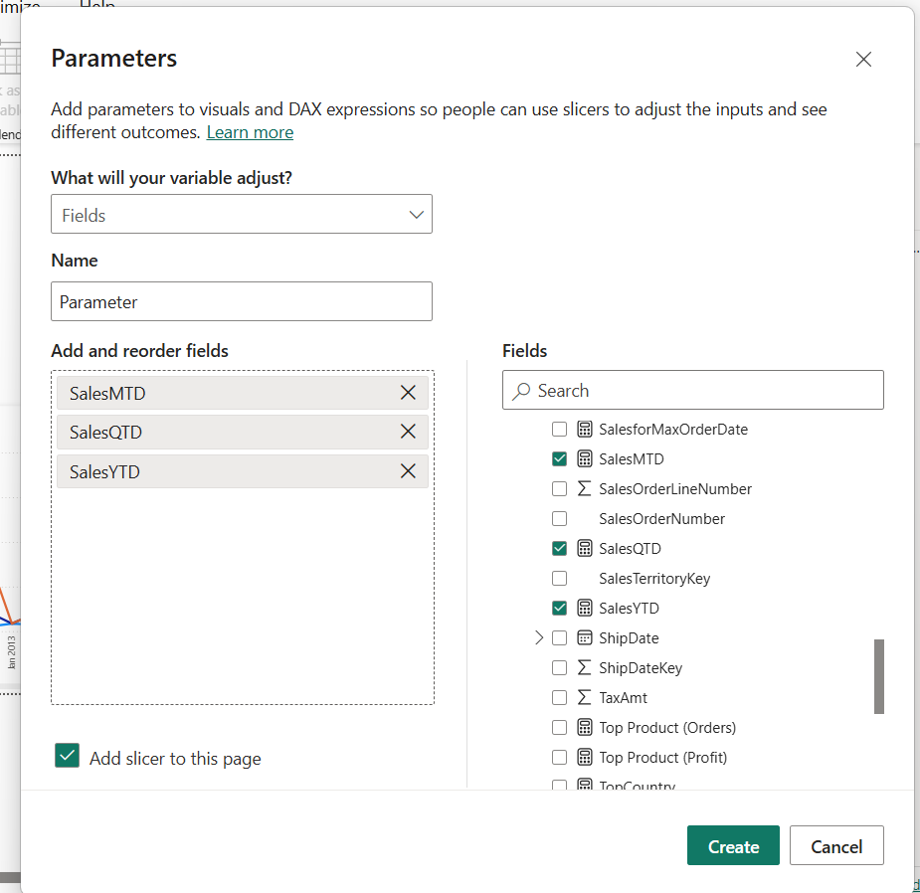

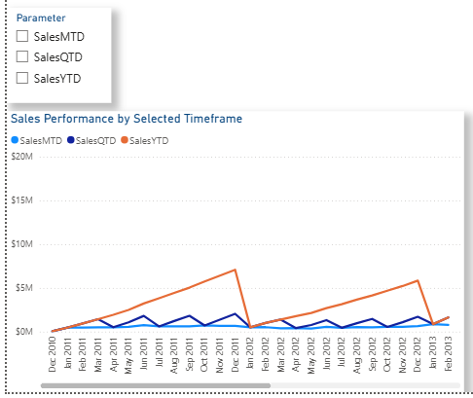

4, 5. DECOMPOSITION TREE & TOOLTIPS
Description:
I integrated a Decomposition Tree visual to allow for ad-hoc breakdown of Sales by Category, Color, and Gender. This enables users to perform an "Explain By" analysis to find underlying trends. Additionally, I created a Custom Tooltip page that provides secondary insights (Profit and Subcategory split) when hovering over main visuals, reducing the need for drill-through actions.
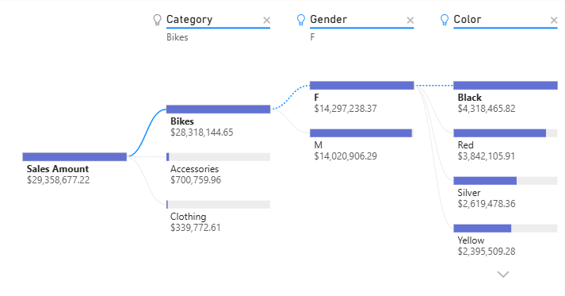
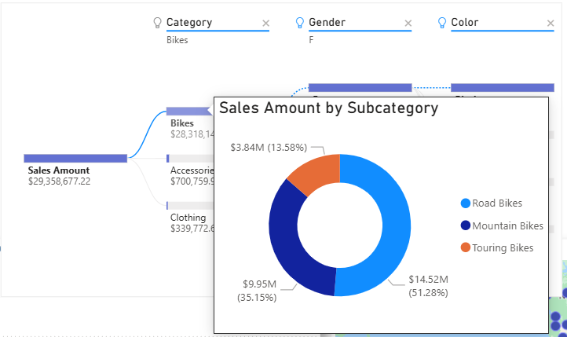

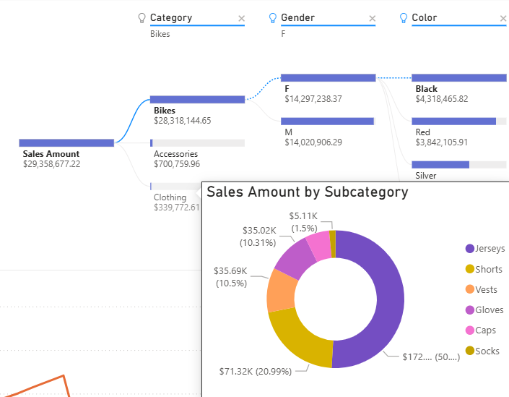

6*. CUSTOM VISUAL
Description:
I tried various custom visuals, but decided to use the "HTML Content" visual for creating my own visualizations. I believe the visual component of a report is crucial for business. To make the report more beautiful and stylized, I created DAX measures that generate dynamic HTML5 and CSS3 code. By embedding styles directly into measures, I can display data-driven elements not natively supported by the standard Power BI engine. I tried to enhance the color style I had previously chosen for my report. I added gradients, rounded corners, and text combinations within a single block. I created DAX measures for the report title, user welcome, buttons (map, chart, reset all filters), a card with a high-impact KPI (Sales Amount), and a category slicer. Using CSS, I can include visual elements such as custom progress bars or status icons, which are much more flexible than standard conditional statements. In my opinion, this improves the attractiveness and readability of the report.

 | 

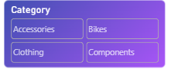 | 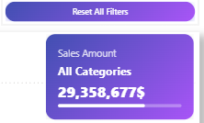

All Report view:
