Description of homework
  - CREATING CALCULATED COLUMNS
Description:
I switched to Data View and created a new calculated column in the DimDate table named "Year Month Label" using the formula:
Year Month Label = FORMAT('DimDate'[FullDateAlternateKey], "MMM yyyy").
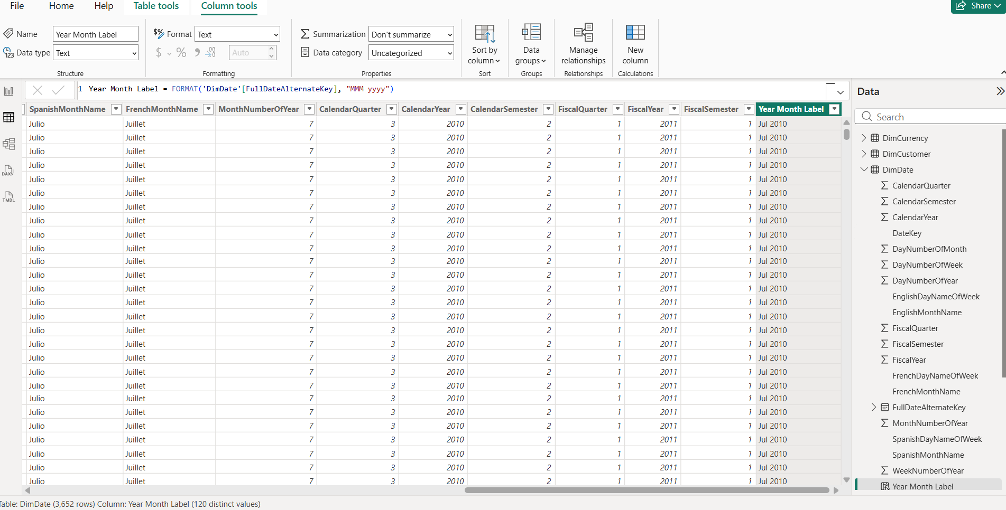

In the Report View, I added a new page (Task 3) and created a Line Chart to display sales by date. Instead of using the default date hierarchy, I used the "Year Month Label" for the X-axis to provide a cleaner monthly view. To focus on recent data, I applied a visual-level filter on the Calendar Year field, restricting the display to years from 2013 onwards.
To resolve the issue of months appearing in alphabetical order, I created a numeric helper column YearMonthSort (using CalendarYear * 100 + MonthNumberOfYear) and used the "Sort by Column" feature to ensure the X-axis follows a correct chronological sequence.

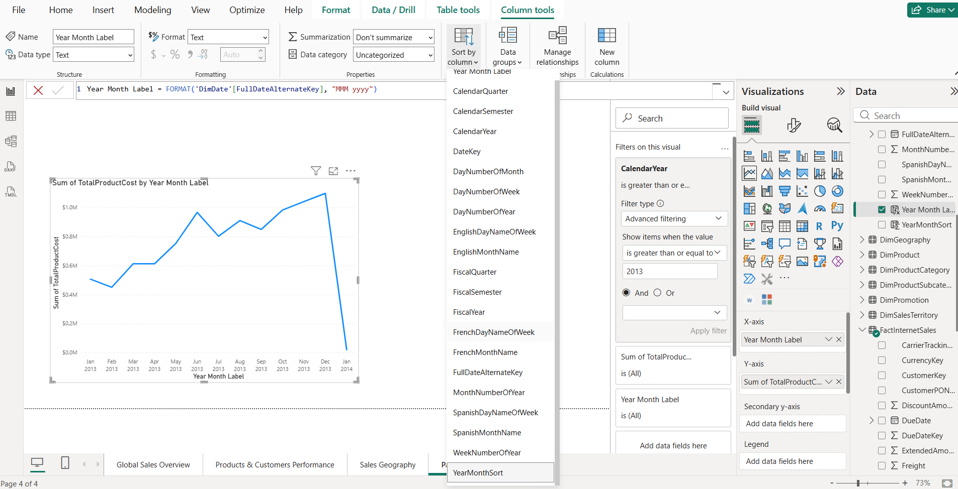

1.2. MEASURE
Description:
I implemented several DAX measures to enhance the analytical capabilities of the report. First, I created a "Today Date" measure using the TODAY() function, which I displayed in a Card visualization. I formatted this card to a Short Date style and positioned it in the bottom-right corner as a report footer.
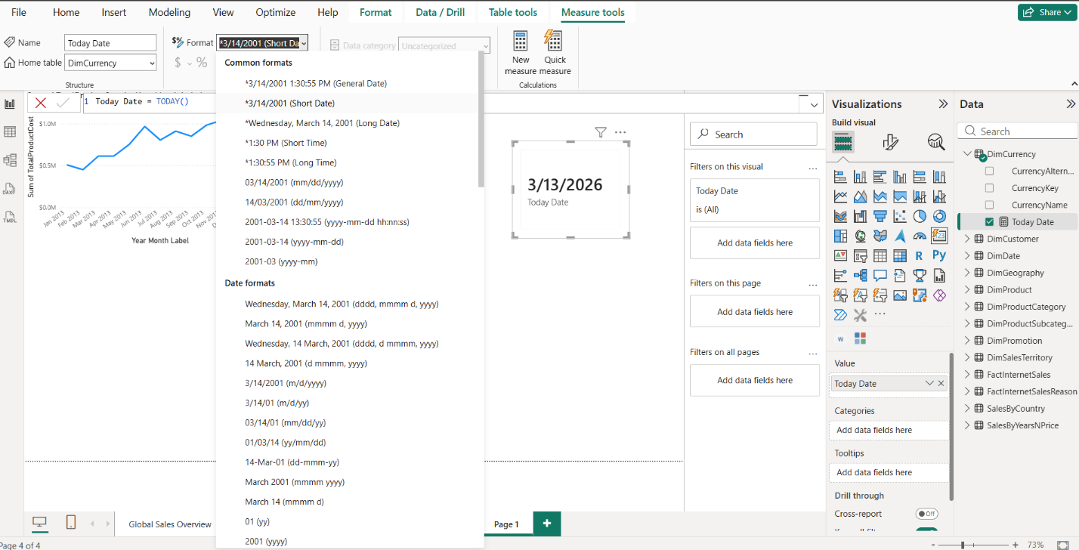

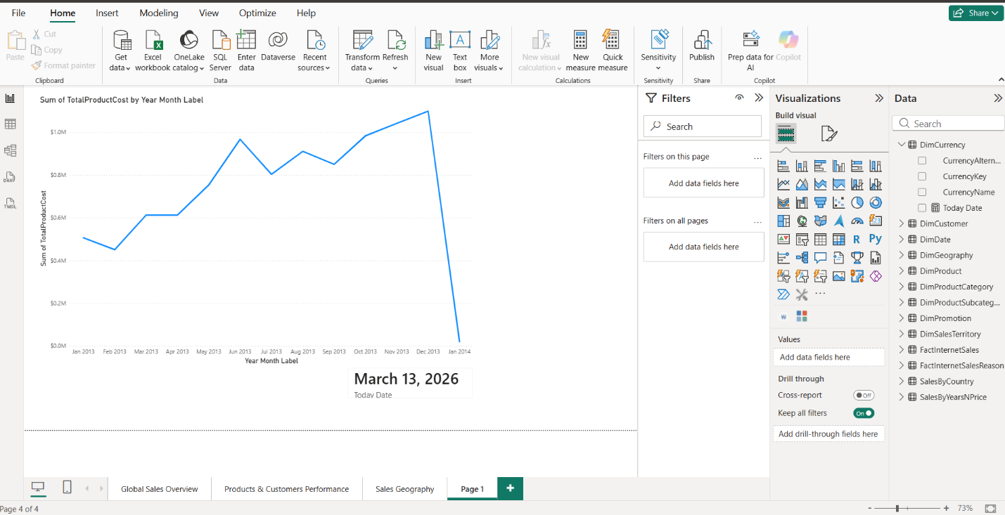

Next, I created the [Order Quantity] measure using:
SUM('FactInternetSales'[OrderQuantity]) to aggregate total units sold. To enable cumulative analysis, I created the [Order Quantity YTD] measure using the CALCULATE and DATESYTD functions:
Order Quantity YTD = CALCULATE([Order Quantity], DATESYTD('DimDate'[FullDateAlternateKey]))
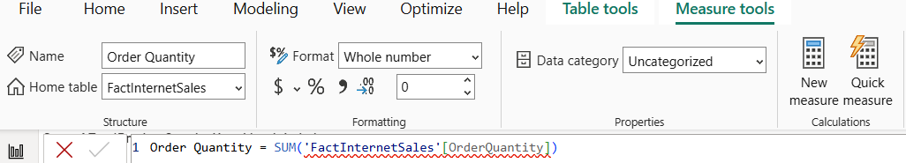
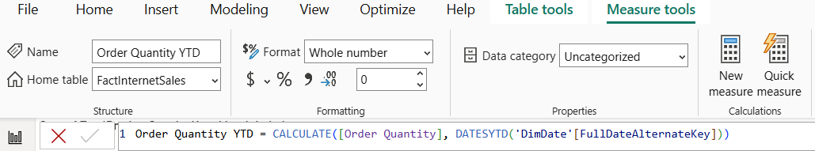

To validate these measures, I configured the DimDate table as a "Date Table" (Mark as Date Table) to ensure Time Intelligence functions operate correctly.
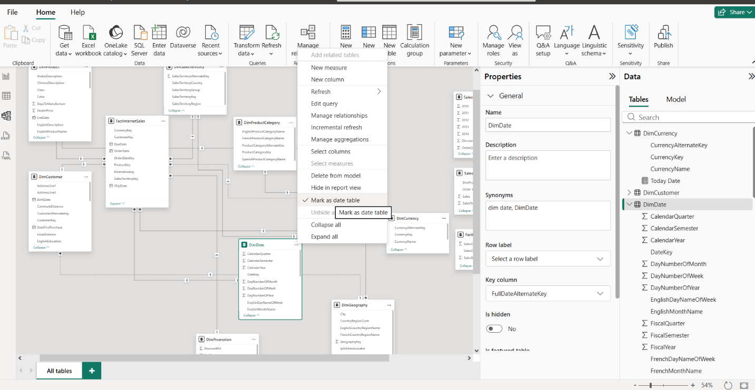

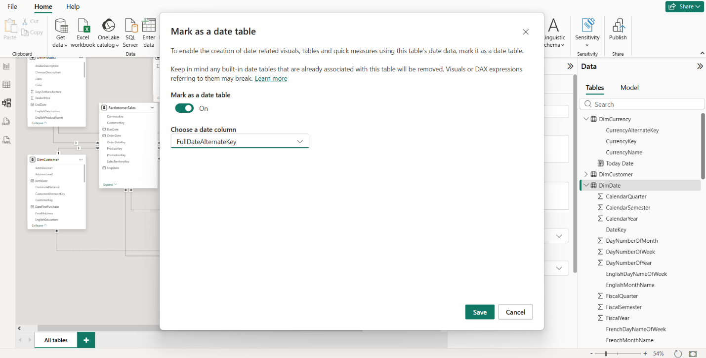

Then I created a Table visualization containing the date, daily order quantity, and YTD quantity. This successfully demonstrated the YTD logic, where the sum accumulates throughout the year and resets every January 1st.
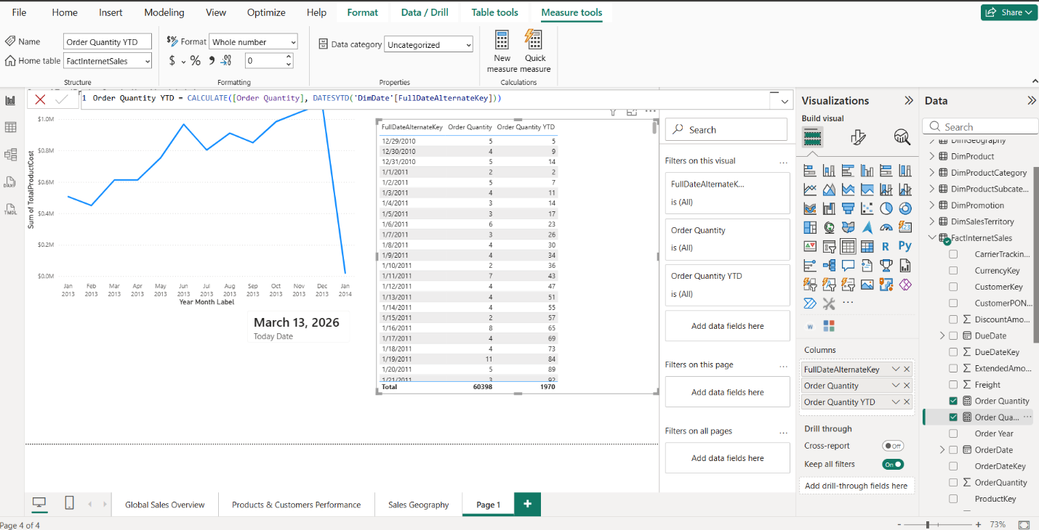

2. CREATE LAB REPORT
I added a new page (Lab Report Task 3)
1, 2. CREATING MEASURES AND TIME INTELLIGENCE
Description:
To analyze sales dynamics, I created several DAX measures. I calculated Order Quantity YTD using the TOTALYTD function to aggregate values from the start of the year. To enable period-over-period analysis, I created a Previous Year YTD measure using CALCULATE combined with SAMEPERIODLASTYEAR.
Order Quantity YTD = CALCULATE([Order Quantity], DATESYTD('DimDate'[FullDateAlternateKey]))
Order Quantity PY YTD = CALCULATE([Order Quantity YTD], SAMEPERIODLASTYEAR('DimDate'[FullDateAlternateKey]))
I repeated this process for Sales Amount to track financial performance. These measures allow for a direct comparison of current growth against the same timeframe in the prior year.
Sales Amount YTD = CALCULATE(SUM(FactInternetSales[SalesAmount]), DATESYTD('DimDate'[FullDateAlternateKey]))
Sales Amount PY YTD = CALCULATE([Sales Amount YTD], SAMEPERIODLASTYEAR('DimDate'[FullDateAlternateKey]))
VISUALIZING TRENDS
Description:
I added two Line Charts to the report page. The first chart displays Order Quantity YTD and Order Quantity YTD (PY), while the second shows the same for Sales Amount.
I chose Line Charts because they are the industry standard for displaying time-series data. They effectively highlight trends, seasonal patterns, and the "gap" between current and previous year performance, which is critical for identifying whether the business is over-performing or under-performing.
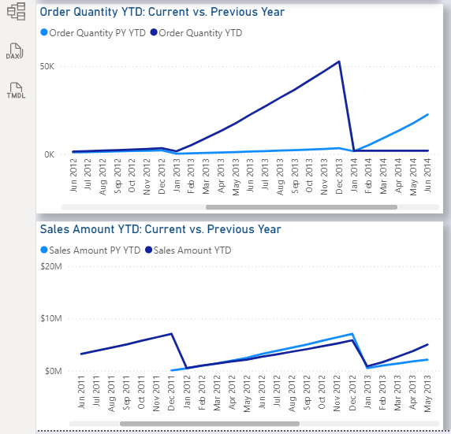

3. REPORT HEADER AND CURRENT DATE
Description:
I implemented a dynamic header using DAX measures and Card visuals. I used the USERNAME() function to create a "Welcome" greeting and the FORMAT(TODAY()) function to display the current date. This ensures the report feels personalized.
WelcomeMessage = "Welcome, " & USERNAME()
CurrentDateHeader = "Current Date is: " & FORMAT(TODAY(), "dd MMMM yyyy")
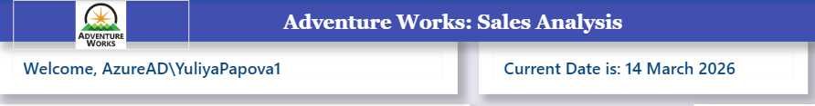
4. DETAILED PRODUCT ANALYSIS TABLE
Description:
I constructed a Table visual including Year-Month Label, Product Name, Color, and Order Quantity. To provide deeper insights, I created a DAX measure to calculate the % of Total Order Quantity by dividing the current selection by the total quantity using ALLSELECTED.
Percent = DIVIDE([Order Quantity], CALCULATE([Order Quantity], ALLSELECTED('FactInternetSales')))
Visualization Choice: A Table was chosen here because the requirement involves multiple high-cardinality dimensions (Name, Color, Month). Tables are superior for granular data lookups where exact figures and percentages must be cross-referenced line-by-line.
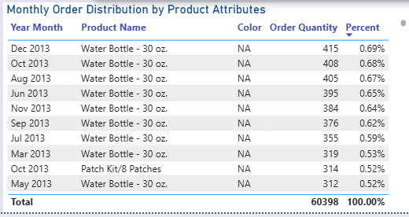
5. LATEST SALES AND MAX DATE
Description:
I created a measure to isolate Sales Amount for the maximum OrderDate available in the dataset using MAX and FILTER logic.
I also added a subtitle to the card that indicates the date. I think this will make it easier for users to understand which day the amount applies to.
SalesforMaxOrderDate = VAR LDate = MAX('FactInternetSales'[OrderDate]) RETURN CALCULATE(SUM(FactInternetSales[SalesAmount]), 'FactInternetSales'[OrderDate] = LDate)
Visualization Choice: I used a Card visual for this measure. Justification: Since the goal is to show a single "Latest Snapshot" value, a Card is focusing the user's attention on the most recent business outcome without the distraction of historical noise.
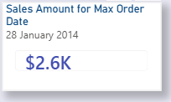

6, 7. GEOGRAPHICAL LEADERSHIP AND RANKING
Description:
I created a DAX measure using TOPN and MAXX to identify the country with the highest lifetime sales. Additionally, I implemented a Ranking measure using RANKX to sort Product Categories by their Sales Amount.
I also added a subtitle to the card that indicates the total sales for country. I think this will make it easier for users to understand what the corresponding sales amount is.
TopCountry = MAXX(TOPN(1, ALL('DimGeography'[EnglishCountryRegionName]), [Total Sales], DESC), 'DimGeography'[EnglishCountryRegionName])
ProductCategoryRank = RANKX(ALLSELECTED('DimProductCategory'[EnglishProductCategoryName]), [Total Sales])
Visualization Choice & Justification (Top Country): I used a Card visual to display the top country. Justification: This provides a definitive answer to a specific question ("Which country is #1?") more efficiently than a chart.
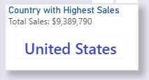

Visualization Choice & Justification (Ranking): I used a Table for the Ranking. Justification: Rankings are ordinal data. A table allows the user to see the exact rank (1, 2, 3...) alongside the category name, ensuring there is no ambiguity in the hierarchy, which can sometimes happen with bar charts if values are very close.
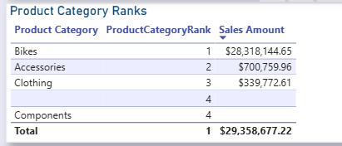

To provide flexible data analysis, I also created Date Filter: A "Between" style slider using DimDate[FullDateAlternateKey].
I also added a button to reset all filters.

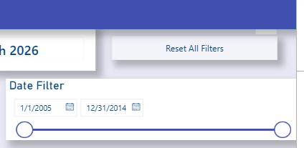

All Report view:
