Task 1. Figure out what security precautions are already used in your 'dvd_rental' database. Prepare description.

The analysis showed that security measures are basic and use the default configuration. Access to data is strictly limited to a single superuser (postgres).
1.Existing users/roles and their permissions:
"pg_database_owner"
"pg_read_all_data"
"pg_write_all_data"
"pg_monitor"
"pg_read_all_settings"
"pg_read_all_stats"
"pg_stat_scan_tables"
"pg_read_server_files"
"pg_write_server_files"
"pg_execute_server_program"
"pg_signal_backend"
"postgres"
Only the postgres role has access to the system.
SQL query used:
SELECT * FROM pg_roles;

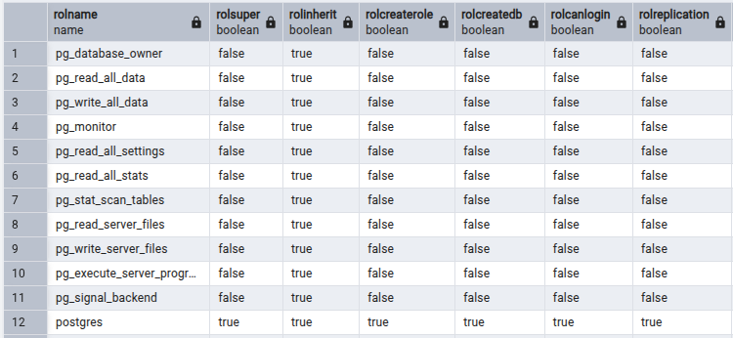

2.Table-level privileges:

All objects in the public schema belong to the postgres user.
Privileges were granted from postgres to postgres. This means that security is based on the principle of ownership: only the owner (postgres) can interact with the data.
SQL query used:
SELECT grantor, grantee, table_name, privilege_type
FROM information_schema.table_privileges
WHERE table_schema = 'public';
The results showed Postgres had exclusive control over all tables: actor, address, film, payment, rental, etc., with a full set of privileges.

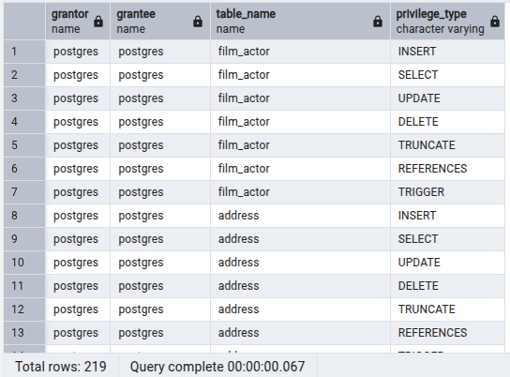

3. Any existing row-level security policies:

There are no active RLS policies in the database.
SQL queries used:
SELECT relname, relrowsecurity FROM pg_class WHERE relrowsecurity = true;
-- Result: Empty result set (0 rows).
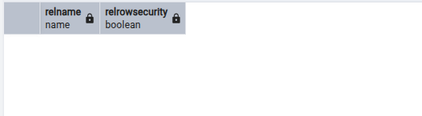

SELECT policyname, qual, with_check FROM pg_policies;
-- Result: Empty result set (0 rows).

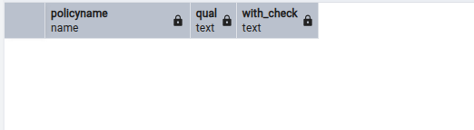

4. Database-level settings like connection limits or authentication methods:

There is a limit of 100 simultaneous connections.
SQL query used:
SHOW max_connections;
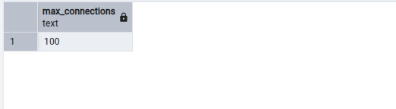

There are two main authentication methods:
1) scram-sha-256: the recommended and secure password authentication method in PostgreSQL.
2) peer: passwordless authentication used for local connections.
SQL query used:
SELECT * FROM pg_hba_file_rules;

