To implement the BL_3NF level loading process, I chose the Function + Procedure concept. You confirmed my intentions. As I already mentioned, the function is responsible for the logic: DISTINCT filtering, NULL handling (via COALESCE), UPPER, and the procedure is responsible for inserting into 3NF, error handling (EXCEPTION), and logging. In each function, I implemented return table types. All procedures (except CE_CUSTOMERS) implemented a FOR loop. (I also tried using a FOR loop for the CE_CUSTOMERS table, but due to the significant volume of records, I decided to use the bulk insertion method via INSERT ... SELECT). This reduced the loading time.
Repeatability is implemented through a WHERE NOT EXISTS check on business keys (SRC_ID + SOURCE_SYSTEM) within the procedure. Functions and procedures are created via CREATE OR REPLACE. I also added an Exception block to each procedure. Any error is logged to MTA_LOGGING with the 'ERROR' status.
I've now added the "Default Row" insertion to the beginning of each procedure. I think it would be better to move the insertion of all default rows into a separate procedure that would be executed once before the entire ETL process starts. Perhaps you could give me some advice.

Test results:
First run: All tables were successfully populated. Logs confirm insertion of records (rows_affected > 0).
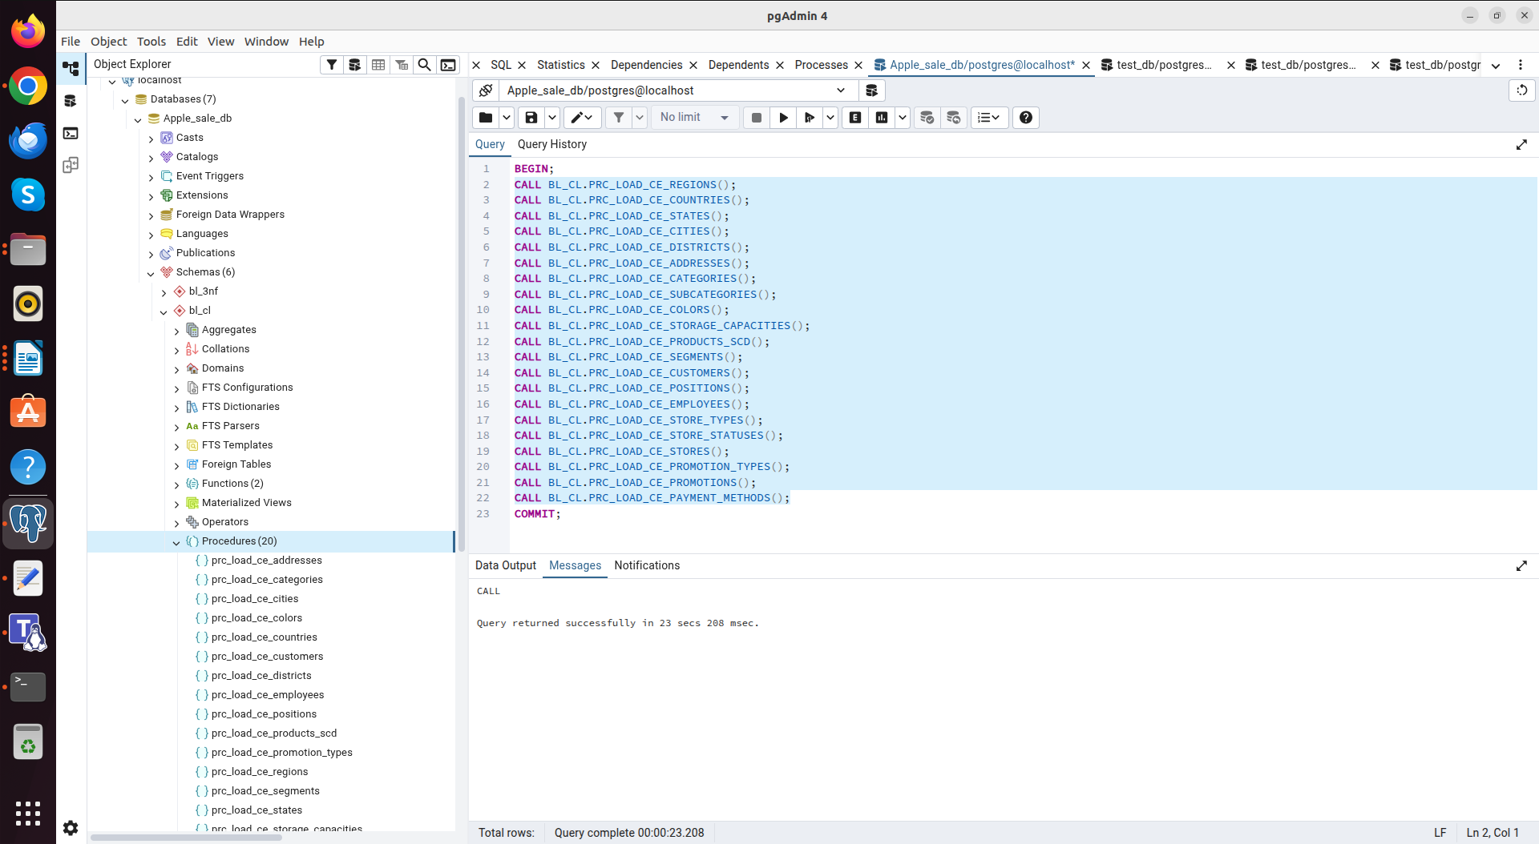

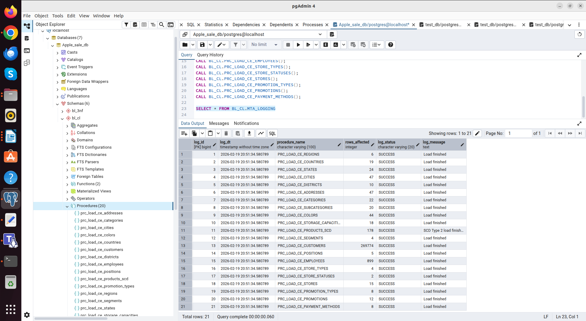

Second run: All procedures completed successfully, confirming the absence of duplicates (rows_affected = 0).

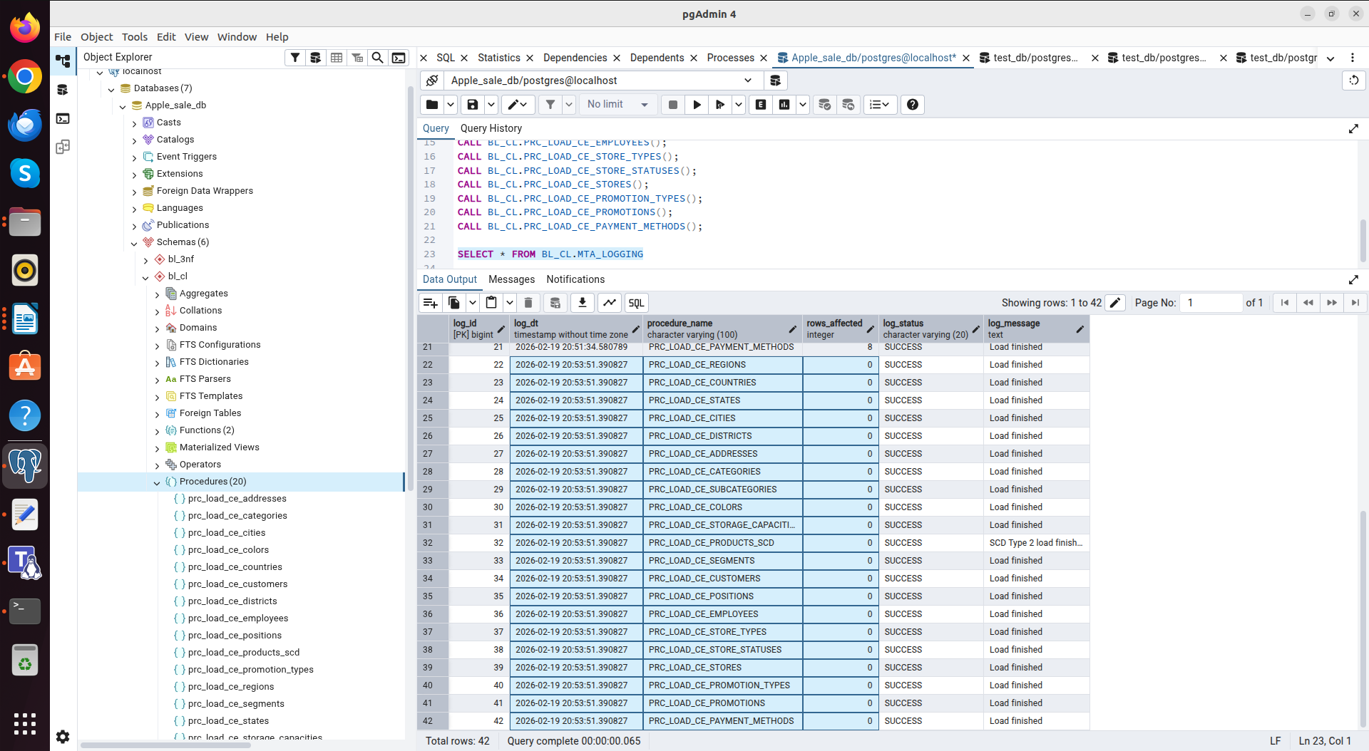

For example, the data loaded into the table BL_3NF.CE_STORES
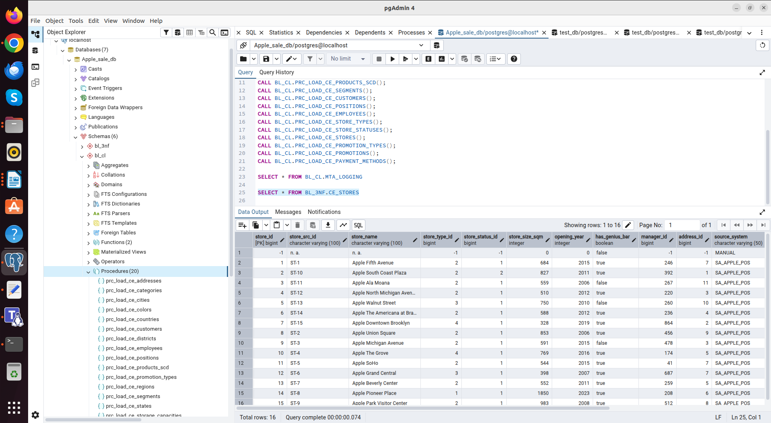

For convenience, I made a small query about the data of the first and second inserts
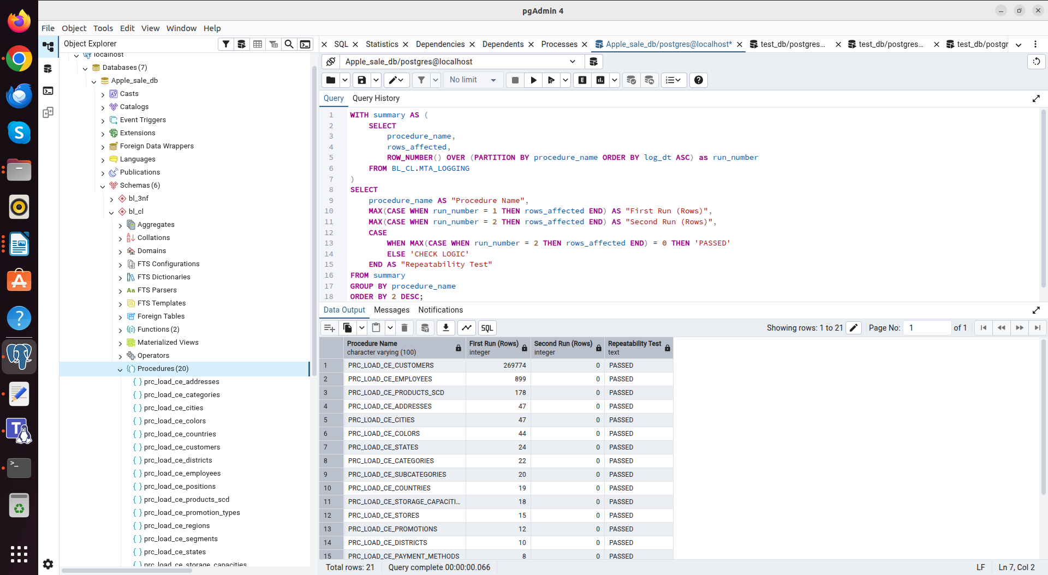

The SCD2 logic was successfully tested: when the product warranty period (iMac Pro warranty period was changed from 12 to 24) was changed in the CSV file, the procedure correctly identified the changes. The old version of the record was deactivated (closed with the end date), and a new version was created with the current data. The data was changed correctly on both storage layers.

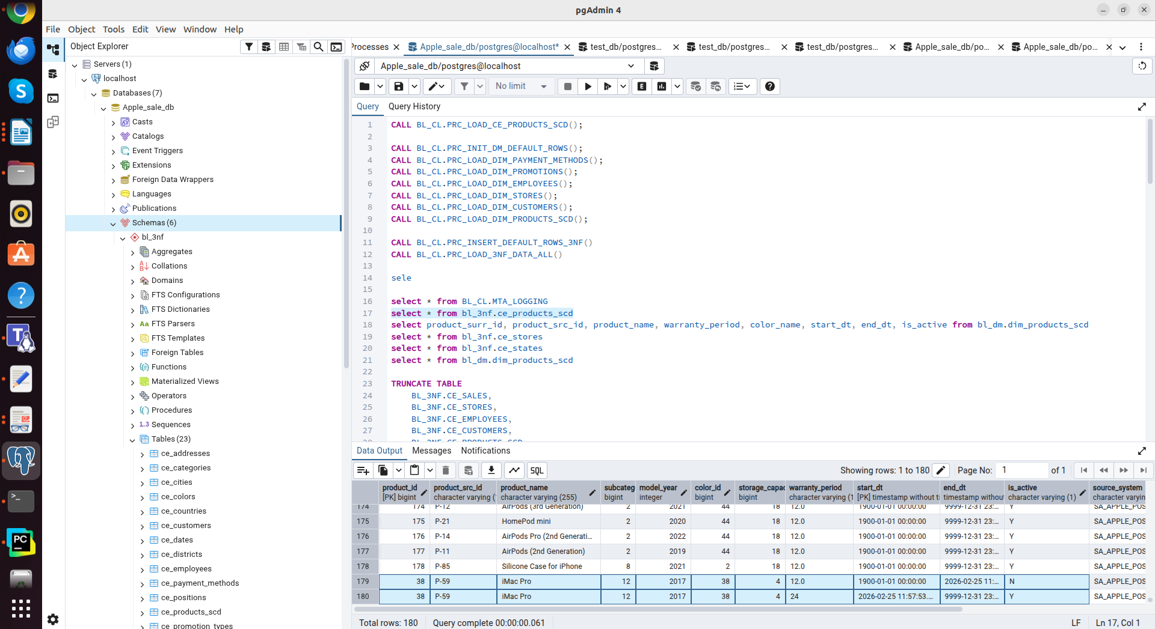
Changed warranty period from 12 to 24 (BL_3NF)

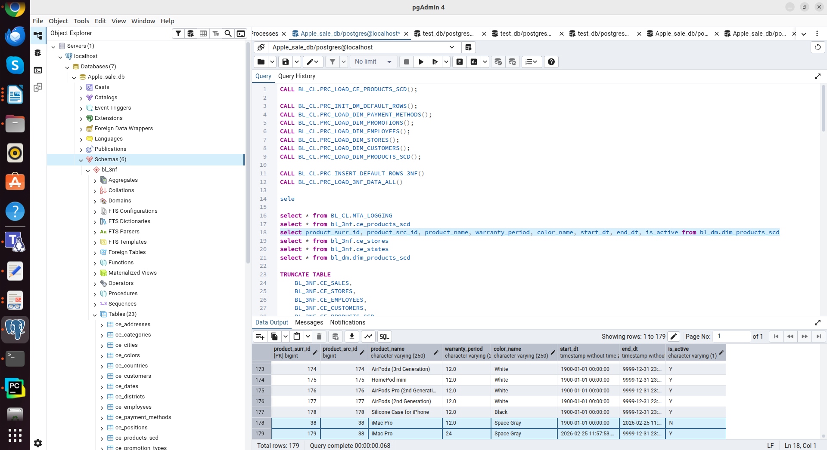
Changed warranty period from 12 to 24 (BL_DM)

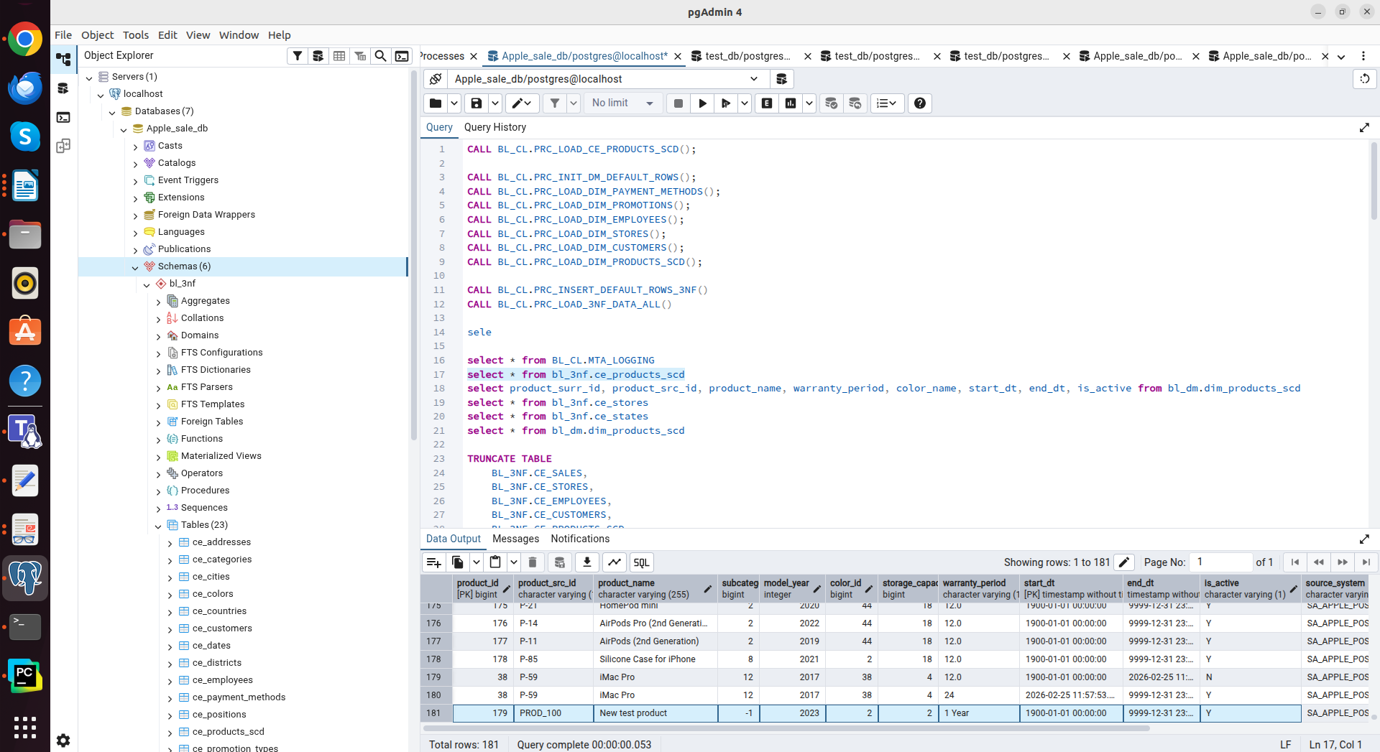
Add new product for test

