Description:
During Task 1, I compared the performance of a regular and unlogged table. The test_unlogged table demonstrated significantly higher insert speeds for a million rows. This is because PostgreSQL doesn't waste resources writing changes to the transaction log (WAL). However, such tables are unsafe: if the server crashes, the data in them will be lost.

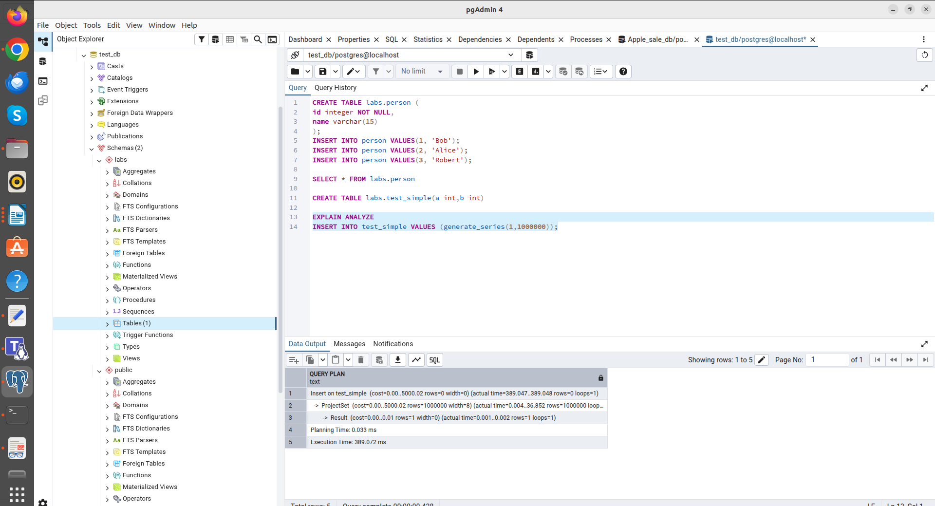
regular table

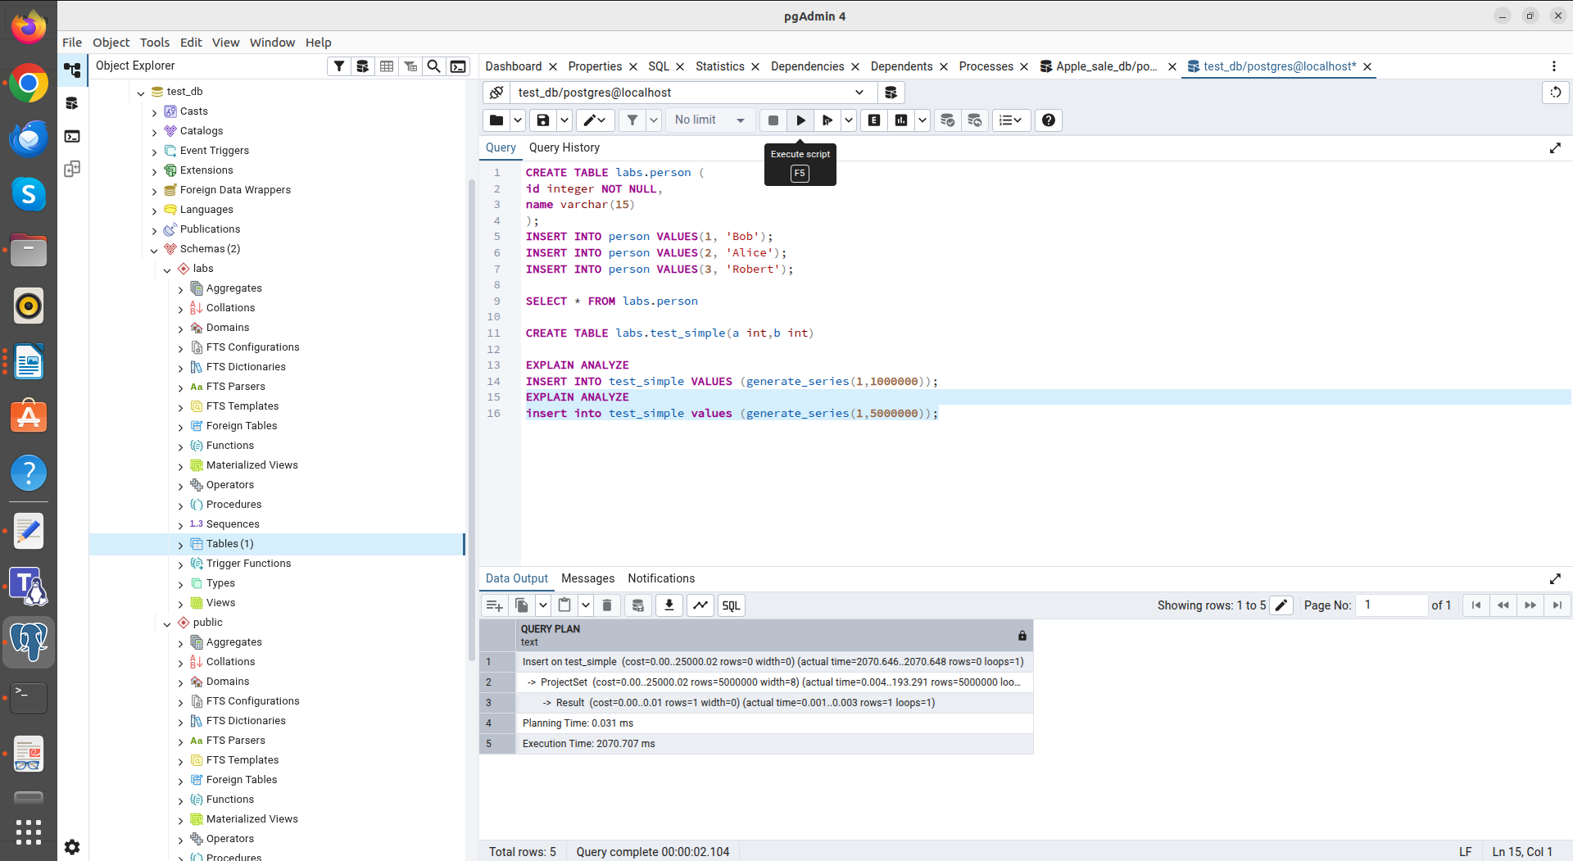
regular table

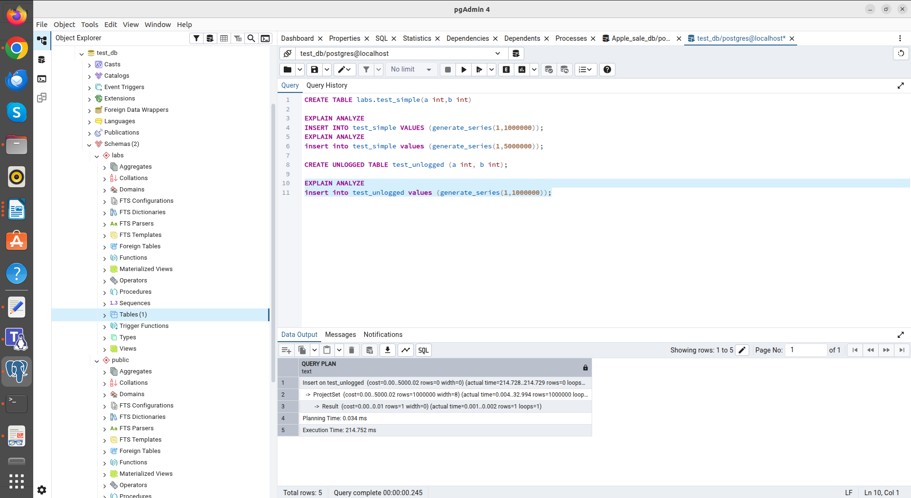
unlogged table

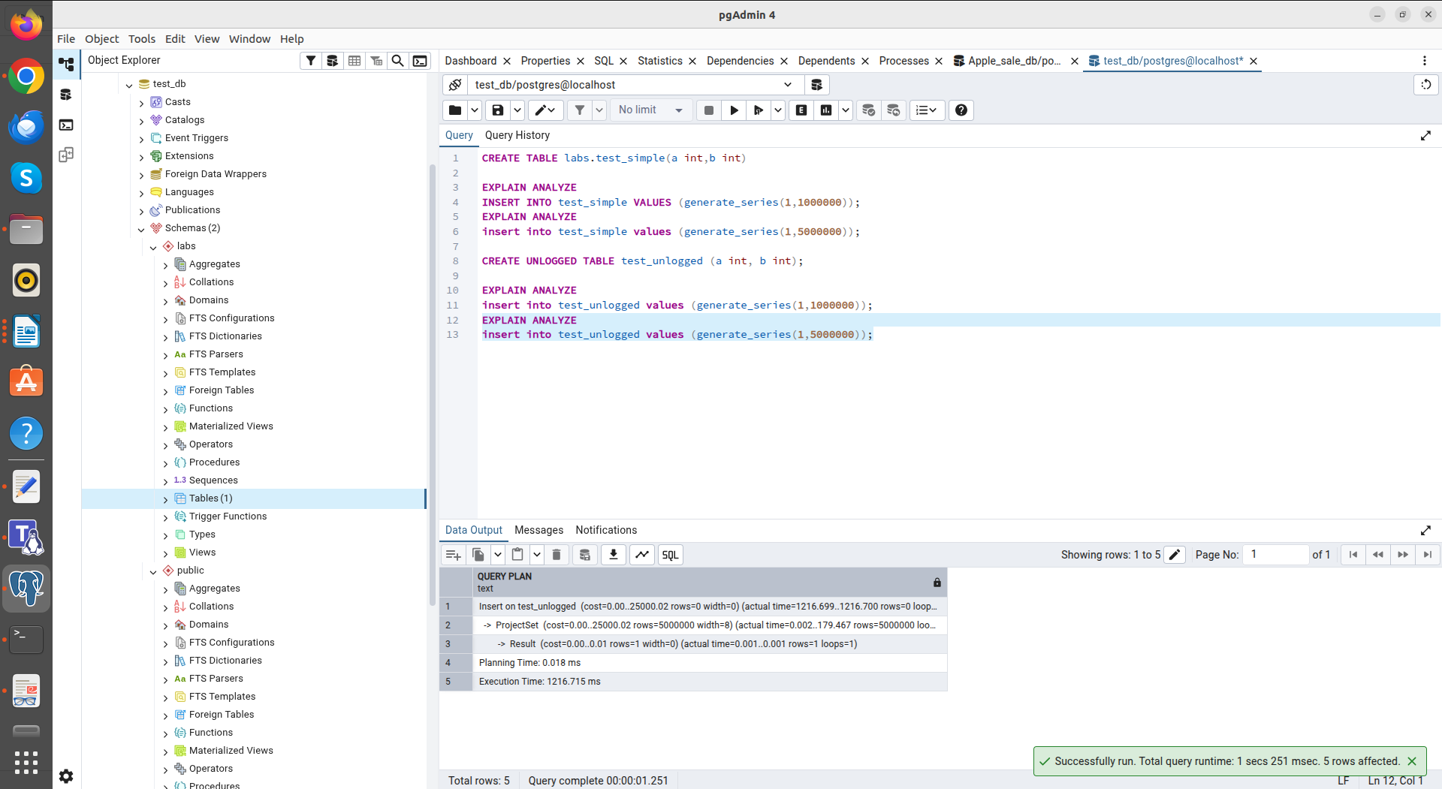
unlogged table

In Task 2, I used INHERITS, which meant the users table inherited all the columns from the person table. An important observation: a query on a parent table, by default, returns data from all of its descendants. To access only the parent's data, I used the ONLY keyword. UPDATE and DELETE commands also propagate up the inheritance tree unless ONLY is specified.
When adding a column to the parent table, it was automatically propagated to all child tables. However, using the NO INHERIT flag when creating the constraint allowed me to limit the rule checking to the base table without overloading the child table.
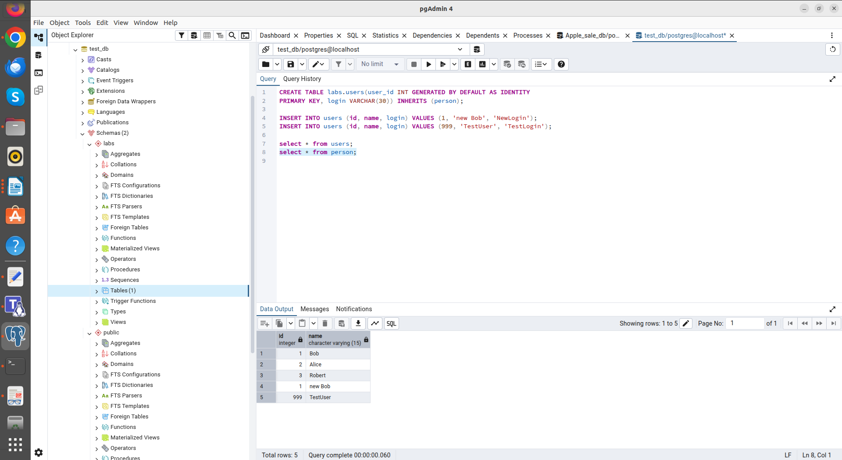

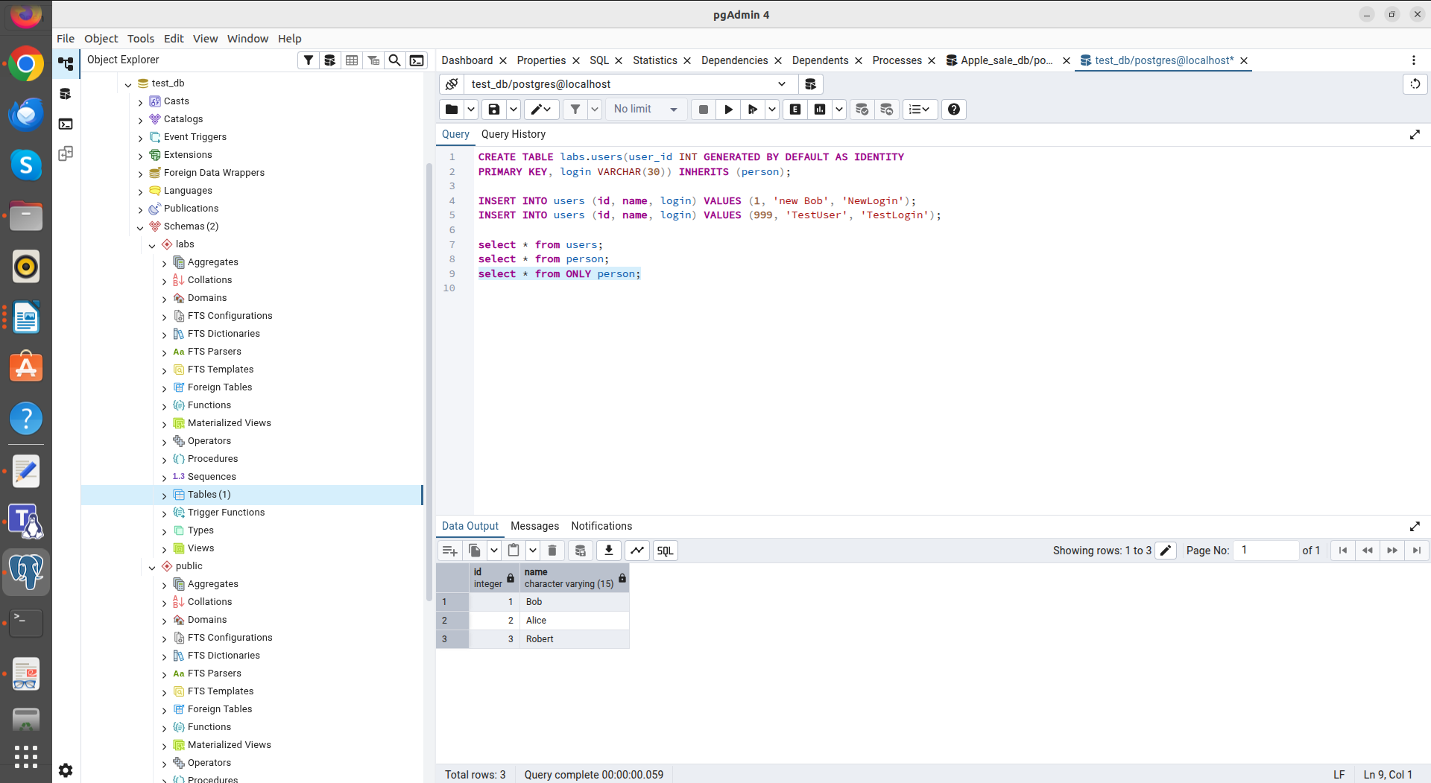
from ONLY person

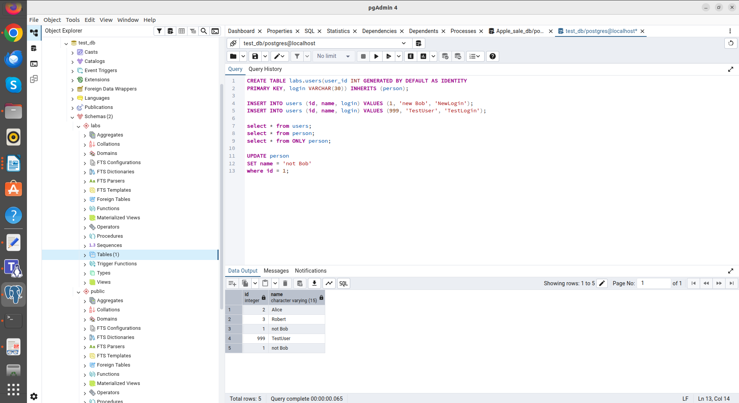
after update person

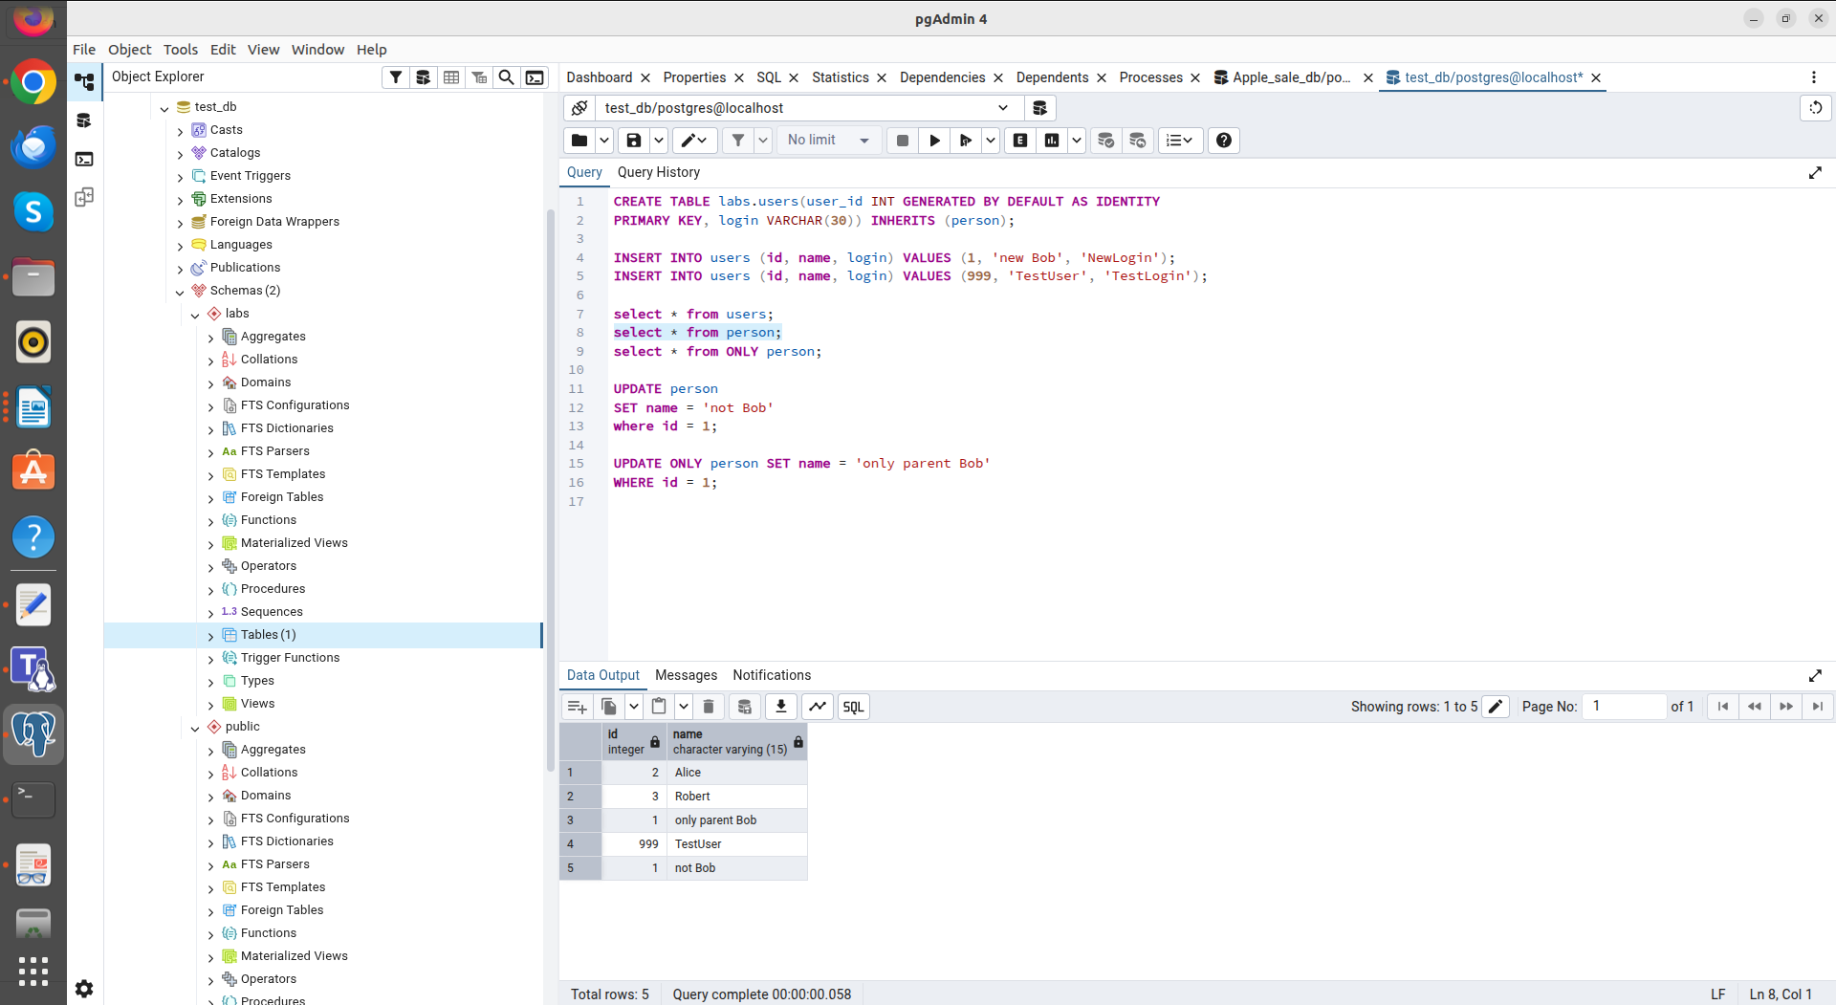
after update ONLY person

When adding a column to the parent table, it was automatically propagated to all child tables. However, using the NO INHERIT flag when creating the constraint allowed me to limit the rule checking to the base table without overloading the child table.
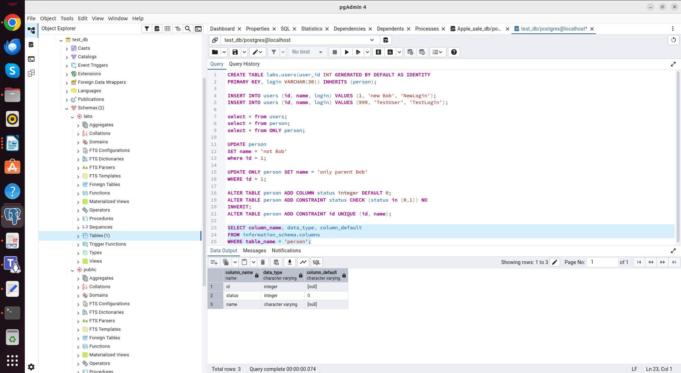
after ALTER tables

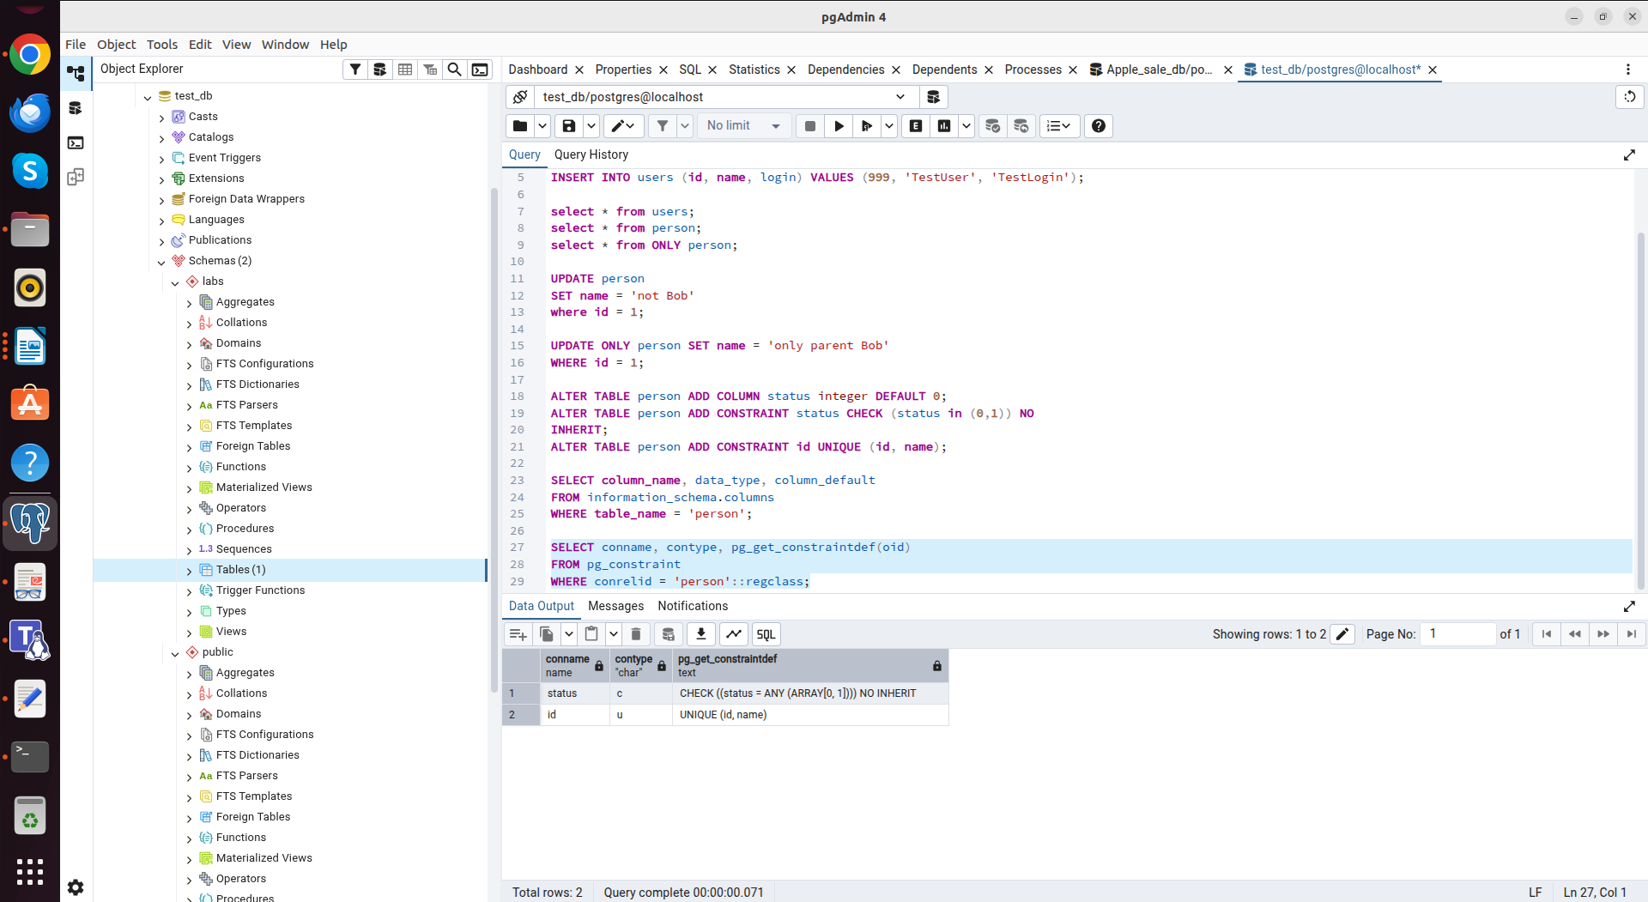

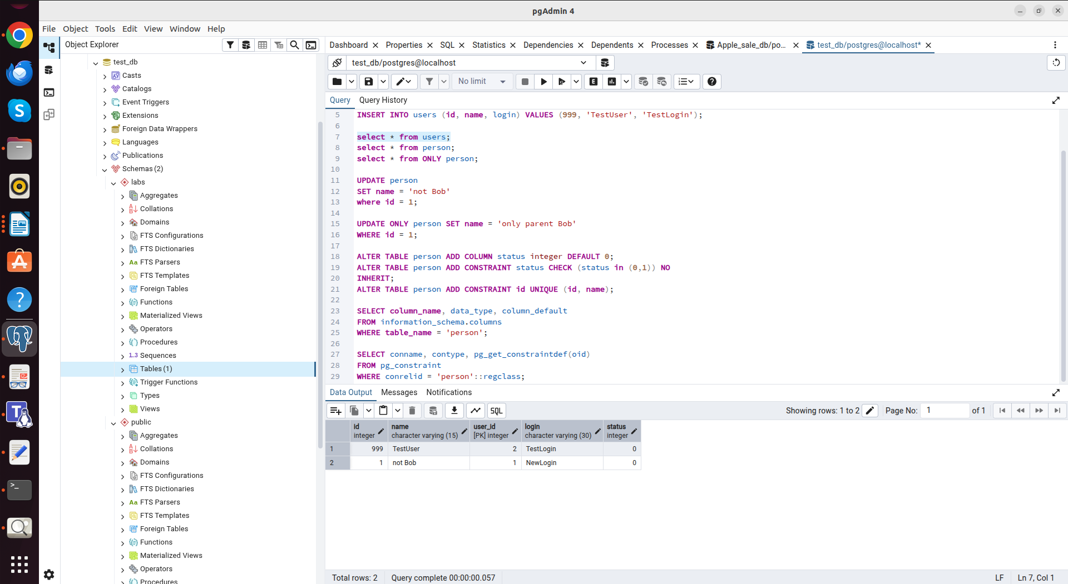

In Task 3, I analyzed the difference between a classic B-Tree index and a BRIN block index.
Without indexes: Searching by date range took a significant amount of time, as the server had to scan millions of rows (Sequential Scan). (Execution time: 419.083 ms)
B-Tree index: Query execution speed increased. However, the index took up a significant amount of disk space (comparable to half the size of the table itself), and its creation took 2 sec 745 msec. (Execution time: 190.372 ms) (Size: 338 MB)
BRIN index: This index type proved to be compact (it takes up hundreds of times less space than a B-Tree). Query execution speed increased. Its creation was almost instantaneous: 1 sec 174 msec. (Execution time: 98.446 ms) (Size: 40 KB)

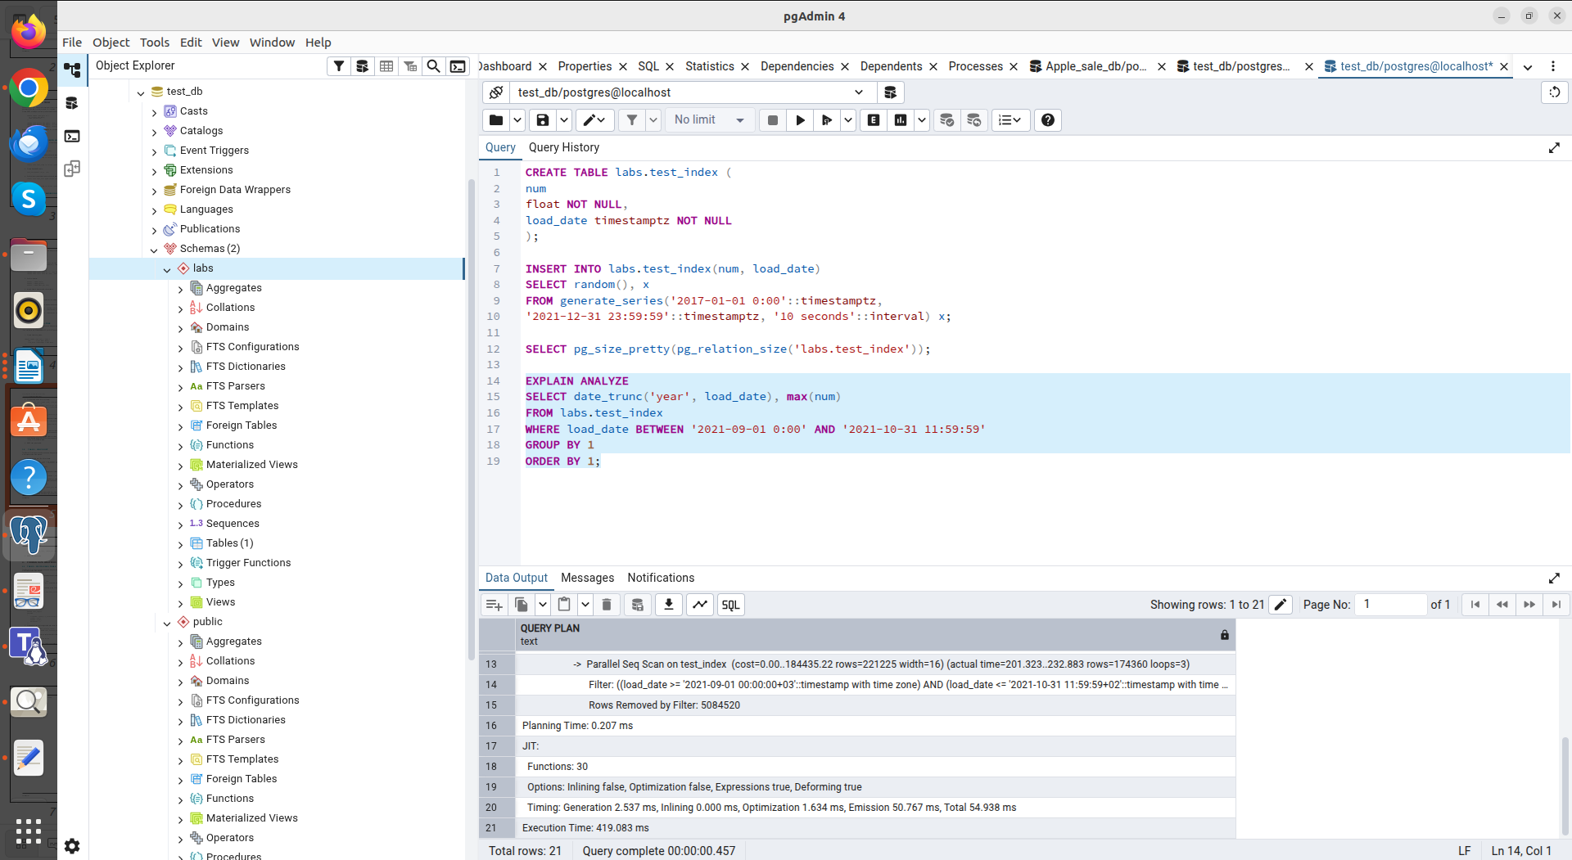
Without indexes

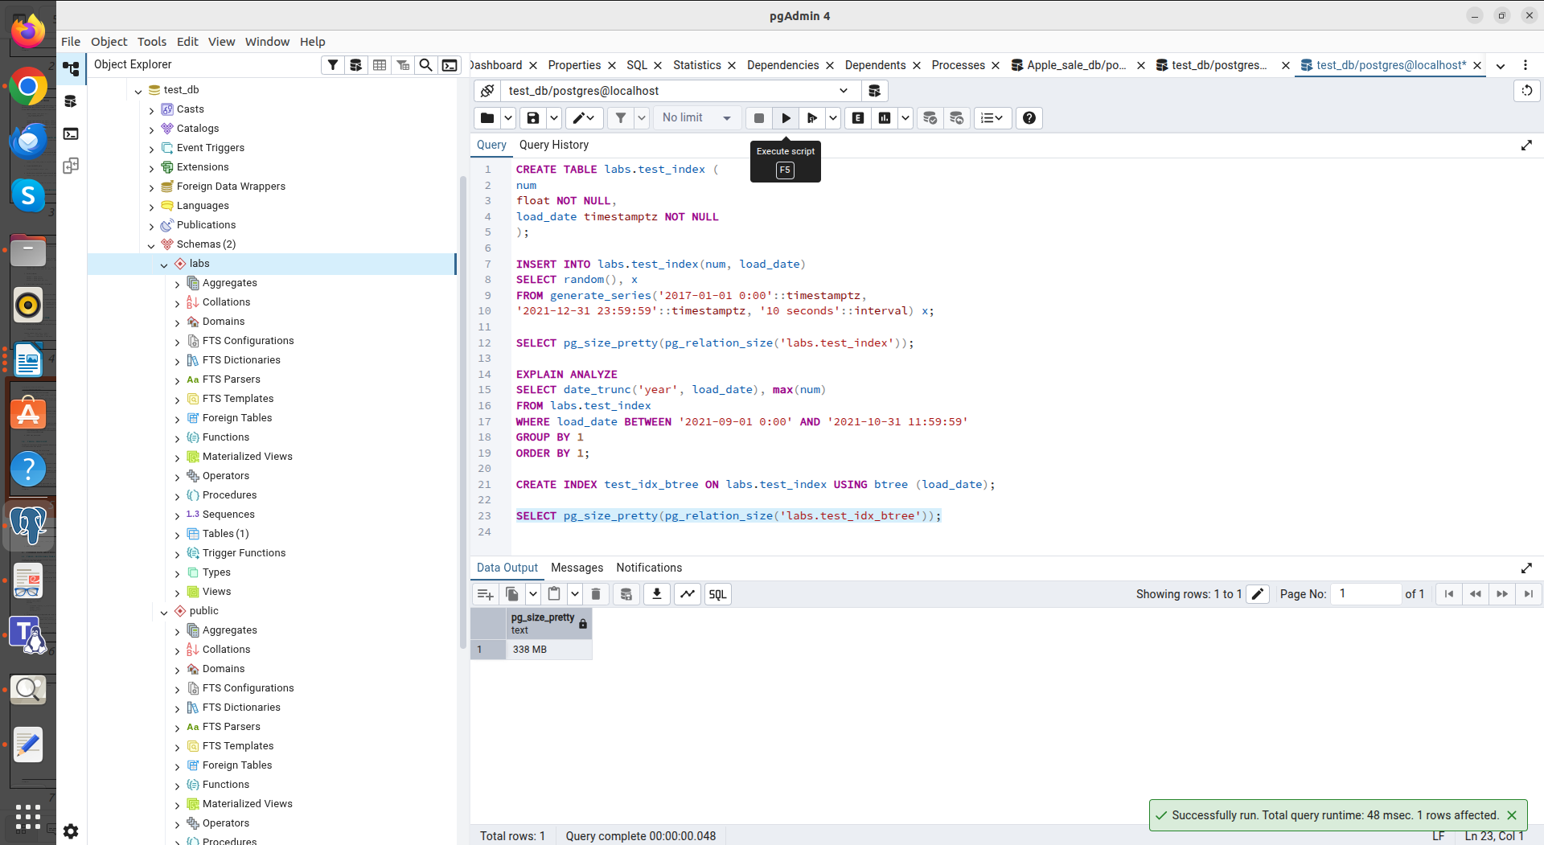

B-Tree (size)
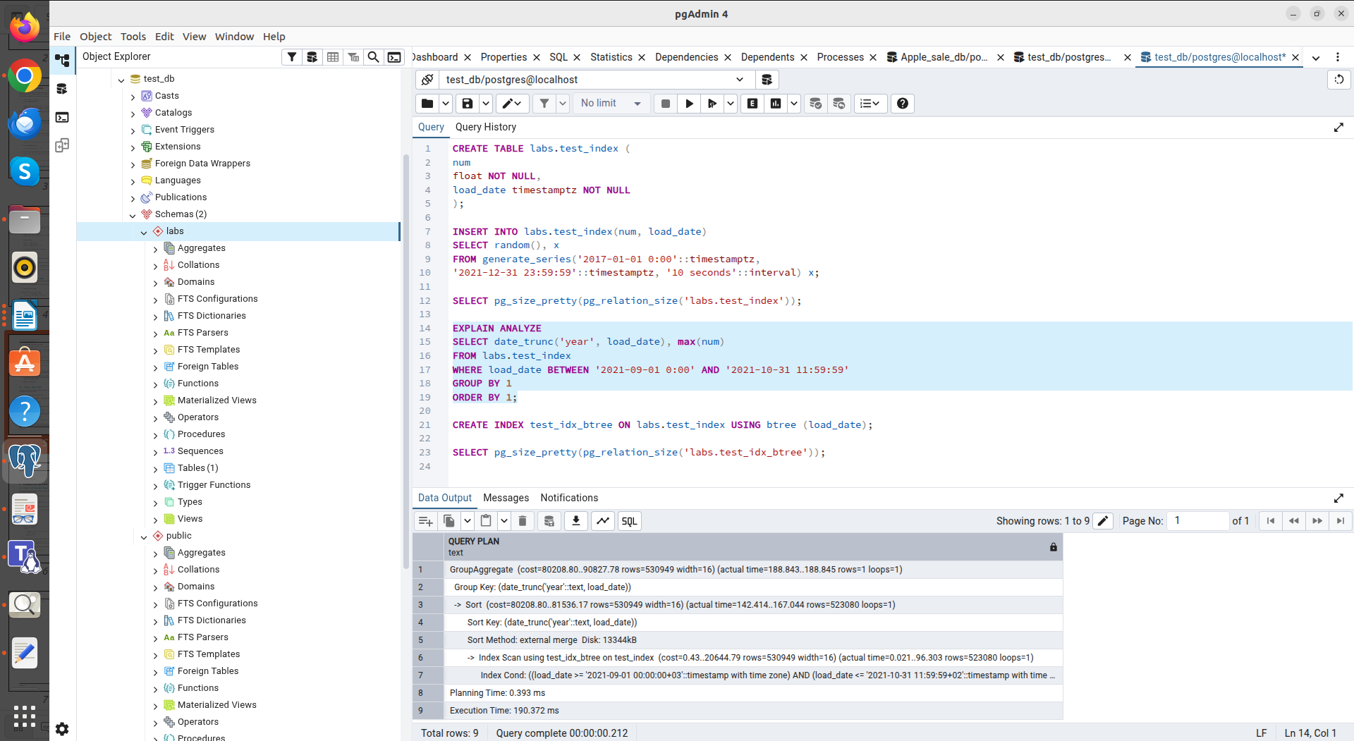
B-Tree (Execution time)

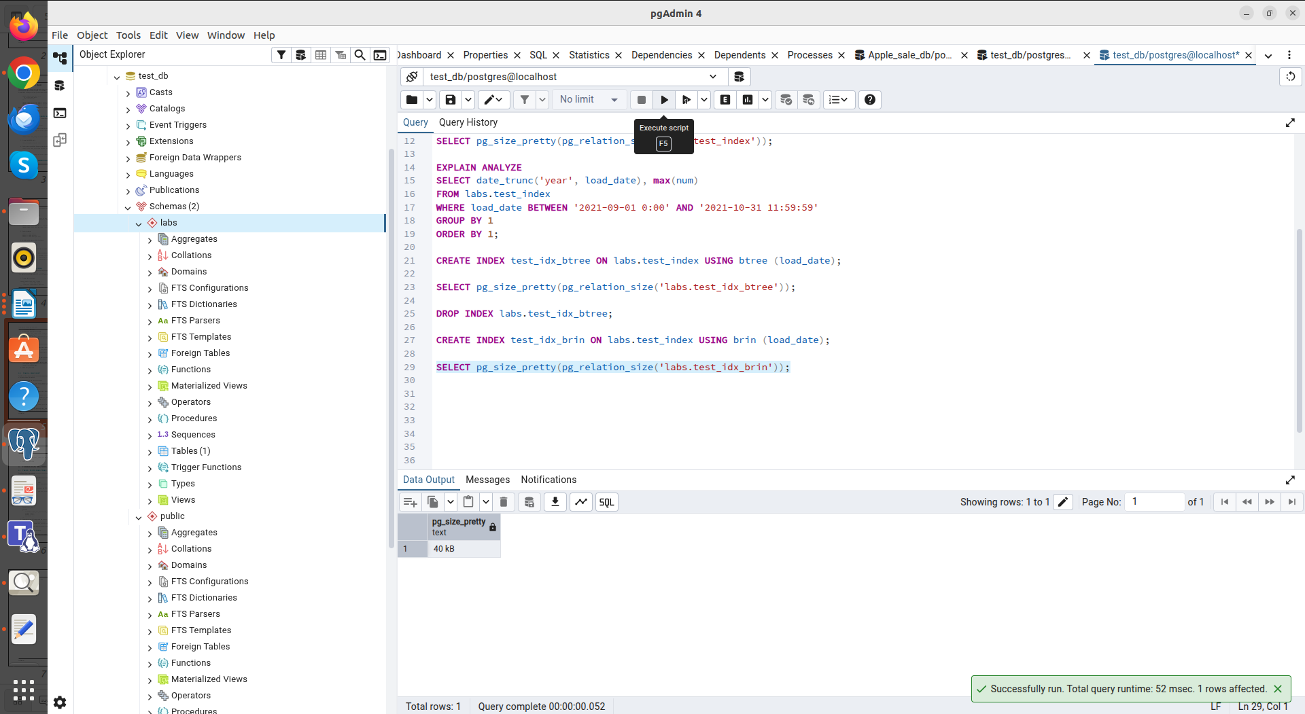
BRIN (size)

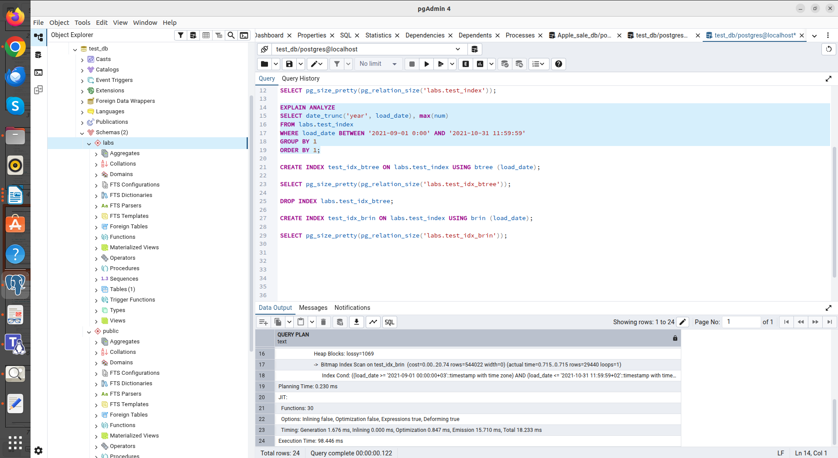
BRIN (Execution time)

In Task 4, I analyzed the difference between a GIN index and a GIST index.
Without indexes: Substring searches using LIKE '%...%' were slow. The system used Sequential Scan, iterating through all 10 million records. (Execution time: 371.909 ms)
GIST index: Proved to be average. It was created in 2 minutes 25 seconds and consumed 185,608,6016 bytes. However, the search speed has not improved much (Execution time: 338.523 ms).
GIN index: Demonstrated faster search speed (several times faster than GIST) (Execution time: 13.674 ms). It was created in 1 minute 8 seconds and consumed 64,302,2848 bytes.

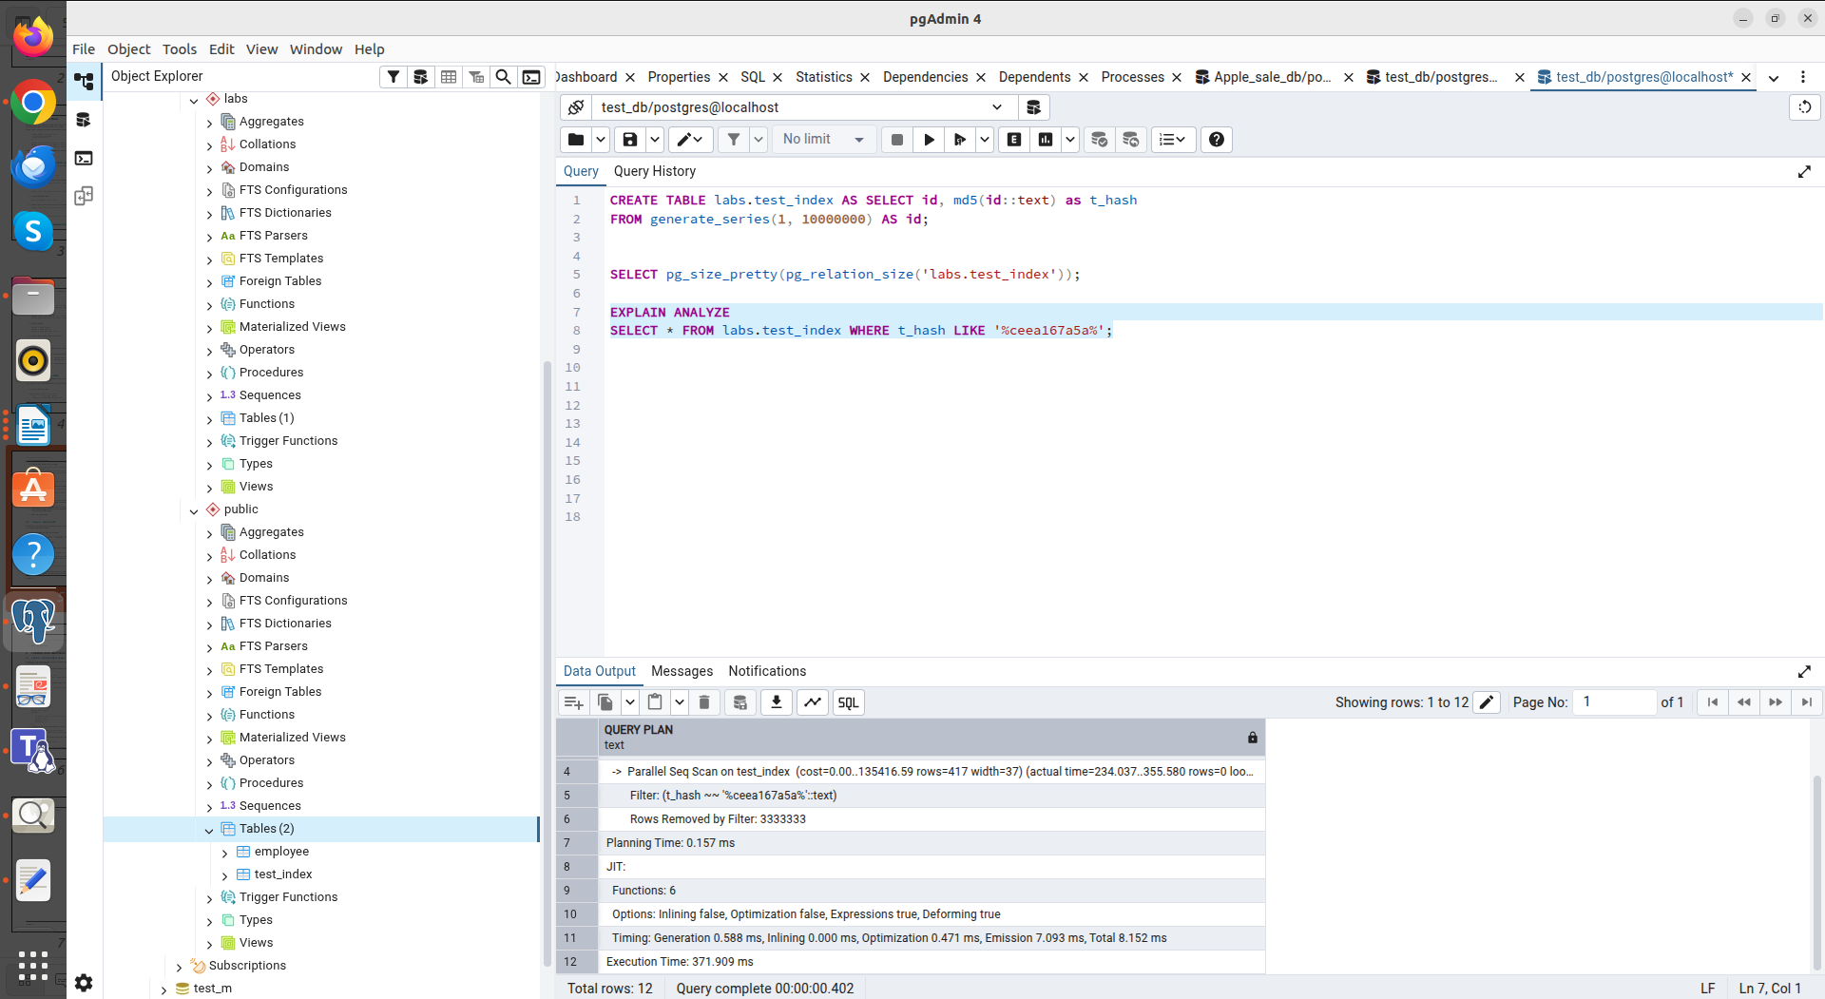
Without indexes

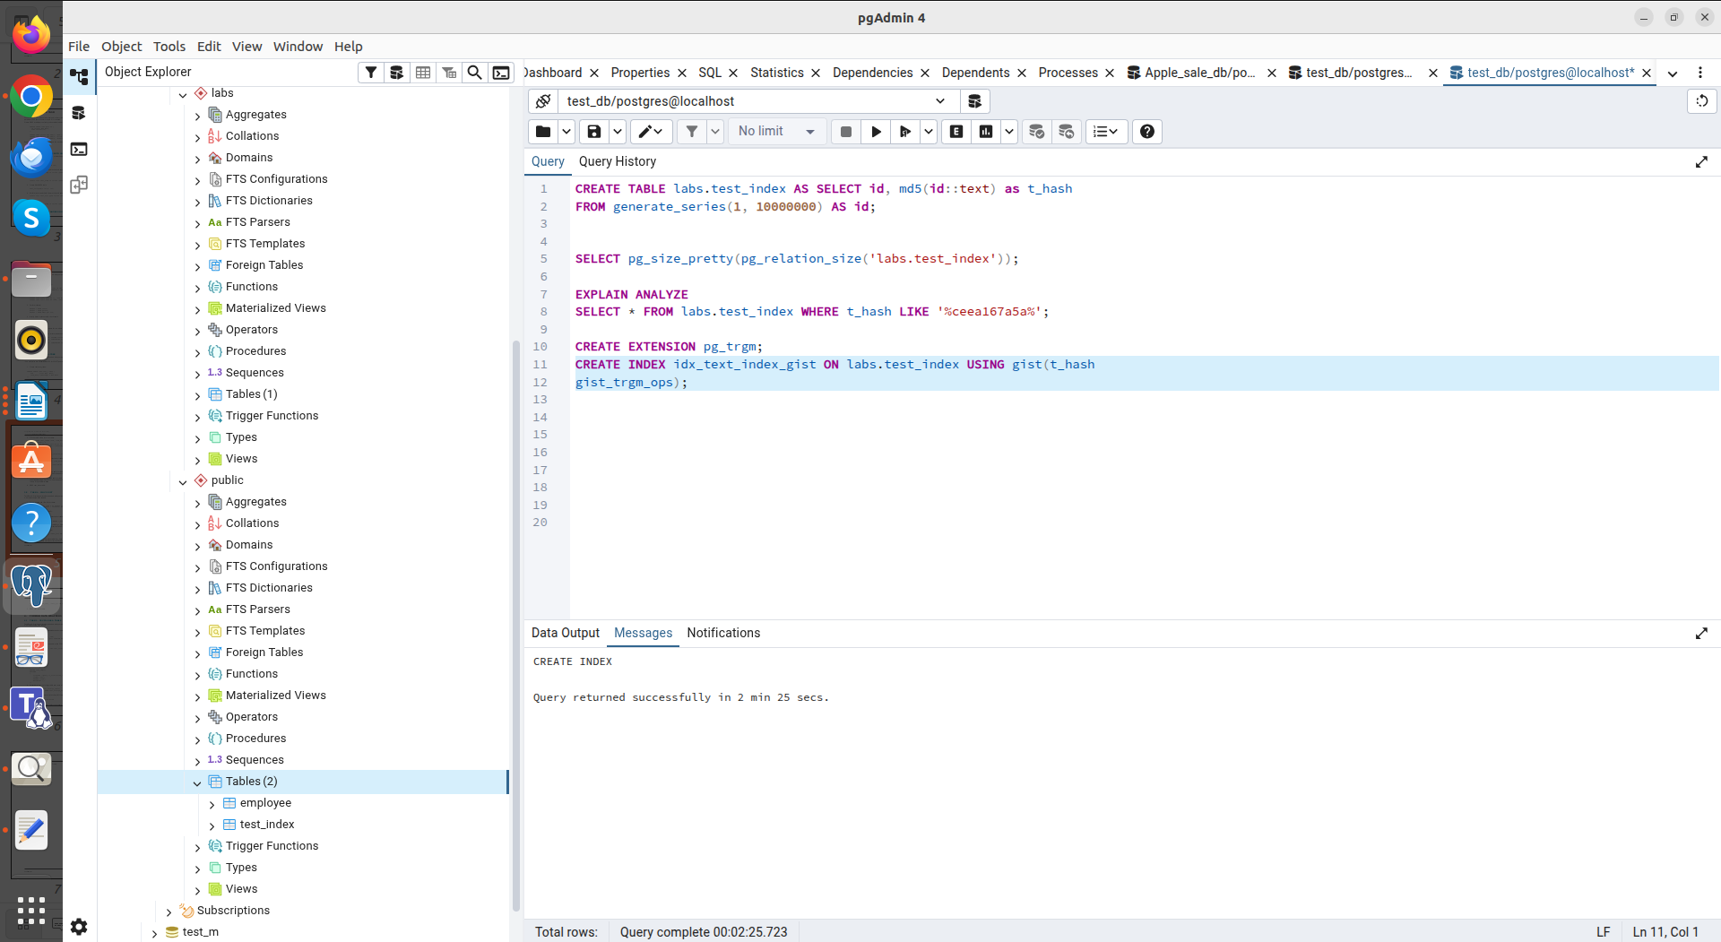
GIST

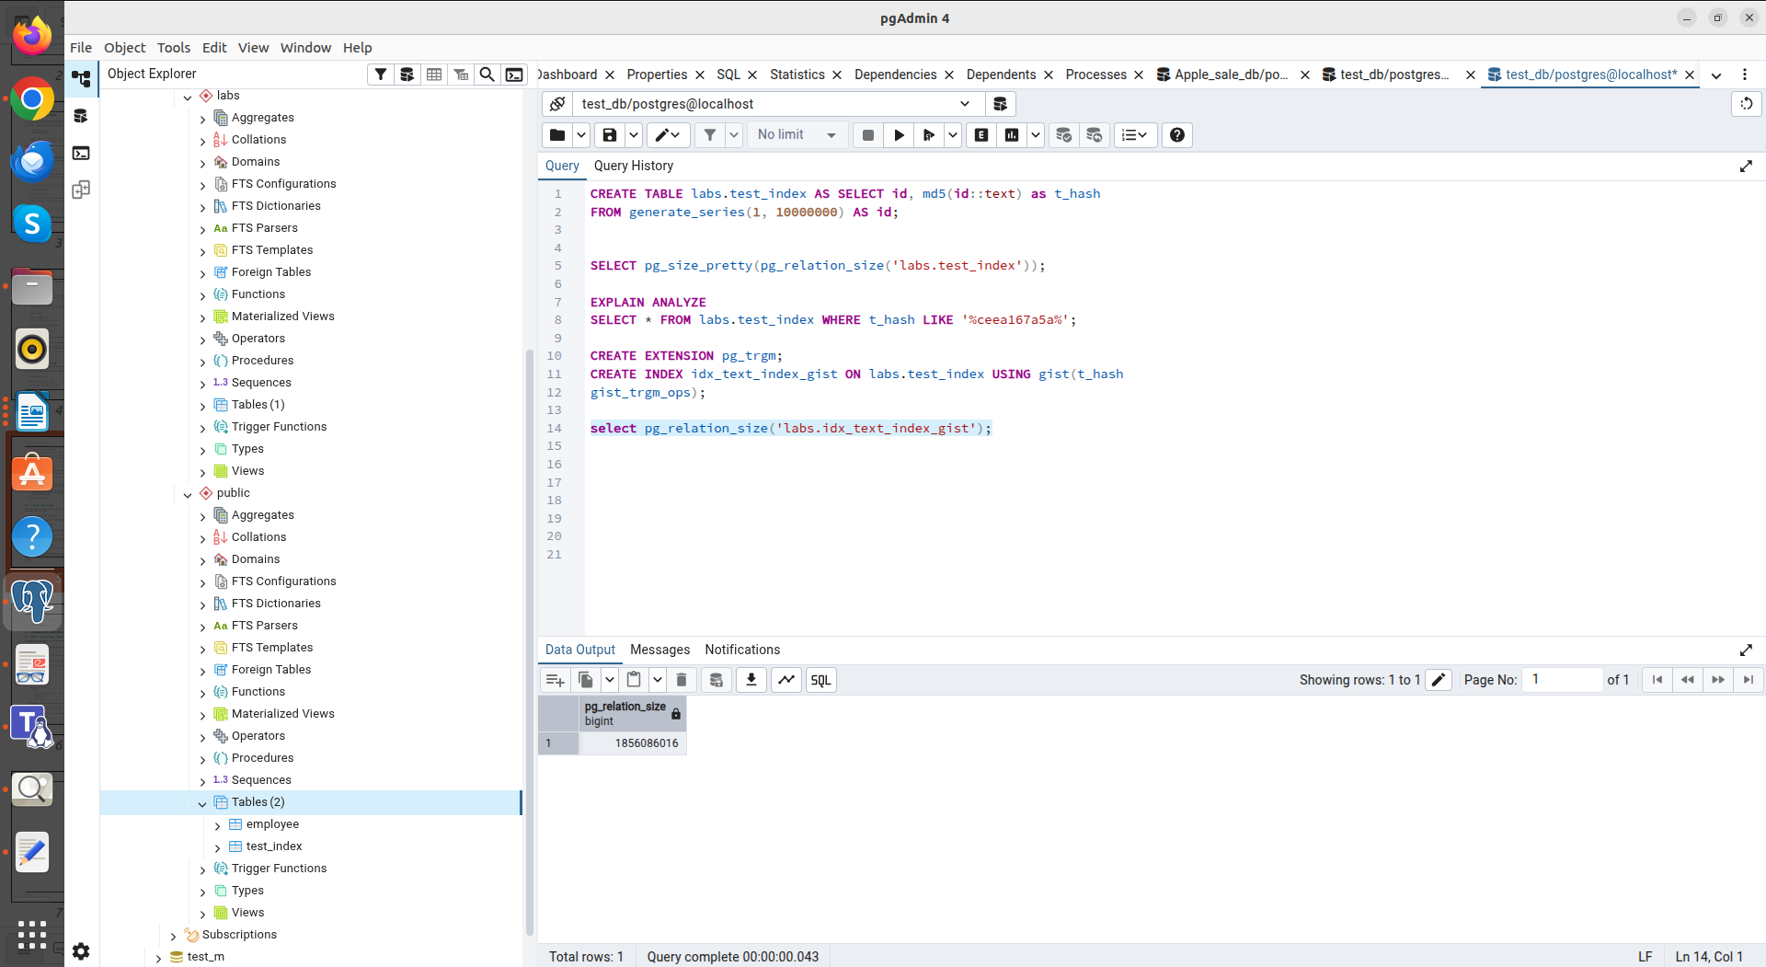
GIST

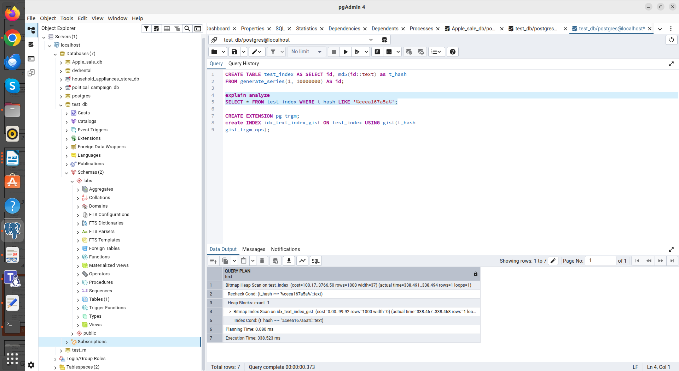
GIST

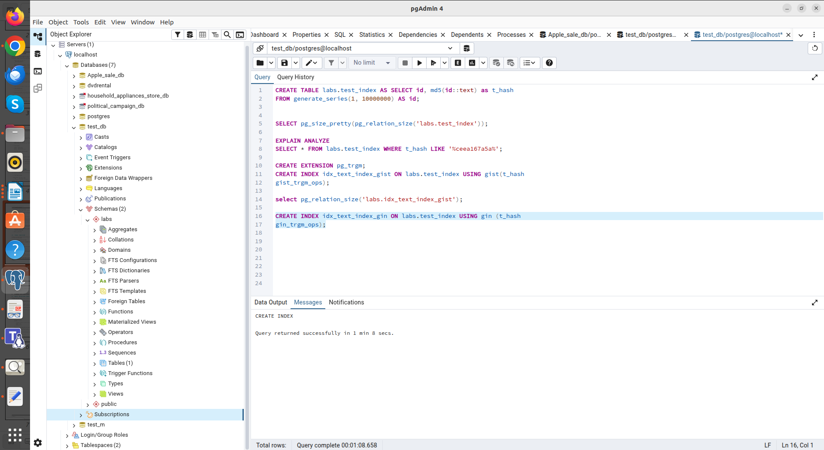

GIN
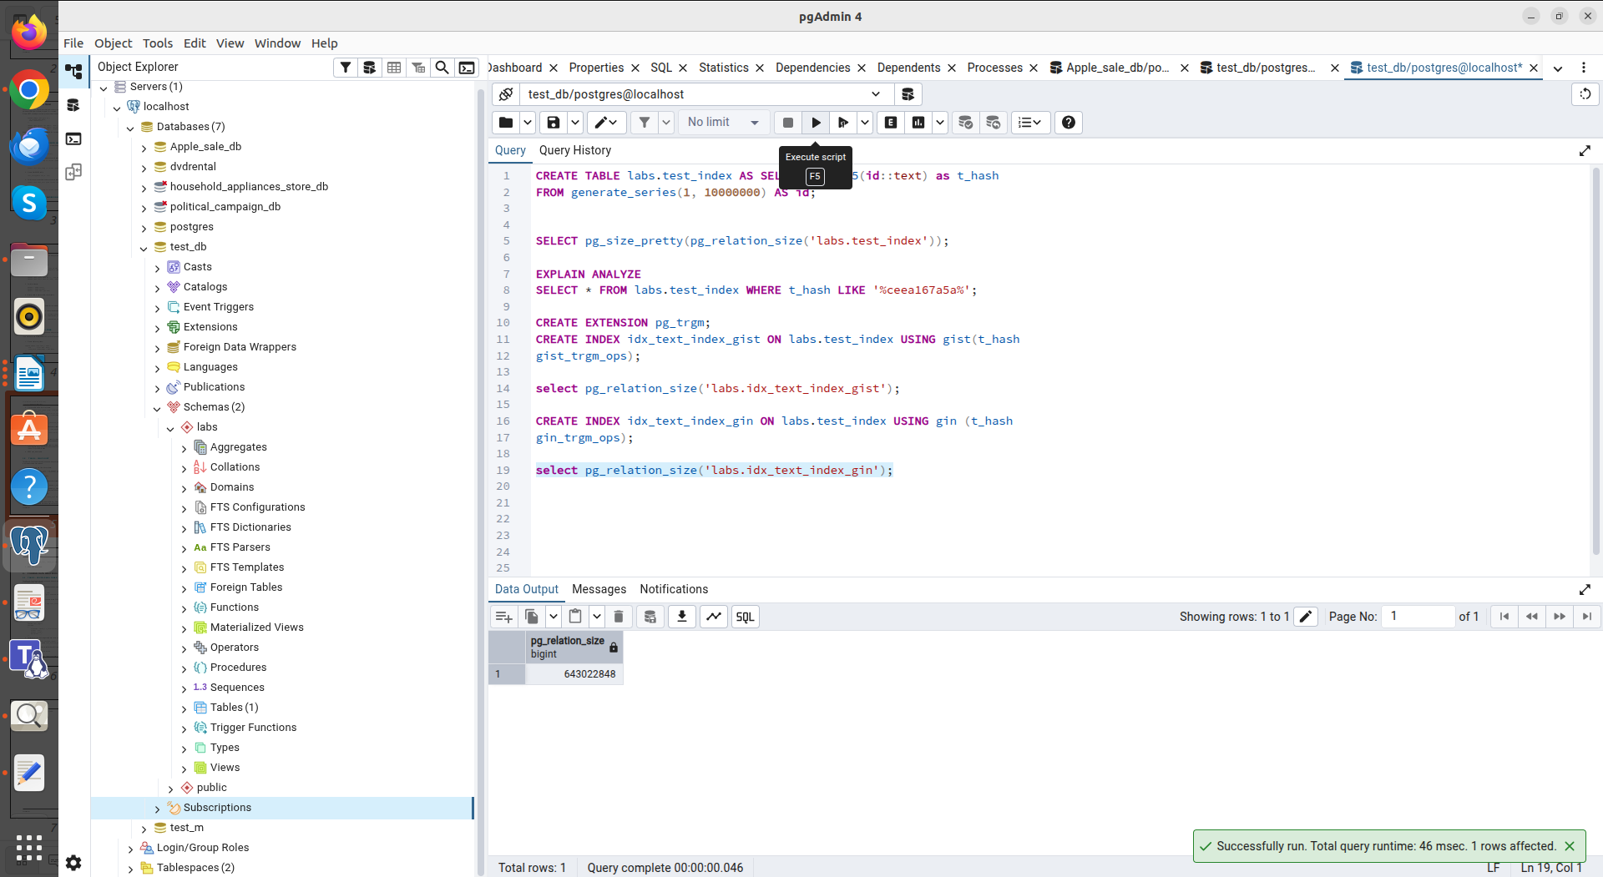
GIN
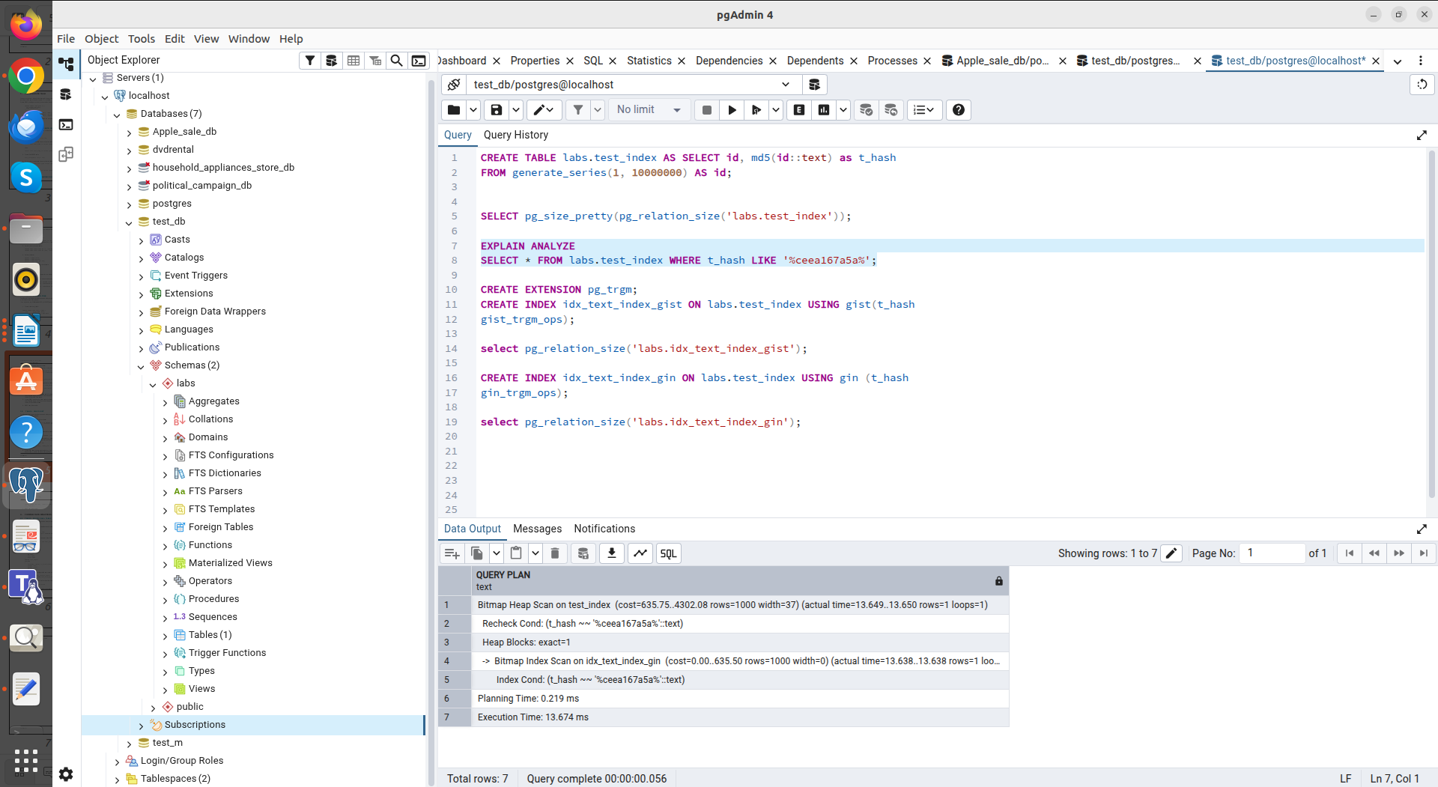
GIN

In Task 5, I analyzed the use of FDW and Materialized View.
FDW: file_fdw allows you to work with a regular CSV file as a standard SQL table. This is convenient for importing data without actually loading it into the database.
Materialized View feature: After deleting a row in the CSV file itself, the data in the Materialized View remained the same. This confirms that MV takes a physical snapshot of the data at the time of creation.
After using the REFRESH command, the database re-accessed the file via FDW and refreshed the data in memory.

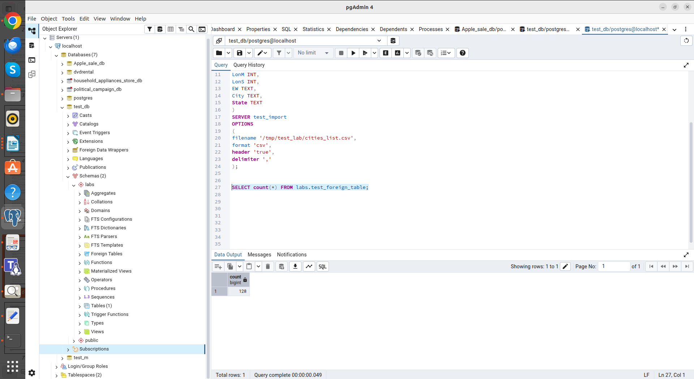
Count (Foreign table)
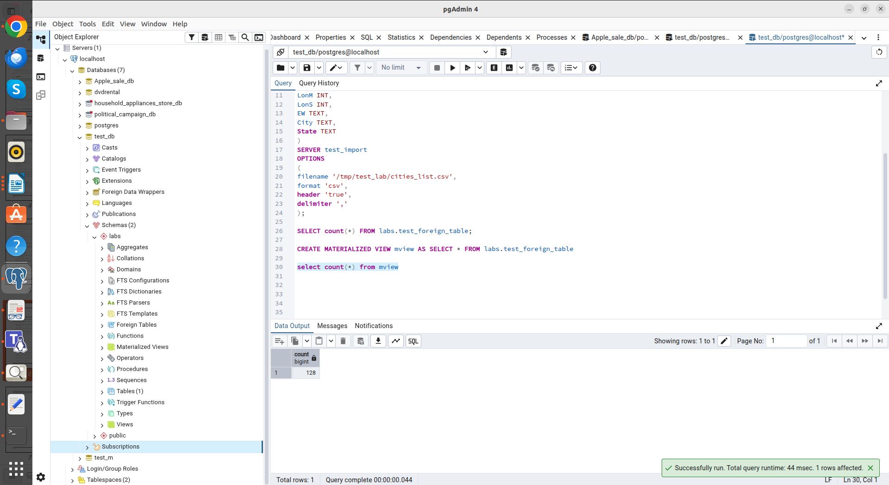
Count (mview)

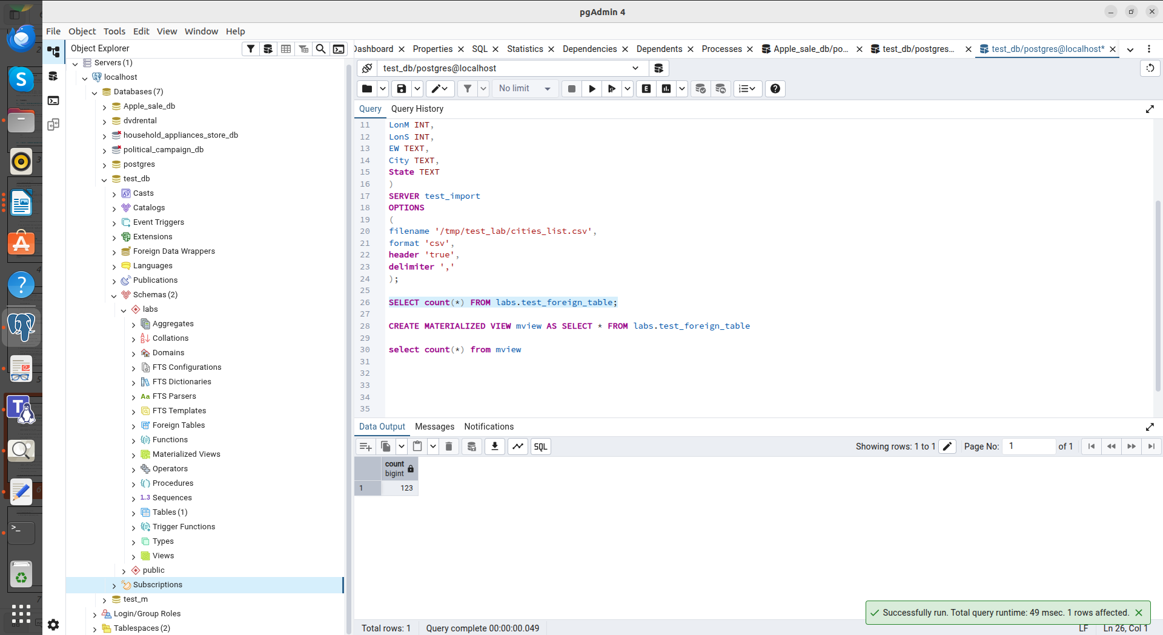
Count (Foreign table) after change

Count (mview) after change

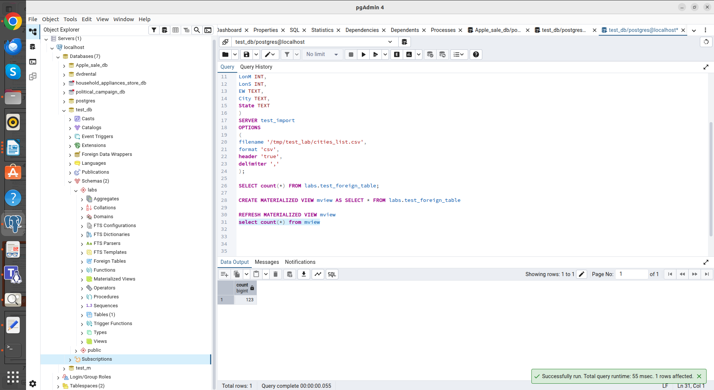
Count (mview) after change and refresh

