To implement logic to load FACT table into 3NF layer, I created a procedure that implements the batch Incremental load approach. For the DM layer, I used a loading approach using partitioning and a rolling window. The fact table is divided into partitions by month (I used event date, in my case - DATE_SURR_ID). I selected rolling window logic (3 months): The procedure is configured to loop through the "Month before previous + Previous month + Current month" window. I assume that in real systems, data for the past period may be adjusted (for example, due to returns). Reloading the window ensures that the DM is always synchronized with the current 3NF state for the recent past. I implemented two operating modes in the procedure: (Initial full load) and (rolling windows), which depend on the state of the fact table. When rerunning, the number of lines in the logs is equal to the window size, but the final number of records in the DM fact table remains unchanged, eliminating duplication. Repeatability is implemented through a WHERE NOT EXISTS. Procedures created via CREATE OR REPLACE. I also added an Exception block to procedures. Any error is logged to MTA_LOGGING with the 'ERROR' status.

Test results:
First run: The fact table on 3NF layer has been successfully populated. Logs confirm insertion of records (rows_affected > 0).
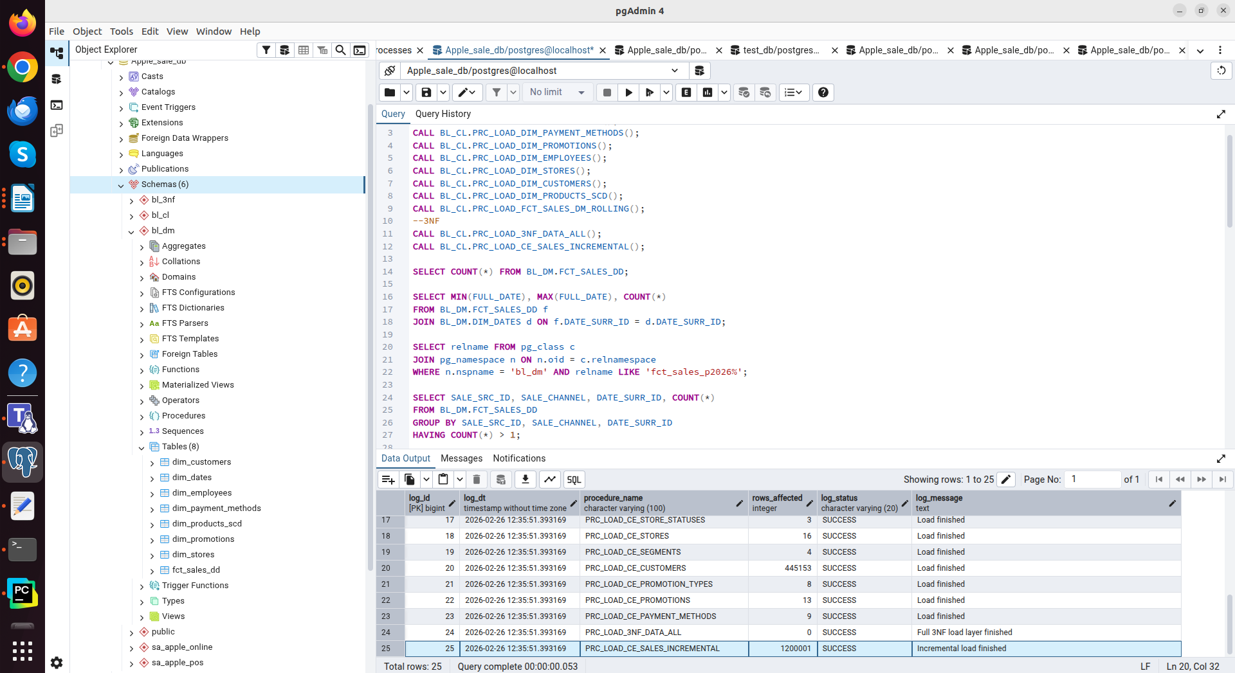

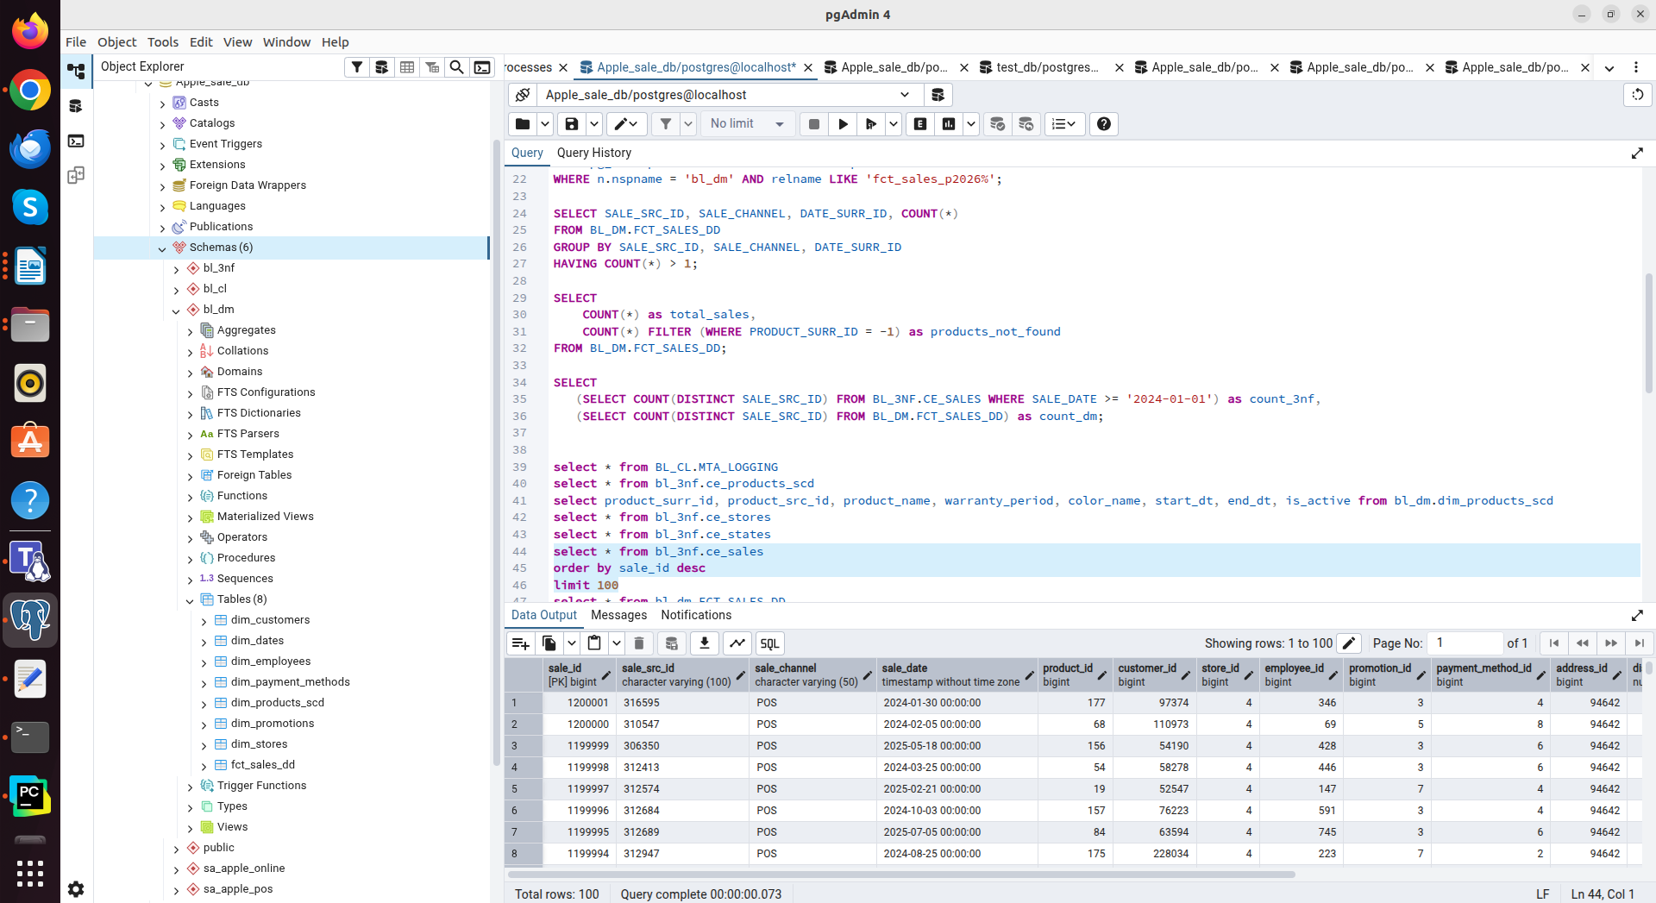

Second run: Procedure completed successfully, confirming the absence of duplicates (rows_affected = 0).
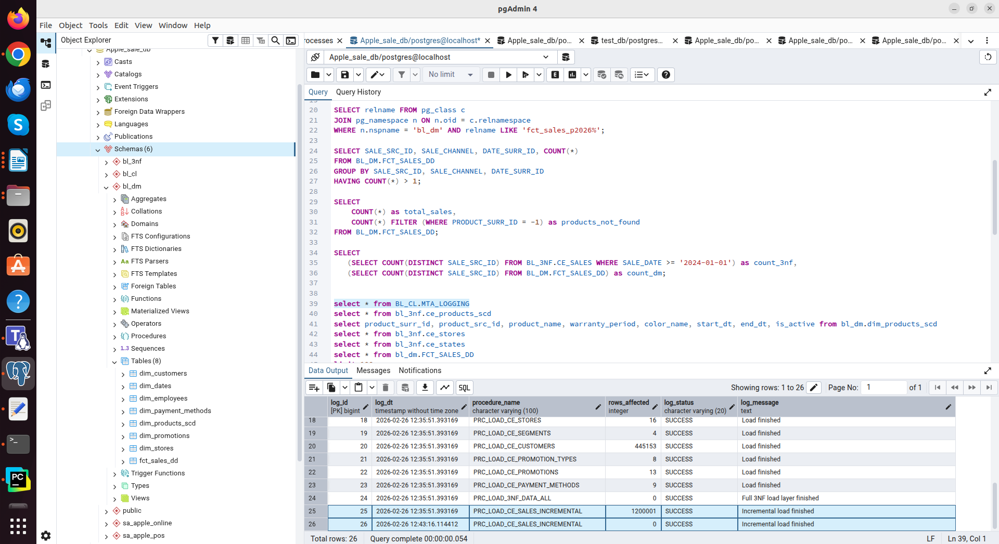

As I mentioned earlier, in the DM Layer loading procedure, I implemented two operating modes: (Initial Full Load) and (Rolling Window), which depend on the state of the fact table. When the BL_DM.FCT_SALES_DD table is empty during the first run, the procedure initializes Initial Load mode. The procedure scans the entire historical dataset in the 3NF layer (starting from 2022). Each month for which transactions exist is analyzed in a loop. The procedure creates the appropriate partitions and loads all data from the 3NF layer.

First run: The fact table on DM layer has been successfully populated. Logs confirm insertion of records (rows_affected > 0).
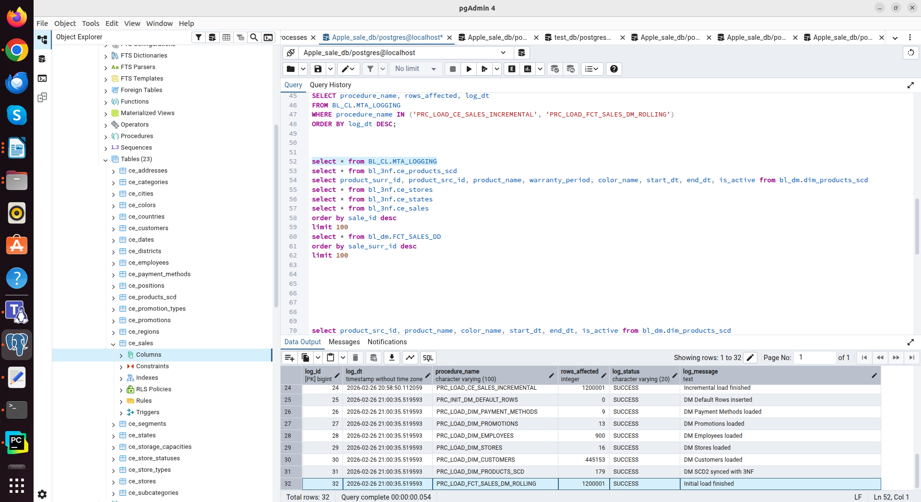

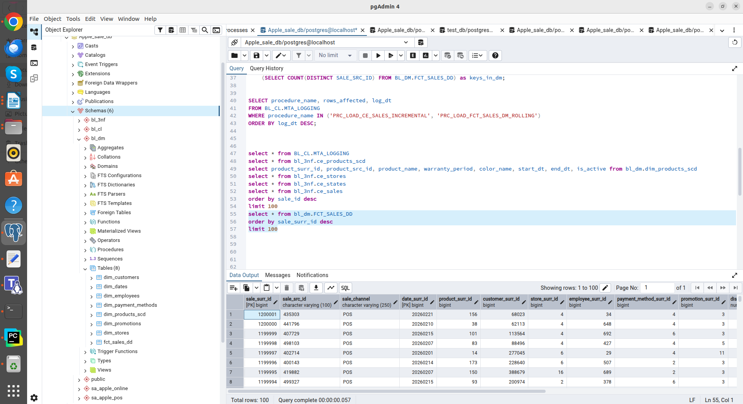

For all next runs, the procedure switches to Rolling Window mode and focuses on a time interval (3 months: before previous, previous and current). Each of the three target partitions is updated using the DETACH/ATTACH method.

Second run (load only 3 partitions):
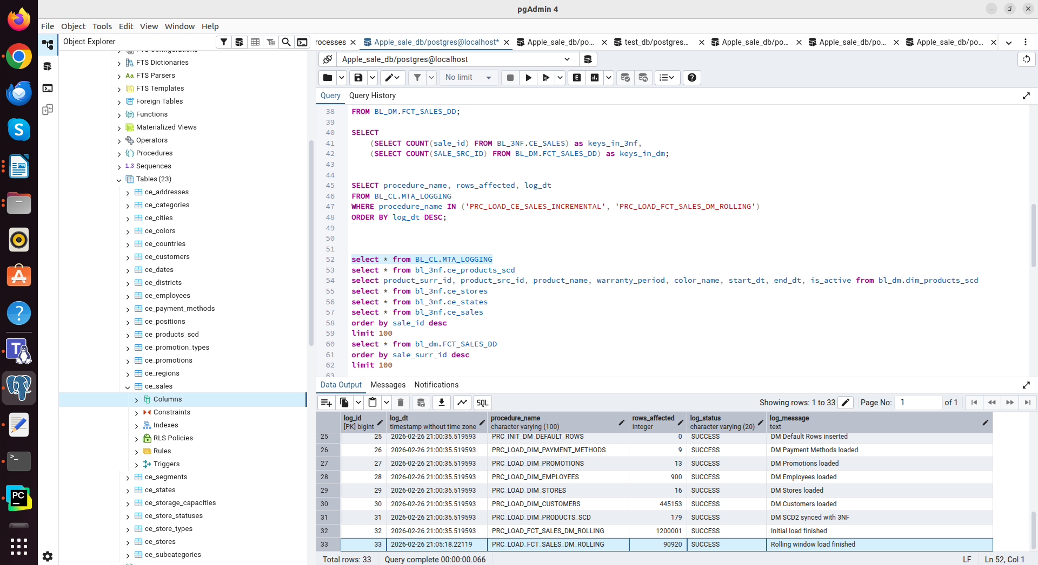

Third run (load only 3 partitions):
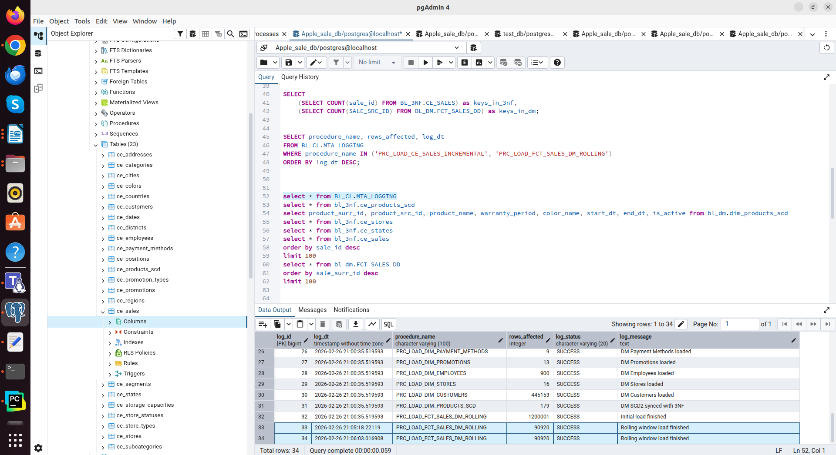
Final number of records in the DM fact table remains unchanged, eliminating duplication.

Check for duplicates in the target table and whether all business keys from the SA/3NF table have been loaded into the DM fact table.

SELECT
(SELECT COUNT(SALE_SRC_ID) FROM BL_3NF.CE_SALES) as keys_in_3nf,
(SELECT COUNT(SALE_SRC_ID) FROM BL_DM.FCT_SALES_DD) as keys_in_dm;
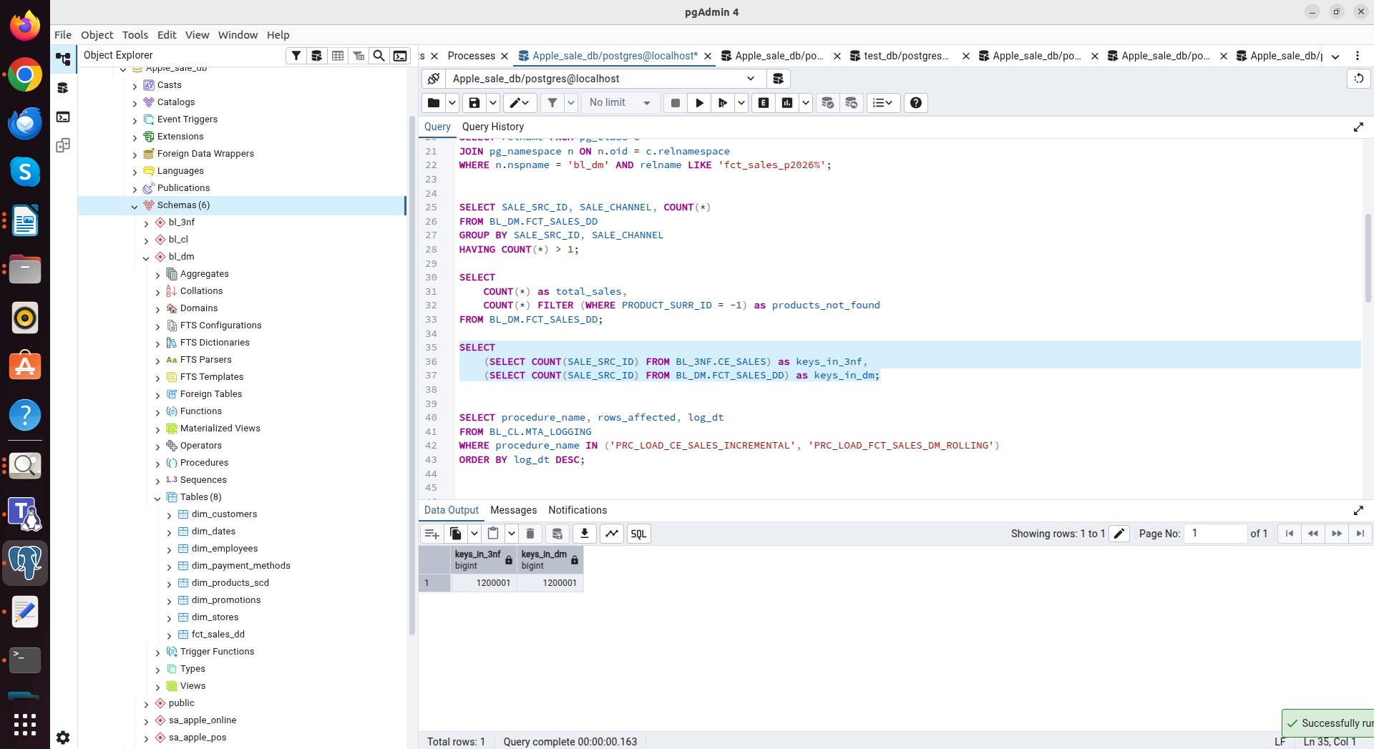

SELECT SALE_SRC_ID, SALE_CHANNEL, COUNT(*)
FROM BL_DM.FCT_SALES_DD
GROUP BY SALE_SRC_ID, SALE_CHANNEL
HAVING COUNT(*) > 1;
