Student: Alexei Revenko

Please, look through the doc attached, analyze the requirements and prepare your list of questions to the customer to clear out all the possible details not mentioned here (in the same doc).
Deadline – next class.

Requirements for test application

General: Test application is purposed for collecting information about families, i.e. Husband, Wife and Children.
- Who will be using this application?
- Is it legal?
- Does the database have to be encrypted? (Because personal information)
- For which regions is this application (localization)?
- What does it mean:
  - Family?
  - Husband?
  - Wife?
  - Child?
  - Adult child?
- Do we have to save to database adult child?
- The default path to save the file.
- The encoding of the text in the application.
- What the application will be called?

1. Application should be supported by all versions of all operation systems.
- Do you really need all versions of all operation systems? (Because it takes a long time, expensive and almost usefulness).
- What operation systems do you need?
- What versions of operation systems do you need?

2. Each family’s information (called ‘family database’) should be contained within 1 file, which can be saved with empty fields.
- Some questions about file:
  - Extension?
  - Minimum size (in Byte)?
  - Maximum size (in Byte)?
  - What does it mean empty fields?
    - Do we have to use something special (“–“ or “N/A” or another) for empty fields?
    - Can we save the file if all the fields is empty?
  - What fields cannot be empty fields?
  - We need to discuss the internal form of saved file.
  - The encoding of the text in the saved files.

3. Several applications should be able to be launched simultaneously.
- What is maximum possible quantity of applications is launched simultaneously?
- If the Application try open the file is being used with one of another Application then we will forbid / allow / propose to open as read-only / something else?

4. When starting the Application is started the window main form should contain menu with three hinted standard buttons (New Database, Open Database, Save Database (Save Database should be disabled - see requirement 4.1)), input text field (Description), input data field with pop-up Calendar (Date of marriage) and tabs (General, Husband, Wife, Children) and General tab should be enabled (see Sketch 1).
  - What does it mean standard buttons?

4.1 These The buttons “remove quotation mark New, Open, Save”remove quotation mark buttons should be eligible also for other three tabs: Husband, Wife, Children. Button Save should be disabled until the user clicks on New (or Open) button (Contradicts point 7.2 of requirements).
- Let's define the exact name of the buttons:
  - New Database or New?
  - Open Database or Open?
  - Save Database or Save?

5. To create a new family database the user should click on New button. The user might fill in Description (see BR 2) of a family and select Date of marriage using Calendar (BR 1).
- If we inputted some dates (information) in available fields before click on the New button do we need to save it or all fields must be empty?

6. To open an existing family database the user should click on Open button, select it from a dialog form and click on OK (can we use Enter?, double-click of left button of mouse?, something else?)
6.1 If the user is editing new (or opened) family database and then clicks on New (or Open) button the application should propose to Save the current family database (changes).
- Let's define the message
for example: - “Save the current family database? (Yes / No)”

7. To save a current family database the user should click on Save button.
7.1 The saved family database name should be clearly visible for the User.
- What does it mean clearly visible for the User?

7.2 If opened family database is not edited yet, the Save button should be disabled (contradicts point 4.1 of requirements).

7.3 If the user is trying to save saves family database under the name which already exists in the path, the application should send the alert message. Alert message is TBD (To Be Determined).
- We need to decide on the logic of the program in this case (allow, forbid, something else…)
- Let's define the Alert message
for example: - “A family database with the same name already exists. Please change the name.”
- “A family database with the same name already exists. Continue? (Yes / No).”

8. Ability to select different languages in application is optional.
- What the language(s) for application is?

9. The application allows only fill information about family and save it in a database. Application doesn’t allow working with existing database (contradicts point 6.1; 7.2; 19 of requirements).

10. To fill in the information about a husband the user should click on Husband tab (see Sketch 2)
10.1 The following attributes of Husband might be filled in: First Name, Middle Name, Last Name (see BR 3 (BR 3 is missing, we need to add it)), Birth Day (BR 1).
10.2 The field Age has default value. The field age shouldn’t be editable. It should be calculated by application as soon as Birth Day is filled in.
- What does it mean as soon as? (1 second; 0.1second; …)

11. The application shall support functionality to enter full information about wife and these details shall be stored in a database.
- What does it mean full information about wife?
- Is functionality the Wife tab equal the Husband tab? (we have to clarify it and add to requirements)

12. To fill in the information about children the user should click on Children tab (see Sketch 3).

13. The table (2 rows and 3 columns) with children should be empty in a new database. These 3 columns should have names “Name” and “Height” and Birthday consequently.
13.1 The cells in the table are not editable, but they can be selected.

14. The user is able to insert more than one child.
- Maximum quantity of children?

15. Scrolling functionality should be available on this page.
- What does it mean on this page? (we have to clarify it)
- What does it mean be available? (constantly or somehow else)

16. The screen Children tab should have three hinted buttons Add Child, Del Child, Edit Child.
16.1 If the table has no records Del Child button and Edit Child button should be disabled.
16.2 Add Child button should be always enabled

17. When the user clicks on Add Child, the new screen form (we need to discuss the view of this form) should appear with 3 5 Attributes:
- Name (see BR 3 (BR 3 is missing, we need to add it))
- Height (see BR 4)
- Birth Day Birthday (see BR 2 BR 1)
- OK button (see point 17.1)
- Cancel button (see point 17.2)

17.1 If the user clicks on OK button, the new record should appear in the table filled with filled attributes.
17.2 If the user clicks on Cancel button, the table should be with no changes.

18. To delete a child the user should select a record to delete and click on Del Child button. When the user clicks on this button the message should appear.
Let's define the text of message.
for example: “Do you really want to delete this record about child? (OK / Cancel)”
If the user clicks on OK, the record should be deleted. If the user clicks on Cancel the record shouldn’t be deleted.

18.1 After successful record deletion, User can edit only “Birth Day” field (not “Name” or “Height” field) for this record. The record has been deleted, we cannot edit anything.

19. If the user clicks on Edit Child button the screen new form (we need to discuss the view of this form) with 3 5 attributes should appear.
- Name (see BR 3 (BR 3 is missing, we need to add it))
- Height (see BR 4)
- Birthday (see BR 1)
- OK button (see next paragraph)
- Cancel button (see next paragraph)

If the user clicks on OK button, the changes should be applied to the table, if the user clicking clicks on Cancel button then changes shouldn’t be applied.

BR 1. The field of date should have the date format. Other format should be ignored by the application (Let's discuss the message for user and add it to requirements). Date can be blank. The date can be typed manually or selected using the Calendar pop-up. The Calendar should have normal size and be user-friendly.
- Let's discuss needed format of date: for example DD/MM/YYYY, MM/DD/YYYY, YYYY/MM/DD, …?
- What to do if user entered a date from the future?
- What does it mean normal size of Calendar?
- What does it mean be user-friendly?

BR 2. Application allows to enter alpha and others characters to the field
- Field should be of maximum length 50
- Field can be blank
- What does it mean others characters? (special symbols, the numbers, …?)
- What does it mean maximum length 50? (pixels, points, characters, …?)

BR 3. We needs discuss requirements for fields First Name, Middle Name, Last Name, Name. For example:
- Field should be alpha
- Field should be of maximum length 30 characters
- Field can be blank

BR 4. Field should be alphanumerical,
- Value should be maximum 300 cm, minimum = ?
- measuring should be in cm (label cm should exist in the form) Where in the form?
- should be entered manually or using Calculator pop-up. Calculator should have standard Windows UI We propose to leave manually only because the calculator will complicate the program, but will not be used
- Field can be blank
- Let's discuss the message in case the user goes beyond the allowed values
for example: “The inputted value can be only in range 0-300. (OK)”

Sketch 1
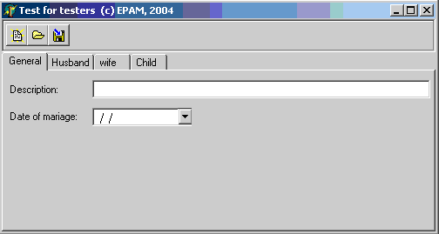
- Misprints: Wife
Date of marriage
- I think that background of form's name would better to change on standard (like for Sketch 2 and 3).
- Test for testers (c) EPAM, 2004 replace by Application Name.

Sketch 2
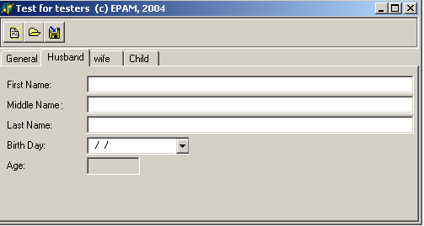
- Misprint: Wife
Birthday
- Test for testers (c) EPAM, 2004 replace by Application Name.

Sketch 3
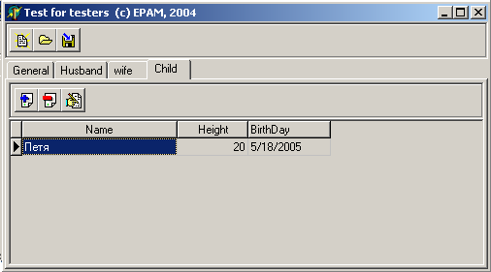
- Misprints: Wife
Children
Birthday
- The location of the unit measurements of Height (cm) is being specified. (see BR 4)
- Test for testers (c) EPAM, 2004 replace by Application Name.

