№1
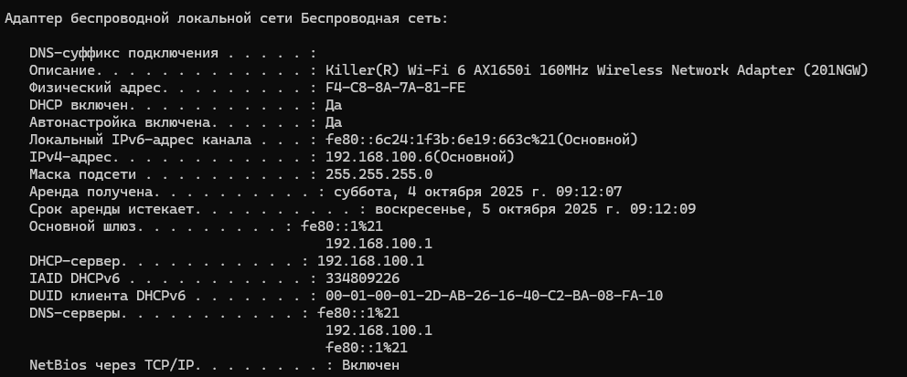
Адрес сети: 192.168.100.0
Количество устройств: 254
5.2.1.7.
1.d:
MAC-destination:
FFFF.FFFF.FFFF
1.e
Три копии
1.f
172.16.31.3
1.g
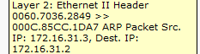
1.h
1
2.c Все
3.c
172.16.31.1
3.e 3
3.f 172.16.31.1
Packet tracer 5.3.3.5.

interface GigabitEthernet0/0
ip address 172.16.31.1 255.255.255.0
duplex auto
speed auto
!
interface GigabitEthernet0/1
ip address 192.168.0.2 255.255.255.0
duplex auto
speed auto
!
interface GigabitEthernet0/2
no ip address
duplex auto
speed auto
shutdown
!
interface Serial0/0/0
no ip address
encapsulation ppp
clock rate 2000000
shutdown
!
interface Serial0/0/1
no ip address
clock rate 2000000
shutdown
!
interface Vlan1
no ip address
shutdown
# 8.3.2.5
PC1:
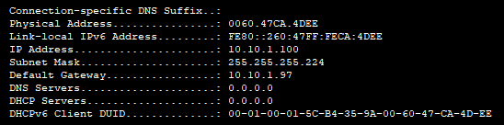
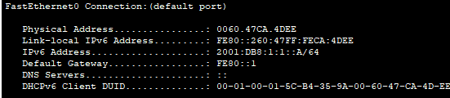
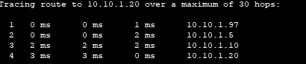
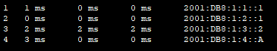
PC2:
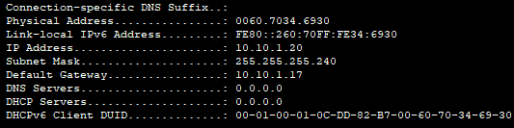
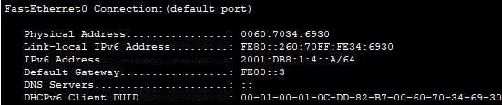
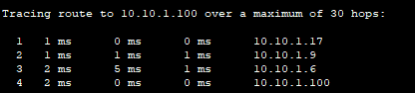
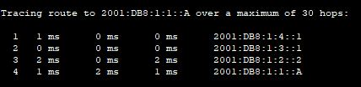
8.3.2.6
PC1:
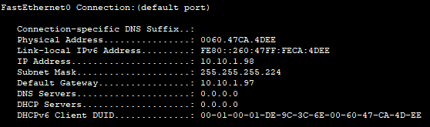
10.10.1.97
10.10.1.6
PC2:
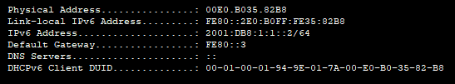
PC3:
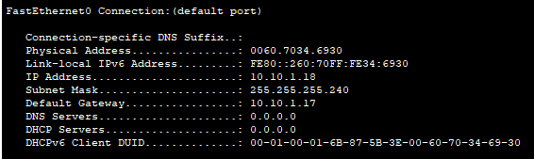
PC4:
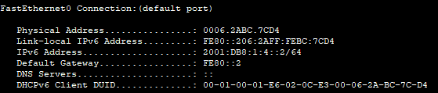
# 9.1.4.6
Net 0: 192 . 168 . 100 . 0 0 0 0 0 0 0 0
Net 1: 192 . 168 . 100 . 0 0 1 0 0 0 0 0
Net 2: 192 . 168 . 100 . 0 1 0 0 0 0 0 0
Net 3: 192 . 168 . 100 . 0 1 1 0 0 0 0 0
Net 4: 192 . 168 . 100 . 1 0 0 0 0 0 0 0
Net 5: 192 . 168 . 100 . 1 0 1 0 0 0 0 0
Net 6: 192 . 168 . 100 . 1 1 0 0 0 0 0 0
Net 7: 192 . 168 . 100 . 1 1 1 0 0 0 0 0
11111111.11111111.11111111. 1 1 1 0 0 0 0 0
255 . 255 . 255 . 224
Номер подсети | Адрес Подсети | Первый используемый адрес сети | Последний используемый адрес сети | Широковещательный адрес
0 | 192.168.100.0 | 192.168.100.1 | 192.168.100.30 | 192.168.100.31
 | 192.168.100.32 | 192.168.100.31 | 192.168.100.62 | 192.168.100.63
 | 192.168.100.64 | 192.168.100.65 | 192.168.100.94 | 192.168.100.95
 | 192.168.100.96 | 192.168.100.97 | 192.168.100.126 | 192.168.100.127
 | 192.168.100.128 | 192.168.100.129 | 192.168.100.158 | 192.168.100.159
 | 192.168.100.160 | 192.168.100.161 | 192.168.100.190 | 192.168.100.191
 | 192.168.100.192 | 192.168.100.193 | 192.168.100.222 | 192.168.100.223
 | 192.168.100.224 | 192.168.100.224 | 192.168.100.254 | 192.168.100.255

№7
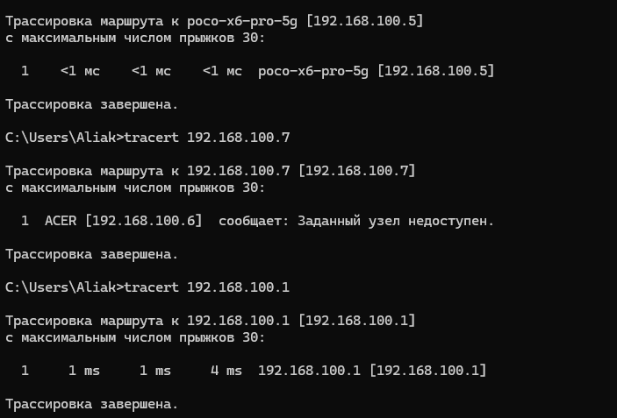
ICMP:
