**Employee API**

**Developer Guide**

History

|  |  |  |  |
| --- | --- | --- | --- |
| **Author** | **File name** | **Version** | **Comment** |
| Florian BRETAUD | Developer_Guide | 0.1 | Coding challenge |

# Architecture

## Global architecture schema



## Archetecture details

* Controller layer: Layer composed of REST controllers intercepting http requests. Controllers interacts with services. Data proceeded in input and output of a controller is business object (DTO)
* Service layer: Business services, contains the logic of application treatment
* Repository layer: JPA repositories (equivalent to DAO), composed of interfaces making queries to the database
* Database: H2 embedded database.

# Swagger

The Swagger UI interface is available at <http://localhost:8080/swagger-ui.html>

To perform requests via the Swagger UI, an authentication is required, click on « Authorize » button :

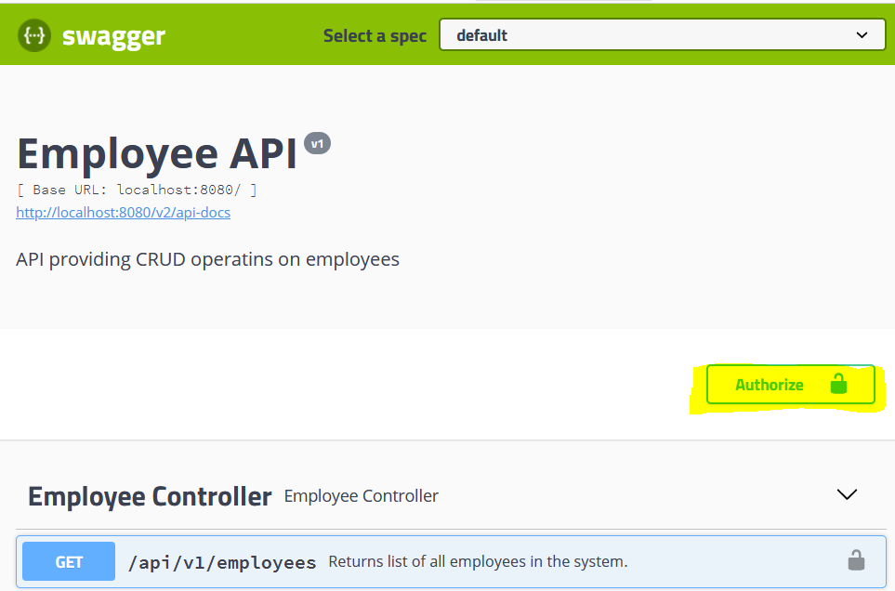

Enter the API key (defined in application.properties) :

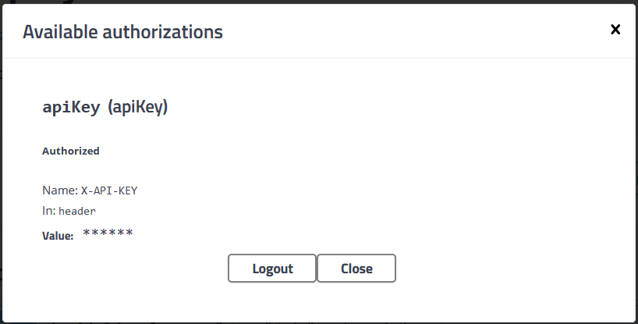

# Test coverage

The application’s test coverage can be generated via the JaCoCo plugin.

|  |
| --- |
| mvn clean install |

The report is located in **target/site/jacoco/index.html**

