Midterm Paper Codes Analysis



Spring 2024
CSE-308 Digital System Design

Submitted by: Ali Asghar
Registration No.: 21PWCSE2059
Class Section: C

“On my honor, as student of University of Engineering and Technology, I have neither given nor received unauthorized assistance on this academic work.”

Submitted to:
Dr. Rehmat Ullah Khattak

Date:
7th April 2024

Department of Computer Systems Engineering
University of Engineering and Technology, Peshawar
Problem 1:
part(a)
DATAFLOW_CIRCUIT

Code:
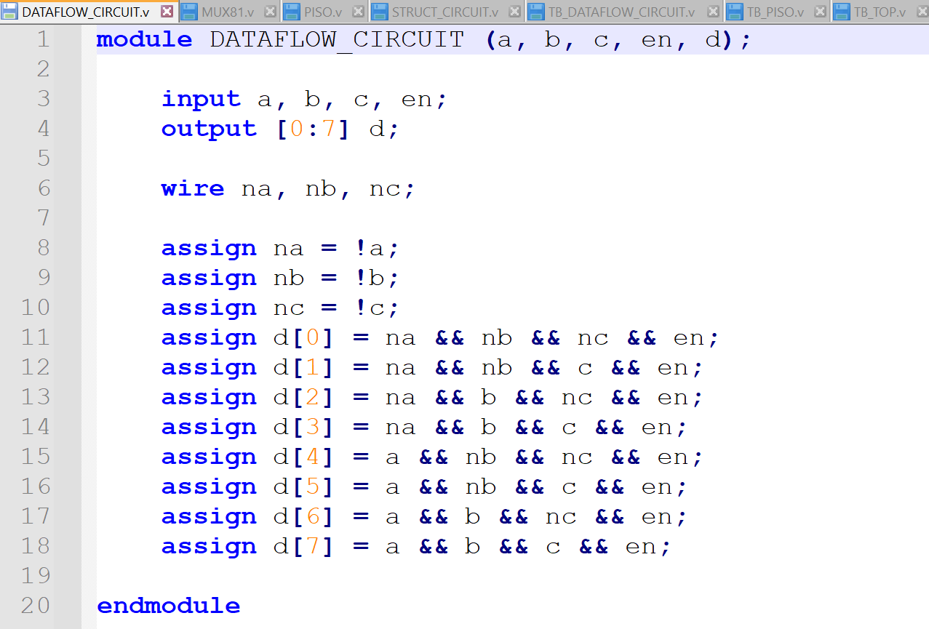

Output:
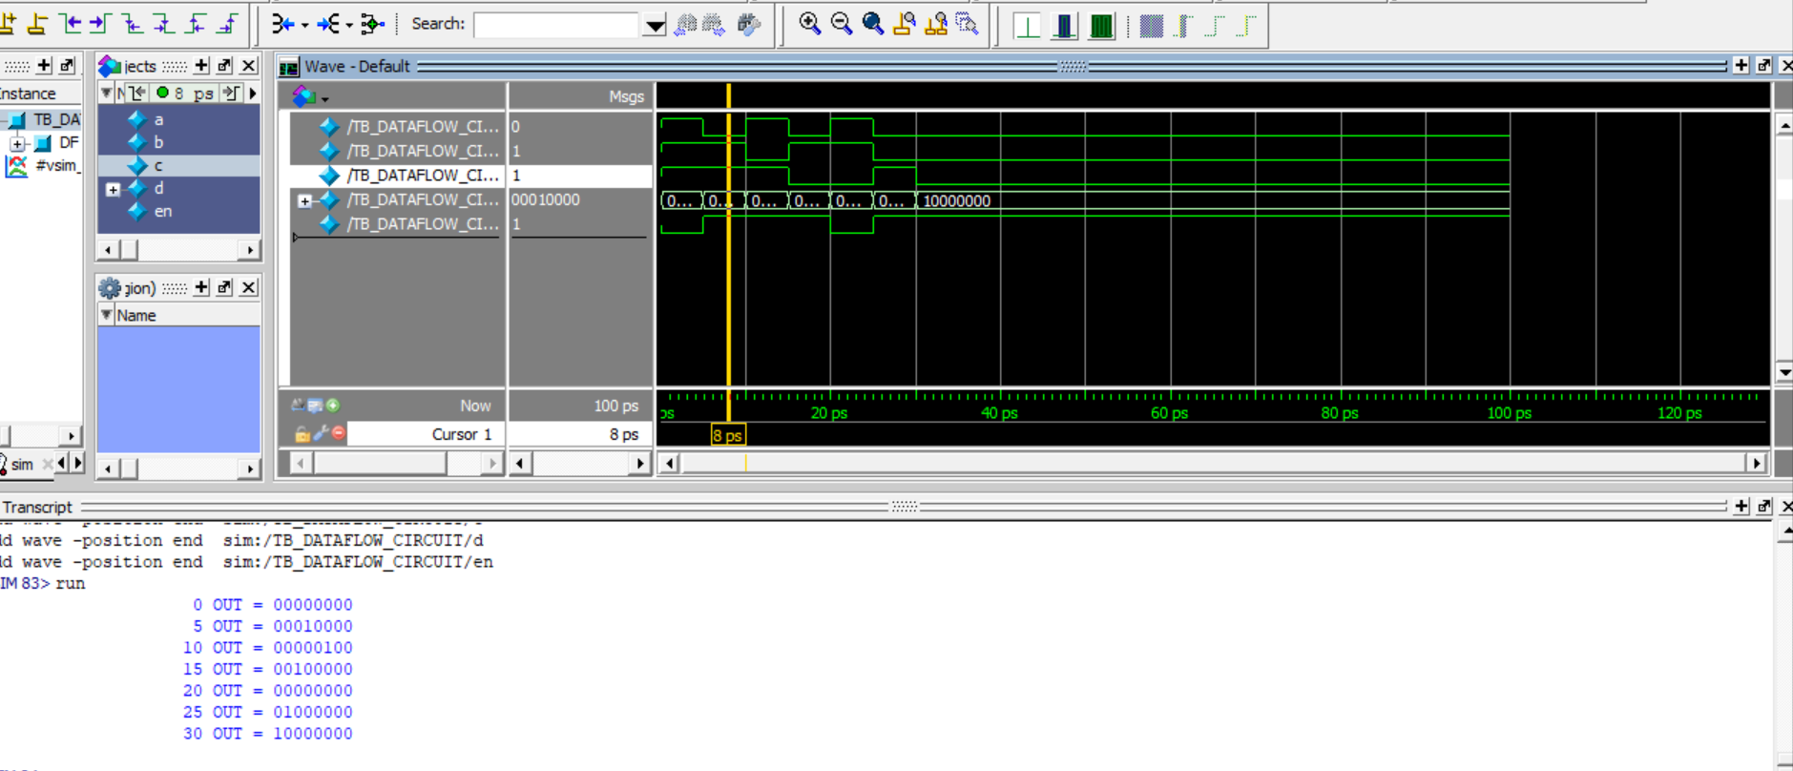
Analysis:
This code is error-free. The code works as intended and it implements a 3x8 decoder with enable input(using Dataflow Modelling).

part (c):
STRUCT_CIRCUIT
Rewrite the DATAFLOW_CIRCUIT using Verilog built-in primitives and structural Verilog. Part of the module is done for you.

Code:
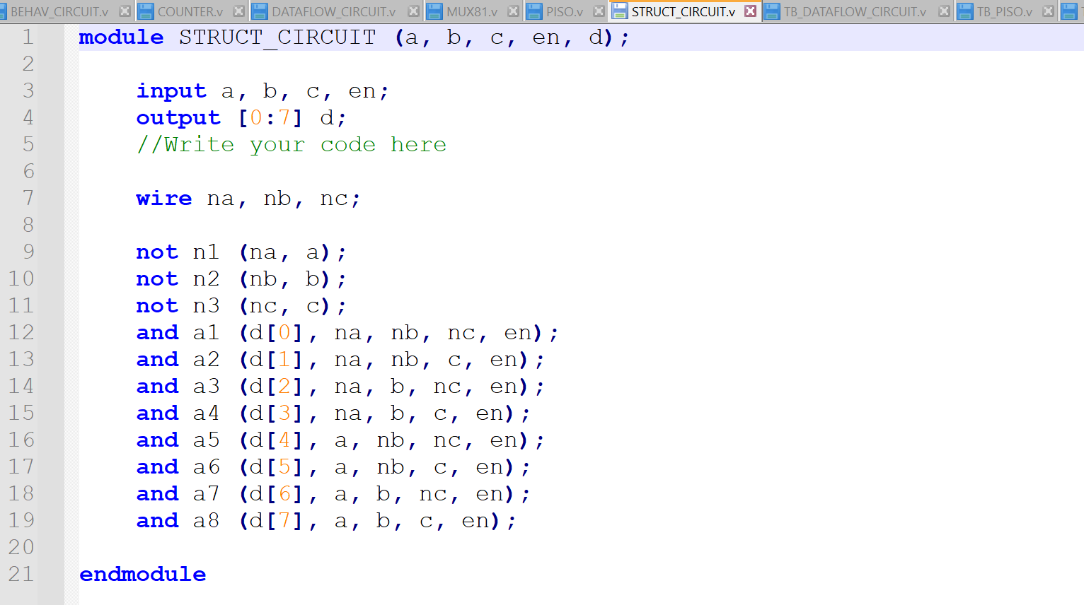

Output:
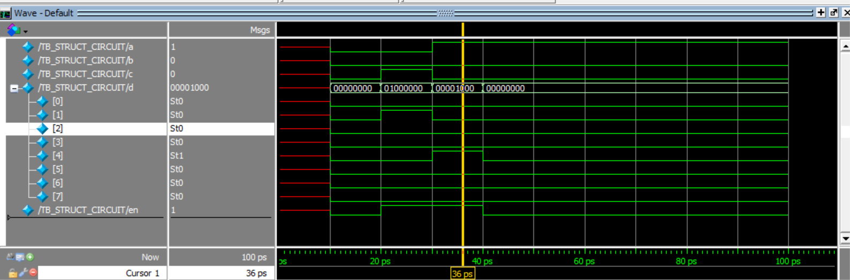
Analysis:
This code is fine and error-free. The code works as intended and it implements a 3x8 decoder with enable input(using gate-level modelling).

part (d):
BEHAV_CIRCUIT
Rewrite the DATAFLOW_CIRCUIT using behavioral Verilog. Part of the module is done for you.

Code:
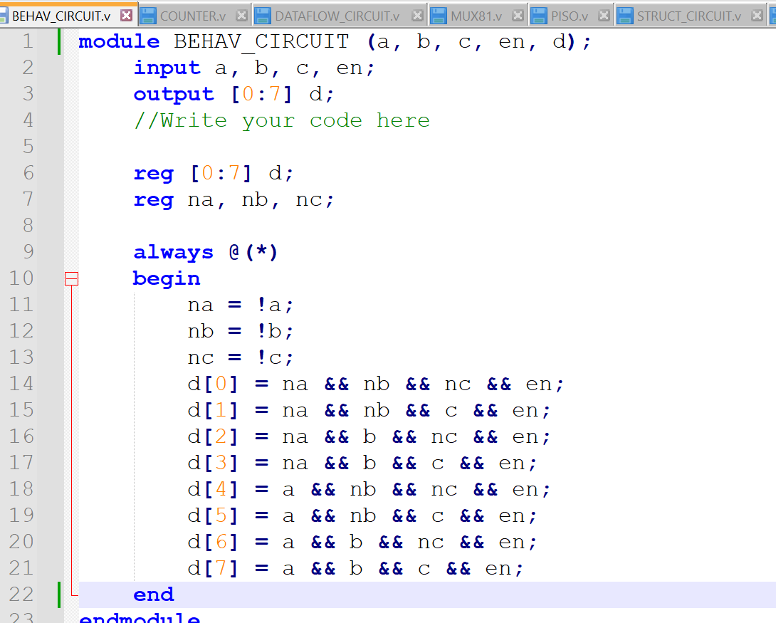

Output:
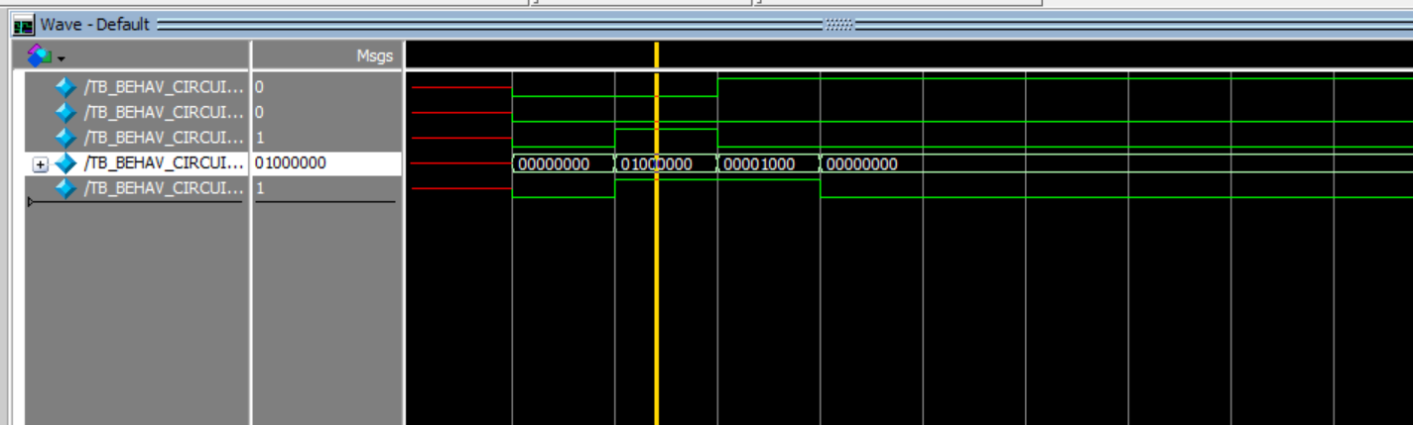
Analysis:
This behavioral version of the above code is error-free. However, it’d have been better to use switch statement in this code. The reason is that in behavioral modelling, we describe the behavior of the system, and our desired circuit is synthesized. While attempting paper, I implemented the same functionality using switch statement.

Problem 2:
part (a):
COUNTER
In this module, design a 3-bit up / down counter, a counter that counts in both up and down directions.

Code:
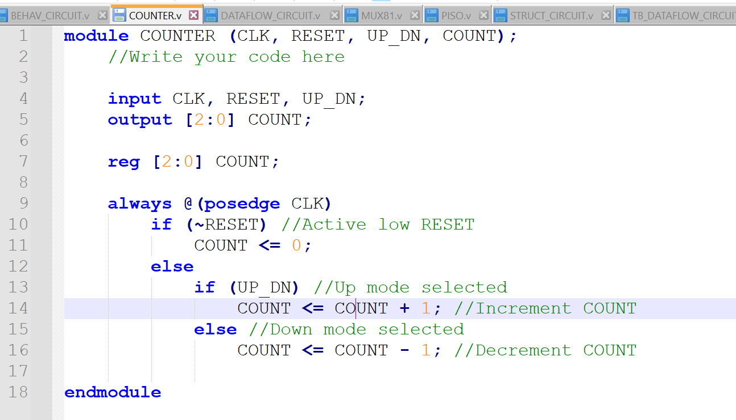

Output:
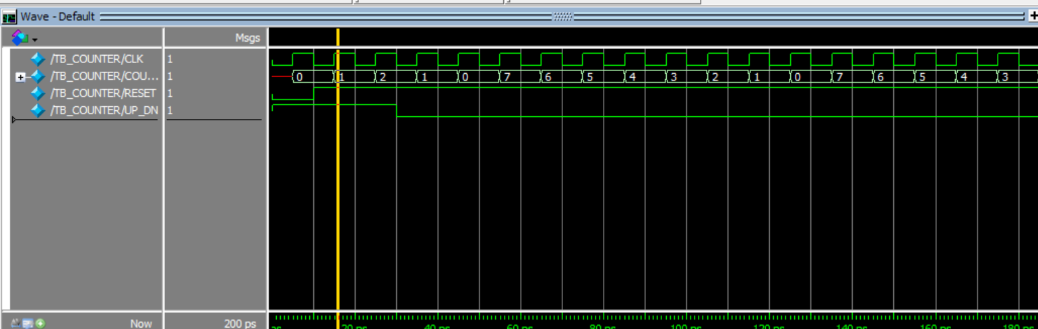

Analysis:
This code is error-free and it perfectly models a sequential circuit (3-bit Up/Down Counter). However, it generates a warning in xlinx ise because of one ambiguity in this code. We are incrementing the counter without considering the overflow case. For example, if we have COUNT = 111 and then we increment it. We would be getting a 4-bit result with a carry.
Solution:
Write it in this format.
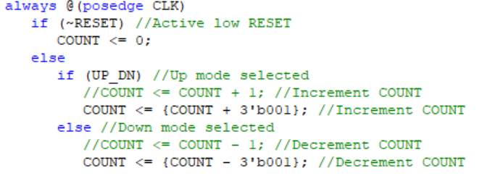

part (b):
MUX81
In this module, design a byte-wide 8-to-1 multiplexer. In this case, the value on the 3-bit select line will route 1 of 8 inputs to the output. This module is purely combinatorial.

Code:
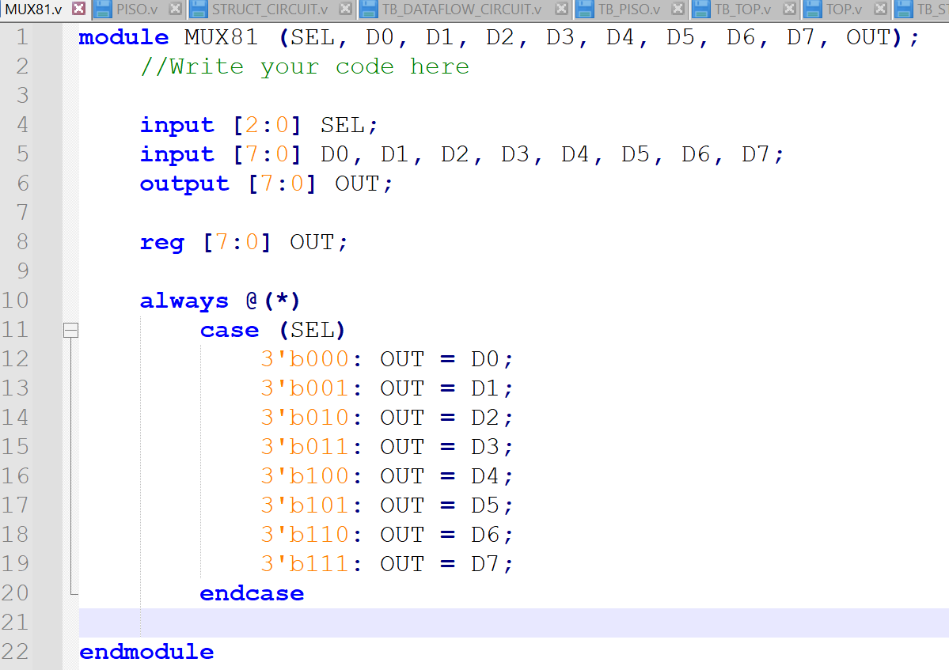

Output:
Its output can be seen in the upcoming last part of this problem. So, no need to attach it here.

Analysis:
This code is error-free, and it perfectly models a combinational circuit (byte-wide 8-to-1 multiplexer).

part (c):
PISO
In this module, create a register that loads data in parallel but shifts data out serially, MSB first.

Code:
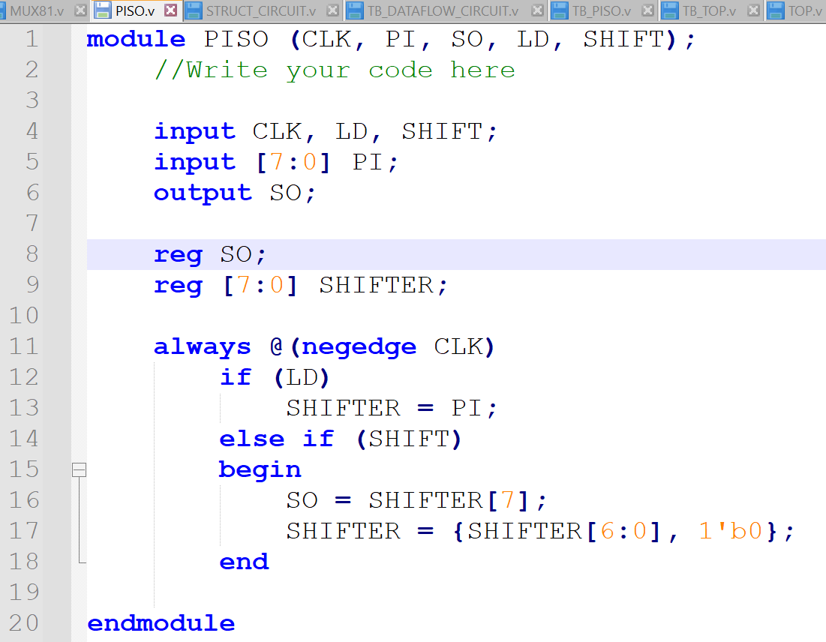

Output:
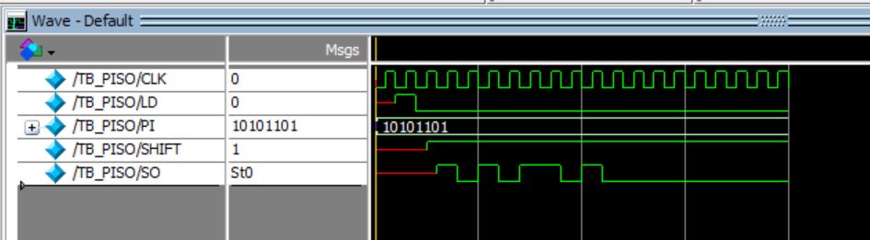

Analysis:
This code is error-free, and it perfectly models an 8-bit Parallel In Serial Out (PISO) shift register.

part (d):
TOP
For this design, combine the 3-bit up/down counter (Module 1) with the 8-to-1 multiplexer (Module 2) to create a circuit such that the output of the counter controls the select lines of the multiplexer.

Code:
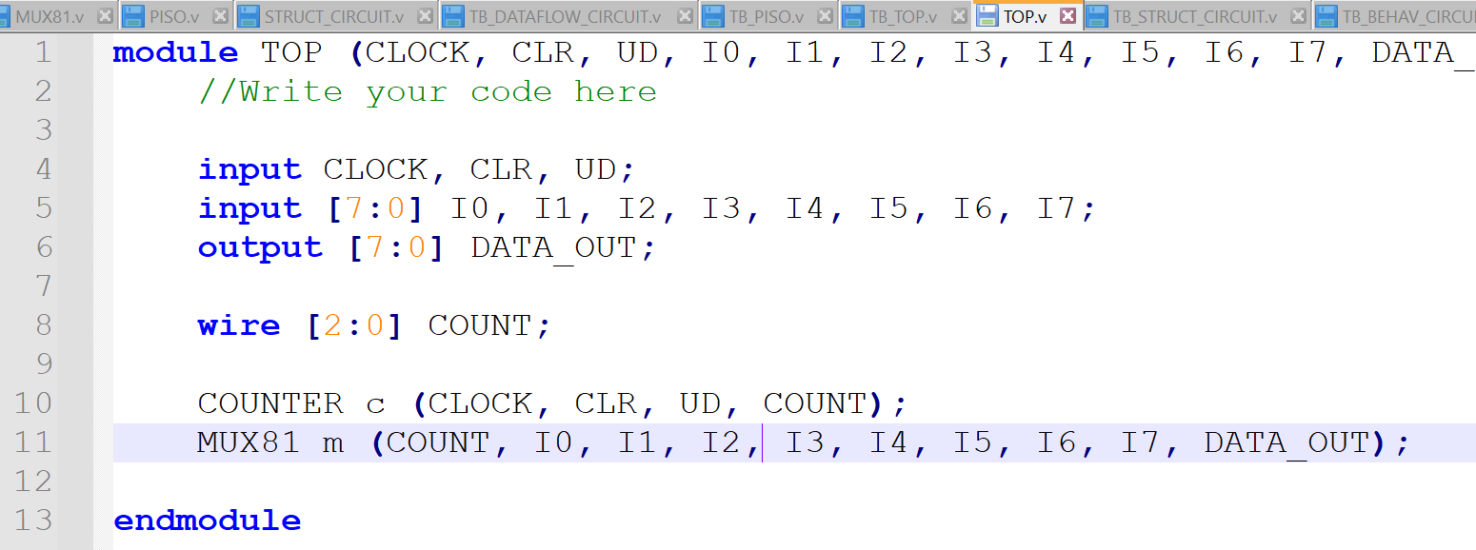

Output:
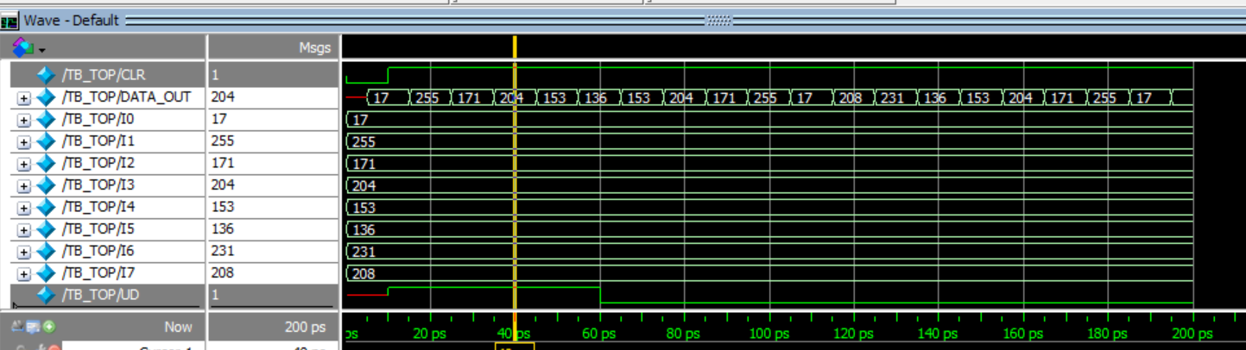

Analysis:
This code is error-free. It instantiates and interconnects both the MUX81 and COUNTER modules.

