Problem 1……………………………………….(20 pts.)

As discussed in the class, it is possible to combine two chips to form a composite memory containing the same number of words but with twice as many bits in each word. Figure below shows the interconnection of two 1Kx32 RAM chips to form a 1Kx64 memory. The 64 input and output data lines are split between the two chips. Both receive the same 10-bit address and the common CS and RW control inputs.

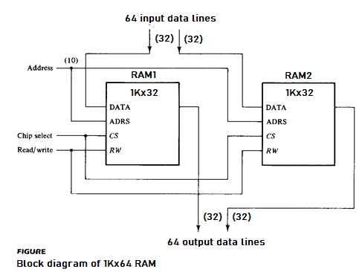

1(a) (10 pts.) Given the following partial modules for two 1Kx32 RAM chips, fill in the blanks to complete the modules.

module RAM1_1Kx32 (adrs, CS, RW, idata, odata);

input CS, RW;
input [9:0] adrs;
input [31:0] idata;
output [31:0] odata;
reg [31:0] d_out;
reg [31:0] Mem1 [0:1023];
assign odata = (CS && RW) ? d_out : 32’bz;
always @ (adrs or idata or CS or RW)
if (CS && !RW)
Mem1 [adrs] = ida ta ;
always @ (adrs or CS or RW)
if (CS && RW)
d_out = Mem1 [adr s];
endmodule

module RAM2_1Kx32 (odata, CS, RW, idata, adrs);

input CS, RW;
reg [31:0] Mem2 [0:1023];
input [9:0] adrs;
input [31:0] idata;
output [31:0] odata;
reg [31:0] d_out;
assign odata = (CS && RW) ? d_out : 32’bz;
always @ (adrs or idata or CS or RW)
if (CS && !RW)
Mem2 [adrs] = idat a ;
always @ (adrs or CS or RW)
if (CS && RW)
d_out = Mem1 [adrs ];
endmodule
1(b) (10 pts.) Write a top-level module to combine the two 1Kx32 RAM chips (given in 1(a)) to form a 1Kx64 RAM.
module RAM_1Kx64 (adrs, CS, RW, idata, odata);

endmodule

Problem 2……………………………………….(20 pts.)

In this problem, design an electronic lock system (lockSys, see Figure) for a garage door lock. The electronic lock accepts a 3-bit user code input, one bit at a time. If the input code sequence exactly matches 101, the electronic lock is opened (openLock is asserted). If any part of the 3-bit code input sequence is incorrect, the user is forced to restart code entry i.e. all backward arcs go back to the initial state if a "wrong" bit is entered. When openLock is asserted after the correct code has been entered, the lock stays open. And the lock shuts itself (openLock is de-asserted) if the asynchronous input signal rst is asserted or a 0/1 is entered after the correct input code sequence until the correct input code is again entered.

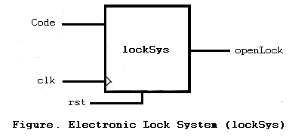

2(a) (10 pts.) Design a Moore FSM for lockSys.
2(b) (10 pts.) Implement the FSM in 2(a) in Verilog. Use the same standard format as was presented in the class. (Define your states; use one always block for next state; use one always block for state transitions; assign statement for output.)
module sysLock (Code, clk, rst, openLock);

endmodule
Problem 3……………………………………….(30 pts.)

Consider the below given circuit based on the single stuck-at fault assumption and answer the questions related to this.

3(a) (2 pts.) What is the number of all possible faults?

3(b) (3 pts.) How many checkpoint faults are in the circuit?

3(c) (15 pts.) Write the reduced fault list using the method of fault equivalence and fault dominance reduction. What is the collapse ratio after you perform fault collapsing (based on the equivalent and dominant faults you find)?
RFL = {-------------------------------------------------------------------------------------------------------------------------------------------------------------------------------------------------------------------------------------------------------------------------------------------------------------------------------------------------------------------------------------------------------------------------------------------------------------------------------------------------}

CR = -------------------------------------------------------------------------------------------------------------------

3(d) (10 pts.) Label the sequence of assignments made by the D algorithm to generate a test for the sa1 fault on line c indicated below. Be sure to give the order and show the values for all nodes in the circuit.

