Q Il. Draw an E-R Diagram for each of the following scenario. Ensure that all entities, attributes, relationships, degree of relationships, types of relationship, cardinalities and the given business rules are correctly depicted with appropriate notations in the ERD. If you believe that you need to make additional(CLO-2) assumptions, clearly state them for each situation. (Marks=70)
a)An Employee may be assigned a company CAR, but some Employees do not qualify for a company CAR. A CAR will be assigned to one and only one Employee. Each car has associated with it zero to any number of recorded accidents.
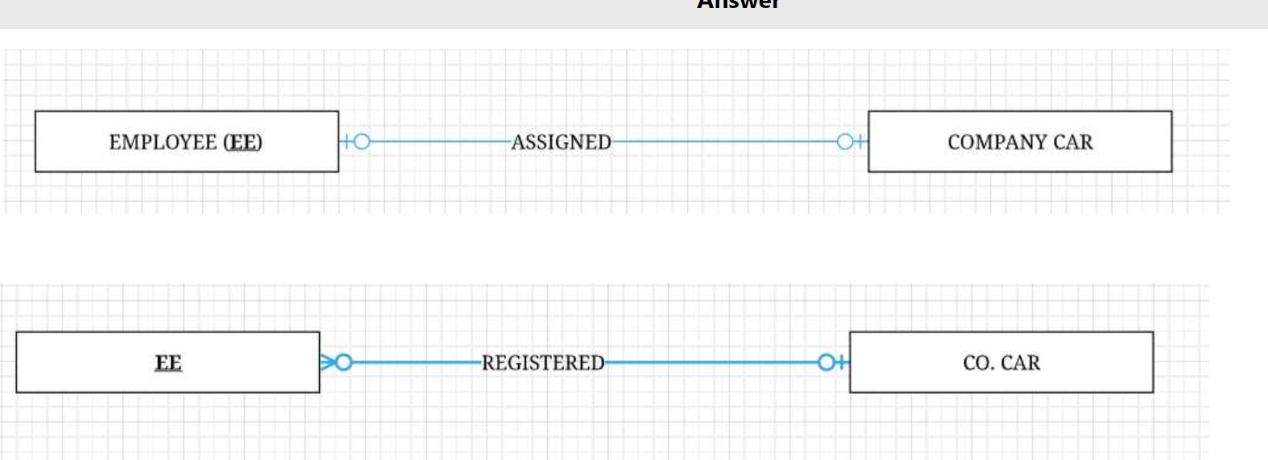

b)An animal may eat many other different animals or may not eat any animals (vegetarian). An animal may be eaten by many different animals or may not be eaten by-any animal at all.

c) In a Manufacturing Company, a part has at least one alternative part (or substitute part). Some parts do not serve as an alternative (substitute) for any parts. Also, a part may serve as an alternative for many different parts.

d) Create an ERD for a service station business that provides goods and services to its customers. Typically a customer comes in with their vehicle and requests certain work to be performed. For example a customer may request an oil change and for a new set of four tires to be provided and installed. The work items that can be performed or supplied can be of two types: a service (such as the oil change) and actual physical items (such as litres of oil). There will be several services that can be performed such as tire installation, changing oil, or fixing a flat tire. Each of these will have some cost to be charged to a customer. There are many concrete items that are supplied and charged to a customer such as fan belts, litres of oil, or tires — these are things that are kept in inventory. Consider creating a hierarchy for products (goods / services); make up reasonable attributes.
This service station has customers that fall into two groups: some are private individuals and others are businesses. Individuals will have a first name, last name, address and .pwone number. A business will have a business name, address, phone numberand a contact person who håSÄåfrst name and lgsenaxne. Consider creating a hierarchy for customers.
The service station needs to keep track of all the goods and services it provides to its customers so that it has a historical record and knows what it has charged to each customer. Each visit to the service station by a customer will generate a work order that keeps track of the work that was done for the customer's vehicle. Vehicles have license plate numbers, and other attributes to describe them (make, model, colour, ...). For each visit of a customer to the station the system needs to know the date the visit occurred, the details of the work performed and goods provided, and the total charge to the customer.

f). An institute facilitates its students to participate in three types of sports events: Long Jump, Discus Throw and 100- Meter race. The following attributes are recorded for each event: e Long Jump: Student Roll Number, Name, House, Age, Recorded Jump
Discus Throw: Student Roll Number, Name, House, Age, Distance covered
• 100 m. Race: Student Roll Number, Name, House, Age, Time taken
Apply rule of generalization and develop an EER model segment using Visio notation. Assume that each of this sport event can be a part of exactly one of these subtypes.
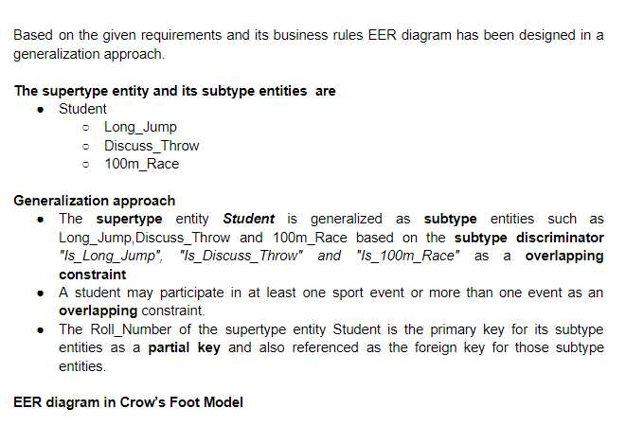
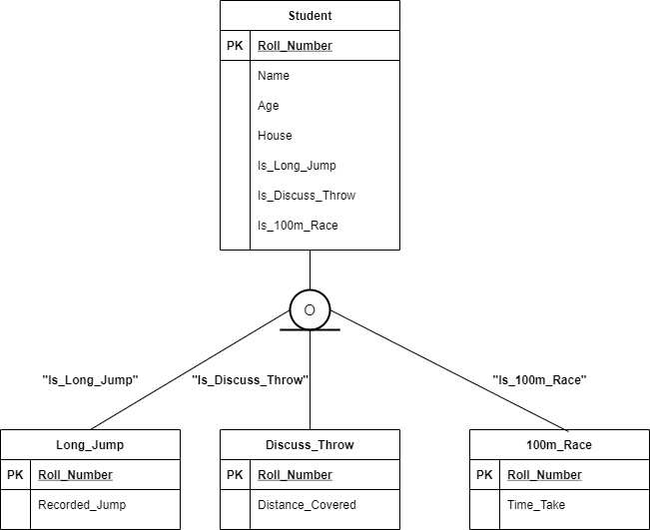
Q Ill. List 5 potential benefits and costs/risks associated with Database åpproach over conventional file (Marks=10)

