**Implementation of Root Locus using MATLAB**

**LAB # 10**



**Fall 2024**

**CSE-310L Control Systems Lab**

Submitted by: **Ali Asghar**

Registration No.: **21PWCSE2059**

Class Section: **C**

“On my honor, as student of University of Engineering and Technology, I have neither given nor received unauthorized assistance on this academic work.”

Submitted to:

**Dr. Muniba Ashfaq**

Date:

10**th December 2024**

**Department of Computer Systems Engineering**

**University of Engineering and Technology, Peshawar**

**Objectives:**

To Implement Root Locus in MATLAB

**Task 1 (Example):**

**G(s)H(s) = (s-2)/(s+2)(s+2j)(s-2j)**

**= (s-2)/(s+2)(s^2+2s+3)**

**= (s-2)/(s^3+2s^2+4s+8)**

**Code:**

**Output:**

**Task 1 part 2:**



**Code:**

**Output:**

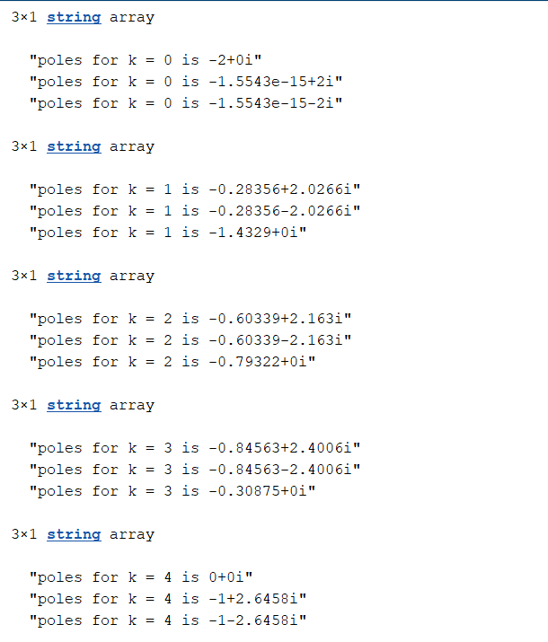

**Analysis:**

Loop gain or K start from 0 and approaches to 3.99 for stable system. As the values goes beyond 3.99 or 4 so the system become unstable. K is stable for 0 to 3.99 and unstable for 4 to 10.

**Conclusion:**

Rlocus() is used to check the stability of a system. It's or very hard to determine from the differential equation or the transfer function of a system whether the system is stable not. MATLAB helps in properties or characteristics of a system.