**Implementation of Root Locus using Sisotool in MATLAB**

**LAB # 11**



**Fall 2024**

**CSE-310L Control Systems Lab**

Submitted by: **Ali Asghar**

Registration No.: **21PWCSE2059**

Class Section: **C**

“On my honor, as student of University of Engineering and Technology, I have neither given nor received unauthorized assistance on this academic work.”

Submitted to:

**Dr. Muniba Ashfaq**

Date:

**22nd December 2024**

**Department of Computer Systems Engineering**

**University of Engineering and Technology, Peshawar**

**Tasks:**

1. Using sisotool find the root locus design for the following system:

G(S)H(S) = k(S+3)(S+4)/(S+5)(S+6);

1. Add a pair of complex poles to the system defines above.
2. Add a pair of complex zeros to the system defines above.
3. Add a real zero to the system.
4. Add a real pole to the system.

Also find the following for Questions 1 to 5.

* The range of k for which the system is stable.
* The break in/ breakout points if any.
* The impulse response for k=2.
* the step response for k=3
* the rise time and peak response for k=3

**Introduction:**

SISOTOOL is Graphical User Interface allows us to design single-input/single-output (SISO) compensators by using the root locus, Bode, and Nichols plots of the open-loop system.

**Root Locus:**

rlocus computes the Evans root locus of a SISO open-loop model. The root locus gives the closed-loop pole trajectories as a function of the feedback gain k (assuming negative feedback). Root loci are used to study the effects of varying feedback gains on closed-loop pole locations. In turn, these locations provide indirect information on the t ime and frequency responses.

**Equipment:**

Using SISOTOOL in Matlab software.

**Task # 1,2,3,4,5:**

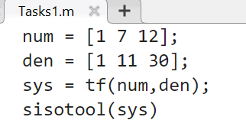

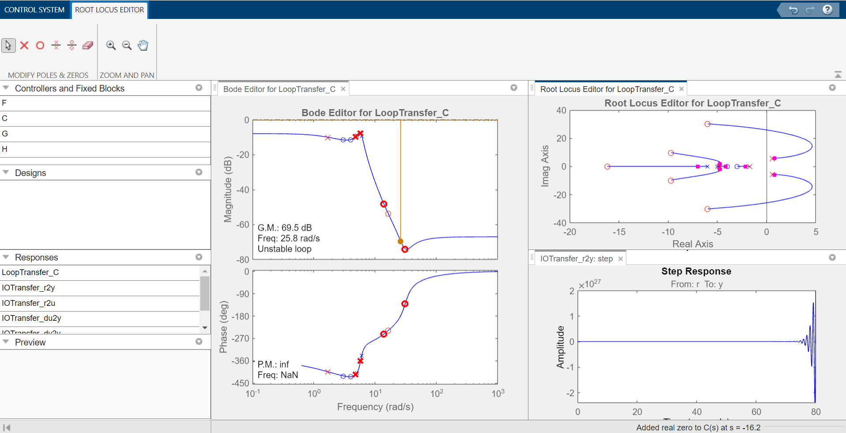

* The range of k for which the system is stable is **0 to $∞$**
* The break in/ breakout points if any.

Break Away Point: -5

Break In Point: N/A

* The impulse response for k=2.

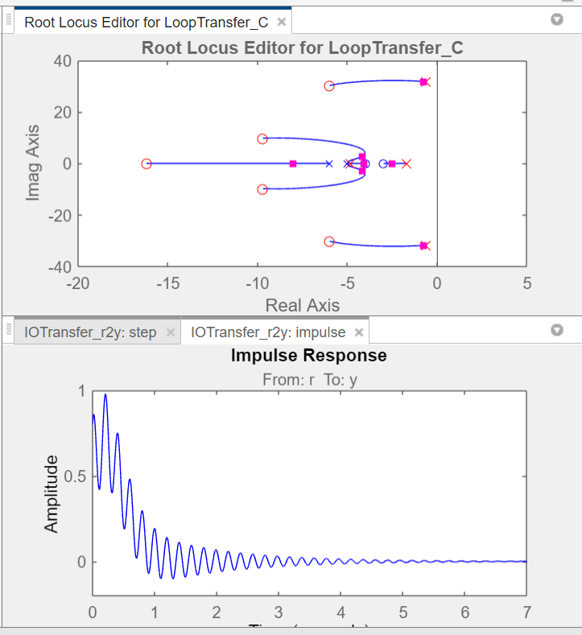

* the step response for k=3

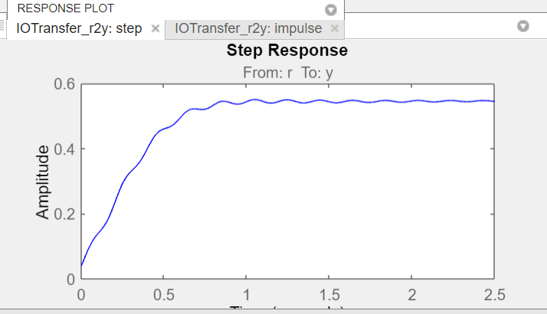

* the rise time and peak response for k=3

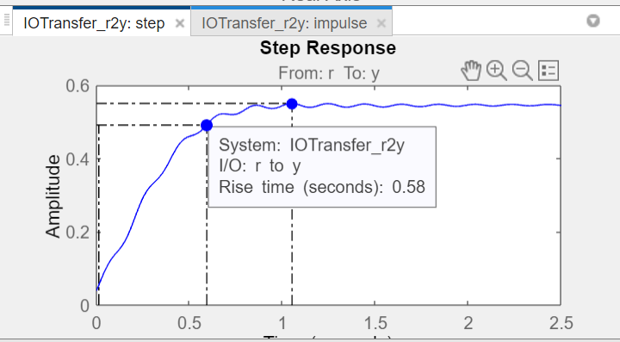

peak response for k = 3

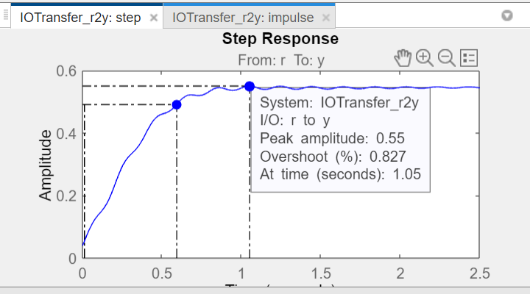

rise time for k = 3