**Implementation of Root Locus using Sisotool in MATLAB**

**LAB # 11**



**Fall 2024**

**CSE-310L Control Systems Lab**

Submitted by: **Ali Asghar**

Registration No.: **21PWCSE2059**

Class Section: **C**

“On my honor, as student of University of Engineering and Technology, I have neither given nor received unauthorized assistance on this academic work.”

Submitted to:

**Dr. Muniba Ashfaq**

Date:

**22nd December 2024**

**Department of Computer Systems Engineering**

**University of Engineering and Technology, Peshawar**

**Objectives:**

The objective of this lab is to:

1. Using sisotool find the root locus design for the following system: G(S)H(S) = k(S+3)(S+4)/(S+5)(S+6);
2. Add a pair of complex poles to the system defines above.
3. Add a pair of complex zeros to the system defines above.
4. Add a real zero to the system.
5. Add a real pole to the system.

Also find the following for Questions 1 to 5.

* The range of k for which the system is stable.
* The break in/ breakout points if any.
* The impulse response for k=2.
* the step response for k=3
* the rise time and peak response for k=3

**Introduction:**

SISOTOOL is Graphical User Interface allows us to design single-input/single-output (SISO) compensators by using the root locus, Bode, and Nichols plots of the open-loop system.

**Root Locus:**

rlocus computes the Evans root locus of a SISO open-loop model. The root locus gives the closed-loop pole trajectories as a function of the feedback gain k (assuming negative feedback). Root loci are used to study the effects of varying feedback gains on closed-loop pole locations. In turn, these locations provide indirect information on the t ime and frequency responses.

**Equipment:**

Using SISOTOOL in Matlab software.

**Task 1:**

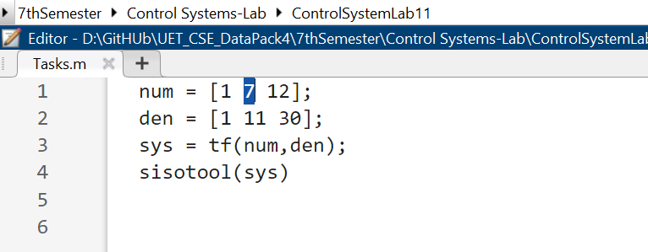

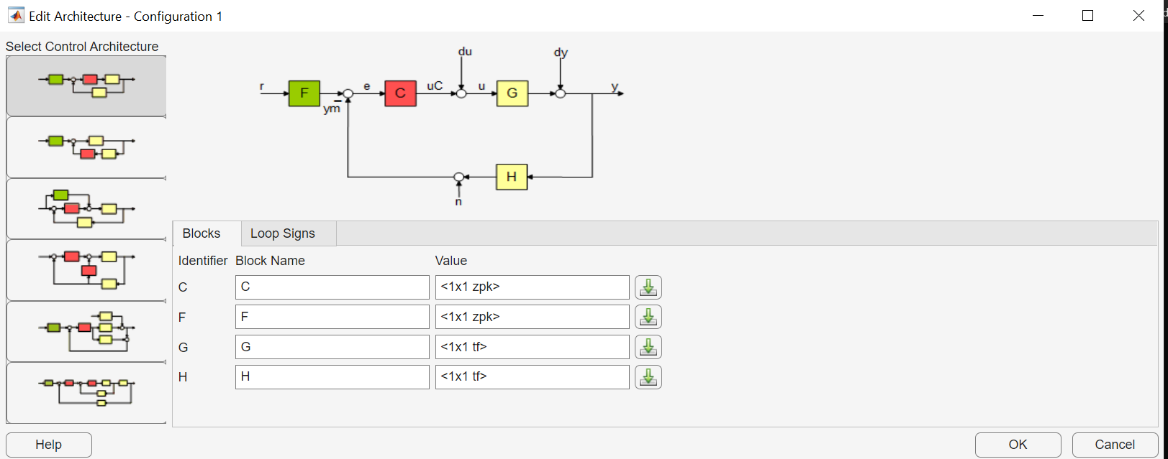

**Task 2,3,4,5:**

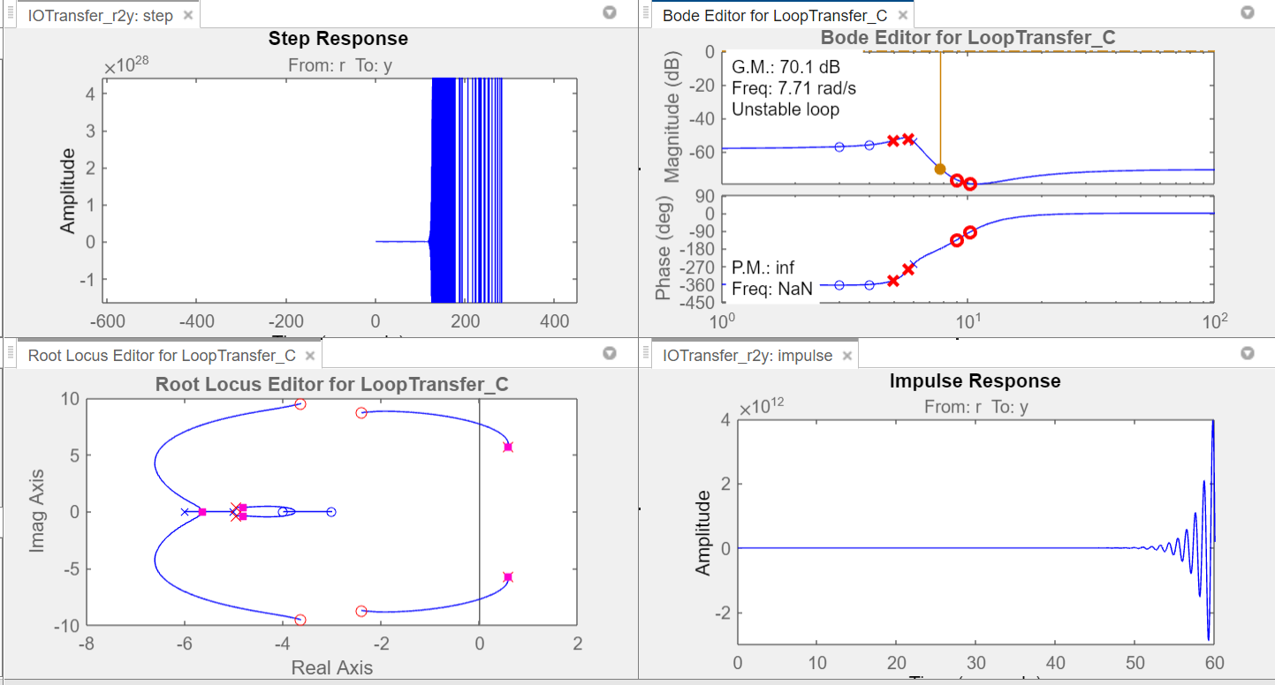

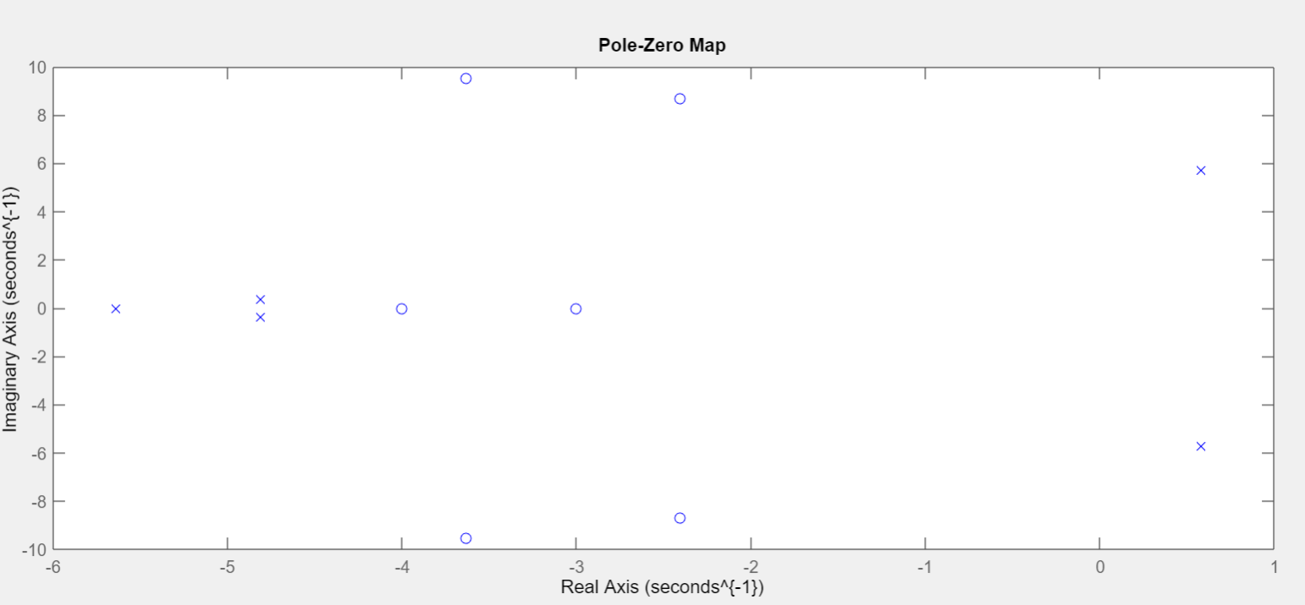

* The range of k for which the system is stable

**Range = [10.77, 3448100]**

* The break in/ breakout points if any.

**Break Away Point: -5.65**

**Break In Point: -3.75**

* The impulse response for k=2.

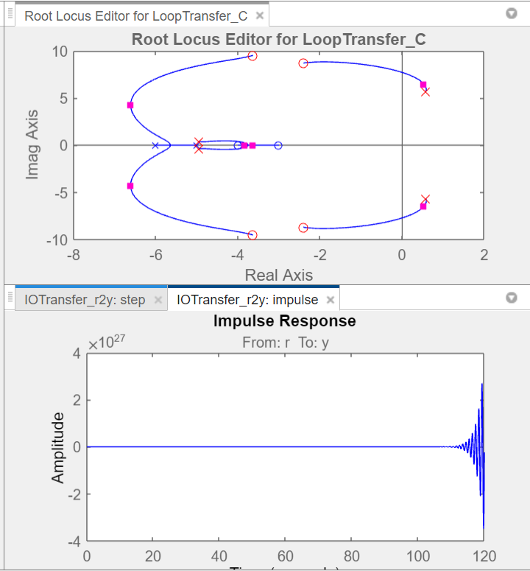

* the step response for k=3

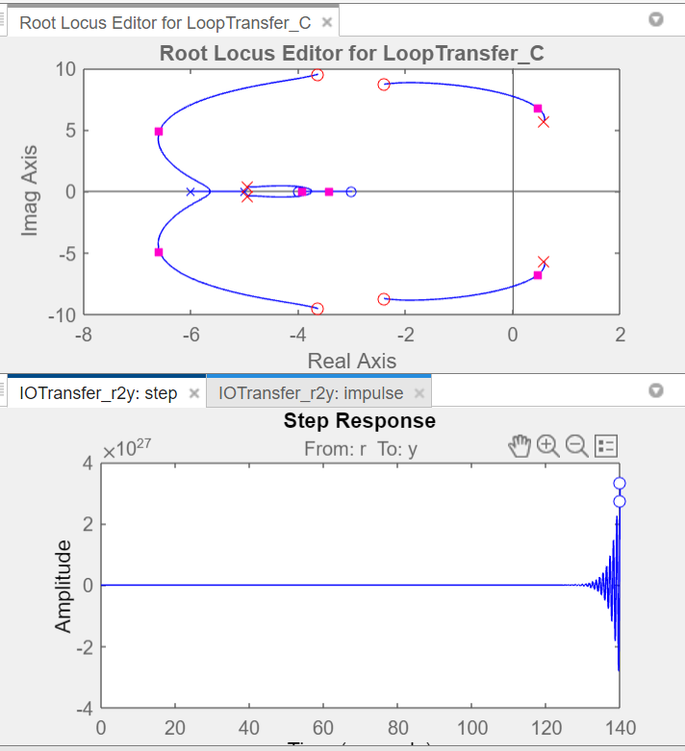

* the rise time and peak response for k=3

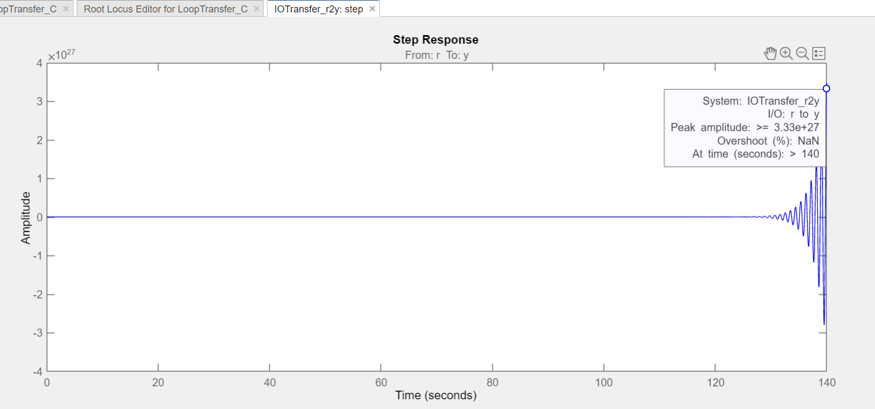

peak response for k = 3

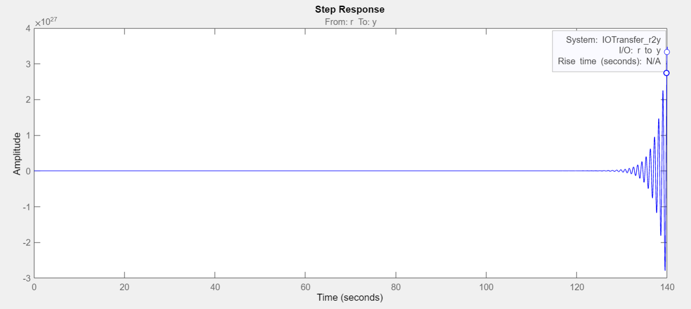

rise time for k = 3

**Analysis:**

Through root locus we can find the stability of a system. It also shows that at which points the system will be stable and which point the system is unstable. Root Locus also shows rise time and peak time. It also inform about maximum overshoot.