**System Design using Sisotool**

**LAB # 12**



**Fall 2024**

**CSE-310L Control Systems Lab**

Submitted by: **Ali Asghar**

Registration No.: **21PWCSE2059**

Class Section: **C**

“On my honor, as student of University of Engineering and Technology, I have neither given nor received unauthorized assistance on this academic work.”

Submitted to:

**Dr. Muniba Ashfaq**

Date:

**31st December 2024**

**Department of Computer Systems Engineering**

**University of Engineering and Technology, Peshawar**

**Task:**

For K<2, design a system (second order) with the following characteristics:

* Percent overshoot < 50
* Damping ratio > 0.2
* Stable system

**Introduction:**

Percent overshoot: Systems may be stable system, unstable system and marginally stable system. A stable system may overshoot for some values at the start before coming to the stable level. Similarly in this lab a system is designed whose percent overshoot is <50.

**Damping ratio:**

Damping ratio is a parameter that indicates that whether system is over damped(ς>1),under damped((ς<1) or critically stable((ς=1). In this lab a system is designed which must have damping ratio > 0.2.

**Stable system:**

Third condition which the system must satisfy is it must be stable for K<2, also all the values (damping ratio and % overshoot) are set. It must be unstable for K>=2.

**Task:**

**Code:**

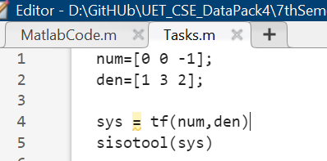

**Output:**

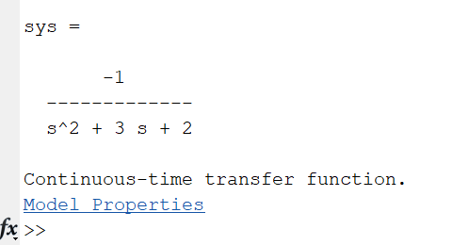

**Sisotool Output:**

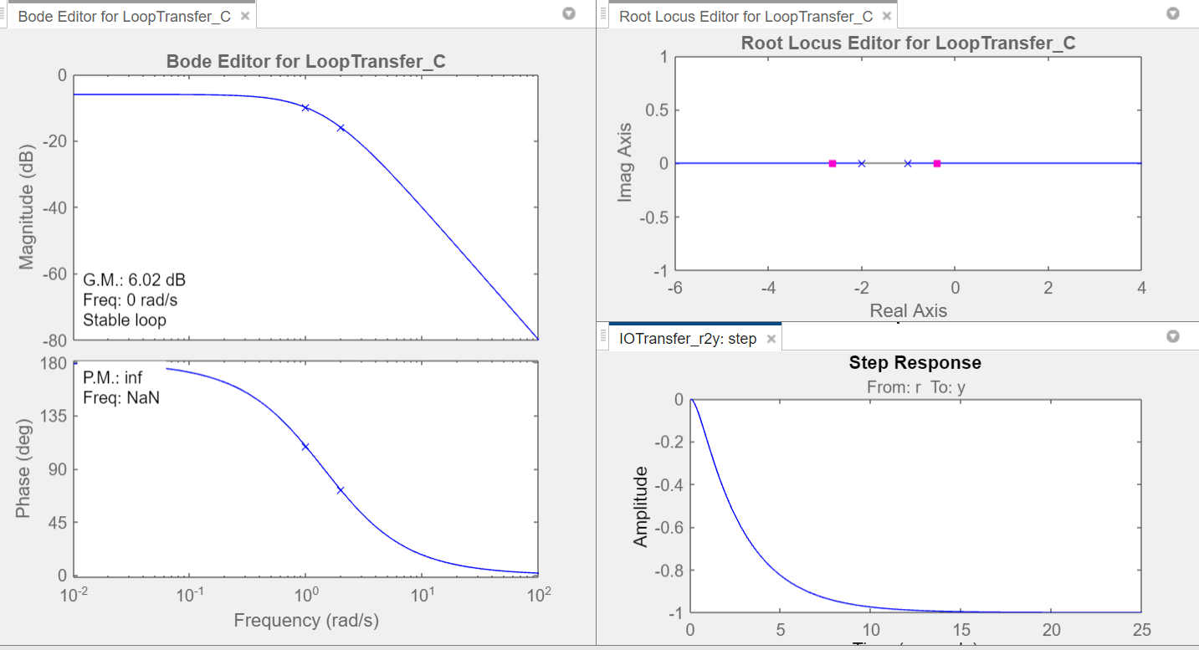

For k=1

**Setting %Overshoot to <50:**

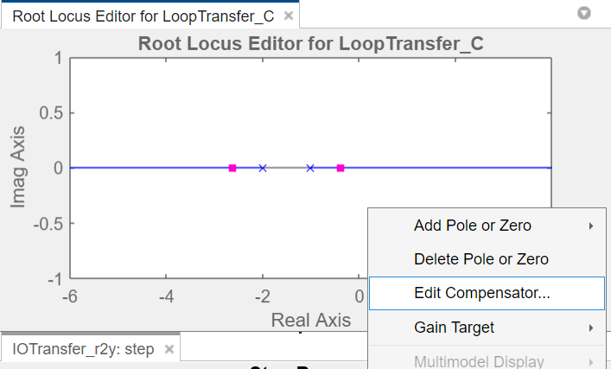

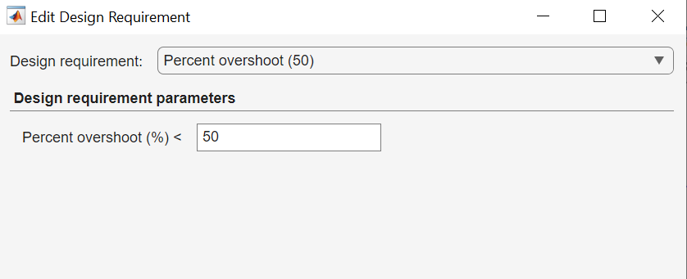

**Setting Damping Ratio to >0.2:**

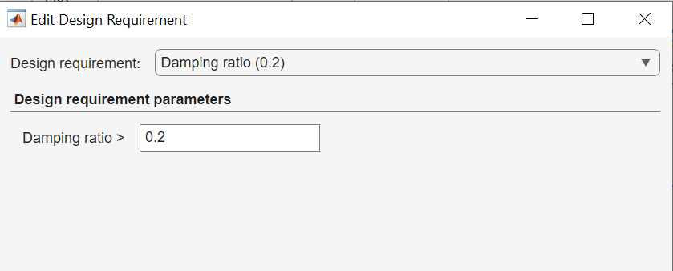

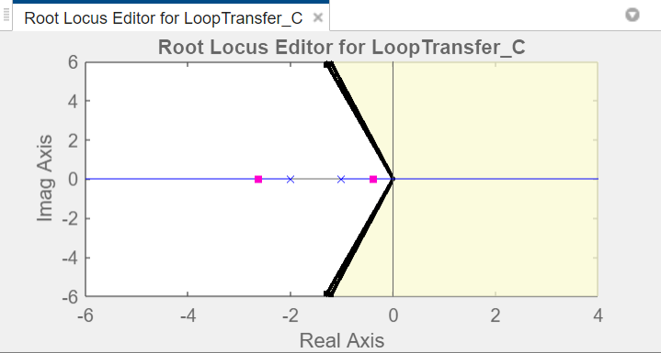

**Checking Stability for different k values:**

**For k = 1 (Stable System)**

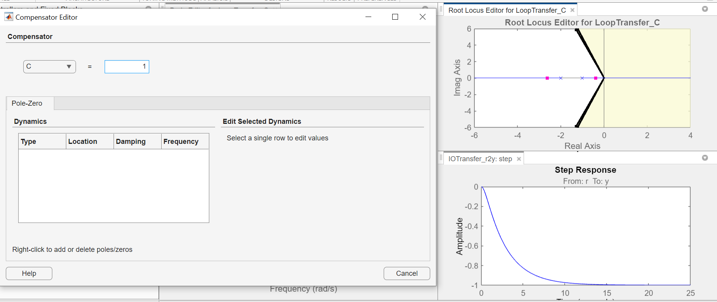

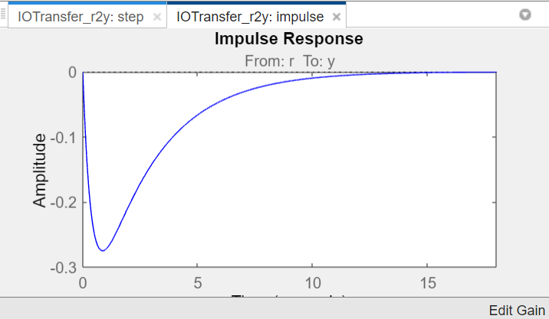

**For k = 2 (Marginally Stable System)**

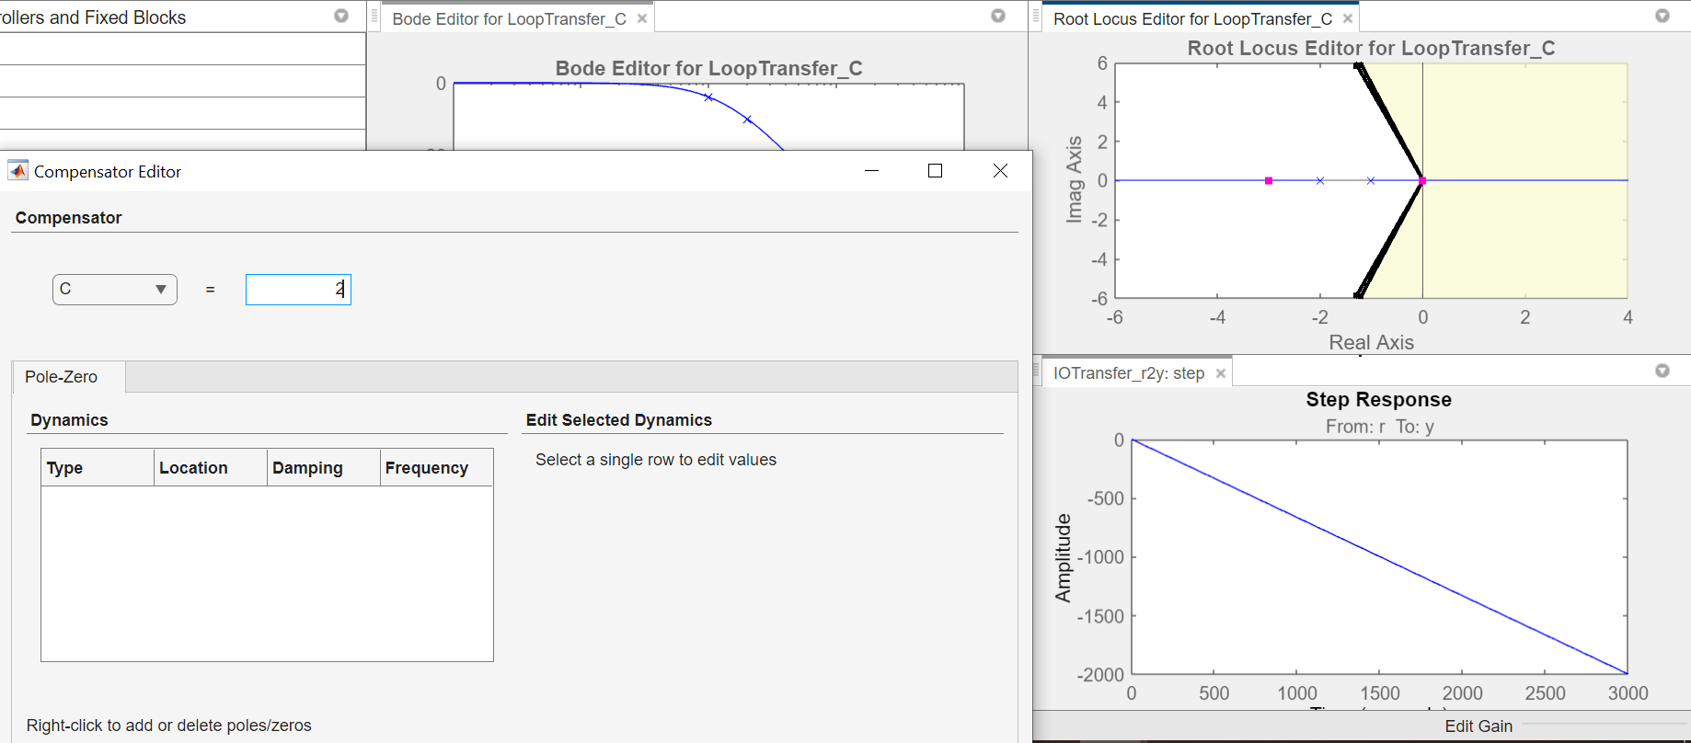

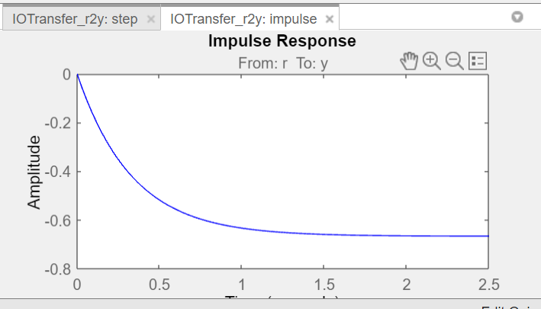

**For k = 3 (Unstable System)**

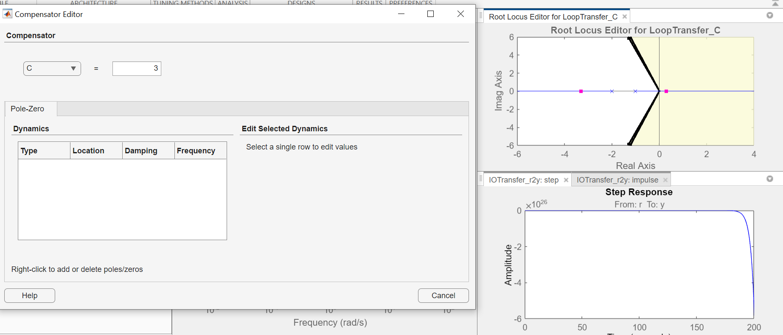

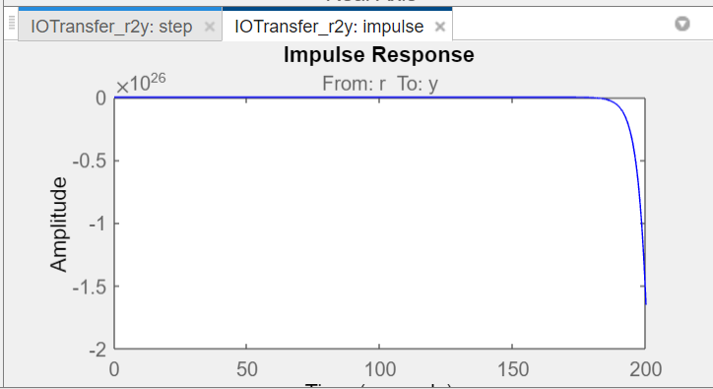

**Conclusion:**

All the requirements for system are satisfied. The System is stable for all K=2. So this system fulfills all the conditions.