**System Response by different inputs in MATLAB and Simulink**

**LAB # 02**



**Fall 2024**

**CSE-310L Control Systems Lab**

Submitted by: **Ali Asghar**

Registration No.: **21PWCSE2059**

Class Section: **C**

“On my honor, as student of University of Engineering and Technology, I have neither given nor received unauthorized assistance on this academic work.”

Submitted to:

**Dr. Muniba Ashfaq**

Date:

20**th October 2024**

**Department of Computer Systems Engineering**

**University of Engineering and Technology, Peshawar**

**Objectives:**

The objective of this lab is to learn about:

* Step and Impulse Response of the system
* Simulating Response of the system using sinusoidal as input

**Task 1:**

Find an impulse and step response of the following system by using MATLAB. Use Simulink to find both responses and compare them with MATLAB results. (Hint: impulse, step,

Impulse is the derivative of the step)

**MATLAB:**

**Code:**

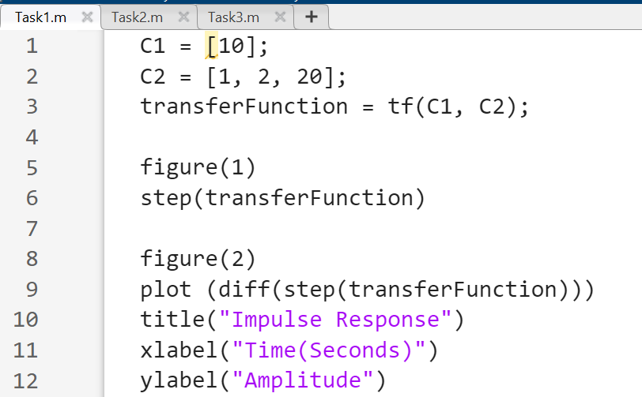

**Output:**

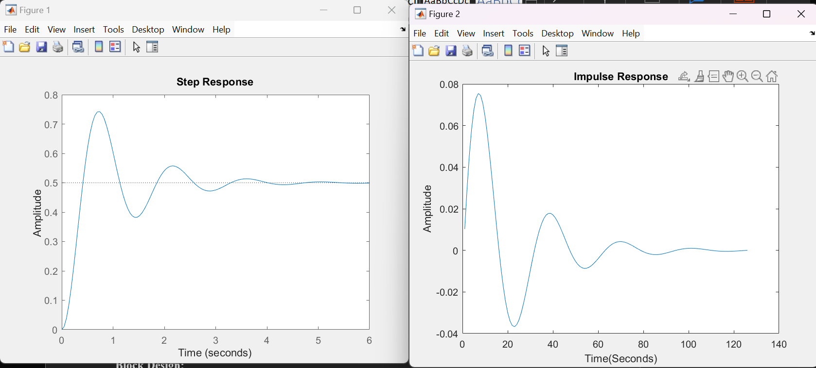

**Simulink:**

**Block Design:**

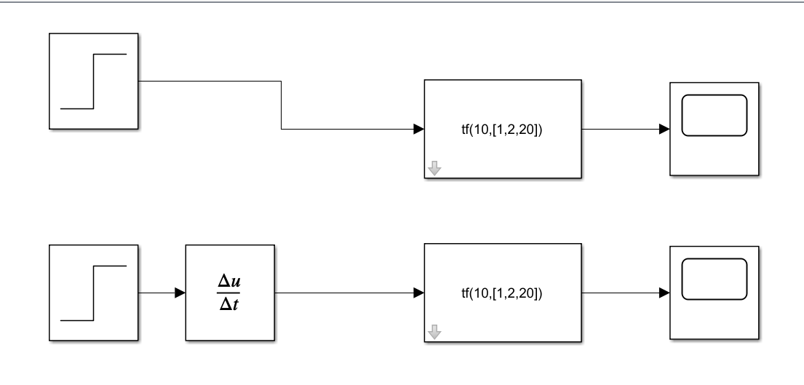

**Output:**

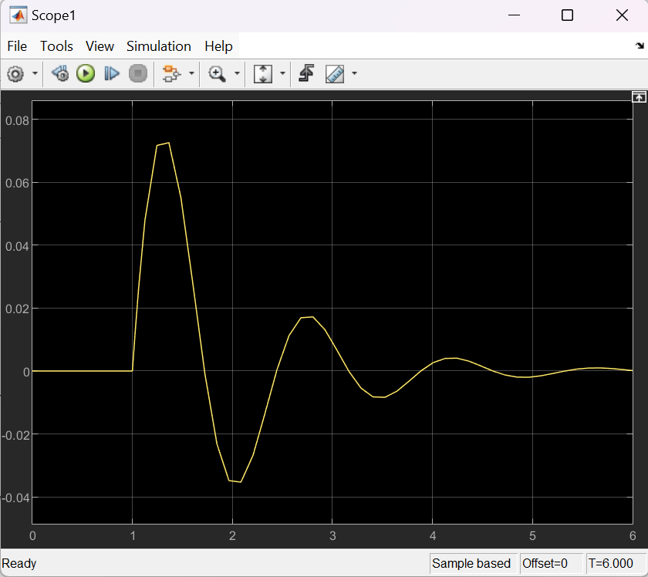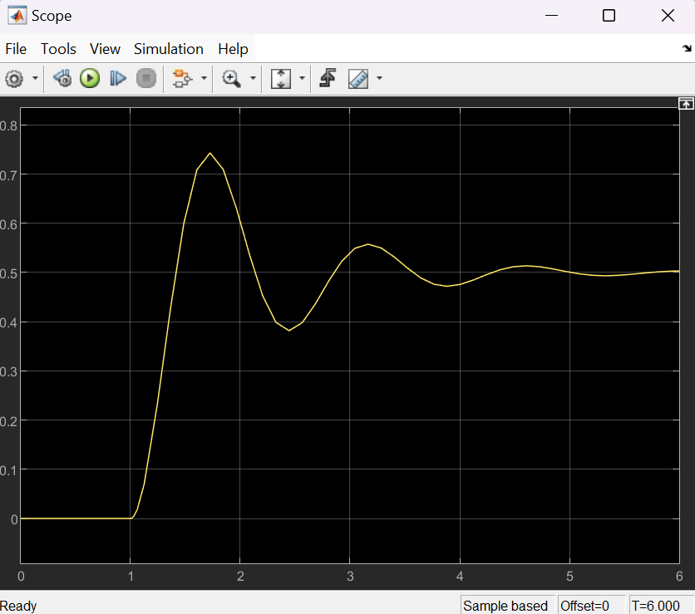

Impulse response

Step response

**Task 2:**

Apply the sinusoidal input to the above mentioned system in both MATLAB and Simulink. Compare both the results too. Also plot output vs input in both. (Hint:lsim)

**MATLAB:**

**Code:**

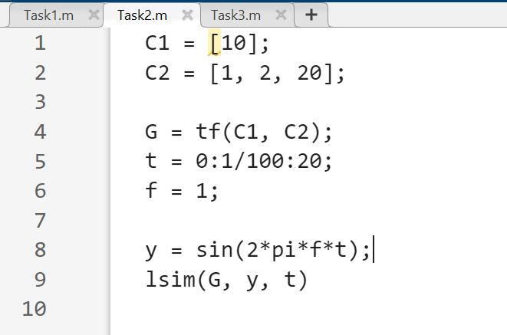

**Output:**

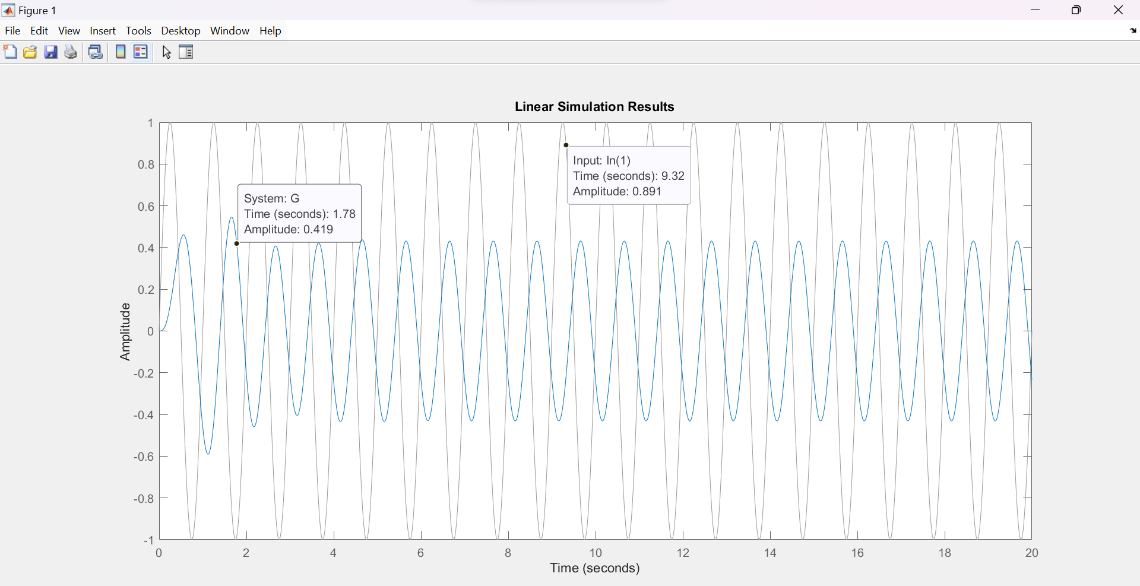

**Simulink:**

**Block Design:**

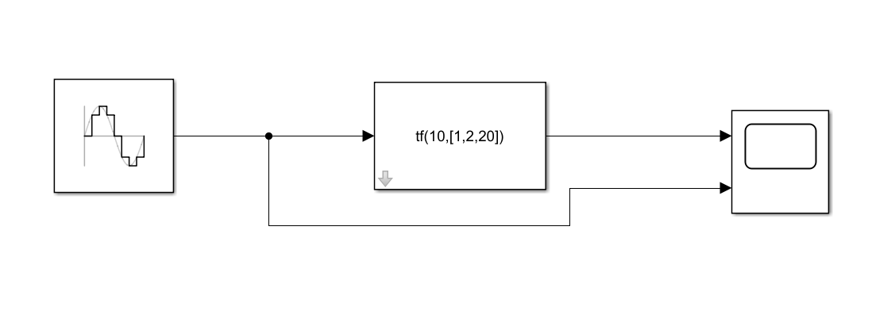

**Output:**

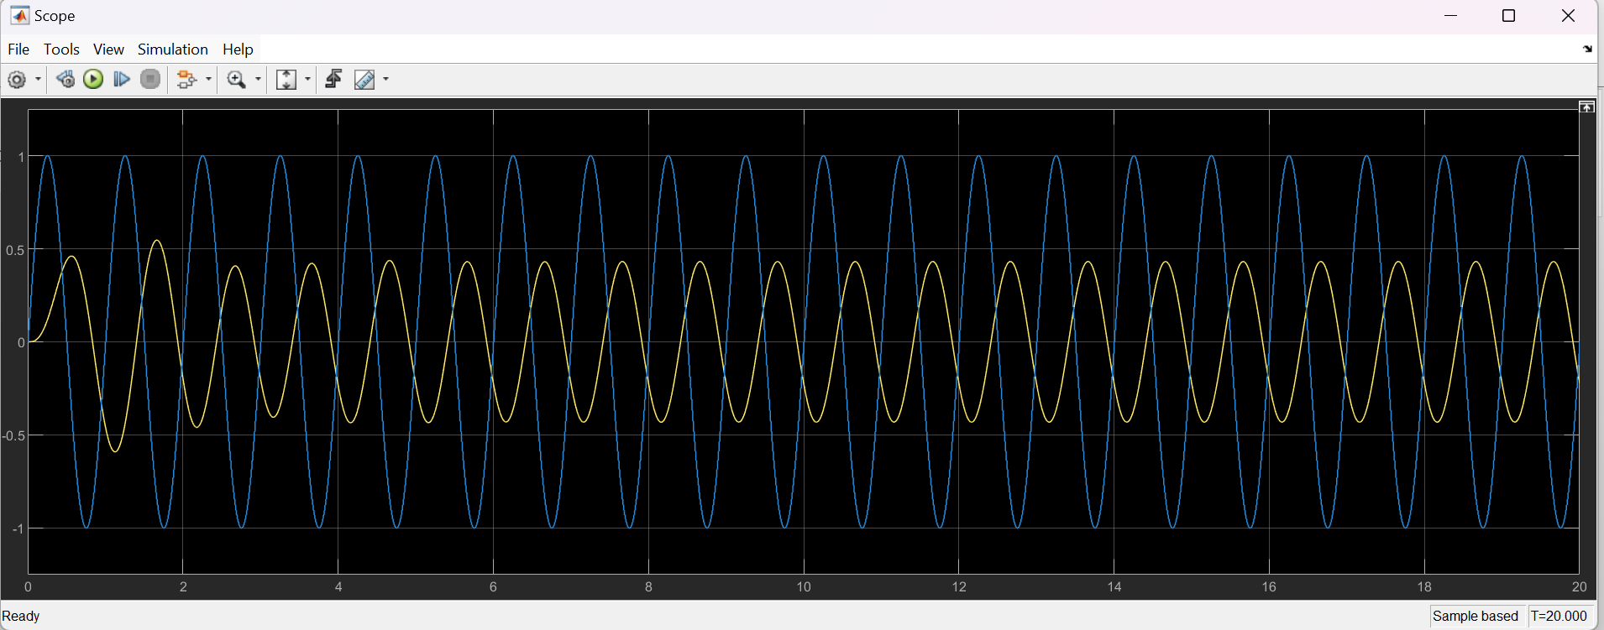

**Task 3:**

Apply the following input to the system in both Simulink and MATLAB.

sin(2πt) + u(t) + 2u(t-5)

**MATLAB:**

**Code:**

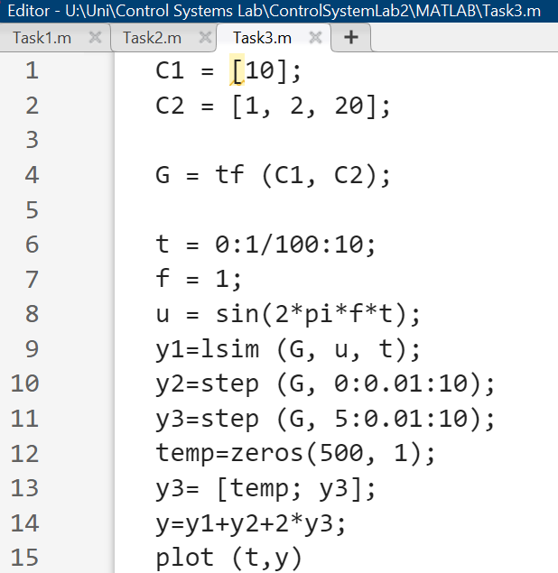

**Output:**

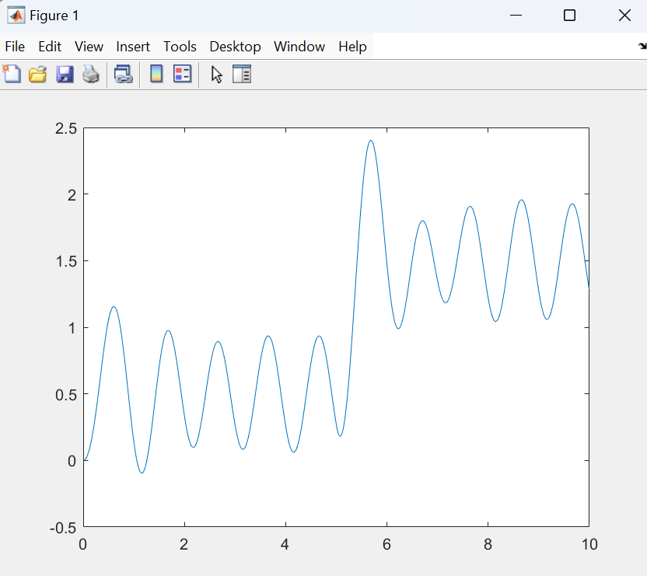

**Simulink:**

**Block Design:**

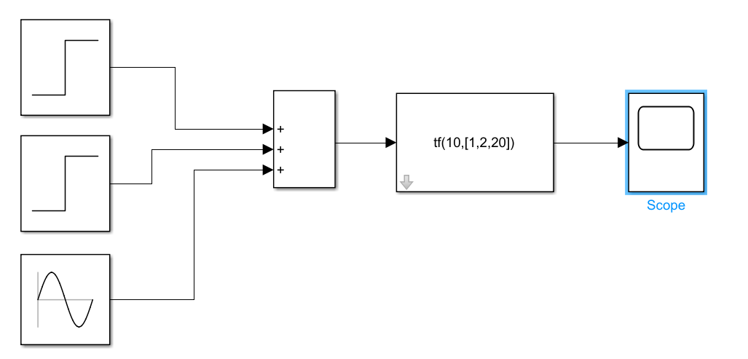

**Output:**

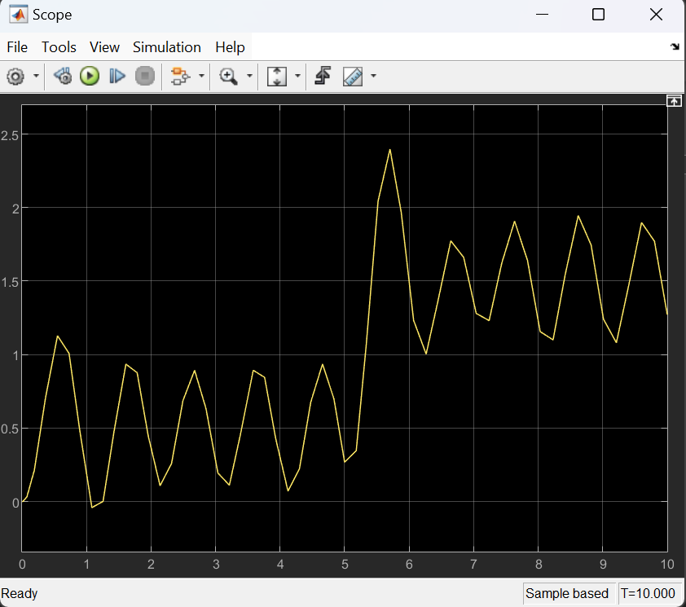

**Task 4:**

Square input with amplitude equal to 1 and time period equal to 10 seconds. Simulate the system for at least 40 seconds.

**MATLAB:**

**Code:**

**Output:**

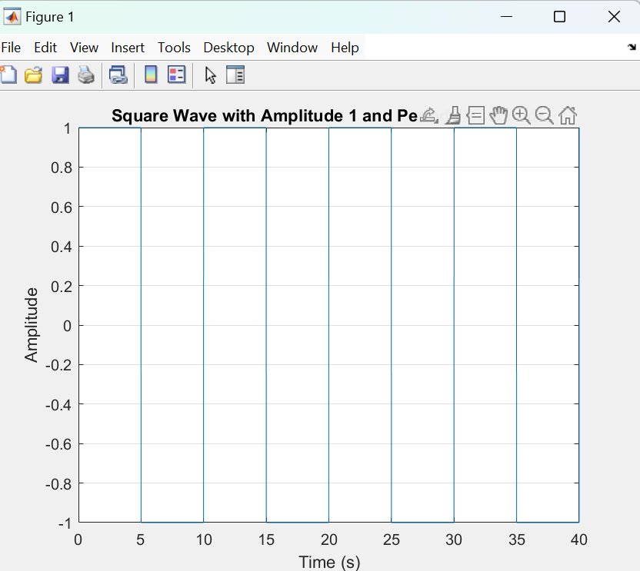

**Simulink:**

**Block Design:**

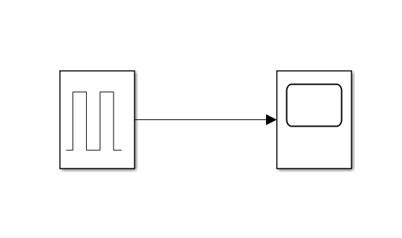

**Output:**

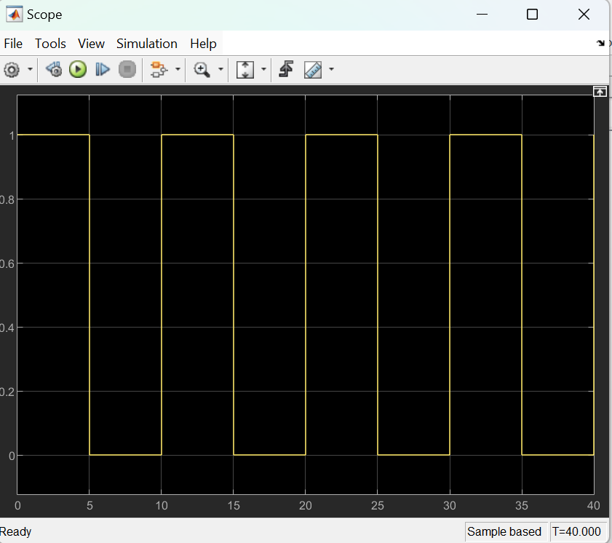

**Task 5:**

Combine both of the inputs of Q#3 and Q#4.

**MATLAB:**

**Code:**

**Output:**

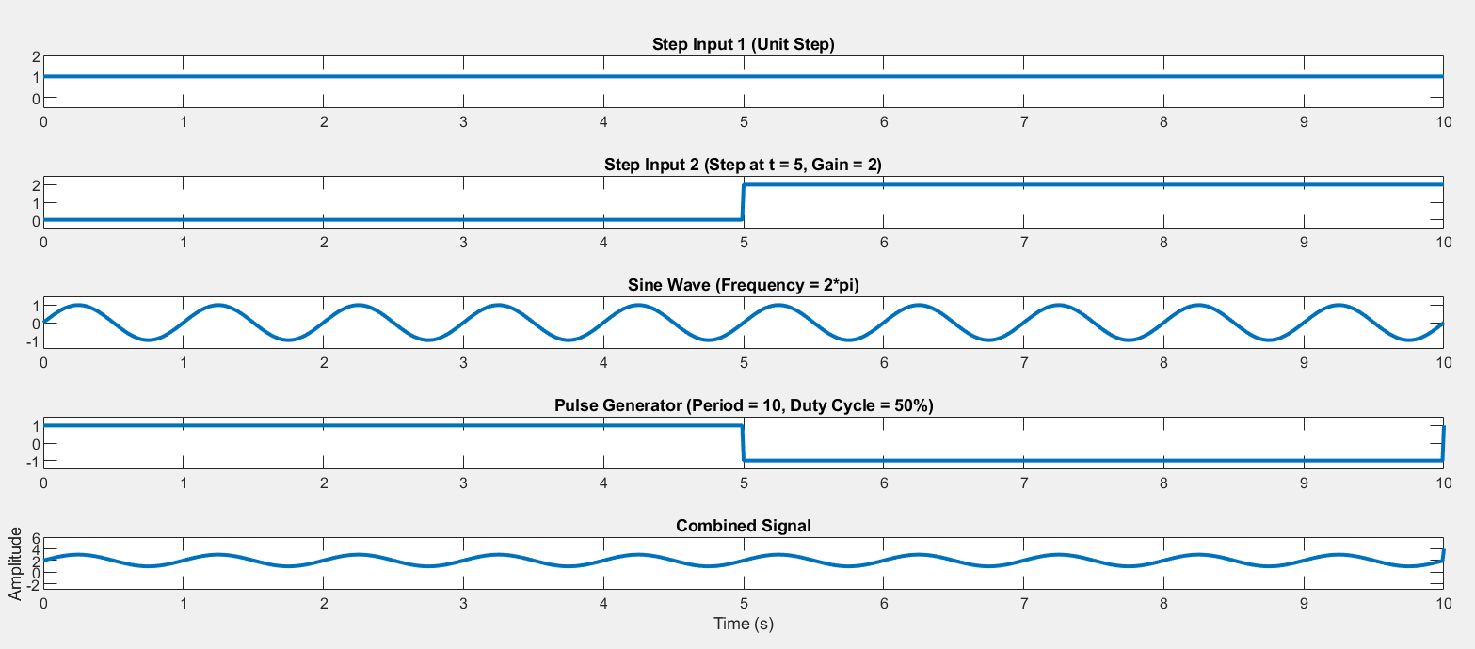

**Simulink:**

**Block Design:**

**Output:**

